**E-Project Status Report**

**PC Center**

Introduction: -

Here is outline of our E-Project. As our is PC Center which contains hardware, software, peripherals, networking, communications, media, supplies and accessories etc. We have build a Figma design as a conceptual idea which can help us to develop in real phase. In the end of this report we have attached the screen of our website design.

Status: -

In our group we are four members Arsalan Abdul Wahid the leader of the group and other group members are Muhammad Afnan, Muhammad Asim and Shahrukh Khan. Arsalan and Afnan made home, our services and about us pages and Asim made popular brands and contact us page.

Detail: -

The reason we select this design because we consider it user friendly and very easy to navigate for user. So that user can easily get access to each and every page and understand the website easily. We focus to made this website in such a way that the user find this website very easy and visit our website every time.

Home Page

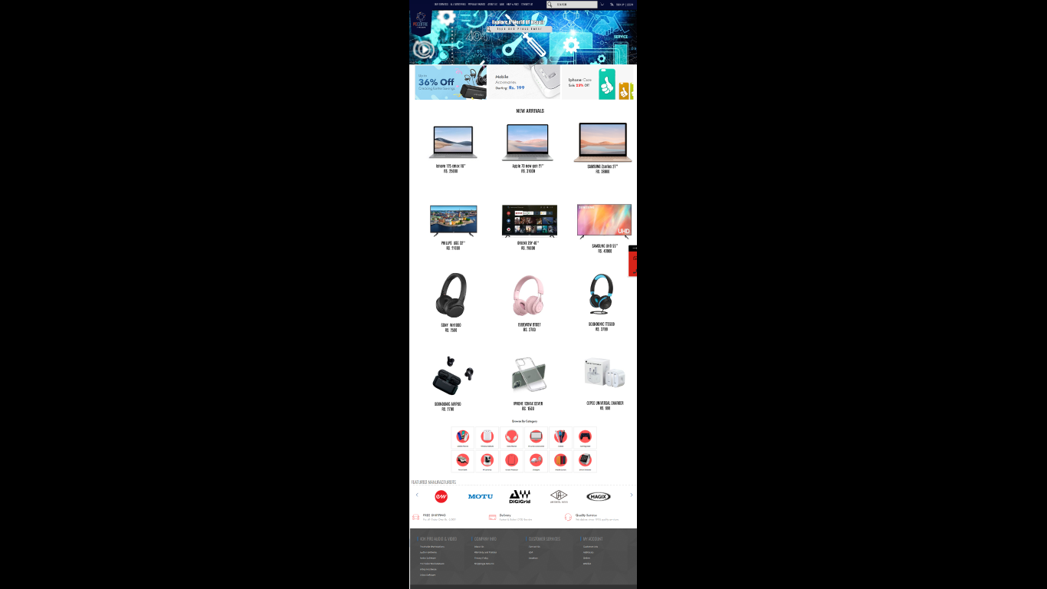

Our Services

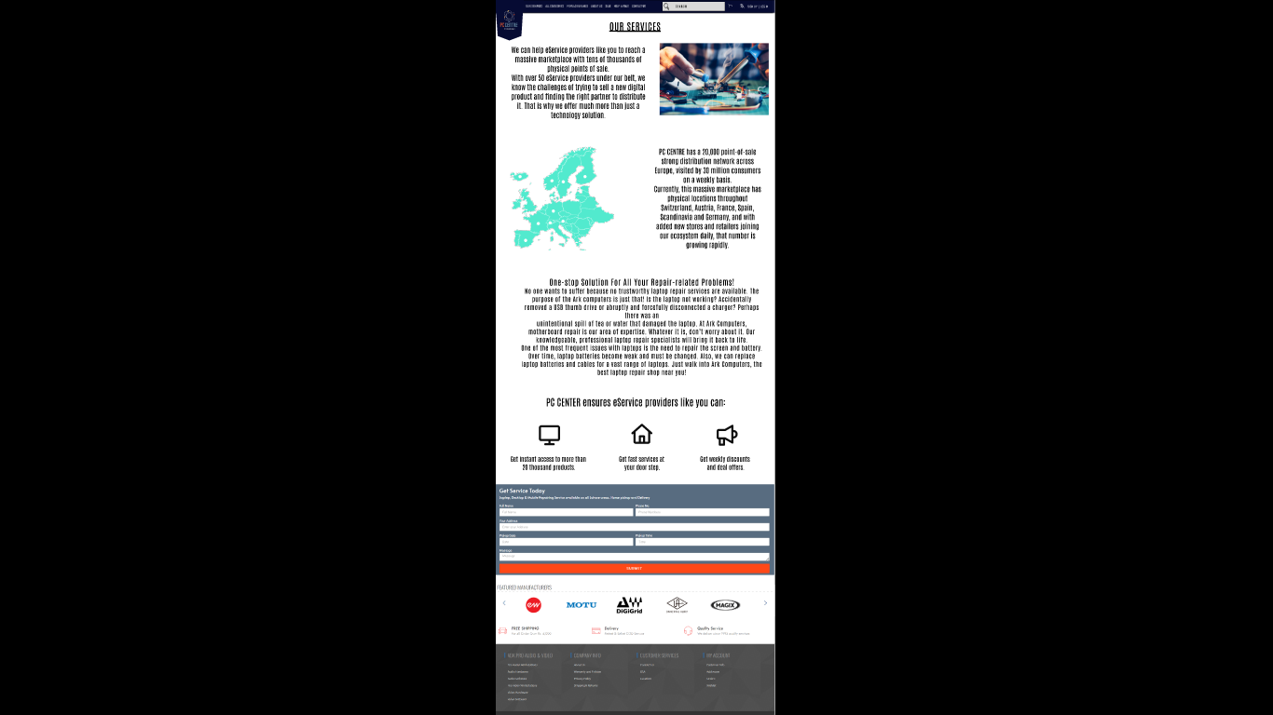

Popular Brand

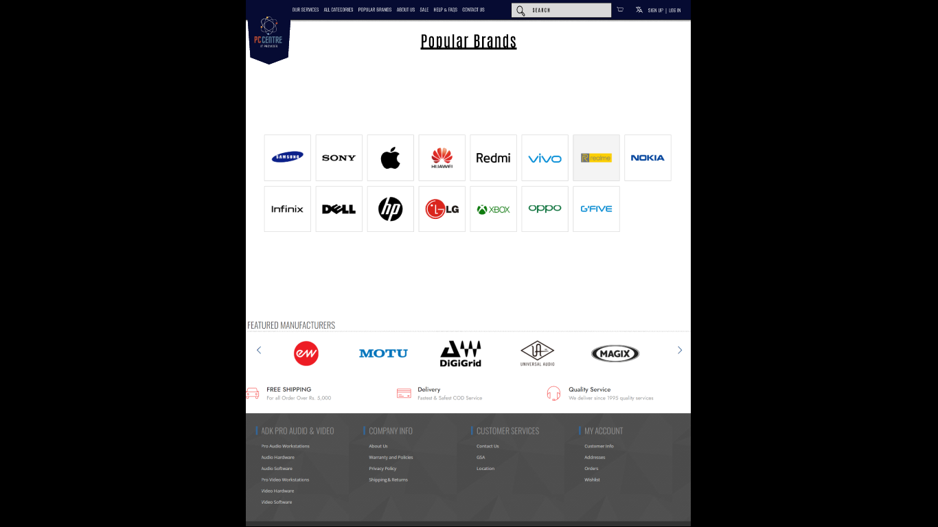

About Us



Contact Us

