
University of Central Punjab
Faculty of Information Technology

Object Oriented Programming - Lab 03
Topic
C++ Classes: Syntax, Access Specifiers, Data Members, Member Functions, Setters & Getters
Objective
- To understand the basic syntax and structure of a C++ class.
- To learn the role of access specifiers (public, private) in encapsulation.
- To differentiate between data members and member functions.
- To implement setters and getters for accessing private data safely.
- To gain practical experience in writing and using simple class definitions.
Outcomes
By the end of this Lab, you will be able to:
- Define and implement a C++ class with proper structure.
- Use access specifiers effectively to control data access.
- Declare and utilize data members and member functions.
- Write getter and setter functions to access and modify private members.
- Develop simple programs demonstrating object-oriented principles.
Content
The following sections will be covered during this lab session.

- Basic Syntax and Structure of a C++ Class – Introduction to defining classes, understanding class components, and creating objects.
- Access Specifiers (public, private) – Demonstrating encapsulation, controlling access to class members, and ensuring data security.
- Data Members and Member Functions – Declaring variables (attributes) and defining functions (behaviors) within a class.
- Writing a Simple Class Definition – Implementing a class with meaningful data members and functions to demonstrate OOP basics.
- Setters and Getters – Writing accessor and mutator functions to safely update and retrieve private data.

Instructions
  - Indent your code properly.
  - Use meaningful variable and function names. Use the camelCase notation.
  - Use meaningful prompt lines/labels for all input/output.
  - In each file of your task either it is .cpp file or .h file Your name and roll no must be mentioned in the start of your file as comment. For example, //L1F20BSCS0000 – Ahmad
  - You are not allowed to use any built-in function.
  - You are required to complete the following tasks in lab timings

Task 01
In Lab 1 (Question 1), you implemented a function swapNumbers(int a, int b) to swap two integers using pass-by-value. Now, reuse the same concept but implement it using class.
- Define a class with an appropriate name (e.g., NumberSwapper).
- The class should contain data members for the two integers.
- Write setter functions to assign values to these private d ata members.
- Write getter functions to retrieve and display the values.
- Implement a member function swapNumbers(int a, int b) inside the class that attempts to swap the values (still using pass-by-value).
- Create an object of the class in main () and demonstrate swapping.
- Display the numbers before and after calling the member Display ().
CODE:
/////L1F24BSCS0069
#include<iostream>
using namespace std;
class NumberSwapper{
private:
int Num1,Num2; //creating variable name for storing of the data
public:
//////////setters
void setNum1(int value){
Num1=value; //assigning the value to NUm1
}
void setNum2(int val){
Num2=val; //assigning the value to NUm2
}
////////////getters
int getNum1(){
return Num1; //retriving value from num1
}
int getNum2(){
return Num2; //retriving value from num1
}
/////////////swapping of numbers
void swapNumbers(int a, int b){ //function to swap numbers by using a third variable
int temp=a;
a=b;
b=temp;
cout<<"The value of num1 after swapping is = "<<a<<" and the value of num2 after swapping is = "<<b;
}
//display
void displayNUmbers(int c,int d){
cout<<"The orignial value of num1 is = "<<c<<" and the original value of num2 is = "<<d<<endl;
}
};

int main()
{
NumberSwapper obj; //making an object
int number1,number2,n1,n2; //creating variables so can store the initial numbers and also the getter ones
cout<<"Enter the first number"<<endl;
cin>>number1; //taking first number form the user
obj.setNum1(number1); //initilizing the number with the num1 variable in the class
cout<<"Enter the second number"<<endl;
cin>>number2; //taking first number form the user
obj.setNum2(number2); //initilizing the number with the num1 variable in the class
n1=obj.getNum1(); //getting the numbers so can be used to pass as argument in display and swap function
n2=obj.getNum2(); //getting the numbers so can be used to pass as argument in display and swap function
obj.displayNUmbers(n1,n2);
obj.swapNumbers(n1,n2);
return 0;
}
OUTPUT:
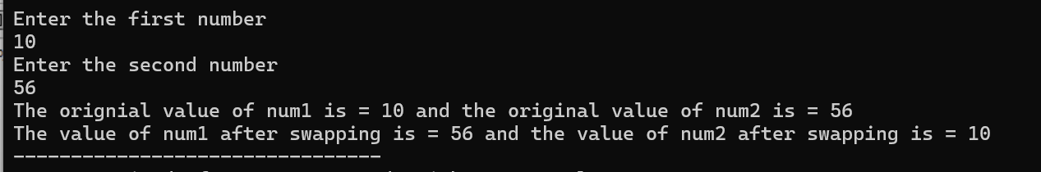

Task 02
In Lab 1 (Question 3), you implemented a function calculateArea(int length, int width = 5) that calculated the area of a rectangle using default arguments. But this time, do that by using class.
- Define a class (e.g., Rectangle) with two private data member (length and width).
- Assign a default value of 5 to width directly when declaring the attribute (instead of using a default argument in a function).
private:
int length;
int width = 5; // default
- Write setter functions to set the values of length and width.
  - If only length is set, the default value of width should remain 5.
- Write a member function that calculates and returns the area of the rectangle.
- Write a getter function to display the calculated area.

In main():
  - Create an object of the class.
  - Use the setter to assign only length, then display the area (should use default width).
  - Use the setters again to assign both length and width, and display the updated area.
CODE:
/////L1F24BSCS0069
#include<iostream>
using namespace std;
class Area{ //creating class for area.
private:
int Lenght; //ceating variables for storing lenght value
int Widht=5; //ceating variables for storing widht value
public:
//////////setters
void setLenght(int value){
Lenght=value; //updating the value lenght
}
void setWidht(int val){
Widht=val; //updating the value of widht
}
/////////////getters
int getLenght(){
return Lenght; //retriving the lenght data.
}
int getWidht(){
return Widht; //retriving the widht data.
}
int calArea(int a,int b){ //function for alculating area
return a*b; //logic for area calculation
}
};

int main(){
Area obj; //making an object
int recLenght,recWidht,a,b,result,result1; //creating variabes for the data storing
cout<<"Enter the lenght of the reactangle"<<endl;
cin>>recLenght; //user defined value
obj.setLenght(recLenght); //updating the value of lenght in the class
a=obj.getLenght(); //retriving the data for using in the class
b=obj.getWidht(); //retriving the data for using in the class
result1=obj.calArea(a,b); //calculating the area with default value
cout<<"The ouput of the area with widht equal to five is "<<result1<<endl;
cout<<"Enter the widht of the reactangle"<<endl;
cin>>recWidht; //user defined value
obj.setWidht(recWidht); //updating the value of lenght in the class
a=obj.getLenght(); //retriving the data for using in the class
b=obj.getWidht(); //retriving the data for using in the class
result=obj.calArea(a,b); //calling the function for calculating area of the retangle
cout<<"The area of the rectangle is "<<result;
return 0;
}
OUTPUT:
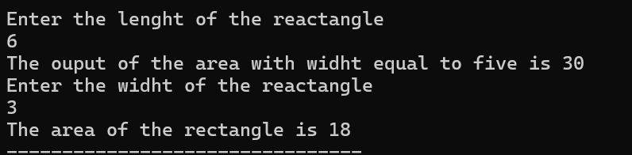

Task 03
In Lab 1 (Question 4), you implemented a program that dynamically allocated memory for an integer array, calculated the sum and average of its elements using functions. Now, reuse the code but do it using class.
- Define a class (e.g., ArrayOperations) with the following private data members:
  - int* arr; (pointer to dynamically allocated array)
  - int size; (to store array size)
- Write a member function UserInput ( ) to take input values from the user and store them in the array.
- Write a member function int calculateSum() that returns the sum of all elements.
- Write a member function double calculateAverage() that returns the average of the elements.
- Write a member function Display( ) to display the array elements.
- In the main() function:
  - Create an object of the class.
  - Call the input function to fill the array.
  - Call and display the results of calculateSum() and calculateAverage().
  - Display the array elements as well.
CODE:
///L1F24BSCS0069 - MUHAMMAD ASMAR NAEEM
#include<iostream>
using namespace std;
class ArrayOperations {
private:
int* arr;
int size;
public:
// Function to take user input
void UserInput() {
cout << "Enter the size of the array"<<endl;
cin >> size; //asking the user for the size of the array for dynamic size grow
arr = new int[size]; // dynamically alocating the size of the array at run time
cout << "Enter the values of the array" << endl;
for (int i = 0; i < size; i++) {
cin >> arr[i]; //taking input of the array from the user
}
}
// Function to calculate sum of array elements
int calculateSum() {
int sum = 0; //variable to store the sum
for (int i = 0; i < size; i++) {
sum += arr[i]; //accessing all the enteries and adding them to get to the final ans
}
return sum; //returning the value
}
// Function to calculate average of array elements
double calculateAverage() {
return (double)calculateSum() / size; //logic for the avegerage of the entries of the array
}
// Function to display array elements
void Display() {
cout << "Array elements are: ";
for (int i = 0; i < size; i++) {
cout << arr[i] << " ";
}
}
// Destructor to release dynamically allocated memory
void FreeMemory() {
delete[] arr;
arr = NULL; // pointing to a null so not dangling pointer
}
};

int main() {
ArrayOperations obj;
obj.UserInput();
obj.Display();
int sum = obj.calculateSum();
double avg = obj.calculateAverage();
cout << "Sum of array elements = " << sum << endl;
cout << "Average of array elements = " << avg << endl;
obj.FreeMemory();
return 0;
}
OUTPUT:
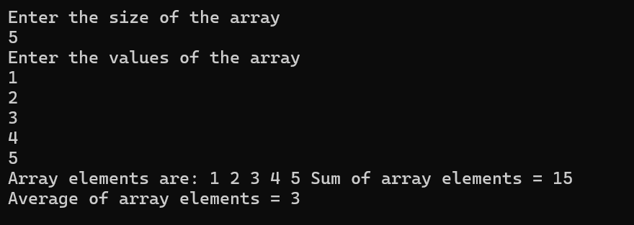

Task 04
In Lab 1 (Question 5), you implemented a program that demonstrated dynamic memory allocation for a single integer, squaring its value using a function, handling dangling pointers, and reusing the pointer safely.
- Define a class (e.g., PointerDemo) with a private data member:
  - int* ptr; (a pointer to dynamically allocated memory).
- Write a member function UserInput ( ) to take input from the user and store it in the allocated memory.
- Write a member function int squareValue() that returns the square of the stored value.
- Write a member function to display the stored value and the squared result.
- Write a member function to deallocate the memory using delete.
- Demonstrate the issue of a dangling pointer by attempting to access the deleted memory (after deletion, but before resetting the pointer).
- Correct the dangling pointer problem by assigning the pointer to NULL or nullptr after deletion.
- Write a member function to reallocate new memory to the same pointer, assign a new value, and display it.
- In main(), create an object of the class and demonstrate all the above functionalities step by step.

Task 05
Write a C++ program that extends the previous question with the following additional tasks:
- Reuse the same code from Question 4 (implemented by using class).
- Dynamically allocate memory for the integer, take input, display it, and demonstrate squaring the value (as in Question 4).
- Before deallocating the first allocated memory, reassign the pointer to a new dynamically allocated memory location without calling delete first.
- Show (via program flow and comments) that the old memory block is now inaccessible, resulting in a memory leak.
- Explain in comments why failing to delete the previous allocation before reassigning the pointer causes the leak.
- Correct the issue by properly deleting the old memory before reassigning the pointer.
- In main (), create an object of the class and demonstrate both cases:
  - With a memory leak (no delete before reassigns).
  - With the correct fix (delete before reassign).
CODE:
///L1F24BSCS0069 - MUHAMMAD ASMAR NAEEM
#include<iostream>
using namespace std;
class PointerDemo {
private:
int* ptr;

public:
// Take input from user and allocate memory
void UserInput() {
ptr = new int; //creating dynmaic memoery of one as only one int vvalue
cout << "Enter an integer value: ";
cin >> *ptr; //takking the value
}
//Return square of stored value
int squareValue() {
return (*ptr) * (*ptr);
}
//Display stored value and its square
void Display() {
cout << "Stored value: " << *ptr << endl;
cout << "Square of value: " << squareValue() << endl;
}
// Delete allocated memory
void Deallocate() {
delete ptr; //the memory is deleted
cout << "Memory deleted. Pointer is now dangling." << endl;
}
//Demonstrate dangling pointer issue
void ShowDanglingEffect() {
cout << "Attempting to access deleted memory (undefined behavior demonstration):" << endl;
cout << "Pointer address after delete: " << ptr << endl;
cout << "(Accessing *ptr now would be dangerous and may crash the program)" << endl;
}
// Fix dangling pointer
void FixDangling() {
ptr = NULL; //assiging the pointer to null
cout << "Pointer reset to NULL successfully." << endl;
}
// Reallocate memory and assign a new value
void Reallocate() {
ptr = new int; // allocating new dynamic memeory
cout << "Enter a new integer value: ";
cin >> *ptr; //taking a new value
cout << "New value stored successfully: " << *ptr << endl;
}
};

int main() {
PointerDemo obj;
cout << "Allocating memory and taking the input value." << endl;
obj.UserInput();
cout << endl << "Displaying the value and its square." << endl;
obj.Display();
cout << endl << "Deallocating memory to create dangling pointer." << endl;
obj.Deallocate();
cout << endl << "Demonstrate dangling pointer issue." << endl;
obj.ShowDanglingEffect();
cout << endl << "Fixing the dangling pointer by setting it to NULL." << endl;
obj.FixDangling();
cout << endl << "Reallocatin ght ememory to new input" << endl;
obj.Reallocate();
obj.Display();
return 0;
}
OUTPUT:
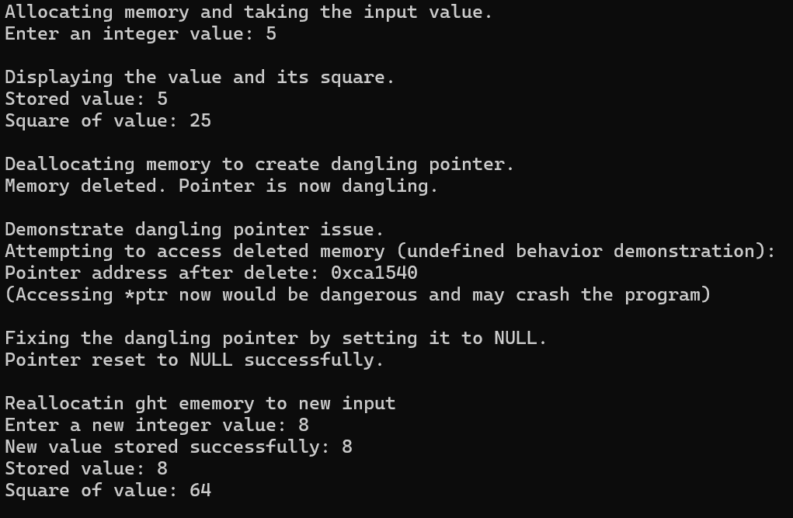

Task 06
You are required to design a class StudentRecord that represents a student’s academic information. The class will store attributes, provide setter and getter functions for data manipulation, and implement methods to display information and perform basic operations.
- Create a class named StudentRecord with the following attributes (all private):
  - int rollNumber
  - int marks1
  - int marks2
- Provide setter and getter methods for each attribute.
- Implement a method display() that prints all the details of a student.

Calculate Total Marks
  - Write a method calculateTotal() that calculates and displays the sum of marks1 and marks2.

Calculate Grade
  - Write a method calculateGrade() that assigns a grade based on the total marks:
    - A → 85 and above
    - B → 70 to 84
    - C → 50 to 69
    - F → below 50
Sample Output :
Roll Number: 101
Marks1: 40
Marks2: 35
Total Marks: 75 Grade: B

Task 07
You are working as a software developer for a local community library that wants to digitize its book management system. The library staff currently maintains book records manually in registers, which often leads to errors, missing information, and difficulty tracking whether a book is available or issued.
Your task is to design a C++ class named Book that will help the library automate its data management process by storing and managing detailed information about each book in the system.
Each Book object should store the following information:
- title (string)
- author (string)
- publisher (string)
- ISBN (int)
- genre (string)
- language (string)
- publicationYear (int)
- pageCount (int)
- availabilityStatus (bool)
- shelfNumber (int)

Functional Requirements:
- Constructor: Create a parameterized constructor to initialize all book attributes at the time of object creation.
- Setters and Getters: Implement setter and getter functions for each attribute to allow secure modification and retrieval of data.
- Display Function: Create a function displayDetails( ) that prints all the book’s information in a user- friendly format.
- Availability Update: Implement a function updateAvailability(bool status) that updates whether a book is available or checked out.
- Availability Check: Implement a function isAvailable( ) that returns true if the book is available, otherwise false.

Programming isn’t about perfection, it’s about patience, persistence, and sometimes pretending you know what you’re doing until it finally works !

