
University of Central Punjab
Faculty of Information Technology

Object Oriented Programming - Lab 04
Topic
Constructors, Destructors, Overloading, Default Arguments, and Working with Multiple Files.
Objective
- To understand the concept of constructors and destructors in C++.
- To learn the difference between default and parameterized constructors.
- To explore constructor overloading and the use of default arguments in constructors.
- To understand the role of destructors in freeing dynamically allocated memory.
- To learn how to separate class interface and implementation using multiple files (.h and .cpp).
Outcomes
By the end of this Lab, you will be able to:
- Define and implement constructors and destructors in C++ classes.
- Differentiate between default and parameterized constructors and apply each appropriately.
- Implement constructor overloading and default arguments to handle multiple initialization scenarios.
- Explain and demonstrate how destructors help in memory management and prevent memory leaks.
- Separate class interface (header file) and implementation (source file) for modular program design.
- Develop simple programs illustrating object creation, initialization, and destruction in C++.
Content
The following sections will be covered during this lab session.

- Introduction to Constructors and Destructors: Understanding the purpose of constructors for object initialization and destructors for resource cleanup in C++ classes.
- Default and Parameterized Constructors: Learning how constructors can be defined with or without parameters to initialize objects in different ways.
- Constructor Overloading and Default Arguments: Exploring how multiple constructors can coexist within a class to handle various initialization scenarios efficiently.
- Role of Destructors in Dynamic Memory Management: Demonstrating how destructors are automatically invoked to release dynamically allocated memory and prevent memory leaks.
- Separating Interface and Implementation: Learning to organize class definitions and implementations across multiple files (.h and .cpp) for better modularity and maintainability.

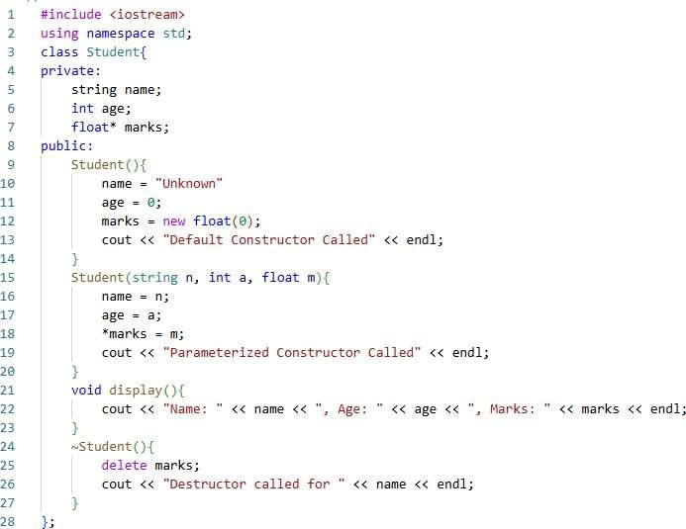
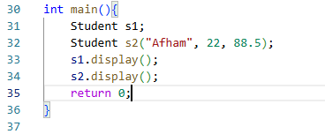
Instructions
  - Indent your code properly.
  - Use meaningful variable and function names. Use the camelCase notation.
  - Use meaningful prompt lines/labels for all input/output.
  - In each file of your task either it is .cpp file or .h file Your name and roll no must be mentioned in the start of your file as comment. For example, //L1F20BSCS0000 – Ahmad
  - You are not allowed to use any built-in function.
  - You are required to complete the following tasks in lab timings

Task 01
The following C++ program contains multiple syntax, logical, and semantic errors related to constructors, destructors, and class structure.

Your task is to:
- Identify and fix all errors.
- Write the corrected version of the program.
- Comment the type of each error (syntax / logical / semantic).
- Write the expected output of the corrected program.

CODE:
//L1F24BSCS0069- MUHAMMAD ASMAR NAEEM
#include<iostream>
using namespace std;
class Student{
private:
string name;
int age;
float* marks;
public:
Student() {
name = "Unkown";
age = 0;
marks = new float(0);
cout << "Default constructor called " << endl;
}
Student(string n, int a, float m) {
name = n;
age = a;
marks = new float(0); //LOGICAL AND RUNTIME ERROR-chnaging the logic beacuse in the earlier code the value was not being assigned to the float pointer because the pointer was not decleraed.
cout << "Parametrized construcrtor is called" << endl;
}
void display() {
cout << "name: " << name << ", Age: " << age << ", Marks" << *marks << endl; //SYNTAX ERROR-marks variale is corrected by assigned the * sign so that it access memorry and then display the data.
}
~Student() {
delete marks;
cout << "Destructor is called" << endl;
}
};
int main() {
Student s1;
Student s2("Afham", 22, 88.5);
s1.display();
s2.display();
return 0;

}

OUTPUT:

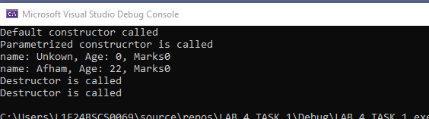

Task 02

Design a C++ class named Car having private data members:
- brandName(string) 2. modelYear(int).
Now perform the following operations:
  - Use a default constructor to assign initial values when an object is created.
  - Implement setters and getters to update and display car details.
  - In the main() function, create multiple objects and display their data using getter functions.
CODE:
#include "Car.h"
int main() {

//delecraing variables to store the user defines input
string carname;
int model = 0;

//creating classes
Car Car1;
Car Car2;

//getting input
cout << "ENter the name of the car brand" << endl;
cin >> carname;
cout << "Enter the model year of the car" << endl;
cin >> model;

//setting the values to the classes
Car2.setbrandName(carname);
Car2.setmodelYear(model);

//delecraing varaibles tot stoe the data from the class for display
string nameofbrand1;
int modelofcar1 = 0;
string nameofbrand2;
int modelofcar2 = 0;

//getting the values
nameofbrand1 = Car1.getbrandName();
modelofcar1 = Car1.getmodelYear();
nameofbrand2 = Car2.getbrandName();
modelofcar2 = Car2.getmodelYear();

//displaying the data
cout << "The first car brand is " << nameofbrand1 << " and its model is " << modelofcar1 << endl;
cout << "The second car brand is " << nameofbrand2 << " and its model is " << modelofcar2 << endl;
return 0;
}
#include "Car.h"
Car::Car() {
brandName = "Honda";
modelYear = 2006;
}

void Car::setbrandName(string name) {
brandName = name;
}

void Car::setmodelYear(int modelY) {
modelYear = modelY;
}

string Car::getbrandName() {
return brandName;
}

int Car::getmodelYear() {
return modelYear;
}
#include "Car.h"
Car::Car() {
brandName = "Honda";
modelYear = 2006;
}

void Car::setbrandName(string name) {
brandName = name;
}

void Car::setmodelYear(int modelY) {
modelYear = modelY;
}

string Car::getbrandName() {
return brandName;
}

int Car::getmodelYear() {
return modelYear;
}

OUTPUT:
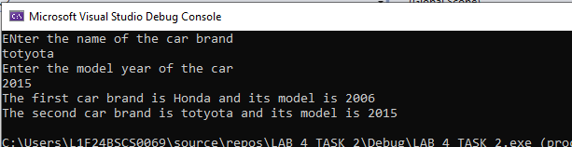

Task 03
Design a C++ class named Laptop that represents basic specifications of a laptop. The class should contain the following private data members:
- brand (string)
- ramSize (integer, representing GB)
- price (float)
Now perform the following operations:
  - Implement a parameterized constructor to initialize these data members when an object is created.
  - Define appropriate setter and getter functions for each data member to update and access their values safely.
  - Create two objects of the Laptop class with different initial values using the parameterized constructor.
  - Display their details using getter functions.
CODE:
#include "Laptop.h"
int main() {

//intilizing by parametrized constructor
Laptop L1("HP", 16, 78000.56);
Laptop L2("DELL", 16, 60000.15);

//delecraing variables to store the input from the class to display
string NameofBrand;
int SizeofRam = 0;
float Expenseoflap = 0.0;
string NameofBrand1;
int SizeofRam1 = 0;
float Expenseoflap1 = 0.0;

//getting the value to display
NameofBrand=L1.getbrand();
SizeofRam = L1.getramSize();
Expenseoflap = L1.getramSize();
NameofBrand1 = L2.getbrand();
SizeofRam1 = L2.getramSize();
Expenseoflap1 = L2.getramSize();

//displaying the data
cout << "The first laptop brand is " << NameofBrand << " ,ram size is " << SizeofRam << " and the price is " << Expenseoflap << endl;
cout << "The second laptop brand is " << NameofBrand1 << " ,ram size is " << SizeofRam1 << " and the price is " << Expenseoflap1 << endl;

return 0;
}
#include "Laptop.h"
//parametrized constructor
Laptop::Laptop(string brandName, int size, float exepense) {
brand = brandName;
ramSize = size;
price = exepense;
}

//setters
void Laptop::setbrand(string brandName) {
brand = brandName;
}
void Laptop::setramSize(int size) {
ramSize = size;
}
void Laptop::setprice(float exepense) {
price = exepense;
}

//getters
string Laptop::getbrand(){
return brand;
}
int Laptop:: getramSize() {
return ramSize;
}
float Laptop::getprice() {
return price;
}
#include<iostream>
using namespace std;
class Laptop {
private:
//delecraing variables to store data
string brand;
int ramSize = 0;
float price = 0.0;
public:
//declearing the class function
Laptop(string brandName, int size, float exepense);//parametried constructior
//setters
void setbrand(string brandName);
void setramSize(int size);
void setprice(float exepense);
//getters
string getbrand();
int getramSize();
float getprice();
};
OUTPUT:
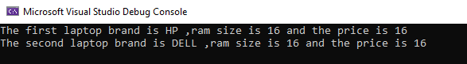

Task 04
Design a C++ class Student with private data members:
- name(string)
- rollNumber(int)
- cgpa(double) Implement the following:
  - A default constructor initializing all members with predefined values.
  - A parameterized constructor with default arguments for optional parameters (e.g., if cgpa is not given).
  - Proper setters and getters to modify and display details.
  - Create multiple objects using different constructors and observe the output.

CODE:
#include"Student.h"
int main() {
//making the classes
Student s1;
Student s2("asmar", 69, 3.0);
Student s3("hashim", 70, 3.1);

//displaying the data of each student
s2.display();
s1.display();
s3.display();

return 0;
}
#include "Student.h"
//default constructor
Student::Student() {
name = "Unknown";
rollNumber = 0;
cgpa = 0.0;
}
//parametrized constructor
Student::Student(string Sname, int rollN, double Cgpa) {
name = Sname;
rollNumber = rollN;
cgpa = Cgpa;
}

//setters
void Student::setname(string Sname) {
name = Sname;
}

void Student::setrollNumber(int rollN) {
rollNumber = rollN;
}

void Student::setcgpa(double Cgpa) {
cgpa = Cgpa;
}

//getters
string Student::getname() {
return name;
}

int Student::getrollNumber() {
return rollNumber;
}

double Student::getcgpa() {
return cgpa;
}

//display

void Student::display() {
cout << "The name of the student is " << name << " ,the roll is " << rollNumber << " and the gpa is " << cgpa << endl;
}
#include<iostream>
using namespace std;
class Student {
private:
//delecraing variavbles for storing the data
string name;
int rollNumber = 0;
double cgpa;
public:
//defaulr constructor
Student();
//parametrized conmatructor
Student(string Sname, int rollN, double Cgpa);
//setters
void setname(string Sname);
void setrollNumber(int rollN);
void setcgpa(double Cgpa);
//getters
string getname();
int getrollNumber();
double getcgpa();
//display function
void display();
};
OUTPUT:
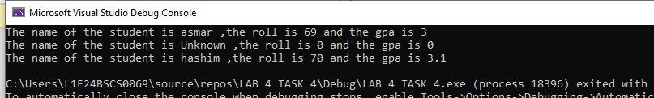

Task 05
Design a C++ class Employee using three separate files:
- Employee.h → Class definition (declaration)
- Employee.cpp → Implementation of all member functions
- main.cpp → Program execution file Your class should include:
  - Private data members:
    - empName 2. Salary 3. designation.
  - A default and parameterized constructor.
  - A destructor displaying a farewell message.
  - Setters and getters to update and view employee details.
  - Demonstrate how separating interface and implementation improves code organization and readability.
CODE:
#include"Employee.h"
int main()
{
Employee E1;
Employee E2("asmar", "manager", 100000);
Employee E3("ahmad", "developer",50000);
//display
E1.display();
E2.display();
E3.display();

return 0;
}
#include "Employee.h"
//deault contructor
Employee::Employee() {
empName = "Unknown";
Designation = "None";
Salary = 0.0;
}

//parametrized conatructor
Employee::Employee(string employName, string desig, double salary) {
empName = employName;
Designation = desig;
Salary = salary;
}

//destruictor
Employee::~Employee() {
cout << "Farewell" << endl;
}

//setters
void Employee::setempName(string employName) {
empName = employName;
}
void Employee::setDesignation(string desig) {
Designation = desig;
}
void Employee::setSalary(double salary) {
Salary = salary;
}

//getters
string Employee::getempName() {
return empName;
}
string Employee::getDesignation() {
return Designation;
}
double Employee::getsalary() {
return Salary;
}
//display
void Employee::display() {
cout << "The name of the employee is " << empName << " ,his designation is " << Designation << " ,and his salary is " << Salary << endl;
}
#include<iostream>
using namespace std;
class Employee {
private:
//delecraing variabels
string empName;
string Designation;
double Salary;
public:
//default
Employee();
//parametrized conatruvtor
Employee(string employName, string desig, double salary);
//destructive constructor
~Employee();
//setters
void setempName(string employName);
void setDesignation(string desig);
void setSalary(double salary);
//getters
string getempName();
string getDesignation();
double getsalary();
//display
void display();
};
OUTPUT:
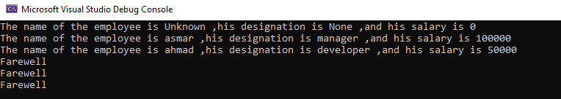

Task 06
You are required to design a modular C++ program that manages smartphone information for a mobile store. The implementation should follow object-oriented principles and be divided into three separate files to ensure clean code organization

File Structure
- SmartPhone.h → Contains the class definition (declaration of data members and member functions).
- SmartPhone.cpp → Contains the implementation (definition) of all class member functions.
- main.cpp → Contains the main function to create and manipulate objects.

Create a class named SmartPhone with the following private data members:
  - brand (string)
  - model (string)
  - price (float)
  - storage (int, representing GB)

Implement the following:
- Initializes all data members with generic default values (e.g., "Unknown", 0, etc.).
- One constructor that initializes all data members.
- Another constructor that only takes brand and model, while setting other members to default values.
- Define proper setter and getter functions for all data members to safely modify and retrieve private data.
- Implement a function displayDetails( ) to print all smartphone details in a formatted output.
- Implement a destructor that displays a message like:"SmartPhone object destroyed. Memory released successfully." to confirm automatic cleanup when an object goes out of scope.

In the main() Function:
- Create three objects of the SmartPhone class using different constructors (default, partial, and full parameterized).
- Update one attribute using a setter function.
- Display details of all objects using either getter functions or the displayDetails( ) function.
- Observe the destructor messages printed automatically when the program ends.

Task 07
A tech company is designing a SmartHomeDevice class to represent a variety of smart appliances in a connected home, including lights, fans, sensors, thermostats, air purifiers, and security cameras. Each device has attributes such as deviceName, deviceID, and powerStatus (ON/OFF).
During development, engineers create multiple devices dynamically and integrate them into a centralized home automation system. The system must track device states, manage power efficiently, and simulate device disconnection when a device is removed from the network. Constructors are used to initialize device attributes, setters and getters provide controlled access, and destructors are intended to handle device shutdown messages and memory cleanup.
However, during extensive testing, the team observes several issues:
- Some dynamically created devices fail to display shutdown messages consistently when deleted.
- Memory usage gradually increases over time, suggesting memory leaks, particularly when hundreds of devices are created and destroyed dynamically.
- Direct external modification of attributes like deviceName or powerStatus leads to inconsistent system state.for instance, a device may be marked ON in the system while physically OFF.
- Devices that internally allocate memory for logs, configuration settings, or temporary buffers are not always released correctly before the object is destroyed.
- Copying or assigning device objects sometimes causes double deletion or shallow copy issues, leading to crashes or unexpected behavior.

Your Task:
  - Analyze the possible mistakes the developers made with constructors, destructors, and dynamic memory handling.
  - Explain how proper destructors, memory management, and adherence to the Rule of Three/Five can resolve memory leaks and ensure consistent shutdown messages.
  - Discuss how setters and getters help maintain safe and controlled access to device data, preventing inconsistent states.
  - You are required to explain the reasoning and implement the scenario in C++ as per your understanding.

Lab Life Tip: “If at first your code doesn’t work, just call it a 'hidden feature' and keep trying.
Persistence always beats perfection”

