
University of Central Punjab
Faculty of Information Technology

Object Oriented Programming - Lab 05
Topic
Destructor, deep copy and shallow copy, copy constructor and deep copy constructor, this pointer.
Objective
- To understand the concept of constructors in C++.
- To understand the concept and purpose of destructors in C++.
- To explore the difference between shallow copy and deep copy.
- To learn how copy constructors and deep copy constructors work in object copying.
- To understand the use and significance of the this pointer in C++ programming.
Outcomes
By the end of this Lab, you will be able to:
- Define and implement constructors and destructors in C++ classes.
- Define and implement destructors in C++ to manage resource cleanup effectively.
- Differentiate between shallow copy and deep copy, and understand their impact on object behavior,
- Implement and compare copy constructors and deep copy constructors in various object-copying scenarios.
- Utilize the this pointer to access object members and resolve naming conflicts within class methods.
- Develop programs that demonstrate object copying, destruction, and the role of the this pointer in C++.
Content
The following sections will be covered during this lab session.

- Introduction to Destructors: Understanding the purpose of destructors in C++ for releasing resources and preventing memory leaks.
- Shallow Copy vs Deep Copy: Exploring how object copying works in C++, the differences between shallow and deep copies, and their effects on program behaviour.
- Copy Constructor and Deep Copy Constructor: Learning how copy constructors’ function, and how deep copy constructors help in creating independent object copies.
- this Pointer: Understanding the role of the this pointer in accessing current object members and resolving naming conflicts within class methods.
- Practical Implementation: Developing programs that demonstrate object destruction, deep copying, and the use of the this pointer in real C++ scenarios.

Instructions
- Indent your code properly.
- Use meaningful variable and function names. Use the camelCase notation.
- Use meaningful prompt lines/labels for all input/output.
- In each file of your task either it is .cpp file or .h file Your name and roll no must be mentioned in the start of your file as comment. For example, //L1F20BSCS0000 – Ahmad
- You are not allowed to use any built-in function.
- You are required to complete the following tasks in lab timings

Task 01
Create a class Book with the following attributes;
- Char* name
- Char* authorName
- float price
Implement the following operations;

default constructor and a parameterized constructor.
  - Add setters and getters for both data members using shallow copy.
  - Create two Book objects and perform a shallow copy.
  - Modify the copied object and observe whether it affects the original one.
CODE:
Header file
//L1F24BSCS0069-MUHAMMAD ASMAR NAEEM
#include<iostream>
using namespace std;
class Book {
private:
//delecraing variables for storing data
char* Name = NULL;
char* authorName = NULL;
float Price = 0.0;
public:
//default constructor
Book();
//parametrized constructor
Book(char* Name, char* authorName, float Price);
//setters
void setName(char* Name);
void setauthorName(char* authorName);
void setPrice(float Price);
//getters
char* getName();
char* getauthorName();
float getPrice();
//function for display
void display();
};
Classname.cpp
//L1F24BSCS0069-MUHAMMAD ASMAR NAEEM
#include "Book.h" //header file
//default constructor
Book::Book() {
char* Name = NULL;
char* authorName = NULL;
float Price = 0.0;
}

//parametrized construtor
Book::Book(char* Name, char* authorName, float Price) {
this->Name = Name;
this->authorName = authorName;
this->Price = Price;
}

//setters
void Book::setauthorName(char* authorName) {
this->authorName = authorName;
}

void Book::setName(char* Name) {
this->Name = Name;
}

void Book::setPrice(float Price) {
this->Price = Price;
}

//getters
char* Book::getauthorName() {
return authorName;
}

char* Book::getName() {
return Name;
}

float Book::getPrice() {
return Price;
}

//display function
void Book::display() {
cout << "The name of the book is " << Name << " ,the name of the author is " << authorName << " and the price is " << Price << endl;
}
Main.cpp
//L1F24BSCS0069-MUHAMMAD ASMAR NAEEM
#include"Book.h"
int main() {
//declearing the char arary string for updating the data
char bookName1[100] = "C++ programming";
char Author1[100] = "Afham nazir";
float price1 = 2066.57;
char bookName2[100] = "OOP programming";
char Author2[100] = "Asmar Naeem";
float price2 = 3066.57;
//making two objects
Book obj1(bookName1,Author1,price1);
Book obj2 = obj1;//copying the constructor
//dispkaying the content before the updatation
obj1.display();
obj2.display();
//setting the new data in obj 2 so se the effect of shalow copy
obj2.setauthorName(Author2);
obj2.setName(bookName2);
obj2.setPrice(price2);
//again displaying the data
obj1.display();
obj2.display();

return 0;
}
OUTPUT:
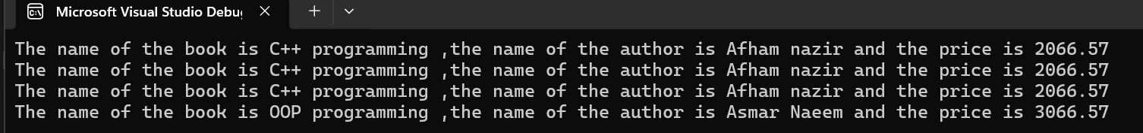

Task 02
Create a class Student with the following attributes;
- Char* name
- Char* registrationNumber
- Float CGPA
- Int semester
Now implement the following operations;
  - Implement default and parameterized constructors.
  - Add setter and getter functions for both members using shallow copy
  - Implement a copy constructor that performs a deep copy.

CODE:
Header file
#include<iostream>
using namespace std;
class Student {
private:
//decleraing variables
char* name = NULL;
char* registrationNumber = NULL;
float CGPA = 0.0;
int semester = 0;
public:
//deafult constructor
Student();
//Parametrized constructor
Student(char* name, char* registrationNumber, float CGPA, int semester);
//destructor constructor
~Student();
//setters
void setname(char* name);
void setregistrationNumber(char* registrationNumber);
void setCGPA(float CGPA);
void setsemester(int semester);
//getters
char* getname();
char* getregistrationNumber();
float getCGPA();
int getsemester();
//copy constructor
Student(const Student &obj);
//display function
void display();
};
Class.cpp file

#include "Student.h"

//default constructor
Student::Student() {
char* name = NULL;
char* registrationNumber = NULL;
float CGPA = 0.0;
int semester = 0;
}

//parametrized construtor
Student::Student(char* name, char* registrationNumber, float CGPA, int semester) {
this->name = name;
this->registrationNumber = registrationNumber;
this->CGPA = CGPA;
this->semester = semester;
}

//setters
void Student::setname(char* name) {
this->name = name;
}

void Student::setregistrationNumber(char* registrationNumber) {
this->registrationNumber = registrationNumber;
}

void Student::setCGPA(float CGPA) {
this->CGPA = CGPA;
}

void Student::setsemester(int semester) {
this->semester = semester;
}

//getters
float Student::getCGPA() {
return CGPA;
}

char* Student::getname() {
return name;
}

char* Student::getregistrationNumber() {
return registrationNumber;
}

int Student::getsemester() {
return semester;
}

//copy construtor for deep copy
Student::Student(const Student &obj) {
//for deep copy of name
int lenght1=0; //finding the lenght for making the dynamic memory allocation accordingly
for (int i = 0; obj.name[i]!='\0'; i++) { //logic to find the lenght
lenght1++;
}
name = new char[lenght1 + 1];//creating the dynamic memeory according to the lenght and adding 1 for null terminator
for (int i = 0; i < lenght1; i++) { //copying the data in name
name[i] = obj.name[i];
}
name[lenght1] = '\0';//adding the null terminator at the end

//for deep copy of registration number
int lenght2 = 0;//finding the lenght for the dynamic allocation
for (int i = 0; obj.registrationNumber[i] != '\0'; i++) {//logic to find the lenght of the array
lenght2++;
}
registrationNumber = new char[lenght2 + 1];//creating the dynamic memory according to the lenght and adding 1 for the null terminator
for (int i = 0; i < lenght2; i++) {
registrationNumber[i] = obj.registrationNumber[i];//copying the registration number in dynamically allocated array
}
registrationNumber[lenght2] = '\0';//addding the null terminator
//deep copy of CGPA
CGPA = obj.CGPA;
//deep copy of semester
semester = obj.semester;
}

//display function
void Student::display() {
cout << "The name of the student is " << name << endl;
cout << "His registration number is " << registrationNumber << endl;
cout << "His CGPA is " << CGPA << endl;
cout<< "And his semester is " << semester << endl;
}

//destructor constructor
Student::~Student() {
if (name != NULL) {
delete[] name;
name = NULL;
}
if (registrationNumber != NULL) {
delete[] registrationNumber;
registrationNumber = NULL;
}
}

Main.cpp file

#include"Student.h"
int main() {
//char array data for object
char studentName1[100] = "Asmar Naeem";
char regnumber1[100] = "L1F24BSCS001";
float cgpa1 = 3.0;
int semester1 = 2;

//char array data for updation
char studentName2[100] = "Ahmad";
char regnumber2[100] = "L1F24BSCS002";
float cgpa2 = 4.0;
int semester2 = 5;

//creating objects
Student obj1(studentName1,regnumber1,cgpa1,semester1);
Student obj2(obj1);

//displaying the data
obj1.display();
obj2.display();

//updating the data by using the settter functions
obj2.setCGPA(cgpa2);
obj2.setname(studentName2);
obj2.setregistrationNumber(regnumber2);
obj2.setsemester(semester2);

//displaying the data
obj1.display();
obj2.display();

return 0;
}

Output:

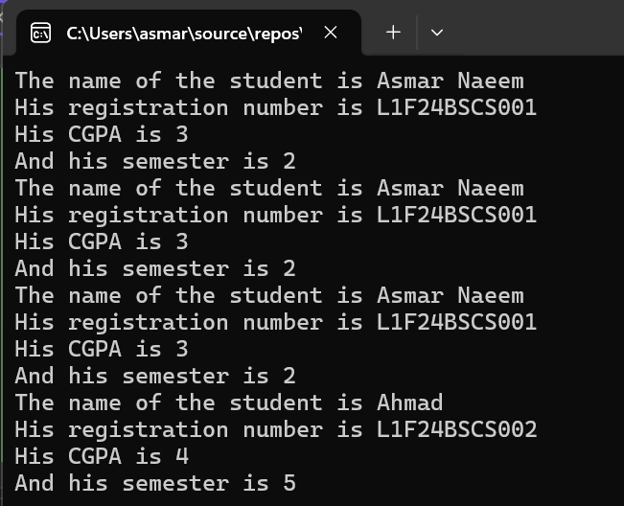

Task 03
Design a C++ class named Laptop that represents basic specifications of a laptop. The class should contain the following private data members:
- brand (char*)
- ramSize (integer, representing GB)
- price (float)
Nowperform the following operations:
- Implement a parameterized constructor to initialize these data members when an object is created.
- Define appropriate setter and getter functions for each data member to update and access their values safely (deep Copy).
- Implement the deep copy constructor for copying two objects.
- Create two objects of the Laptop class with different initial values using the parameterized constructor.
- Display their details using getter functions.
CODE
Header file:
//L1F24BSCS0069-MUHAMMAD ASMAR NAEEM
#include<iostream>
using namespace std;
class Laptop {
private:
//declearing variables
char* brand;
int ramSize;
float price;
public:
// Default constructor
Laptop();
// Parameterized constructor
Laptop(char* brand, int ramSize, float price);
// Copy constructor
Laptop(const Laptop& obj);
// Destructor
~Laptop();
// Setters
void setBrand(char* brand);
void setRamSize(int ramSize);
void setPrice(float price);
// Getters
char* getBrand();
int getRamSize();
float getPrice();

// Display function
void display();
};

Classname.cpp
#include "Laptop.h"

// Default constructor
Laptop::Laptop() {
brand = NULL;
ramSize = 0;
price = 0.0;
}

// Parameterized constructor
Laptop::Laptop(char* brand, int ramSize, float price) {
int length = 0;
while (brand[length] != '\0') {
length++;
}
this->brand = new char[length + 1];
for (int i = 0; i < length; i++) {
this->brand[i] = brand[i];
}
this->brand[length] = '\0';
this->ramSize = ramSize;
this->price = price;
}
// Copy constructor
Laptop::Laptop(const Laptop& obj) {
int length = 0;
while (obj.brand[length] != '\0') {
length++;
}
brand = new char[length + 1];
for (int i = 0; i < length; i++) {
brand[i] = obj.brand[i];
}
brand[length] = '\0';
ramSize = obj.ramSize;
price = obj.price;
}
// Destructor
Laptop::~Laptop() {
if (brand != NULL) {
delete[] brand;
brand = NULL;
}
}
// Setters
void Laptop::setBrand(char* brand) {
if (this->brand != NULL) {
delete[] this->brand;
}
int length = 0;
while (brand[length] != '\0') {
length++;
}

this->brand = new char[length + 1];
for (int i = 0; i < length; i++) {
this->brand[i] = brand[i];
}
this->brand[length] = '\0';
}

void Laptop::setRamSize(int ramSize) {
this->ramSize = ramSize;
}

void Laptop::setPrice(float price) {
this->price = price;
}

// Getters
char* Laptop::getBrand() {
return brand;
}

int Laptop::getRamSize() {
return ramSize;
}

float Laptop::getPrice() {
return price;
}

// Display function
void Laptop::display() {
cout << "Laptop Brand: " << brand << endl;
cout << "RAM Size: " << ramSize << " GB" << endl;
cout << "Price: $" << price << endl;
cout << endl;
}

Main.cpp
#include "Laptop.h"
int main() {
// Create two Laptop objects with different values
char brand1[100] = "Dell Inspiron";
char brand2[100] = "HP Pavilion";

Laptop l1(brand1, 16, 1200.50);
Laptop l2(brand2, 8, 950.75);

l1.display();
l2.display();

// Use copy constructor to make a deep copy
Laptop l3(l1);

l3.display();

// Modify l3 using setters to check independence
char newBrand[100] = "Lenovo ThinkPad";
l3.setBrand(newBrand);
l3.setRamSize(32);
l3.setPrice(2000.00);

l3.display();

cout << "Original l1 remains unchanged:" << endl;
l1.display();

return 0;
}
OUTPUT:


Task 04
Create a C++ class Employee using three separate files:
- Employee.h → Class definition (declaration)
- Employee.cpp → Implementation of all member functions
- main.cpp → Program execution file Your class should include:
  - Private data members:
    - empName(char*) 2. Salary 3. Designation(char*) 4. Address
  - A default and parameterized constructor.
  - Setters and getters to update and view employee details using deep copy.
  - A destructor displaying a farewell message.
  - In main create 3 objects and perform the both default and deep copy construtors.

CODE:
Header file:
#include<iostream>
using namespace std;
class Employee {
private:
char* empName;
float salary;
char* designation;
char* address;
public:
// Default constructor
Employee();

// Parameterized constructor
Employee(char* empName, float salary, char* designation, char* address);

// Copy constructor (Deep Copy)
Employee(const Employee& obj);

// Destructor
~Employee();

// Setters (Deep Copy)
void setEmpName(char* empName);
void setSalary(float salary);
void setDesignation(char* designation);
void setAddress(char* address);

// Getters
char* getEmpName();
float getSalary();
char* getDesignation();
char* getAddress();

// Display function
void display();
};

Classname.cpp
#include "Employee.h"

// Default constructor
Employee::Employee() {
this->empName = NULL;
this->salary = 0.0;
this->designation = NULL;
this->address = NULL;
}

// Parameterized constructor (Deep Copy)
Employee::Employee(char* empName, float salary, char* designation, char* address) {
// Deep copy for empName
int len1 = 0;
while (empName[len1] != '\0') len1++;
this->empName = new char[len1 + 1];
for (int i = 0; i < len1; i++) this->empName[i] = empName[i];
this->empName[len1] = '\0';

// Deep copy for designation
int len2 = 0;
while (designation[len2] != '\0') len2++;
this->designation = new char[len2 + 1];
for (int i = 0; i < len2; i++) this->designation[i] = designation[i];
this->designation[len2] = '\0';

// Deep copy for address
int len3 = 0;
while (address[len3] != '\0') len3++;
this->address = new char[len3 + 1];
for (int i = 0; i < len3; i++) this->address[i] = address[i];
this->address[len3] = '\0';

this->salary = salary;
}

// Copy constructor
Employee::Employee(const Employee& obj) {
// Deep copy for empName
int len1 = 0;
while (obj.empName[len1] != '\0') len1++;
this->empName = new char[len1 + 1];
for (int i = 0; i < len1; i++) this->empName[i] = obj.empName[i];
this->empName[len1] = '\0';

// Deep copy for designation
int len2 = 0;
while (obj.designation[len2] != '\0') len2++;
this->designation = new char[len2 + 1];
for (int i = 0; i < len2; i++) this->designation[i] = obj.designation[i];
this->designation[len2] = '\0';

// Deep copy for address
int len3 = 0;
while (obj.address[len3] != '\0') len3++;
this->address = new char[len3 + 1];
for (int i = 0; i < len3; i++) this->address[i] = obj.address[i];
this->address[len3] = '\0';

this->salary = obj.salary;
}

// Destructor
Employee::~Employee() {
cout << "Destructor called for Employee: ";
if (this->empName != NULL) cout << this->empName;
cout << " — Farewell!" << endl;

if (this->empName != NULL) {
delete[] this->empName;
this->empName = NULL;
}
if (this->designation != NULL) {
delete[] this->designation;
this->designation = NULL;
}
if (this->address != NULL) {
delete[] this->address;
this->address = NULL;
}
}

// Setters (Deep Copy)
void Employee::setEmpName(char* empName) {
if (this->empName != NULL) delete[] this->empName;
int len = 0;
while (empName[len] != '\0') len++;
this->empName = new char[len + 1];
for (int i = 0; i < len; i++) this->empName[i] = empName[i];
this->empName[len] = '\0';
}

void Employee::setSalary(float salary) {
this->salary = salary;
}

void Employee::setDesignation(char* designation) {
if (this->designation != NULL) delete[] this->designation;
int len = 0;
while (designation[len] != '\0') len++;
this->designation = new char[len + 1];
for (int i = 0; i < len; i++) this->designation[i] = designation[i];
this->designation[len] = '\0';
}

void Employee::setAddress(char* address) {
if (this->address != NULL) delete[] this->address;
int len = 0;
while (address[len] != '\0') len++;
this->address = new char[len + 1];
for (int i = 0; i < len; i++) this->address[i] = address[i];
this->address[len] = '\0';
}

// Getters
char* Employee::getEmpName() {
return this->empName;
}

float Employee::getSalary() {
return this->salary;
}

char* Employee::getDesignation() {
return this->designation;
}

char* Employee::getAddress() {
return this->address;
}

// Display function
void Employee::display() {
cout << "Employee Name: " << this->empName << endl;
cout << "Salary: $" << this->salary << endl;
cout << "Designation: " << this->designation << endl;
cout << "Address: " << this->address << endl;
cout << endl;
}

Main.cpp:
#include "Employee.h"

int main() {
// Data for first employee
char name1[100] = "Asmar Naeem";
char designation1[100] = "Software Engineer";
char address1[100] = "Lahore, Pakistan";
float salary1 = 120000.0;

// Data for second employee
char name2[100] = "Ahmad Raza";
char designation2[100] = "Project Manager";
char address2[100] = "Karachi, Pakistan";
float salary2 = 150000.0;

// Default constructor
cout << "Creating Employee 1 (Default Constructor):" << endl;
Employee e1;
e1.setEmpName(name1);
e1.setSalary(salary1);
e1.setDesignation(designation1);
e1.setAddress(address1);
e1.display();

// Parameterized constructor
cout << "Creating Employee 2 (Parameterized Constructor):" << endl;
Employee e2(name2, salary2, designation2, address2);
e2.display();

// Copy constructor
cout << "Creating Employee 3 (Copy Constructor from e1):" << endl;
Employee e3(e1);
e3.display();

cout << "Program is ending, destructors will be called automatically." << endl;

return 0;
}

OUTPUT:
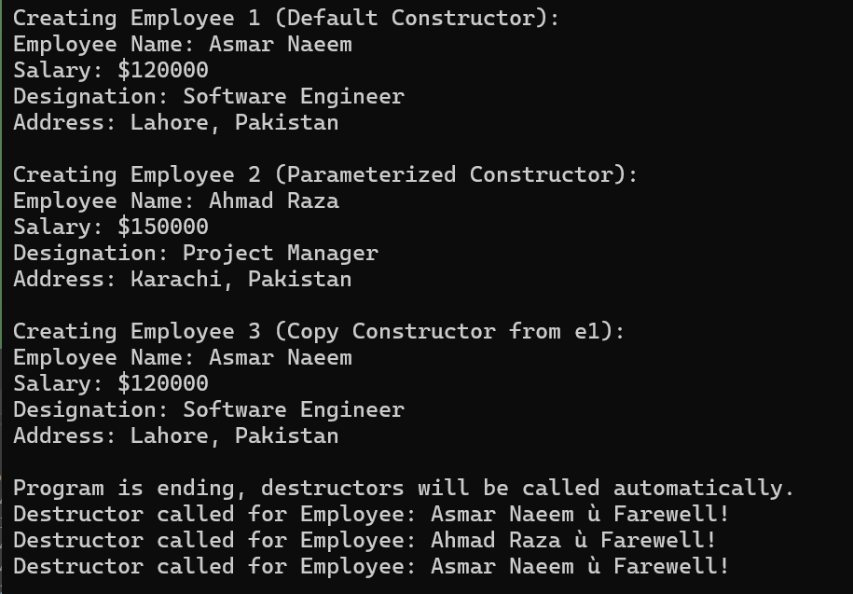

Task 05
You are required to design a modular C++ program that manages information about Laptop products for a computer store.
The program should be organized using object-oriented programming principles and divided into three separate files to ensure modularity, readability, and proper code organization.
- Laptop.h → Contains the class definition (declaration of data members and member functions).
- Laptop.cpp → Contains the implementation (definition) of all class member functions.
- main.cpp → Contains the main function to create and manipulate objects. Create a class named Laptop with the following private data members:
  - brand (char*) 2. price (float pointer) , dynamically allocated to demonstrate memory management Now Implement the following;
    - Default Constructor: Initializes brand with "Unknown" and dynamically allocates memory for price with a default value of 0.0.

Parameterized Constructor:
      - Takes parameters for both brand and price.
      - Dynamically allocates memory for price and assigns the given value.

Deep Copy Constructor:
      - Creates a deep copy of another Laptop object.
      - Ensures separate memory allocation for the price pointer.
      - Displays a message such as "Deep Copy Constructor Called" when invoked.

Setter and Getter Functions:
      - Implement setBrand() and setPrice() using the this pointer to differentiate between data members and parameters.
      - Example:
      - void setBrand(string brand) { this->brand = brand; }
      - void setPrice(float p) { *(this->price) = p; }
      - Implement getBrand() and getPrice() to safely access private data members.

displayDetails() Function:
      - Prints all the details of a Laptop object in a user-friendly format.
      - Example Output:
      - Brand: Dell
      - Price: 120000

In the main() Function:
- Create three objects of the Laptop class:
  - One using the default constructor.
  - One using the parameterized constructor.
  - One using the deep copy constructor.
- Update one of the object’s attributes using a setter function (e.g., change brand or price).
- Display the details of all objects using the displayDetails() function.
- Observe and note how the deep copy constructor creates independent copies and how the destructor is automatically called for each object when the program ends.

CODE:
Header file:
#include <iostream>
using namespace std;

class Laptop {
private:
char* brand; // dynamically allocated brand name
float* price; // dynamically allocated float pointer

public:
// Default Constructor
Laptop();

// Parameterized Constructor
Laptop(char* brand, float price);

// Deep Copy Constructor
Laptop(const Laptop& obj);

// Destructor
~Laptop();

// Setters
void setBrand(char* brand);
void setPrice(float p);

// Getters
char* getBrand();
float getPrice();

// Display Function
void displayDetails();
};

Classname.cpp
#include "Laptop.h"

// Default Constructor
Laptop::Laptop() {
// Set brand to "Unknown" manually
char temp[] = "Unknown";
int len = 0;
while (temp[len] != '\0') len++;

this->brand = new char[len + 1];
for (int i = 0; i < len; i++) {
this->brand[i] = temp[i];
}
this->brand[len] = '\0';

// Dynamically allocate price and set to 0.0
this->price = new float;
*(this->price) = 0.0;
}

// Parameterized Constructor
Laptop::Laptop(char* brand, float price) {
// Deep copy for brand
int len = 0;
while (brand[len] != '\0') len++;

this->brand = new char[len + 1];
for (int i = 0; i < len; i++) {
this->brand[i] = brand[i];
}
this->brand[len] = '\0';

// Allocate and assign price
this->price = new float;
*(this->price) = price;
}

// Deep Copy Constructor
Laptop::Laptop(const Laptop& obj) {
cout << "Deep Copy Constructor Called!" << endl;

// Deep copy for brand
int len = 0;
while (obj.brand[len] != '\0') len++;

this->brand = new char[len + 1];
for (int i = 0; i < len; i++) {
this->brand[i] = obj.brand[i];
}
this->brand[len] = '\0';

// Allocate and copy price
this->price = new float;
*(this->price) = *(obj.price);
}

// Destructor
Laptop::~Laptop() {
cout << "Destructor Called for Laptop: " << this->brand << endl;
delete[] this->brand;
delete this->price;
}

// Setters
void Laptop::setBrand(char* brand) {
if (this->brand != NULL)
delete[] this->brand;

int len = 0;
while (brand[len] != '\0') len++;

this->brand = new char[len + 1];
for (int i = 0; i < len; i++) {
this->brand[i] = brand[i];
}
this->brand[len] = '\0';
}

void Laptop::setPrice(float p) {
*(this->price) = p;
}

// Getters
char* Laptop::getBrand() {
return this->brand;
}

float Laptop::getPrice() {
return *(this->price);
}

// Display Function
void Laptop::displayDetails() {
cout << "Brand: " << this->brand << endl;
cout << "Price: " << *(this->price) << endl;
cout << "-----------------------------" << endl;
}

Main.cpp
#include "Laptop.h"

int main() {
cout << "Creating Laptop 1 (Default Constructor):" << endl;
Laptop l1;
l1.displayDetails();

cout << "Creating Laptop 2 (Parameterized Constructor):" << endl;
char brand2[] = "Dell";
Laptop l2(brand2, 120000);
l2.displayDetails();

cout << "Creating Laptop 3 (Deep Copy Constructor from Laptop 2):" << endl;
Laptop l3(l2);
l3.displayDetails();

cout << "Updating Laptop 3 Brand and Price using Setters:" << endl;
char newBrand[] = "HP";
l3.setBrand(newBrand);
l3.setPrice(95000);
l3.displayDetails();

cout << "Original Laptop 2 (to verify deep copy):" << endl;
l2.displayDetails();

cout << "Program ending — destructors will now be called automatically." << endl;

return 0;
}

OUTPUT:
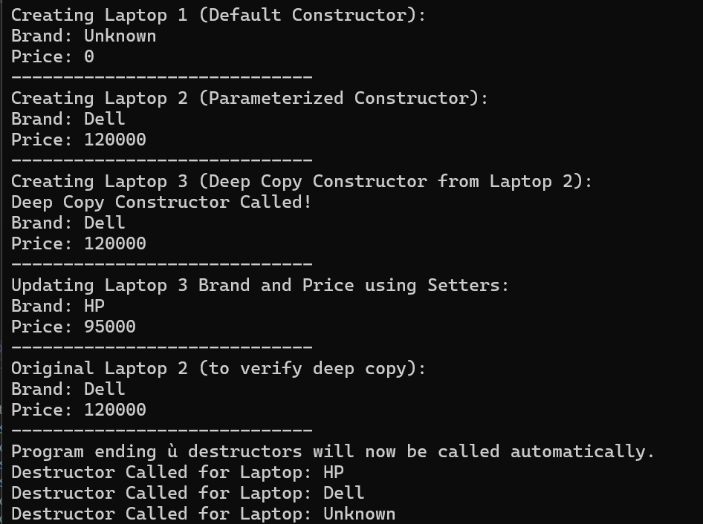

Task 06
You are required to design a modular C++ program that manages smartphone information for a mobile store. The implementation should follow object-oriented principles and be divided into three separate files to ensure clean code organization

File Structure
- SmartPhone.h → Contains the class definition (declaration of data members and member functions).
- SmartPhone.cpp → Contains the implementation (definition) of all class member functions.
- main.cpp → Contains the main function to create and manipulate objects.

Create a class named SmartPhone with the following private data members:
  - brand (string)
  - model (string)
  - price (float)
  - storage (int, representing GB)

Implement the following:
  - Initializes all data members with generic default values (e.g., "Unknown", 0, etc.).
  - One constructor that initializes all data members.
  - Another constructor that only takes brand and model, while setting other members to default values.
  - Define proper setter and getter functions for all data members to safely modify and retrieve private data using deep copy.
  - Implement the deep Copy Constructor
  - Implement a function displayDetails( ) to print all smartphone details in a formatted output.
  - Implement a destructor that displays a message like:"SmartPhone object destroyed. Memory released successfully." to confirm automatic cleanup when an object goes out of scope.

In the main() Function:
- Create three objects of the SmartPhone class using different constructors (default, partial, and full parameterized).
- Update one attribute using a setter function.
- Display details of all objects using either getter functions or the displayDetails( ) function.
- Observe the destructor messages printed automatically when the program ends.

CODE:

Header file:

// L1F24BSCS0069 - MUHAMMAD ASMAR NAEEM

#include <iostream>
#include <string>
using namespace std;

class SmartPhone {
private:
string brand;
string model;
float price;
int storage;

public:
// Default Constructor
SmartPhone();

// Constructor with brand and model only
SmartPhone(string brand, string model);

// Constructor with all parameters
SmartPhone(string brand, string model, float price, int storage);

// Deep Copy Constructor
SmartPhone(const SmartPhone& obj);

// Destructor
~SmartPhone();

// Setters
void setBrand(string brand);
void setModel(string model);
void setPrice(float price);
void setStorage(int storage);

// Getters
string getBrand();
string getModel();
float getPrice();
int getStorage();

// Display function
void displayDetails();
};

Classname.cpp:

// L1F24BSCS0069 - MUHAMMAD ASMAR NAEEM

#include "SmartPhone.h"

// Default Constructor
SmartPhone::SmartPhone() {
this->brand = "Unknown";
this->model = "Unknown";
this->price = 0.0;
this->storage = 0;
}

// Constructor with only brand and model
SmartPhone::SmartPhone(string brand, string model) {
this->brand = brand;
this->model = model;
this->price = 0.0;
this->storage = 0;
}

// Constructor with all parameters
SmartPhone::SmartPhone(string brand, string model, float price, int storage) {
this->brand = brand;
this->model = model;
this->price = price;
this->storage = storage;
}

// Deep Copy Constructor
SmartPhone::SmartPhone(const SmartPhone& obj) {
cout << "Deep Copy Constructor Called!" << endl;
this->brand = obj.brand;
this->model = obj.model;
this->price = obj.price;
this->storage = obj.storage;
}

// Destructor
SmartPhone::~SmartPhone() {
cout << "SmartPhone object destroyed. Memory released successfully." << endl;
}

// Setters
void SmartPhone::setBrand(string brand) {
this->brand = brand;
}

void SmartPhone::setModel(string model) {
this->model = model;
}

void SmartPhone::setPrice(float price) {
this->price = price;
}

void SmartPhone::setStorage(int storage) {
this->storage = storage;
}

// Getters
string SmartPhone::getBrand() {
return this->brand;
}

string SmartPhone::getModel() {
return this->model;
}

float SmartPhone::getPrice() {
return this->price;
}

int SmartPhone::getStorage() {
return this->storage;
}

// Display function
void SmartPhone::displayDetails() {
cout << "Brand: " << this->brand << endl;
cout << "Model: " << this->model << endl;
cout << "Price: " << this->price << endl;
cout << "Storage: " << this->storage << " GB" << endl;
cout << "-----------------------------" << endl;
}

Main.cpp:

// L1F24BSCS0069 - MUHAMMAD ASMAR NAEEM

#include "SmartPhone.h"

int main() {
cout << "Creating SmartPhone 1 (Default Constructor):" << endl;
SmartPhone s1;
s1.displayDetails();

cout << "Creating SmartPhone 2 (Partial Constructor - Brand & Model):" << endl;
SmartPhone s2("Samsung", "Galaxy S25");
s2.displayDetails();

cout << "Creating SmartPhone 3 (Full Parameterized Constructor):" << endl;
SmartPhone s3("Apple", "iPhone 16", 450000, 512);
s3.displayDetails();

cout << "Creating SmartPhone 4 (Deep Copy Constructor from s3):" << endl;
SmartPhone s4(s3);
s4.displayDetails();

cout << "Updating SmartPhone 2 details using setters:" << endl;
s2.setPrice(120000);
s2.setStorage(256);
s2.displayDetails();

cout << "Displaying all SmartPhones again:" << endl;
s1.displayDetails();
s2.displayDetails();
s3.displayDetails();
s4.displayDetails();

cout << "Program ending... destructors will be called automatically." << endl;

return 0;
}

OUTPUT:

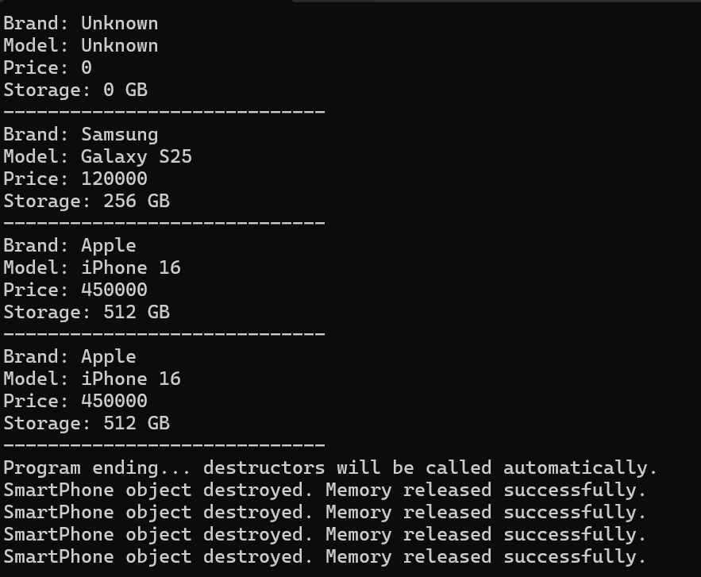

Task 07
A tech company is developing a system to manage a network of connected smart devices such as lights, thermostats, and sensors.Each device has a unique name, a battery level that changes over time, and an operational status (either Active or Inactive).
- Device.h → Contains the class definition (declaration of data members and member functions).
- Device.cpp → Contains the implementation (definition) of all class member functions.
- main.cpp → Contains the main function to create, copy, and manipulate Device objects.

Create a class named Device with the following private data members:
  - deviceName (char*)
  - batteryLevel (int pointer) — dynamically allocated to store current battery percentage
  - status (string) — stores either "Active" or "Inactive"

Implementation Requirements:
- Default Constructor:
  - Initializes deviceName as "Unknown", allocates memory for batteryLevel with a default value of 0, and sets status to "Inactive".

Parameterized Constructor:
  - Accepts values for deviceName, batteryLevel, and status.
  - Dynamically allocates memory for batteryLevel and assigns the provided value.

Copy Constructor (Shallow Copy):
  - Creates a new Device object by copying data members directly from another object (pointer copied as-is).
  - This will help demonstrate shared memory issues later in the program.

Deep Copy Constructor:
  - Creates a separate copy of the batteryLevel pointer to ensure independent memory allocation.
  - Displays a message such as "Deep Copy Constructor Called".

Setter and Getter Functions:
  - Implement setDeviceName(), setBatteryLevel(), and setStatus() using the this pointer to differentiate between parameters and class members.
  - void setStatus(string status) { this->status = status; }
  - Implement getDeviceName(), getBatteryLevel(), and getStatus() for safe access.

displayDetails() Function:
  - Prints all device information in a readable format:
  - Device Name: Smart Light
  - Battery Level: 85%
  - Status: Active

