**Analysis Report**

**Project Title:** Automotive License Plate Office Operations

**Software Used:** Arena

**Date:** 11th May, 2025

**Group Members:**

* Ausaja Hussain (22K-5186)
* Ammar Hyder (22K-4816)
* Muhammad Abdullah (22K-5156)

**Problem Description:**

An office that dispenses automotive license plates has divided its customers into categories to level the office workload. Customers arrive and enter one of three lines based on their residence location. Model this arrival activity as three independent arrival streams using an exponential inter-arrival distribution with a mean of 10 minutes for each stream, and an arrival at time 0 for each stream. Each customer type is assigned a single, separate clerk to process the application forms and accept payment, with a separate queue for each. The service time is UNIF(8, 10) minutes for all customer types. After completion of this step, all customers are sent to a single, second clerk who checks the forms and issues the plates (this clerk serves all three customer types, who merge into a single first-come, first-served queue for this clerk). The service time for this activity is UNIF(2.65, 3.33) minutes for all customer types.

Develop a model of this system and run it for a single replication of 5,000 minutes; observe the average and maximum time in the system for all customer types combined.

A consultant has recommended that the office not differentiate between customers at the first stage and use a single line with three clerks who can process any customer type.

Develop a model of this system, run it for a single replication of 5,000 minutes, and compare the results with those from the first system. Put text boxes in your Arena files with the numerical results requested.

**Approaches used:**

In the first model (separate lines and clerks), we model three independent customer arrival streams, each following an **EXPO(10)** minutes interarrival time, with arrivals beginning at time 0. Each customer type enters a separate queue and is served by a dedicated clerk with a service time distributed uniformly between 8 and 10 minutes (**UNIF(8, 10)**). After completing the first stage, all customers merge into a single, first-come, first-served queue to be processed by a second clerk, who checks the forms and issues license plates, with a service time of **UNIF(2.65, 3.33)** minutes.

In the second model (single line and flexible clerks), customers still arrive independently, but now form a single common queue. Three clerks are available, and any clerk can serve any customer, using the same **UNIF(8, 10)** minutes service time as in the first model. After the initial service, customers proceed to the same final clerk for form checking and plate issuance.

Both simulations are ran for **5000 minutes**, and the average, minimum & maximum time in the system is recorded.

**NOTE:** During the simulation of Model 2, Arena produced a **runtime error due to exceeding the maximum number of entities (150)**. To maintain fairness and prevent simulation crashes, we set **80 Max Arrivals** for both Model 1 and Model 2.

**Arena Diagrams:**

1. **Model 1 – Separate Queues and Clerks:**

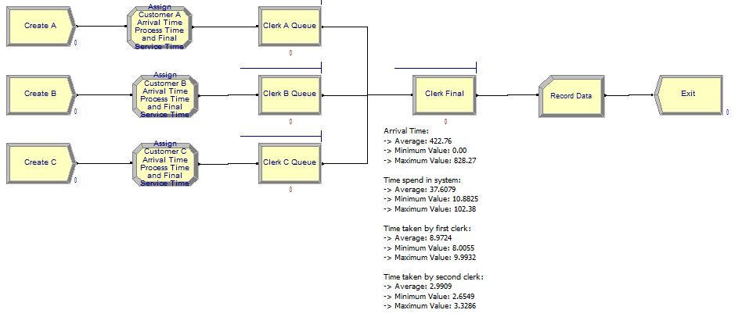

1. **Model 2 – Shared Queue with flexible Clerks:**

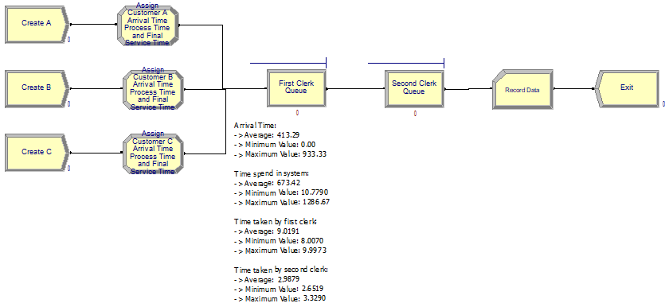

**Results (the Arena-generated reports have been attached along with this report):**

1. **Model 1 – Separate Queues and Clerks:**

|  |  |
| --- | --- |
| **Total Number Seized** | **Value** |
| Clerk A | 80.0000 |
| Clerk B | 80.0000 |
| Clerk C | 80.0000 |
| Final Clerk | 240.00 |

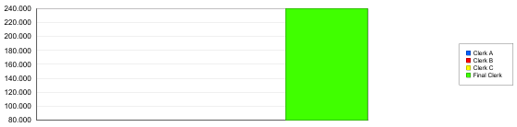

|  |  |  |  |
| --- | --- | --- | --- |
| **Expression** | **Average** | **Minimum Value** | **Maximum Value** |
| Arrival Time | 422.76 | 0.00 | 828.27 |
| Time spent in the System | 37.6079 | 10.8825 | 102.38 |
| Time taken by the First Clerk | 8.9724 | 8.0055 | 9.9932 |
| Time taken by the Second Clerk | 2.9909 | 2.6549 | 3.3286 |

1. **Model 2 – Shared Queue with flexible Clerks:**

|  |  |
| --- | --- |
| **Total Number Seized** | **Value** |
| Clerk A | 240.00 |
| Clerk B | 240.00 |
| Clerk C | 240.00 |
| Final Clerk | 240.00 |

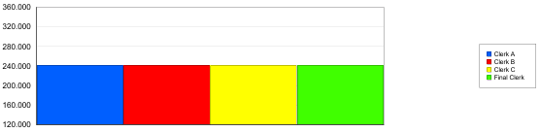

|  |  |  |  |
| --- | --- | --- | --- |
| **Expression** | **Average** | **Minimum Value** | **Maximum Value** |
| Arrival Time | 413.29 | 0.00 | 933.33 |
| Time spent in the System | 673.42 | 10.7790 | 1286.67 |
| Time taken by the First Clerk | 9.0191 | 8.0070 | 9.9973 |
| Time taken by the Second Clerk | 2.9879 | 2.6519 | 3.3290 |

**Analysis:**

1. **Time Spent in System:**

In Model 1, the independent dedicated queues and clerks ensure parallel processing, ensuring efficient customer flow, avoiding queue congestion, and having lower waiting times, averaging a total of **37.6079 minutes** and having a maximum of **102.38 minutes** of **Total Time Spent in System**.

In Model 2, even though the clerks are flexible and can serve any customer, the shared queue results in queue congestion and higher waiting times. The shared arrival stream leads to an uneven workload distribution, and with customers competing for the same pool of clerks, delays are amplified. Using this approach, we managed to get an average of **673.42 minutes** and a maximum of **1286.67 minutes** of **Total Time Spent in System**.

1. **Clerk Utilization:**

In Model 1, the workload is naturally balanced as one clerk is assigned per customer stream, ensuring a divided workload. In this approach, each of the three clerks handles **80 customers** each, and the final clerk processes all **240 customers**.

In Model 2, the system is designed in such a way that each clerk faces significantly more customers, increasing the chance of queue formation due to stochastic variability in service time. In this approach, each of the three clerks handles **240 customers**, and the final clerk handles **240 customers**.

1. **Queuing Behavior and System Congestion:**

In Model 1, the queue separation allowed independent processing, which prevents bottlenecks and delays from occurring in the system.

In Model 2, the lack of separation introduces competition amongst entities as each customer tries to acquire a clerk for processing. This leads to congestion, especially when customers wait in a common queue.

**Conclusion:**

The simulation study was conducted to analyze and evaluate two different approaches to a problem, with the primary goal of determining which approach is more efficient in terms of processing, yields lower waiting times, and improved resource utilization. A key constraint imposed on the both approaches is capping max arrivals to **80 entities** as the second approach exceeded the entity limit of 150 in Arena demo version. This ensures fairness in the analysis of both approaches.

The first approach (i.e., **Model 1**) involves separate queues and dedicated clerks for each customer type, demonstrating a significantly better overall performance, with the average time spent in the system being **37.6079 minutes**. The separation of queues based on customer category allows each customer stream to be processed independently, preventing bottlenecks and balancing the workload across all clerks. Additionally, the final clerk handles all entities consistently without causing congestion.

The second approach (i.e., **Model 2**) uses a shared queue and three flexible clerks, which produced less desirable results. This approach resulted in an average of **673.42 minutes** of time spent in the system, which is a significantly higher amount compared to the first approach. Even though all clerks were capable of serving any customer, the shared queue caused all entities to wait longer due to increased competition for service. This approach may appear more flexible, but in practice, it resulted in significant inefficiencies.

In conclusion, while both models simulate realistic office workflows, the **first approach (Model 1)** outperforms the **second approach (Model 2)** in terms of system time and operational stability.