AI Workflow Audit and Tool Setup
FL-02 | Muhammad Azan Rizvi | FlyRank AI Fluency Track

1. Task Audit
# | Task | Classification | Rationale
1 | Debugging errors in my Colab notebooks (syntax errors, path errors, etc.) | Delegate w/ review | AI spots the likely cause fast, but I verify the fix actually runs before trusting it
2 | Writing the markdown framing sections in my research notebook (decision, action, cost) | Collaborate | The thinking has to be mine — AI helps me sharpen wording, not generate the reasoning
3 | Studying for exams (reading + memorizing course material) | Just me | Understanding sticks better when I struggle through it myself; outsourcing this defeats the purpose
4 | Summarizing a long lecture or textbook chapter into study notes | Delegate w/ review | Saves time condensing, but I check it against the source for accuracy
5 | Deciding my provisional research lane for the capstone | Just me | This is a judgment call about what I find genuinely interesting — not something to hand off
6 | Writing boilerplate setup code (repo cloning, path-finding cells) | Fully automate | Purely mechanical, same pattern every time, low risk if wrong (easy to spot)
7 | Drafting messages to internship coordinators or professors | Collaborate | I know the point I want to make; AI helps me phrase it professionally without losing my voice
8 | Running the reference ML pipeline (scripts/run_all.py) | Fully automate | It's a fixed script — my job is to interpret the output, not touch the pipeline itself
9 | Choosing what to say in the "careful words" section (claims vs. non-claims) | Just me | This is about intellectual honesty — I need to own exactly what I'm claiming
10 | Formatting a table or report for submission | Delegate w/ review | Formatting is tedious and low-judgment, but I glance over it for correctness
11 | Exploring a new pandas function I haven't used before | Collaborate | I learn best asking follow-up questions in the moment rather than reading docs cold
12 | Prioritizing which assignments to tackle first each week | Just me | Depends on my own energy, deadlines, and context AI doesn't have
13 | Proofreading my own written explanations before submitting | Delegate w/ review | Good at catching typos/awkward phrasing, but I make the final call on tone
14 | Brainstorming what "belief to test" to explore in a new dataset | Collaborate | AI throws out options I wouldn't think of, but I pick which one is actually interesting
15 | Tracking my own study/assignment deadlines across courses and this internship | Just me | Personal organization — outsourcing this just moves the problem, doesn't solve it

2. Tool Setup Evidence
Anthropic Academy — AI Fluency: Framework & Foundations
- Enrolled and completed the course; final assessment: 9/10 (90%), passed.

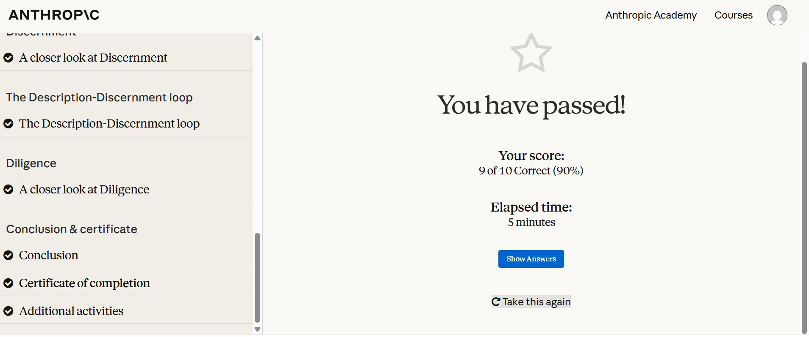

Claude Project — configured with custom instructions
- Created a "FlyRank Internship" project with custom instructions covering role, tone preferences, and current goals.

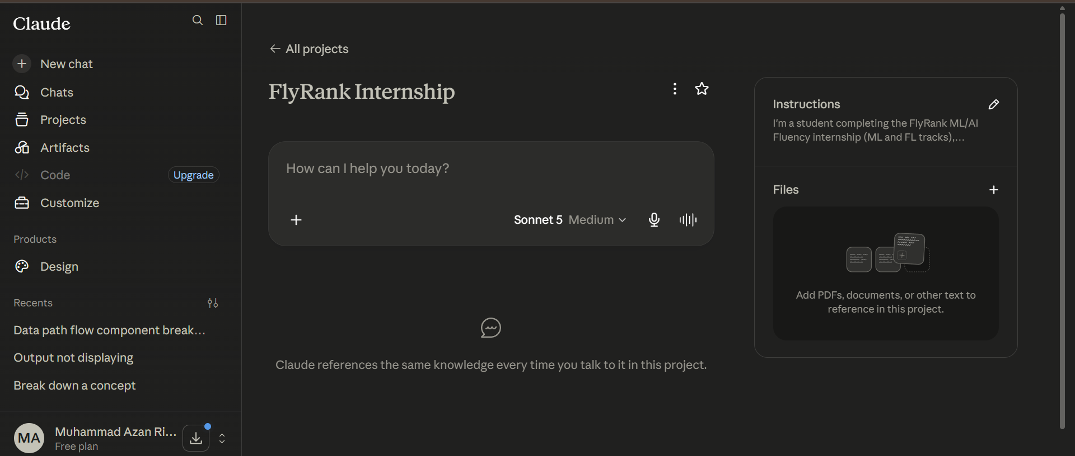

3. Three Target Tasks (for FL-02 – FL-04)
Target Task | "Done well" means
Debugging notebook errors | AI's first suggested fix resolves the error without introducing a new one, in ≤2 back-and-forth turns, at least 80% of the time
Summarizing lecture material into study notes | Summary preserves every key term/concept from the source (checked by re-reading original), cuts my note-taking time by at least half
Writing research-question framing | Final wording is clearer and more precise than my first draft, but the core argument/claim is unchanged from what I originally reasoned through

