SmartMaint AI
AI-Powered Predictive Maintenance and Asset Monitoring
System for Industrial IoT

Group Name: | N/A
Number of Group Members: | 1
Report Title: | SmartMaint AI — AI-Powered Predictive Maintenance System
Student Name: | Muhammad Mustafa Baig
Course: | CSIT 317 Systems Analysis and Design
Date: | March 31, 2026

Systems Analysis and Design — System Proposal Report

Executive Summary
Unplanned equipment failures cost the manufacturing industry around $50 billion every year in emergency repairs, lost production, and supply chain delays. Most factories still rely on reactive or schedule-based maintenance, neither of which takes advantage of the real-time data that modern machines already produce.
SmartMaint AI is a cloud-based platform that uses IoT sensors and machine learning to predict equipment failures before they happen. It monitors machine health in real time, spots unusual patterns, and automatically creates maintenance work orders. Role-based dashboards give operators, technicians, and managers exactly the information they need.
Industry research shows that adopting predictive maintenance can reduce unplanned downtime by 40–50%, cut maintenance costs by 20–30%, and extend equipment lifespan by 15–25%. The expected ROI payback period is 12 to 18 months.
1. Introduction and Background
1.1 Organisation Overview
SmartMaint AI is designed for mid-to-large manufacturing plants — such as automotive parts factories or food processing facilities — that operate 24/7 with hundreds of critical machines including CNC mills, conveyor belts, compressors, pumps, and motors. These plants employ maintenance teams that currently rely on manual inspections, fixed schedules, and reactive repairs.
1.2 Current Issues and Inefficiencies
- Reactive Maintenance: About 35–45% of maintenance work only happens after a breakdown, causing emergency repairs and lost production.
- Wasted Preventive Work: Parts are replaced on fixed schedules whether they need it or not, wasting roughly 30% of the maintenance budget.
- Disconnected Data: Sensor data sits in separate systems with no unified view of overall equipment health.
- Slow Alerts: Abnormal readings may go unnoticed until the next shift, worsening the damage.
- Knowledge Loss: Expert technician knowledge is lost when staff retire, with no system to capture it.
1.3 Why Build This System Now
Three technology trends make this the right time to build SmartMaint AI. First, IoT sensors are now cheap and accurate enough to instrument every key machine. Second, ML models like LSTM networks and XGBoost can predict failures days in advance with over 85% accuracy. Third, cloud platforms (Docker, Kubernetes, AWS) make deploying and scaling such a system practical without large upfront hardware investment. SmartMaint AI combines all three into one integrated platform.

2. System Requirements Analysis
2.1 Functional Requirements
The following table lists what the system must do, prioritised using the MoSCoW method:
ID | Requirement | Category | Priority
FR-01 | Collect live sensor data (vibration, temperature, pressure, current, RPM) | Data Ingestion | Must
FR-02 | Clean and normalize sensor streams within 500 ms | Data Ingestion | Must
FR-03 | Run ML models to detect anomalies and calculate health scores | ML / AI | Must
FR-04 | Send alerts (Critical / High / Medium / Low) when issues are detected | Alerting | Must
FR-05 | Auto-create and assign work orders from high-severity alerts | Work Orders | Must
FR-06 | Provide role-based dashboards with live KPIs and alert feeds | Dashboards | Must
FR-07 | Maintain a searchable asset and sensor registry | Asset Mgmt | Must
FR-08 | Generate maintenance reports (PDF/CSV) on demand or on schedule | Reporting | Should
FR-09 | Connect to ERP and CMMS systems via REST APIs | Integration | Should

2.2 Non-Functional Requirements
ID | Category | Requirement
NFR-01 | Performance | Handle 10,000+ sensor readings/sec with < 500 ms end-to-end latency
NFR-02 | Availability | 99.9% uptime (< 9 hours downtime per year)
NFR-03 | Security | TLS 1.3 in transit, AES-256 at rest, OAuth 2.0 + RBAC
NFR-04 | Scalability | Support up to 50,000 sensors without architectural redesign
NFR-05 | Usability | Dashboards learnable within 2 hours of training
NFR-06 | ML Accuracy | Minimum 85% precision and 80% recall on failure predictions
NFR-07 | Maintainability | Microservices design — components updatable independently

2.3 Stakeholder Analysis
Stakeholder | Primary Need | Access Level
Machine Operator | Real-time health indicators and visual alerts | Read-Only Dashboard
Maintenance Technician | Work orders, diagnostic guidance, repair history | Read/Write Work Orders
Operations Manager | KPI dashboards, downtime stats, cost reports | Full Read + Reports
IT Administrator | System settings, user management, security logs | Full Admin
Plant Director | ROI summaries and executive reports | Executive Dashboard
ERP / CMMS System | Automated work order sync, asset data exchange | API Access

3. Process Modeling
Process modeling illustrates how data flows through SmartMaint AI and who interacts with each part of the system. Three diagrams are used: a Use Case Diagram, a Context Diagram, and a Level-0 Data Flow Diagram.
3.1 Use Case Diagram
The Use Case Diagram shows five actor types — Machine Operators, Maintenance Technicians, Operations Managers, IT Admins, and the ML Engine — and the seven main use cases they interact with: equipment monitoring, alert management, work order handling, dashboard viewing, asset configuration, ML model management, and report generation.
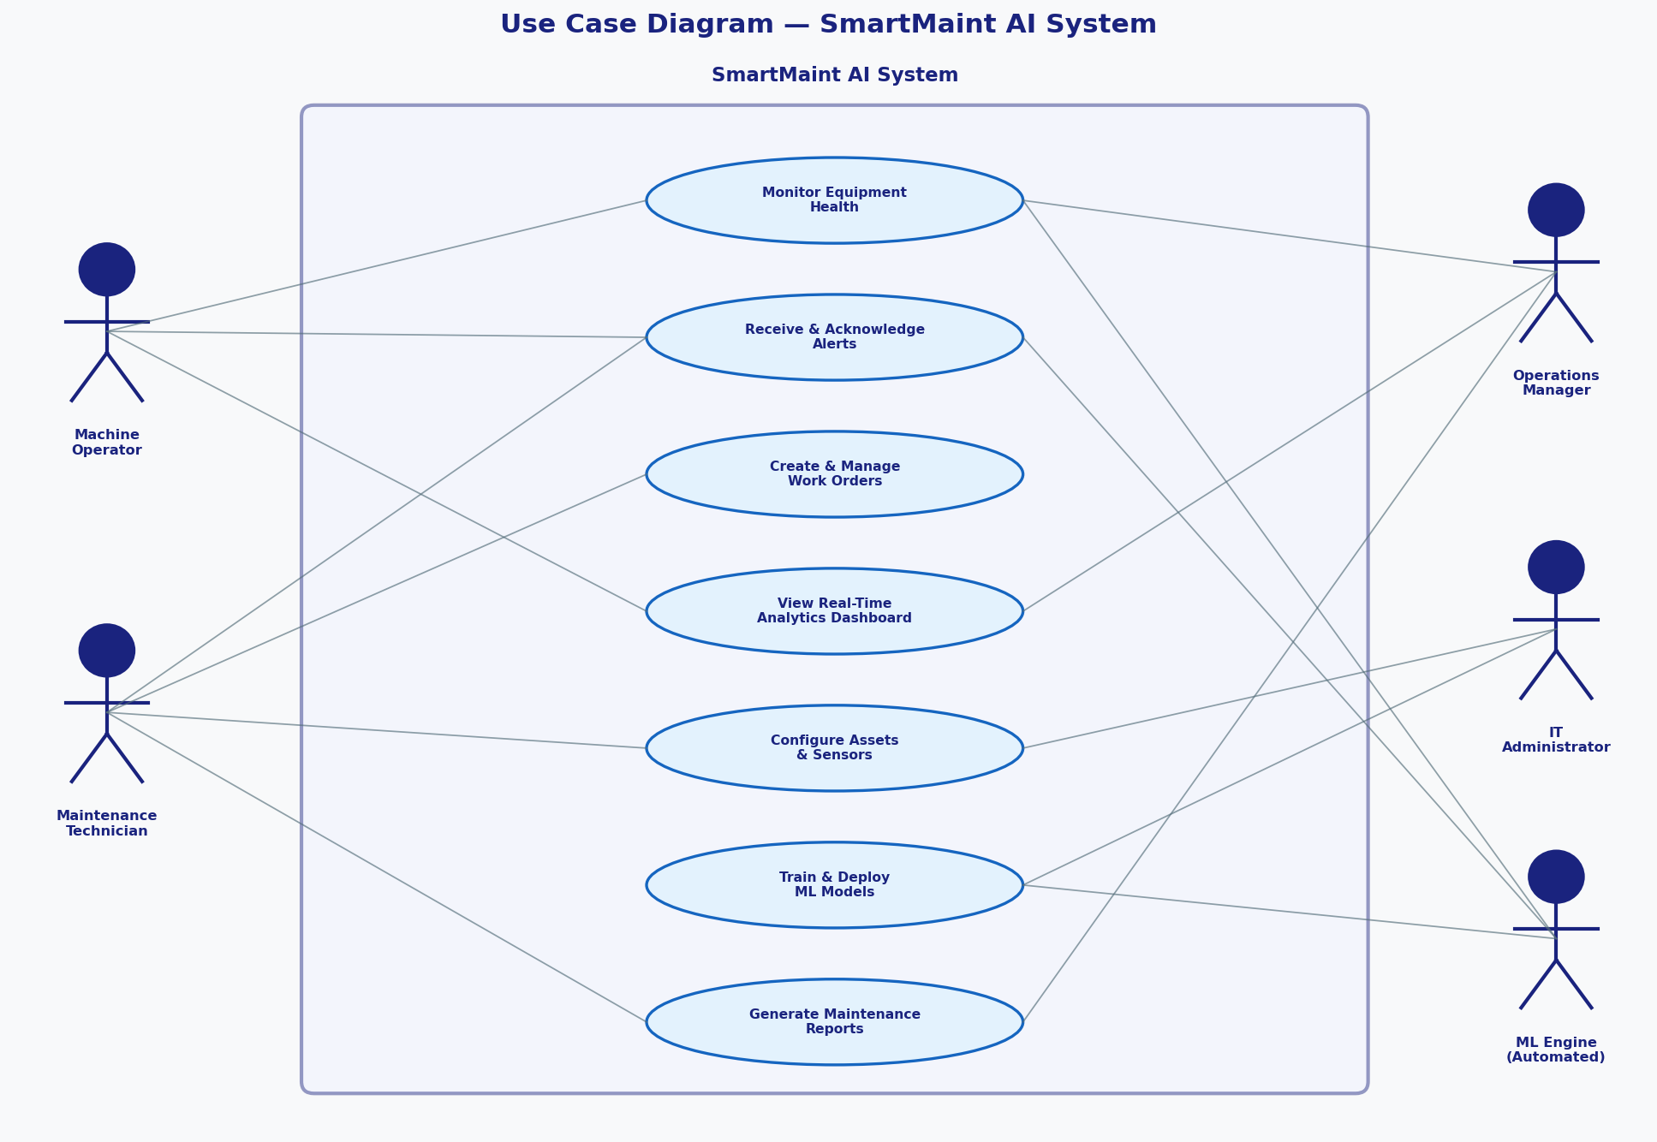
Figure 3.1 — Use Case Diagram
3.2 Context Diagram
The Context Diagram represents SmartMaint AI as a single process and shows all external entities: IoT sensors, four user types, an ERP/CMMS system, a notification service, and a data warehouse for long-term archival.
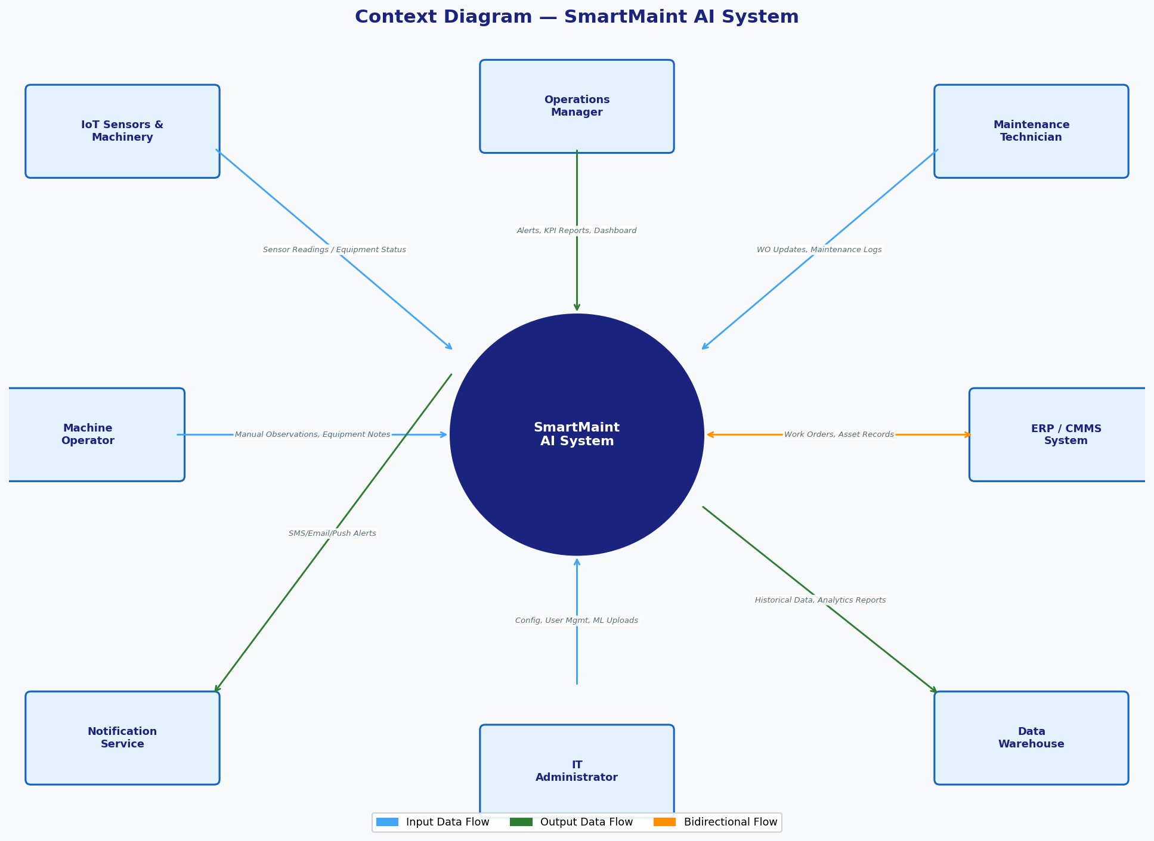
Figure 3.2 — Context Diagram
3.3 Level-0 Data Flow Diagram
The Level-0 DFD decomposes SmartMaint AI into six core processes and five data stores. Raw sensor data enters via P1 (Data Ingestion), is analysed by P2 (Anomaly Detection) and P3 (ML Prediction), then triggers P4 (Alerts and Work Orders). P5 handles configuration and P6 generates reports.
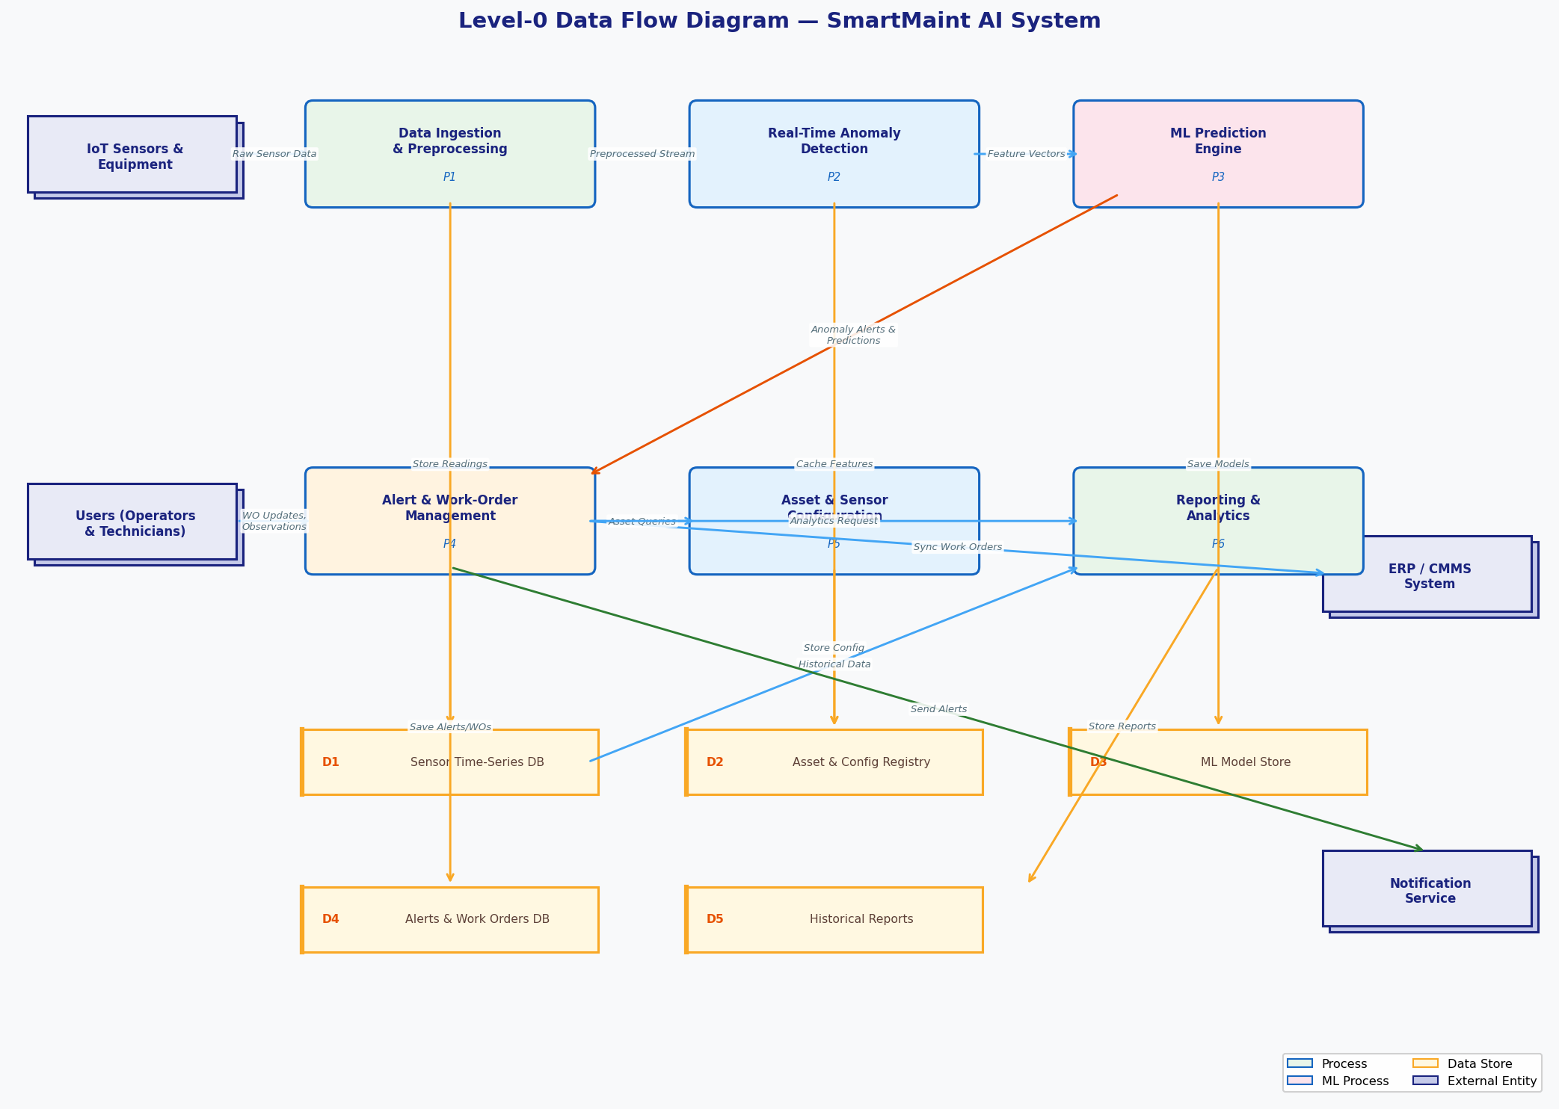
Figure 3.3 — Level-0 Data Flow Diagram
Process | Name | Description
P1 | Data Ingestion | Receives raw sensor data via MQTT, cleanses it, and writes to InfluxDB.
P2 | Anomaly Detection | Applies ML models to incoming readings, calculates health scores, and flags anomalies.
P3 | ML Prediction | Runs TensorFlow and XGBoost models to estimate failure probability and timing.
P4 | Alert & Work Orders | Generates alerts, creates work orders, assigns technicians, and sends notifications.
P5 | Asset Configuration | Allows admins to add/edit assets, sensors, thresholds, and users.
P6 | Reporting | Produces scheduled and on-demand PDF/CSV reports from historical data.

4. Data Modeling
The Entity-Relationship Diagram (ERD) below uses Crow's Foot notation to show the nine main database entities and their relationships. The central entity is ASSET, which connects to sensors, work orders, alerts, and ML predictions.
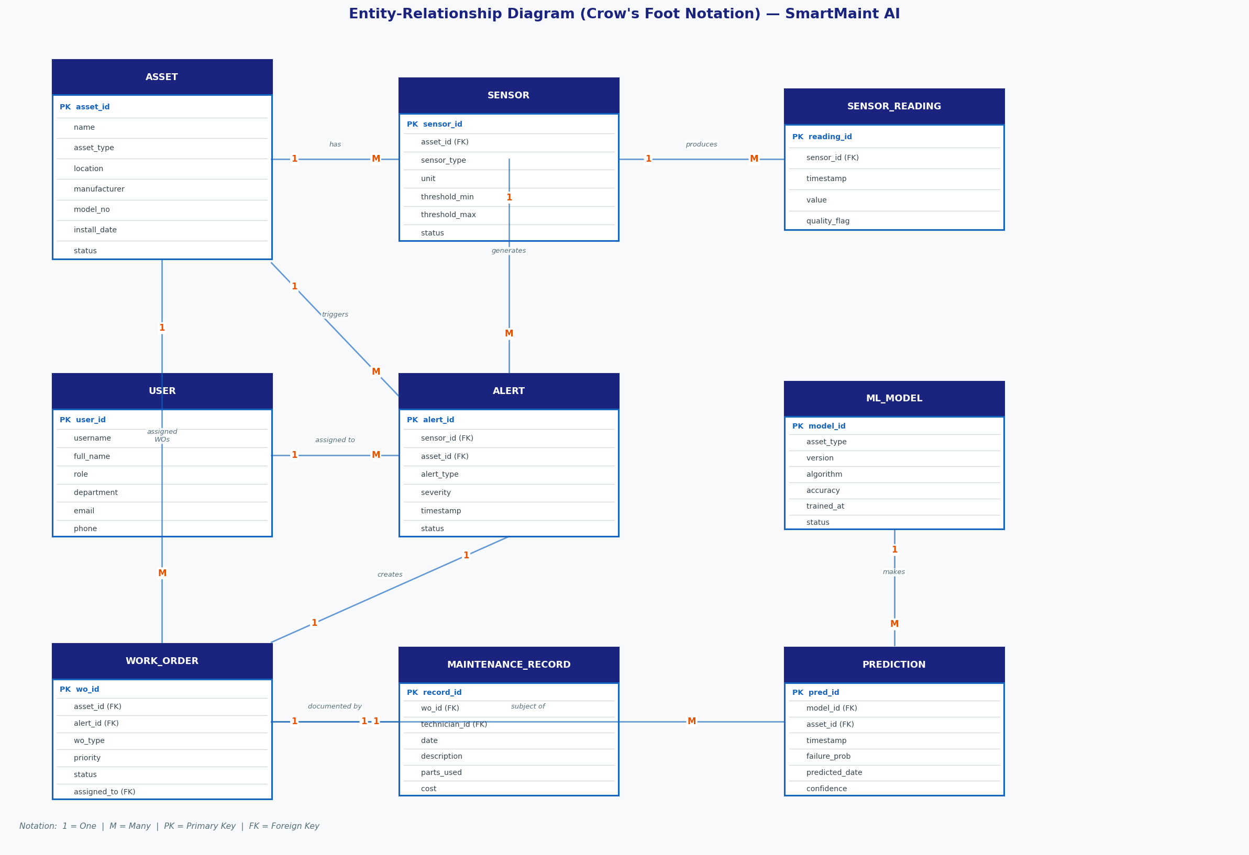
Figure 4.1 — Entity-Relationship Diagram

4.1 Entity Descriptions
Entity | What It Stores | Key Relationships
ASSET | Physical machine details: name, location, type, status | Has many sensors; generates alerts and predictions; has work orders
SENSOR | Sensor type, unit, alarm thresholds, calibration date | Belongs to one asset; produces readings; triggers alerts
SENSOR_READING | Timestamped data points with value and quality flag | Belongs to one sensor
ALERT | Anomaly notification with severity, timestamp, and description | Linked to a sensor and asset; may spawn a work order
WORK_ORDER | Maintenance task: priority, status, assigned technician, due date | Linked to an asset and alert; completed via a maintenance record
MAINTENANCE_RECORD | Work completed, parts used, labour hours, and cost | Linked to a work order and technician
USER | System users with roles (Operator, Technician, Manager, Admin) | Assigned work orders; creates maintenance records
ML_MODEL | Algorithm, version, accuracy metrics, training date | Generates predictions for assets
PREDICTION | Failure probability, predicted failure date, confidence score | Belongs to a model; linked to an asset

5. System Architecture Design
5.1 Proposed Architecture
SmartMaint AI uses a Cloud-Based Three-Tier Architecture with an Edge Computing Layer. This hybrid approach places time-sensitive processing at the factory edge (response under 5 ms) while offloading ML training, long-term storage, and business integrations to the cloud. The three tiers — Presentation, Application, and Data — keep components loosely coupled so each can be updated independently. The system is designed to start with a small pilot (50 machines) and scale to 50,000+ sensors using Kubernetes auto-scaling and horizontally scalable Kafka and InfluxDB clusters.
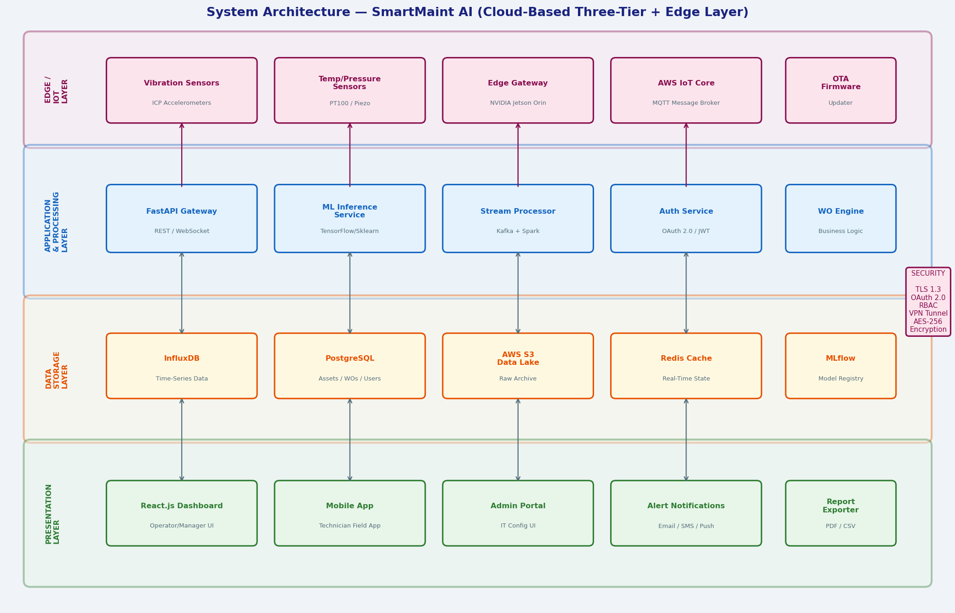
Figure 5.1 — System Architecture Diagram
5.2 Architecture Layers
Layer | Components | Key Technologies
Edge / IoT | Vibration, temperature, and pressure sensors; NVIDIA Jetson gateways for local pre-processing; AWS IoT Core for MQTT messaging | NVIDIA Jetson Orin, MQTT, TLS 1.3, AWS IoT Core
Application | FastAPI REST gateway, ML inference service, Kafka event streaming, Spark stream processing, OAuth 2.0 authentication | Python, FastAPI, TensorFlow, Scikit-learn, Kafka, Spark, Docker, Kubernetes
Data Storage | InfluxDB (time-series), PostgreSQL (relational), S3 (archival), Redis (cache), MLflow (model registry) | InfluxDB, PostgreSQL, AWS S3, Redis, MLflow
Presentation | React.js web dashboards, React Native mobile app, email/SMS notifications, PDF/CSV reports | React.js, React Native, Chart.js, Node.js

5.3 Security and Hardware
Security is built into every layer. Key measures include:
- Encryption: All data in transit encrypted with TLS 1.3; stored data encrypted with AES-256 via AWS KMS.
- Authentication: Users authenticate with OAuth 2.0 and JWT tokens; role-based access control limits what each role can see or do.
- Network & Audit: IoT devices are isolated on their own network segment, separated by firewalls and VPNs. All API calls and admin actions are logged for 12 months.
Key hardware components include:
Component | Specification
API / App Servers | AWS EC2 m6i.2xlarge (8 vCPU, 32 GB RAM); 2–10 instances with auto-scaling
ML Training | AWS EC2 p3.2xlarge with Tesla V100 GPU; spot instances
Edge Gateways | NVIDIA Jetson Orin 32 GB; industrial-grade, IP67 rated
Databases | AWS RDS PostgreSQL 15 (multi-AZ); InfluxDB 2.7 with 500 GB SSD (3× replicated)
Message Broker | AWS Managed Kafka — 3 broker nodes, 1 TB storage each

6. Conclusion and Recommendations
6.1 Expected Benefits
Benefit | Expected Improvement | Source
Unplanned Downtime | Reduced by 40–50% | McKinsey, Deloitte studies
Maintenance Costs | Reduced by 20–30% | GE Digital benchmarks
Equipment Lifespan | Extended by 15–25% | IBM case studies
Emergency Repairs | Reduced by 60–70% | Siemens deployment data
ROI Payback Period | 12–18 months | Industry averages

6.2 Implementation Challenges
- Sensor Installation: Older machines may need physical retrofitting to add sensors, requiring vendor coordination and brief downtime.
- Data Quality: ML models require well-labelled failure history. A 3–6 month data collection period before full ML deployment is recommended.
- Change Management: Staff accustomed to manual processes will need a structured training program and gradual rollout.
- Legacy Integration: Connecting to legacy ERP systems (SAP, Oracle) may need custom middleware and extra testing effort.
6.3 Implementation Roadmap
Phase | Timeline | Key Activities
Phase 1 — Pilot | Months 1–3 | Deploy on one production line (10–20 machines). Install sensors, collect baseline data, train initial ML models, onboard core team.
Phase 2 — Expansion | Months 4–9 | Roll out to 3–5 lines. Connect to ERP/CMMS. Improve models with live failure data. Enable full alert and work order workflows.
Phase 3 — Full Rollout | Months 10–18 | Facility-wide deployment. Executive dashboards live. Security audit completed. Regular model retraining cycle established. Measure ROI.

6.4 Final Thoughts
SmartMaint AI addresses a real and costly problem in manufacturing by combining IoT sensors, cloud infrastructure, and machine learning into a unified predictive maintenance platform. Its modular microservices design means individual components can evolve as better tools emerge. The recommendation is to begin with a feasibility study and proof-of-concept pilot in Q3 2026, targeting full deployment by Q2 2027.

References
[1] Deloitte Insights. (2022). Predictive Maintenance and the Smart Factory. Deloitte University Press.
[2] GE Digital. (2023). Industrial IoT ROI Benchmark Report: Predictive Maintenance Use Cases.
[3] IBM Institute for Business Value. (2023). AI and the Future of Maintenance. IBM Corporation.
[4] McKinsey Global Institute. (2022). Industry 4.0: Reimagining Manufacturing Operations After COVID-19.
[5] Siemens Digital Industries. (2023). MindSphere Industrial IoT Platform: Predictive Analytics Case Studies.
[6] NIST. (2018). Framework for Improving Critical Infrastructure Cybersecurity (Version 1.1).
[7] IEC. (2021). IEC 62443: Security for Industrial Automation and Control Systems.
[8] Amazon Web Services. (2024). AWS IoT Core Developer Guide.
[9] Apache Software Foundation. (2023). Apache Kafka 3.5 Documentation.
[10] MLflow Project. (2024). MLflow: An Open Source Platform for the Machine Learning Lifecycle.
[11] InfluxData. (2023). InfluxDB 2.7 Documentation — Time Series Data Platform.
[12] ISO. (2014). ISO 55000: Asset Management — Overview, Principles and Terminology.

