Expense Management System
Dated: 13th. Aug 2015

Assigned to : Badar, Lahore

Tables
- Region
- City
- Area
- Manager
- Doctor
- ExpGroup
- ExpHead

Definition

- Region Definition Section

Form Name: a_region.aspx
Table: Region

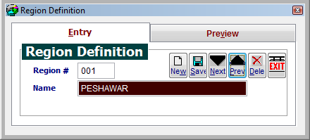

- City Definition Section
Form Name: a_city.aspx
Table: 1. City 2. Region

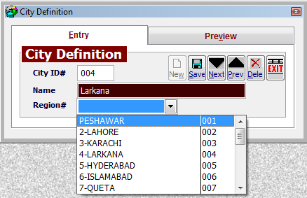

- Area Definition

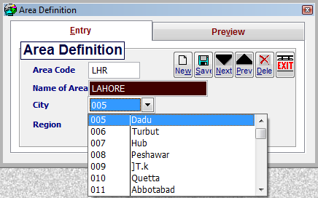

- Manager Definition

- Doctor/Cost Center Definition

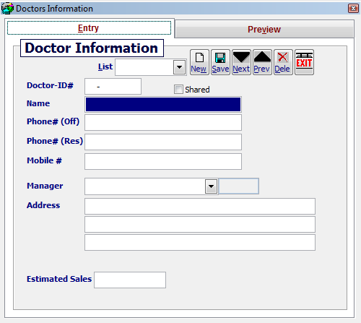

- Expenses Groups Definition
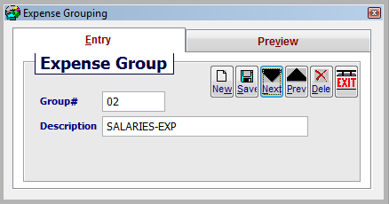

- Expenses Heads Definition

