Nama : Muhammad Bagja Nasrulloh

NIM : 1207070073

Kelas : TKK

Praktikum 9 Edge Detection

1. Filter Sobel

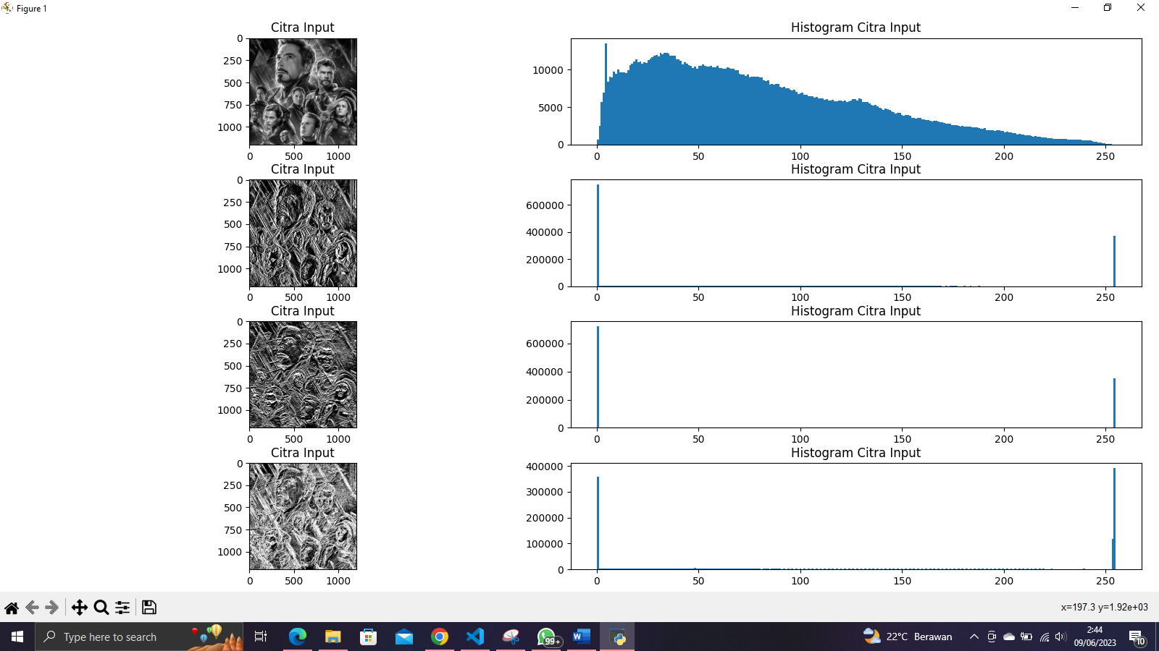

1. Filter Prewitt

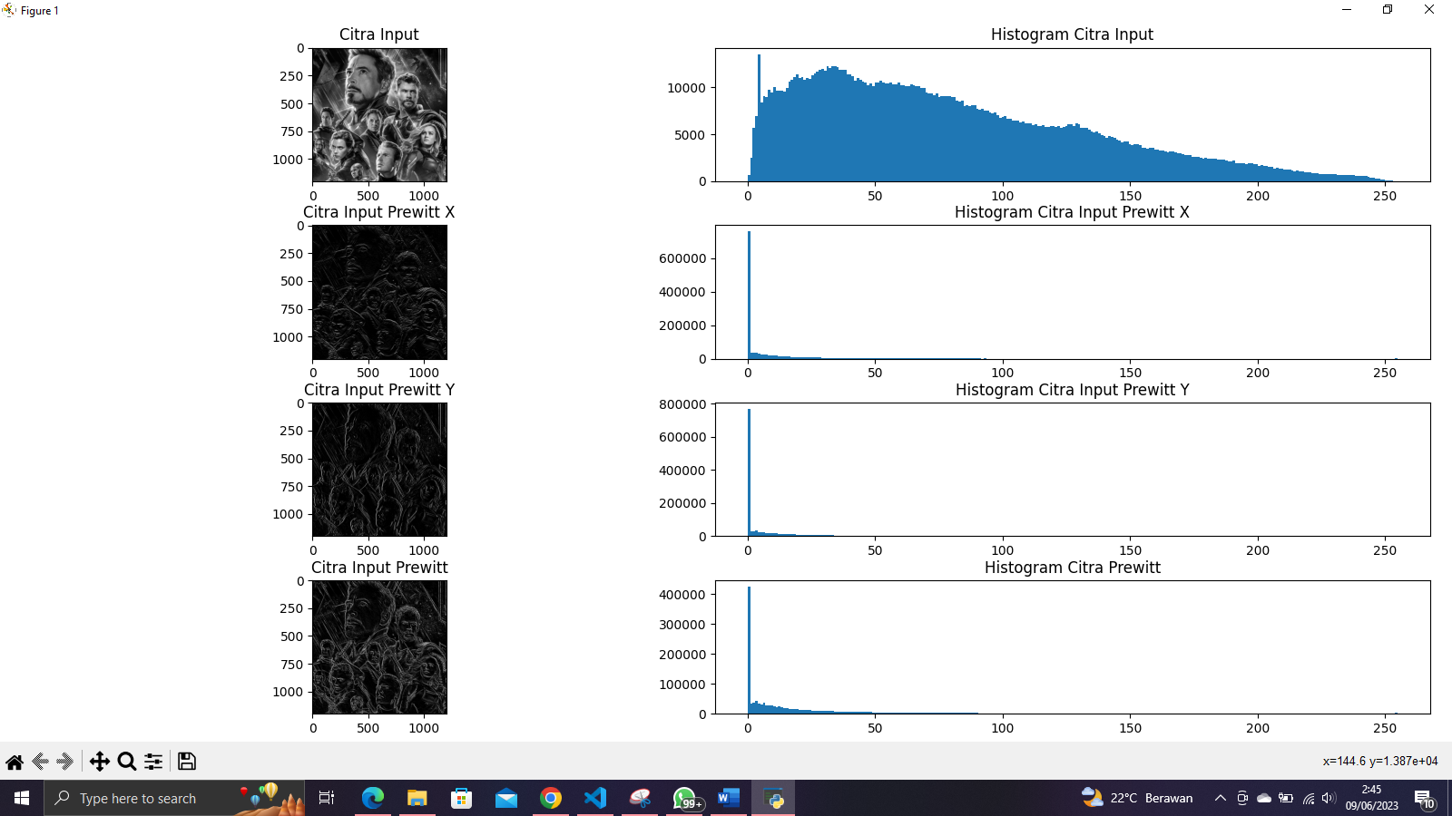

1. Filter Canny

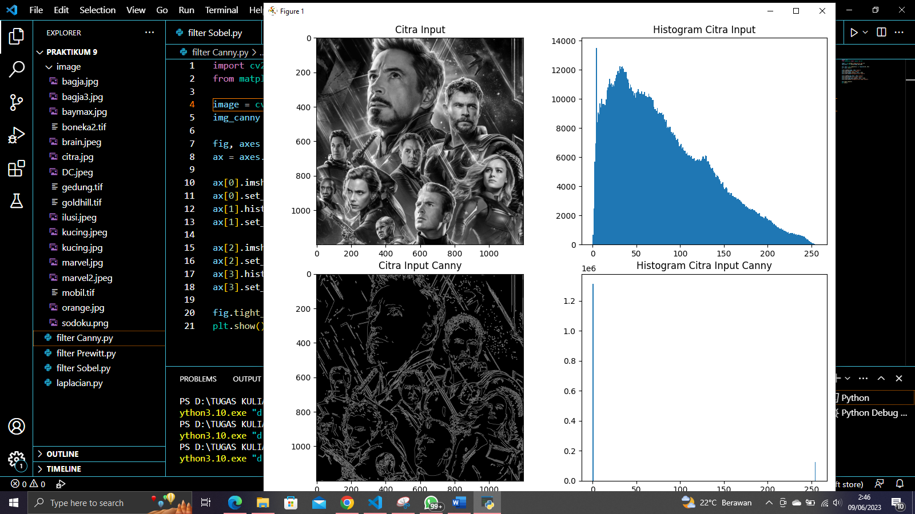

1. Laplacian

