

Name: Muhammad Bilal
Section: AM
Teacher: Tahir Hassan
Id: FA23-BSCS-0028
Submit Date: 3/4/2026
Course: Mobile App Development

- UI(in light mode):

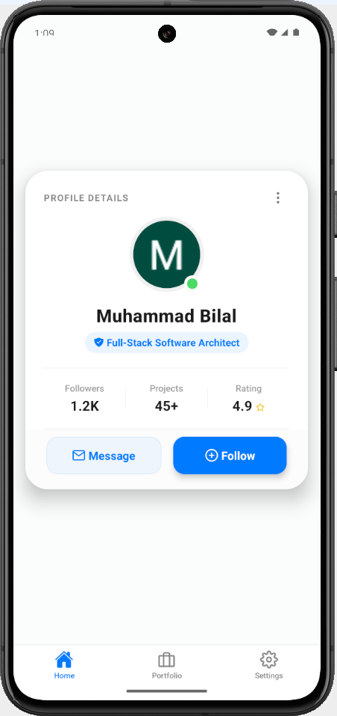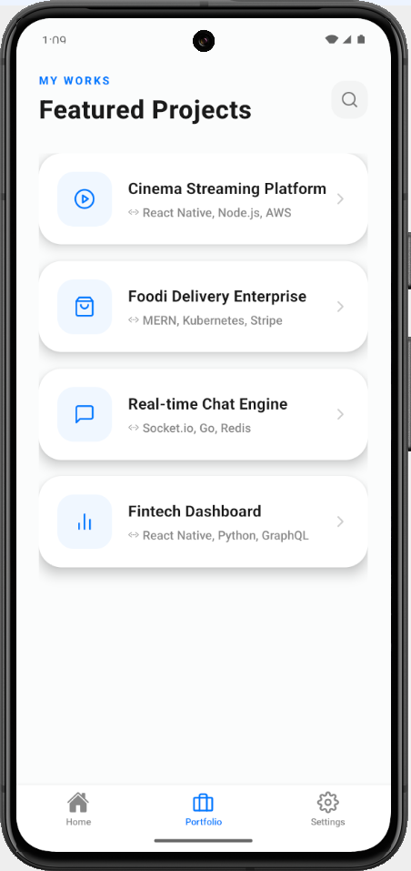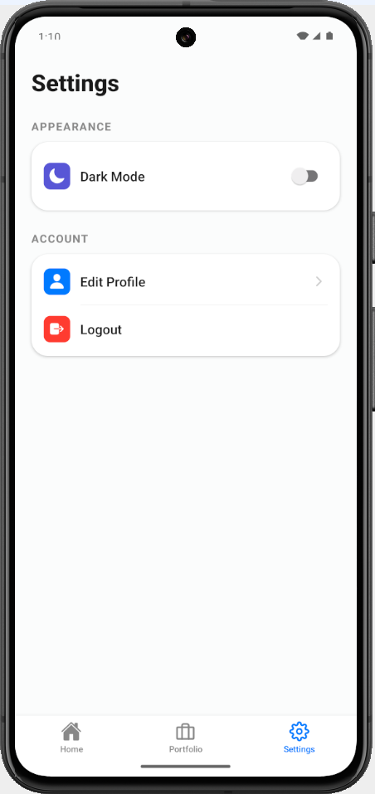

In dark mode:

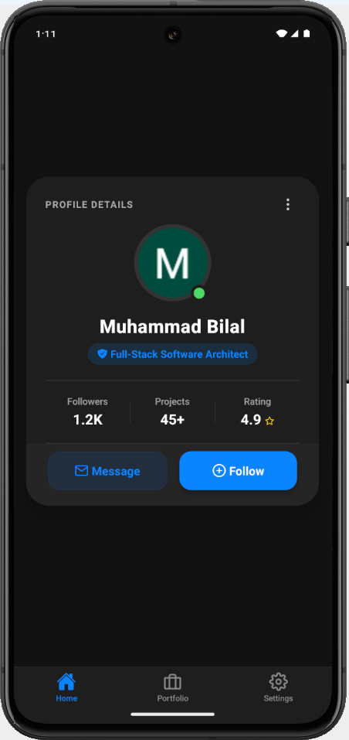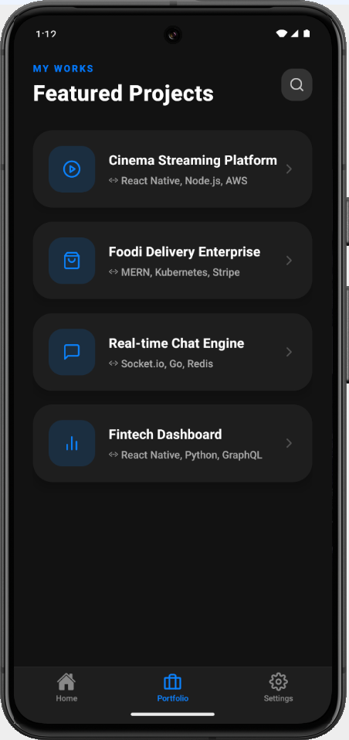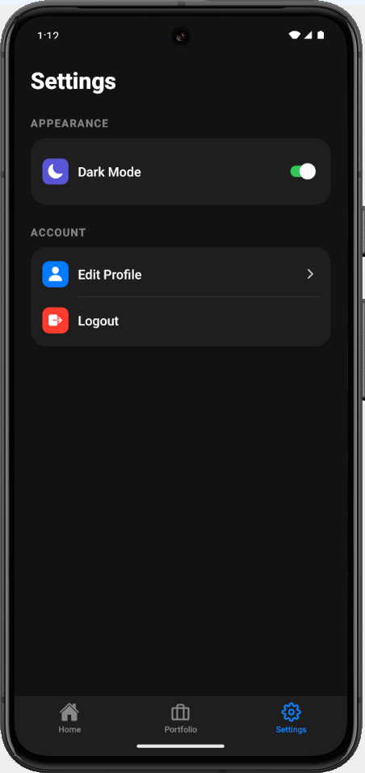

Github Url: https://github.com/MuhammadBilal-dev1/Mobile-App-Development-Course-Elective/tree/main/Assignments/Assignment_01

Description:

• How your component works:
Theme Switching: I used React Context API to create a global theme system. This allows the user to switch between Light and Dark mode across the entire app instantly.
Dynamic Styles: Components like the ProfileCard don't use fixed colors. Instead, they automatically change their background and text colors based on the selected theme.
Easy Navigation: I used Expo Router to build a professional tab bar. This makes it very easy for users to move between the Home, Projects, and Settings screens.
· Any additional features you implemented:
Modern Design: The app uses a clean, card-based layout with soft shadows to give it a premium and professional look.
Online Status Badge: I added a small "Online" indicator on the profile picture that stays clearly visible in both light and dark backgrounds.
Mobile Optimized: The layout is designed to fit perfectly on all screen sizes, including phones with notches or bottom bars.

