

Name: Muhammad Bilal
Section: AM
Teacher: Tahir Hassan
Id: FA23-BSCS-0028
Submit Date: 16/4/2026
Course: Mobile App Development

- UI(in light mode):

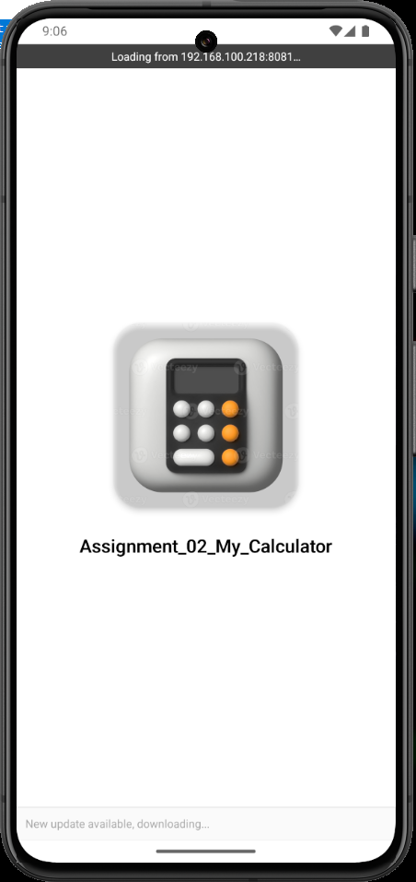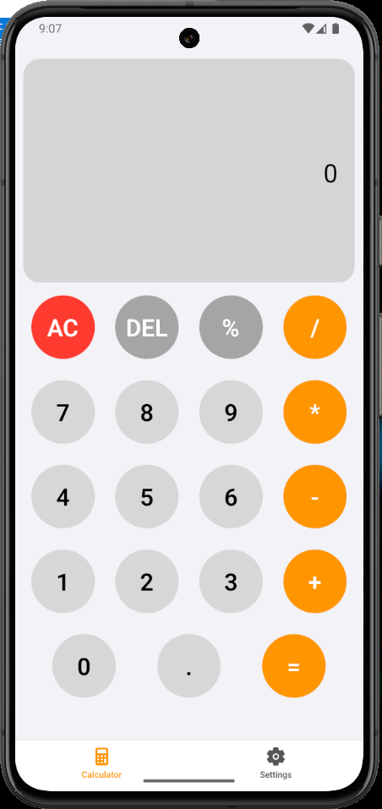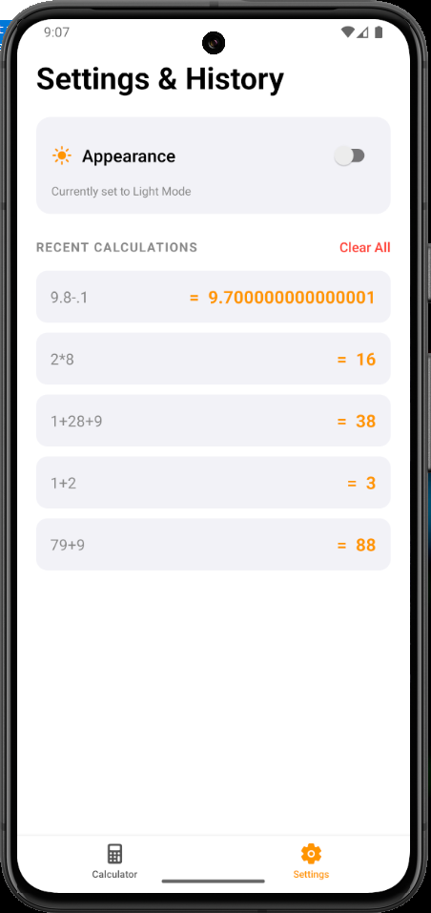

In dark mode:

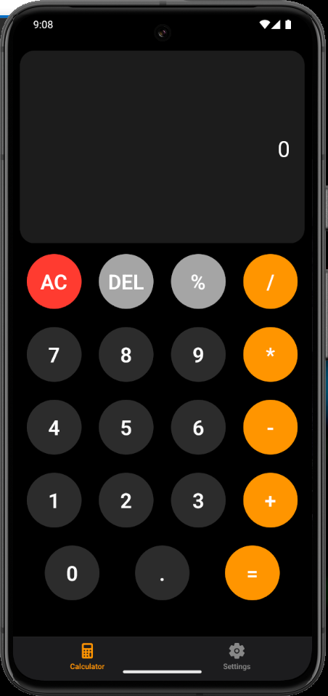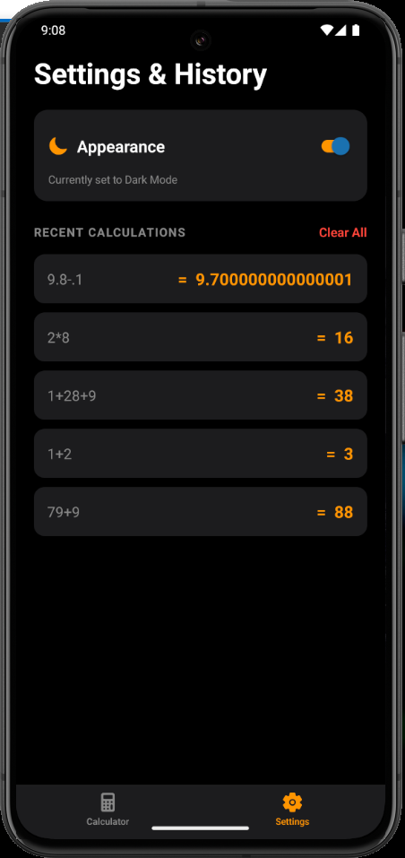

Github Url: https://github.com/MuhammadBilal-dev1/Mobile-App-Development-Course-Elective/tree/main/Assignments/Assignment_02_My_Calculator

Description:

How Your Component Works
Global State Management (Context API): I implemented the React Context API to create a centralized theme system that synchronizes Light and Dark modes across all app screens and the navigation bar instantly.
Dynamic UI Architecture: Components like the calculator display and buttons utilize the useTheme hook to dynamically update their styles (colors, backgrounds) based on the current theme state rather than using hardcoded values.
Persistent User Preferences: I integrated AsyncStorage to ensure that the user's theme selection and their calculation history are preserved even after the application is closed or restarted.
Modular Navigation: Built with Expo Router, the app features a professional tab-based layout that provides seamless transitions between the Calculator interface and the Settings/History view.

Additional Features Implemented
Tactile Audio Feedback: To enhance the user experience, I integrated the expo-av library to trigger subtle, high-quality click sound effects for every button interaction.
Advanced History Logic: Developed a custom history management system that automatically tracks the last 5 calculations and includes a "Clear All" functionality for user privacy.
Adaptive Display Scaling: The calculator display features dynamic font scaling to ensure that complex mathematical expressions remain legible and contained within the UI across various device sizes.
Modern Premium Aesthetic: The interface utilizes a clean, card-based layout with soft shadows and refined Flexbox alignments to deliver a professional mobile-first design.

