Operating System Lab

Name: Muhammad Bilal Ahmad
ID: F2024332089

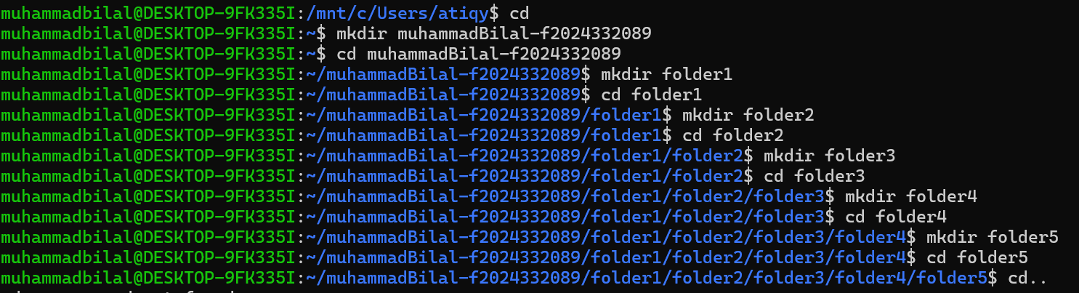

Created a folder using mkdir ,then create subfolders in it using the mkdir method

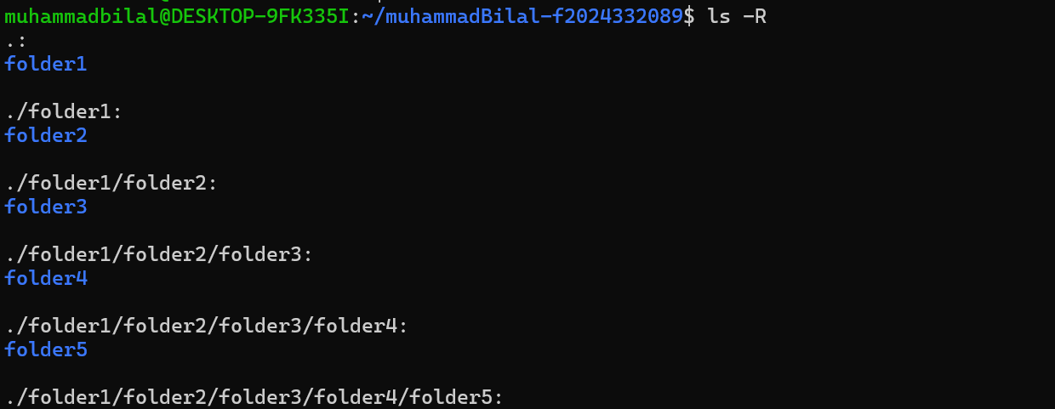

Show all folders recursively using ls -R

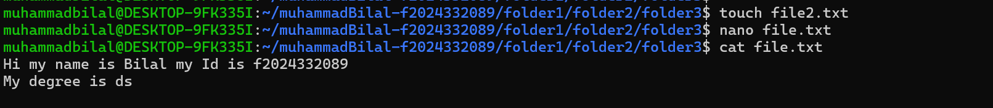

Use nano command to edit the file and write my intro in it then I use cat command to display it

