**Use Cases for Hospital Management System**

**Actors:**

* **Patient:** Individual seeking medical treatment
* **Receptionist:** Individuals who manages patient intake and scheduling
* **Hospital Administration:** Individuals who manage the staff members
* **Hospital Staff:**
  + **Doctor:** Licensed medical professional who diagnoses and treats patients
  + **Nurses:** Staff member attending patients aiding in their recovery
  + **Drivers:** Staff member managing and driving ambulances to ensure swift transport of patients

**USE CASE 1: Patient Appointment**

This use case diagram depicts the interaction between a patient and a receptionist to schedule an appointment with a doctor.

**Description:**

A patient arrives at the hospital or calls the reception to schedule an appointment with a doctor. The receptionist gathers information from the patient, checks the doctor's availability, and schedules the appointment.

**Actors:**

* **Patient:** Individual seeking medical treatment
* **Receptionist:** Staff member who manages patient intake and scheduling

**Flows:**

* Patient requests appointment
* Receptionist gathers patient information
* Receptionist checks doctor availability
* Receptionist schedules appointment (successful/unsuccessful)
* Receptionist confirms appointment details with patient

**Alternative Flows:**

* Appointment scheduling system unavailable
* No doctor available for the requested time slot

**Use case Diagram:**

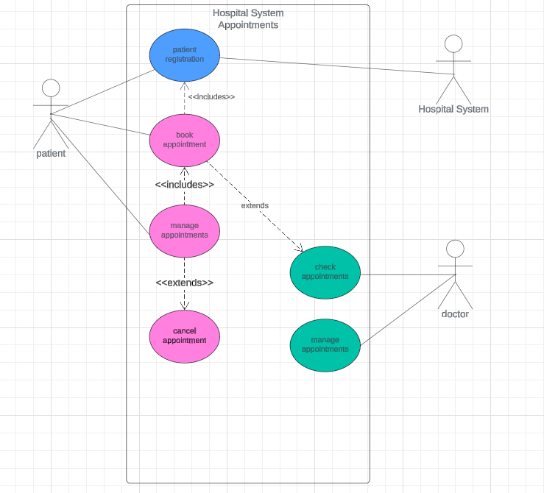

**Data flow Diagram:**

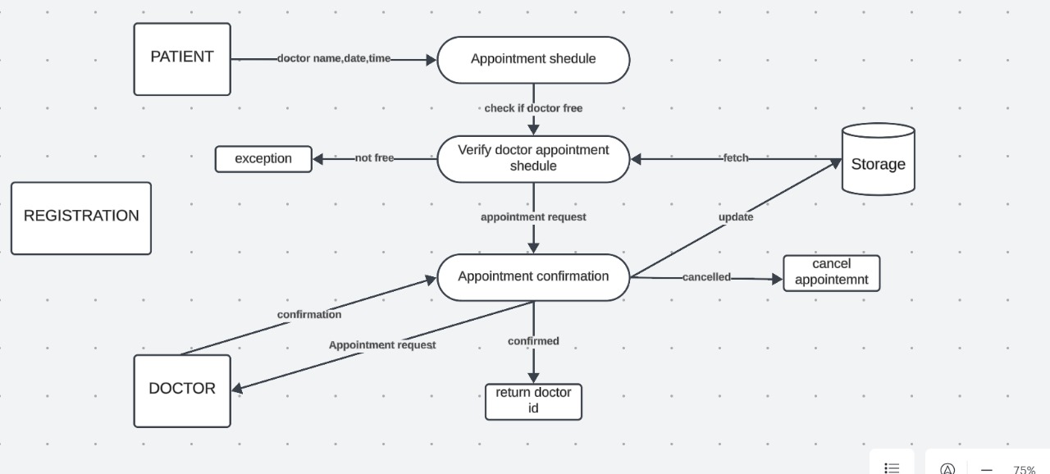

**Sequence Diagram:**

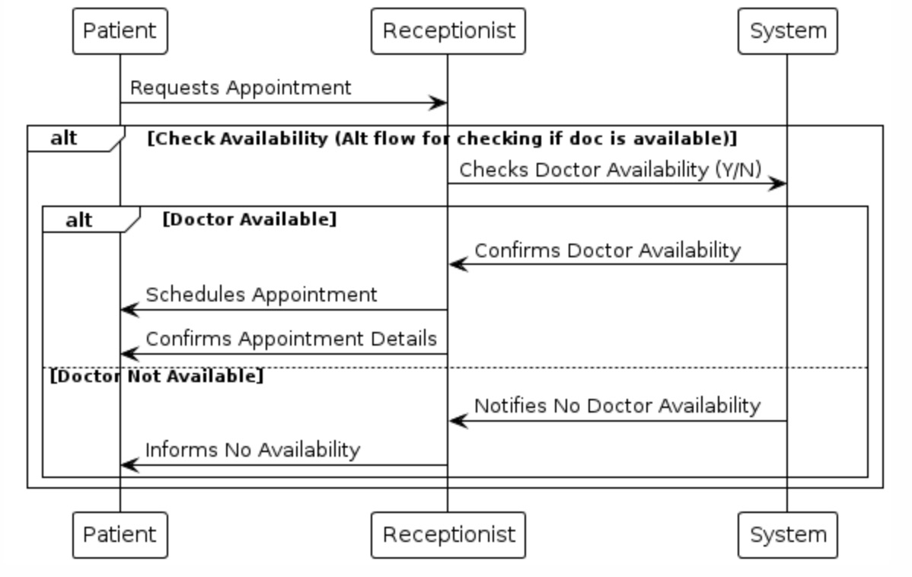

**Benefits:**

* Improves appointment scheduling efficiency for the receptionist and patients.
* Reduces waiting times and patient frustration.
* Ensures doctors are aware of their appointments and can manage their time effectively.
* Provides a record of patient appointments for future reference.

**Conclusion:**

The "Patient Appointments" use case is a crucial component of the Hospital Management System. It streamlines the appointment scheduling process, improving overall patient experience and staff productivity.

**USE CASE 2: Manage Patients**

This use case diagram illustrates the interaction between hospital staff and patient-related functionalities within the hospital management system.

**Description:**

This use case involves hospital staff managing patient-related activities within the hospital management system. It includes functionalities such as registering new patients, accessing patient details, hospitalizing patients, managing patient records, and handling patient discharge or other medical events.

**Actors:**

* Hospital Staff (Doctors, Nurses)

**Flows:**

* Register a New Patient
* Get Patient Details
* Hospitalize a Registered Patient
* Report a Patient's Death
* Discharge a Patient or Their Body
* Fetch Patient Details from History
* Get Details of All Registered Patients

**Alternative Flows:**

* Patient information inaccessible due to system issues

**Use Case Diagram:**

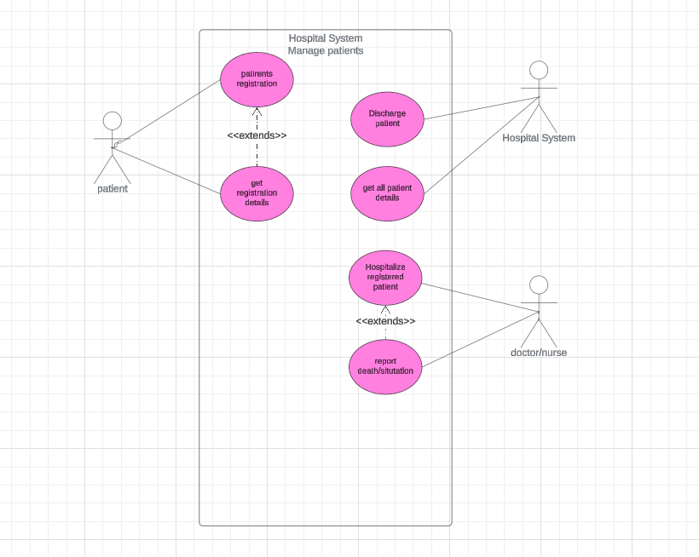

**Sequence Diagram:**

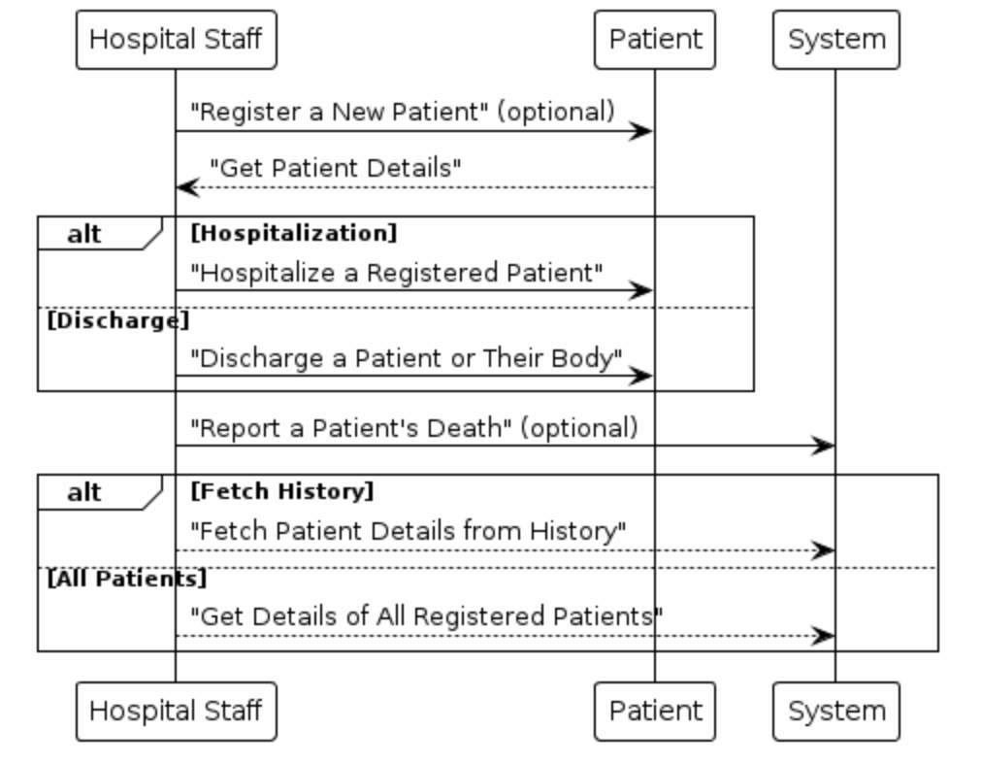

**Benefits:**

* **Efficient Management:** Streamlines patient registration, record access, and communication for healthcare providers.
* **Improved Care:** Informed decisions lead to better treatment plans and patient outcomes.
* **Enhanced Communication:** Facilitates seamless sharing of patient information among staff.
* **Compliance and Security:** Ensures adherence to healthcare regulations and protects patient data.

**Conclusion:**

Manage Patient, plays a crucial role in enhancing patient care within the hospital management system. By streamlining processes and promoting effective communication among staff members, it ensures that healthcare providers have access to comprehensive patient information. This enables them to make informed decisions, improving patient outcomes and overall operational efficiency.

**Use Case 3: Manage Personnel and Resources**

This use case diagram illustrates the interaction between hospital administrators and the management of personnel and resources within the hospital management system.

**Description:**

Hospital administrators and managers utilize the system to manage personnel information, allocate resources, and monitor overall hospital operations, including:

* **Personnel Management:**
  + Registering new doctors, nurses, and drivers.
  + Retrieving details of existing staff members.
  + Removing staff members from the system (e.g., resignation).
  + Fetching staff details from history (e.g., past employment records).
  + Obtaining an overview of all registered staff members (doctors, nurses, drivers).
* **Ambulance Management:**
  + Adding new ambulances to the system.
  + Dispatching ambulances to patients in need.
  + Retrieving details of specific ambulances.
  + Reporting ambulance arrivals at the hospital.
  + Removing ambulances from service (e.g., decommissioning).
  + Fetching ambulance details from history (e.t., maintenance records).
  + Obtaining an overview of all registered ambulances.

**Actors:**

* Hospital Administrator: The staff member responsible for managing hospital personnel and resources.

**Flows:**

**Personnel Management**

* + The administrator accesses the staff management module.
  + The administrator selects the desired action (register new, get details, remove, fetch history, view all).
  + **Register New Staff:** The administrator enters the staff member's details (name, qualifications, contact information, etc.). The system validates and stores the information.
  + **Get Details, Remove, Fetch History:** The administrator searches for a specific staff member using ID or name. The system retrieves and displays the requested details, or facilitates removal with confirmation steps, or retrieves historical data based on selection.
  + **View All Staff:** The system displays a list of all registered staff members categorized by role (doctor, nurse, driver).

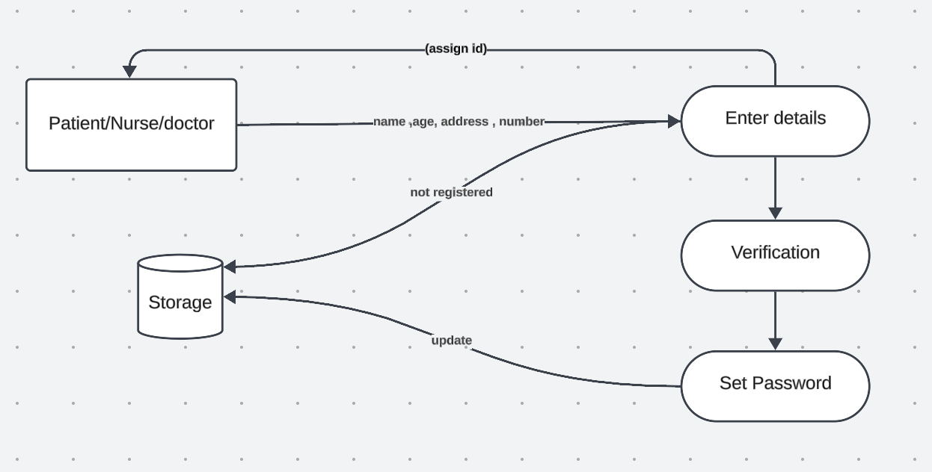

**Ambulance Management**

* + The administrator accesses the ambulance management module.
  + The administrator selects the desired action (add ambulance, dispatch, get details, report arrival, remove ambulance, fetch history, view all).
  + **Add Ambulance:** The administrator enters the ambulance details (registration number, model, etc.). The system validates and stores the information.
  + **Dispatch Ambulance:** The administrator selects an ambulance for dispatch based on availability and urgency. The system might display a map interface to track the ambulance's location.
  + **Get Details, Report Arrival, Remove Ambulance, Fetch History:** Similar to staff management, the administrator performs actions based on selected options.
  + **View All Ambulances:** The system displays a list of all registered ambulances with their current status (available, on duty, etc.).
* .

**Use Case Diagram:**

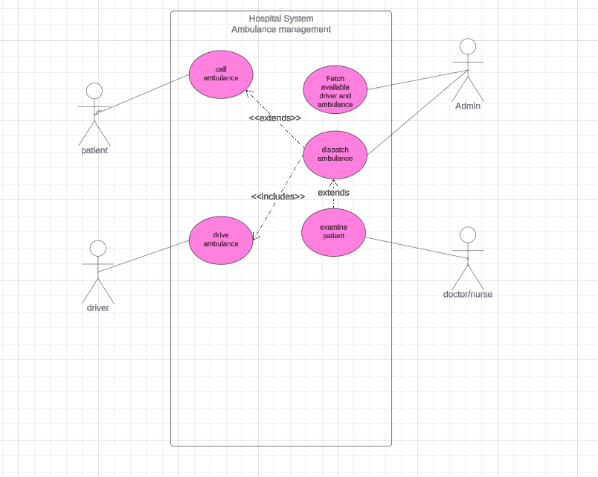

**Data flow diagram:**

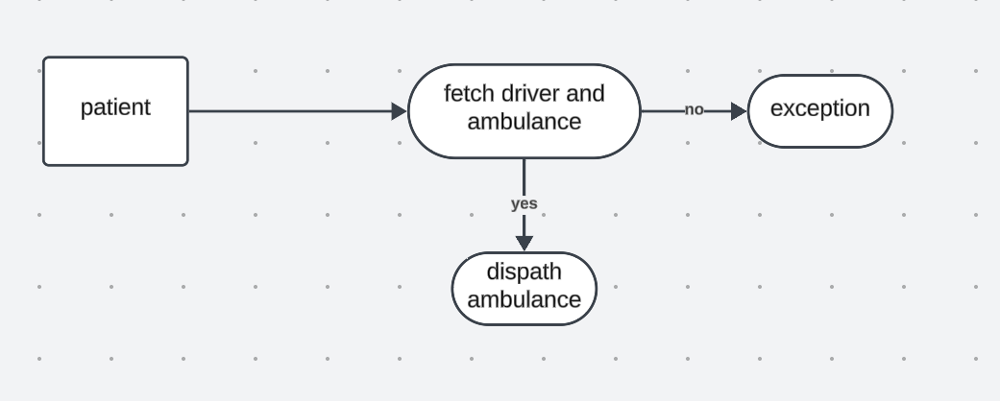

**Sequence Diagram:**

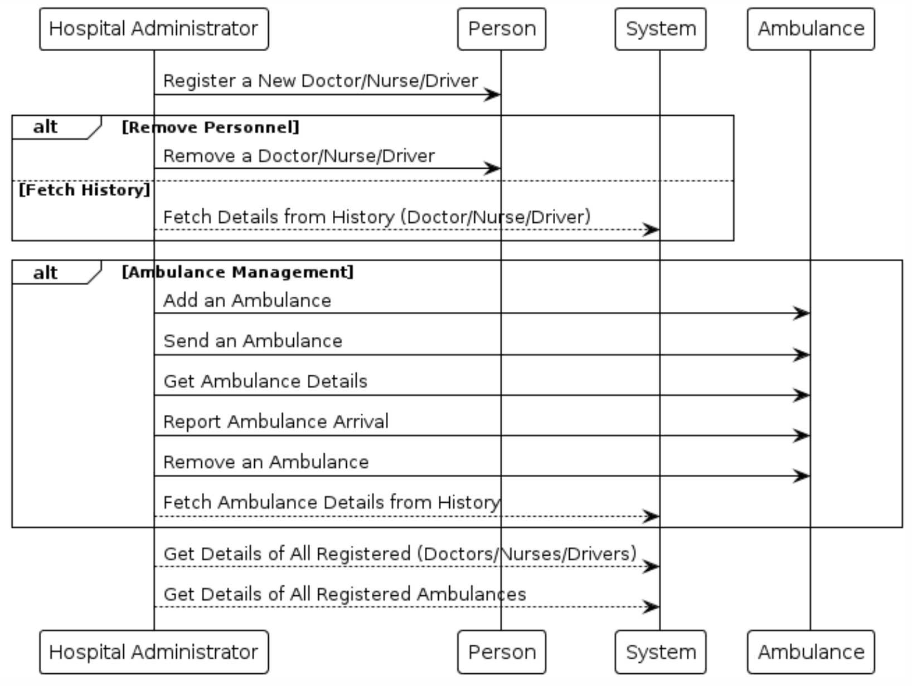

**Benefits:**

* Efficiently manages staff onboarding, information access, and departures.
* Optimizes ambulance dispatch based on real-time needs.
* Maintains a centralized record of staff and ambulance details.
* Tracks ambulance history for maintenance purposes.

**Conclusion**

* The "Manage Personnel and Resources" use case is essential for smooth hospital operations. It empowers the administrator to effectively manage staff and ensure optimal utilization of ambulances, contributing to better patient care and resource allocation.

**UML**

