Software Requirements Specification

for

AllureArcade

**Version 1.0 approved**

**Muhammad Bilal Nasir-21L-1809**

**Muhammad Ahmed Akram-21L-1833**

**Muhammad Bilal Mir-21L-5257**

**Ahmed Aziz-21L-1873**

**Muhammad Abdullah Farooq-21L-1771**

**FAST NUCES, Lahore March 13,2024**

**Table of Contents**

**Table of Contents ii**

**Revision History ii**

**1. Introduction 1**

1.1 Purpose 1

1.2 Document Conventions 1

1.3 Intended Audience and Reading Suggestions 1

1.4 Product Scope 1

1.5 References 1

**2. Overall Description 2**

2.1 Product Perspective 2

2.2 Product Functions 2

2.3 User Classes and Characteristics 2

2.4 Operating Environment 2

2.5 Design and Implementation Constraints 2

2.6 User Documentation 2

2.7 Assumptions and Dependencies 3

**3. External Interface Requirements 3**

3.1 User Interfaces 3

3.2 Hardware Interfaces 3

3.3 Software Interfaces 3

3.4 Communications Interfaces 3

**4. System Features 4**

4.1 Selection of Products electronic Appliances 4

4.2 Selection of Products Clothes and Beauty items 4

**5. Other Nonfunctional Requirements 4**

5.1 Performance Requirements 4

5.2 Safety Requirements 5

5.3 Security Requirements 5

5.4 Software Quality Attributes 5

5.5 Business Rules 5

**6. Other Requirements 5**

**Appendix A: Glossary 5**

**Appendix B: Analysis Models 5**

**Appendix C: To Be Determined List 6**

**Revision History**

|  |  |  |  |
| --- | --- | --- | --- |
| **Name** | **Date** | **Reason For Changes** | **Version** |
| NA | NA | NA | NA |
| NA | NA | NA | NA |

# Introduction

## Purpose

The purpose of the **AllureArcade** project is to create a competitive e-commerce platform that meets the diverse needs of modern consumers, provides a superior shopping experience, and establishes itself as a trusted destination for online shopping.

## Document Conventions

This document follows the IEEE standard for writing a software requirements specification document. As per Academic standards, this document follows the “**Times New Roman**” font and “**12**” size for text and “**14**” size for headings.

## Intended Audience and Reading Suggestions

This document is designed to resolve all the functional and supporting requirements of the application into a defined form. Hence, all the personnel who are directly or indirectly involved in analyzing and developing the functionalities and using the application will be the intended audience. This audience includes our project supervisor who will direct us, analysts who will analyze all the requirements, designers who will use the requirements to prepare models, testers who will stress test the application based on requirements, and finally the Salesmen who will use the application. For all the readers, it is strongly recommended to read the document in the following sequence:

1. Introduction

2.Overall Description

4. System Features

5.Other Non-functional requirements (optional for Users)

6.Other Requirements (optional for Users)

3. External Interface Requirements (optional for Users)

## Product Scope

The product scope of AllureArcade encompasses the development of a user-friendly e-commerce platform aimed at addressing the diverse needs of modern consumers. Through intuitive navigation and a visually appealing interface, customers will have easy access to a wide range of products spanning electronics, books, clothing, beauty items, and more. Secure payment gateways will ensure smooth transactions, while a robust inventory management system will maintain product availability and facilitate timely delivery. Features such as product reviews, ratings, and personalized recommendations will enhance the shopping experience, fostering informed decision-making. Responsive customer support will be provided to promptly address inquiries and concerns, ensuring customer satisfaction. Additionally, the platform may offer exclusive deals, discounts, and loyalty programs to incentivize repeat business and foster customer loyalty.

## References

[Requirements](https://docs.google.com/document/d/1IvqSXReb-ubnWrKh9AekAydWFdWhMvsgupEeyn08Tpg/edit?usp=sharing)

[Muhammad Hashim Bilal Qureshi Project Proposal-20L-1219.docx](https://docs.google.com/document/d/1-OGLr6ochR2FoABmjcB3RznoQs1t-bVu/edit?usp=sharing&ouid=112099395939821702027&rtpof=true&sd=true)

# Overall Description

## Product Perspective

AllureArcade aims to fulfill the evolving needs of consumers in the digital marketplace by providing a comprehensive and seamless shopping experience. The platform focuses on offering a diverse range of products across multiple categories, ensuring convenience and variety for customers seeking electronics, books, clothing, beauty products, and more. By integrating secure payment gateways and implementing robust inventory management systems, AllureArcade prioritizes reliability and trust, fostering confidence in transactions and timely product delivery. Features such as product reviews, ratings, and personalized recommendations enhance user engagement and facilitate informed purchasing decisions. Responsive customer support further ensures a positive interaction with the platform, addressing inquiries and feedback promptly. Through exclusive deals, discounts, and loyalty programs, AllureArcade aims to cultivate customer loyalty and retention, solidifying its position as a trusted and preferred destination for online shopping.

## Product Functions

• Browse through diverse products across multiple categories.

• Utilize search and filtering options for quick product discovery based on preferences.

• Access detailed descriptions, specifications, images, and customer reviews.

• Complete transactions securely through integrated payment gateways.

• Track product availability, manage stock levels, and ensure timely delivery.

• Create accounts to save preferences, view order history, and manage personal information.

• Leave reviews and ratings for purchased products, aiding others in decision-making.

• Receive tailored product suggestions based on browsing and purchase history.

## User Classes and Characteristics

User Classes that might use this product are:

* **Administrators:**

Characteristics:

* + Platform administrators responsible for managing and maintaining the AllureArcade website.
  + Oversee website operations, including product listings, user accounts, and security measures.
  + Ensure compliance with regulations, policies, and best practices.
  + Monitor website performance, resolve issues, and implement improvements.
* **Shoppers:**

Characteristics:

* + Individuals who visit AllureArcade to browse and purchase products across various categories.
  + Seek convenience, variety, and quality in their shopping experience.
  + Value user-friendly interfaces, secure transactions, and reliable delivery services.
  + May be interested in personalized recommendations and exclusive deals.

* **Sellers:**

Characteristics:

* + Businesses or individuals who list and sell products on AllureArcade's platform.
  + Provide product information, images, and details for display to shoppers.
  + Value access to a large customer base and reliable payment processing services.
  + May require tools and resources for managing inventory, orders, and customer inquiry
* **Testers:**

Use software rarely to test only. They will use all of the functions provided by our software one by one to test. Technical expertise will be high for them. Security will be high. The education level or experience expected will be High.

## Operating Environment

Software will operate in a normal work or home environment. The hardware platform includes a keyboard, laptop, mouse & desktops. Any operating system version will work well with the software. This software should peacefully coexist with any other software applications or software components*.*  The system must coexist peacefully with other software components or applications used in the organization and comply with relevant security protocols and regulations.

## Design and Implementation Constraints

This software limits concurrent users to 250. The software does not provide downloading of information. All available information will be online & records will also only be saved online. The system must be user-friendly. The software must ensure the security considerations, and integrity of the user's information, and no user information will be shared with any third party without the consent of the user first.

Visual Studio Code & Microsoft SQL server will be used to deal with user information and provide the interface. The language used should be JavaScript and SQL. Moreover, Communication Protocols like TCP, HTTP, IP, and HTTPS will be used.

Lastly, the Customer's organization will be responsible for maintaining the delivered software. If any additional maintenance guidance is required from our team, it will be subject to additional charges that include $900 per session.

## User Documentation

The user documentation will be delivered in electronic format, accessible through the system's user interface, and also available for download in PDF or HTML format. The documentation will comply with industry standards and best practices for technical writing, including clear and concise language, consistent formatting, and proper use of visual aids. Following is the list of user documentation components:

* User manual: detailed instructions for users.
* Online help: context-sensitive assistance.
* Tutorials: instructional guides for specific tasks.
* Release notes: information about new features and changes.
* Knowledge base: additional system information.
* Electronic format: accessible via a user interface and downloadable.
* Compliance with industry standards: clear and concise language, consistent formatting, and proper use of visual aids.

## Assumptions and Dependencies

**Assumptions:**

* Market Demand: It is assumed that there is a significant demand for an e-commerce platform like AllureArcade catering to the diverse needs of modern consumers.
* User Adoption: The success of the platform relies on the assumption that users will adopt and engage with it positively, seeking convenience, variety, and quality in their shopping experience.
* Technical Compatibility: The software is assumed to be compatible with various operating systems and hardware configurations commonly used by the target audience.
* Security Measures: It is assumed that the implemented security measures, such as secure payment gateways and data encryption, will effectively protect user information and transactions from unauthorized access and breaches.

**Dependencies:**

1. The system needs stable hardware and network infrastructure to work properly.
2. The system depends on the availability and compatibility of third-party software components and libraries.
3. The project needs external data or resources delivered on time for development and testing.
4. The project team depends on qualified developers and other resources.

# External Interface Requirements

## User Interfaces

Our software product will have an easy-to-use interface that helps users to easily use this software. The simplicity of the designs will help the users to access the options provided by our software and get things done easily.

This software product will provide an interface for login. The login page will have a box that will be displayed on it having two dialogue boxes; one for Username and the other for Password. This login page is for all the users using this website. Thus, if the administrator enters his username and password, he will be able to see all his concerned pages and the same will go for other users. There will be a window for forgotten passwords below the password space, on clicking this user will go to a new page and he can now set a new password and log in as he has forgotten his password. A sign-up option will also be provided for new users where they can make an account if they are new users of this website. There will also be a logout option at the top bottom of the main page for the users to log out from this software product. Some of the template pictures of the login page are given below of our system.

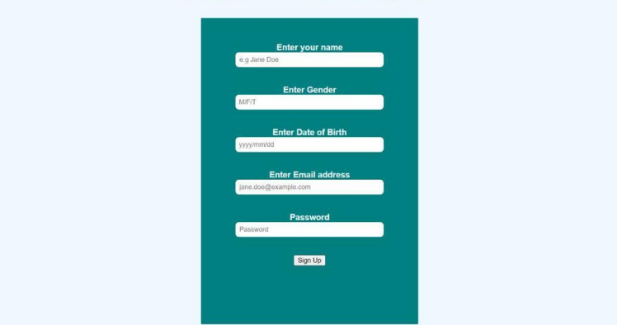

Figure 3.1.1 Sign-up page

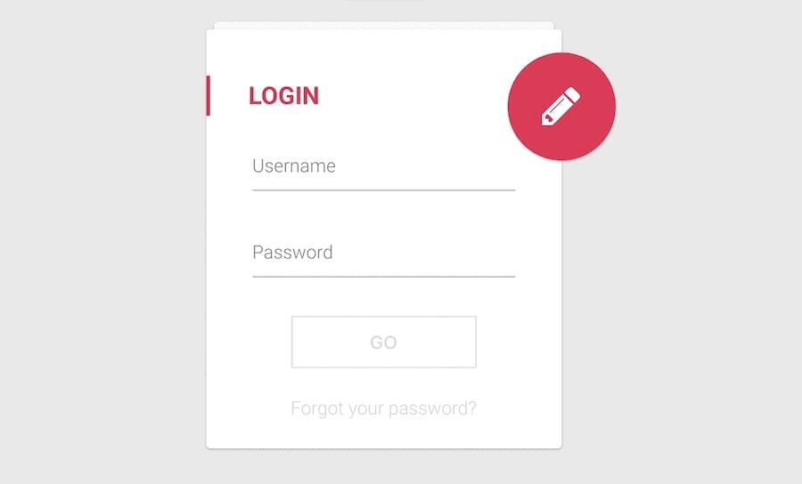

Figure 3.1.2 Login Page

Our shopping website will also have the following pages:

* Home Page: Displays featured products and promotions.
* Product Listing Page: Displays a list of products based on user search or category selection.
* Product Details Page: Displays detailed information about a selected product.
* Shopping Cart Page: Displays the contents of the user's shopping cart and allows for editing.
* Checkout Page: Guides users through the checkout process and collects payment information.
* User Account Page: Allows users to manage their account settings and view order history.

## Hardware Interfaces

The hardware required for the software product shall include the following:

● Personal Computer

● Internet

● Hardware Peripherals

The supported devices for the system shall include Windows 32-bit or Windows 64-bit. Since the application must run over the internet, the hardware required to connect to the internet shall also be included. For example, WAN-LAN cable, ethernet cross cable, Modems, etc. The user would require a stable internet connection to access the application through their personal computer. This product will be a website that will be accessed by mobile devices as well.

## Software Interfaces

In our website we will be using different softwares like mongoDB for storing data into the database. React.js for front-end development, Node.js for server-side scripting, and Express.js for handling HTTP requests. In order to handle payment methods payment gateways like JazzCash or easypaisa will be used. In our website incoming data will be user requests, such as browsing product pages, adding items to the shopping cart, and initiating the checkout process while outgoing data will be responses to user actions, including displaying product information, updating the shopping cart, and confirming orders. We will need HTTP services for handling client-server communication, database services for create, read, update, delete operations, and secure payment processing services. Client-server communication will occur over the HTTP/HTTPS protocol. Database communication will involve SQL queries for data retrieval and manipulation. Payment processing communication will utilize secure API calls to payment gateways. The website may refer to API documentation provided by external services, such as payment gateways, for integrating their services into the website. Our website will contain shared data in the form of product information, user authentication tokens, shopping cart contents, and order. The website may require the use of session management techniques to maintain user authentication state across multiple HTTP requests.

## Communications Interfaces

The system shall use the HTTP protocol for communication over the internet. Moreover, the system uses HTML forms to get data from users. Moreover, communication interface requirements are as follows:

● CSS

● HTML

● Javascript

This system supports all types of web browsers. The user interface for the software shall be compatible with any search browser where the user can access SMS.

# System Features

## System Feature 1

The first feature that our website will provide will be user registration and authentication:

4.1.1 Description and Priority

* Description: Enables users to create accounts and log in securely.
* Priority: High (Benefit: 9, Penalty: 2, Cost: 5, Risk: 7)

4.1.2 Stimulus/Response Sequences

* Stimulus: User navigates to the registration or login page.
* Response: System displays the registration or login form.

4.1.3 Functional Requirements

* REQ-1: Provide registration form with fields for username, email, password, etc.
* REQ-2: Validate user inputs and display appropriate error messages.
* REQ-3: Hash and securely store user passwords in the database.
* REQ-4: Implement password recovery mechanism (e.g., reset password via email).

## System Feature 2

The second feature that our website will provide will be product browsing.

4.2.1 Description and Priority

* Description: Allows users to browse products by categories and subcategories.
* Priority: High (Benefit: 8, Penalty: 1, Cost: 6, Risk: 6)

4.2.2 Stimulus/Response Sequences

* Stimulus: User selects a product category or subcategory.
* Response: System displays products within the selected category/subcategory.

4.2.3 Functional Requirements

* REQ-1: Display list of product categories/subcategories.
* REQ-2: Implement filters (price, brand, size, etc.) and sorting options.
* REQ-3: Show product thumbnails, titles, and prices.

## System Feature 3

The third feature that our website will provide will be product pages.

4.3.1 Description and Priority

* Description: Provides detailed information about individual products.
* Priority: High (Benefit: 9, Penalty: 2, Cost: 5, Risk: 7)

4.3.2 Stimulus/Response Sequences

* Stimulus: User clicks on a product thumbnail or title.
* Response: System displays the product page with description, images, reviews, etc.

4.3.3 Functional Requirements

* REQ-1: Display product description, specifications, and multiple images.
* REQ-2: Show product availability and stock quantity.
* REQ-3: Allow users to add products to the shopping cart.

### 4.4 System Feature 4

### The seventh system feature that our website will provide will be shopping cart..

4.4.1 Description and Priority:

* Description: Allows users to add/remove items and proceed to checkout.
* Priority: High (Benefit: 8, Penalty: 2, Cost: 6, Risk: 6)

4.4.2 Stimulus/Response Sequences:

* Stimulus: User adds/removes items from the cart.
* Response: System updates the cart summary and total amount.

4.4.3 Functional Requirements:

* REQ-1: Display items in the shopping cart with quantity and price.
* REQ-2: Allow users to modify item quantities or remove items.
* REQ-3: Calculate and display subtotal, taxes, shipping costs, and total amount.

### 4.5 System Feature 5

### The seventh system feature that our website will provide will be the checkout process..

4.5.1 Description and Priority:

* Description: Guides users through the payment and order confirmation process.
* Priority: High (Benefit: 9, Penalty: 3, Cost: 7, Risk: 8)

4.5.2 Stimulus/Response Sequences:

* Stimulus: User clicks on the "Checkout" button in the shopping cart.
* Response: System prompts the user to enter billing/shipping information and select payment method.

4.5.3 Functional Requirements:

* REQ-1: Provide checkout form with fields for billing and shipping address.
* REQ-2: Support multiple payment options (credit/debit cards, JazzCash, etc.).
* REQ-3: Validate user inputs and display error messages for invalid entries.

### 4.6 System Feature 6

### The seventh system feature that our website will provide will be order management.

4.6.1 Description and Priority:

* Description: Allows users to view order history, track orders, and manage account details.
* Priority: Medium (Benefit: 7, Penalty: 2, Cost: 5, Risk: 5)

4.6.2 Stimulus/Response Sequences:

* Stimulus: User navigates to the "My Orders" section in their account.
* Response: System displays a list of previous orders with order details and status.

4.6.3 Functional Requirements:

* REQ-1: Provide order history with details such as order number, date, items, and status.
* REQ-2: Allow users to track order status and view estimated delivery dates.
* REQ-3: Implement order cancellation or modification functionality (if applicable)

### 4.7 System Feature 7

### The seventh system feature that our website will provide will be search functionality.

4.1.1 Description and Priority:

* Description: Enables users to search for products using keywords or filters.
* Priority: High (Benefit: 8, Penalty: 2, Cost: 6, Risk: 7)

4.1.2 Stimulus/Response Sequences:

* Stimulus: User enters a search query or selects filters.
* Response: System displays relevant search results based on the query/filters.

4.1.3 Functional Requirements:

* REQ-1: Implement a search bar with autocomplete suggestions.
* REQ-2: Support filtering by category, price range, brand, etc.
* REQ-3: Display search results with relevant product thumbnails, titles, and prices.

### 4.8 System Feature 8

### The eight system feature that our website will provide will be customer support.

4.8.1 Description and Priority:

* Description: Provides assistance and support to users through various channels.
* Priority: Medium (Benefit: 6, Penalty: 1, Cost: 4, Risk: 4)

4.8.2 Stimulus/Response Sequences:

* Stimulus: User clicks on the "Support" or "Help" section.
* Response: System provides access to FAQs, live chat, or support ticket submission.

4.8.3 Functional Requirements:

* REQ-1: Offer live chat support with customer service representatives.
* REQ-2: Provide a searchable FAQ section addressing common user queries.
* REQ-3: Allow users to submit support tickets with detailed descriptions of issues.

# Other Nonfunctional Requirements

## Performance Requirements

## Response time / Real-time Performance:

## The system shall have a quick response. The system shall respond to requests with some of the requests. It should not lag and take a lot of time when doing tasks like signing in, listing/displaying products, payment transactions, etc.

**Scalability:**

The system shall be able to work and operate when there are increased workloads and traffic on the system is greatly increased. In these scenarios, it should be able to perform its functions correctly and effectively.

**Availability:**

The system should be highly available and its downtime should be very low so that it can efficiently handle enormous data without crashing.

**Maintainability:**

The system should be easy to maintainand update with proper documentation and version control.

## Safety Requirements

The system may fail during payment processing. The system may fail in protecting the privacy of the data of its users. It may fail while placing an order. The system must have some mechanism for error checking in order to prevent faulty data input and it must ensure correct allocation processes. Moreover, the system shall have error recovery mechanisms in case of data loss.

## Security Requirements

The system must have some ways to validate any user who is logging into the system. The ReCAPTCHA code is entered in order to verify the user. Furthermore, the password is confirmed every time the system user accesses the system. The interpersonal details of the user are also stored as a backup. The system must obtain security certifications or accreditations in order to demonstrate its commitment to security and data protection.

## Software Quality Attributes

Some of the features the system must have in order to ensure its quality are as follows:

**Correctness:**

The system must correctly help users to place the order of their desired product.

**Usability:**

The system should be easy to use and it should be easy to train the users to it. It should have provided interfaces for the users to easily navigate the available features of the system.

**Robustness:**

The system must be error tolerant and must be able to operate during any unseen situation. Moreover, it should be able to recover from those errors instead of becoming completely nonfunctional.

**Reliability:**

The system should perform correctly during a specific time duration. During this correct operation: The system should adequately follow the defined performance specifications.

## Business Rules

Sellers will be allowed to add products, define features of their product, specify price to their product, announce different offers.

Buyers will be allowed to add their product to the cart, search for their desired product, and perform transactions.

# Other Requirements

Some other requirements include

**Legal Requirements:**

The software cannot be copied (developed on the same design) or stolen by any outside individual or another university without any legal permission.

**Business Requirements:**

The software is being developed to ensure that customers get all of their desired products at a single platform. Therefore, the system shall meet all the functional requirements up to the standards so that efficiency and improvement objectives of the system can be achieved and help cope with the business needs.

**User Requirements:**

The system shall meet all the functional requirements that involve users that are customers and sellers to maximize the advantage targeted.

**Appendix A: Glossary**

CSS Cascading Style Sheets

HTML Hypertext Markup Language

HTTP Hypertext Transfer Protocol

**Appendix B: Analysis Models**

Our system requirements specification document consists of the following models to represent the requirements:

**DATA FLOW DIAGRAME:**

**LEVEL 0 DFD:**

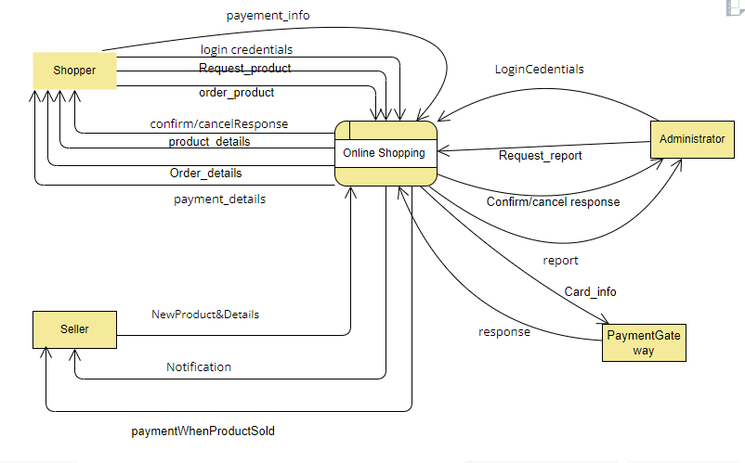

**LEVEL 1 DFD:**

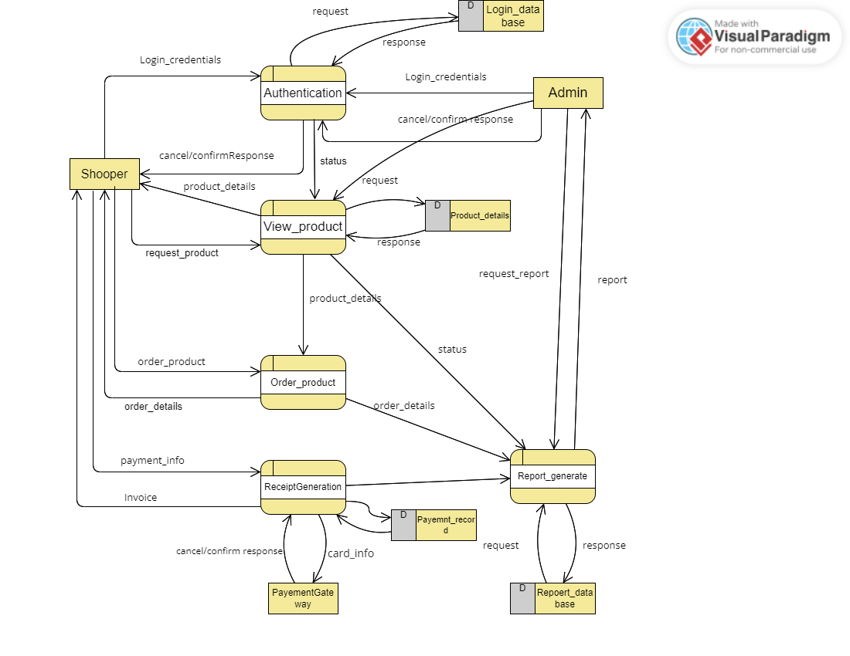

**Analysis Class Diagrame:**

