

# Project Proposal (P1)

# رکھوالا “Rakhwala” (Child Security System )

Group Members

Muhammad Umar (Reg # 36682)

Muhammad Bilal Qamar (Reg # 35985)

Adeel Arshad (Reg #)

Submitted To

Instructor: Sir Muhammad Faizan

**USE CASE DIAGRAM OF CHILD SECURITY SYSTEM**

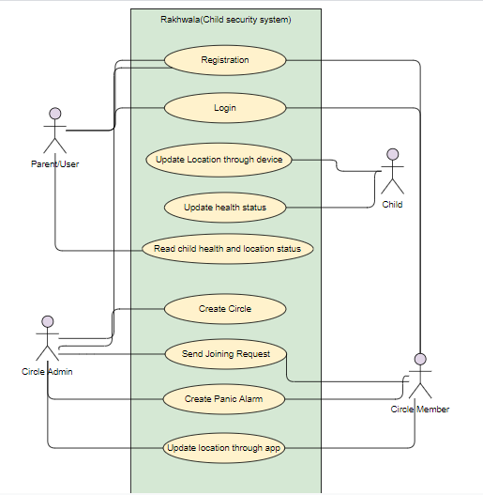

|  |  |  |
| --- | --- | --- |
| **Use Case Name:** | **User Login** | |
| **Use Case ID:** | Rakhwala.UC.1.1.1 | |
| **Actors Involved:** | User/Admin/Parrents | |
| **Priority:** | High | |
| **Brief Description:** | User admin or parents will login to the system to activate further events. Or access app features | |
| **Pre Condition:** | User must be logged out | |
| **Post Condition:** | User would be logged in the system and will access features | |
| **Flow Of Events:** | **Actor Actions** | **System Response** |
| Provide email and password | System should validate email and password |
| Click on login button | Dashboard will appear |
|  |  |
|  |  |

|  |  |  |
| --- | --- | --- |
| **Use Case Name:** | **User** Registration | |
| **Use Case ID:** | Rakhwala.UC.1.1.2 | |
| **Actors Involved:** | User | |
| **Priority:** | High | |
| **Brief Description:** | User will register to the app by providing neccessory information like name, email, password | |
| **Pre Condition:** | Must not be register to the app before.And should be a new user | |
| **Post Condition:** | Will be register to the app and allowed to take benefit from system | |
| **Flow Of Events:** | **Actor Actions** | **System Response** |
| Provide email, name password,child name, image, and click on register button. | System should validate all the data and do register successfully |

|  |  |  |
| --- | --- | --- |
| **Use Case Name:** | **Update Location** | |
| **Use Case ID:** | Rakhwala.UC.1.1.3 | |
| **Actors Involved:** | Child, or user | |
| **Priority:** | High | |
| **Brief Description:** | Whenever child move, his real time location(coordinates:{latitude & longitude}) will update in database through IOT device(Watch). | |
| **Pre Condition:** | Child or user must have IOT device on hand. | |
| **Post Condition:** | Update coordinates after particular interval of time | |
| **Flow Of Events:** | **Actor Actions** | **System Response** |
| Provide latitude, name longitude,child name, image, through device | Get latitude and longitude through device and update it on live server |

|  |  |  |
| --- | --- | --- |
| **Use Case Name:** | **Read Child Location** | |
| **Use Case ID:** | Rakhwala.UC.1.1.4 | |
| **Actors Involved:** | Parrents(or may be a family member) | |
| **Priority:** | High | |
| **Brief Description:** | Fetch location of the child from the database and display it on map in application. | |
| **Pre Condition:** | Device must be active and update location continuously after particular period of time | |
| **Post Condition:** | Check status about the child location. | |
| **Flow Of Events:** | **Actor Actions** | **System Response** |
| Do request for location | After some interval of time application would display the child real time location |

|  |  |  |
| --- | --- | --- |
| **Use Case Name:** | **Update Health Status** | |
| **Use Case ID:** | Rakhwala.UC.1.1.5 | |
| **Actors Involved:** | Child | |
| **Priority**: | High | |
| **Brief Description:** | Pulse rate sensor and Temperature sensor will get the health status of the child and send it to the server through IOT device. | |
| **Pre Condition:** | Child or user must have IOT device and sensors must works properly. | |
| **Post Condition:** | Update status in database after particular interval of time. | |
| **Flow Of Events:** | **Actor Actions** | **System Response** |
| Provide temperature and pulse rate through sensors | Send it to database |

|  |  |  |
| --- | --- | --- |
| **Use Case Name:** | **Read Health Status** | |
| **Use Case ID:** | Rakhwala.UC.1.1.6 | |
| **Actors Involved:** | Parrents or a family member | |
| **Priority**: | High | |
| **Brief Description:** | Fetch temperature and pulse rate of the child from the database and display it in application. | |
| **Pre Condition:** | Device and sensors must be active and update status continuously after particular period of time. | |
| **Post Condition:** | Check status about the child health.. | |
| **Flow Of Events:** | **Actor Actions** | **System Response** |
| Request for health status | After some interval of time application would display the child updated status in the form of pulse rate and temperature |

**SOME ADDITIONAL FEATURES USE CASE**

|  |  |  |
| --- | --- | --- |
| **Use Case Name:** | **Create Family Circle** | |
| **Use Case ID:** | Rakhwala.F2.1.1 | |
| **Actors Involved:** | Admin, User | |
| **Priority**: | Medium | |
| **Brief Description:** | Admin/User will create family circle (group) by providing circle name and image and send joining request to other family members. | |
| **Pre Condition:** | Admin/User must be login into the application. | |
| **Post Condition:** | Admin must provide circle name and image in order to create new one. | |
| **Flow Of Events:** | **Actor Actions** | **System Response** |
| Provide circle name, image and click on create button | Circle will have been successfully created |

|  |  |  |
| --- | --- | --- |
| **Use Case Name:** | **Create Panic Alarm** | |
| **Use Case ID:** | Rakhwala.F2.1.2 | |
| **Actors Involved:** | Admin or circle member | |
| **Priority**: | Low | |
| **Brief Description:** | If the circle member is in panic condition then there is an button called panic alarm. By pressing it ,push notification will send to every group member that member is in panic.. | |
| **Pre Condition:** | Send panic notification to other group members | |
| **Post Condition:** | Admin must provide circle name and image in order to create new one. | |
| **Flow Of Events:** | **Actor Actions** | **System Response** |
| Press Alarm button | all-members get notification, also member location will be marked in the form of red circle and display it on map |

|  |  |  |
| --- | --- | --- |
| **Use Case Name:** | **Read Circle Members Location** | |
| **Use Case ID:** | Rakhwala.F2.1.3 | |
| **Actors Involved:** | Circle member(user) | |
| **Priority**: | High | |
| **Brief Description:** | Fetch real time location and image of the members from the database and display it on map in application | |
| **Pre Condition:** | User must be member of that particular circle and gps and internet of mobile should be on | |
| **Post Condition:** | Update real time location of every member in database whenever they can move . | |
| **Flow Of Events:** | **Actor Actions** | **System Response** |
| * Open particular circle * check where members are present through maps | * Display members on map * Members location will display in the form of marker with picture |

**ENTITY RELATION DIAGRAM OF CHILD SECURITY SYSTEM**

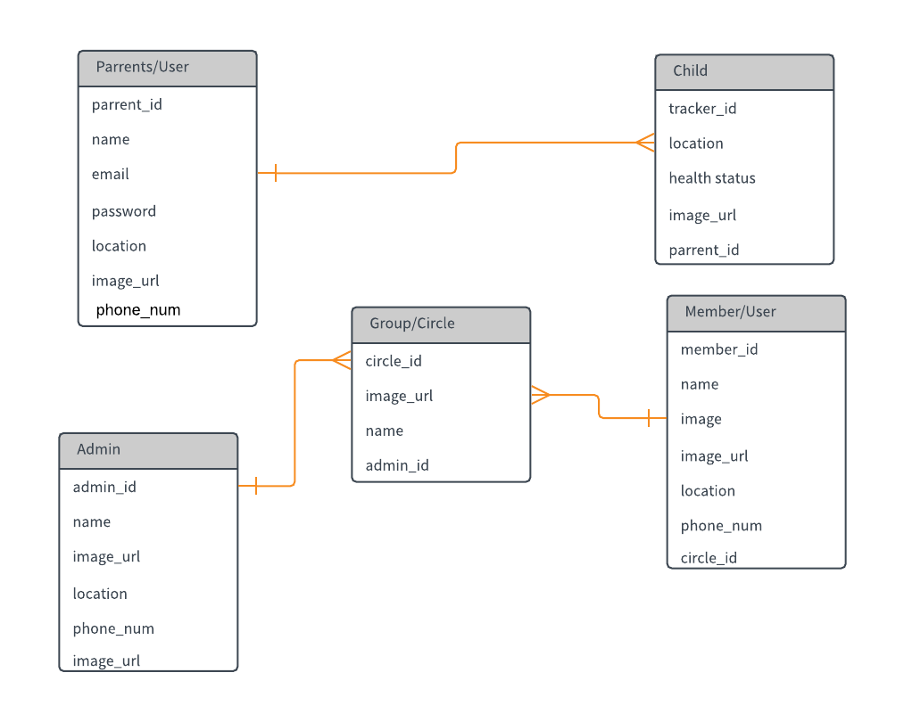

**FUNCTIONAL REQUIREMENTS OF CHILD SECURITY SYSTEM**

* User should be able to register in the system.
* User should be login to the system.
* System should send real time location of the child to the server.
* System should send temperature send pulse rate of the child to the server.
* Application should show real time location and health status in the form of pulse rate and temperature by clicking an status button.
* User should be able to create family circle group and add any family member by sending a joining request.
* Every group should show joined members real time location with their image on google map.
* Location should be auto updated in database when user move from one location to another.
* If any of the group member in panic condition,there is an alarm button which will send the push notification to all of the group member that the member (ABC-) in panic.

**NON-FUNCTIONAL REQUIREMENTS OF CHILD SECURITY SYSTEM**

* Users shall receive notification of profile changes via preferred communication method of record when profile information is modified.
* Passwords shall never be viewable at the point of entry or at any other time.
* The system for child security purpose should be accessible for only the peoples who has IOT device.
* Unless the system is non‐operational, the system shall present a user with notification informing them that the system is unavailable.
* At least 20 percent of the processor capacity and storage space available to the system.
* People with no training shall be able to use the system.
* The application development process must have a regression test procedure that allows complete re‐testing.
* The system shall not be shut down for maintenance more than once in a 24‐hour period.