

Final Year Project Proposal

رکھوالا “Rakhwala” (Child Security )

Submitted By :
Muhammad Umar (Reg # 36682)
Muhammad Bilal Qamar (Reg # 35985)
Adeel Arshad (Reg #36498)

Supervisor:
Sir Mansoor Ibrahim

Coordinator:
Sir Talib Abbas
List of Abbreviations and Acronyms

Table of Contents

Description Page #

Section – 1 1
1.1 Project Identification 1
Section – 2 5
2.1 Background 5
2.2 Outcomes and Benefits 6
2.3 Objectives 6
2.4 Research Approach 7
2.5 Risk Analysis 8
Section – 3 9
3.1 Resources & Other Requirements 9
Annexure–A: Project Schedule / Milestone Chart 11
Annexure–B: Proposed Budget 12
Annexure–C: Business Canvas Model 13
Bibliography 14

Final Year Project Proposal

Section – 1

1.1 Project Identification
Project Title:

“Rakhwala” (Child Security )

Group Leader (GL):
1. | Name: |  | Muhammad Bilal Qamar
 | Reg #: |  | 35985
 | CGPA: |  | 3.02
 | Mobile # : |  | 03131036141 |  | Email: |  |  |  | Bilalqmr1@gmail.com
 | Signature:
Group Members (GM’s):
2. | Name: |  | Adeel Arshad
 | Reg #: |  | 36498
 | CGPA: |  | 2.4
 | Mobile # : |  | 03112373363 |  |  |  |  | Email: |  | Adeelarshad132@gmail.com
 | Signature:
3. | Name: |  | Muhammad Umar
 | Reg #: |  | 36682
 | CGPA: |  | 2.4
 | Mobile # : |  | 03122025939 |  |  |  |  | Email: |  | Darazkha250@gmail.com
 | Signature:
What technology is core to your product? (Please mark ☑ where applicable)
[ ] 3D/4D Printing |  | [ ] Augmented Reality / Virtual Reality
[ ] Big Data, Artificial Intelligence |  | [ ] Blockchain
[ ] Cloud |  | [ ] Neurotech
[ ] Robotics |  | [ ] Shared economy
[ ] The Internet of Things |  | [ ] Wearables, Implantables
[ ] Others (specify):

What is the target market(s) for the products? (Please mark ☑ where applicable)
[ ] Automotive, aviation, marine |  | [ ] Business, marketing, finance
[ ] Defence, security, safety |  | [ ] Education and training
[ ] Environment, water management |  | [ ] Entertainment, tourism, sport/recreation
[ ] Food, livestock, agribusiness |  | [ ] Healthcare
[ ] Infrastructure, housing & transport |  | [ ] Mining equipment technology & services
[ ] Oil, gas, energy |  | [ ] Textiles, clothing, footwear
[ ] Others (specify):

Other Organizations Involved in the Project: (Please identify all affiliated organizations collaborating in the project, and describe their role/contribution to the project.)
Academic Organizations:
# |  | Organization Name |  |  |  |  | Role / Contribution
Industrial Organizations:
# |  | Organization Name |  |  |  | Role / Contribution
Funding Organizations:
# |  | Organization Name |  |  |  |  | Role / Contribution
Key Words: (Please provide a maximum of 5 key words that describe the project)
Child security , child health monitoring , family care , location tracker
Research and Development Theme: (please identify the Research Theme.)
U Watch

Project Status: (Please mark ☑)
[ ] New [ ] Modification to previous Project
[ ] Extension of existing project

Project Duration: |  |  |  | Months
Proposed Budget: |  |  |  | PKR
The Problem:
- (Please describe the problem / opportunity / gap / need that you want to address/solve. Maximum 300 words.)

When child is out of home he/she can not be tracked by parents which is a great source of tension and worry . Not only the child is trackable he/she cannot be saved if he/she gets injured,kidnapped, or is any emergency situation .Families are not yet combined on a single platform by which they can keep them selves in contact in any emergency scenario .Health monitoring is a great factor which is not being measured
By the current market solution U-Watch

Following are some of the Current State of the Art (well-known -identify the best known if possible) existing solutions to this problem. Their known strengths and weaknesses are also provided.
(Maximum 200 words.)
U WATCH
U watch is first solution in Pakistan which is providing child security for the first time . it was first initiated by jazz but later on when it was not so much popular then ufone came up with their name as Uwatch by purchasing this from jazz .

Our solution will address the following weaknesses of above mentioned solutions.
(Maximum 200 words.)
Water irresistible, Not for children below age of 4, No child Health Monitoring, Childs cannot talk below age of 4 so calling is not a good option, Lcd displays the calling to parameter which can alert the kidnapper, Manually press button in emergency situation

We will use the following techniques to achieve improvements mentioned above.
(Maximum 200 words.)
Front-End :-

- React-Native(CLI/Expo)

Back-End:-

- NodeJs/Python

Databases:-

- SQL
- Firebase

Apis:-

- Google Maps api
- Directions api
- Search Places api

IOT :-

- Arduino Interface
- Arduino boards

Sensors:-

- Temperature
- Pulse rate

Synopsis:
(A brief description of the idea, in non-technical language, explaining product benefit, target market, basic technology, commercial partners, investors, and potential customers. Maximum 200 words.)
Rakhwala is a child security app which ensures parents about their child security . not only having superiority in child security as well as in child health monitoring. Where as rakhwala joins a family over single platform in emergency situations.. we are using the state of the art languages and tools such as react native,nodejs/python,IOT(Arduino) .

Section – 2

2.1 Background
Scope of the Project:
The scope of this project is to ease family member(Parents) and provide their child location and health status .

Literature Review: (Detailed summary of what all has been done internationally in the proposed area quoting references and bibliography. Maximum 1500 words.)
Embedded system is a computer system with specified functions within large devices with real time computations. It is the combination of both hardware and software. Embedded systems play a vital role in the development of technologies. The integration of hardware and software can be used in many fields such as industries, automobiles, medical and other commercial applications especially in the field of automation. One of the main driving forces to start this wearable device is that the children are more vulnerable to danger and they are frequently kidnapped. In this modern world everyone are chasing behind money so that the parents cannot look after their children on the whole day and also they cannot restrict the children to stay inside the confined area. So for the continuous monitoring of the children’s location this device can be used. If the child is missed in any crowd then they can also alert their parent and family members. The devices present in the present world to monitor the location and health activities of the children uses GSM and Wi-Fi.
- This objective deals with the tracking device which can be worn by the children. This device does not need any expensive technology and it is user friendly. Both educated and uneducated people can use this device effectively. The main purpose of this device is to trace the location of the child in an easy manner. The child can also send alert message along with their location to their parents. The existing devices use Wi-Fi or GSM for communication. As these two technologies cover only a short range, the communication over the far area is highly impossible. This device uses SMS based technology to overcome this problem. To know the latitude and longitude of the child’s location the parents are not in the need of sending any specific code to the device. If they press the key they can receive the SMS. There are two ways to alert the parents and neighbors if the child feels insecure. The alert message is send to the parents or guardian mobile via SMS and the buzzer is activated. It indicates that the child is in danger to the by passer. Hence this paper makes the parents to know the location of their children and their safety.

References:https://www.ijert.org/research/child-tracking-device-IJERTCONV6IS08021.pdf

Challenges: (Please describe the challenges, specific to this research topic, currently being faced internationally. Maximum 500 words.)
Though many developments have been done in this field of tracking even related to the current events but none of the platform could provide a solution which combines location and health of a particular person in one single app. Another challenge

Motivation and Need: (Please describe the motivation and need for this work. Maximum 500 words.)
The motivation for this work is the protection of childrens and family members . the need of this app is due to frequent incidents happening with childrens and even adult family members in daily life . also it is a need for every parent as all parent are very curios about their childrens. This app is also needed by any family member when he is in emergency situation and cannot make a phone call or is not able to perform any action . this app will automatically send health and location updates via push notifications on the mobile app installed on other family member phones. This way if one family member misses the notification other family member can see
The notification as the distribution of notification is group based so all of the members in group are notified individually at once.

2.2 Outcomes and Benefits
Expected Outcomes: (Provide a list of proposed project outputs including publications, databases etc.)
By this application and IOT based watch, Parent can update themselves by their childrens and also there is a functionality called family circle where all family members are present and check the location of other family members. And if any of the member is in panic condition there is an button called send panic alarm by pressing it push notification would sended to all members which are currently exists in a particular group.

Key Benefits and Beneficiaries: (Please identify clearly the benefits and potential customers/beneficiaries of the project.)
Parents,Family members and childrens are the beneficiaries of this app and the benefits they are getting are:

Parents can trace current location and health of their child every second.
Family members can trace current location and health of their loved ones every moment .
Childs are safe from incidents such as kidnapping , lost and many other incidents are entertained.

Technology Transfer/Diffusion Approach: (Please describe how the outputs of the project will be transferred to the beneficiaries/customers. Maximum 500 words.)
We can publish our app in playstore and ios appstore, also we will advertise it on different platforms like facebook, Olx etc.

2.3 Objectives
Commercial Objectives: (if any)
- The main purpose of our app is to serve tensed parents and family members whenever their child/loved ones are out of home and they are very worried about them . this platform reduces their tension by providing them current location, and health updates for child and for family members with in a single group. All of this qualities are in a single app and available with in a range of single touch.

2.4 Research Approach
Development / Research Methodology:
(Please describe the technical details and justification of your development and research plan. The block diagrams, system flow charts, high level algorithm details etc. have to be provided in this section. Maximum 3000 words.)
We are using Agile model in this project. This model is easily used in any project because our requirements are not final and will be changeable in the future. Using languages are (React Native, Node js, Arduino and MYSQL) and some other languages like Html, CSS, JavaScript.
we will host our server and on heroku as cloud hosting and our server will be hosted on a domain like (www.rakhwala-herokuapp.com)

Key Milestones and Deliverables:
(Please list and describe the principal milestones and associated deliverables of the project. The timing of milestones is also to be shown in the Gantt chart in Annexure-A. Quarterly deliverables are preferred.)
S. No. | Elapsed time since start of the project | Milestone | Deliverable
1. | Week 01 – 04 | Idea Presented | Idea Approved
2. | Week 05 – 08 | Requirement Gathering | Functional/Non-Functional
3. | Week 09 – 12 | Identified Entities and their relationship | ERD, Usecase diagram
4. | Week 13 – 16 | Collect, procedure proposition notice outline/ Assemble, Methodology, Proposal, Poster Design | Proposal
5. | Week 17 – 20 | Prototype | Prototype and poster design
6. | Week 25 – 24 | Implementation
7. | Week 25 – 28 | Implementation
8. | Week 29 – 32 | Implementation
9. | Week 37 – 36 | Testing
10. | Week 37 – 40 | Final
(Please add more rows if required.)

2.5 Risk Analysis
(Please list the risks that may cause delays in, or prevent implementation of, the project. For each risk estimate the likelihood, likely impact/consequences on the project and steps to minimize/avoid the risk.)

Risk | Likelihood  (Low, Med, High) | Impact | Mitigation
IOT Device Hack | High | All data will be hacked by hackers.and location of child will be interrupted. | Anti-virus will be install to prevent security threats.
Child location intermixed | High | child location will get mixed if any interruption is there in signals or internet | Time delay should be minimized.
Mobile Application crash | Low | The user will encounter application crash while using our application. | This will only happen when too many users using application at a time..
Watch not in child hands | High | No data will be exchanged between app and IOT device | device if child is not wearing the watch and no pulse rate could be measured.

Section – 3

3.1 Resources & Other Requirements
Project Team:
The numbers in the table below must tally with the HR Cost sheet in the Budget file.
Title / Position | Number
Team Leads | 2
Researchers / Developers | 2 or 3
Researcher / Development Assistants | 1
Support Staff | 1
Contract Staff (please specify) | 1
Others (please specify) | 2 or 3
Add more rows if required
Team Structure:
(Please define the team structure (organogram) and role/key responsibilities of each member. If in collaboration with another partner, the division of manpower at various locations of partners be provided.)
- Muhammad Bilal Qamar(35985)
Leads team, he will handle whole Front-end, Back-end, IOT and database and will be given backup also. He will do all of the documentation and analysis the documents also. He will also develop and research for the project.

- Muhammad Umar(36682)
He will do all the documentation and make a System's layout and it’s designing. He will do all the Security of the project and make it up to date and also help in research in project.

- Adeel Arshad(36498)
He will do all the documentation and read out research papers and gathered data
from different websites about the system and abstract it.

Title/Position  (of each member) | Role/Key Responsibilities | Minimum Qualification Required | Expertise / Background Required | Minimum Experience Required (years)
Team Lead | Team Lead, planning , make decision | BS(SE) | Group Leader in various projects such as Database Project , Web Programming Language Project , Visual Software Analytics Project | 3 Years
Researchers/Developers | To research and develop idea for Project | BS(SE) | Developer in VPL project (School Management System_) and (Restaurant Management System) | 3 Months
Researcher / Development Assistants | All the work of research of product will be provided by assistant. | BS(SE) | Code Analyzer and Word Press Project | 1 years
Security Checker | Check the Security of project i.e., the firewall of website. | BS(SE) | Web Programming Language Lab Project (Clothing Website) | 1 Year
Database Administrator | Will handle whole database and will be given backup. | BS(SE) | School Attendance System | 2 Years
Documentation | All the documentation of this project will be done such as ERD, Use Case, and Narrative. | BS(SE) | Software Engineering Course Project | 3 Years

Remarks:

1. Name & Signature of Supervisor:

2. Name & Signature of Co-Supervisor:

3. Name & Signatures of FYP Coordinator:

Annexure–A: Project Schedule / Milestone Chart

(Project schedule using MS-Project (or similar tools) with all tasks, deliverables, milestones, cost estimates, payment schedules clearly indicated are preferred.)

Example:
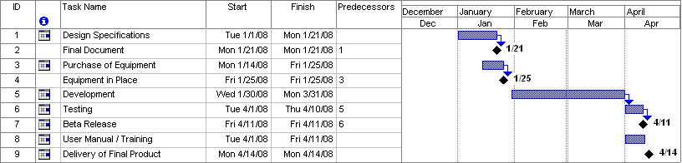
SPECIMEN

Annexure–B: Proposed Budget

Please use the embedded Excel Worksheet for providing budget details.

Double click the icon to open the worksheet.

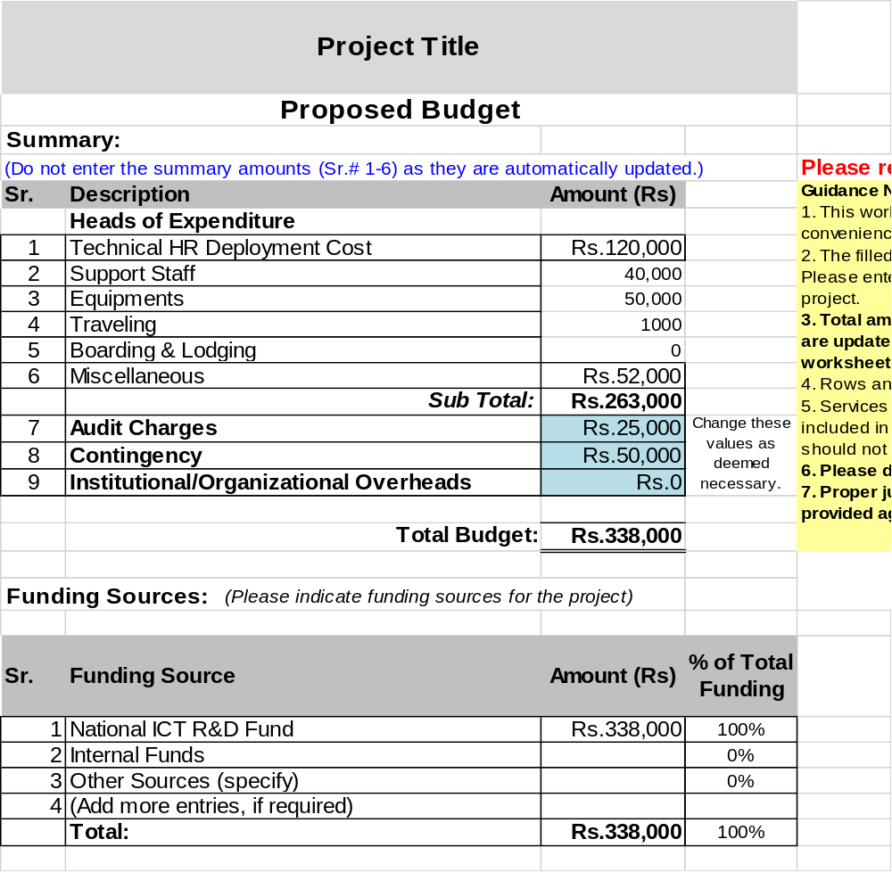

Annexure–C: Business Canvas Model

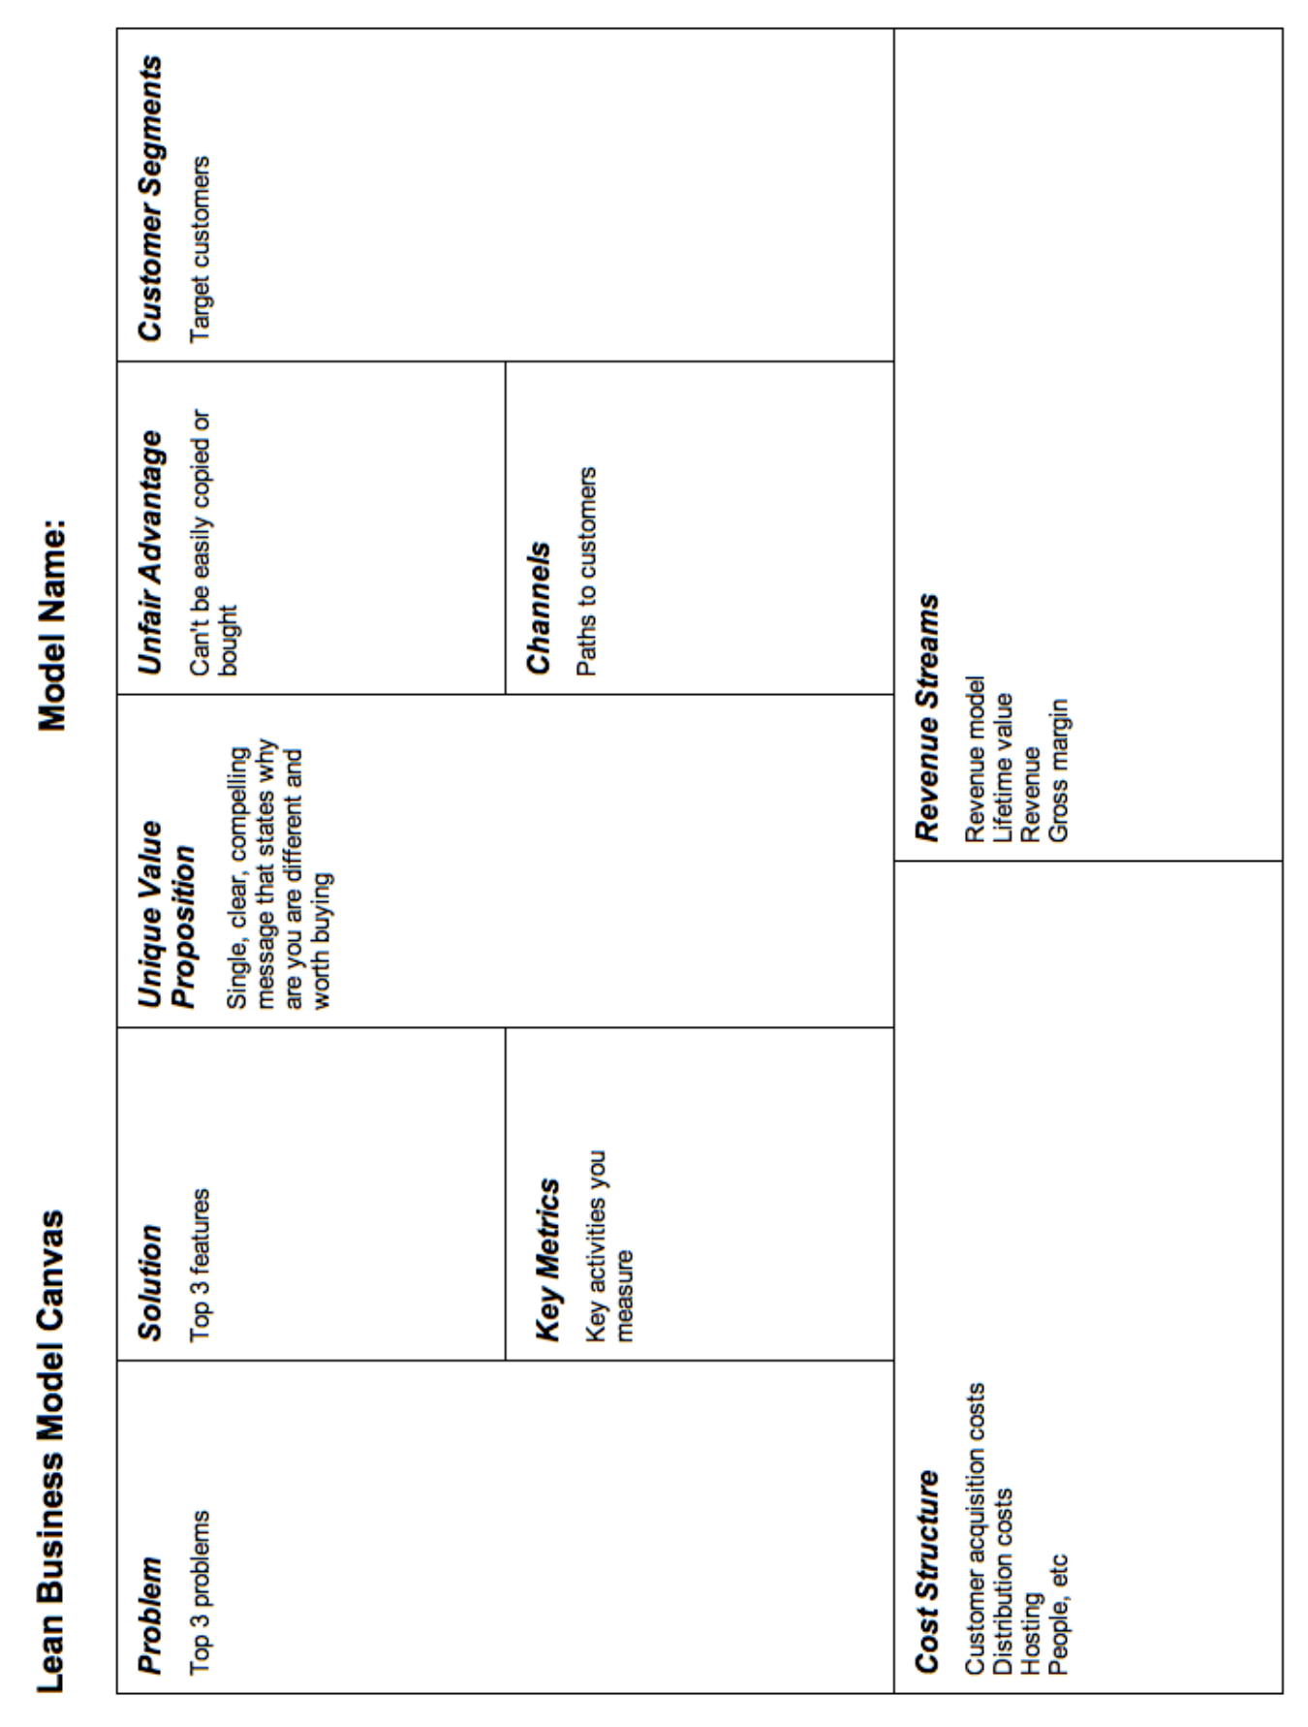

Bibliography

<type here>

