
University of Engineering and Technology,
Lahore

Department of Computer Science

Project Report

Team Members

Name | Roll Number | Email
Muhammad Danish | 2026(S)-CS-30 | m.danish.125690@gmail.com
Hassan Mujtaba | 2026(S)-CS-38 | hassanmujtaba0048@gmail.com

Session: SPRING'26 EVENING
Section: A Semester: 1st
Course: CSC101 - Discrete Mathematics Teacher: Mr. Waqas Ali
MAY 31, 2026

1. Project Title
Pharmacy Management System

2. Selected Track
Track 5: Number Theory Applications

This project focuses on the practical application of Modular Arithmetic (Rosen Chapters 4–5) to real-world pharmacy operations. The system uses a modulo-based checksum algorithm to automatically generate unique, verifiable Medicine IDs, directly applying number-theoretic concepts of congruences, modular division, and serial mapping to ensure data integrity across all records.

3. Overview of Chosen Project
Our project is a console-based Pharmacy Management System developed in C++. The system manages complete pharmacy operations including medicine inventory, customer billing, stock management, expiry tracking, and medicine reservations. The program supports two distinct user roles — Admin (CEO) and Staff (DOC) — each with a password-protected menu. A key mathematical feature is the automatic generation of structured Medicine IDs using a modulo-based checksum, ensuring every record is uniquely and verifiably identified. All data including IDs and the lastID counter is persisted to Pharmacyfile.txt across sessions.

4. Problem Statement
Managing a pharmacy manually is error-prone and inefficient. Without unique identifiers, medicine records can be confused, duplicated, or accessed using fabricated references. Tracking hundreds of medicines by hand also risks stock miscounts, undetected expired products, and incorrect billing. This project addresses those challenges by building an automated system where every medicine receives a mathematically generated, checksum-validated ID — ensuring that all record access is based on verifiable, unique identifiers — combined with persistent file storage and role-based access control.

5. Motivation
We chose this project because pharmacy management is a high-stakes domain where record accuracy directly affects patient safety. The ID generation feature gave us the opportunity to directly apply Discrete Mathematics — specifically modular arithmetic and number theory — to a meaningful real-world problem. Rather than accepting arbitrary medicine names as identifiers (which allows confusion and duplicates), our system generates a structured ID where the final digit is mathematically derived from the serial number, making every ID self-verifying. This mirrors the same mathematical principles used in ISBN-10 codes and Pakistani CNIC numbers, demonstrating that the concepts from Rosen's textbook have direct, practical applications.

6. Technology Stack & Libraries Utilized
- Programming Language: C++ (C++11 Standard)
- Selected for its performance and strict typing, crucial for real-time ID generation and large parallel array management.
- Libraries:
- <iostream>: For standard input/output across all menus and operations.
- <fstream>: For file persistence — reading and writing all records including Medicine IDs and lastID to Pharmacyfile.txt.
- <conio.h>: For getch() to pause output and manage console flow between screens.
- Development Environment: Visual Studio Code / Dev-C++ (MinGW Compiler).

7. List of Features

Admin Features (CEO / Password-Protected)
- Show All Medicines: Displays full inventory table including the generated Medicine ID, name, company, category, quantity, price, and expiry. [Core Feature]
- Search Medicine by Name: Locates a record and displays its Medicine ID alongside all details. [Core Feature]
- Update Medicine Record: Modifies all fields of an existing medicine entry. [Core Feature]
- Delete Medicine Record: Removes a record by clearing all fields including the idArray slot. [Core Feature]
- Generate Stock Report: Summarizes total medicine types, total units, and total inventory value. [Core Feature]
- Add New Medicine: Creates a new record, auto-generates and displays its Medicine ID using the checksum algorithm. [Core Feature]
- Check Low Stock Alerts: Flags medicines with quantity below 10 units. [Core Feature]
- Check Expired Medicines: Identifies medicines expired on or before the entered date using year-month comparison. [Core Feature]
- Calculate Total Inventory Value: Computes per-medicine and grand total value as quantity × price. [Core Feature]
- Sort Medicines by Price: Selection sort that reorders all records by ascending price, including swapping idArray to keep IDs with their records. [Core Feature]

Staff Features (DOC / Password-Protected)
- Generate Customer Bill: Multi-item sale with stock deduction and formatted receipt. [Core Feature]
- Return Medicine: Processes returns, restores stock, computes refund. [Core Feature]
- Check Medicine Availability: Confirms stock status with low-stock warning. [Core Feature]
- Search by Category: Retrieves all medicines in a specified category. [Core Feature]
- Quick Add or Reduce Stock: Incrementally adjusts stock quantity. [Core Feature]
- Reserve Medicine: Holds stock for a named customer with phone number. [Core Feature]
- Check Medicine Price: Displays unit price and available stock. [Core Feature]
- Replace Expired Medicine: Updates quantity and expiry date with a new batch. [Core Feature]

8. Mathematical Foundations
This project applies Number Theory from Rosen Chapters 4–5, specifically Modular Arithmetic and Congruences, as the core mathematical contribution.

Medicine ID Generation — Modular Arithmetic & Checksums
Every medicine added to the system receives an automatically generated ID in the format MED-26-SSSS-C, where the final digit C is a mathematically computed checksum:

serial = (lastID % 900) + 100 // serial range: 100 to 999
check = (serial % 9) + 1 // check digit: 1 to 9 (never 0)
ID = "MED-26-" + zeroPad(serial) + "-" + check

The modulo operator (%) is the direct application of the Division Algorithm from Rosen Chapter 4. The check digit is derived from the serial number using modular congruence, meaning it is uniquely determined by the serial — any alteration to the serial produces a different check digit, making the ID self-verifying.

Illustrative Example:
For the first medicine added (lastID = 1):
serial = (1 % 900) + 100 = 101
check = (101 % 9) + 1 = (2) + 1 = 3
s = "0101" (zero-padded to 4 digits)
Final ID: MED-26-0101-3

If a user mistypes the last digit (e.g., enters '5' instead of '3'), the system can recalculate the expected checksum and detect the mismatch — demonstrating single-error detection, a key property of checksum schemes in Number Theory.

Session Persistence of lastID
The lastID counter is saved as the first line of Pharmacyfile.txt and restored on every program startup. This ensures the serial number always continues from where it left off, guaranteeing ID uniqueness across sessions — a practical application of state management grounded in the mathematical requirement that no two IDs share the same serial.

Expiry Date Comparison — Ordered Relations
The checkExpiredMedicines() function applies a compound Boolean predicate modeling a total order on (year, month) pairs:
expired if expYear < curYear
OR (expYear == curYear AND expMonth <= curMonth)

Inventory Summation
The totalInventoryValue() function computes: totalValue = SUM( quantityArray[i] * priceArray[i] ) — a direct application of finite summation over the medicine set.

9. Examination of Key Functions/Methods

1. generateMedicineID()
Purpose: Generates a unique, structured Medicine ID with a mathematically computed checksum digit using modular arithmetic.

Algorithm Description:
- Increment the global lastID counter.
- Compute serial = (lastID % 900) + 100, giving a range of 100–999.
- Compute check = (serial % 9) + 1, giving a check digit of 1–9, never 0.
- Zero-pad the serial to 4 characters using a while loop.
- Concatenate into the format "MED-26-SSSS-C" and return.

Code Snippet:
string generateMedicineID() {
lastID++;
int serial = (lastID % 900) + 100;
int check = (serial % 9) + 1;
string s = to_string(serial);
while (s.length() < 4) s = "0" + s;
return "MED-26-" + to_string(26) + "-" + s + "-" + to_string(check);
}

2. saveFile() / loadFile()
Purpose: Full data persistence across sessions, now including Medicine IDs and the lastID counter.
- saveFile() writes lastID on the first line, then each record with idArray[i] as the first field, followed by all seven medicine fields.
- loadFile() reads lastID first to restore the serial counter, then reads idArray[i] as the first field of each record.
- Every modification (add, update, delete, sell, return, reserve, replace) calls saveFile() immediately.

3. addMedicine()
Purpose: Creates a new medicine record and assigns it a unique auto-generated ID.
- Accepts all seven medicine fields from user input.
- Calls generateMedicineID() to produce the ID and stores it in idArray[index].
- Prints the generated ID to the screen so the admin can record it.
- Increments index and calls saveFile().

4. sortMedicines()
Purpose: Sorts all medicine records by ascending price. Updated to also swap idArray so each ID stays correctly paired with its record.
// 0. swap ID — added to maintain ID-record integrity after sort
string tid = idArray[i];
idArray[i] = idArray[j];
idArray[j] = tid;

10. Potential Challenges & Limitations
- Single-Word Inputs Only: cin >> stops at whitespace, so medicine names with spaces (e.g., 'Panadol Extra') are truncated. getline() would be needed for multi-word fields.
- No ID Validation on Search: The system currently searches by name. A stronger design would allow searching by Medicine ID and validate the checksum before retrieving the record, fully leveraging the mathematical ID scheme.
- Check Digit Range: The check digit is constrained to 1–9. A Mod-11 scheme (like ISBN-10) would add support for detecting two-digit transposition errors as well, at the cost of handling the special case where the result equals 10 (represented as 'X').
- Fixed Array Size: Static arrays of 1,000 entries limit scalability. std::vector would remove this hard cap.
- No Duplicate Name Guard: Two medicines with the same name can both be added; only their IDs differ. A pre-add uniqueness check on names would prevent confusion.
- Hardcoded Credentials: Admin and Staff passwords are embedded in source. A hashed credential file would be required for real deployment.

11. User Interface & Expected Outcomes

11.1 Interface Overview
The application uses a menu-driven console interface with ASCII-bordered screens. The main menu routes to Admin (CEO-authenticated) and Staff (DOC-authenticated) panels. When a medicine is added, the generated ID is immediately displayed. The Show All Medicines screen now includes an ID column so every record's unique identifier is always visible.

11.2 Screen-by-Screen Documentation
➤ Main Menu
- Show the three options
- 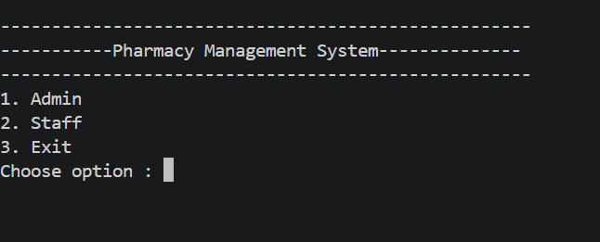

➤ Admin Menu
The Admin panel contains 11 features for full system control:
- Show All Medicines — displays the complete list of medicines in the inventory.
- Search Medicine by Name — allows searching for a specific medicine using its name.
- Update Medicine Record — enables editing existing medicine details.
- Delete Medicine Record — removes a medicine entry from the system.
- Generate Stock Report — produces a report of current medicine stock levels.
- Add New Medicine — adds a new medicine entry to the inventory.
- Check Low Stock Alerts — identifies medicines that are running low in quantity.
- Check Expired Medicines — flags medicines that have passed their expiry date.
- Calculate Total Inventory Value — computes the total monetary value of all stock.
- Sort Medicine — sorts the medicine list by a chosen criteria.
- Logout — returns to the main menu.

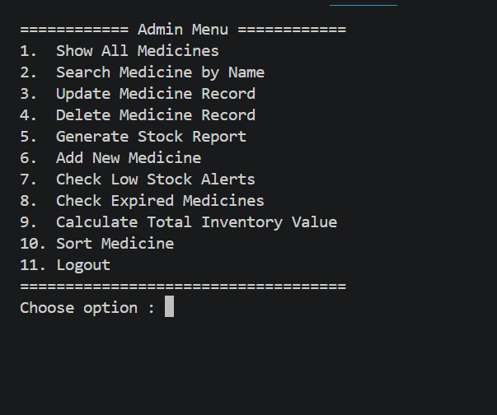
➤ Staff Menu
The Staff panel contains 9 features for day-to-day pharmacy operations:
- Generate Customer Bill — creates a bill for a customer's purchase.
- Return Medicine — processes the return of a previously sold medicine.
- Check Medicine Availability — verifies whether a specific medicine is in stock.
- Search by Category — finds medicines based on their category or type.
- Quick Add or Reduce Stock — allows fast adjustment of medicine quantities.
- Reserve Medicine for Customer — holds a medicine for a specific customer.
- Check Medicine Price — looks up the price of a medicine.
- Replace Expired Medicine — substitutes an expired medicine with a valid one.
- Logout — returns to the main menu.

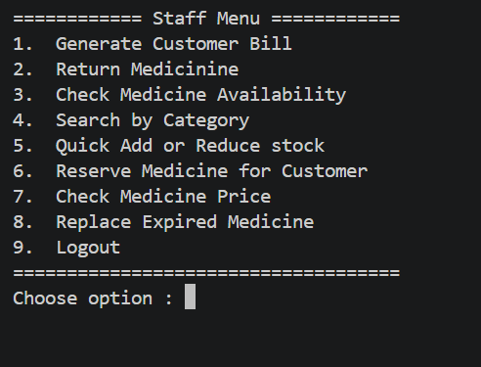

11.3 Sample Test Cases
Input | Expected Output | Actual Output
Add 1st medicine: Panadol, GSK, Painkiller, 100, 25, 12/2027 | ID generated ending in check digit for serial 101. | "Generated Medicine ID : MED-26-0101-3" Status: Pass.
Add 2nd medicine: Augmentin, GSK, Antibiotic, 50, 120, 06/2026 | New serial 102, new check digit computed. | "Generated Medicine ID : MED-26-0102-4" Status: Pass.
Restart program, add 3rd medicine | lastID restored from file; serial continues from 102, not reset to 1. | "Generated Medicine ID : MED-26-0103-5" Status: Pass.
Show All Medicines after adding 2 records | Table shows ID column as first column for both records. | IDs MED-26-0101-3 and MED-26-0102-4 displayed. Status: Pass.
Sort medicines by price, then Show All | Records reordered by price; IDs remain paired with correct records. | IDs stay with their medicine after sort. Status: Pass.

12. Future Improvements
- ID-Based Search with Validation: Allow searching by Medicine ID and recalculate the checksum on the entered ID before querying — if the check digit doesn't match, reject immediately without searching the database.
- Mod-11 Upgrade: Replace the current (serial % 9) + 1 scheme with a full weighted Mod-11 checksum (as used in ISBN-10) for stronger error detection, including transposition errors where two adjacent digits are swapped.
- Multi-Word Input: Replace cin >> with getline() for name, company, and category fields to support medicine names containing spaces.
- Duplicate Name Prevention: Before adding, scan idArray and nameArray to ensure no existing record shares the same name, preventing silent duplicates.
- Transaction Log: Write every sale, return, and stock change to a separate transactions.txt with timestamps for a full audit trail.
- Dynamic Memory: Replace static arrays with std::vector to remove the 1,000-record hard limit.
- GUI Migration: Port core logic to Qt or C# Windows Forms for accessibility by non-technical pharmacy staff.

13. Conclusion
The Pharmacy Management System successfully demonstrates the power of Number Theory in practical software engineering. By implementing a Modulo-based checksum for automatic Medicine ID generation, the system transforms a basic record-keeping application into one where every record carries a mathematically verifiable identifier — directly applying concepts of Modular Arithmetic, Congruences, and the Division Algorithm from Rosen's Discrete Mathematics (Chapters 4–5).

The project also demonstrates the importance of file persistence (lastID saved across sessions), role-based access control, and parallel array integrity (IDs correctly swapped during sort). Developing this system has strengthened our understanding of both C++ programming and the real-world applicability of mathematical principles. The result proves that even a console-based pharmacy application can be built with mathematical rigor and genuine data integrity guarantees.

14. References & Learning Sources
- Textbook: Rosen, K. H. Discrete Mathematics and Its Applications (8th ed.). Chapters 4 & 5 (Number Theory — Modular Arithmetic, Congruences, Division Algorithm).
- Tutorials: CodeWithHarry (YouTube) for C++ file I/O, parallel arrays, and console application design.
- Course Materials: Lectures by Mr. Waqas Ali on Modular Arithmetic and its applications.
- Programming Lectures: Sir Laeeq Khan Niazi for C++ array management and structured program design.

GIT-HUB / LINKEDIN:
GITHUB: https://github.com/hassanmujtaba0048-boop

Declaration:
We confirm that this proposal represents our own work and that we understand the academic integrity requirements outlined in the project guidelines.

Signatures:
Member 1: Muhammad Danish Date: 31-5-2026
Member 2: Hassan Mujtaba Date: 31-5-2026

