UTS-PWEBII

Nama : Muhammad Dody

NPM : 2024250049

Github Api : [MuhammadDody2002/UTS-IF3B-2024250049-API](https://github.com/MuhammadDody2002/UTS-IF3B-2024250049-API)

Api-Vercel : [uts-if-3-b-2024250049-mxfplkkpn-muhammaddody2002s-projects.vercel.app/api/api/mahasiswa](https://uts-if-3-b-2024250049-mxfplkkpn-muhammaddody2002s-projects.vercel.app/api/api/mahasiswa)

Github React : [MuhammadDody2002/UTS-IF3B-2024250049-REACT](https://github.com/MuhammadDody2002/UTS-IF3B-2024250049-REACT)

React- Vercel :

Rest-api Post Man

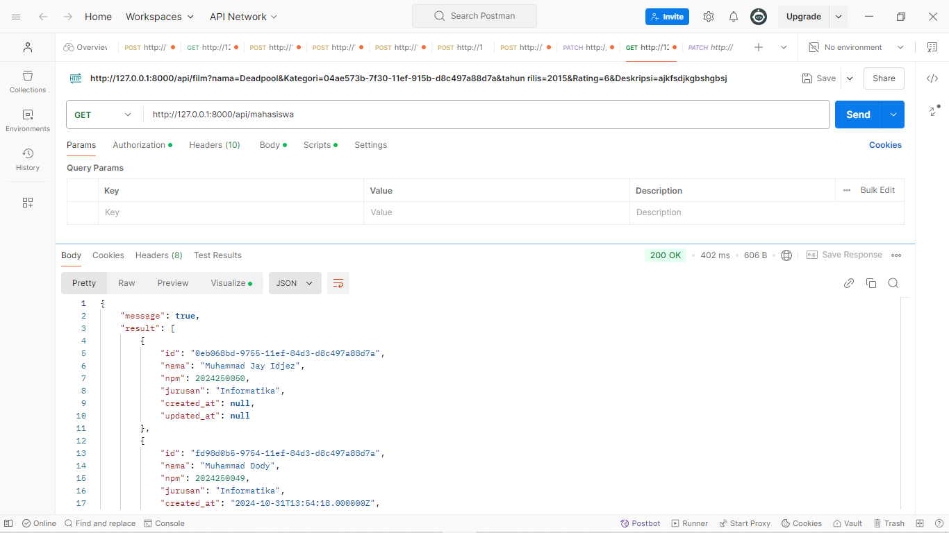

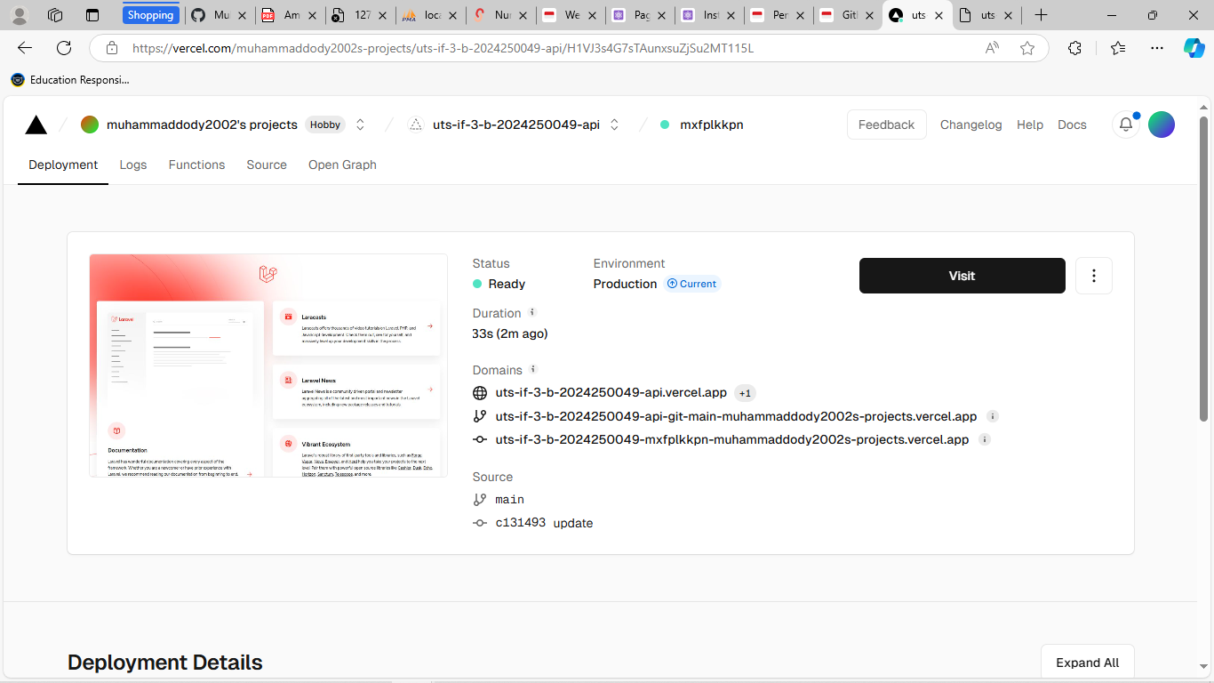

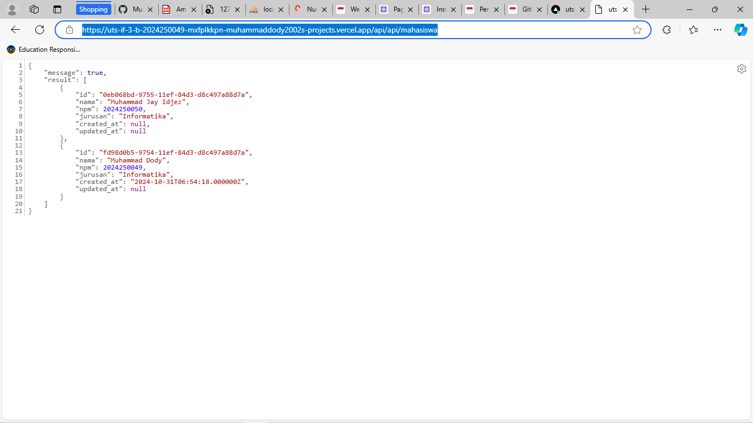

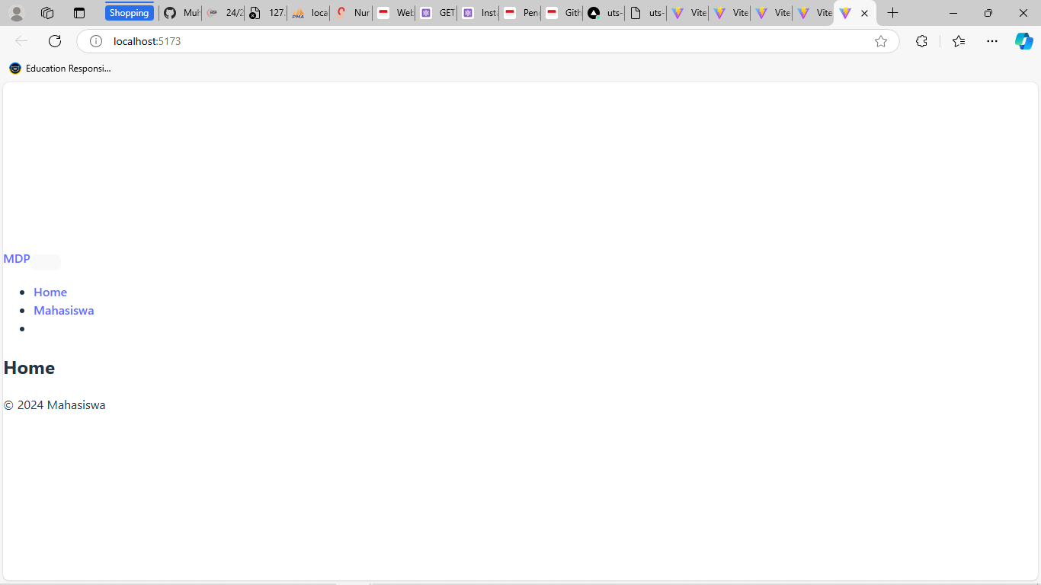

Bootstrap :  
