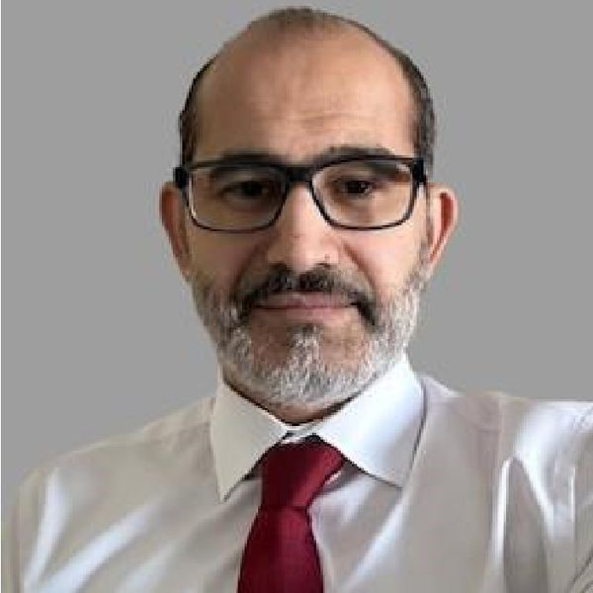**AHMED M. ABOELSAOUD**

**General Manager | Senior Management | Business Development Expert**

E **+1(780) 709-6722**  **ah.aboelsaoud@yahoo.com**  **Edmonton, Alberta, Canada**

# SUMMARY

Results-driven professional with over 15 years of experience in clinical pharmacy operations and business development, with expertise in strategic planning and regulatory compliance. My key achievements include enhancing patient care and compliance at Catalyst Pharmacy—which led to improved healthcare outcomes—and successfully growing the market presence of multiple pharmacies through effective business strategies at Rayat Consultants, resulting in a significant increase in client retention rates. I am seeking a Senior Management position at a forward-thinking company where I can leverage my extensive expertise in pharmacy management and business development to support your mission of advancing healthcare solutions and achieving excellence in customer service

# EDUCATION

## Bachelor's degree in Pharmaceutical science

### Cairo University

09/2001 - 09/2001

## Additional Prescribing Authority

### Alberta College of Pharmacy

01/2016 - 01/1970 Alberta, Canada

# KEY ACHIEVEMENTS

##  **Customer Retention Improvement**  **Service Expansion Impact**

Increased client retention by 30% by implementing customer Successfully expanded services at Catalyst Pharmacy, increasing service protocols at Rayat Consultants. business by 25% within one year.



##  **Sales Growth Achievement**

Achieved 20% growth in sales through effective marketing strategies at MSD Gulf.

# EXPERIENCE

## Founder and Operations Director

### Rayat Consultants

11/2016 - Present Edmonton, Alberta, Canada

A consultancy firm focused on pharmacy operations.

* Developed and executed strategic business plans to drive growth and expand market presence for both pharmacies.
* Led all marketing and branding initiatives, including digital campaigns, community events, and partnerships with local organizations.
* Monitored financial performance, managed budgets, and identified opportunities to improve profitability.
* Implemented customer service protocols that increased client retention and satisfaction by a specific percentage.
* Optimized inventory management, reducing costs while ensuring adequate stock levels.
* Recruited, trained, and managed a high-performing team, fostering a collaborative and results-driven workplace culture.
* Navigated regulatory requirements, ensuring full compliance with provincial and federal laws.
* Expanded the scope of services offered, including immunizations and wellness programs.



## Clinical Pharmacist and Director

### Catalyst Pharmacy chain

01/2015 - 01/2020 Edmonton, Alberta, Canada A pharmacy chain providing community healthcare services.

* Managed daily operations through supervision of technicians.
* Provided ongoing clinical education to enhance regulatory compliance.
* Reviewed patients' medication orders for efficacy and safety.
* Identified untreated health problems and referred patients to physicians.
* Consulted on dosages and the correct administration of drugs.
* Collaborated with healthcare professionals to ensure optimal patient care.

## Sales Manager

### MSD Gulf

10/2008 - 10/2014 Doha, Qatar

A leading pharmaceutical company in the Middle East.

* Maintained up to date with the latest pharmaceutical products.
* Responsible for medical communication and drug information inflow for the team.
* Taught, trained, and coached sales professionals regarding products.
* Conducted monthly business reviews with the team on objectives.
* Developed strategies to approach potential customers.



## Hospital Pharmacist

### Heliopolis Psychiatric Hospital

01/2002 - 12/2006 Cairo, Egypt

A psychiatric hospital focusing on inpatient healthcare.

* Monitored the supply of all medicines used in the hospital.
* Provided information on medication use and potential side effects.
* Worked closely with other healthcare professionals in clinical settings.
* Managed both in-patient and out-patient pharmacies.

# CERTIFICATION

**Certificate in Transformational Leadership Sales and Marketing Certificate**

Certificate in transformational leadership and positive thinking Sales and marketing certificate

# TRAINING / COURSES

## **Advanced Selling Skills Effective E-marketing Negotiation Skills**

Advanced selling skills course Effective E-marketing seminar Negotiation skills course



## **Customer Service: Emotional Care Team Building Pharmaceutical Marketing**

Customer service: emotional care course Team Building workshop The Pharmaceutical Marketing course



## **Successful Selling Strategies Customer Centricity Interaction Emotional Intelligence**

Successful selling strategies course Customer Centricity Interaction course Emotional Intelligence training



## **Strategic Thinking Presentation Skills Six Sigma**

Strategic thinking training Presentation skills training Six Sigma training



**Coaching Fundamentals The Master Negotiator**

Coaching Fundamentals course Master Negotiator course

# SKILLS

**Business Development GCC negotiation skills Oncology Product Knowledge six sigma Team Building**

**INTERESTS**  **Hobbies**

Reading, hunting, and sports

# LANGUAGES

**English**

Native

**Arabic**

Native

# STRENGTHS

s **Business Development Skills**

Strong abilities in business development and strategic marketing.

141-530-5256