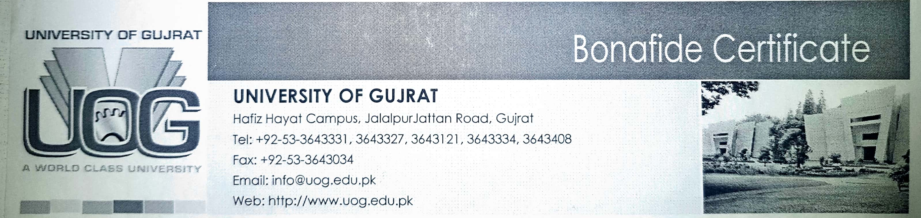

***Date: AUGUST 6, 2018***

***Document: UOG/HOD-SOC/2018***

***To Whom It May Concern***

*It is certified that* ***Mr. Abdul Mateen*** *S/O* ***Mr. Abdullah Jan*** *Roll number* ***14041516-052*** *is bonafied student of BS-SOCIOLOGY 8th Semester in Sociology Department University of Gujrat.*

***___________________***

*Head of Sociology Department*

*University of Gujrat*

FACULTY OF SOCIOLOGY

UNIVERSITY OF GUJRAT a world class university