Abstract
[Draw your reader in with an engaging abstract. It is typically a short summary of the document.
When you’re ready to add your content, just click here and start typing.]
[Document title]
[Document subtitle]

Overview

CarRently is a car renting platform that has core business entities such as users, vehicle listings, and booking transactions that get operated by the corresponding SQL Server database.
As the platform grows, relying solely on the operational database becomes insufficient to support analytical and reporting needs. Operational databases are used for fast transactional processing (OLTP). Due to their design they are not suited for complex queries, aggregations and historical analysis. Such activities are essential for decision-making and business intelligence (OLAP)
In order to search this limitation, a fully devoted data engineer layer was envisaged and applied.
It involves creating a Data Warehouse (CarRentlyDW) and ensuring that data from the source system continuously flows into the warehouse in real-time.
This project aims to capture real-time changes from the source, apply transformations on them, and load them into the analytical model for reporting–insight generation.

System Architecture

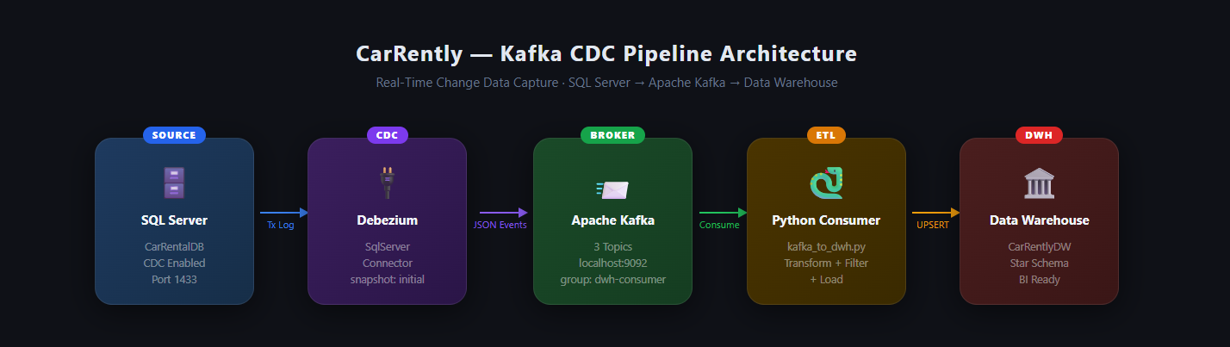

Source Layer — SQL Server

The SQL Server database (CarRentalDB) serves as the source system storing transactional data for the car rental application.
Key characteristics :
• OLTP database (Online Transaction Processing)
• Capture changes to data like CDC
Used major tables :
• User
• Car
• Booking
The database has other entities (i.e., Review, Message, Notification) but only core tables for analytics were chosen.

  - User Table :

  - 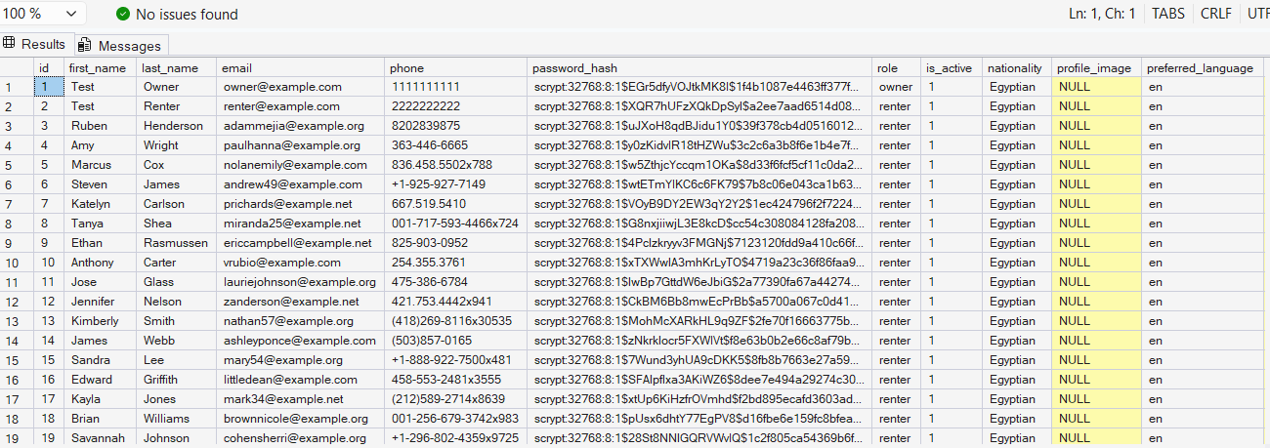

  - Car Table :
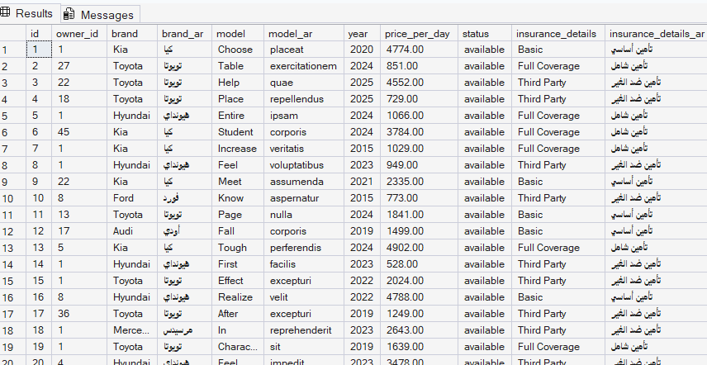

  - Booking Table :
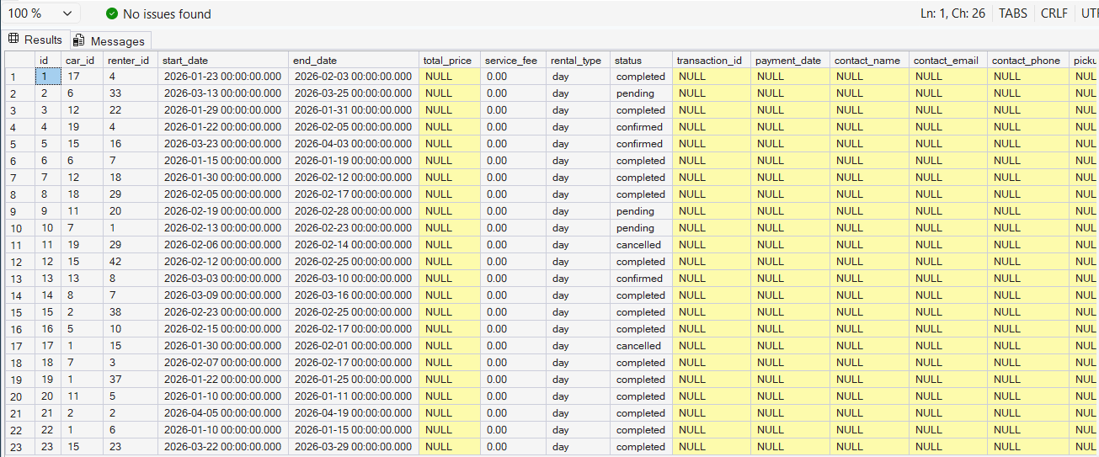

CDC Layer — Debezium

Debezium is used to capture real-time changes from SQL Server.
- Functionality:
- Reads from SQL Server transaction log (CDC)
- Captures INSERT, UPDATE, DELETE operations
- Converts changes into structured JSON events
- Streams events into Kafka topics

- Connector configuration:

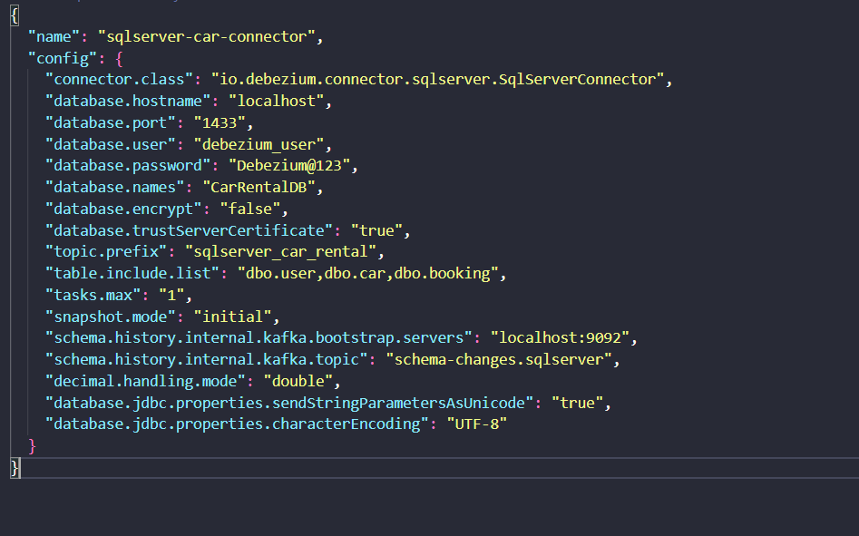

3. Streaming Layer — Apache Kafka
Apache Kafka acts as a distributed message broker that stores and streams data events.
Each database table is mapped to a Kafka topic.
- Topics:

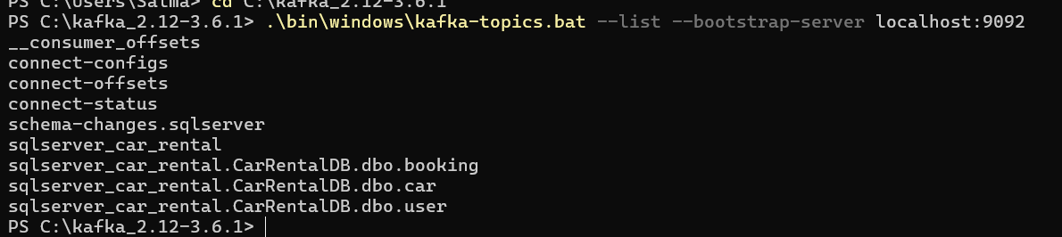
- Kafka ensures:
- High-throughput data streaming
- Decoupling between source and consumer
- Fault-tolerant data delivery
- Topic sqlserver_car_rental.CarRentalDB.dbo.car :
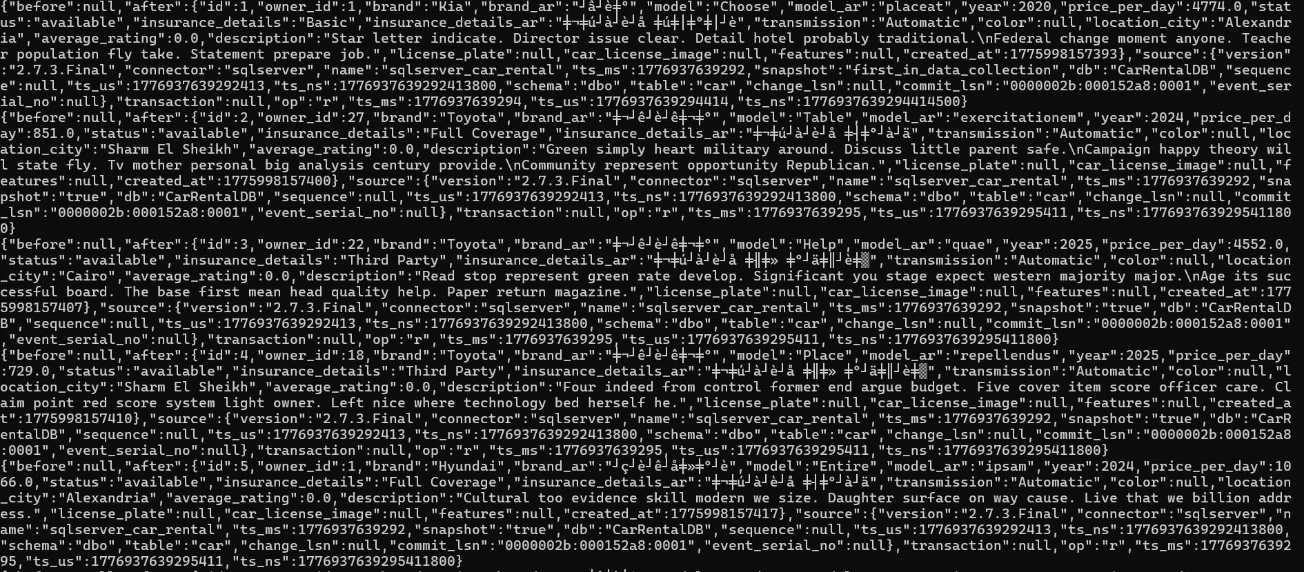

- Topic sqlserver_car_rental.CarRentalDB.dbo.user :
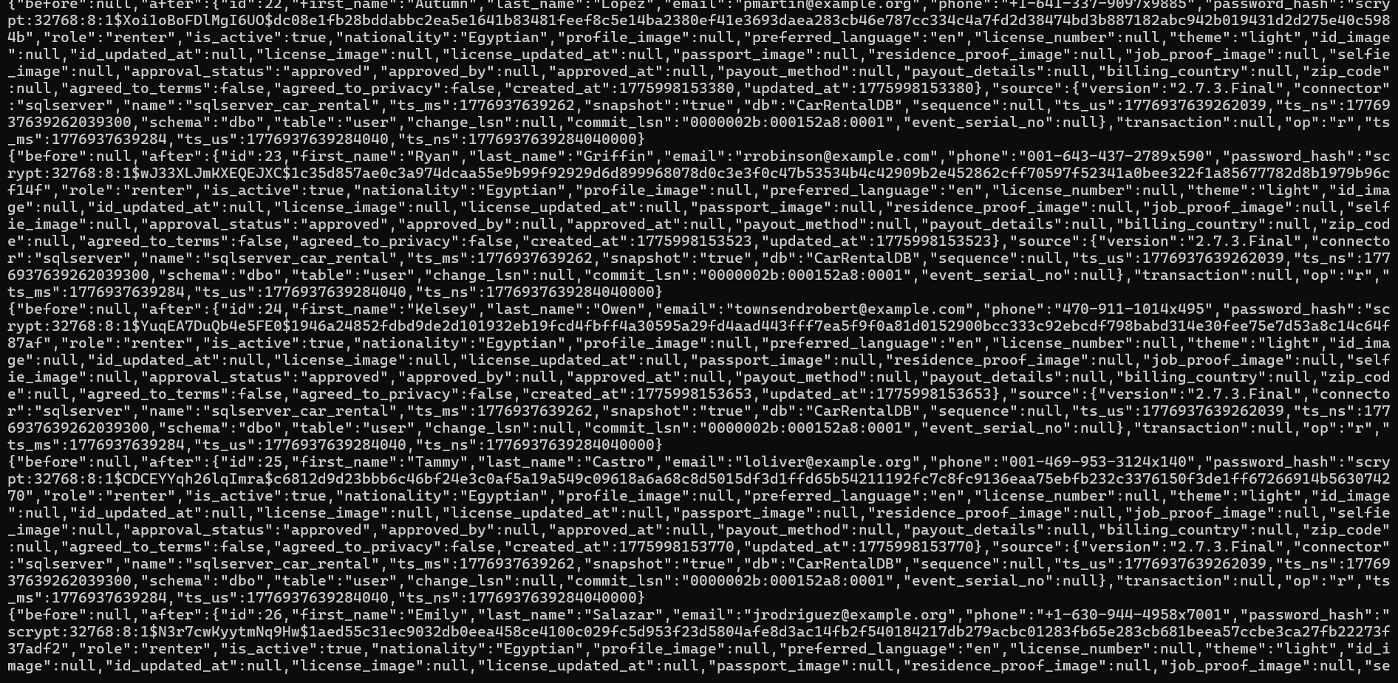

- Topic sqlserver_car_rental.CarRentalDB.dbo.booking :
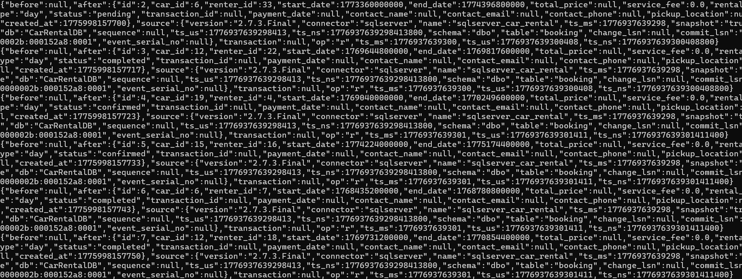

4. Processing Layer — Python Consumer (ETL)
A Python-based Kafka consumer is responsible for processing streaming data.
- Main responsibilities:
- Consumes messages from Kafka topics
- Cleans and transforms data
- Applies business logic
- Loads processed data into the Data Warehouse
- Data Processing Includes:
- Text normalization (e.g., brand, model)
- Transmission mapping (auto/manual standardization)
- Decimal decoding (Debezium base64 handling)
- Date/time conversion
- Filtering:
  - Only approved users
  - Only confirmed/completed bookings
- Business Logic:
- Soft delete handling using is_deleted flag
- Calculating total_price based on rental duration and car price

5. Storage Layer — Data Warehouse
The final processed data is stored in a SQL Server Data Warehouse (CarRentlyDW).
The warehouse follows a dimensional model consisting of:
- Dimension Tables:
- DIM_USERS
- DIM_CARS
- Fact Table:
- FACT_BOOKINGS
- Key features:
- Surrogate keys for dimensions
- Foreign key relationships
- Derived columns (e.g., rental_days)
- Pre-calculated metrics (e.g., total_price)
The warehouse is designed to support business intelligence and analytical queries.

Summary
This pipeline provides a scalable and real-time solution for transforming transactional data into a structured analytical format.
- It demonstrates:
- Real-time data ingestion using CDC
- Stream processing using Kafka
- Data transformation using Python
- Dimensional modeling in a Data Warehouse

