Results:

Rashmi- used binary target variable -random forest but with different sampling techniques (over sampling, undersampling, both and ROSE

*#### print the performance of each model*  
**paste**("Area under curve of random forest: ", ROC_rftrain_auc)

## [1] "Area under curve of random forest: 0.559679102335201"

**paste**("Area under curve of random forest: ", ROC_rfover_auc)

## [1] "Area under curve of random forest: 0.558920240270693"

**paste**("Area under curve of random forest: ", ROC_rfunder_auc)

## [1] "Area under curve of random forest: 0.557824093493108"

**paste**("Area under curve of random forest: ", ROC_rfboth_auc)

## [1] "Area under curve of random forest: 0.55081775845968"

**paste**("Area under curve of random forest: ", ROC_rfrose_auc)

## [1] "Area under curve of random forest: 0.583663418852903"

Random Forest with no sampling

Accuracy : 0.6457

Sensitivity : 0.1794 Specificity : 0.87076

Random Forest with over sampling

Accuracy : 0.5532

Sensitivity : 0.4906 Specificity : 0.5834

Random Forest with under sampling

Accuracy : 0.5376

Sensitivity : 0.5461 Specificity : 0.5335

Random Forest with both sampling

Accuracy : 0.5421

Sensitivity : 0.5196 Specificity : 0.5530

Random Forest with ROSE sampling

Accuracy : 0.5617

Sensitivity : 0.5458 Specificity : 0.5694

Zaahir- random forest- used binary target variable

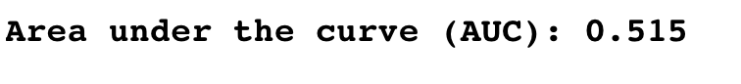

Hussein- binary target variable- svm

My accuracy is about 0.61  
AUC is 0.48

Sensitivity = 0.68  
Specificity = 0.25

Waiting for him to send his roc plot will send soon

Qamar- kept 3 classes instead of doing binary target variable – KNN

Me- kept 3 classes also- used svm

Please include screenshots of outputs like I have done above when explaining the eda and predictions