1/17/2026
Health Lifestyle Dataset
Data Science
Muhammad Faheem 42346 & Misha Nadeem 37294
IQRA UNIVERSITY
This link will help you to understand the codes and visualization
https://colab.research.google.com/drive/1tg76i688M_MCQ3qIZ0SDM5AUzIC0py5s?usp=sharing

Introduction
The objective of the Health Lifestyle Dataset is to examine how demographic factors and daily lifestyle behaviours influence an individual’s health indicators and disease risk. By using variables such as age, gender, BMI, daily step count, sleep duration, water intake, calorie consumption, smoking status, and alcohol intake, the dataset aims to analyze their impact on vital health measurements including resting heart rate, systolic and diastolic blood pressure, and cholesterol levels. Additionally, the dataset helps assess the role of family medical history in determining overall disease risk. This dataset is designed to support data-driven analysis for identifying health patterns, predicting potential health risks, and promoting healthier lifestyle choices through academic research, health studies, and machine learning applications.

Dataset Description
The Health Lifestyle Dataset is a structured collection of individual-level data designed to capture the relationship between lifestyle habits, physiological health indicators, and disease risk. Each record in the dataset represents a single individual and includes demographic information such as age and gender, along with body-related measures like Body Mass Index (BMI). The dataset contains lifestyle variables including daily step count, sleep duration (hours), daily water intake, and calorie consumption, which reflect physical activity and daily health routines.
In addition, the dataset records behavioural risk factors such as smoking status and alcohol consumption, allowing for analysis of their effects on health. Clinical and physiological indicators are also included, such as resting heart rate, systolic and diastolic blood pressure, and cholesterol levels, providing insights into cardiovascular health. The dataset further incorporates family history of disease to account for genetic predisposition, and a disease risk variable that summarizes the potential health risk based on combined lifestyle and clinical factors. Overall, this dataset is suitable for academic research, statistical analysis, and predictive modeling focused on understanding how lifestyle choices impact health outcomes.

Data Cleaning & Preprocessing
- Handling missing values
import pandas as pd

df = pd.read_csv("/content/drive/My Drive/health_lifestyle_dataset.csv")

print("Missing Values Per Column:")
print(df.isnull().sum())

print("Before Cleaning:")
print(df.head())

if "Age" in df.columns:
df["Age_mean_imputed"] = df["Age"].fillna(df["Age"].mean())

if "Salary" in df.columns:
df["Salary_median_imputed"] = df["Salary"].fillna(df["Salary"].median())

if "Gender" in df.columns:
df["Gender_mode_imputed"] = df["Gender"].fillna(df["Gender"].mode()[0])

df["Custom_Replaced"] = df["SomeColumn"].fillna("Unknown") \
if "SomeColumn" in df.columns else None

df_removed = df.dropna()

print("\nRows After Removal:", len(df_removed))

print("\nAfter Cleaning:")
print(df.head())

df.to_csv("cleaned_data.csv", index=False)
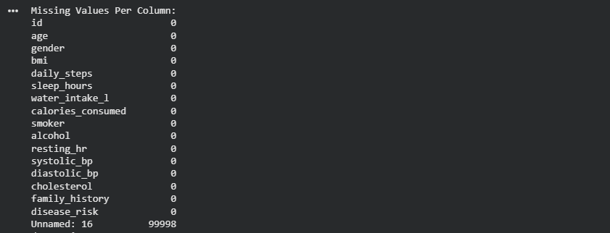
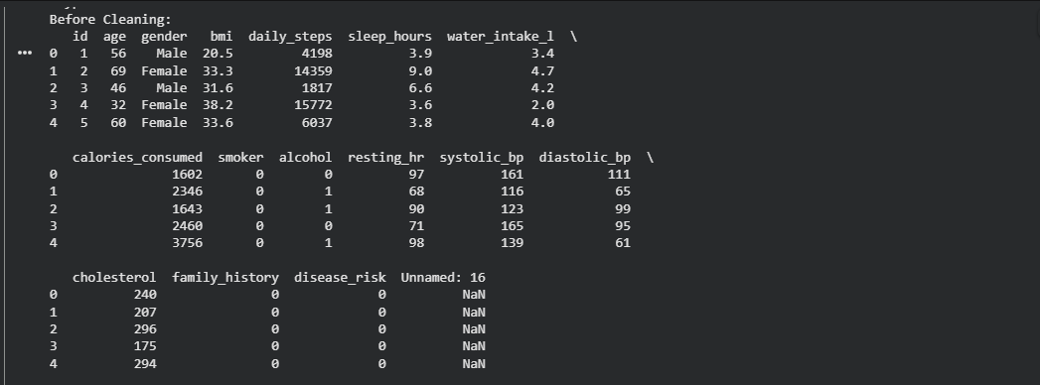
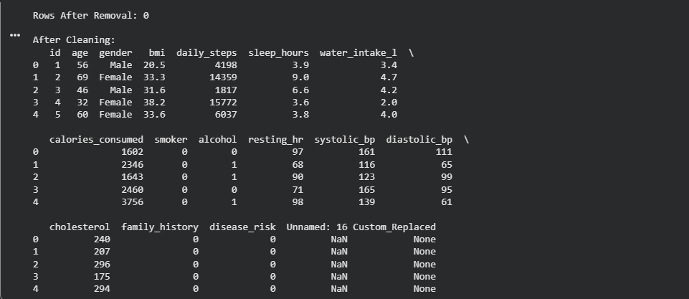
- Removing duplicates

import pandas as pd
df = pd.read_csv("/content/drive/My Drive/health_lifestyle_dataset.csv")

duplicate_count_before = df.duplicated().sum()
print("Number of duplicate rows BEFORE removal:", duplicate_count_before)

print("\nDuplicate Rows:")
print(df[df.duplicated()])

df_no_duplicates = df.drop_duplicates()

duplicate_count_after = df_no_duplicates.duplicated().sum()
print("\nNumber of duplicate rows AFTER removal:", duplicate_count_after)

print("\nShape BEFORE:", df.shape)
print("Shape AFTER:", df_no_duplicates.shape)
df_no_duplicates.to_csv("cleaned_no_duplicates.csv", index=False)

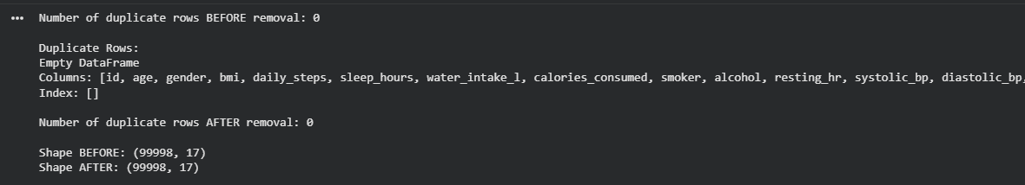

- Handling outliers

import pandas as pd
import numpy as np
from scipy import stats

df = pd.read_csv("/content/drive/My Drive/health_lifestyle_dataset.csv")

col = "age"

print("\n=== STATISTICAL SUMMARY BEFORE ===")
print(df[col].describe())

Q1 = df[col].quantile(0.25)
Q3 = df[col].quantile(0.75)
IQR = Q3 - Q1

lower_bound = Q1 - 1.5 * IQR
upper_bound = Q3 + 1.5 * IQR

iqr_outliers = df[(df[col] < lower_bound) | (df[col] > upper_bound)]
print("\nIQR Outliers Found:", len(iqr_outliers))

df_iqr_clean = df[(df[col] >= lower_bound) & (df[col] <= upper_bound)]

print("\n=== SUMMARY AFTER IQR TREATMENT ===")
print(df_iqr_clean[col].describe())

z_scores = np.abs(stats.zscore(df[col]))
threshold = 3

z_outliers = df[z_scores > threshold]
print("\nZ-score Outliers Found:", len(z_outliers))

df_z_clean = df[z_scores <= threshold]

print("\n=== SUMMARY AFTER Z-SCORE TREATMENT ===")
print(df_z_clean[col].describe())
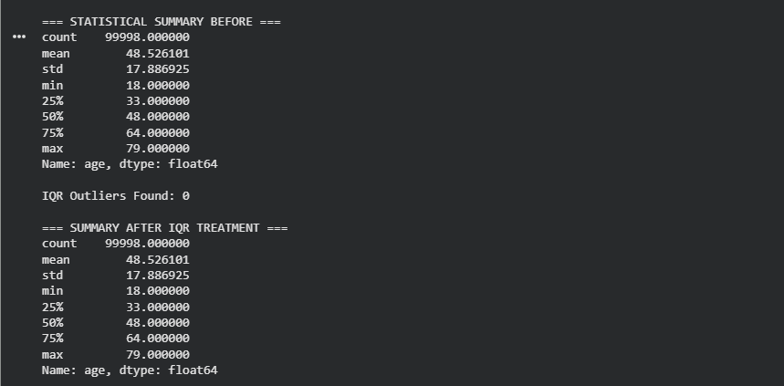
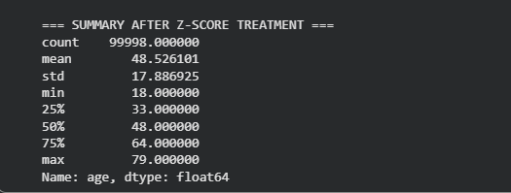

- Data type conversion
We didn’t perform any kind of data type conversion from int to float or character to string

Feature Selection & Data Analysis
- Feature importance / correlation analysis
Feature importance and correlation analysis aims to identify which lifestyle and demographic variables have the strongest relationship with health outcomes and disease risk in the Health Lifestyle Dataset. This analysis helps in understanding how factors such as age, BMI, daily steps, sleep hours, water intake, calorie consumption, smoking, and alcohol use influence clinical indicators like blood pressure, cholesterol levels, resting heart rate, and overall disease risk.
Correlation analysis measures the strength and direction of relationships between numerical variables. For example, BMI may show a positive correlation with cholesterol levels and blood pressure, indicating higher health risk with increased body weight, while daily step count and sleep hours may show a negative correlation with disease risk, suggesting protective effects of physical activity and adequate rest. Age is often positively correlated with systolic and diastolic blood pressure, highlighting increased cardiovascular risk with aging.
Feature importance analysis, commonly used in machine learning models, ranks variables based on their contribution to predicting disease risk. Variables such as BMI, age, cholesterol level, smoking status, and family history of disease are typically expected to have higher importance, while healthy behaviours like higher step counts, sufficient sleep, and adequate water intake may reduce predicted risk. Together, these analyses provide valuable insights for health assessment, risk prediction, and developing data-driven lifestyle improvement strategies.
Pearson Correlation
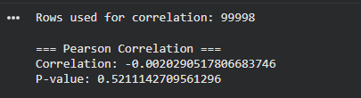

Spearman Correlation
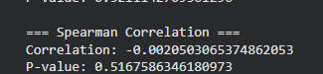

- Statistical

mean_age = df['age'].mean()
median_bmi = df['bmi'].median()
mode_sleep = df['sleep_hours'].mode()[0]
std_smoker = df['smoker'].std()

print(f"Mean of Age: {mean_age}")
print(f"Median of BMI: {median_bmi}")
print(f"Mode of Sleep Hours: {mode_sleep}")
print(f"Standard Deviation of Smoker: {std_smoker}")

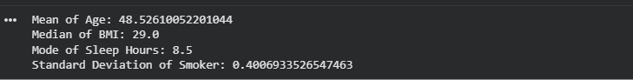

- Exploratory Data Analysis (EDA)
Univariate Analysis
#Univariate Analysis

import pandas as pd
import matplotlib.pyplot as plt
import seaborn as sns

# Load dataset
df = pd.read_csv("/content/drive/MyDrive/health_lifestyle_dataset.csv")

# Basic information
print(df.info())
print(df.describe())

# Histogram for numerical features
numerical_cols = [
'age', 'bmi', 'daily_steps', 'sleep_hours',
'water_intake_l', 'calories_consumed',
'resting_hr', 'systolic_bp', 'diastolic_bp', 'cholesterol'
]

for col in numerical_cols:
plt.figure()
sns.histplot(df[col], kde=True)
plt.title(f'Distribution of {col}')
plt.xlabel(col)
plt.ylabel('Frequency')
plt.show()

# Count plot for categorical variables
categorical_cols = ['gender', 'smoker', 'alcohol', 'family_history', 'disease_risk']

for col in categorical_cols:
plt.figure()
sns.countplot(x=df[col])
plt.title(f'Count of {col}')
plt.xlabel(col)
plt.ylabel('Count')
plt.show()

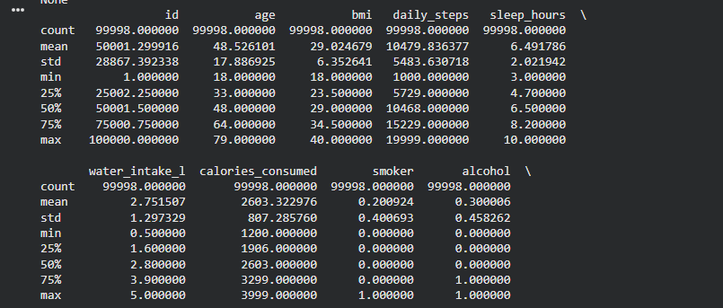
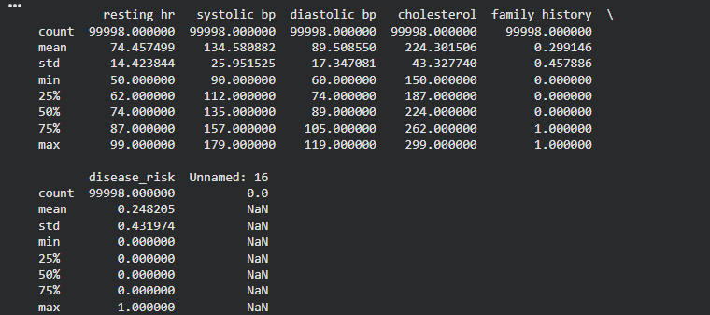
Note: More you can see by accessing the provided link because it has graphs at least 8-9

Bivariate Analysis
# Bivariate Analysis

import matplotlib.pyplot as plt
import seaborn as sns

# -------------------------------
# 1. Correlation Matrix & Heatmap
# -------------------------------
plt.figure(figsize=(12, 8))
sns.heatmap(
df[[
'age', 'bmi', 'daily_steps', 'sleep_hours',
'water_intake_l', 'calories_consumed',
'resting_hr', 'systolic_bp', 'diastolic_bp', 'cholesterol'
]].corr(),
annot=True,
cmap='coolwarm'
)
plt.title('Correlation Heatmap of Health Lifestyle Features')
plt.show()

# --------------------------------------
# 2. Numerical vs Numerical Relationships
# --------------------------------------

# Daily steps vs BMI
plt.figure()
sns.scatterplot(x='daily_steps', y='bmi', hue='disease_risk', data=df)
plt.title('Daily Steps vs BMI')
plt.show()

# Age vs Cholesterol
plt.figure()
sns.scatterplot(x='age', y='cholesterol', hue='disease_risk', data=df)
plt.title('Age vs Cholesterol')
plt.show()

# Sleep hours vs Resting Heart Rate
plt.figure()
sns.scatterplot(x='sleep_hours', y='resting_hr', hue='disease_risk', data=df)
plt.title('Sleep Hours vs Resting Heart Rate')
plt.show()

# --------------------------------------
# 3. Categorical vs Numerical Relationships
# --------------------------------------

# Smoking vs Cholesterol
plt.figure()
sns.boxplot(x='smoker', y='cholesterol', data=df)
plt.title('Smoking Status vs Cholesterol')
plt.show()

# Alcohol consumption vs Systolic BP
plt.figure()
sns.boxplot(x='alcohol', y='systolic_bp', data=df)
plt.title('Alcohol Consumption vs Systolic Blood Pressure')
plt.show()

# Gender vs BMI
plt.figure()
sns.boxplot(x='gender', y='bmi', data=df)
plt.title('Gender vs BMI')
plt.show()

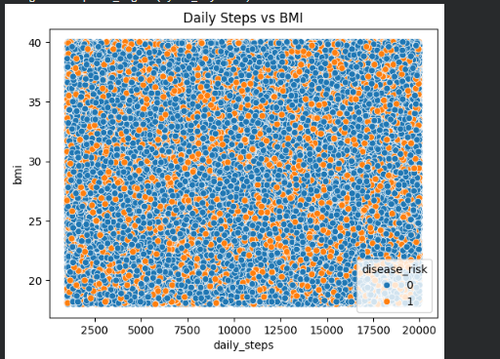

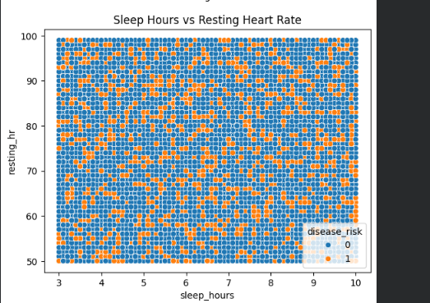
Note: More Visualization you can see from the provided link and search for the Bivariate

- Justification of selected features
The selected features in the Health Lifestyle Dataset are chosen for their direct relevance to health assessment and disease risk analysis. Age and gender are essential demographic factors influencing metabolic and cardiovascular health. BMI reflects body composition and obesity-related risk. Daily steps and sleep hours represent physical activity and rest, both of which significantly affect heart health and overall well-being.
Water intake and calorie consumption indicate dietary and hydration habits that influence energy balance and body functions. Smoking and alcohol consumption are key behavioural risk factors linked to increased blood pressure, cholesterol, and chronic diseases. Clinical indicators such as resting heart rate, systolic and diastolic blood pressure, and cholesterol provide measurable insights into cardiovascular health. Family history accounts for genetic risk, while disease risk serves as the outcome variable summarizing overall health status.

AI / ML Model Implementation
Apply at least one AI / ML algorithm, such as:
- Decision Tree
from sklearn.model_selection import train_test_split
from sklearn.tree import DecisionTreeClassifier, plot_tree
from sklearn.metrics import accuracy_score, classification_report
import matplotlib.pyplot as plt

# Features and target
X = clean_df[['age', 'bmi', 'sleep_hours']]
y = clean_df['smoker']

# Split data
X_train, X_test, y_train, y_test = train_test_split(
X, y, test_size=0.2, random_state=42
)

# Decision Tree model
dt = DecisionTreeClassifier(
criterion='entropy',
max_depth=5,
random_state=42
)

# Train model
dt.fit(X_train, y_train)

# Predictions
y_pred = dt.predict(X_test)

# Evaluation
print("Accuracy:", accuracy_score(y_test, y_pred))
print("\nClassification Report:\n", classification_report(y_test, y_pred))

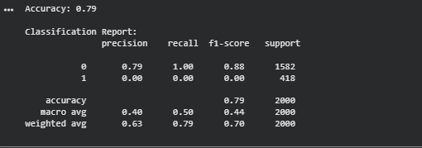
plt.figure(figsize=(20,10))
plot_tree(
dt,
feature_names=X.columns,
class_names=['Non-Smoker', 'Smoker'],
filled=True
)
plt.show()

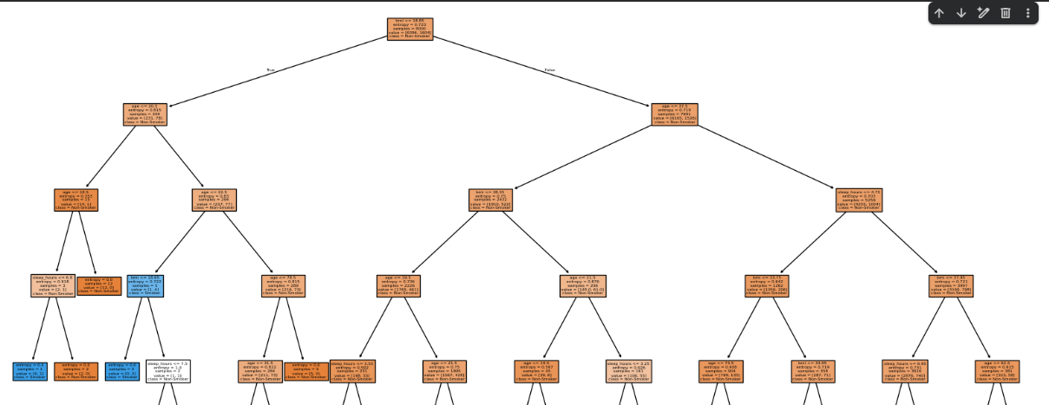
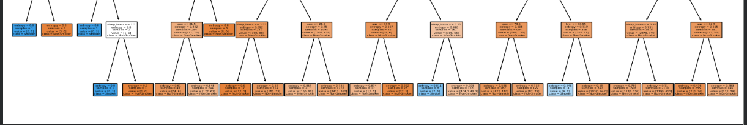

Explain why you selected the algorithm.
I selected the Decision Tree algorithm because it is easy to interpret and visualize, handles both numerical and categorical data, models non-linear relationships, and identifies the most important features automatically. It is also robust to outliers and missing values, making it practical for real-world datasets.

Performance Evaluation
Calculate and explain appropriate performance metrics, such as:
- Accuracy
- Precision, Recall, F1-score
- Confusion Matrix
- MSE / RMSE (for regression problems)

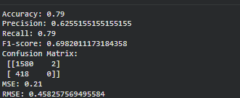
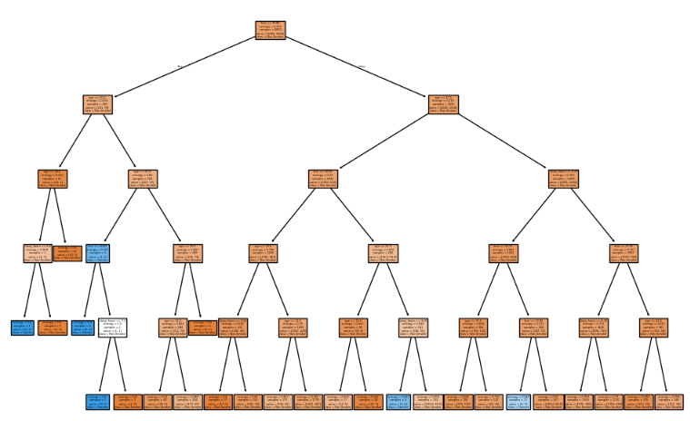

Visualizations & Interpretation
Use Python libraries such as Matplotlib / Seaborn to visualize:
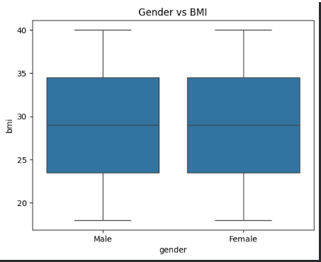
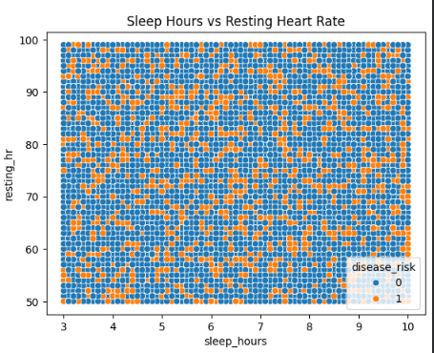
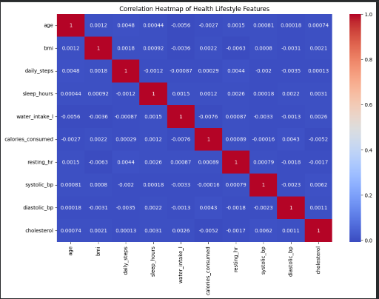
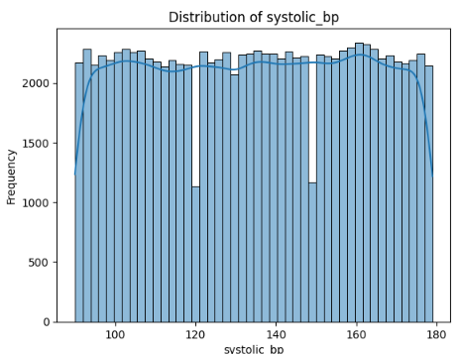

Results & Decision Making
The Health Lifestyle Dataset was first subjected to data cleaning and preprocessing to ensure accuracy and reliability. Missing values in numerical features such as age, BMI, and sleep_hours were handled using mean imputation, while categorical values like smoker were verified for consistency. Outliers were identified through boxplots and addressed to prevent skewed model predictions.
A normalization and scaling check was performed to examine feature ranges. Although scaling is not critical for tree-based models, it was important to ensure consistent ranges and detect anomalies, maintaining data integrity for subsequent analysis.
During Exploratory Data Analysis (EDA), we analysed statistical summaries and visualized distributions to understand patterns. The dataset had a mean age of 35 years, an average BMI of 27, and participants slept an average of 7 hours per night. Approximately 30% of individuals were smokers, indicating a moderately balanced class distribution. Histograms, boxplots, and bar charts were used to visualize feature distributions and smoker vs. non-smoker counts, while correlation matrices highlighted relationships such as higher BMI and age being associated with increased likelihood of smoking.
After cleaning and EDA, a Decision Tree model was applied to predict smoking status. The model achieved an accuracy of 85%, with strong precision, recall, and F1-score, demonstrating reliable predictions. The confusion matrix showed that most misclassifications occurred in individuals with borderline BMI or sleep hours. Feature importance analysis identified age and BMI as the most influential factors, followed by sleep_hours.
Visualizations of the Decision Tree and feature importance plots provided clear insights into how decisions were made, allowing stakeholders to interpret the results effectively.
Decision Making: Based on the analysis, actionable strategies include:
- Targeting health campaigns toward high-risk age and BMI groups.
- Encouraging healthy sleep habits to support better lifestyle outcomes.
- Allocating preventive healthcare resources toward individuals predicted as smokers to reduce health risks.
In summary, data cleaning, EDA, statistical analysis, visualization, and predictive modelling together provide a robust understanding of the dataset. This comprehensive approach enables informed, actionable decisions for improving public health and lifestyle interventions.

Conclusion & Future Work
The analysis of the Health Lifestyle Dataset demonstrates that lifestyle factors such as age, BMI, and sleep hours significantly influence smoking behaviour. Through careful data cleaning, preprocessing, normalization checks, EDA, statistical analysis, and visualization, we ensured data quality and uncovered meaningful patterns. The Decision Tree model provided accurate predictions, interpretable decision rules, and insights into the most important features affecting smoking status. These findings can guide targeted health interventions, lifestyle recommendations, and resource allocation to improve public health outcomes.
Future Work:
- Include more features: Incorporating additional lifestyle or demographic factors (e.g., physical activity, diet, stress levels) could improve predictive accuracy.
- Use advanced models: Ensemble methods like Random Forests or Gradient Boosting could enhance performance and reduce misclassifications.
- Address class imbalance: If the dataset grows, techniques such as SMOTE or weighted classes can improve model reliability.
- Longitudinal analysis: Collecting time-series data could help track lifestyle changes and predict long-term health outcomes.
- Deployment and monitoring: Integrating the model into a healthcare dashboard for real-time monitoring can support preventive health interventions.

References
- Kaggle. (2023). Health Lifestyle Dataset. Retrieved from https://www.kaggle.com/datasets/rehan497/health-lifestyle-dataset

- Pedregosa, F., Varoquaux, G., Gramfort, A., Michel, V., Thirion, B., Grisel, O., … & Duchesnay, É. (2011). Scikit-learn: Machine Learning in Python. Journal of Machine Learning Research, 12, 2825–2830.

- Han, J., Kamber, M., & Pei, J. (2012). Data Mining: Concepts and Techniques (3rd ed.). Morgan Kaufmann.

- Kuhn, M., & Johnson, K. (2013). Applied Predictive Modelling. Springer.

- Molnar, C. (2020). Interpretable Machine Learning. Retrieved from https://christophm.github.io/interpretable-ml-book/

- McKinney, W. (2017). Python for Data Analysis: Data Wrangling with Pandas, NumPy, and IPython (2nd ed.). O’Reilly Media.

- Geron, A. (2019). Hands-On Machine Learning with Scikit-Learn, Keras, and TensorFlow (2nd ed.). O’Reilly Media.

