Assignment # 3

CS322 - SC - Software Construction

Gift Registry System (Case Study # 1)

**Group no. 5**

**Team Members:**

* Aftab Burki ( Team Lead ) - 04072113011
* Ghufran Mahmood - 04072213004
* Muhammad Faheem Khan - 04072213031

**Submission Date:** 29-10-2024

**Signature Page**

Quaid i Azam University

Department of Computer Science

**Gift Registry System (Case Study)**

The submitted document titled “**Gift Registry System**” is authentic work submitted by Ghufran Mahmood ( 04072213004), Muhammad Faheem Khan ( 04072213031 ), Aftab Burki ( 04072113011) conducted at Quaid-i-Azam University, Islamabad. The document strictly follows the IEEE guidelines and ensures secure coding practices.

**Team Leader:**

Aftab Burki 04072113011

**Signature: ______________**

**Member2:**

Ghufran Mahmood 04072213004

**Signature: ______________**

**Member3:**

Muhammad Faheem Khan 04072213031

**Signature: ______________**

Date: 29-10-2024

_________________

Sign of Instructor

**Preface**

The documentation of gift registry system web-based Software, developed to deal with the selection and purchasing of different items from the given list by the Registered Person for his/her friends those will give gifts to Registered Person on his particular event. The software allow the credit card payment methodology, and also modifications before payment.

**Change of History**

version:1.0 (This is First Version)

**Table of contents**

Usecase 4………………………………………………………………………………………………..03

Usecase 5………………………………………………………………………………………………..04

Usecase 6………………………………………………………………………………………………..05

Usecase 7………………………………………………………………………………………………..06

Usecase 8………………………………………………………………………………………………..07

Usecase 9………………………………………………………………………………………………..08

**List of Figures:**

System Sequence Diagram ……….…………….…………….…….……...……………….............. 10

System Sequence Diagram ……….……………….………………..……...……………….............. 11

System Sequence Diagram ……….……………….………………..……...……………….............. 12

Domain Model ……………………...……………….………………..……...……………….............. 13

**List of Tables:**

Data Dictionary ………………….….……………….………………..……...……………….............. 14

Use-cases Descriptions

* UC4 (by Aftab)

Title: Register in System

Actor: Shop Owner, Registered Person, Friend

Stakeholders:

1. Friend: Friend will register in the system.
2. Registered person: Registered person will register in the system.
3. Shop Owner: Shop Owner will register in the system.

Pre-conditions:

1. Friend, Registered Person, Shop Owner must have valid email.

Post-conditions:

1. Account has been created.

Special Requirements:

.Password must be strong (contains alphanumeric, special characters, alphabets)

Frequency of Occurrence:

Each user register must once time to interact with the system.

Inputs:

1. Name
2. Email
3. Password
4. Location
5. status

Outputs:

1. Asking for status message
2. “account created successfully” message.

Main Success Scenario:

1. User selects the register option.
2. The system will asked for your status(Shop owner, Registered person(event owner),Friend).
3. User will select the his option.
4. System ask for enter email.
5. User will enter a valid email.
6. System will ask for to set password.
7. User will enter password.
8. System asks for confirmation.
9. User confirm registration.
10. System will register the system.

Alternate Scenario:

1.Invalid email

Failed Scenario:

1.email already registered.

* UC5 (by Aftab)

Title: Set payment Deadline.

Actor: Shop Owner

Stakeholders:

1. Registered person: registered person will create an event .
2. Friend: friend will select items as gift from Gift registry and pay for it.
3. Shop owner: Shop owner sets the deadline.

Pre-conditions:

Registered person must be create an event.

Post-conditions:

1. System will display message for the payment deadline.

Special Requirements:

NA

Frequency of Occurrence:

On regular basis.

Input:

1. Day, month, year
2. Use default

Output:

1. system will display message” payment deadline set successfully “.

Main Success Scenario:

1. Registered person create an event and system will send notification to the shop owner to set the payment deadline for that event.
2. Shop owner receive notification with option set payment or set by default.
3. Shop owner will selects set payment from given option.
4. Shop owner will sets the payment deadline.

Alternate Scenario:

1. Default payment deadline sets.

Failed Scenario:

NA

* UC6 (Gufran Mahmood)

Title: Login to the system.

Actor: Registered Person, Shop Owner, Friend

Stakeholders:

1. Shop owner: Shop Owner login to the system to give inventory list.
2. Registered Person: Registered person will login to the system to give gift registry list.
3. Friend: Friend will login to the system to buy items from list and will gift them.

Pre-conditions:

Friend, shop ownerand registered person must be registered in the system.

Post-conditions:

After login user will receive the successful login message.

Special Requirements:

None.

Frequency of Occurrence:

On regular basis.

Input:

1. email
2. id
3. user type( Friend, shop owner, registered person) .

Output:

1. system will display “successfully login” message to the user.

Main Success Scenario:

1. user enter his/her email and id.
2. The system will asked for type( Friend, shop owner, registered person).
3. User will select type.
4. System will display next option.
5. User will select next.
6. System will user to login to the system.

Alternate Scenario:

2a.user can enter wrong type

Failed Scenario:

1a.user can enter invalid email or password.

* UC7(Ghufran Mahmood)

Title: View Gift Registry

Actor: Friend

Stakeholder:

1. Shop owner:Registered Person give his gift registry to Shop Owner.
2. Registered Person: Registered person will select items from inventory and prepare list of items.
3. Friend: Friend will buy items from list and will gift them.

Pre-conditions:

1. Friend must be login to the system.

Post-conditions:

1. Registry list will be displayed.

Special requirements:

1. None.

Frequency of occurrence:

On regular basis.

Inputs:

1. event id.
2. registry owner name.
3. event date

Outputs:

1. list of registry
2. event details

Main success scenario:

1. He selects View Gift Registry option.

2. The system will show the list of items.

3. He search for viewing category.

4. He will view the registry list.

Alternate scenario:

3a.search category not found.

Failed scenario:

4a.registry unavailable.

* UC8 (by M.Faheem Khan)

Title: Process Payment

Actor: Friend

Stakeholders:

1. Shop owner: Shop owner will manage payment.
2. Friend: Friend will buy items from list and give payment.

Pre-conditions:

1.Friend must be registered.

2.Payment deadline has not passed.

Post-conditions:

1. Friend received confirmation message of payment.

Special Requirements:

Via credit card.

Frequency of Occurrence:

On regular basis.

Input:

1. User id.
2. Event id.
3. Card number.

Output:

1. Transaction confirmation.
2. Detailed payment receipt.

Main Success Scenario:

1. He selects payment option.
2. The system will show enter card number option.
3. He enters the card number.
4. The system will show enter pin.
5. He enters the pin.
6. System will show total bill and confirm payment options.
7. He selects confirm.
8. The system will display successfully payment message.

Alternate Scenario:

3a. He enters Invalid card number.

4a. He enters Invalid pin.

Failed Scenario:

7a.He selects confirm but he has insufficient balance.

* UC9 (by M.Faheem Khan)

Title: Modify selection

Actor: Friend

Stakeholders:

1. Friend: friend will make modifications in selected items.
2. Registered person: Registered person will receive these gifts.

Pre-conditions:

1.Friend must be login to the system.

2.Friend must have selected some items .

Post-conditions:

1. System will updates the selected items of friend.

Special Requirements:

None

Frequency of Occurrence:

Depends on user.

Input:

1. item id .
2. quantity.

Output:

1.Modified list.

2.Modification confirmation.

Main Success Scenario:

1. He selects “Modifications” option.
2. System will show its selected items list.
3. He will selects particular item that will be modified.
4. System will show available items list.
5. He selects item and enter quantity.
6. System will ask for confirmation.
7. He confirms the modifications.
8. System will show “ok” option.
9. He will selects “ok” option.
10. The system will show “done” message.

Alternate Scenario:

5a. He enter more quantity than available.

Failed Scenario:

NA

System Sequence Diagram:

(By Ghufran Mahmood)

(By Aftab)

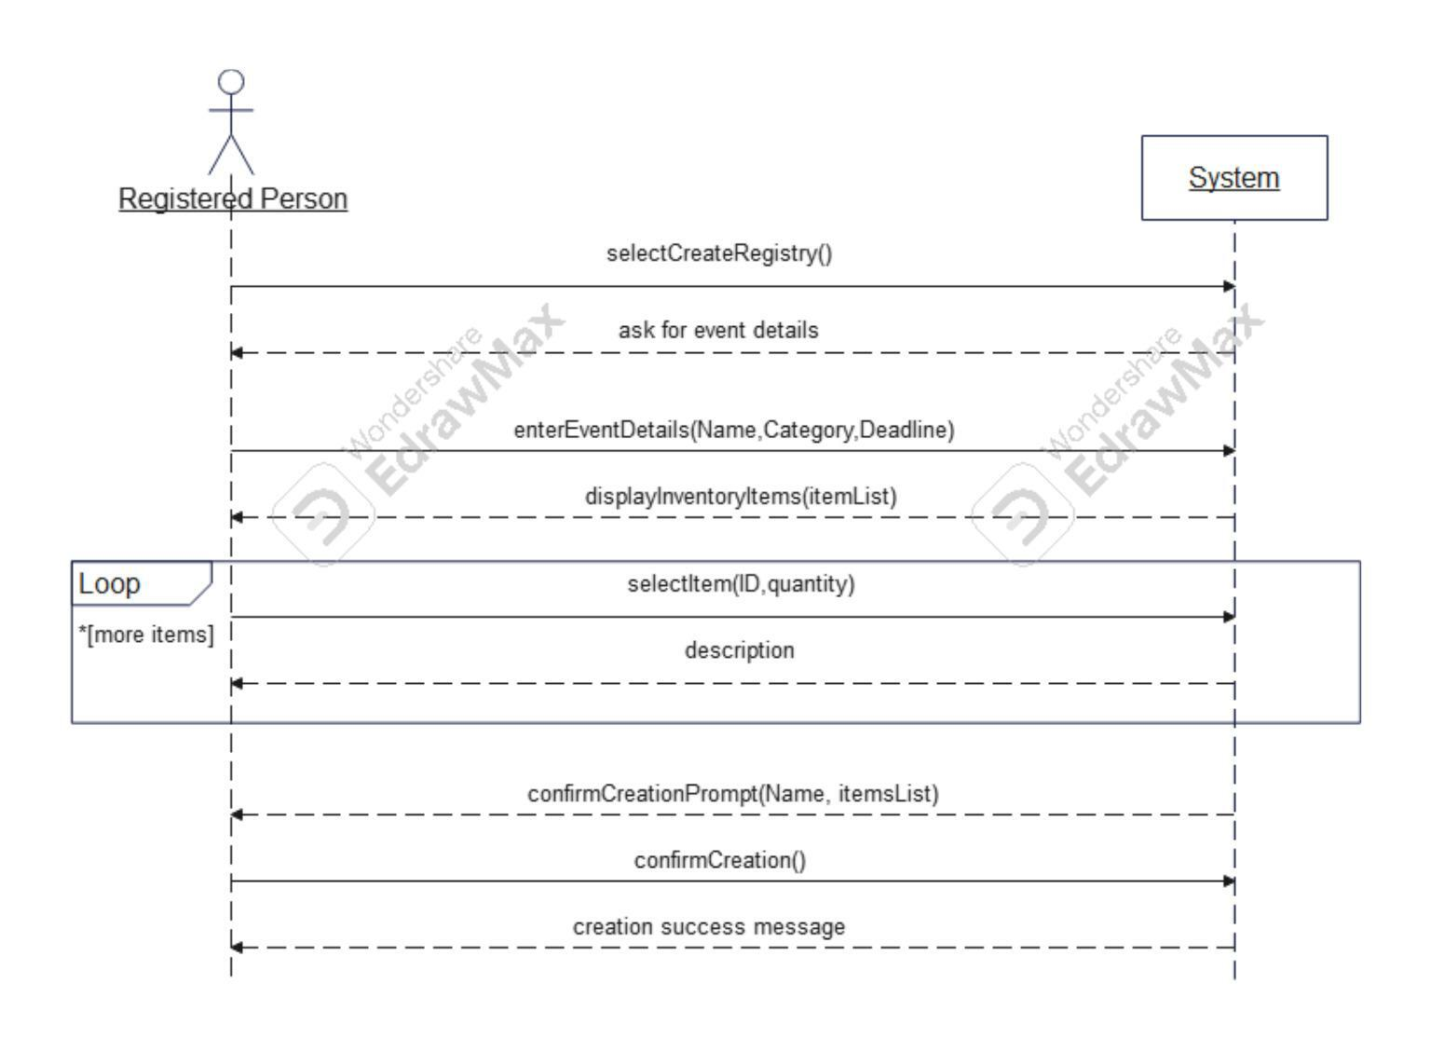

(By Faheem Khan)

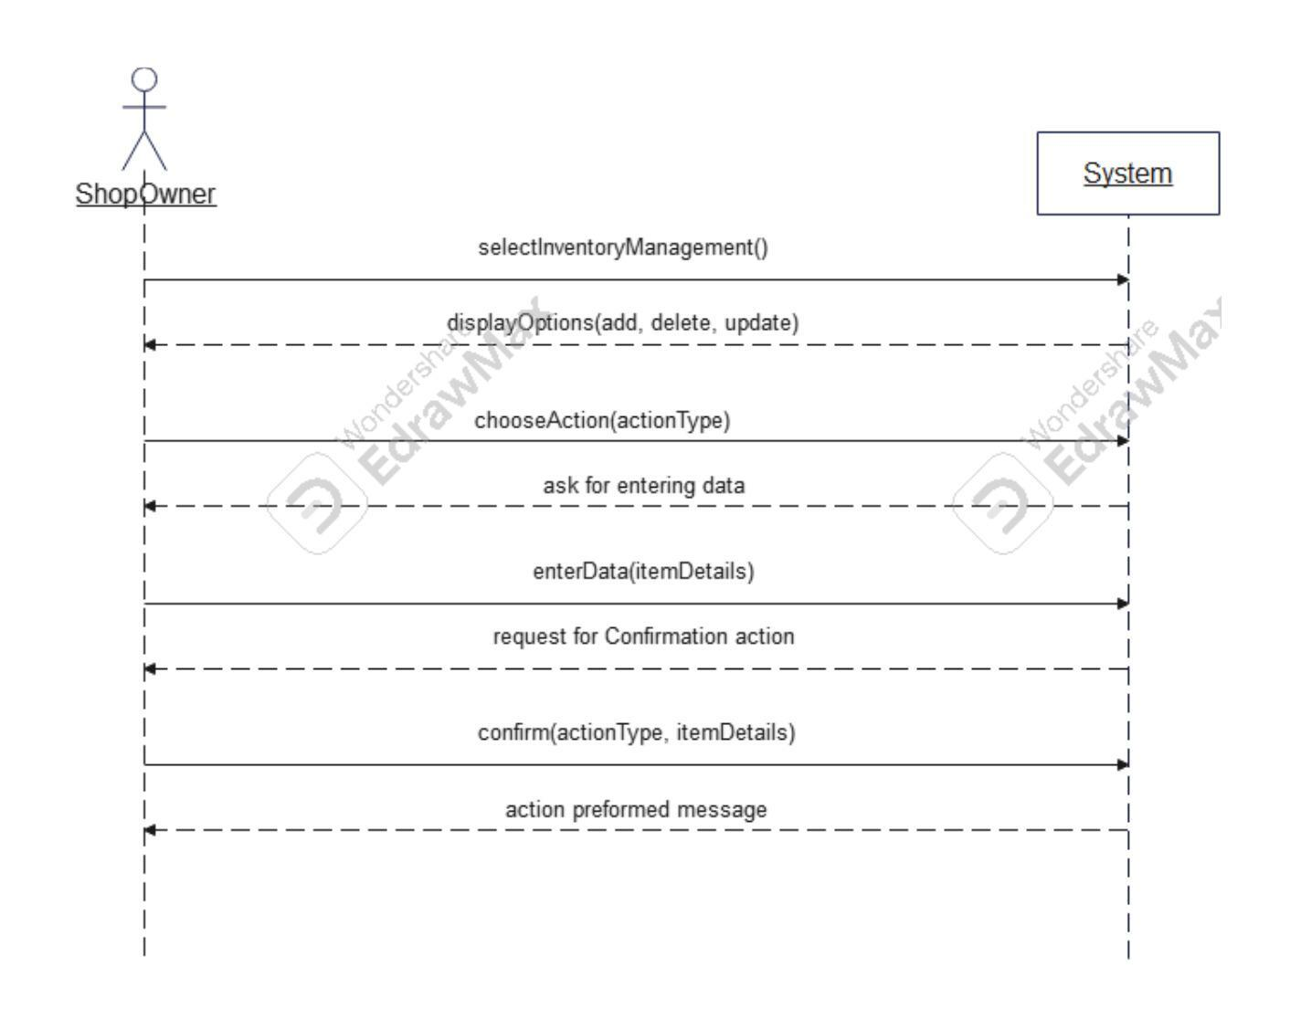

Domain Model:

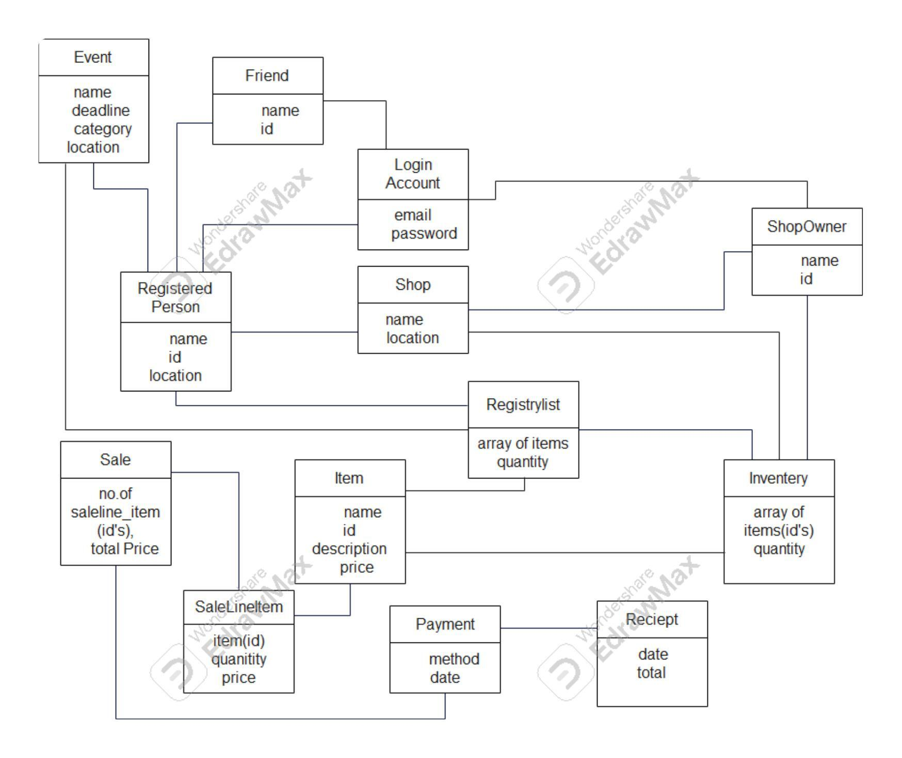

Data Dictionary:

|  |  |  |  |  |  |
| --- | --- | --- | --- | --- | --- |
| **Name** | **Alias** | **type** | **Description** | **Length** | **Constraint** |
| Account | N/A | Structure | N/A |  | N/A |
| Amount | Total, sub-total, price | Decimal | Price of item, total | (8.2) | 0.00 to 99999999.99 |
| Deadline | Date | Date | Represent date and time | 11 | N/A |
| Description | Details | String | Details of entity | 255 | N/A |
| Email | N/A | String | Use for account registration | 30 | Contains @,(gmail),(.com,.org) |
| Event | Function | Structure | Represent details about the event( wedding, birthday) |  | N/A |
| Friend | User | Structure | User which will buy gifts |  | N/A |
| Id | key | Integer | Uniquely identify object through out the system | 6 | Unique |
| Inventory | N/A | Array | List of items present in shop |  | N/A |
| Item | Gift | Structure | Represent the gift |  | N/A |
| Location | Address | String | Represent physical address | 255 | Starting from small ( house no, street , town, city) |
| Name | Title | String |  | 20 | Meaningful |
| Password | N/A | String | Will be used to login to the system | 20 | Contains Alphanumeric( lower and upper case), special characters |
| Payment | N/A | Structure | N/A |  | N/A |
| Quantity | N/A | Integer | Represent the quantity of items | 5 | 0 to 99999 |
| Registered-person | User | Structure | User which organizes the event (event owner) |  | N/A |
| Registry list | N/A | Array | List of items created by registered-person |  | It must be sub set of inventory |
| Sale | N/A | Structure | N/A |  | N/A |
| Sale line item | N/A | Structure | Represent the quantity of each item in sale |  | N/A |
| Shop | N/A | Structure | N/A |  | N/A |
| Shop owner | Shopkeeper | Structure | Owner of the shop |  | N/A |