Game Design Document

Fill up the following document

1. Write the title of your project.

Project-44 ; Make your own game-1

1. What is the goal of the game?

The goal of the game is to survive as long as possible against the horde

1. Write a brief story of your game.

A new deadly and contagious virus has been discovered which causes people to lose their brain function. The virus acts like a parasite and controls the now brain-dead carrier. It forces the person to bite or scratch other people , which infects them. Due to the easy nature of transmission, the virus has claimed a large part of the world population and most world governments have collapsed. The infected people are reffered to as “Zombies”. Finding survivors is relatively hard and most survivors stick together.

1. Which are the playing characters of this game?

* Playing characters are the ones who respond to the user based on the input from the user.
* Cars, monkeys, dinos, wizards, etc., are the playing characters in the game.

|  |  |  |
| --- | --- | --- |
| Number | Character Name | What can this character do? |
| 1 | Zombies | They are the enemies |
| 2 | Jack | Jack is a survivor who specialises in healing |
| 3 | Jill | Jill is a survivor who specialises in tinkering |
| 4 | Jim | Jim is a survivor who helps you fight against the horde. |
| 5 |  |  |
| 6 |  |  |
| 7 |  |  |
| 8 |  |  |

1. Which are the Non-Playing Characters of this game?

* Non-Playing characters are the ones that don't have an action or behavior when the user interacts with the game.
* Hurdles, stones, bananas, coins, etc., are non-playing characters in the game.

|  |  |  |
| --- | --- | --- |
| Number | Character Name | What can this character do? |
| 1 | Ammo | You can reload your weapons through ammo |
| 2 | Uzi | High rate of fire but low magazine capacity and damage |
| 3 | RPD | Big magazine but very damage and rate of fire |
| 4 | Double Barrel | High Damage but low rate of fire and magazine capacity |
| 5 | AK47 | Medium rate of fire, damage and magazine capacity |
| 6 | Medkit | Use this to heal yourself |
| 7 | Grenade | Use this utility to blast a lot of zombies |
| 8 | Machete | Use this large knife to take out zombies near you |

Draw your imagination of this game. What does this game look like?

* Draw the game either on your computer or on paper.
* Add images of the game scenes to show each of the playing and non-playing characters at least once.

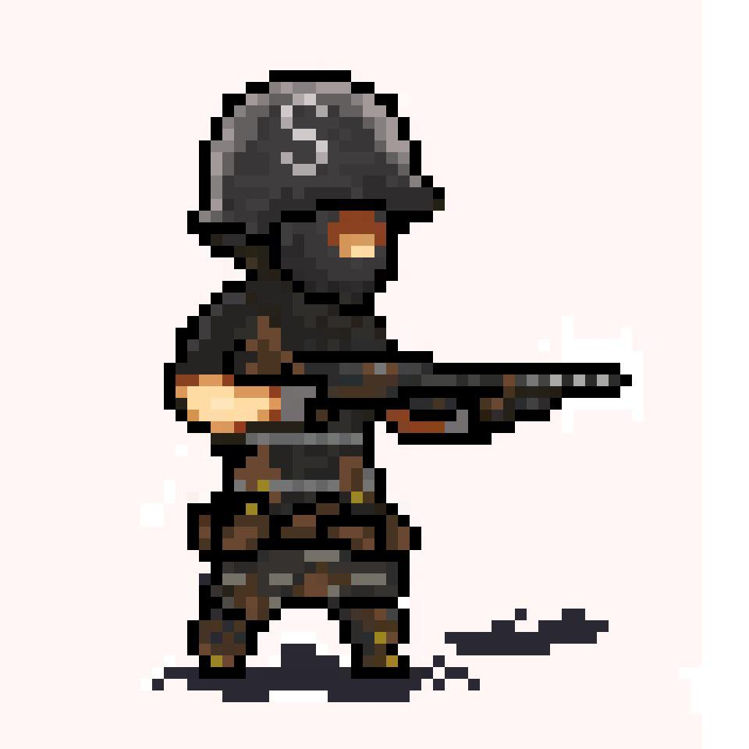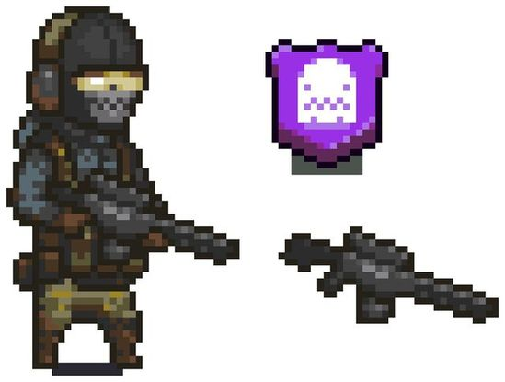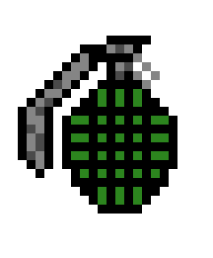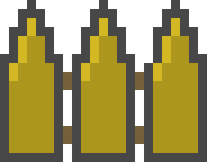

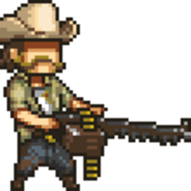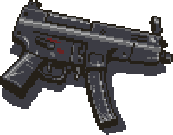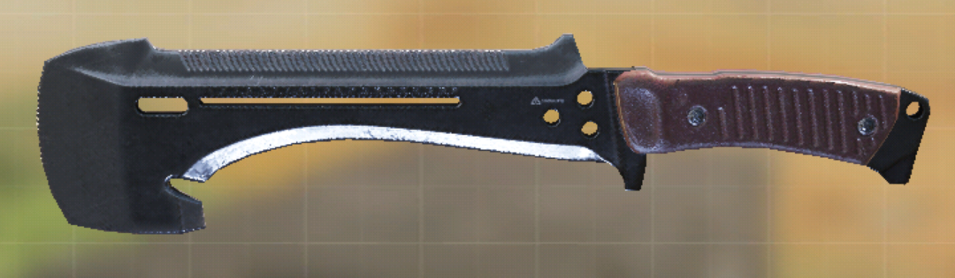

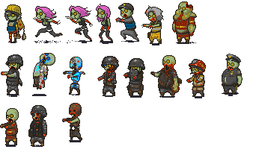

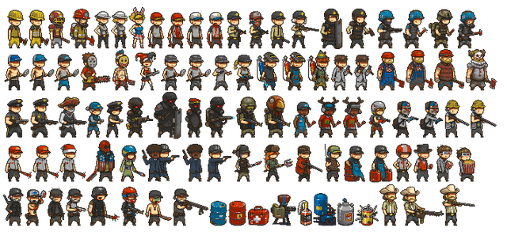

How do you plan to make your game engaging?

I plan on doing that by consistently giving the player character’s new sidekicks and new weapons. However, the zombies will get more powerful and quicker over time as well.