**Bug ID: 01**

**Title: “**Help & FAQs**” doesn’t work**

**Priority: LowSeverity: Low**

**Created by: MFA**

|  |  |  |  |
| --- | --- | --- | --- |
| **Step Numbers** | **Description** | **Expected Result** | **Actual Results** |
| 1 | Open a browser | The browser opens | The browser opens |
| 2 | Go to [demo.vuestorefront.io](http://www.facebook.com) | [demo.vuestorefront.io](http://www.facebook.com) opens | [demo.vuestorefront.io](http://www.facebook.com) opens |
| 3 | Click on “Help & FAQs” on Header | “Help & FAQs” opens up another page showing info | “Help & FAQs” does not open up |

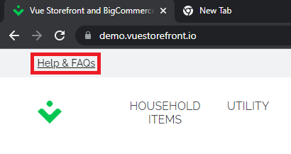

**Bug ID: 02**

**Title: “**Find out more**” doesn’t work**

**Priority: Low**

**Severity: Low**

**Created by: MFA**

|  |  |  |  |
| --- | --- | --- | --- |
| **Step Numbers** | **Description** | **Expected Result** | **Actual Results** |
| 1 | Open a browser | The browser opens | The browser opens |
| 2 | Go to [demo.vuestorefront.io](http://www.facebook.com) | [demo.vuestorefront.io](http://www.facebook.com) opens | [demo.vuestorefront.io](http://www.facebook.com) opens |
| 3 | Click on “Find out more” on Header | “Find out more” opens up another page showing info | “Find out more” doesn’t open up |

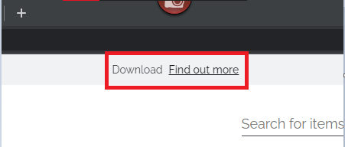

**Bug ID: 03**

**Title: “**Who we are**” doesn’t work**

**Priority: Low**

**Severity: Low**

**Created by: MFA**

|  |  |  |  |
| --- | --- | --- | --- |
| **Step Numbers** | **Description** | **Expected Result** | **Actual Results** |
| 1 | Open a browser | The browser opens | The browser opens |
| 2 | Go to [demo.vuestorefront.io](http://www.facebook.com) | [demo.vuestorefront.io](http://www.facebook.com) opens | [demo.vuestorefront.io](http://www.facebook.com) opens |
| 3 | Click on “Who we are” in ABOUT US on Footer | “Who we are” opens up another page showing info | “Who we are” does not open up |

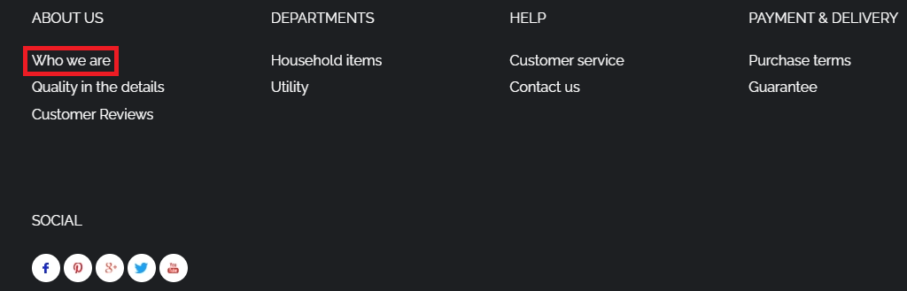

**Bug ID: 04**

**Title: “**Quality in the details**” doesn’t work**

**Priority: Low**

**Severity: Low**

**Created by: MFA**

|  |  |  |  |
| --- | --- | --- | --- |
| **Step Numbers** | **Description** | **Expected Result** | **Actual Results** |
| 1 | Open a browser | The browser opens | The browser opens |
| 2 | Go to [demo.vuestorefront.io](http://www.facebook.com) | [demo.vuestorefront.io](http://www.facebook.com) opens | [demo.vuestorefront.io](http://www.facebook.com) opens |
| 3 | Click on “Quality in the details” in ABOUT US on Footer | “Quality in the details” opens up another page showing info | “Quality in the details” does not open up |

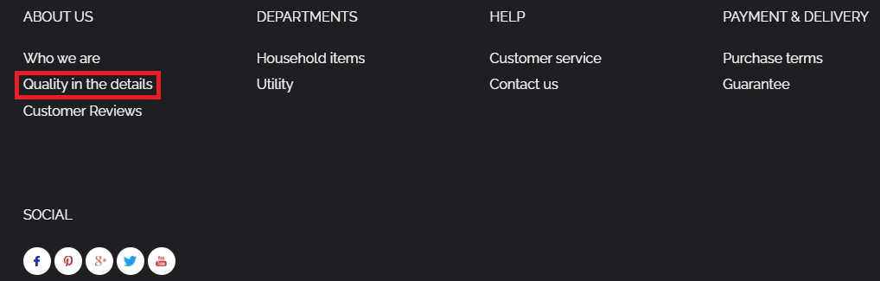

**Bug ID: 05**

**Title: “**Customer Reviews**” doesn’t work**

**Priority: Low**

**Severity: Low**

**Created by: MFA**

|  |  |  |  |
| --- | --- | --- | --- |
| **Step Numbers** | **Description** | **Expected Result** | **Actual Results** |
| 1 | Open a browser | The browser opens | The browser opens |
| 2 | Go to [demo.vuestorefront.io](http://www.facebook.com) | [demo.vuestorefront.io](http://www.facebook.com) opens | [demo.vuestorefront.io](http://www.facebook.com) opens |
| 3 | Click on “Customer Reviews” on Header | “Customer Reviews” opens up another page showing info | “Customer Reviews” does not open up |

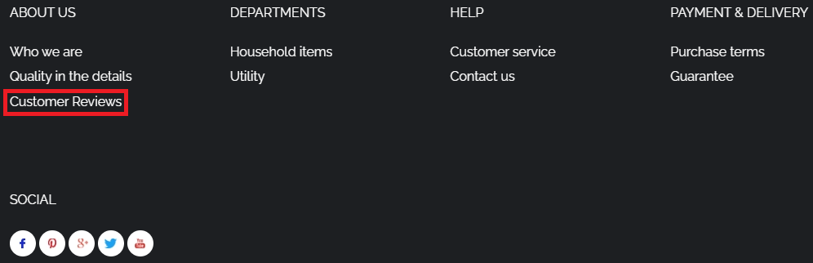

**Bug ID: 06**

**Title: “**Household items**” doesn’t work**

**Priority: Low**

**Severity: Low**

**Created by: MFA**

|  |  |  |  |
| --- | --- | --- | --- |
| **Step Numbers** | **Description** | **Expected Result** | **Actual Results** |
| 1 | Open a browser | The browser opens | The browser opens |
| 2 | Go to [demo.vuestorefront.io](http://www.facebook.com) | [demo.vuestorefront.io](http://www.facebook.com) opens | [demo.vuestorefront.io](http://www.facebook.com) opens |
| 3 | Click on “Household items” in DEPARTMENTS on Footer | “Household items” opens up another page showing info | “Household items” does not open up |

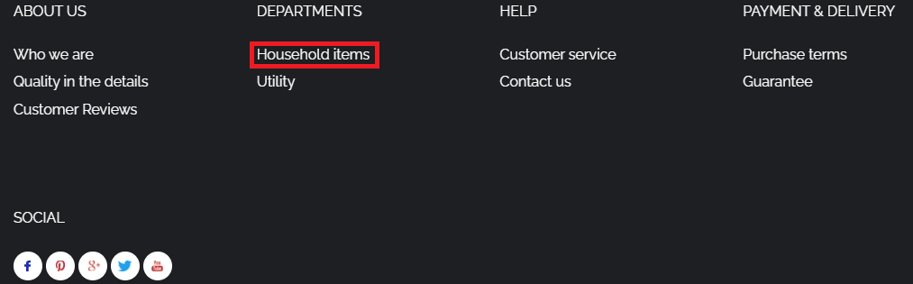

**Bug ID: 07**

**Title: “**Utility**” doesn’t work**

**Priority: Low**

**Severity: Low**

**Created by: MFA**

|  |  |  |  |
| --- | --- | --- | --- |
| **Step Numbers** | **Description** | **Expected Result** | **Actual Results** |
| 1 | Open a browser | The browser opens | The browser opens |
| 2 | Go to [demo.vuestorefront.io](http://www.facebook.com) | [demo.vuestorefront.io](http://www.facebook.com) opens | [demo.vuestorefront.io](http://www.facebook.com) opens |
| 3 | Click on “Utility” in DEPARTMENTS on Footer | “Utility” opens up another page showing info | “Utility” does not open up |

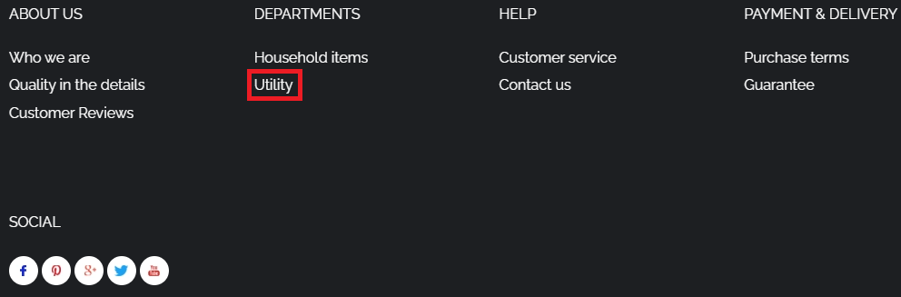

**Bug ID: 08**

**Title: “**Customer Service**” doesn’t work**

**Priority: Low**

**Severity: Low**

**Created by: MFA**

|  |  |  |  |
| --- | --- | --- | --- |
| **Step Numbers** | **Description** | **Expected Result** | **Actual Results** |
| 1 | Open a browser | The browser opens | The browser opens |
| 2 | Go to [demo.vuestorefront.io](http://www.facebook.com) | [demo.vuestorefront.io](http://www.facebook.com) opens | [demo.vuestorefront.io](http://www.facebook.com) opens |
| 3 | Click on “Customer Service” in HELP on Footer | “Customer Service” opens up another page showing info | “Customer Service” does not open up |

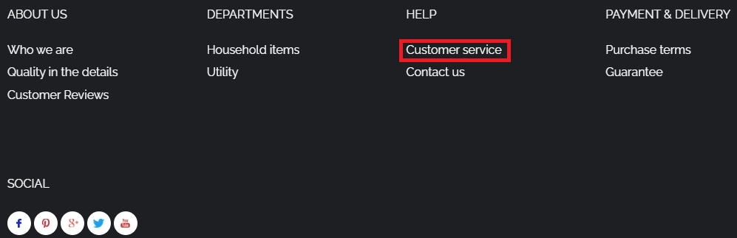

**Bug ID: 09**

**Title: “**Contact us**” doesn’t work**

**Priority: Low**

**Severity: Low**

**Created by: MFA**

|  |  |  |  |
| --- | --- | --- | --- |
| **Step Numbers** | **Description** | **Expected Result** | **Actual Results** |
| 1 | Open a browser | The browser opens | The browser opens |
| 2 | Go to [demo.vuestorefront.io](http://www.facebook.com) | [demo.vuestorefront.io](http://www.facebook.com) opens | [demo.vuestorefront.io](http://www.facebook.com) opens |
| 3 | Click on “Contact us” in HELP on Footer | “Contact us” opens up another page showing info | “Contact us” does not open up |

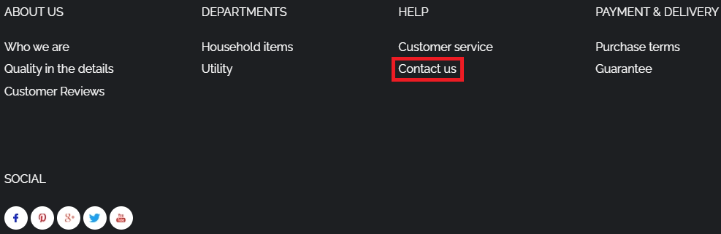

**Bug ID: 10**

**Title: “**Purchase terms**” doesn’t work**

**Priority: Low**

**Severity: Low**

**Created by: MFA**

|  |  |  |  |
| --- | --- | --- | --- |
| **Step Numbers** | **Description** | **Expected Result** | **Actual Results** |
| 1 | Open a browser | The browser opens | The browser opens |
| 2 | Go to [demo.vuestorefront.io](http://www.facebook.com) | [demo.vuestorefront.io](http://www.facebook.com) opens | [demo.vuestorefront.io](http://www.facebook.com) opens |
| 3 | Click on “Purchase terms” in PAYMENT & DELIVERY on Footer | “Purchase terms” opens up another page showing info | “Purchase terms” does not open up |

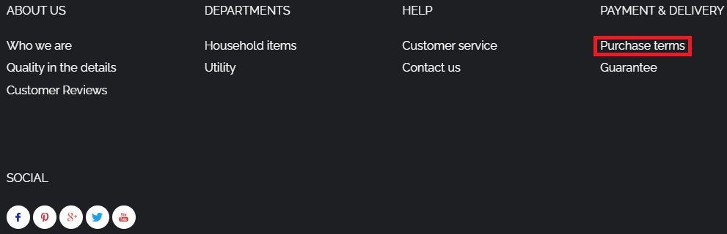

**Bug ID: 11**

**Title: “**Guarantee**” doesn’t work**

**Priority: Low**

**Severity: Low**

**Created by: MFA**

|  |  |  |  |
| --- | --- | --- | --- |
| **Step Numbers** | **Description** | **Expected Result** | **Actual Results** |
| 1 | Open a browser | The browser opens | The browser opens |
| 2 | Go to [demo.vuestorefront.io](http://www.facebook.com) | [demo.vuestorefront.io](http://www.facebook.com) opens | [demo.vuestorefront.io](http://www.facebook.com) opens |
| 3 | Click on “Guarantee” in PAYMENT & DELIVERY on Footer | “Guarantee” opens up another page showing info | “Guarantee” does not open up |

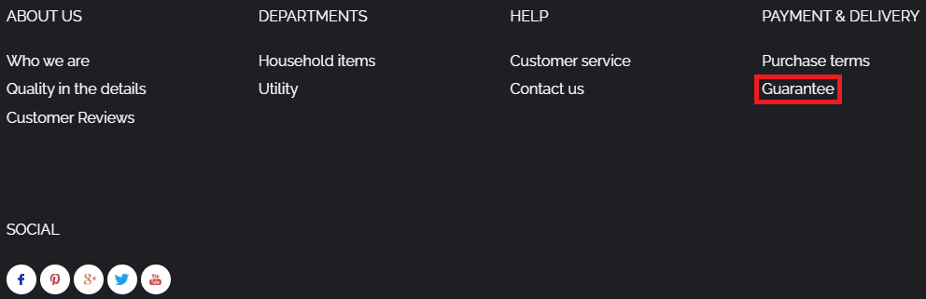

**Bug ID: 12**

**Title: “**Facebook-icon**” doesn’t lead to a link**

**Priority: Low**

**Severity: Low**

**Created by: MFA**

|  |  |  |  |
| --- | --- | --- | --- |
| **Step Numbers** | **Description** | **Expected Result** | **Actual Results** |
| 1 | Open a browser | The browser opens | The browser opens |
| 2 | Go to [demo.vuestorefront.io](http://www.facebook.com) | [demo.vuestorefront.io](http://www.facebook.com) opens | [demo.vuestorefront.io](http://www.facebook.com) opens |
| 3 | Click on “Facebook-icon” in SOCIAL on Footer | “Facebook-icon” opens up another page showing info | “Facebook-icon” does not open up |

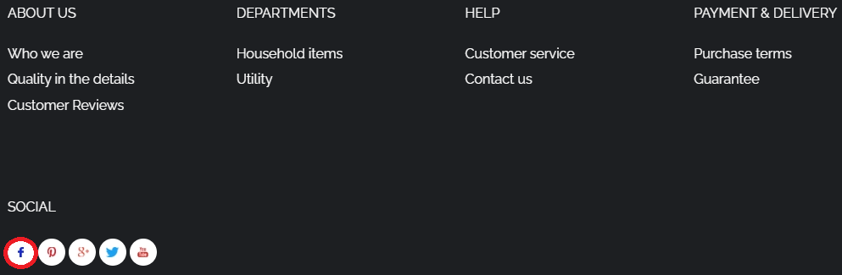

**Bug ID: 13**

**Title: “**Pinterest-icon**” doesn’t lead to a link**

**Priority: Low**

**Severity: Low**

**Created by: MFA**

|  |  |  |  |
| --- | --- | --- | --- |
| **Step Numbers** | **Description** | **Expected Result** | **Actual Results** |
| 1 | Open a browser | The browser opens | The browser opens |
| 2 | Go to [demo.vuestorefront.io](http://www.facebook.com) | [demo.vuestorefront.io](http://www.facebook.com) opens | [demo.vuestorefront.io](http://www.facebook.com) opens |
| 3 | Click on “Pinterest-icon” in SOCIAL on Footer | “Pinterest-icon” opens up another page showing info | “Pinterest-icon” does not open up |



**Bug ID: 14**

**Title: “**Google-icon**” doesn’t lead to a link**

**Priority: Low**

**Severity: Low**

**Created by: MFA**

|  |  |  |  |
| --- | --- | --- | --- |
| **Step Numbers** | **Description** | **Expected Result** | **Actual Results** |
| 1 | Open a browser | The browser opens | The browser opens |
| 2 | Go to [demo.vuestorefront.io](http://www.facebook.com) | [demo.vuestorefront.io](http://www.facebook.com) opens | [demo.vuestorefront.io](http://www.facebook.com) opens |
| 3 | Click on “Google-icon” in SOCIAL on Footer | “Google-icon” opens up another page showing info | “Google-icon” does not open up |

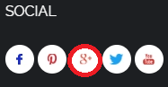

**Bug ID: 15**

**Title: “**Twitter-icon**” doesn’t lead to a link**

**Priority: Low**

**Severity: Low**

**Created by: MFA**

|  |  |  |  |
| --- | --- | --- | --- |
| **Step Numbers** | **Description** | **Expected Result** | **Actual Results** |
| 1 | Open a browser | The browser opens | The browser opens |
| 2 | Go to [demo.vuestorefront.io](http://www.facebook.com) | [demo.vuestorefront.io](http://www.facebook.com) opens | [demo.vuestorefront.io](http://www.facebook.com) opens |
| 3 | Click on “Twitter-icon” in SOCIAL on Footer | “Twitter-icon” opens up another page showing info | “Twitter-icon” does not open up |



**Bug ID: 16**

**Title: “**YouTube-icon**” doesn’t lead to a link**

**Priority: Low**

**Severity: Low**

**Created by: MFA**

|  |  |  |  |
| --- | --- | --- | --- |
| **Step Numbers** | **Description** | **Expected Result** | **Actual Results** |
| 1 | Open a browser | The browser opens | The browser opens |
| 2 | Go to [demo.vuestorefront.io](http://www.facebook.com) | [demo.vuestorefront.io](http://www.facebook.com) opens | [demo.vuestorefront.io](http://www.facebook.com) opens |
| 3 | Click on “YouTube-icon” in SOCIAL on Footer | “YouTube-icon” opens up another page showing info | “YouTube-icon” does not open up |



**Bug ID: 17**

**Title: “**Subscription**” button accepts null email**

**Priority: Low**

**Severity: Medium**

**Created by: MFA**

|  |  |  |  |
| --- | --- | --- | --- |
| **Step Numbers** | **Description** | **Expected Result** | **Actual Results** |
| 1 | Open a browser | The browser opens | The browser opens |
| 2 | Go to [demo.vuestorefront.io](http://www.facebook.com) | [demo.vuestorefront.io](http://www.facebook.com) opens | [demo.vuestorefront.io](http://www.facebook.com) opens |
| 3 | Click on “Subscribe” button on Subscribe to Newsletter | Pop-up opens to enter email | Pop-up opens to enter email |
| 4 | Keep E-Mail section empty | E-Mail section is empty | E-Mail section is empty |
| 5 | Press “I Confirm Subscription” button on pop-up | The System shows message to enter a valid email/email is empty | System confirms null subscription and closes pop-up |

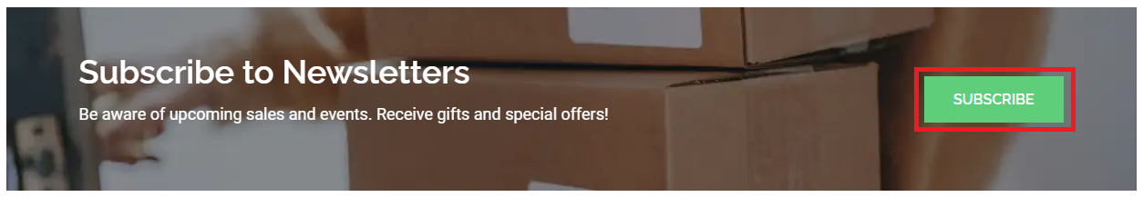

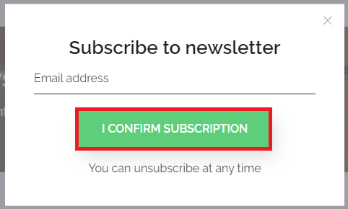

**Bug ID: 18**

**Title: “**Websites takes dummy/unregistered emails on checkout page, when continue as a guest**”**

**Priority: Low**

**Severity: Medium**

**Created by: MFA**

|  |  |  |  |
| --- | --- | --- | --- |
| **Step Numbers** | **Description** | **Expected Result** | **Actual Results** |
| 1 | Open a browser | The browser opens | The browser opens |
| 2 | Go to [demo.vuestorefront.io](http://www.facebook.com) | [demo.vuestorefront.io](http://www.facebook.com) opens | [demo.vuestorefront.io](http://www.facebook.com) opens |
| 3 | Add Items in cart | Items are added in cart | Items are added in cart |
| 4 | Add “dummy/unregistered” email | Dummy E-Mail is shown | Dummy E-Mail is shown |
| 5 | Press “Continue as a guest” in customer section | The System shows message to enter a valid email | System shows next section |

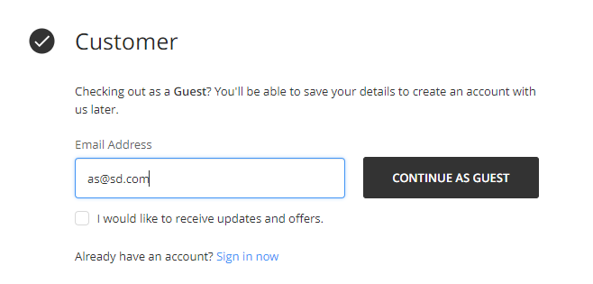

**Bug ID: 19**

**Title: “**First Name & Last Name Accept Numbers only**”**

**Priority: Low**

**Severity: Medium**

**Created by: MFA**

|  |  |  |  |
| --- | --- | --- | --- |
| **Step Numbers** | **Description** | **Expected Result** | **Actual Results** |
| 1 | Open a browser | The browser opens | The browser opens |
| 2 | Go to [demo.vuestorefront.io](http://www.facebook.com) | [demo.vuestorefront.io](http://www.facebook.com) opens | [demo.vuestorefront.io](http://www.facebook.com) opens |
| 3 | Add Items in cart | Items are added in cart | Items are added in cart |
| 4 | Add “dummy/unregistered” email | Dummy E-Mail is shown | Dummy E-Mail is shown |
| 5 | Press “Continue as a guest” in customer section | The System shows message to enter a valid email | System shows next section |
| 6 | Enter “Numbers” in first and last name | “Numbers” display in first and last name sections showing invalid input | “Numbers” display in first and last name sections showing valid input |

