Application

KAF Self-Onboarding Dashboard

Module

Security & User Management

Business Process

Notification & Alert

Reporting

Administration

Document Type

User Functional Acceptance

Document Description

KAF Self-Onboarding Dashboard Documentation.

Prepared by

Information Technology Department

KAF Investment Bank Berhad

Application 1

KAF Self-Onboarding Dashboard 1

Module 1

Document Type 1

Prepared by 1

Information Technology Department 1

SYSTEM SPECIFICATION 3

**1.0 Introduction 3**

**1.1 Goal and Objective 4**

**1.2 Scope of System Statement 4**

**1.3 System Context 5**

**2.0 Functional and Data Description 5**

**2.1 System Architecture 5**

**2.2 System Components (Technology Requirements) 7**

**3.0 Software Requirements 8**

**3.1 Server Side 8**

**3.2 Client Side 9**

**4.0 System Workflow Design 9**

**5.0 Feature Requirements 14**

**5.1 Page Access and Visibility 14**

**5.2 Actions Based on Roles 15**

**6.0 Acknowledgement and Acceptance 18**

# SYSTEM SPECIFICATION

## 1.0 Introduction

KAF Self-Onboarding Dashboard System aims to provide an online on-and-off boarding platform for HR representatives to execute tasks that involve hiring new employees, staff transfer management and handling staff resignations with minimal efforts and risks through process automation system. In addition, the scope of use of this dashboard system allows various roles of users from different KAF departments to perform actions within a system, which includes submitting a request form, creating a system access for user, approving a request form, creating a custom generated form and changing system access right of user.

Self-Onboarding Dashboard will provide an internal service platform for KAF staff, where the access to features and functionalities based on user roles such as Human Resources (HR), IT Head of Department (IT HoD), Head of Department (HoD), Helpdesk (HD), Network and New Employee. In summary, HR users can only have access to certain pages and forms with some features that are corresponding to their role. IT HoD user can have access to authority actions such as rejection and approval on a form. The helpdesk users will have access to pages with features for form assignments, and the new employee will have access to pages with required form submissions to complete the process.

### 1.1 Goal and Objective

The main goal for this project is to develop an online-automated onboarding dashboard that has specific features and functionalities for users to initiate a certain process via fully automated forms as a mechanism in a system without requiring manual procedure to achieve the objectives of the process.

The dashboard will have features to display user case logs (approval, acceptance, and rejection) in the Main page. It provides functions for process-related forms such as on-boarding and off-boarding forms, netword lan id form, email account form, network and communication usage policy form, two-step verification and user acceptance form, application access right request form and application.

### 1.2 Scope of System Statement

KAF Self-Onboarding Dashboard is a web-based application that is developed and developed by KAF IT department as a service for internal use of business management purposes.

The purpose of this system to optimize the efficiency of the processes involving new hiring, employee exit management and user change management with minimal efforts and risks. Thus, it improves productivity due to quick processing and data sharing without using many resources.

It is used by KAF Group staff from different departments where its usage and accessibility is based on user roles given to the relevant employees. The roles mainly involve Human Resources, IT Head of Department, Head of Department, Helpdesk, Network and New Employee. Each user can view the dashboard that consist of functional components such as user case logs, forms and report log.

### 1.3 System Context

In order to make the smooth transition to an entire KAF Self-Onboarding Dashboard, one needs to see some strategic issues:

* What is the structure in the system and how can it handle the organization task?
* What are the user roles and organization in leveraging and supporting this KAF Self-Onboarding Dashboard system?

## 2.0 Functional and Data Description

### 2.1 System Architecture

System architecture is shown as below.

Figure : System architecture

System Interfaces

Security & User Management Module

Security & User Management

Data Access Layer

Other Operations

Common Operation Manager

Data Layer

Business Services

Notification & Alert Module

Notification & Alert

Messaging gateway

Templates Manager

Data Access Layer

Reporting Module

Reporting

Data Access Layer

Business Logic Module

Assessments & Services

Data Access Layer

Other Operations

Administration Module

Administration

Data Access Layer

Other Operations

Data Source

Database

XML

Data Access Components

Data Helpers / Utilities

UI Components

UI Process Components

KAF Self-Onboarding Dashboard is designed using N-tier architecture. *N-tier* data applications are data applications that are separated into multiple *tiers*. Also called "distributed applications" and "multi-tier applications," n-tier applications separate processing into discrete tiers that are distributed between the client and the server.

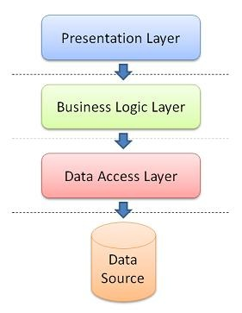

Figure : N-tier Application Architecture

### 2.2 System Components (Technology Requirements)

#### 2.2.1 Presentation Layer

The top-most level of the application is the *presentation tier* (User Interface) which users interact with an application. The main function of the interface is to translate tasks and results to something so that the user can understand.

This web application is built using .NET technology, which is .NET framework 4.x.x, ASP.NET Web Forms model and Bootstrap as the presentation layer.

Bootstrap is currently the most popular front-end web framework for developing responsive web applications. It offers a number of features and benefits that can improve your user experience with your web site, whether you are a novice at front-end design and development or an expert. Bootstrap is deployed as a set of CSS and JavaScript files, and it is used to help the design of website or application scale efficiently from phones to tablets to desktops in responsive manner. Current version of framework would be v4.0.

For this development, AdminLTE template is used to construct and build the user interface design of the dashboard system. Built on top of Bootstrap, AdminLTE provides a range of responsive, reusable, and commonly used components.

#### 2.2.2 Business Logic Layer

This layer coordinates the application, processes commands, makes logical decisions and evaluations, and performs calculations. It also moves and processes data between the two surrounding layers. This layer contains all application business logics.

#### 2.2.3 Data Access Layer

This layer is to stored and retrieved information from database or file system. The information is then passed back to the logic tier for processing, and then eventually back to the users. KAF Self-Onboarding Dashboard is built using Microsoft SQL Server and XML files as data storage.

## 3.0 Software Requirements

### 3.1 Server Side

* Internet Information Services (IIS)
* .NET Framework 4.0
* ASP.NET Web Forms
* Bootstrap framework (Responsive web design) – AdminLTE
* Microsoft SQL Server

### 3.2 Client Side

* Web browser (Cross browsers and cross devices)

## 4.0 Workflow System Designs

Following is an example of workflow of KAF Self-Oboarding Dashboard system for the staff on-boarding process.

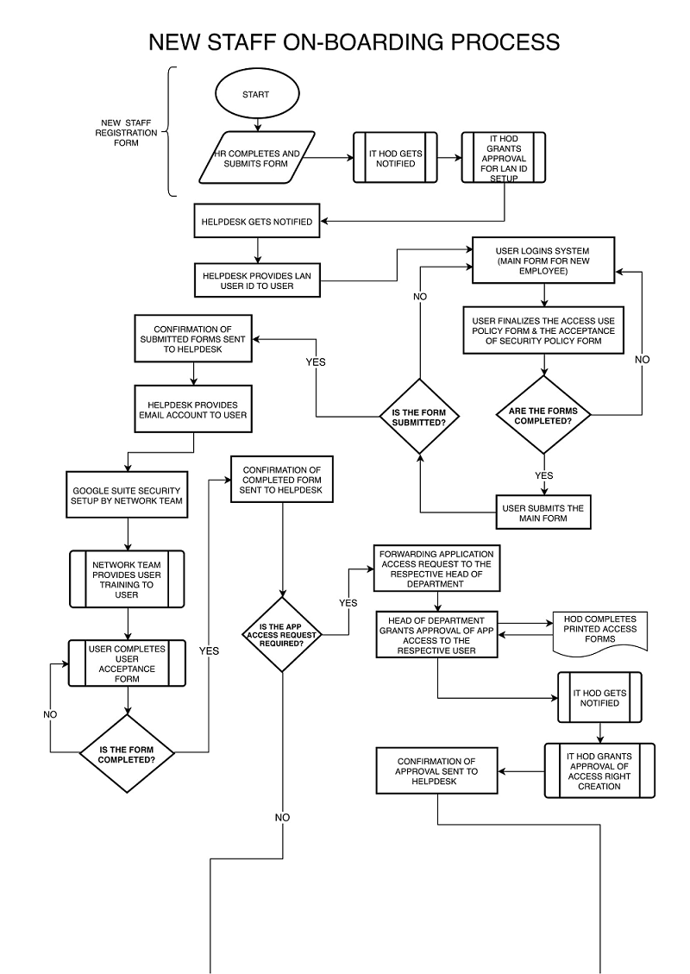

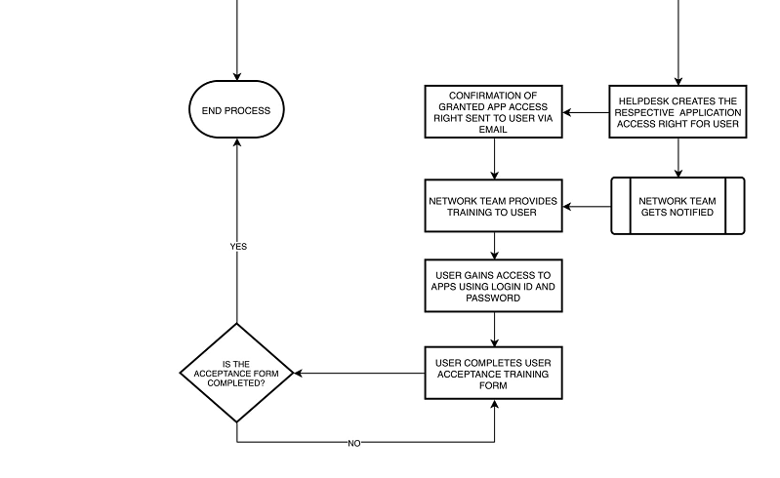

Below is an example of workflow for the user change management process.

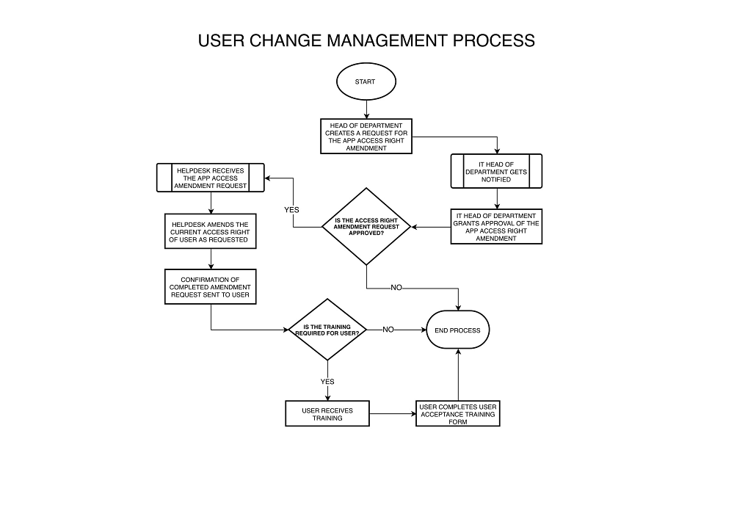

Below is an example of workflow for the staff off-boarding process.

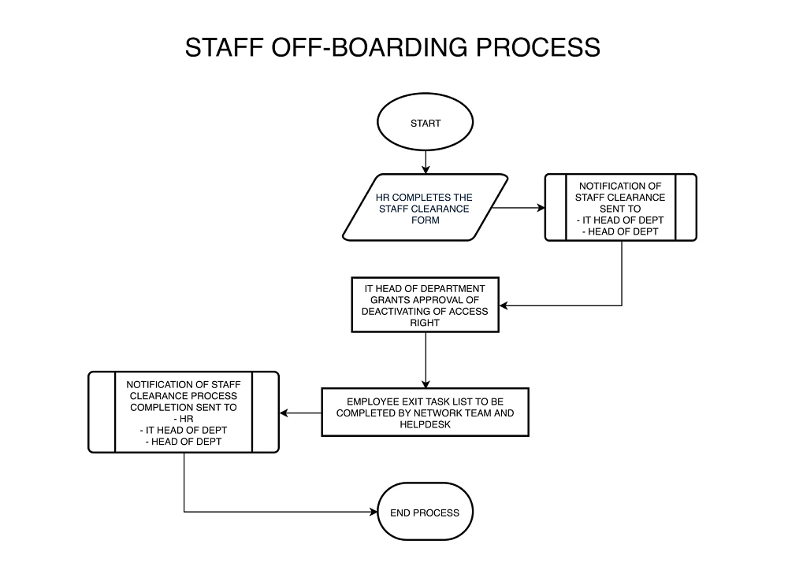

## 5.0 Feature Requirements

At this stage, according to information collected from the product owner, the features and functionalities are required in the Dashboard System are as follows;

### 5.1 Page Access and Visibility

The page access to a system is designed according to different roles of users, which includes Human Resources, IT Head of Department, Head of Department, Helpdesk, Network and New Employee. The possible features may vary in given roles.

#### 5.1.1 Main Page View

* It displays the user case logs with accordion functionality. They may vary in various roles
* Approval case: it records a list of pending request forms for approval.
* Acceptance case: it records a list of approved forms after review.
* Rejection case: it records a list of rejected forms after review.
* New incoming case: it records a list of new cases.
* Menu navigation bar with access to the form-related features based on given roles

#### 5.1.2 Human Resources

* New staff on-boarding form
* Staff off-boarding form / Employee exit form
* New form creation request form

#### 5.1.3 IT Head of Department

* Staff on-boarding approval form
* Staff off-boarding approval form
* Application access right approval form
* Application access right amendment form
* New form creation request form

#### 5.1.4 Head of Department

* Application access right request form
* Application access right amendment form
* New form creation request form

#### 5.1.5 Helpdesk

* Network lan id form
* Email account form
* Application access right request form
* New form creation request form

#### 5.1.6 Network/New Employee

* Two step verification form
* User acceptance form (new employee)
* Network and communication usage policy form (new employee)

### 5.2 Actions Based on Roles

#### 5.2.1 Human Resources

* New Employee Registration
* Create a form for staff registration.
* Submit the form & notify IT HOD.
* Check & review the form submission history on the case log.
* Staff Off-Boarding
* Create a form for the staff clearance.
* Submit the form & notify IT HOD & user’s HOD.
* Check & review the form submission on the case log.
* Receive notification about the completion of staff registration & staff clearance.

#### 5.2.2 IT Head of Department

* Registration Staff On-Boarding
* Receive notification about a new registration form.
* Approve & decline the approval form of LAN ID submission.
* Approve & decline the approval request of app access right creation.
* Check & review the approval history on the case log.
* Application Access Right Amendment
* Approve & decline the approval form of app access right amendment.
* Check & review the approval history on the case log.
* Staff Off-Boarding
* Receive notification about a staff clearance form.
* Approve or decline the approval form of deactivating of app access right for user.
* Check & review the approval history on the case log.

#### 5.2.3 Head of Department

* Registration Staff On-Boarding
* Review the approval of application access right request form.
* Approve or decline the application access right request.
* Check & review the approval forms history on the case log.
* Application Access Right Amendment
* Create a request form for application access right amendment.
* Staff Off-Boarding
* Receive notification about a staff clearance form.
* Receive notification about a completed clearance process.

#### 5.2.4 Helpdesk

* Registration Staff On-Boarding
* Receive notification about a new approval.
* Create a new LAN ID form for user.
* Create a new Email Account for user.
* Create a new Application Access Right request.
* Check & review the approval history on the case log.
* Application Access Right Amendment
* Receive notification about a new approval of the app access right amendment.
* Staff Off-Boarding
* Receive notification about an approval of deactivating of app access right.

#### 5.2.5 Network/User

* Registration Staff On-Boarding
* ** Complete and submit the network and communication usage policy form.
* * Complete & submit the user acceptance form for 2-step verification system.
* ** Check & review the completed forms history on the case log.
* Application Access Right Amendment
* ** Receive notification about a new approval of the app access right amendment.
* ** Complete & submit the user acceptance form for application access right amendment.
* ** Check & review the completed forms history on the case log.

|  |
| --- |
| ** Only applies to User (New Employee) |
| * Only applies to Network |

## 6.0 Acknowledgement and Acceptance

|  |  |
| --- | --- |
| **Developer:** | **Developer:** |
| Signature | Signature |
| Name : | Name : |
| Date : | Date : |
|  |  |

|  |
| --- |
| **Requester:** |
| Signature |
| Name : |
| Date : |
|  |

|  |  |
| --- | --- |
| **Project Manager (Business):** | **Project Manager (IT):** |
| Signature | Signature |
| Name : | Name : |
| Date : | Date : |
|  |  |

|  |
| --- |
| **Manager Application Development:** |
| Signature |
| Name : |
| Date : |

|  |
| --- |
| **Approved By:** |
| Signature |
| **Head of Group IT** |
| Name : Mr Abdul Saheed |
| Date : |