Carbon Transition in Asian Economies: Spatial patterns and environmental economic relationships from 1990 to 2023
05-November, 2026
Muhammad Hamid Khan
muhammadhamidkhan2224@gmail.com
MS Business Analytics
National University of Computer and Emerging Sciences, Islamabad

Data Geographic Scope and Estimation Sample
Measure | Published unit | 2023 observations
CO2 per capita (co2_pc_t) | t CO2e per capita | 49
Total CO2 excluding LULUCF | Mt CO2e | 49
Total GHG excluding LULUCF | Mt CO2e | 49
Total GHG including LULUCF | Mt CO2e | 43
Renewable final-energy share | % of total final energy consumption | 50
Renewable electricity output | % of total electricity output | 0
Fossil energy share | % of total energy use | 44
Energy use per capita | kg of oil equivalent per capita | 44
Primary energy intensity | MJ per constant 2021 PPP US$ GDP | 50
Forest coverage | % of land area | 48
Electricity access | % of population | 50
Renewable generating capacity | watts per capita | 49
GDP per capita | constant 2015 US$ per capita | 47
Urban population | % of total population | 50
Industry value added | % of GDP | 47
Trade | % of GDP | 43
Population | people | 50

Changing Emission Landscape

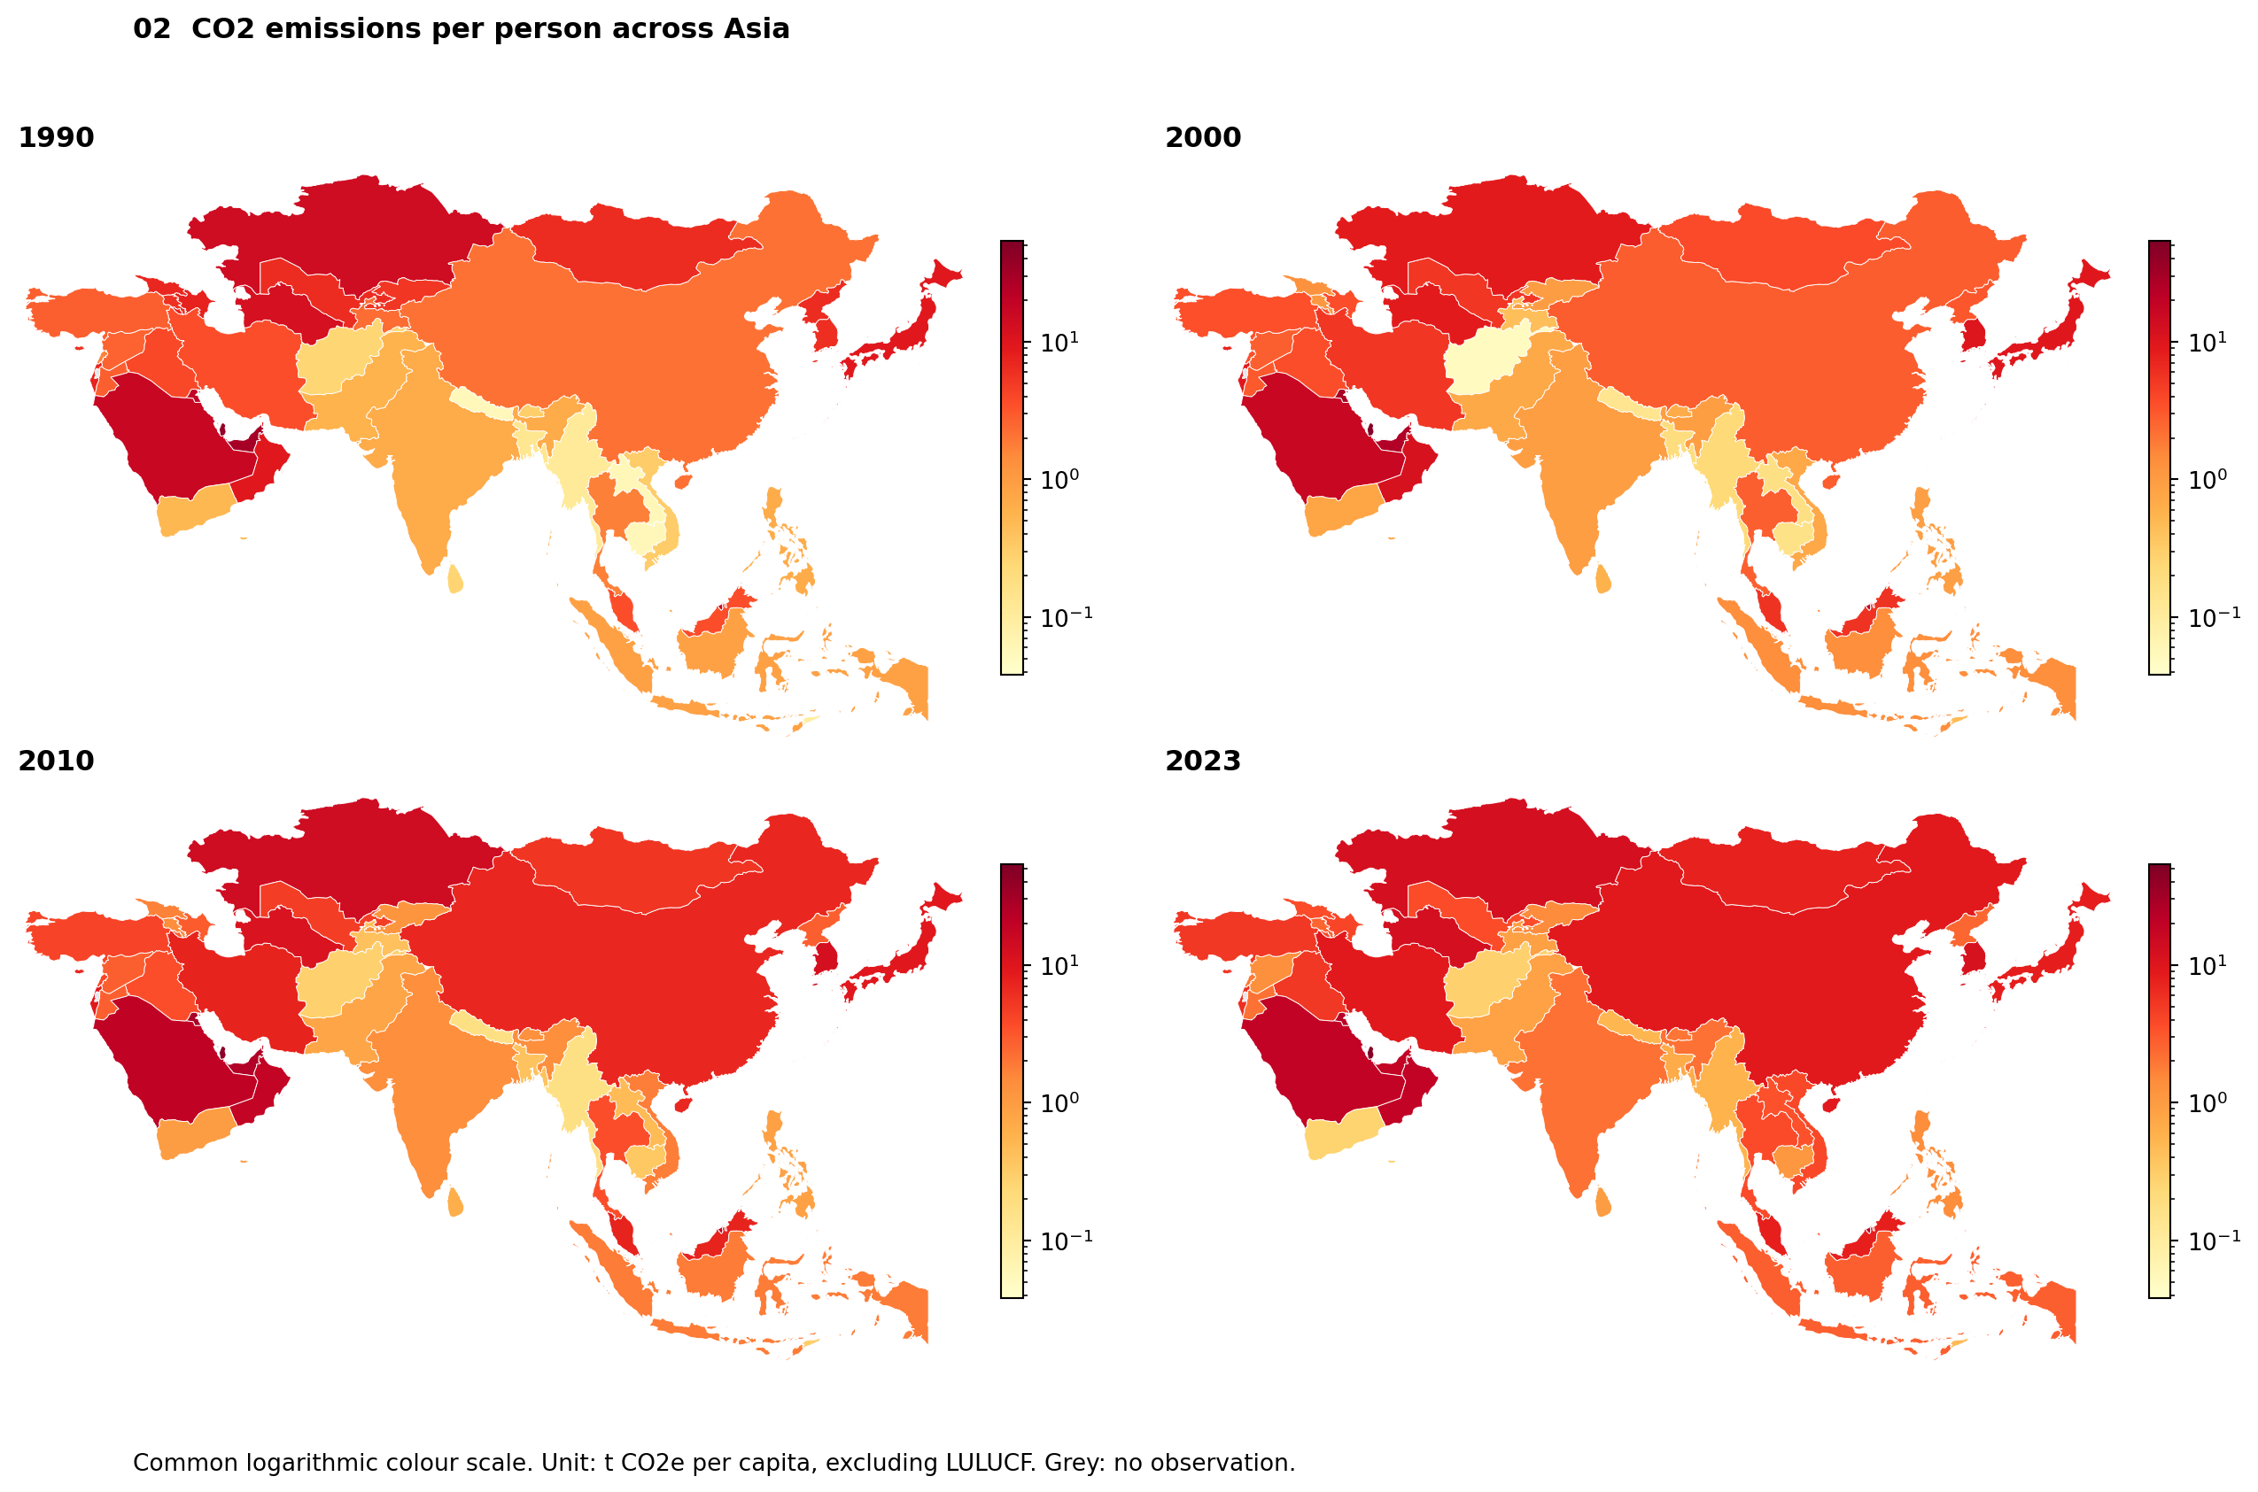
Figure 2. Country-level CO2 emissions per capita in 1990, 2000, 2010 and 2023, using a common scale. Land-use emissions and removals are excluded.

Carbon Emission Decrease and Increase
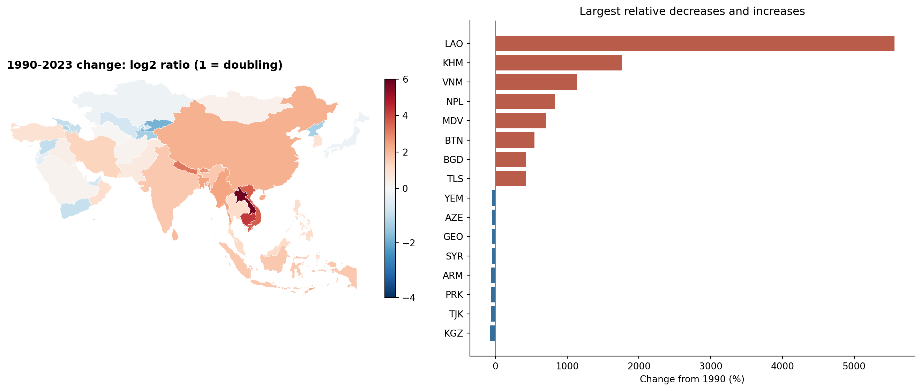
Figure 3. Bars retain actual percent changes in the same 49 economies. A low starting level can produce a large percentage increase.

Renewable Consumption and Energies Efficiency Landscape with varying Transition
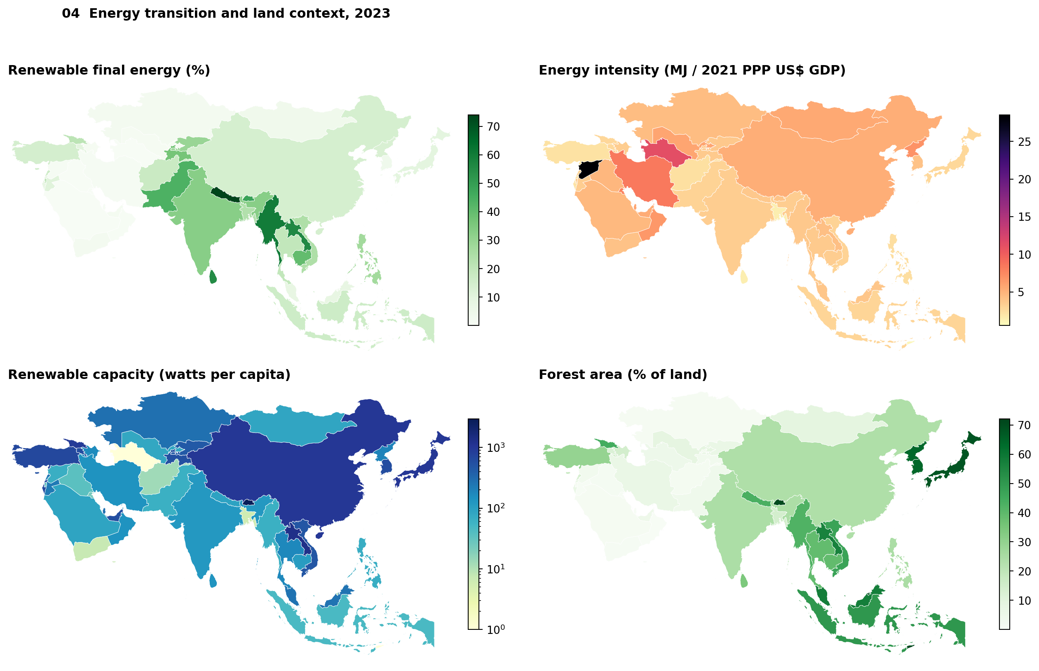
Figure 4. Renewable consumption includes traditional biomass.

Emissions per person and Total Emissions

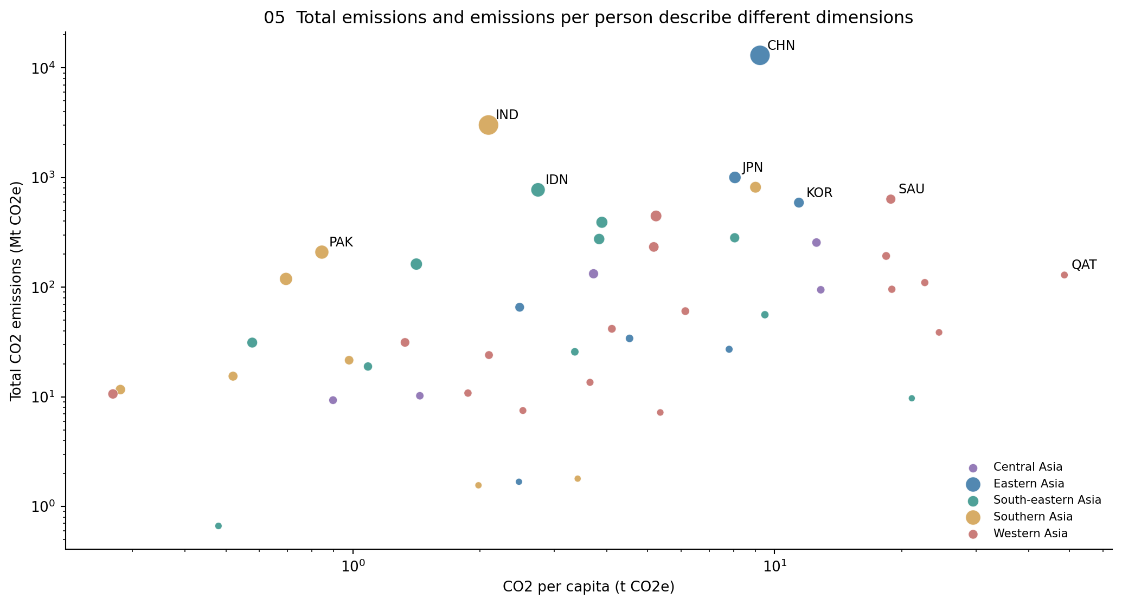

Different Regional Paths
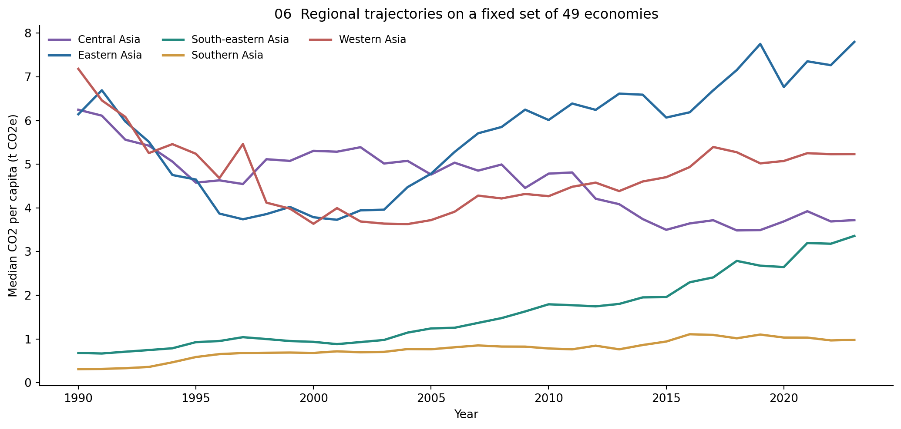
Figure 6. Weight to economies and use a fixed emission.

Countries Connected in the Model

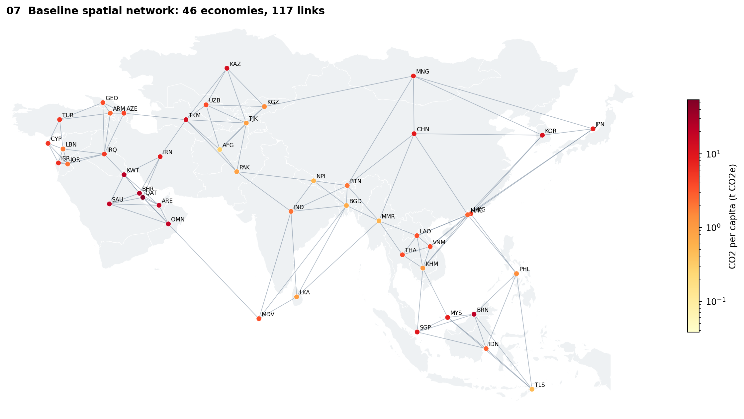
Figure 7. Country-centroid points outside multi-island countries.

Geographic Clustering
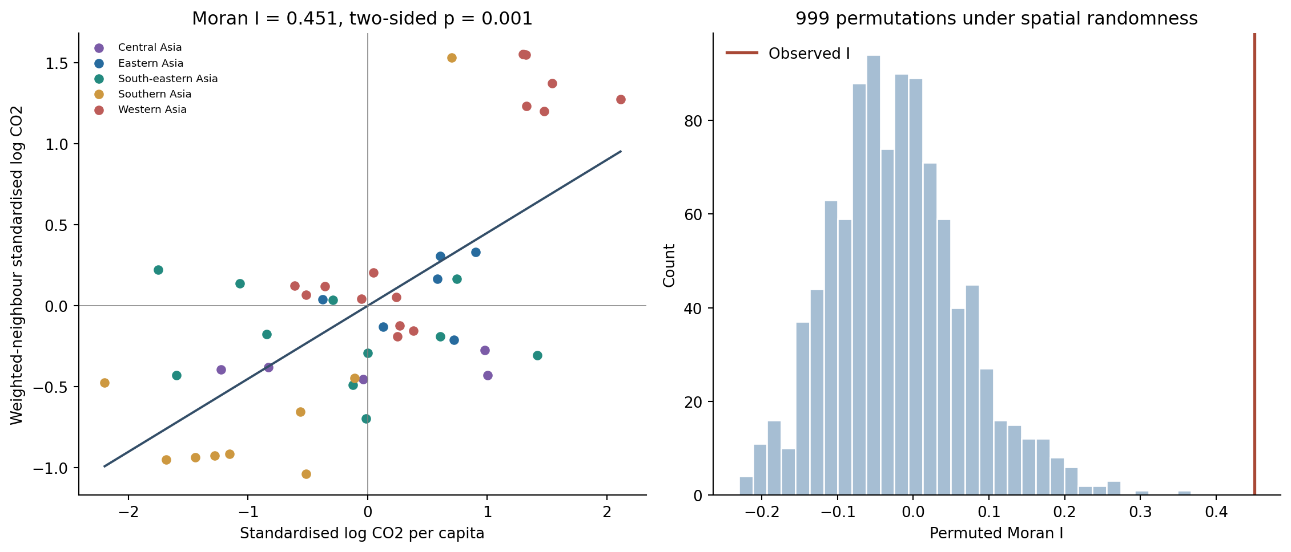

Clustering Across the Full 1990 2023 Period.

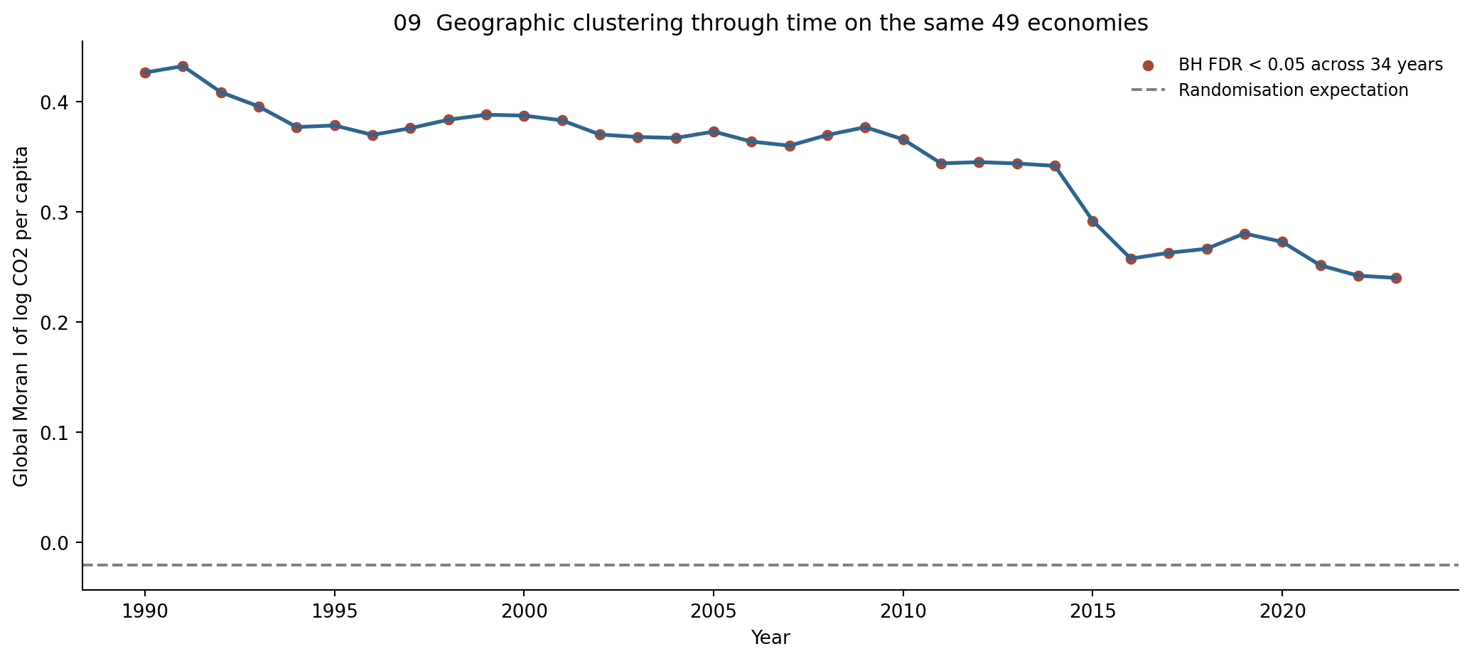
Figure 9. Moran statistics are distinct from the 46-economy

Local High Emission and Low Emission Clusters

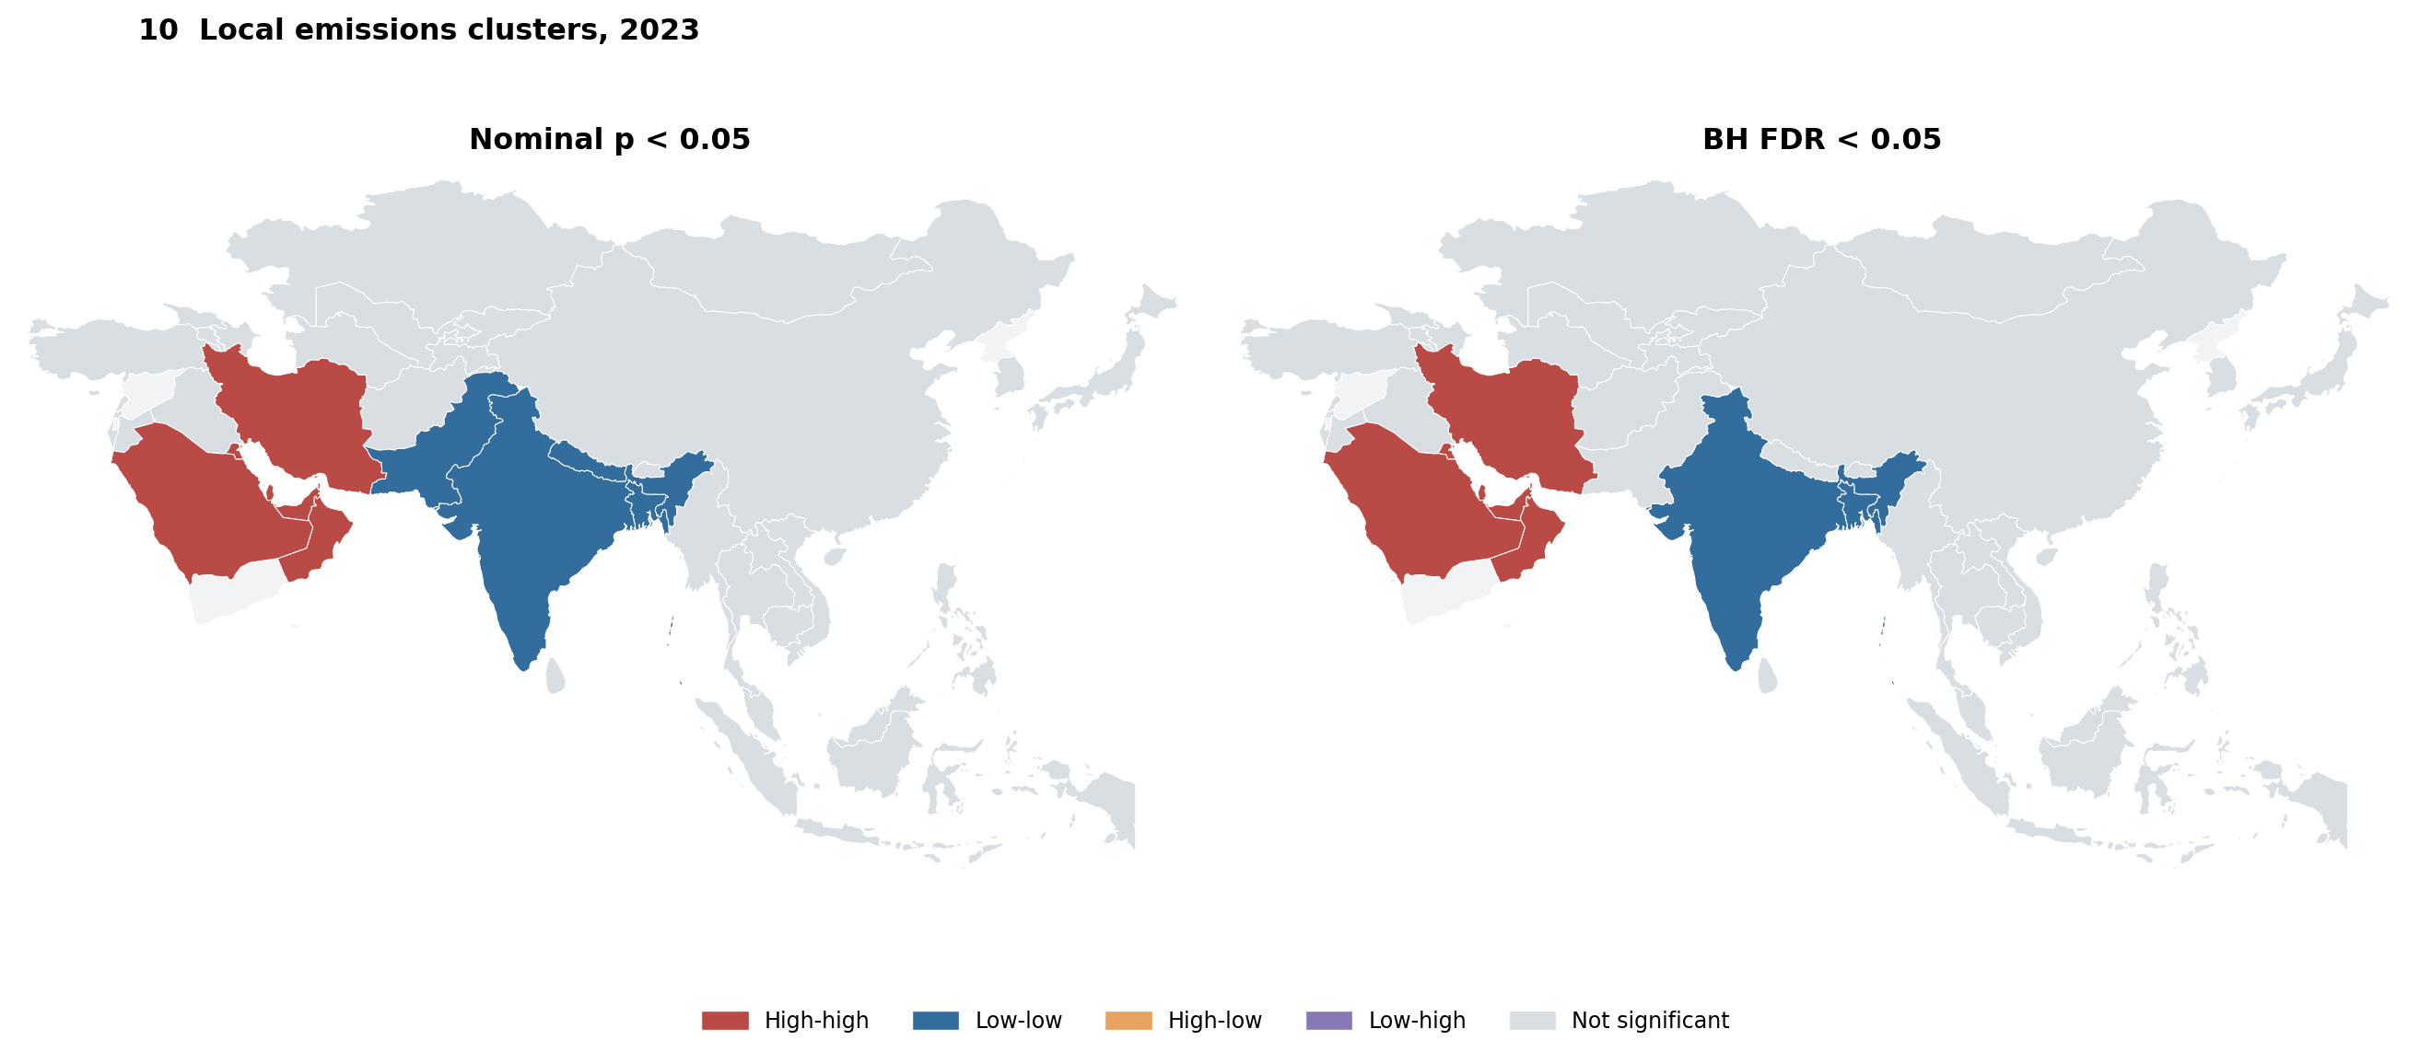

Relationships within and Across Neighboring Economies
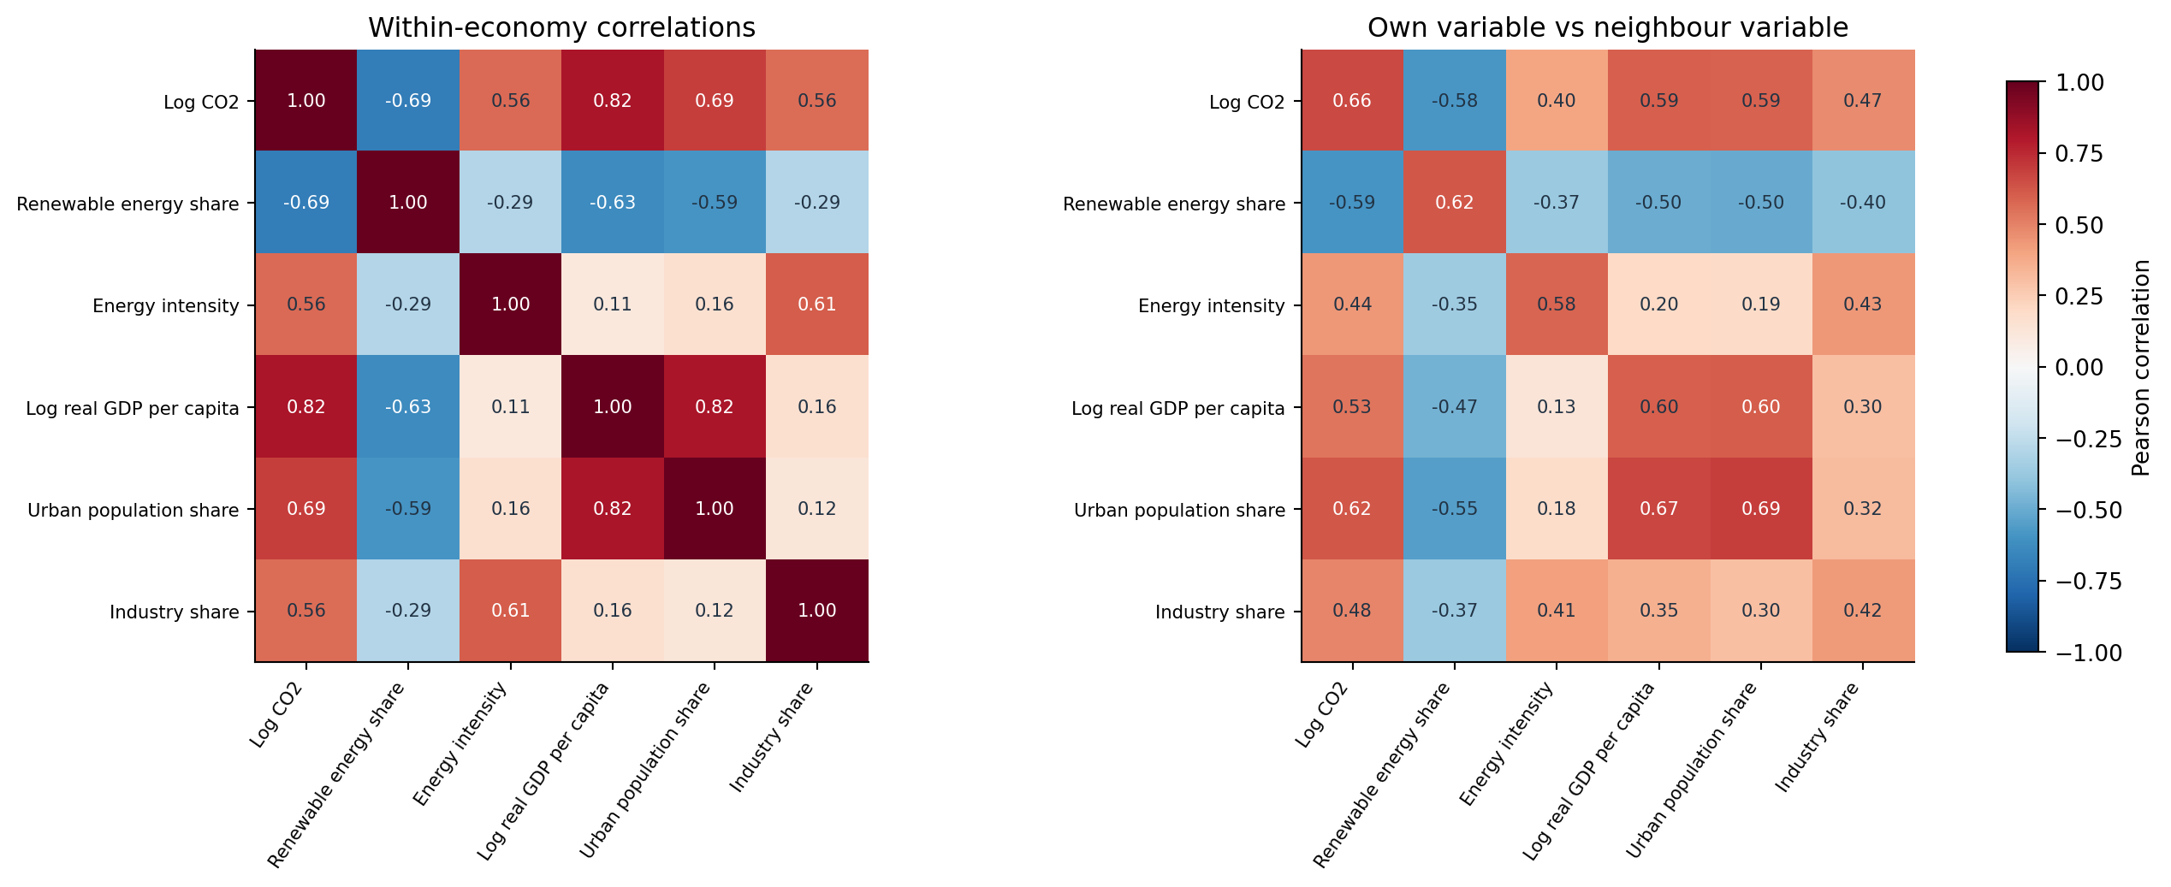
Figure 11. The cross-neighbor matrix is asymmetric by construction.

Energy Income and Industrial Structure

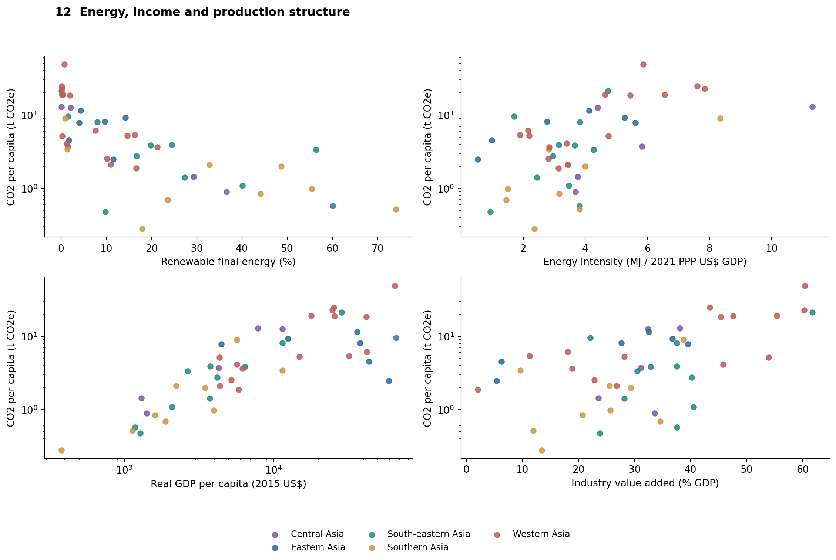
Figure 12. Scatterplots show unadjusted associations

Own Economy Conditions and Neighboring Emissions
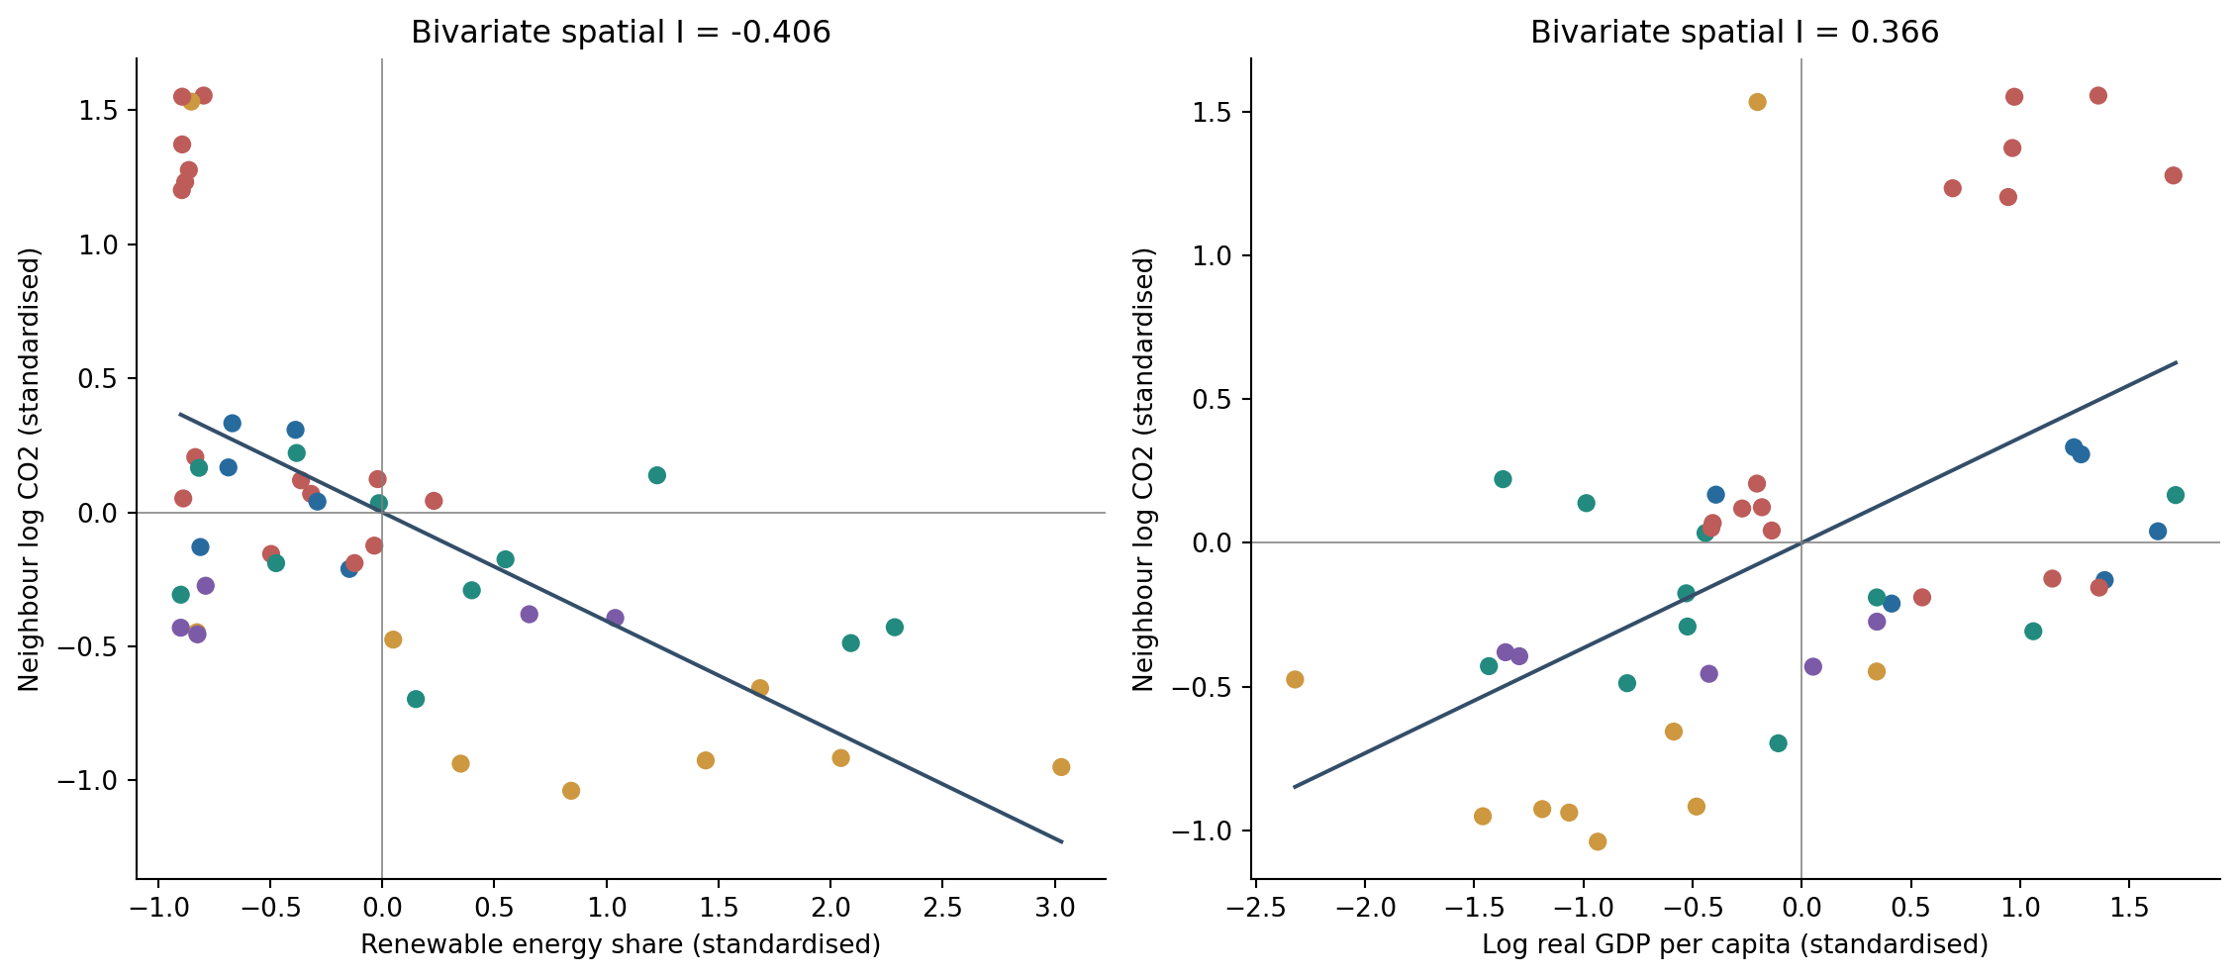
Figure 13. The paired plots compare own renewable energy and own income with weighted-neighbor emissions.

Spatial Regression Improve the Explanation
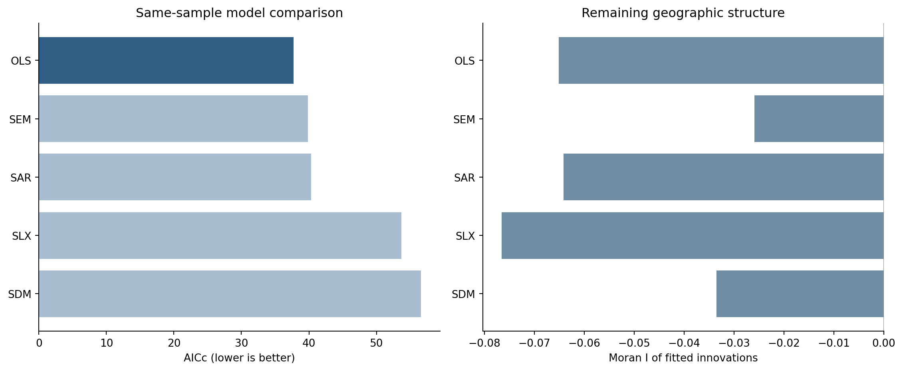
Figure 14. AICc includes the residual-variance parameter.

Economies with More Precise Association

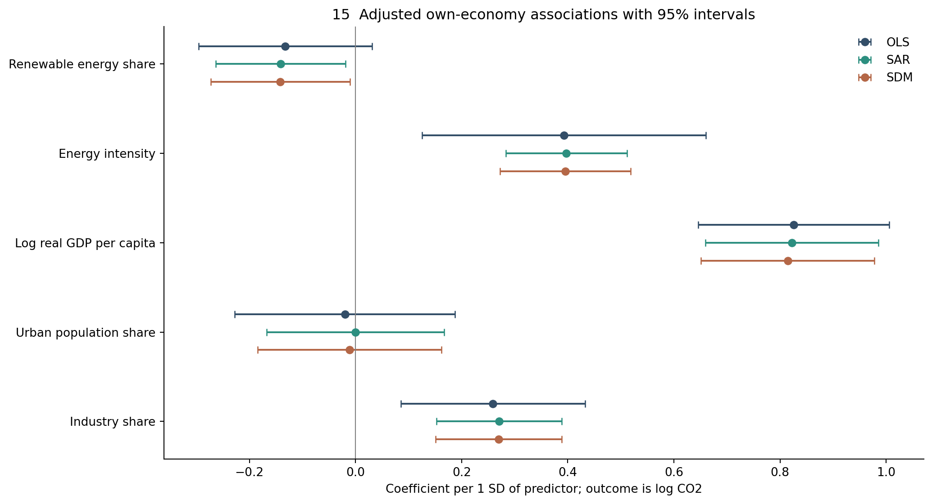
Figure 15. OLS intervals use HC3 standard errors and a t reference. SAR and SDM use model-based normal intervals.

Direct and Indirect Spatial Associations
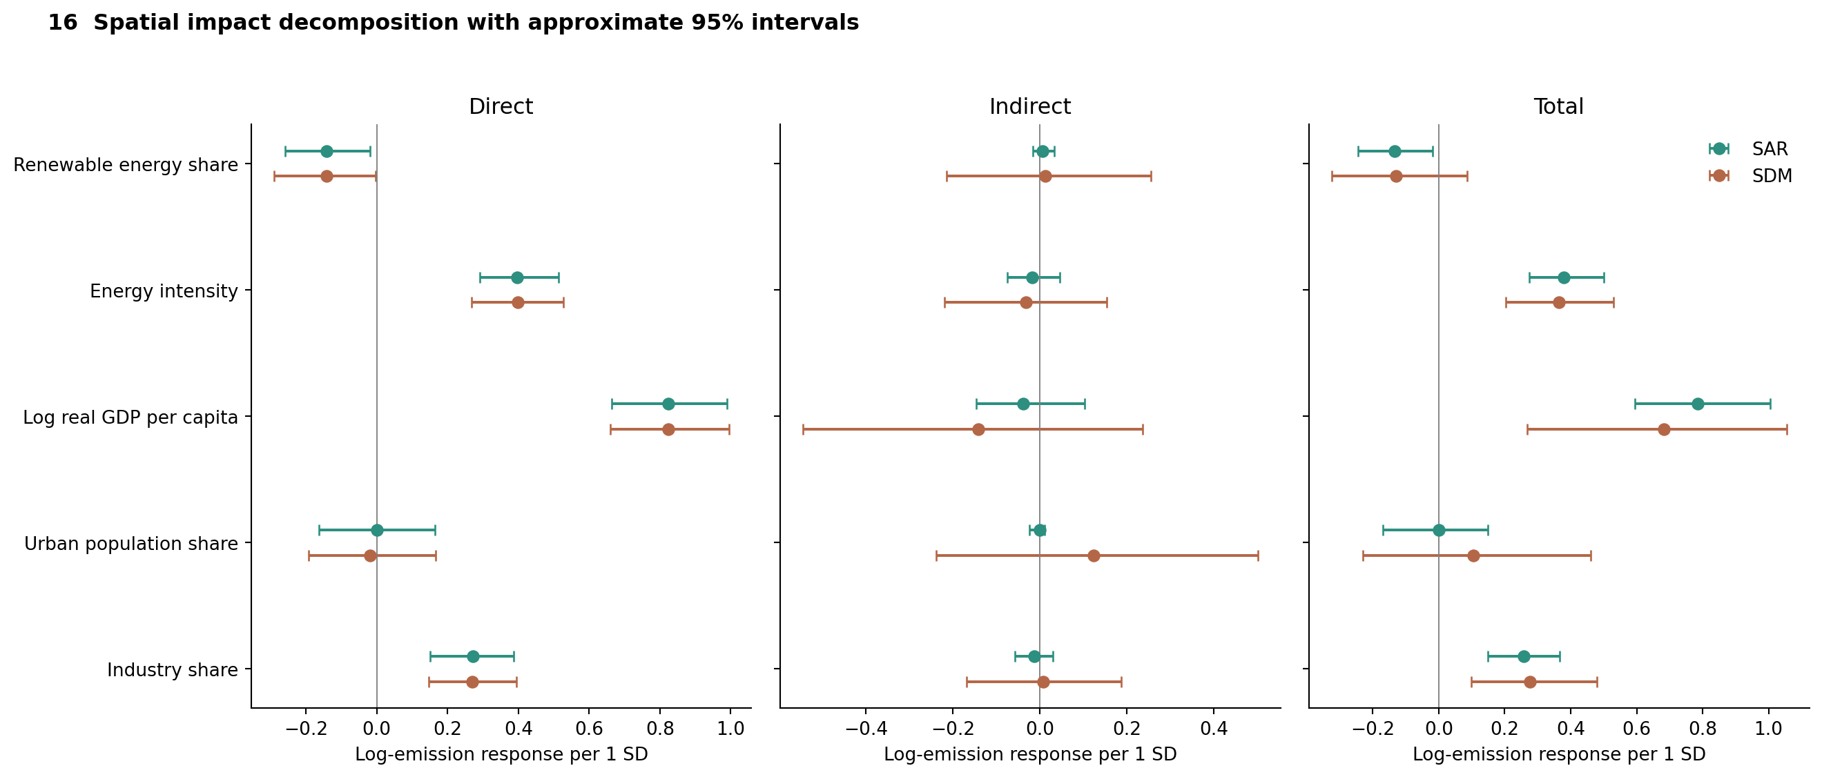
Figure 16. Direct impacts average own-economy responses; indirect impacts average responses elsewhere in the network.
Difference between Fitted and Observed Emission

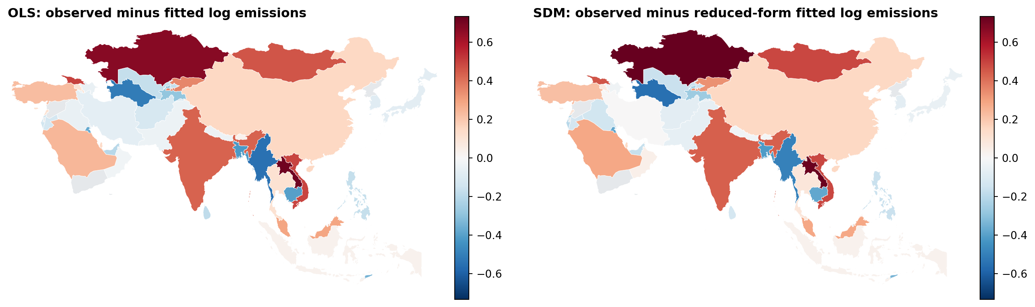
Figure 17. Positive residuals identify economies with higher observed emissions than the fitted model.
Renewable Energy and Energy Intensity
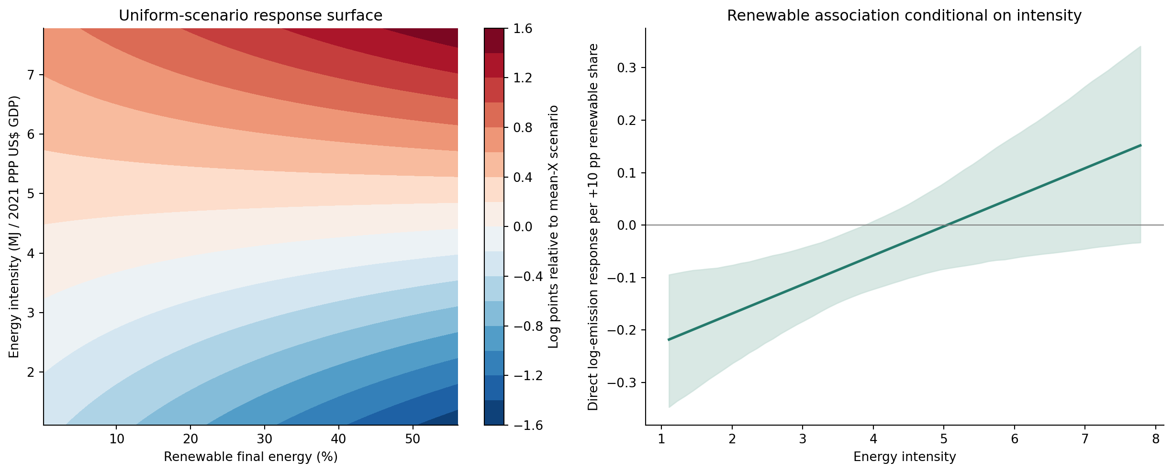
Figure 18. The surface is a model illustration over the central 90% of observed predictor ranges

Neighbors Sensitivity
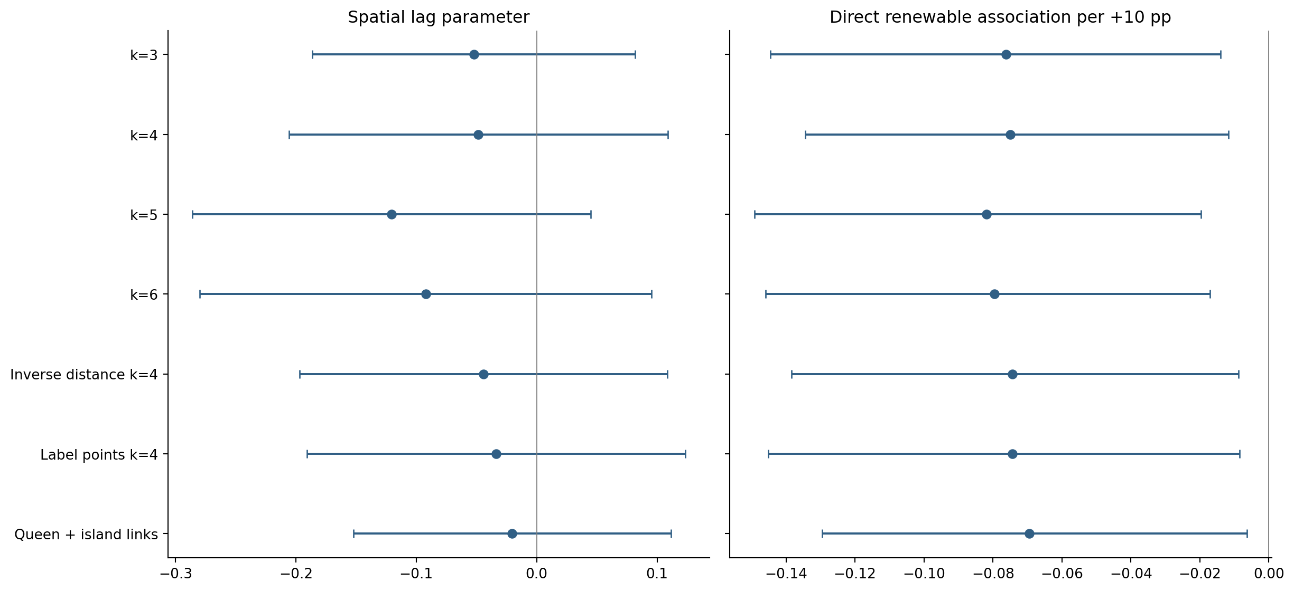
Figure 19. Same 46-economy sample throughout. The Queen-repaired graph retains three connected components, unlike the connected k-nearest-neighbor graphs.

Country Included Sensitivity
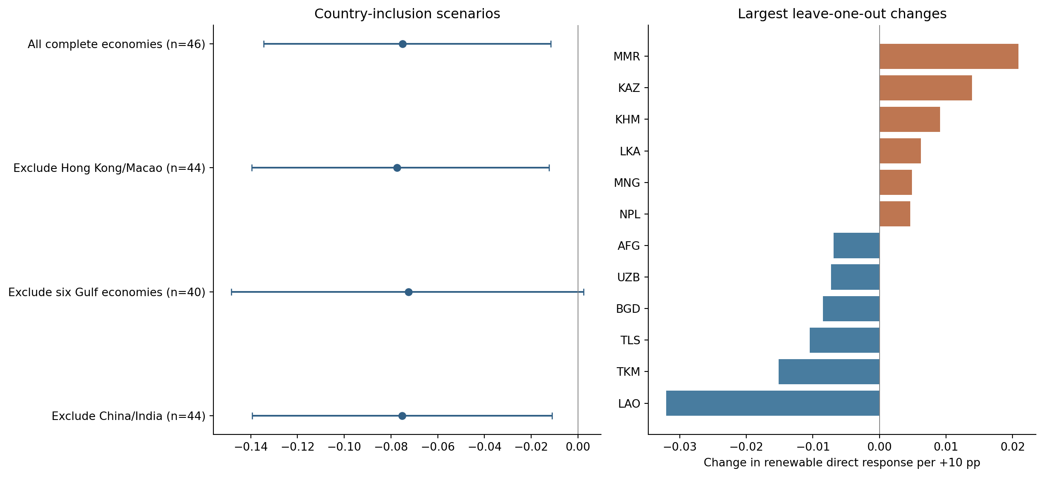
Figure 20. Country scenarios alter both the sample and its spatial graph.
Sensitivity Analysis Over the Year

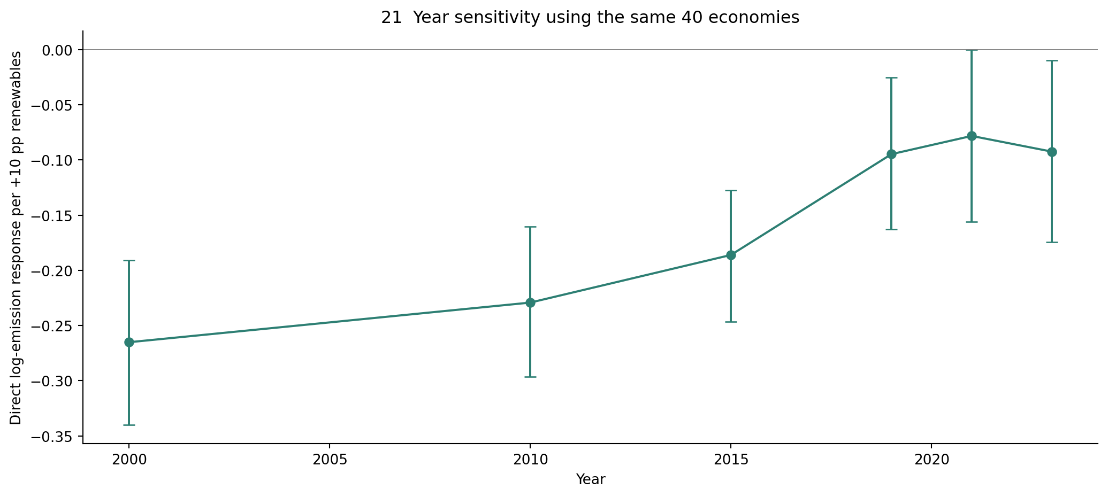
Figure 21. The six annual regressions use one common economy set and one geographic weight structure.
Changes within Economies Over Time

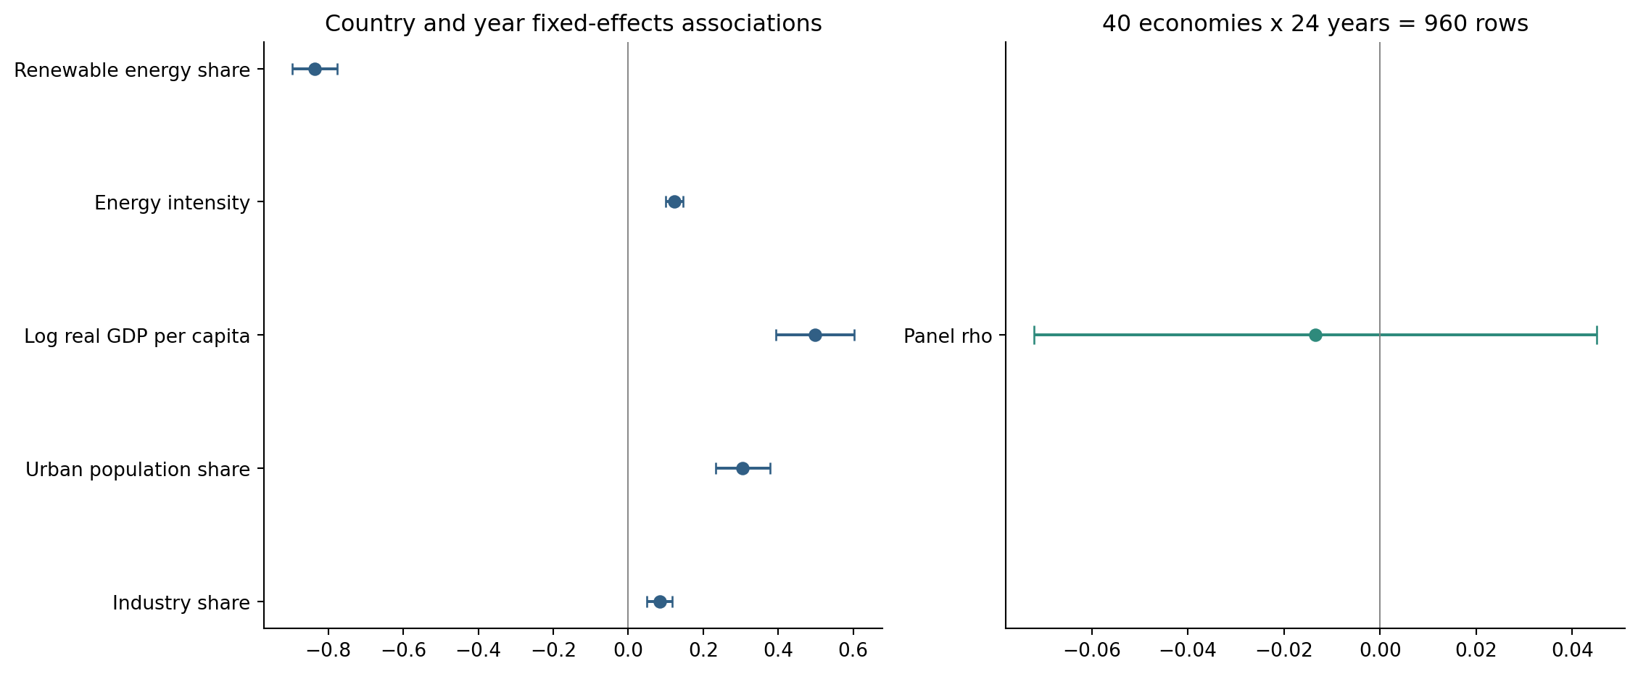
Figure 22. These are static panel SAR estimates with country fixed effects and 23 year indicators.

Residual Distribution

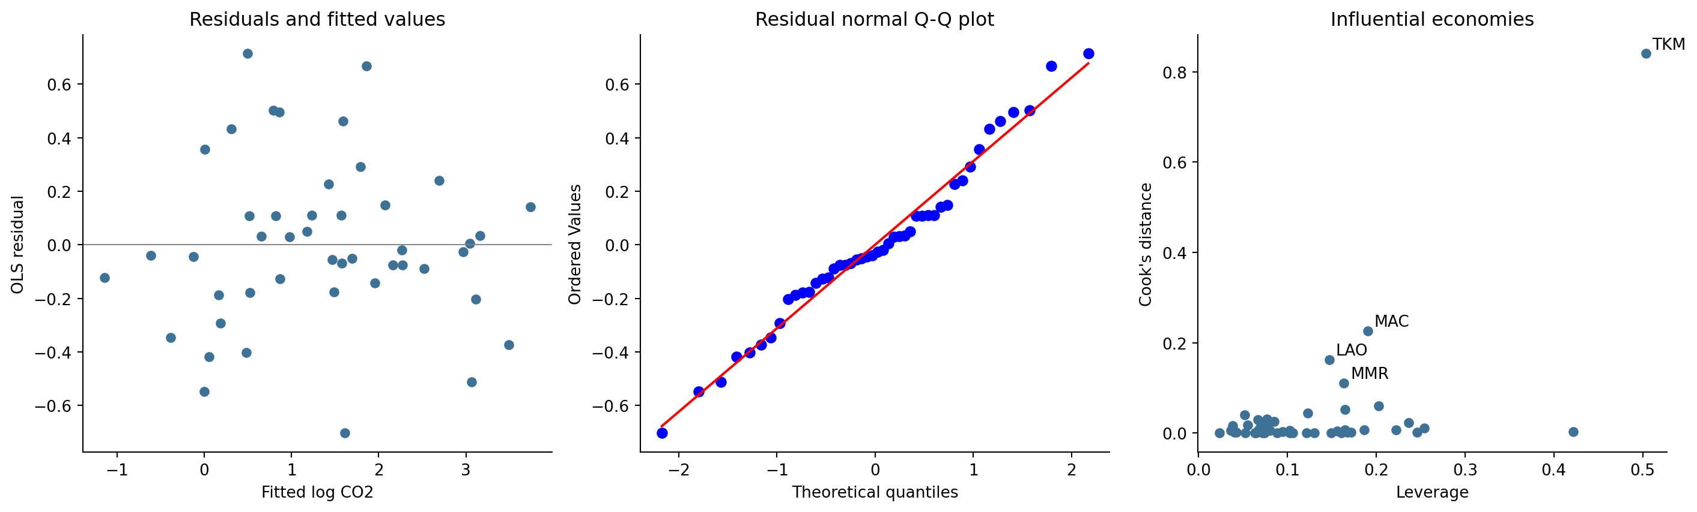
Figure 23. OLS HC3 intervals reduce reliance on constant residual variance.
World Bank WDI
https://data.worldbank.org/indicator/EN.GHG.CO2.PC.CE.AR5
UN renewable-energy metadata
https://unstats.un.org/sdgs/metadata/files/Metadata-07-02-01.pdf
UN energy-intensity metadata
https://unstats.un.org/sdgs/metadata/files/Metadata-07-03-01.pdf
UN geographic scope
https://unstats.un.org/unsd/methodology/m49/
Natural Earth geometry
https://www.naturalearthdata.com/downloads/50m-cultural-vectors/
GeoPandas projections
https://geopandas.org/en/stable/docs/user_guide/projections.html
Local Moran I
https://pysal.org/esda/stable/generated/esda.Moran_Local.html
SAR and spatial Durbin
https://pysal.org/spreg/generated/spreg.ML_Lag.html
Fixed-effects spatial panel
https://pysal.org/spreg/generated/spreg.Panel_FE_Lag.html

