Environmental Patent Shares Across Country Income Groups
  - Country trends from 1990 to 2024 and exploratory spatial regression for 2022
This research investigated the spatial regression and conducted the trend analysis of environmental patents for 195 countries in three income-based grouping. This analysis is based on the geographic mapping, spatial regression and trend variation over the time.
Spatial Association
Income group | Economies | Spatial  coefficient ρ | Nominal  p value | At nominal  5% level
High income | 72 | 0.011 | 0.745 | Inconclusive
Middle income | 102 | 0.074 | 0.035 | Positive association
Low income | 21 | 0.093 | 0.392 | Inconclusive

High Income Country Trends - Environmental patent shares from 1990 to 2024
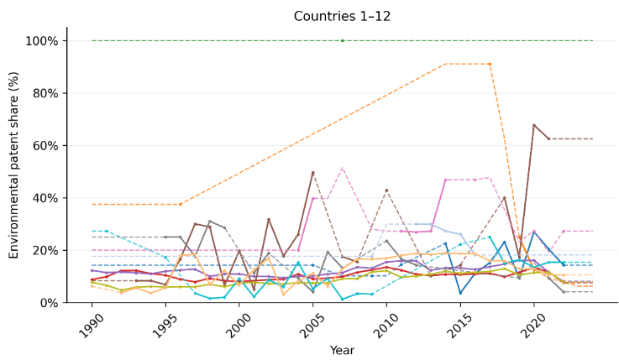
--- Andorra --- Antigua and Barbuda --- Aruba
--- Australia --- Austria --- Bahamas
--- Bahrain --- Barbados --- Belgium
--- British Virgin Islands --- Brunei Darussalam --- Bulgaria

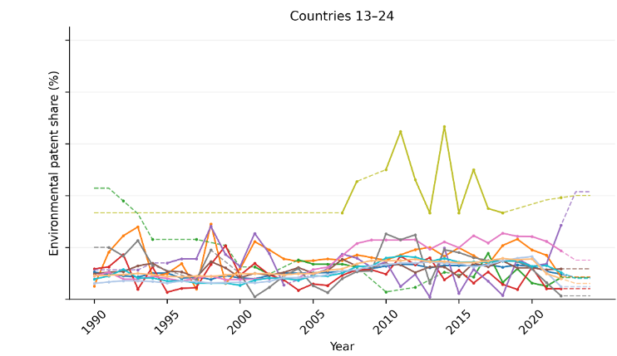
--- Canada --- Chile --- Costa Rica
--- Croatia --- Cyprus --- Czechia
--- Denmark --- Estonia --- Faroe Islands
--- Finland --- France --- Germany

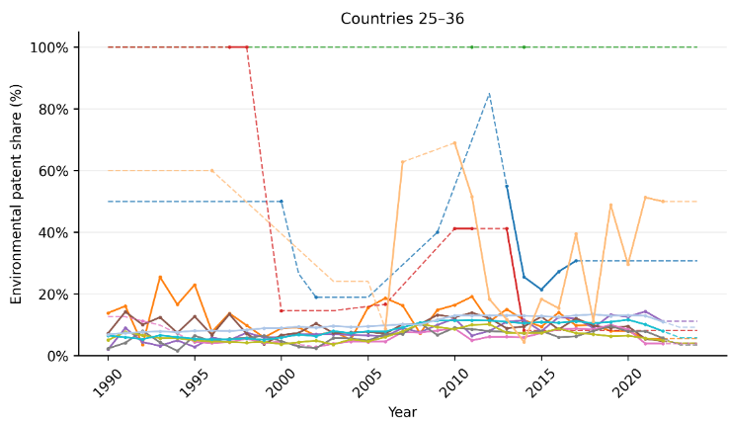
--- Gibraltar --- Greece --- Greenland
--- Guyana --- Hong Kong --- Hungary
--- Iceland --- Ireland --- Israel
--- Italy --- Japan --- Kuwait

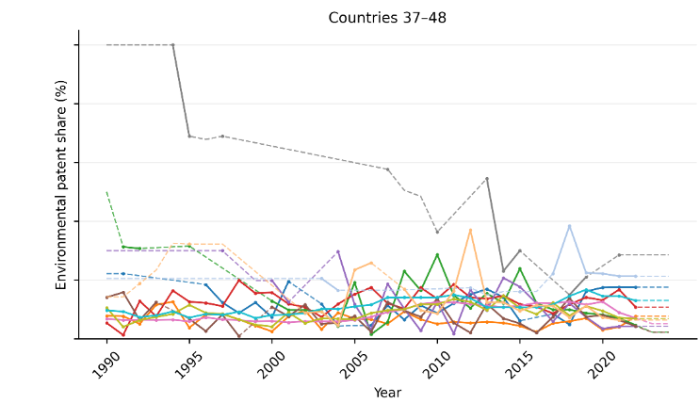
--- Latvia --- Liechtenstein --- Lithuania
--- Luxembourg --- Malta --- Monaco
--- Netherlands --- New Caledonia --- New Zealand
--- Norway --- Oman --- Panama

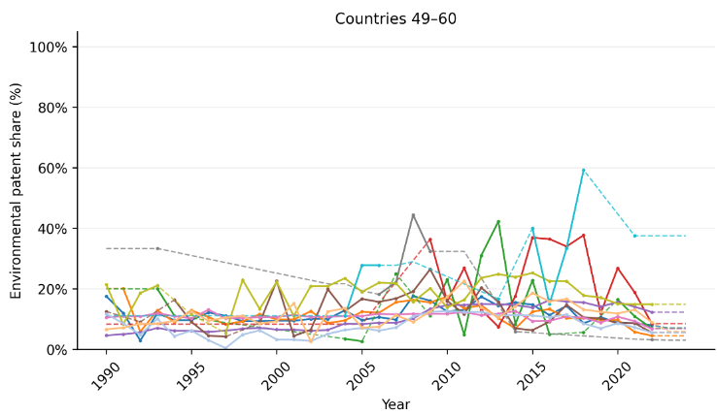
--- Poland --- Portugal --- Puerto Rico
--- Qatar --- Republic of Korea --- Romania
--- Russia --- San Marino --- Saudi Arabia
--- Seychelles --- Singapore --- Slovakia

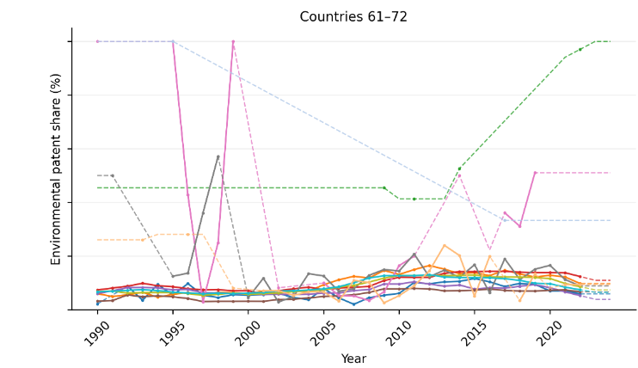
--- Slovenia --- Spain --- St. Kitts and Nevis
--- Sweden --- Switzerland --- Taiwan
--- Trinidad and Tobago --- United Arab Emirates --- United Kingdom
--- United States --- United States Virgin Islands --- Uruguay

High Income Spatial Results

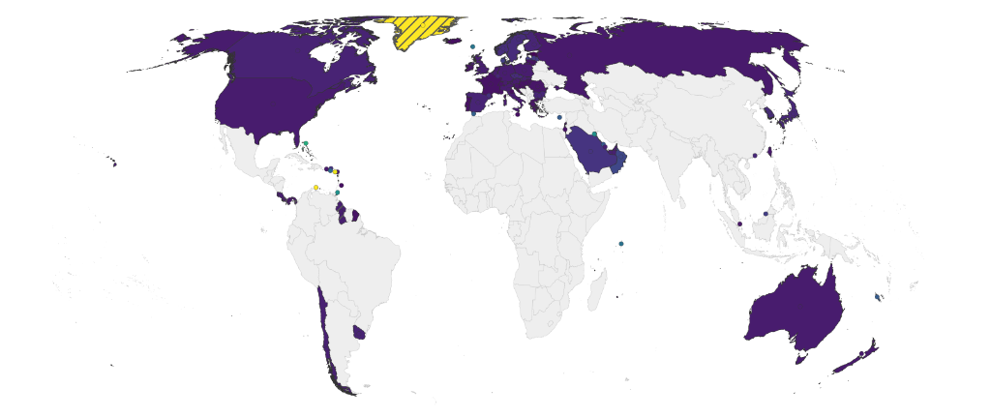
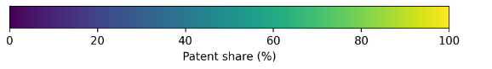

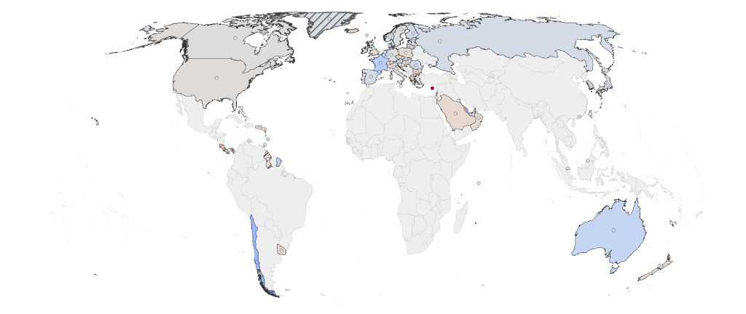
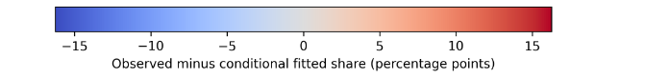

Middle Income Country Trends - Environmental patent shares from 1990 to 2024

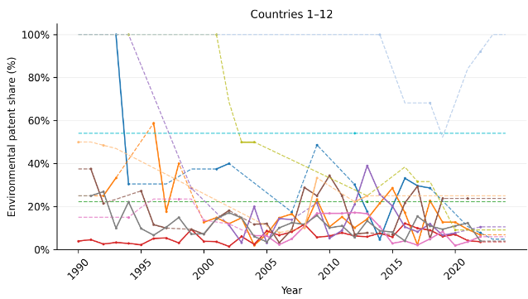
--- Albania --- Algeria --- Angola
--- Argentina --- Armenia --- Azerbaijan
--- Bangladesh --- Belarus --- Belize
--- Benin --- Bhutan --- Bolivia

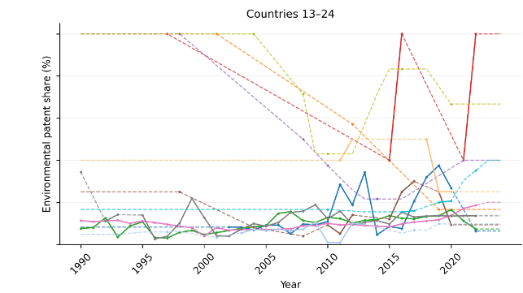
--- Bosnia and Herzegovina --- Botswana --- Brazil
--- Cabo Verde --- Cambodia --- Cameroon
--- China --- Colombia --- Congo Republic
--- Cote d'Ivoire --- Cuba --- Djibouti

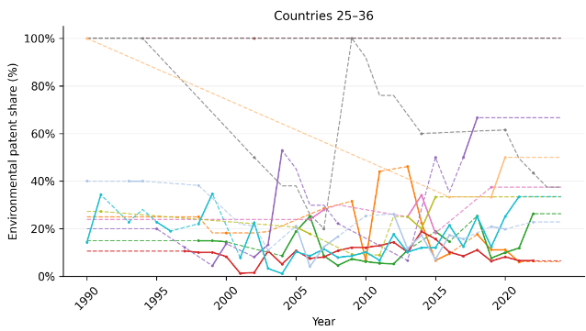
--- Dominica --- Dominican Republic --- Ecuador
--- Egypt --- El Salvador --- Equatorial Guinea
--- Eswatini --- Fiji --- Gabon
--- Georgia --- Ghana --- Grenada

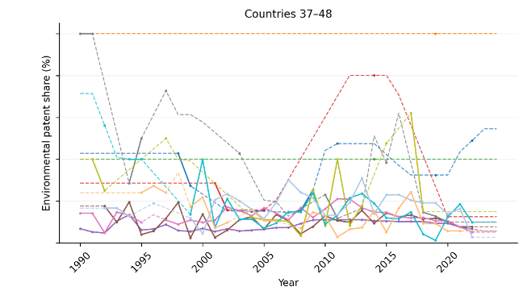
--- Guatemala --- Guinea --- Haiti
--- Honduras --- India --- Indonesia
--- Iran --- Iraq --- Jamaica
--- Jordan --- Kazakhstan --- Kenya

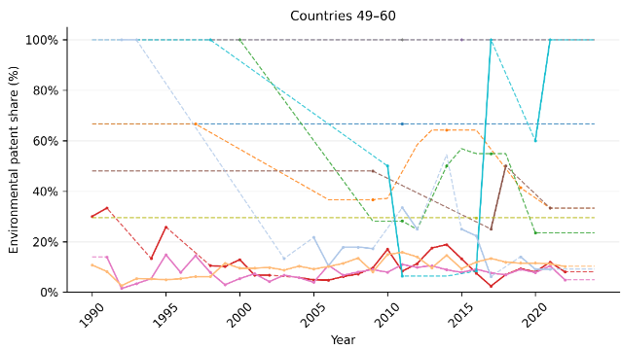
--- Kiribati --- Kyrgyz Republic --- Laos
--- Lebanon --- Lesotho --- Libya
--- Malaysia --- Maldives --- Marshall Islands
--- Mauritania --- Mauritius --- Mexico

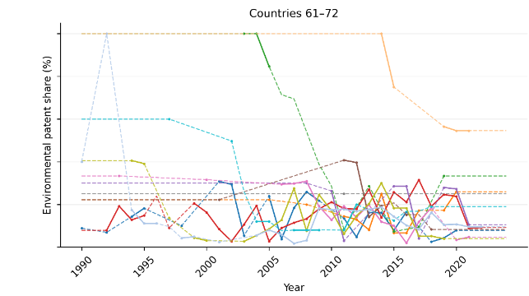
--- Moldova --- Mongolia --- Montenegro
--- Morocco --- Myanmar --- Namibia
--- Nepal --- Nicaragua --- Nigeria
--- North Macedonia --- Pakistan --- Palestine

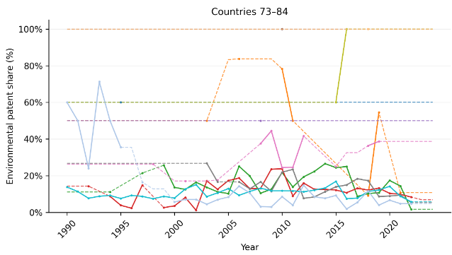
--- Papua New Guinea --- Paraguay --- Peru
--- Philippines --- Samoa --- Sao Tome and Principe
--- Senegal --- Serbia --- Solomon Islands
--- South Africa --- Sri Lanka --- St. Lucia

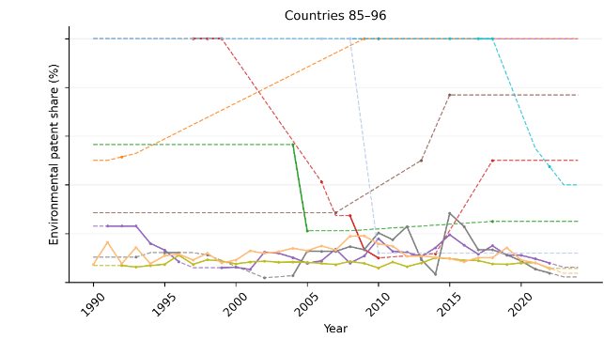
--- St. Vincent and the Grenadines --- Suriname --- Tajikistan
--- Tanzania --- Thailand --- Togo
--- Tonga --- Tunisia --- Turkey
--- Turkmenistan --- Tuvalu --- Ukraine

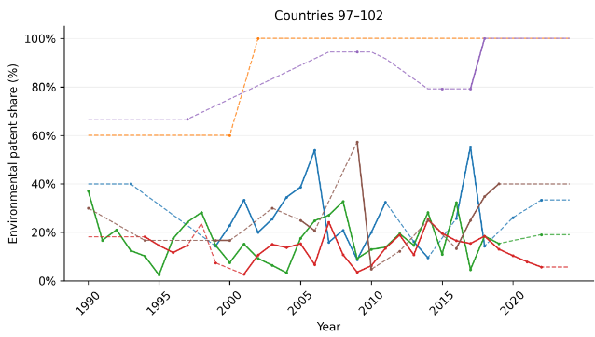
--- Uzbekistan --- Vanuatu --- Venezuela
--- Vietnam --- Zambia --- Zimbabwe

Middle Income Spatial Results
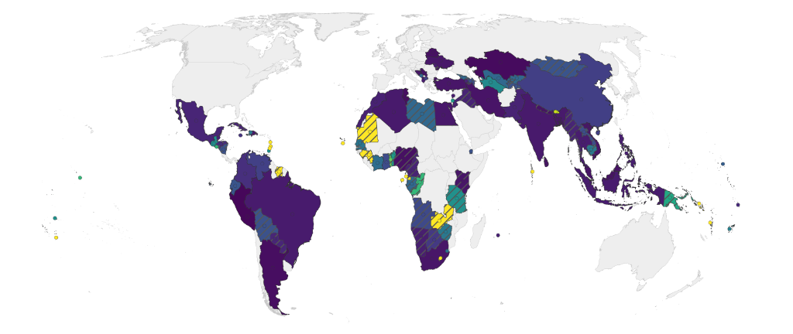
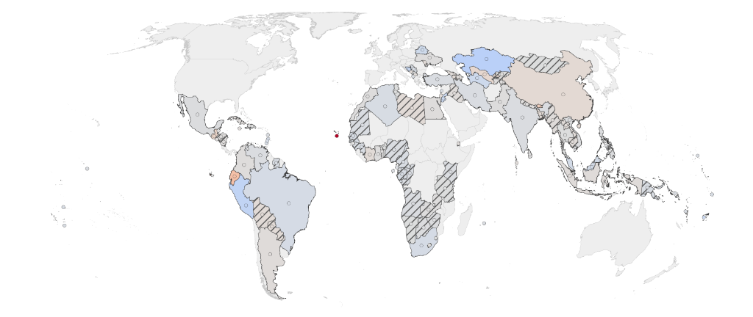


Low Income Country Trends - Environmental patent shares from 1990 to 2024
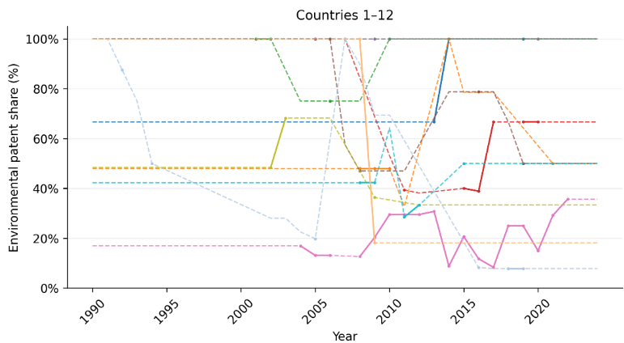
--- Afghanistan --- Burkina Faso --- Burundi
--- Central African Republic --- Chad --- Eritrea
--- Ethiopia --- Gambia --- Liberia
--- Madagascar --- Mali --- Mozambique

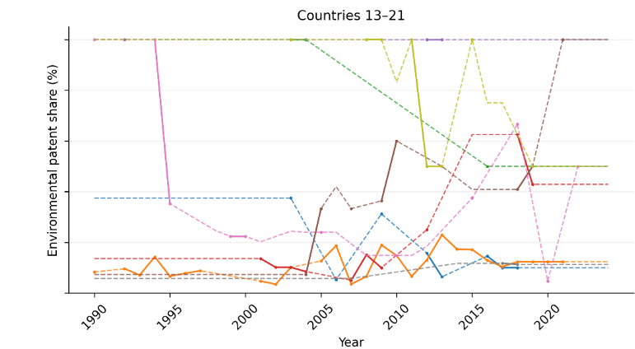
--- Niger --- North Korea --- Rwanda
--- Sierra Leone --- Somalia --- Sudan
--- Syria --- Uganda --- Yemen

Low Income Spatial Results
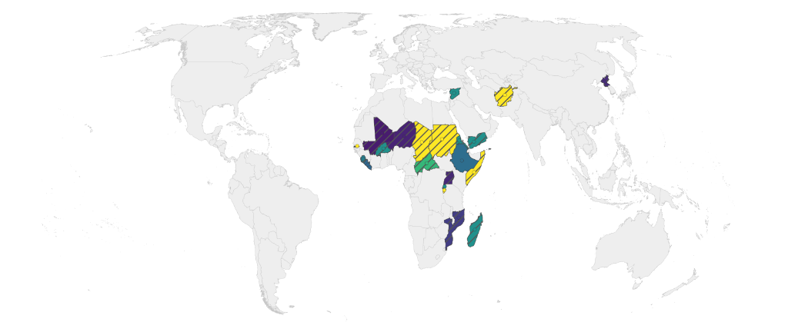
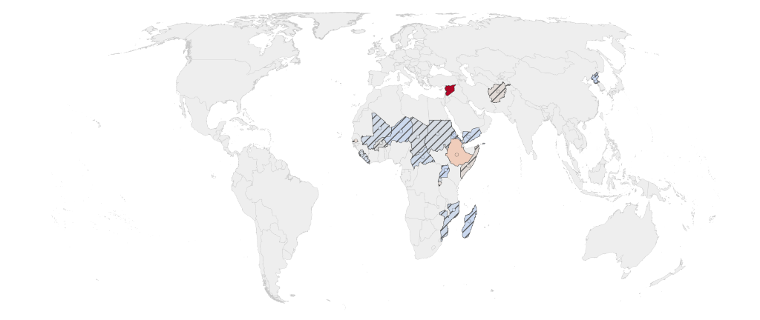


Sources and reproducibility
[1] World Bank. World Bank Country and Lending Groups
[2] PySAL spreg. Maximum likelihood spatial lag regression
[3] PySAL libpysal. Nearest neighbour spatial weights
[4] Natural Earth. Admin 0 Countries boundaries
[5] Matplotlib. Choosing colormaps
.

