Agent Based Spatial Analysis of Global Living Conditions
  - Country evidence from 2000 to 2023 and conditional scenarios to 2030
Muhammad Hamid Khan Niazi
Master of Business Analytics
National University of Computer and Emerging Sciences, Islamabad (FAST_NUCES)

We analyse 166 countries and economies over 24 years using complete annual observations, geographic networks, permutation tests, a spatial panel model, and a country-agent simulation.

Indicator | WDI code | Unit
Electricity access | EG.ELC.ACCS. ZS | % of total population
Clean cooking access | EG.CFT.ACCS. ZS | % of total population
At least basic drinking water | SH.H2O.BASW. ZS | % of total population
Ambient PM2.5 exposure | EN.ATM.PM25.MC.M3 | µg/m³
Urban slum prevalence in housing subset | EN.POP.SLUM.UR. ZS | % of urban population

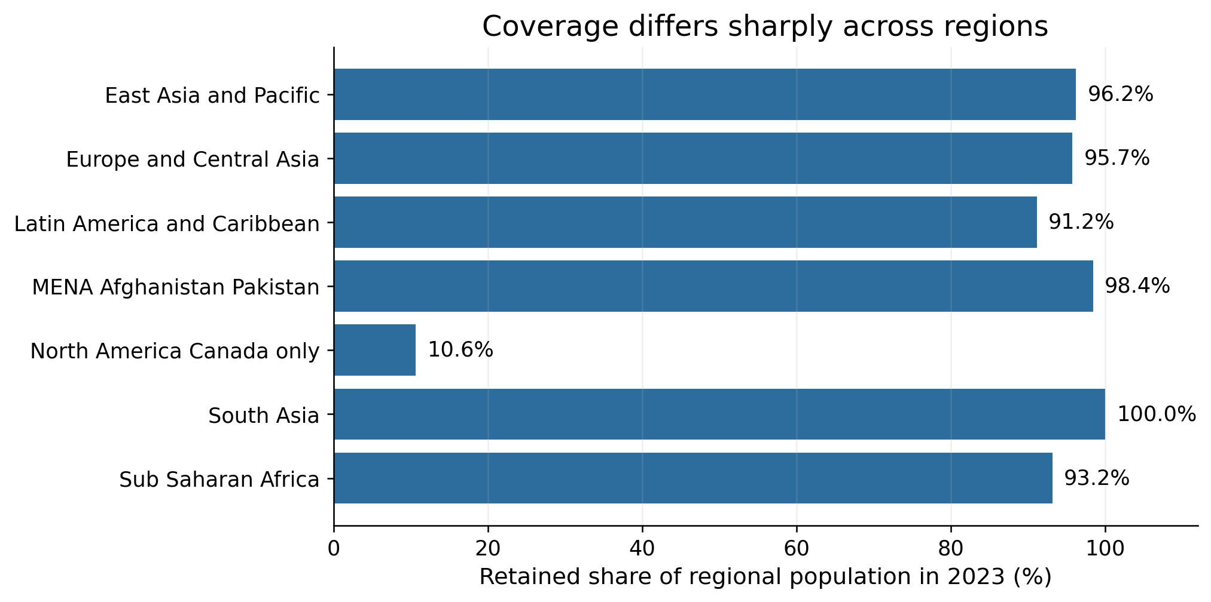
Figure 1. Retained population as a share of the original regional population in 2023. North America is represented only by Canada.

Geographic Structure of the Country Agents

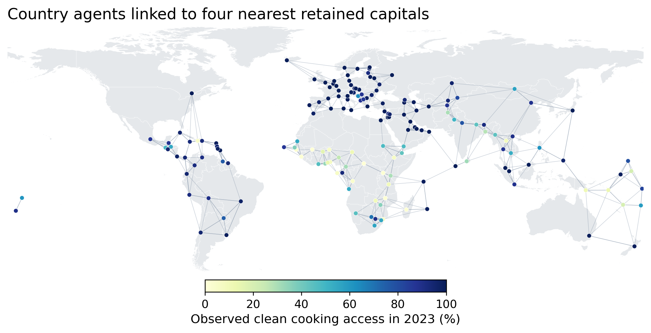
Figure 2. The spatial interaction graph and observed clean-cooking access in 2023.

Network property | Value
Country agents | 166
Directed links | 664
Median link distance | 691 km
Longest link | 3196 km
Links longer than 2500 km | 23
Weakly connected components | 2

Observed Progress in Services and Air Quality

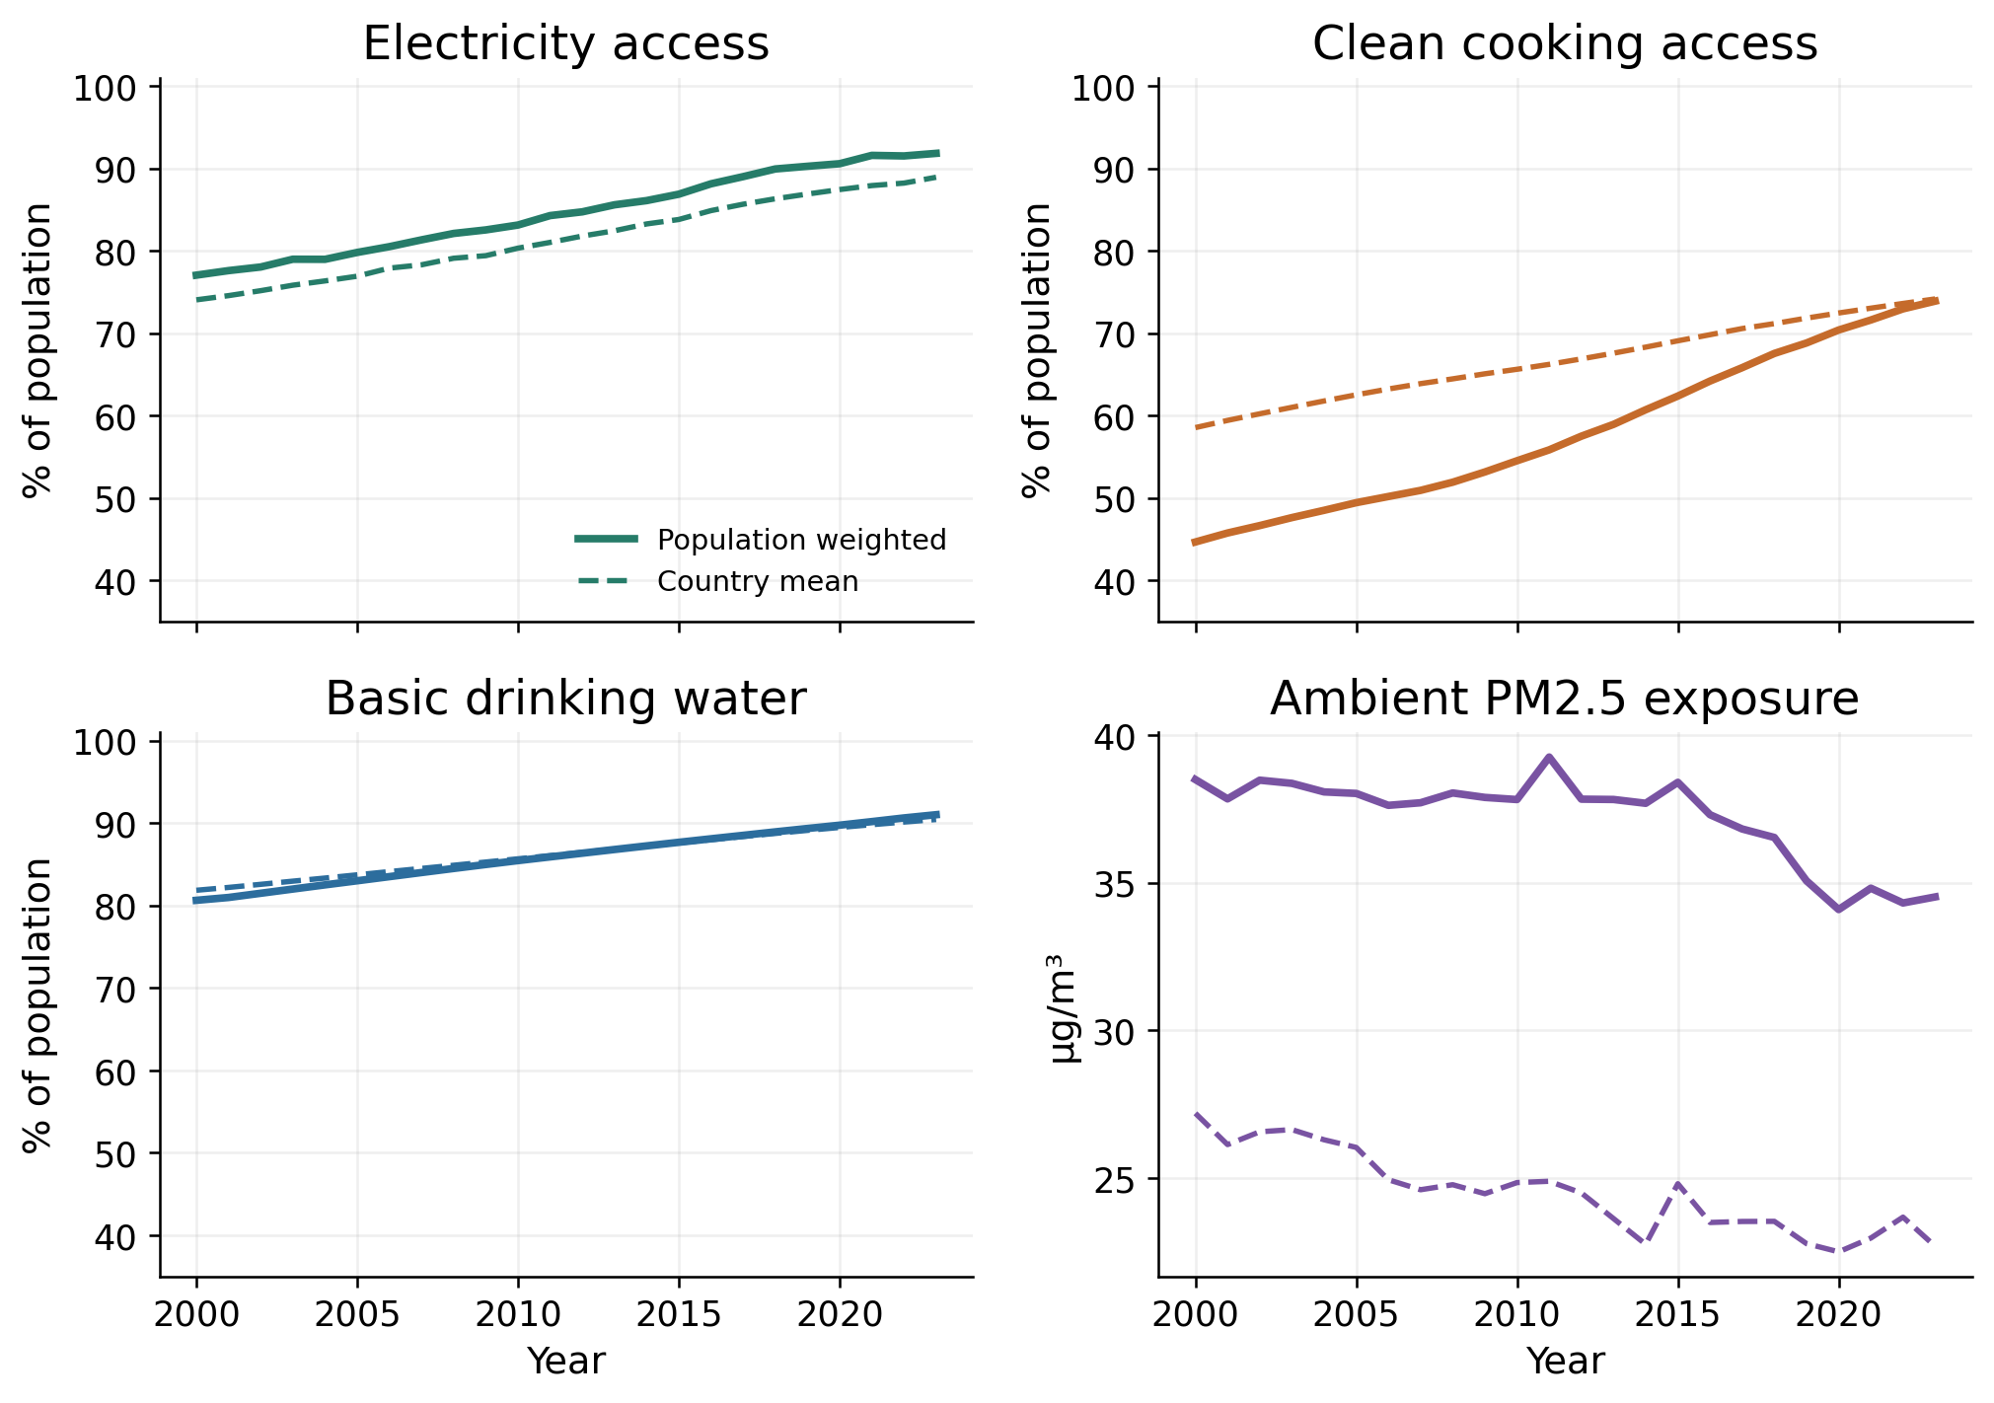
Figure 3. Population-weighted and equally weighted country means in the fixed 166-country sample.

Where Service Gaps and Pollution Remain
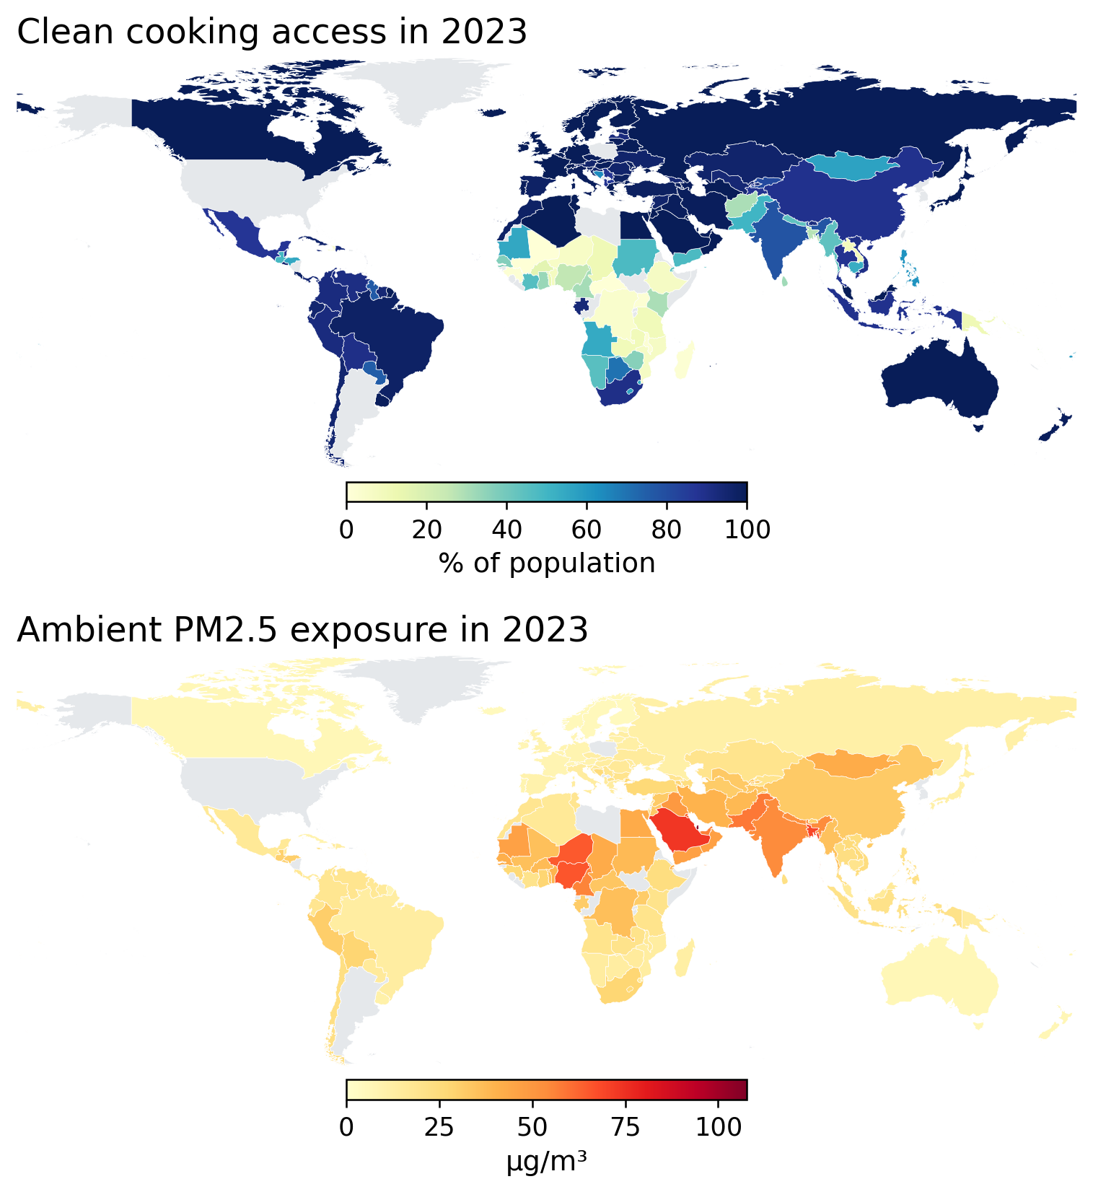
Figure 4. Observed clean-cooking access and ambient PM2.5 exposure in 2023. Grey indicates economies outside the main analytical sample.
Regional Progress and Inequality Between Countries
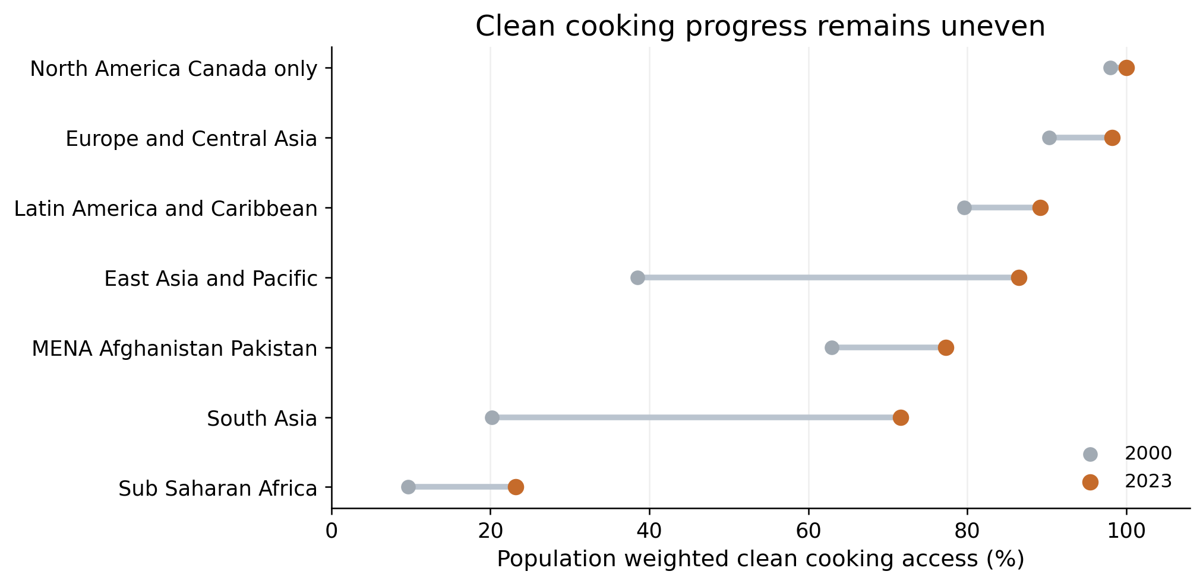
Figure 5. Population-weighted clean-cooking access by the supplied region classification. Each regional comparison uses its own retained country sample.
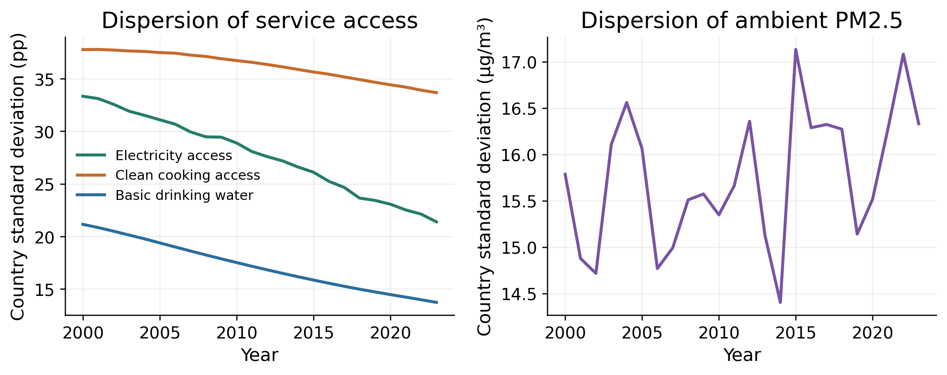
Figure 6. Dispersion across the 166 countries. Service dispersion is measured in percentage points and PM2.5 dispersion in µg/m³.

Global Spatial Dependence and Sensitivity
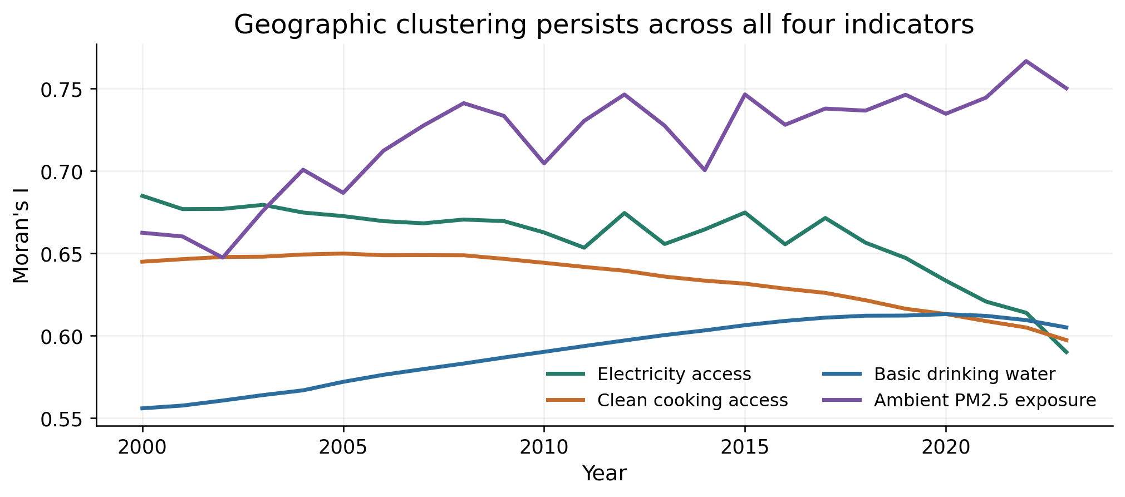
Figure 7. Global Moran statistics under the four-neighbour graph. All 96 primary tests have adjusted q values of 0.0001 at the available permutation resolution.
2023 indicator | Two neighbours | Four neighbours | Eight neighbours
Electricity access | 0.571 | 0.590 | 0.578
Clean cooking access | 0.580 | 0.597 | 0.566
Basic water access | 0.581 | 0.605 | 0.583
Ambient PM2.5 | 0.803 | 0.750 | 0.655

.

Local Clusters after Multiple Testing Adjustment

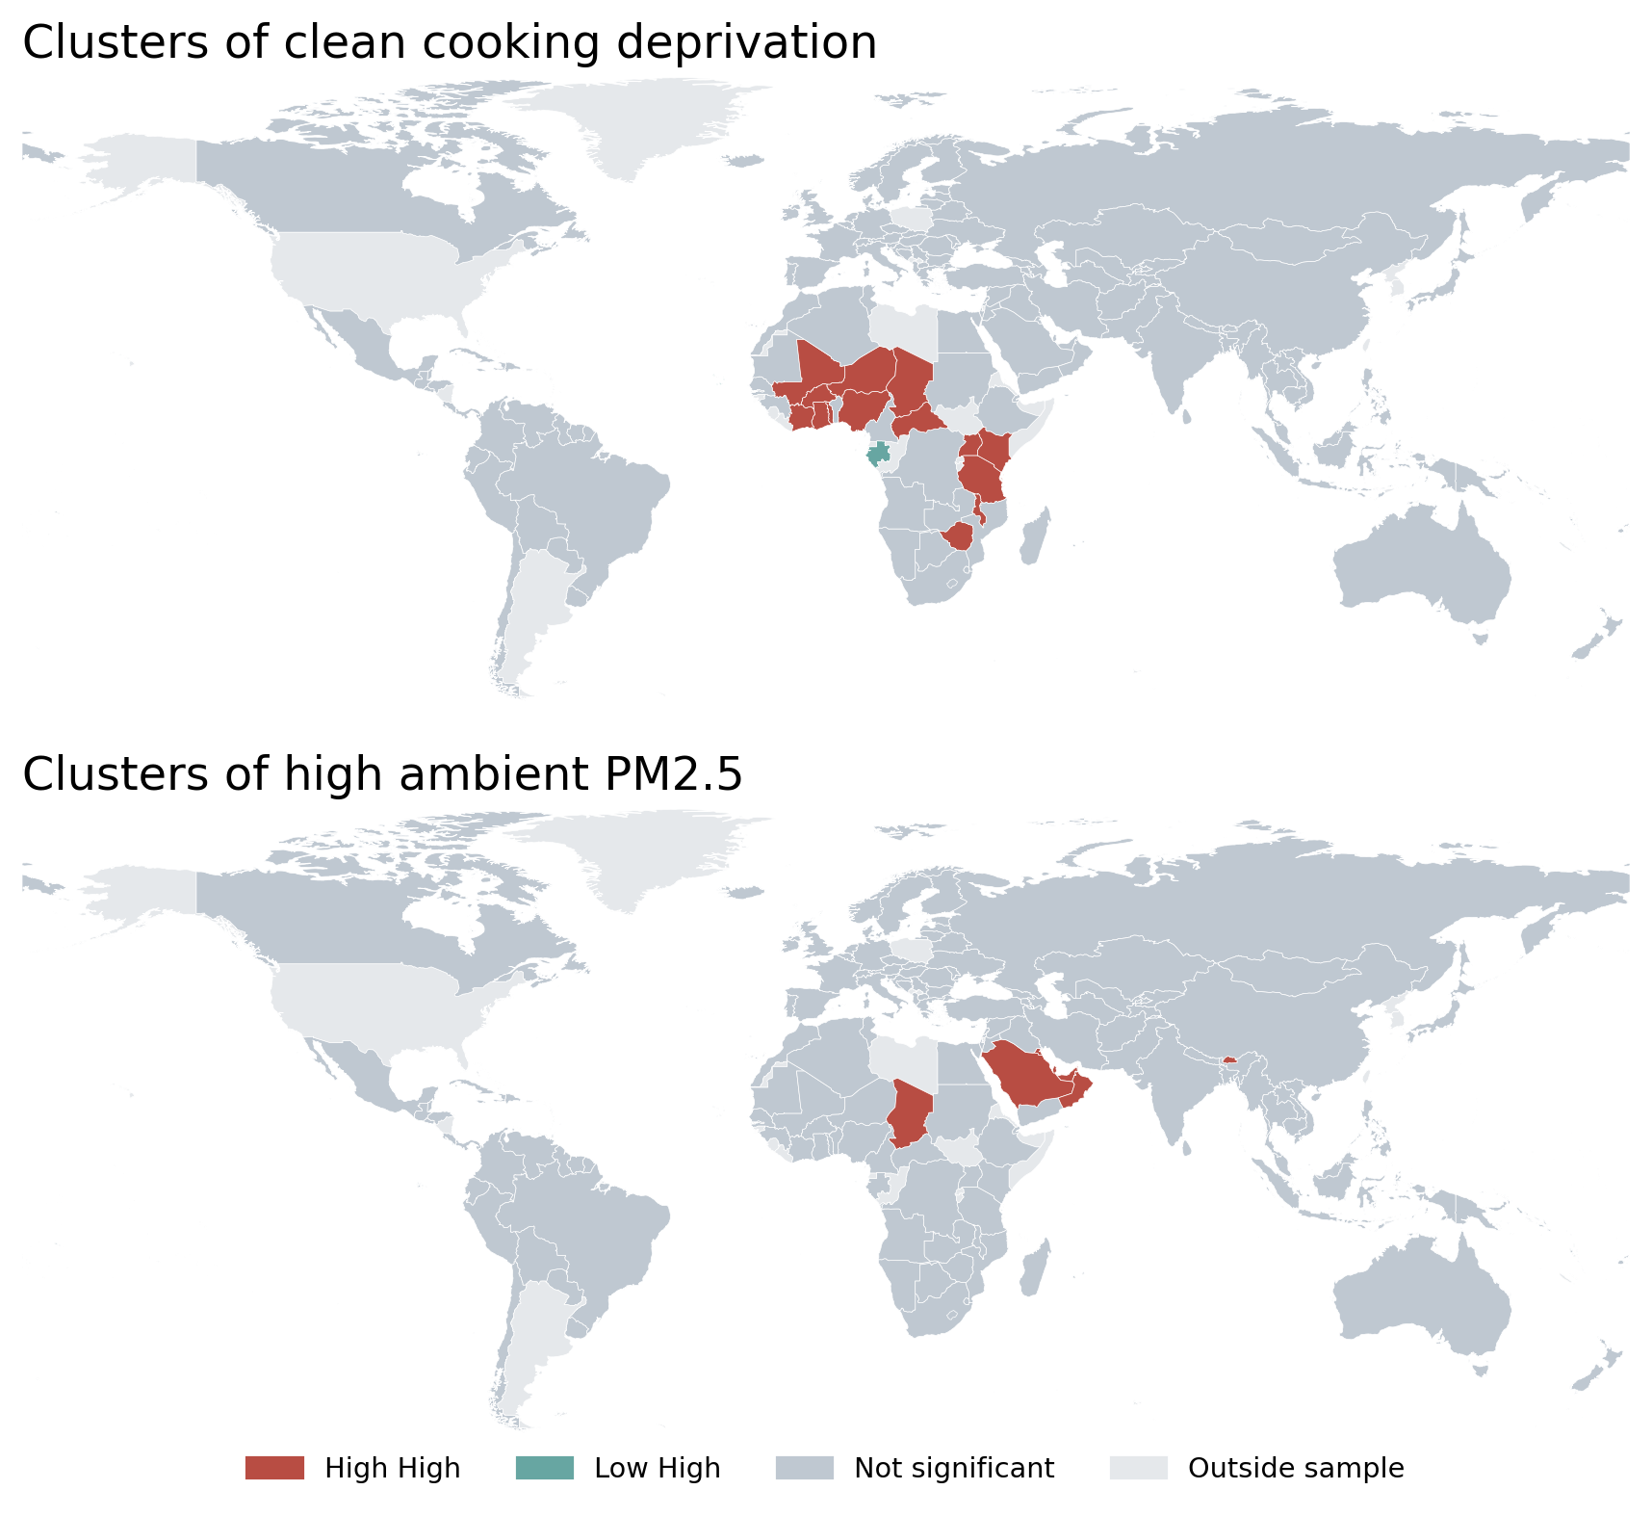
Figure 8. Local Moran clusters in 2023 after Benjamini-Hochberg adjustment across 332 country-outcome tests at q ≤ 0.05.
Service Improvements and Ambient Pollution Associations
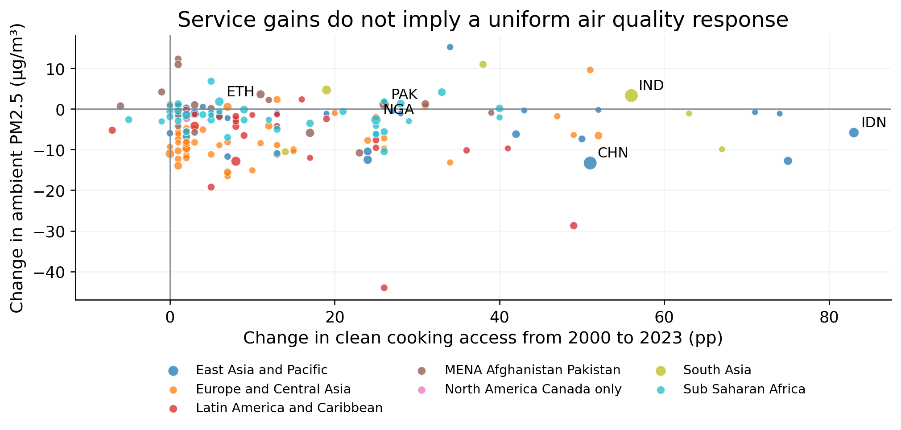
Figure 9. Country changes from 2000 to 2023. Marker sizes reflect 2023 population.

Previous year variable | Estimate | DK 95% interval | DK p | Country cluster p
Own electricity | -0.207 | [-0.684, +0.270] | 0.378 | 0.536
Own clean cooking | -0.374 | [-0.589, -0.159] | 0.002 | 0.198
Own basic water | +0.474 | [+0.021, +0.928] | 0.041 | 0.379
Neighbour electricity | +1.244 | [+0.538, +1.950] | 0.001 | 0.018
Neighbour clean cooking | -0.572 | [-0.963, -0.181] | 0.006 | 0.216
Neighbour basic water | +0.626 | [-0.061, +1.313] | 0.072 | 0.409

Historical Calibration and Held out Validation
The agent model trained on window from 2000 to 2015. The analysis of the neighbor adjustment and regional shrinkage is compared based on the RMSE and for this data is used from 2016 to 2019. This used the give prior years shrinkage and neighbor coefficient value is 0.025.
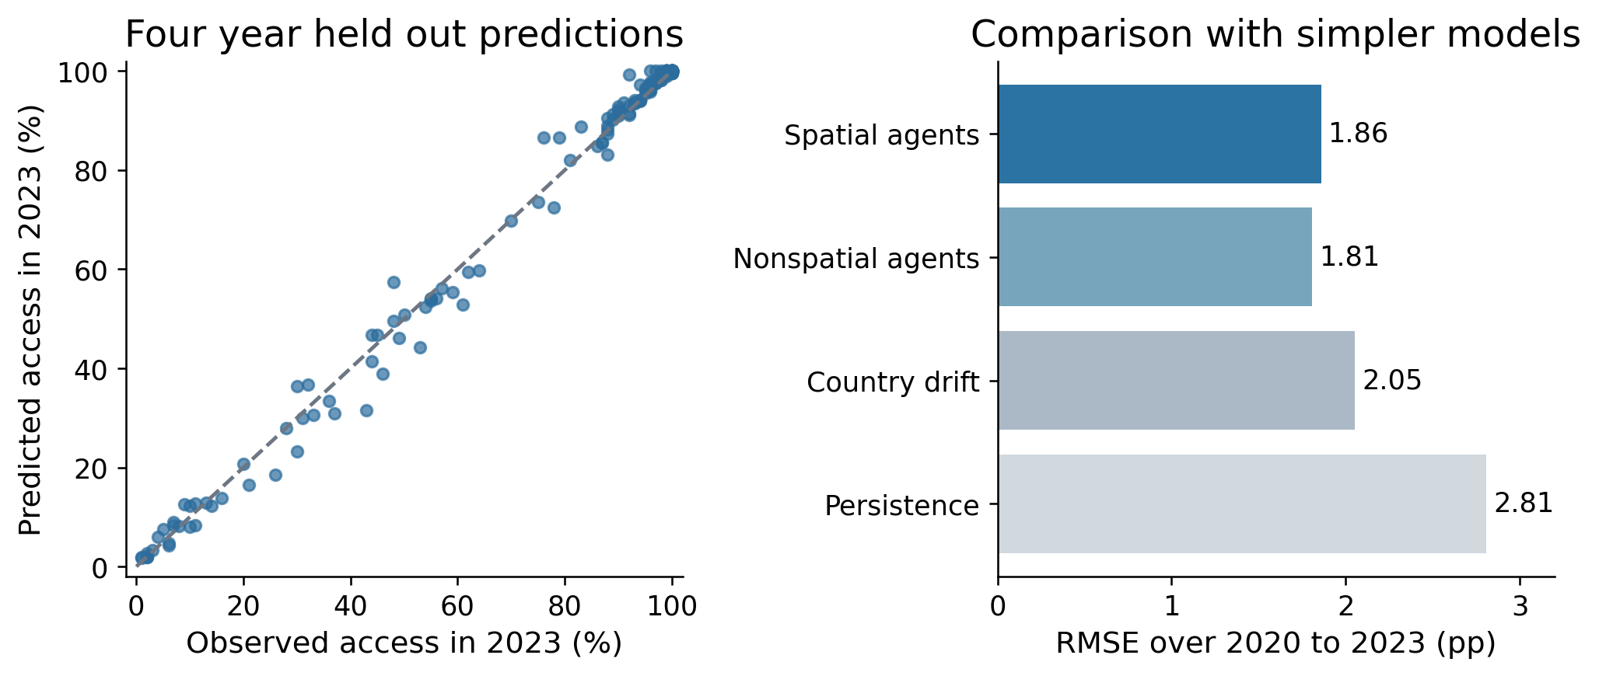
Figure 10. Country-agent historical performance. The scatter shows 2023 predictions from 2019 initial conditions.

Model | RMSE pp | MAE pp | Population weighted RMSE
Spatial country agents | 1.858 | 1.052 | 2.337
Nonspatial country agents | 1.807 | 1.031 | 2.307
Country drift | 2.053 | 1.140 | 2.528
Persistence | 2.808 | 1.572 | 5.485

Conditional Clean Cooking Scenarios Through 2030

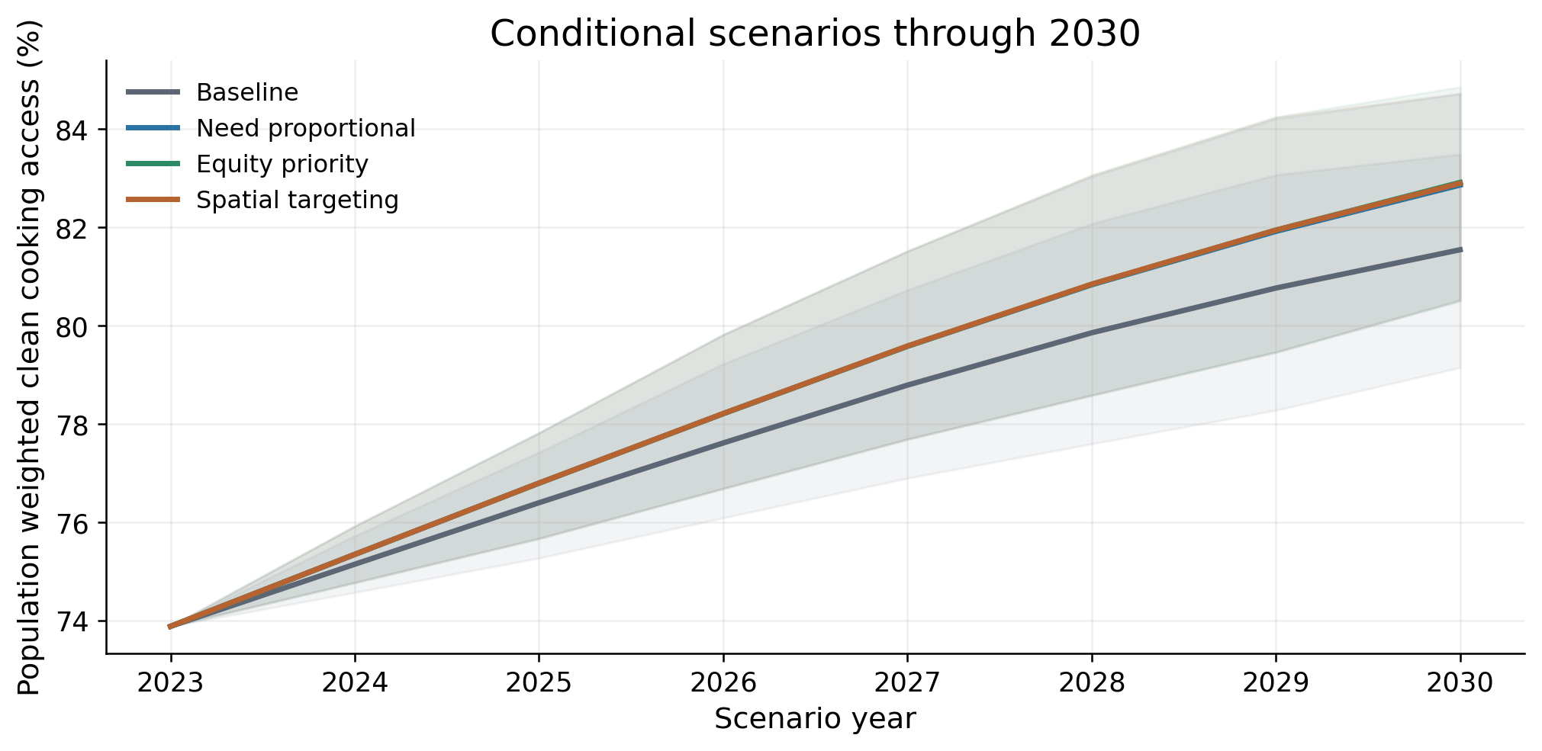
Figure 11. Simulated population-weighted access. Shading is the central 95% process-simulation range from 999 paired replicates, conditional on fitted parameters and stated assumptions.

Scenario | 2030 access % | 95% simulation range | Additional millions | Lowest quartile access %
Baseline | 81.54 | 79.14 to 83.48 | 0.00 | 31.81
Need proportional | 82.86 | 80.50 to 84.71 | 97.61 | 36.41
Equity priority | 82.91 | 80.51 to 84.85 | 101.57 | 37.74
Spatial targeting | 82.89 | 80.52 to 84.72 | 100.18 | 36.65

Distribution of Gains and Structural Sensitivity
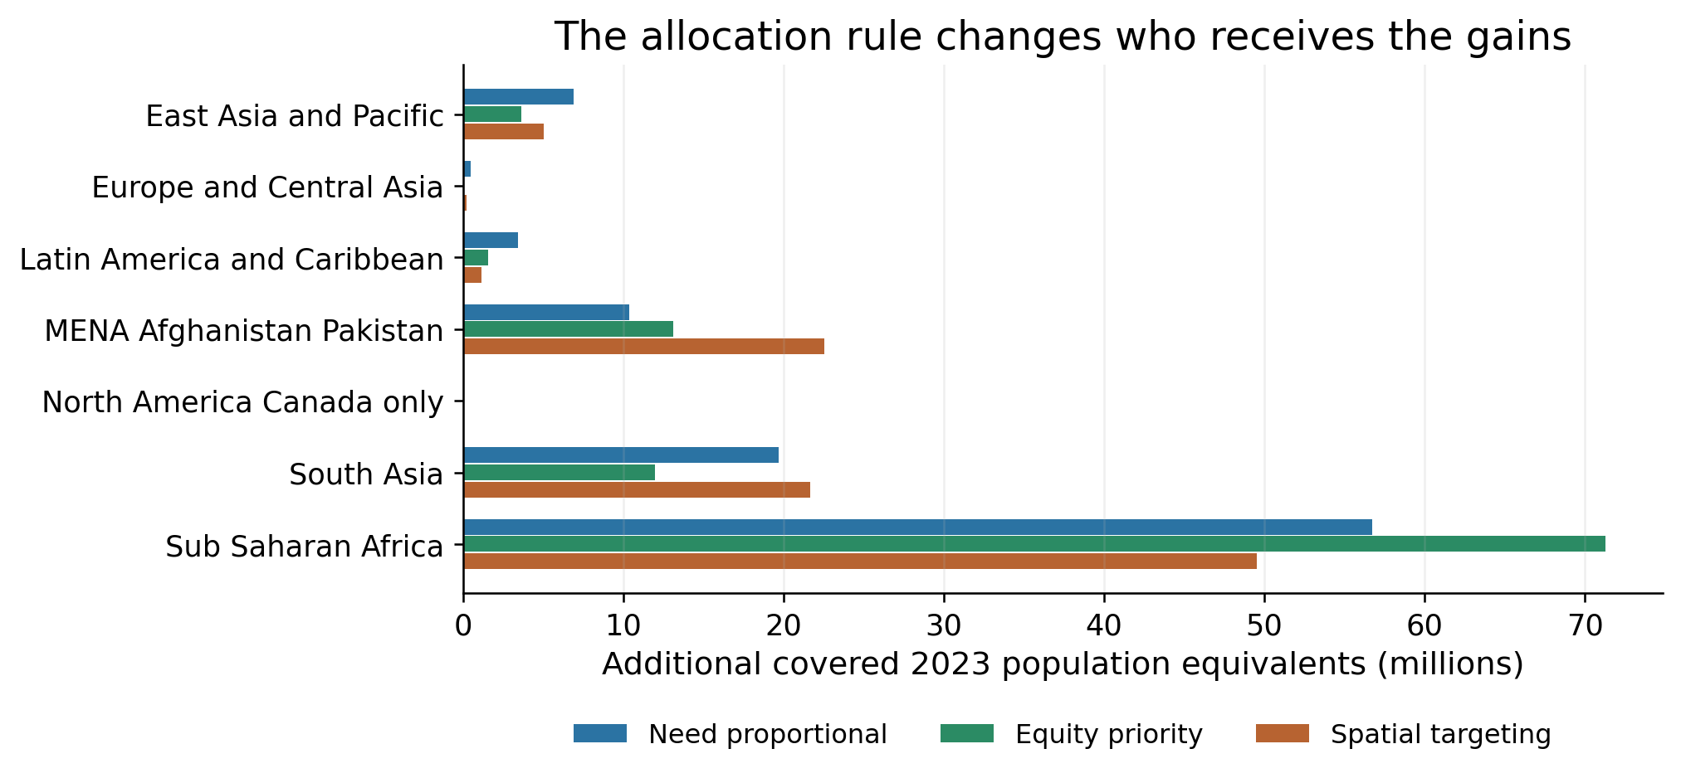
Figure 12. Mean additional coverage equivalents by region in 2030. Population and the total direct support allowance are fixed across rules.

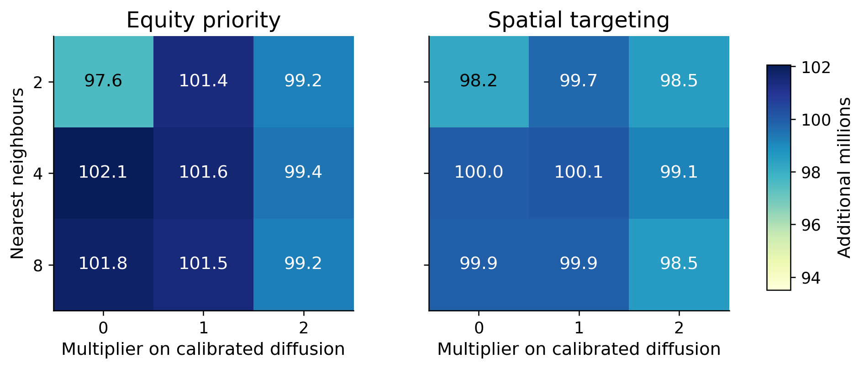
Figure 13. Additional millions under alternative neighbour counts and interaction strengths. Each cell uses 199 paired replicates. Interaction is scaled while the fitted drift for that graph is held fixed.

Housing Deprivation in the Separate Complete Subset
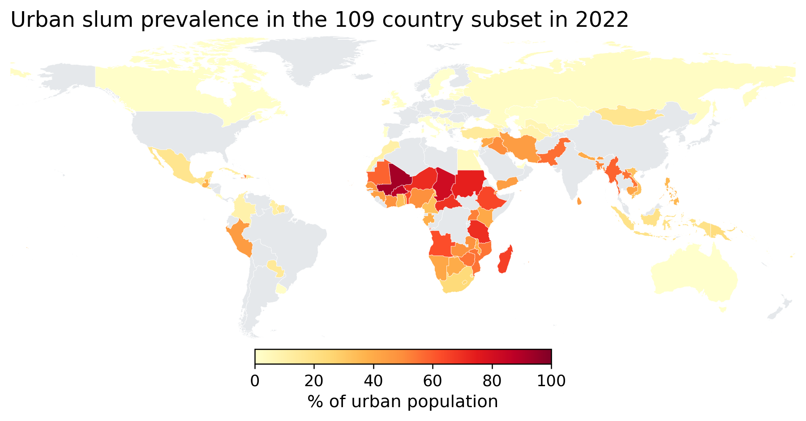
Figure 14. Observed urban slum prevalence in 2022 for 109 countries with complete nonzero data in every even year from 2000 to 2022.
2022 association with urban slum share | Spearman correlation
Electricity access | -0.700
Clean cooking access | -0.685
Basic water access | -0.708
Ambient PM2.5 | +0.525

Pakistan Case and Limits to Generalization
Pakistan indicator | 2000 | 2023 | Change
Electricity access | 72.80 | 95.60 | +22.80
Clean cooking access | 24.00 | 50.00 | +26.00
Basic water access | 87.34 | 90.68 | +3.34
Ambient PM2.5 | 57.25 | 58.37 | +1.12

