Household Wealth and Solar Lighting in Pakistan Empirical evidence from the Household Integrated Economic Survey 2024 to 2025
Household Coverage
Province | Households | PSUs | Share of retained  sample %
Punjab | 12,552 | 960 | 45.02
Sindh | 7,814 | 595 | 28.03
Khyber Pakhtunkhwa | 5,163 | 407 | 18.52
Balochistan | 2,353 | 183 | 8.44
Total | 27,882 | 2,145 | 100.00

Model | Outcome and comparison | Estimation sample | Weighting
A | Any solar versus other lighting | All 27,882 households | Household weights
B | Grid plus solar versus solar only | 6,280 solar users | Household weights
C | Any solar with wealth by urban interactions | All 27,882 households | Household weights
D | Any solar with the Model A controls | All 27,882 households | No sampling weights
E | Any solar using consumption quintiles | All 27,882 households | Household weights

Eight Lighting Categories
Lighting code | Reported source | Sample households | Weighted %
1 | Grid only | 19,882 | 77.63
2 | Grid and solar | 3,480 | 10.68
3 | Solar only | 2,800 | 7.35
4 | Gas | 28 | 0.11
5 | Kerosene / diesel / petrol | 46 | 0.14
6 | Firewood | 171 | 0.50
7 | Candle | 432 | 1.24
8 | Other | 1,043 | 2.35

Wealth group | Households | Any solar  % and 95% CI | Grid plus solar  % and 95% CI | Solar only  % and 95% CI
Q1 poorest | 6,498 | 30.38  (27.78 to 32.78) | 5.73  (4.80 to 6.68) | 24.65  (22.29 to 26.90)
Q2 | 5,898 | 18.59  (16.82 to 20.31) | 10.29  (9.10 to 11.54) | 8.30  (7.06 to 9.61)
Q3 | 5,349 | 14.38  (12.86 to 16.06) | 12.13  (10.71 to 13.66) | 2.25  (1.68 to 2.83)
Q4 | 5,256 | 13.00  (11.49 to 14.60) | 11.73  (10.34 to 13.29) | 1.26  (0.92 to 1.63)
Q5 richest | 4,881 | 14.16  (12.48 to 16.02) | 13.37  (11.73 to 15.18) | 0.79  (0.47 to 1.13)
Solar Lighting by Asset Wealth Quintile

Figure 1 Opposite Wealth Gradients in the Two Solar Arrangements
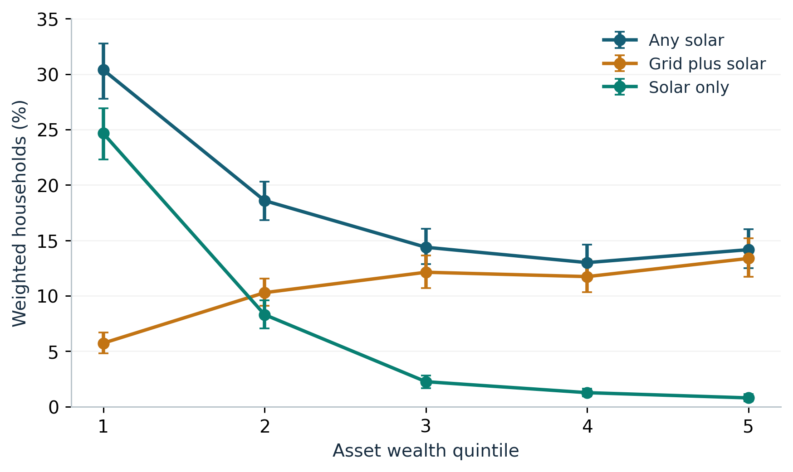

Direct Richest Versus Poorest Differences
Outcome | Q5 minus Q1  percentage points | 95% CI
Any solar | -16.22 | -19.02 to -13.34
Grid plus solar | +7.64 | +5.75 to +9.58
Solar only | -23.86 | -26.10 to -21.56

Differences Across Provinces and Residence
Weighted Solar Lighting by Province
Province | Any solar  % and 95% CI | Grid plus solar  % and 95% CI | Solar only  % and 95% CI
Punjab | 3.61  (3.14 to 4.13) | 2.42  (2.06 to 2.80) | 1.19  (0.90 to 1.56)
Sindh | 35.40  (32.96 to 38.19) | 18.78  (16.52 to 21.14) | 16.62  (14.46 to 18.57)
Khyber Pakhtunkhwa | 37.92  (33.91 to 42.37) | 27.75  (24.29 to 31.33) | 10.17  (7.73 to 12.85)
Balochistan | 36.68  (29.79 to 43.79) | 13.53  (10.44 to 17.25) | 23.15  (17.10 to 30.33)

Pooled Urban and Rural Differences
Outcome | Urban minus rural  percentage points | 95% CI
Any solar | -11.80 | -14.15 to -9.50
Grid plus solar | -2.52 | -4.32 to -0.71
Solar only | -9.28 | -10.71 to -7.93

Figure 2 Solar Lighting by Province and Asset Wealth Group
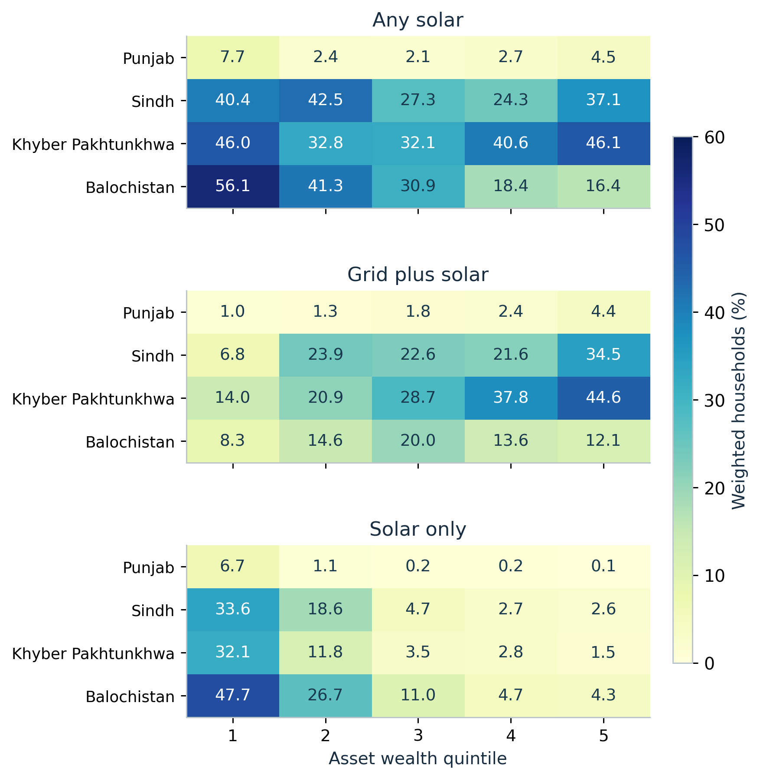

Concentration Over the Wealth Distribution
Outcome | Conventional C  95% CI | Erreygers E  95% CI
Any solar | -0.1680  (-0.1972 to -0.1377) | -0.1211  (-0.1421 to -0.0981)
Grid plus solar | +0.1285  (+0.0960 to +0.1592) | +0.0549  (+0.0404 to +0.0693)
Solar only | -0.5984  (-0.6271 to -0.5695) | -0.1760  (-0.1932 to -0.1576)

Figure 3 Wealth Related Concentration of Solar Lighting
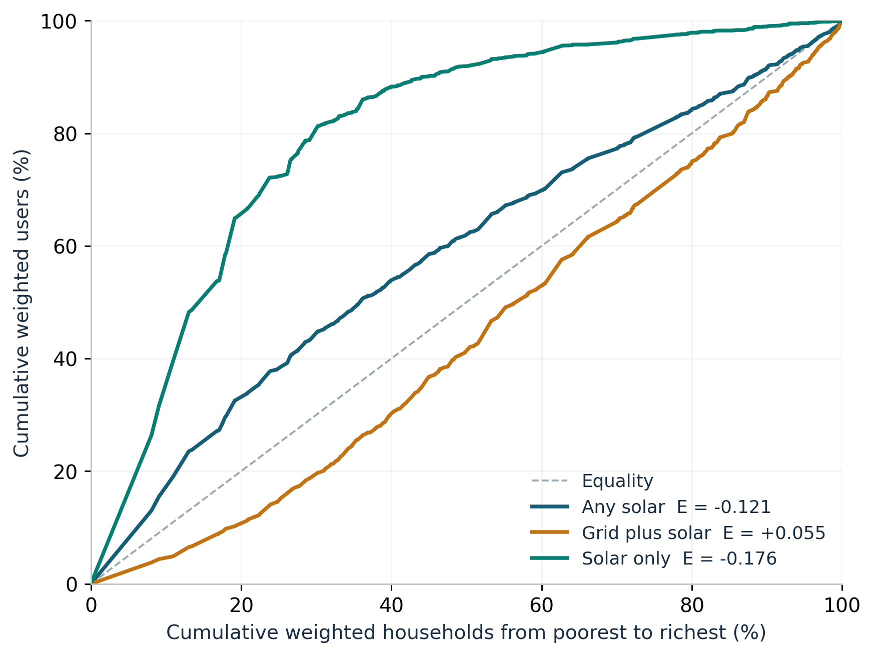

Resource Distributions
Weighted Median Household Resources
Asset wealth  group | Recorded assets  PKR per person | Selected cash receipts  PKR per person per month | Consumption  PKR per person per month
Q1 | 77,652 | 4,663 | 7,291
Q2 | 184,215 | 5,888 | 8,863
Q3 | 271,029 | 7,200 | 10,740
Q4 | 441,772 | 9,115 | 12,895
Q5 | 800,000 | 13,750 | 19,751

Panel Inventory and Reported Lighting Use
Reported Solar Lighting and Panel Inventory
Lighting response | No panels recorded | Panels recorded
No solar lighting reported | 72.73%  (n = 18,835) | 9.24%  (n = 2,767)
Solar lighting reported | 3.73%  (n = 1,240) | 14.30%  (n = 5,040)

Adjusted Associations
Adjusted Wealth Associations in the Two Primary Models
Wealth comparison | Model A  OR and 95% CI | p | Model B  OR and 95% CI | p
Q2 versus Q1 | 0.789  (0.678 to 0.918) | 0.002 | 5.215  (4.117 to 6.606) | <0.001
Q3 versus Q1 | 0.633  (0.522 to 0.767) | <0.001 | 18.973  (13.934 to 25.833) | <0.001
Q4 versus Q1 | 0.685  (0.558 to 0.842) | <0.001 | 31.182  (21.568 to 45.082) | <0.001
Q5 versus Q1 | 1.231  (0.976 to 1.554) | 0.080 | 49.020  (29.395 to 81.747) | <0.001

Adjusted Probability Profiles
Standardized Adjusted Probabilities
Asset wealth  group | Any solar  % and 95% CI | Grid plus solar  % and 95% CI | Solar only  % and 95% CI
Q1 | 20.03  (18.27 to 21.78) | 4.76  (3.92 to 5.61) | 15.26  (13.65 to 16.87)
Q2 | 17.26  (15.92 to 18.61) | 10.09  (9.05 to 11.12) | 7.18  (6.16 to 8.19)
Q3 | 14.90  (13.45 to 16.35) | 12.24  (10.91 to 13.57) | 2.65  (2.05 to 3.26)
Q4 | 15.73  (14.23 to 17.24) | 13.86  (12.41 to 15.31) | 1.87  (1.33 to 2.41)
Q5 | 22.62  (20.55 to 24.69) | 20.84  (18.80 to 22.88) | 1.78  (1.00 to 2.55)

Figure 4 Adjusted Probabilities for any Solar and the Two Solar Arrangements
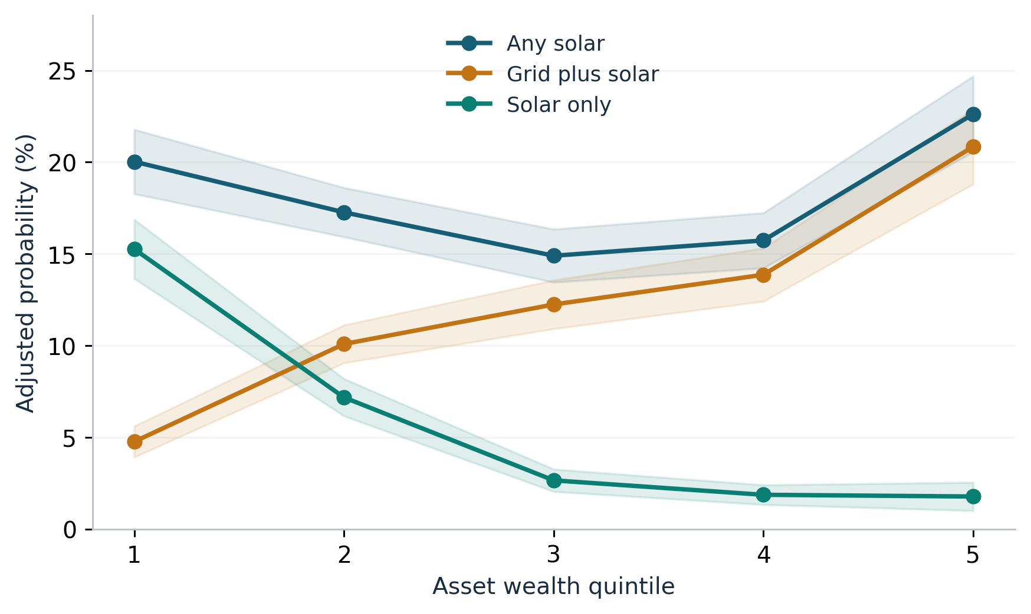

Residence Interactions
Figure 5 Adjusted Wealth Profiles by Rural and Urban Residence
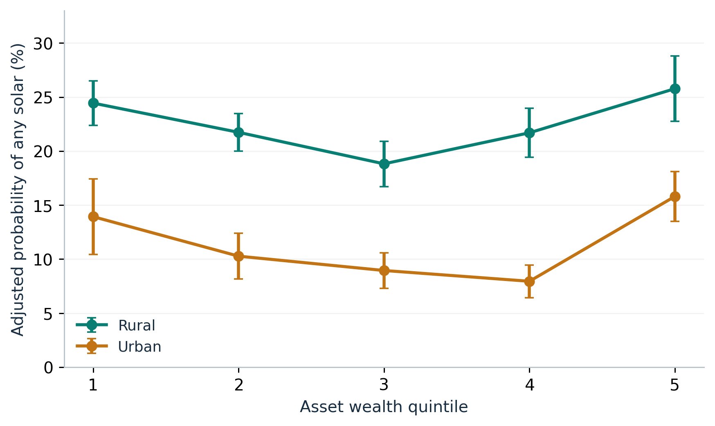
Adjusted any Solar Probabilities by Residence
Asset wealth group | Rural adjusted %  and 95% CI | Urban adjusted %  and 95% CI
Q1 | 24.44  (22.38 to 26.50) | 13.93  (10.44 to 17.42)
Q2 | 21.74  (19.99 to 23.48) | 10.27  (8.14 to 12.39)
Q3 | 18.82  (16.72 to 20.91) | 8.94  (7.30 to 10.58)
Q4 | 21.69  (19.41 to 23.98) | 7.95  (6.43 to 9.46)
Q5 | 25.77  (22.74 to 28.81) | 15.80  (13.50 to 18.10)

Joint Tests and Numerical Diagnostics
Table 16 Joint Tests of Wealth Terms and Residence Interactions
Model | Joint test | F statistic | Degrees of  freedom | p
A | Wealth group terms | 20.982 | 4, 2144 | <0.001
B | Wealth group terms | 112.582 | 4, 1096 | <0.001
E | Wealth group terms | 4.290 | 4, 2144 | 0.002
C | Wealth by urban terms | 3.793 | 4, 2144 | 0.004

Numerical Diagnostics for All Five Fits
Model | Households | Parameters | PSUs | Iterations | Score error | Hessian  condition
A | 27,882 | 22 | 2,145 | 7 | 2.44e-16 | 2,818.8
B | 6,280 | 22 | 1,097 | 7 | 2.31e-15 | 3,748.9
C | 27,882 | 26 | 2,145 | 7 | 2.25e-16 | 2,817.0
D | 27,882 | 22 | 2,145 | 7 | 2.85e-15 | 2,946.1
E | 27,882 | 22 | 2,145 | 7 | 1.90e-16 | 2,821.7

Sensitivity Analysis
Sensitivity of the Highest Versus Lowest Resource Contrast
Specification | Resource comparison | OR and 95% CI | p
A Weighted asset wealth | Highest versus lowest group | 1.231  (0.976 to 1.554) | 0.080
D Unweighted asset wealth | Highest versus lowest group | 1.269  (1.023 to 1.573) | 0.030
E Weighted consumption | Highest versus lowest group | 1.474  (1.187 to 1.830) | <0.001



