Cover page

Design and Developed By:
- Muhammad Hammad (Student 1478294)
- Muhammad Abdullah (Student 1482263)
- Ateeb Ahmed (Student 1478517)
- Muhammad Fahad (Student 1487174)
ADSE-II Project
EDUPREDICT

Acknowledgement
We would like to acknowledge all those who have given moral support and helped us make the project a success. We wish to express our gratitude to the e-projects Team at the Head Office, who guided and helped us. We would also like to express our gratitude to all the staff members of our center for not only providing us with the opportunity to work with them on this project, but also for their support and encouragement throughout the process. We also express our sincere gratitude to our project guide at the organization, for her valuable guidance and support for the completion of this project. And finally, we would like to offer many thanks to all our colleagues for their valuable suggestions and constructive feedback.

Contents
Cover page 1
Acknowledgement 5
Certificate Error! Bookmark not defined.
Problem Definition 10
Hardware Requirements 10
Software Requirements 10
Project Deliverables Error! Bookmark not defined.
Scope of Work 15
Dfd for Context Diagram 16
Dfd for User Authentication 18
Dfd for Academic Performance Error! Bookmark not defined.
Dfd for Attendance Monitoring Error! Bookmark not defined.
Dfd for Course Demand Error! Bookmark not defined.
Dfd for LMS Activity Tracking Error! Bookmark not defined.
Dfd for Student Data Management Error! Bookmark not defined.
Dfd for Machine Learning & Predictive Analysis Error! Bookmark not defined.
Ddf for Dashboard & Reports Error! Bookmark not defined.
Data Tables and Structure Error! Bookmark not defined.
Task Sheet – EduPredict ( Excel & Power BI Based ) 20
Dashboard & Analytics Screenshots Error! Bookmark not defined.

Problem Definition
Background
Education institutions worldwide face numerous challenges, such as declining student retention rates, inefficient resource allocation, and the need to personalize learning experiences. At the same time, advancements in technology and data availability present significant opportunities to address these challenges through data-driven approaches.
By leveraging the capabilities of Hadoop and predictive analytics, EduPredict aims to overcome these challenges, capitalize on data-driven opportunities, and ultimately enhance the educational experience for the students.
Functional Requirements
User Authentication and Authorization:
Implement a secure authentication system for users with different roles, such as administrators, teachers, students, and analysts.
Define access controls to restrict data access based on user roles and responsibilities.
Data Ingestion:
The system should support the ingestion of diverse educational datasets, including academic records, student demographics, LMS data, and attendance records.
Implement mechanisms to handle both historical and real-time data sources.
Ensure compatibility with common data formats used in education.
Data Storage:
Utilize the Hadoop Distributed File System (HDFS) for scalable and fault-tolerant storage of large educational datasets.
Implement data partitioning and organization strategies to optimize retrieval and processing.
Data Processing:
Implement parallel processing of educational data to handle large datasets efficiently.
Develop algorithms for identifying patterns, anomalies, and correlations in educational data.
Include mechanisms to handle missing or incomplete data gracefully.
Real-time Data Processing:
Integrate real-time data streaming capabilities.
Ensure seamless integration with batch processing for a comprehensive analysis.
Machine Learning Models:
Develop machine learning models for predictive analysis of student performance, dropout rates, and course demand.
Include algorithms for anomaly detection, trend prediction, and correlation analysis.
Regularly update and refine models based on the latest available data.

Data Visualization:
Create interactive dashboards for visualizing key metrics and predictions.
Develop visual representations of student performance patterns, anomalies, and predictions.
Provide customizable and user-friendly interfaces for stakeholders to explore data.
Notifications and Alerts:
Set up automated notifications and alerts for stakeholders based on predefined thresholds for academic anomalies or significant events.
Enable configurable alerting mechanisms to notify users in real-time.
Feedback and Support:
A support system for users to contact for assistance, report issues, and provide feedback.
Non-Functional Requirements
Performance:
The system must handle large volumes of data with minimal latency to ensure timely analysis and reporting.
Implement monitoring tools to track system performance, resource utilization, and data processing times.
Include optimization strategies for enhancing the overall efficiency of the system.

Data Security:
Implement encryption mechanisms to secure sensitive educational data during storage and transmission.
Ensure compliance with relevant data protection regulations and standards.
Data Integrity:
Ensure the accuracy and consistency of data throughout its lifecycle.
Implement mechanisms to handle missing or incomplete data gracefully.
Reliability:
Uptime: The application should aim for a minimum of 99% uptime, with scheduled maintenance communicated in advance.
Data Backup: Regular automated data backups must be performed to prevent data loss in case of system failures.
Scalability:
The architecture should support horizontal scaling to accommodate increased data volumes and processing demands.
Implement load balancing mechanisms for optimal resource utilization.
Performance Monitoring:
Implement monitoring tools to track system performance, resource utilization, and data processing times.
Include optimization strategies for enhancing the overall efficiency of the system.
Compliance and Standards:
Ensure adherence to relevant environmental data standards and protocols.
Comply with industry best practices for big data processing and analytics.
Documentation:
User Documentation: Provide user guides, FAQs, and tutorials to help users understand and navigate the application.
Developer Documentation: Provide thorough documentation for system architecture, data processing workflows, and machine learning models. Maintain developer documentation to assist in further development and maintenance.
Video: Provide video displaying complete working of the application.

Hardware Requirements
- Minimum i5 with 4 Cores but i7 is recommended.
- 16 GB of RAM
- 500 GB of SSD storage
- Graphics Card
- 64Bit Windows 10 or higher

Software Requirements
- Jupiter Anaconda Notebook 3
- RStudio
- Visual Code Studio / PyCharm
- Mongo Db Compass, and Shell
- Hadoop, HDFS and Apache server
- Tableau
- Impala server

Project Deliverables
You will design and build the project and submit it along with a complete project
report that includes:
- Problem Definition
- Design specifications
- Diagrams such as flowcharts for various activities, Data Flow Diagrams etc.
- Source Code
- Test Data Used in the Project
- Project Installation Instructions (if any)
Documentation is considered as a very important part of the project. Ensure that documentation is complete and comprehensive. The consolidated project will be submitted as a zip file with a ReadMe.doc file listing assumptions (if any) made.
Submit a video clip demonstrating the working of the Website. Optionally, a live hosted URL can be supplied for the site. Over and above the given specifications, you can apply your creativity and logic to improve the portal.

Scope of Work
The EduPredict – Educational Predictive Analytics System project includes the design, development, testing, and deployment of a scalable big-data–driven analytics platform using Hadoop and machine learning technologies, with the following scope:
- User Management
  - User registration, authentication, and role-based access control (Administrators, Teachers, Students, Analysts).
  - Secure login with encrypted credentials and authorization policies.
- Data Ingestion and Integration
  - Collection and ingestion of academic records, attendance data, LMS activity logs, and student demographic information.
  - Support for both historical and real-time data sources.
  - Compatibility with common educational data formats (CSV, JSON, databases).
- Data Storage and Management
  - Storage of large-scale educational datasets using Hadoop Distributed File System (HDFS).
  - Data partitioning, indexing, and efficient organization for optimized access and processing.
- Data Processing and Analytics
  - Batch processing of educational data using Hadoop ecosystem tools.
  - Data cleansing, transformation, and handling of missing or inconsistent data.
  - Identification of trends, patterns, correlations, and anomalies in student data.
- Real-Time Data Processing
  - Integration of real-time data streaming for live monitoring of academic activities.
  - Seamless coordination between real-time and batch data processing pipelines.
- Machine Learning and Predictive Modeling
  - Development of predictive models for student performance, dropout risk, and course demand.
  - Implementation of algorithms for trend prediction, anomaly detection, and correlation analysis.
  - Periodic model updates and retraining based on new data.
- Dashboard and Data Visualization
  - Development of interactive dashboards for administrators, teachers, and analysts.
  - Visualization of key metrics such as performance trends, risk indicators, and predictions.
  - User-friendly and customizable visual reports using charts and graphs.
- Alerts and Notification System
  - Automated alerts for academic anomalies such as low attendance or declining performance.
  - Configurable notification thresholds and real-time alerts for stakeholders.
- Reporting and Data Export
  - Generation of analytical reports for institutional decision-making.
  - Secure export of reports and datasets in user-selected formats.
- Security, Privacy, and Compliance
  - Implementation of data encryption for secure storage and transmission.
  - Role-based access to sensitive educational data.
  - Compliance with relevant data protection standards and best practices.
- Performance, Scalability, and Reliability
  - Optimization for handling large data volumes with minimal latency.
  - Horizontal scalability to support increasing users and datasets.
  - Load balancing, fault tolerance, and automated data backups.
- Monitoring and System Maintenance
  - Performance monitoring for system health, resource usage, and processing efficiency.
  - Logging and audit mechanisms for system activities and data access.
- Feedback and Support
  - Built-in support system for user queries, issue reporting, and feedback submission.
- Testing and Quality Assurance
  - Comprehensive testing including unit testing, integration testing, performance testing, and security testing.
  - Validation of predictive model accuracy and system reliability.

Ddf for Context Diagram

EduPredict
(System)

Dashboards
Reports
Notifications
User

Dfd for User Authentication
Access Token
Users
- Verify Credentials
- Role Management
User Authentication

Dfd for Academic Performance
Dashboard / ML Input
Academic Performance
- GPA Calculation
- Result Analysis
Academic Data (Excel)
(E

Dfd for Attendance Monitoring
% Attendance
Risk Identification
Attendance Monitoring
Attendance Data
DB
Alerts / Dashboards

Dfd for Course Demand
Dashboard / ML Input
- Popularity
- Enrollment Trend
Course Demand
Course Enrollment
DB

Dfd for LMS Activity Tracking

LMS Logs

LMS Activity Tracking

Login Count

Assignments / Quizzes

Engagement Analysis

Dashboard / ML Input

Dfd for Student Data Management
Dashboard / ML Input
- Dropout Risk
- Profile Categorization
Student Data Management
Student Demographics

Dfd for Machine Learning & Predictive Analysis
Course Demand Prediction
Machine Learning & Predictive
Dropout Prediction
Performance Prediction
Predictions Output / Dashboard
Data from All Modules
Dfd for Dashboard & Reports
Admin / Teachers
Dashboard & Reports
Processed Data & Predictions
Students / Analysts
- Interactive Charts
- Performance Trends

Data Tables and Structure
The EduPredict system uses multiple Excel-based data tables containing large-scale educational data. Each table consists of approximately 5000 records, which are imported into the system for analysis and predictive modeling.

1. Academic_Performance
This table stores academic result information of students and is used to analyze academic performance trends.
Fields:
- Student_ID
- Subject
- Total_Marks
- Obtained_Marks
- GPA
- Result
Purpose:
- Evaluate student academic performance.
- Identify high- and low-performing students.
- Support predictive analysis of academic outcomes.

2. Attendance_Data
This table contains student attendance details collected from academic records.
Fields:
- Student_ID
- Total_Classes
- Attended_Classes
- Attendance_Percentage
Purpose:
- Monitor student attendance behavior.
- Identify students at risk due to low attendance.
- Assist in dropout risk prediction.

3. Course_Demand
This table stores course enrollment data to analyze course popularity and demand trends.
Fields:
- Course_ID
- Course_Name
- Semester
- Enrolled_Students
- Year
Purpose:
- Analyze demand for different courses.
- Assist institutions in resource planning.
- Support predictive analysis for future course demand.

4. LMS_Activity
This table captures student interaction data from the Learning Management System (LMS).
Fields:
- Student_ID
- Login_Count
- Assignments_Submitted
- Quiz_Attempts
- Last_Login
Purpose:
- Measure student engagement with online learning platforms.
- Identify inactive or less-engaged students.
- Enhance predictive accuracy for performance and dropout analysis.

5. Students_Data
This table stores demographic and academic background information of students.
Fields:
- Student_ID
- Student_Name
- Gender
- Age
- City
- Program
- Enrollment_Year
- Status
- Dropout_Risk_Category
Purpose:
- Maintain student demographic profiles.
- Categorize students based on dropout risk.

Task Sheet – EduPredict ( Excel & Power BI Based)
Task ID | Task Description | Assigned To | Start Date | End Date | Status
T1 | Requirement Gathering & Problem Understanding | Hammad & Abdullah | 12-Jan-2026 | 12-Jan-2026 | Completed
T2 | Data Identification & Collection (Academic, Attendance, LMS, Course, Student Data) | Hammad & Abdullah | 13-Jan-2026 | 13-Jan-2026 | Completed
T3 | Data Preparation in Excel | Hammad & Abdullah | 14-Jan-2026 | 14-Jan-2026 | Completed
T4 | Data Cleaning & Validation in Excel | Hammad & Abdullah | 15-Jan-2026 | 15-Jan-2026 | Completed
T5 | Designing Data Tables Structure (Excel-Based) | Hammad & Abdullah | 16-Jan-2026 | 16-Jan-2026 | Completed
T6 | Importing Excel Data into Power BI | Hammad & Abdullah | 17-Jan-2026 | 17-Jan-2026 | Completed
T7 |  | Hammad & Abdullah | 18-Jan-2026 | 18-Jan-2026 | Completed
  Data Modelling & Relationship Mapping in Power BI
T8 | Academic Performance Dashboard Development | Hammad & Abdullah | 19-Jan-2026 | 19-Jan-2026 | Completed
T9 | Attendance & LMS Activity Dashboard | Hammad & Abdullah | 20-Jan-2026 | 20-Jan-2026 | Completed
T10 | Course Demand Analysis & Dropout Risk Insights | Hammad & Abdullah | 21-Jan-2026 | 21-Jan-2026 | Completed
T11 |  | Hammad & Abdullah | 22-Jan-2026 | 22-Jan-2026 | Completed
  Interactive Filters, Slicers & Dashboard Optimization
T12 | Testing of Dashboards & Reports | Hammad & Abdullah | 23-Jan-2026 | 23-Jan-2026 | Completed
T13 | Report Documentation, Video Recording & Final Review | Hammad & Abdullah | 24-Jan-2026 | 24-Jan-2026 | Completed

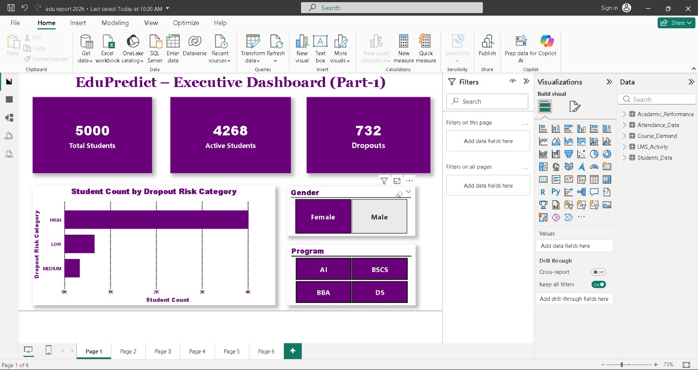

Figure 1: EduPredict – Executive Dashboard ( Part – 1 )
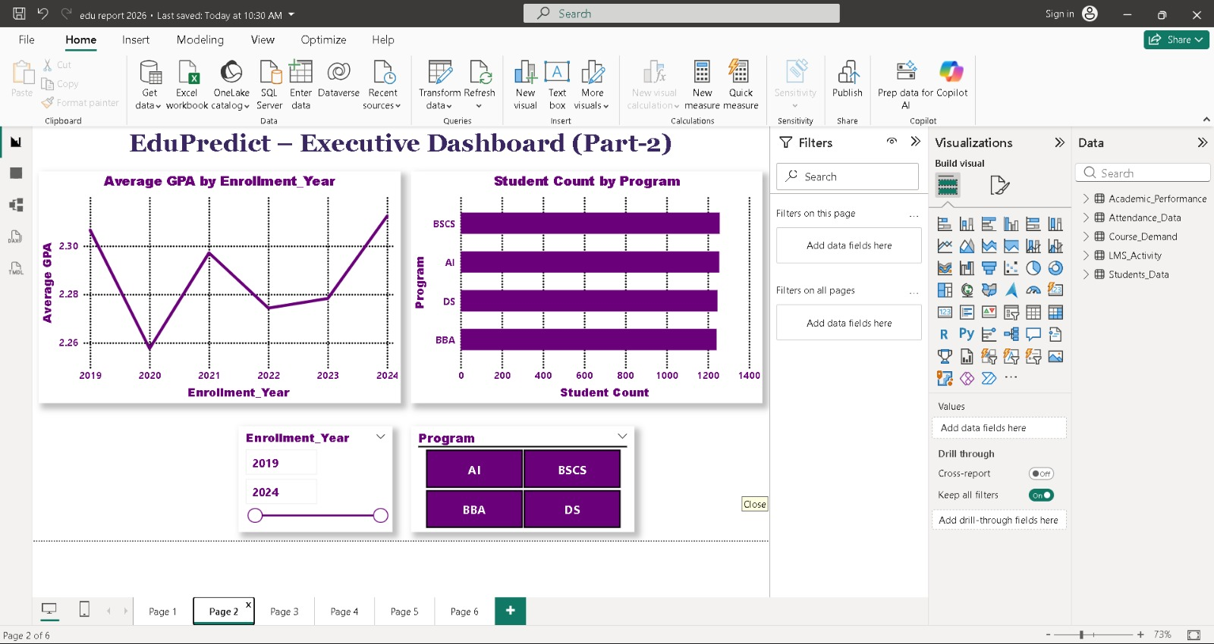

Figure 2: EduPredict – Executive Dashboard ( Part – 2 )

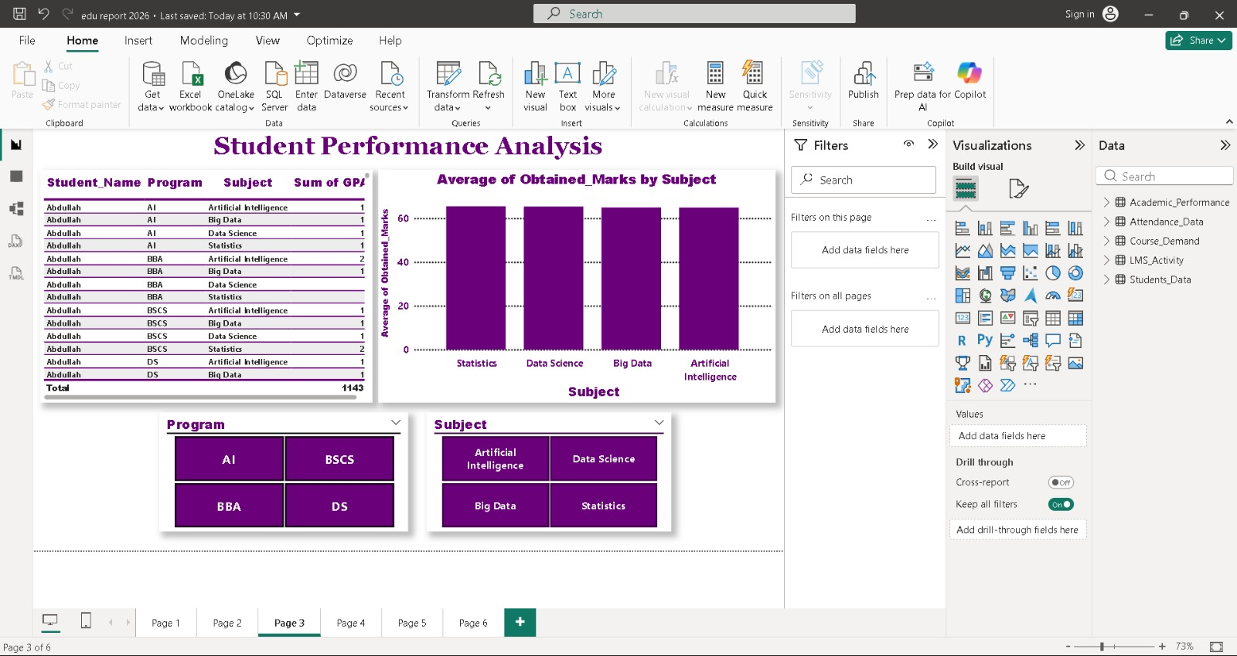

Figure 3: Student Performance Analysis

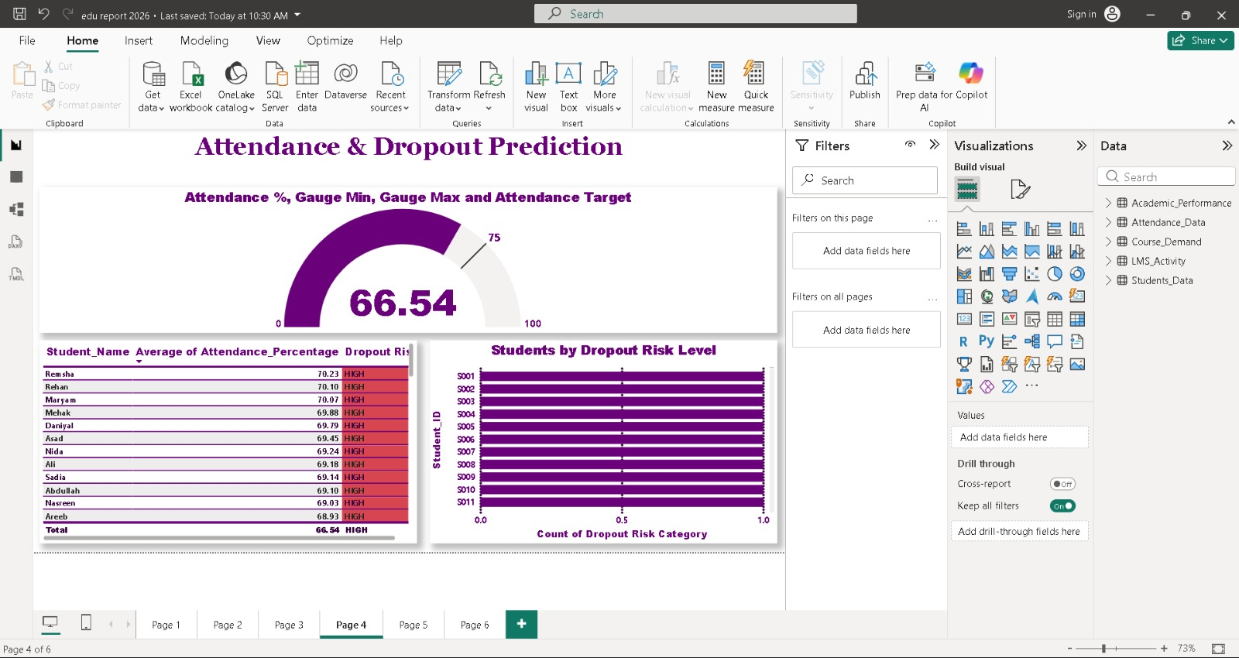

Figure 4: Attendance & Dropout Prediction

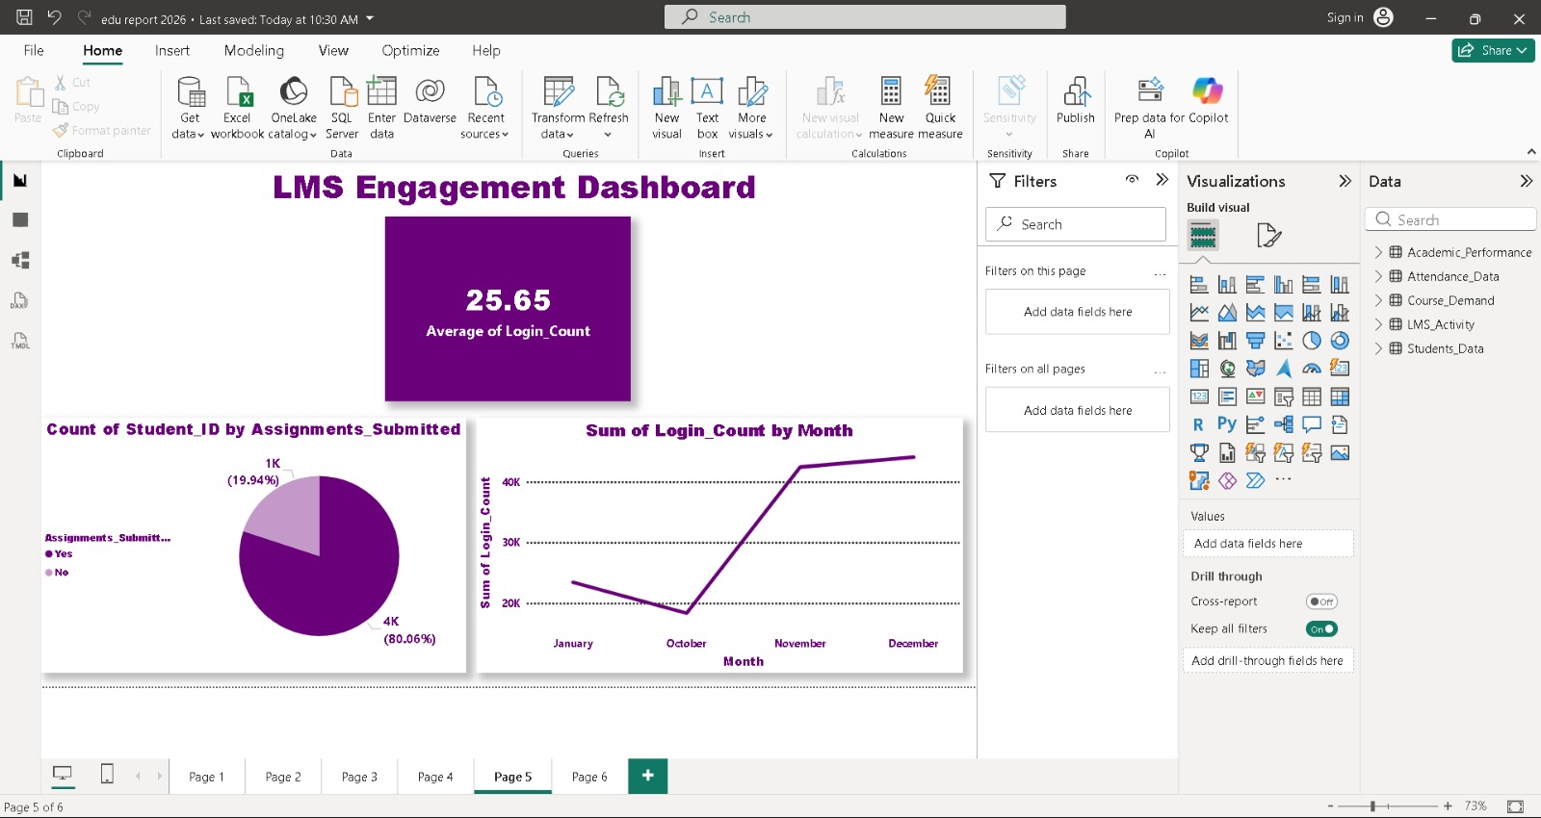

Figure 5: LMS Engagement Dashboard

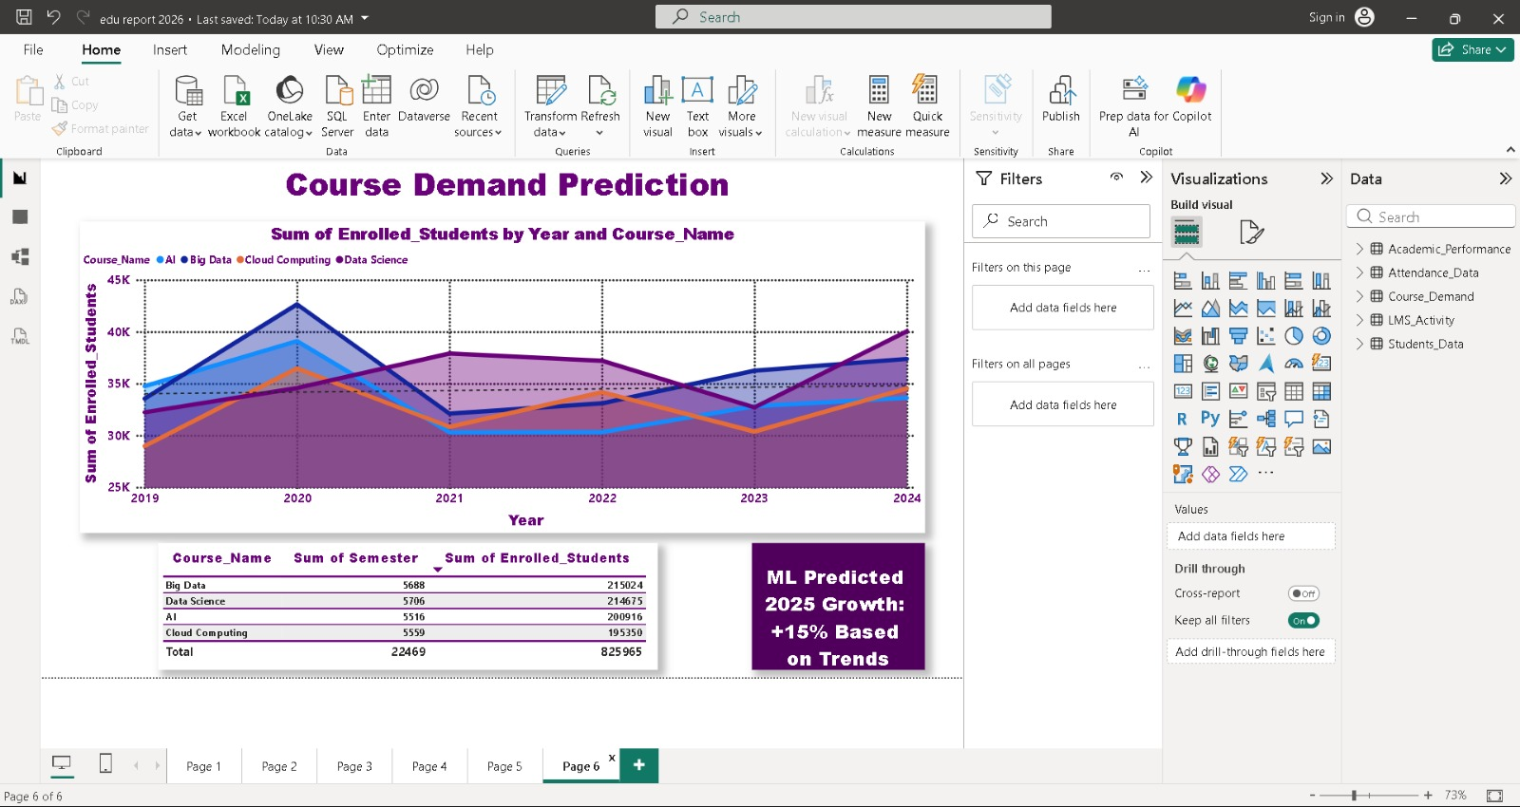

Figure 6: Course Demand Prediction

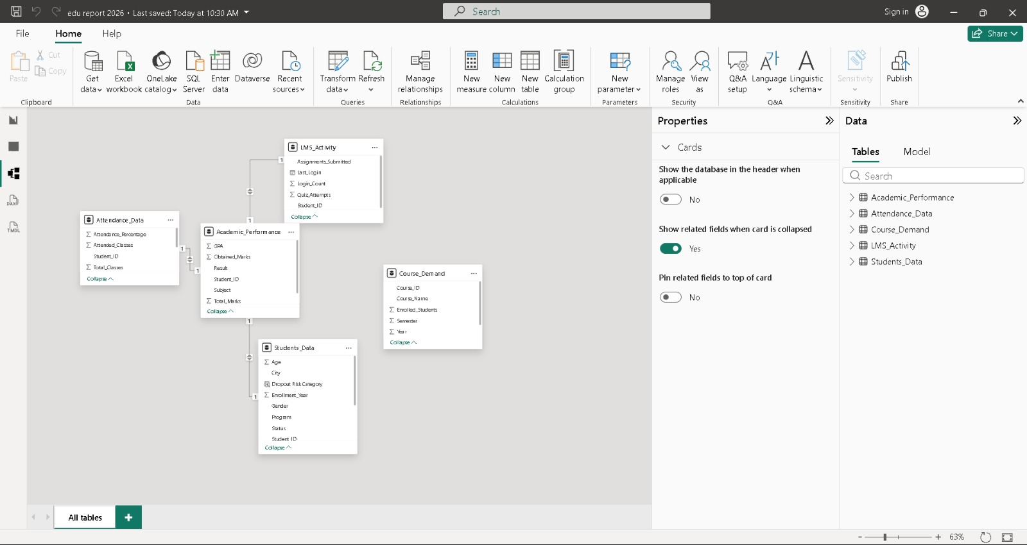

Figure 7: EduPredict – Model View

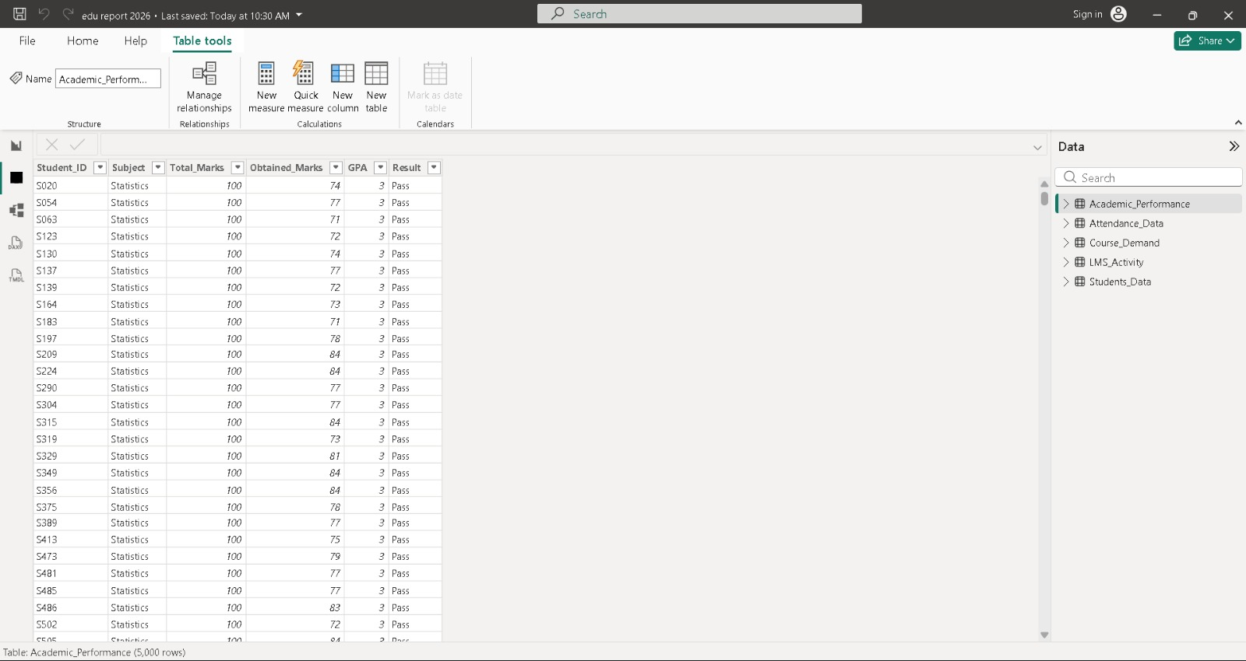

Figure 8: EduPredict – Academic Performance Table View

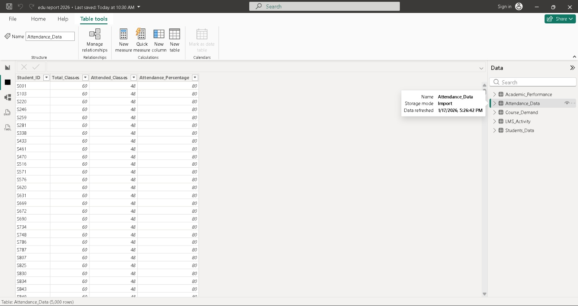

Figure 9: EduPredict – Attendance Data Table View

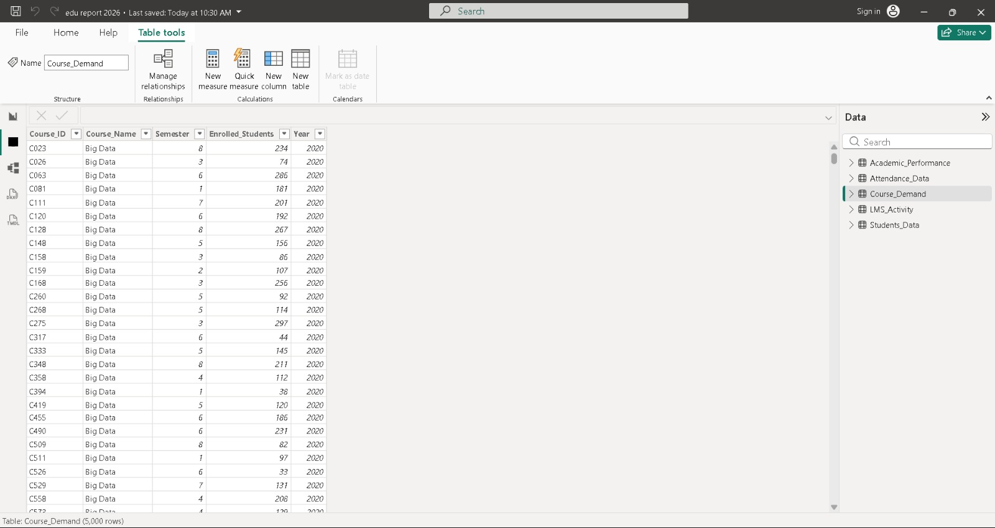

Figure 10: EduPredict – Course Demand Table View

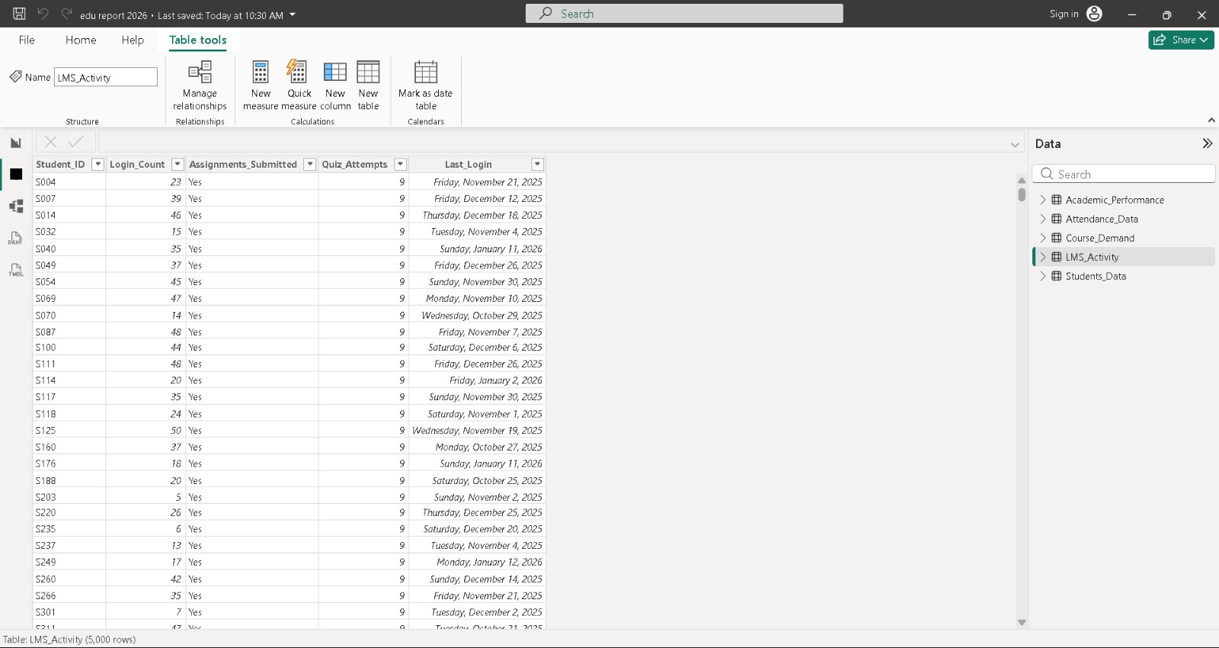

Figure 11: EduPredict – LMS Activity Table View

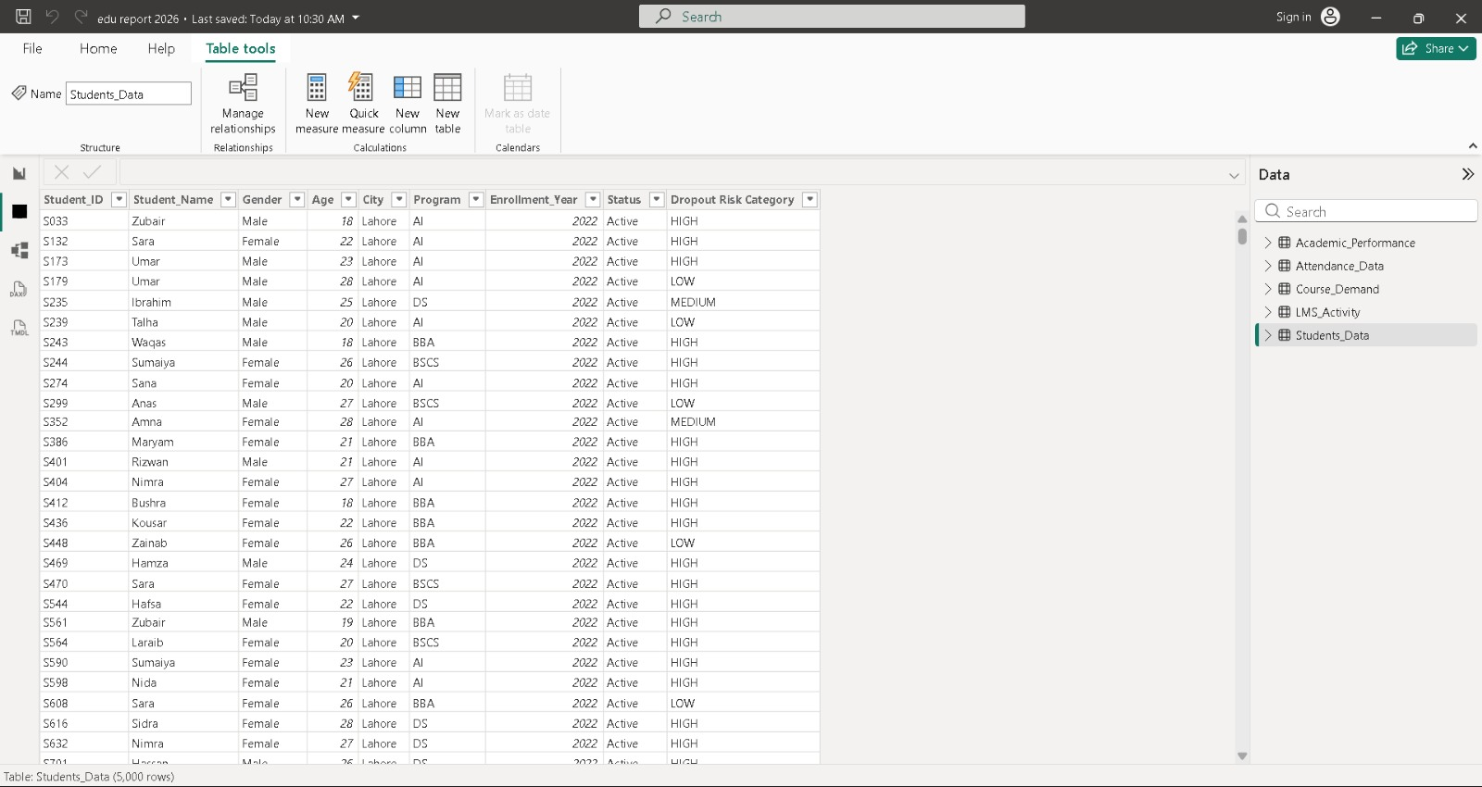

Figure 12: EduPredict – Student Data Table View

