**Muhammad Hamza**

**MCSF19A025**

GitHub Repository:-

Create a repository on GitHub:

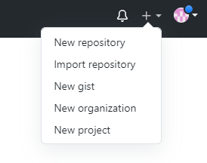

Provide Details of repository on your Account:

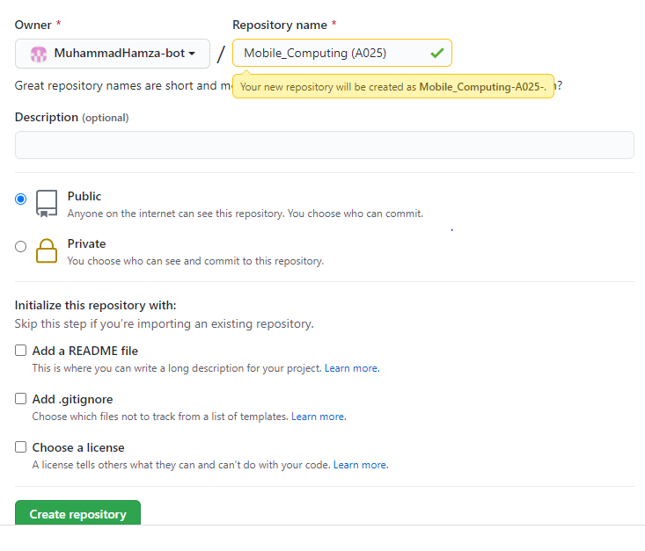

url of repository on your Account: 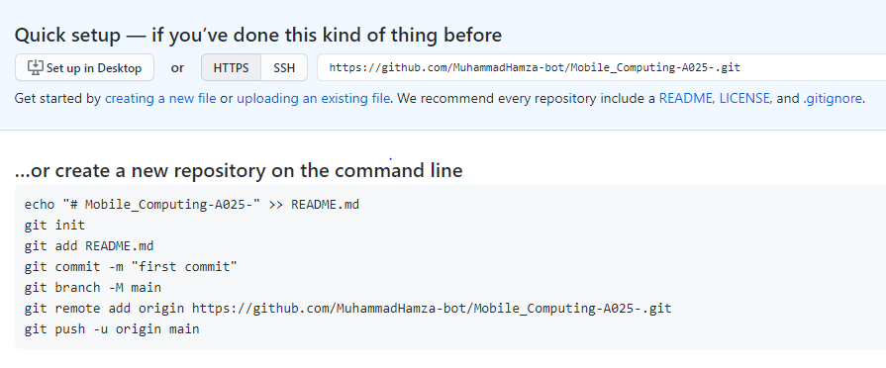

Clone a repository:

git clone:

<https://github.com/MuhammadHamza-bot/Mobile_Computing-A025-.git>

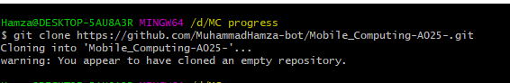

**File Content**

Created simple txt file at local repository:

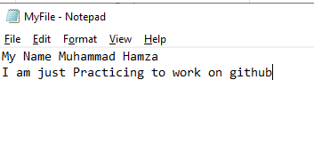

Git add and commit:

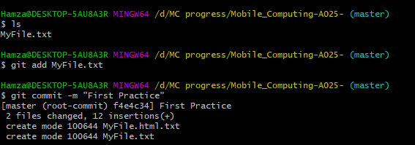

Git Push:

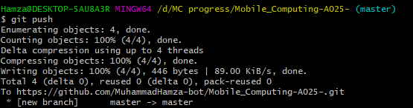

Git Status:

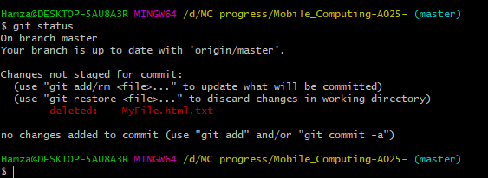

**GitHub Repository**

view of repository after push:

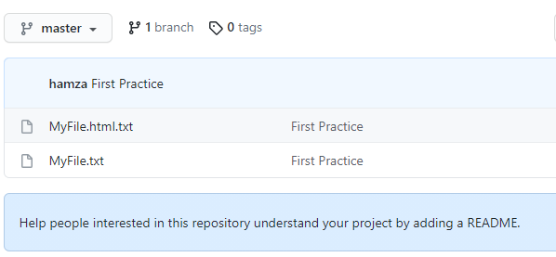

content of file in repository:

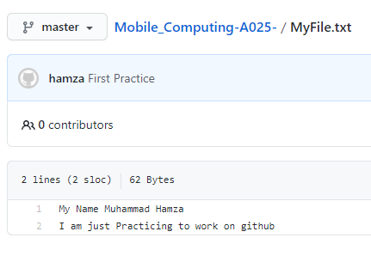

**File Content**

After changes made at local repository:

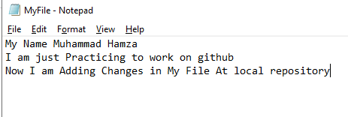

I going to Adding new commit

Committing changes to repository then push and check status of repository:

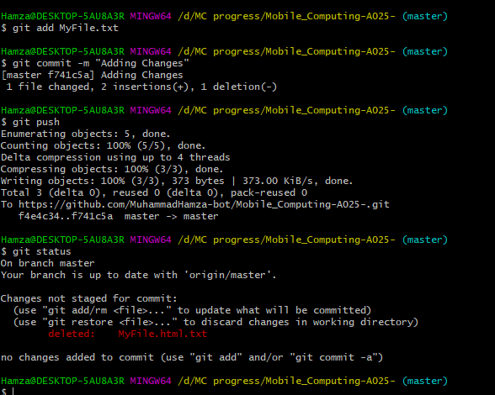

view of repository after Changes push:

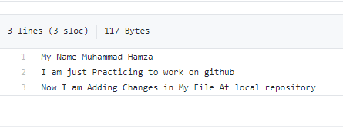

**GitHub Repository**

Track of changes:

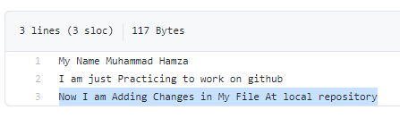

Now, I am going to Edit Online

How to edit files at repository:

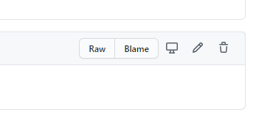

Edit Online

Edit files at repository:

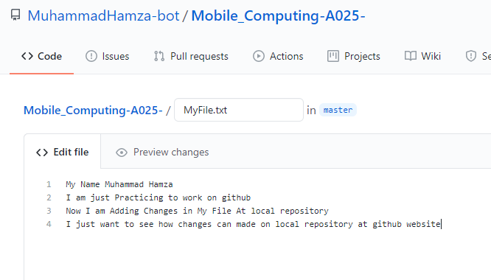

Commit changes at Web:

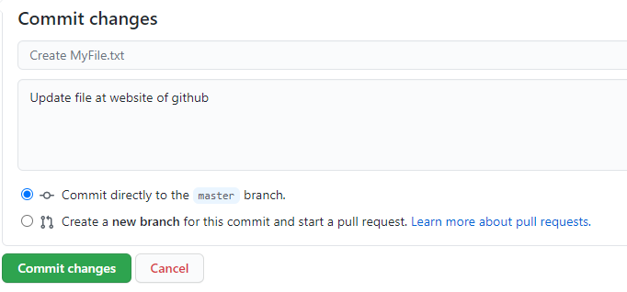

View changes:

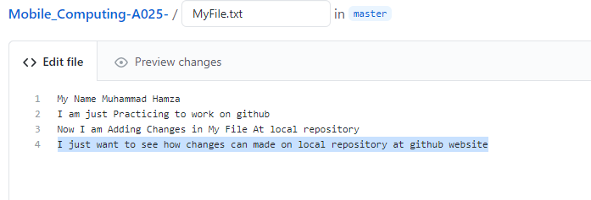

File showing with latest commit:

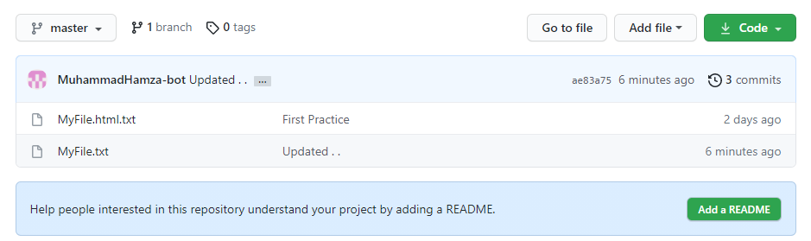

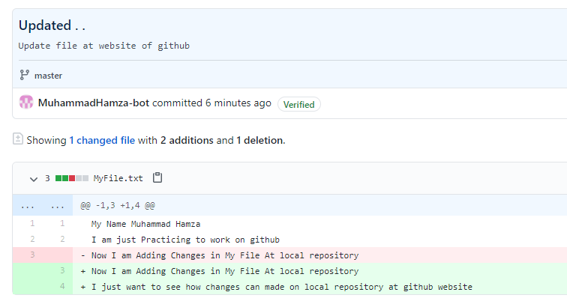

Git Pull:

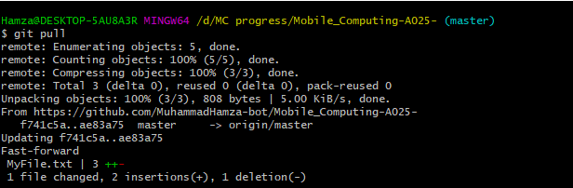

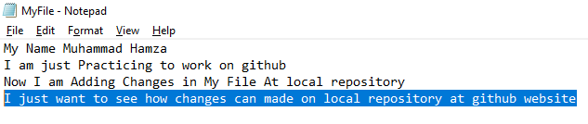

Merge Conflicts:

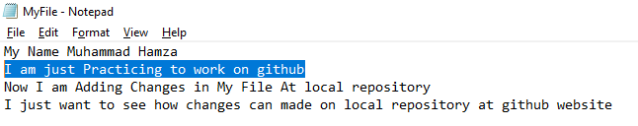

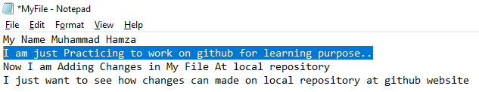

Merge Conflicts:

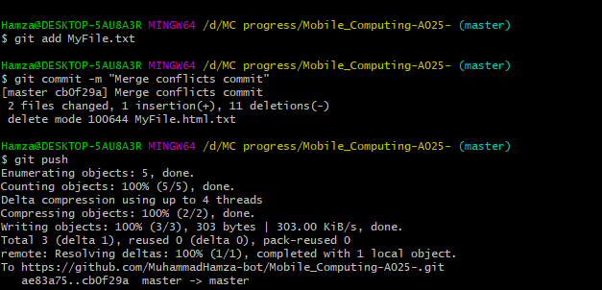

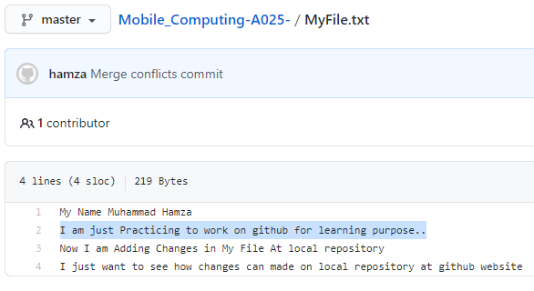

Git log:

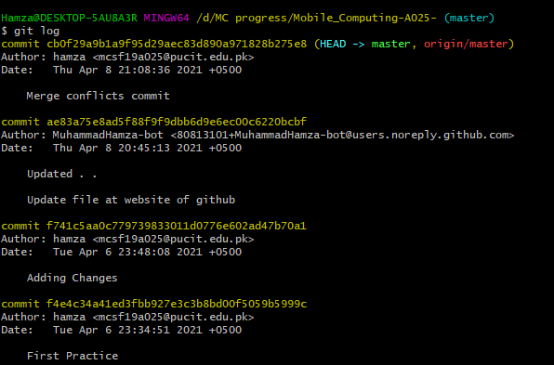

Create a Branch: