



**SQL**

**Portfolio Project**

**Course Instructor**

Miss Mahnoor Fatima

**Teaching Assistant**

Miss Nimra

**Batch-02 DS**

**Submitted By: Muhammad Hamza**

**Data Science & AI Boot Camp**

Table of Contents

Introduction 1

SQL Analysis 1

1. Total Customers 1

2. Monthly Distribution of Trial Plan Start Dates 1

3. Plan Start Dates After 2020 2

4. Customer Churn 2

5. Churn After Free Trial 2

6. Customer Plans After Free Trial 3

7. Plan Breakdown at End of 2020 3

8. Upgrades to Annual Plan in 2020 4

9. Average Time to Upgrade to Annual Plan 4

10. Breakdown of Upgrade Time into 30-Day Periods 5

11. Downgrades from Pro Monthly to Basic Monthly Plan in 2020 6

Conclusion 6

Project Report: Analysis of Foodie-Fi Subscription Data

## Introduction

This report presents an analysis of the subscription data for Foodie-Fi, a food delivery service. The analysis is based on SQL queries that extract insights from the data. The SQL code used for the analysis is included in the report.

## SQL Analysis

### 1. Total Customers

The total number of customers that Foodie-Fi has ever had is determined using the following SQL query:

***SELECT***

***COUNT(DISTINCT customer_id) AS num_customers***

***FROM subscriptions;***

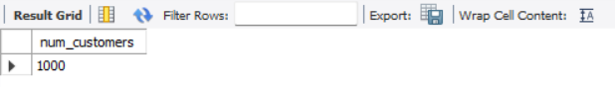

The result is 1000 customers.

### 2. Monthly Distribution of Trial Plan Start Dates

The monthly distribution of trial plan start dates is determined using the following SQL query:

SELECT

MONTH(start_date) AS months,

COUNT(customer_id) AS num_customers

FROM subscriptions

GROUP BY months;

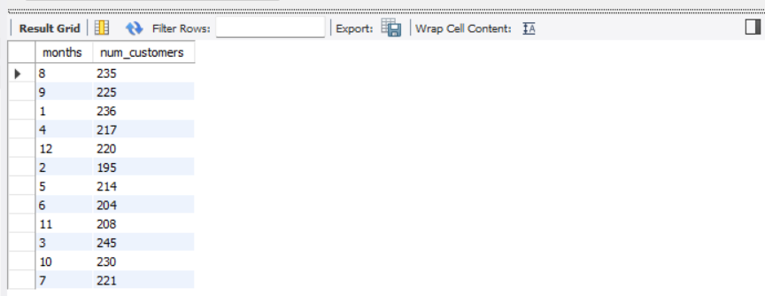

### 3. Plan Start Dates After 2020

The plan start dates that occur after the year 2020 are determined using the following SQL query:

SELECT

 p.plan_name,

 p.plan_id,

 COUNT(*) AS cnt_event

FROM subscriptions s

INNER JOIN plans p ON p.plan_id = s.plan_id

WHERE s.start_date >= '2021-01-01'

GROUP BY p.plan_id,p.plan_name

ORDER BY p.plan_id;

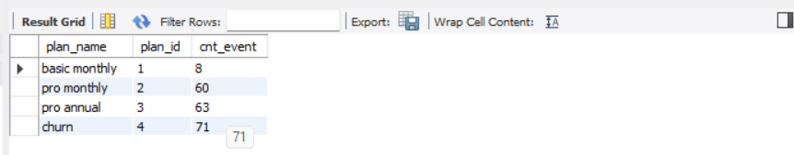

### 4. Customer Churn

The customer count and percentage of customers who have churned is determined using the following SQL query:

SELECT

  COUNT(*) AS cust_churn,

  ROUND(COUNT(*) * 100 / (SELECT COUNT(DISTINCT customer_id) FROM subscriptions),1) AS perc_churn

FROM subscriptions

WHERE plan_id = 4;

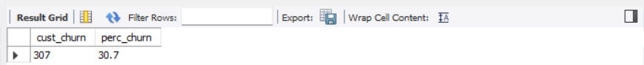

### 5. Churn After Free Trial

The number of customers who churned straight after their initial free trial is determined using the following SQL query:

WITH cte_churn AS (

SELECT *, LAG(plan_id, 1) OVER(PARTITION BY customer_id ORDER BY plan_id) AS prev_plan

FROM subscriptions)

SELECT

COUNT(prev_plan) AS cnt_churn,

   ROUND(COUNT(*) * 100/(SELECT COUNT(DISTINCT customer_id) FROM subscriptions),0) AS perc_churn

FROM cte_churn

WHERE plan_id = 4 and prev_plan = 0;



The result is a churn count of 92, which is 9% of the total customers.

### 6. Customer Plans After Free Trial

The number and percentage of customer plans after their initial free trial is determined using the following SQL query:

WITH cte_next_plan AS (

SELECT

*,

LEAD(plan_id, 1) OVER(PARTITION BY customer_id ORDER BY plan_id) AS next_plan

FROM subscriptions)

SELECT

next_plan,

COUNT(*) AS num_cust,

   ROUND(COUNT(*) * 100/(SELECT COUNT(DISTINCT customer_id) FROM subscriptions),1) AS perc_next_plan

FROM cte_next_plan

WHERE next_plan is not null and plan_id = 0

GROUP BY next_plan

ORDER BY next_plan;

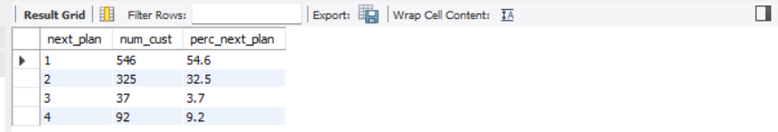

### 7. Plan Breakdown at End of 2020

The customer count and percentage breakdown of all plan names at the end of 2020 is determined using the following SQL query:

WITH cte_next_date AS (

SELECT

*,

LEAD(start_date, 1) OVER(PARTITION BY customer_id ORDER BY start_date) AS next_date

FROM subscriptions

  WHERE start_date <= '2020-12-31'),

plans_breakdown AS(

SELECT

plan_id,

  COUNT(DISTINCT customer_id) AS num_customer

FROM cte_next_date

WHERE (next_date IS NOT NULL AND (start_date < '2020-12-31' AND next_date > '2020-12-31'))

   OR (next_date IS NULL AND start_date < '2020-12-31')

GROUP BY plan_id)

SELECT

plan_id,

num_customer,

  ROUND(num_customer * 100/(SELECT COUNT(DISTINCT customer_id) FROM subscriptions),1) AS perc_customer

FROM plans_breakdown

GROUP BY plan_id, num_customer

ORDER BY plan_id;

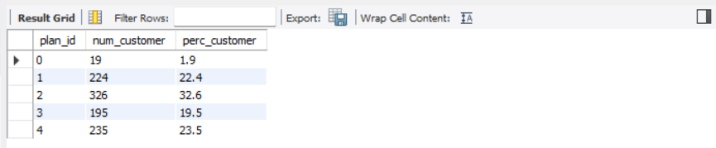

### 8. Upgrades to Annual Plan in 2020

The number of customers who upgraded to an annual plan in 2020 is determined using the following SQL query:

SELECT

COUNT(customer_id) AS num_customer

FROM subscriptions

WHERE plan_id = 3 AND start_date <= '2020-12-31';

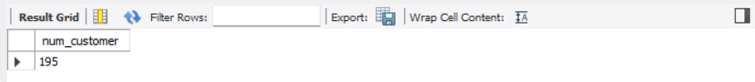

The result is 195 customers.

### 9. Average Time to Upgrade to Annual Plan

The average number of days it takes for a customer to upgrade to an annual plan from the day they join Foodie-Fi is determined using the following SQL query:

WITH annual_plan AS (

SELECT

customer_id,

    start_date AS annual_date

FROM subscriptions

   WHERE plan_id = 3),

trial_plan AS (

SELECT

customer_id,

    start_date AS trial_date

FROM subscriptions

  WHERE plan_id = 0

)

SELECT

ROUND(AVG(DATEDIFF(annual_date, trial_date)),0) AS avg_upgrade

FROM annual_plan ap

JOIN trial_plan tp ON ap.customer_id = tp.customer_id;



The result is an average of 105 days.

### 10. Breakdown of Upgrade Time into 30-Day Periods

The breakdown of the average upgrade time into 30-day periods is determined using the following SQL query:

WITH annual_plan AS (

SELECT

customer_id,

    start_date AS annual_date

FROM subscriptions

  WHERE plan_id = 3),

trial_plan AS (

SELECT

customer_id,

    start_date AS trial_date

FROM subscriptions

  WHERE plan_id = 0

),

day_period AS (

SELECT

DATEDIFF(annual_date, trial_date) AS diff

FROM trial_plan tp

LEFT JOIN annual_plan ap ON tp.customer_id = ap.customer_id

WHERE annual_date is not null

),

bins AS (

SELECT

*, FLOOR(diff/30) AS bins

FROM day_period)

SELECT

CONCAT((bins * 30) + 1, ' - ', (bins + 1) * 30, ' days ') AS days,

COUNT(diff) AS total

FROM bins

GROUP BY bins;

### 11. Downgrades from Pro Monthly to Basic Monthly Plan in 2020

The number of customers who downgraded from a pro monthly to a basic monthly plan in 2020 is determined using the following SQL query:

WITH next_plan AS (

SELECT

*,

LEAD(plan_id, 1) OVER(PARTITION BY customer_id ORDER BY start_date, plan_id) AS plan

FROM subscriptions)

SELECT

COUNT(DISTINCT customer_id) AS num_downgrade

FROM next_plan np

LEFT JOIN plans p ON p.plan_id = np.plan_id

WHERE p.plan_name = 'pro monthly' AND np.plan = 1 AND start_date <= '2020-12-31';



The result is 0 customers.

## Conclusion

The SQL analysis provides valuable insights into the customer behavior and subscription trends of Foodie-Fi. These insights can be used to inform business decisions and improve customer retention strategies. The SQL code used for the analysis is robust and can be adapted for future analyses as the subscription data grows and evolves.