PART A

Aukland Weather Postman
END URL :
https://api.openweathermap.org/data/2.5/weather?q=Auckland&units=metric&appid=12e0d6 89873955d5fde38ffcb3463766

Method : GET
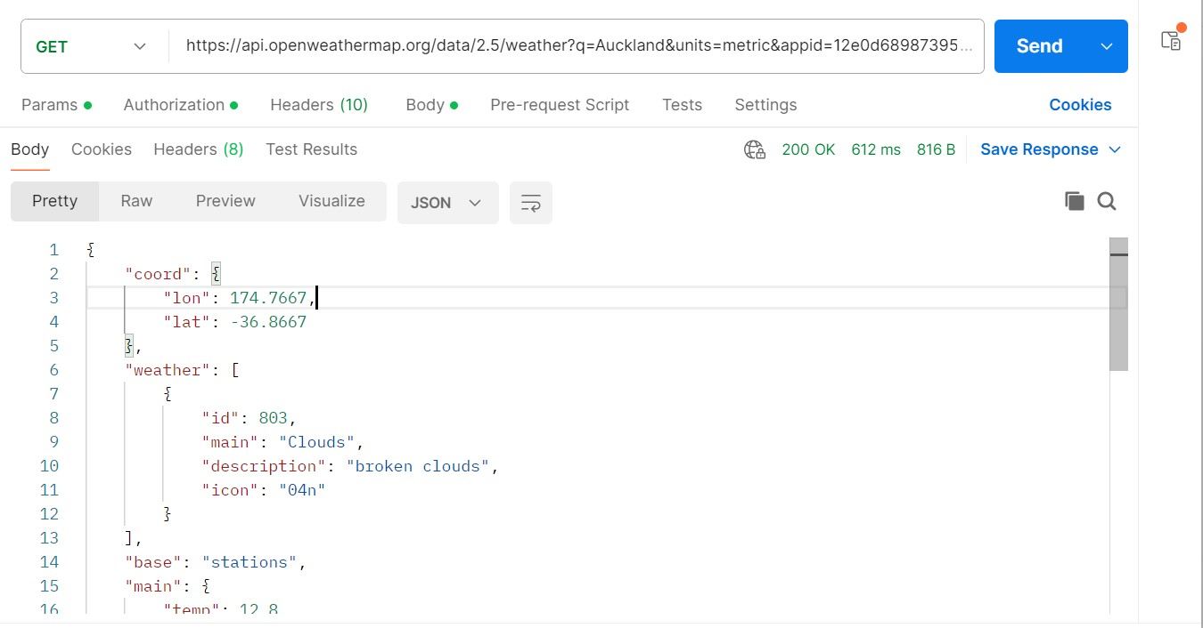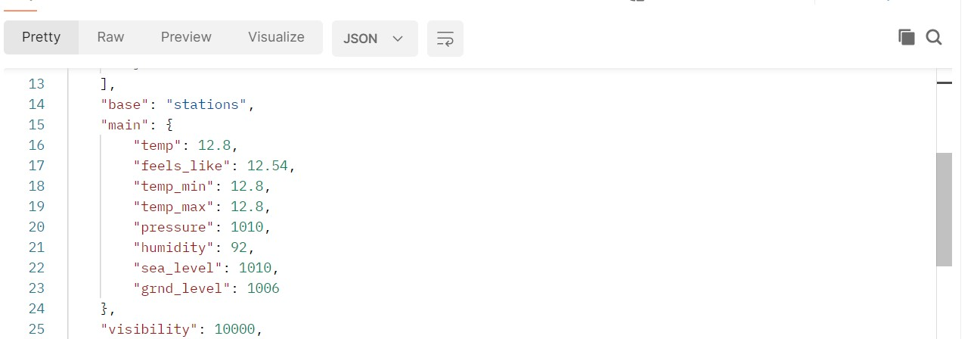
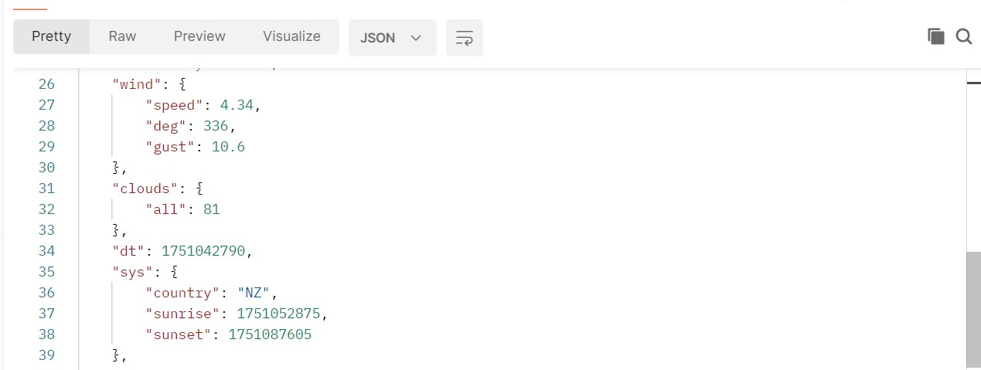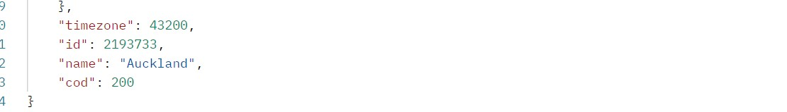

Wellington Weather Details
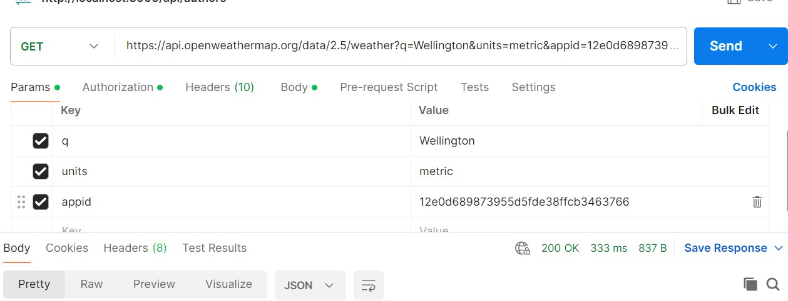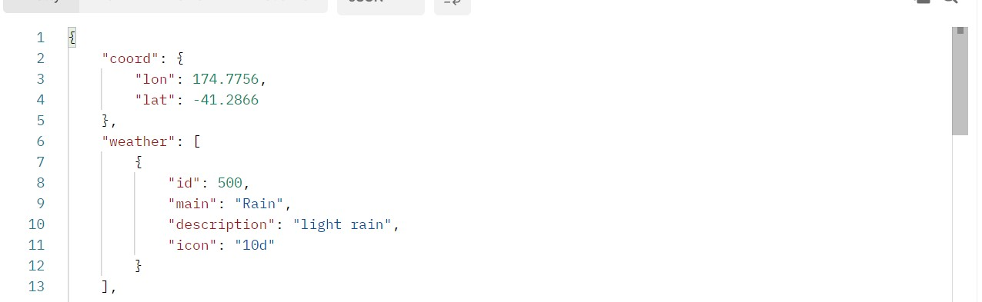
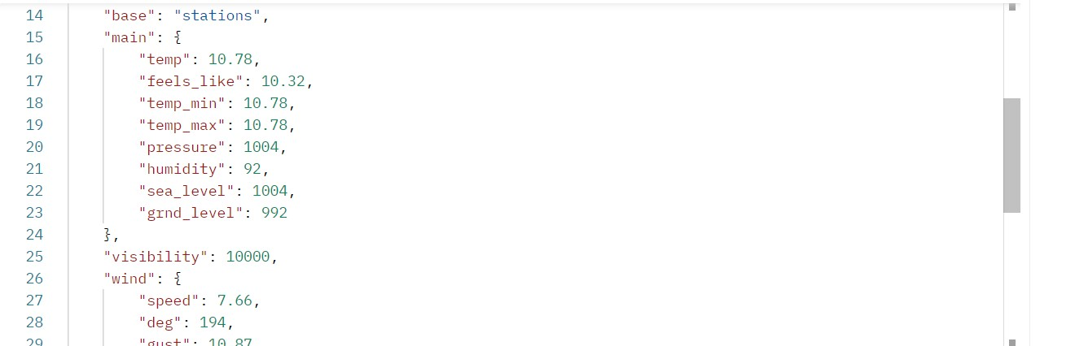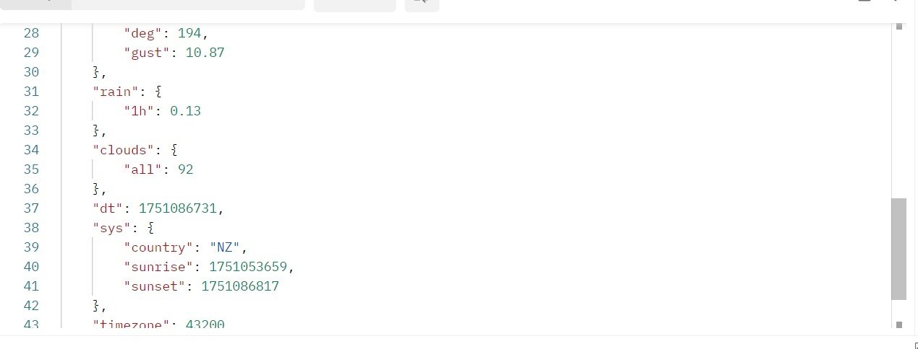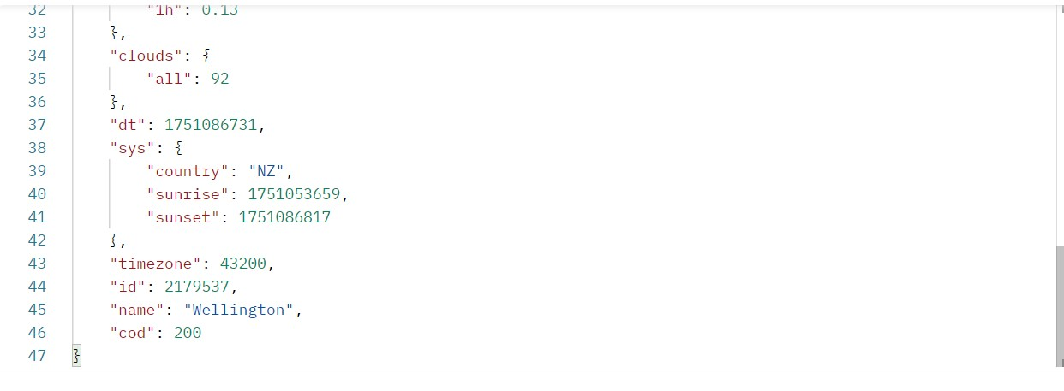

Christchurch Weather Details
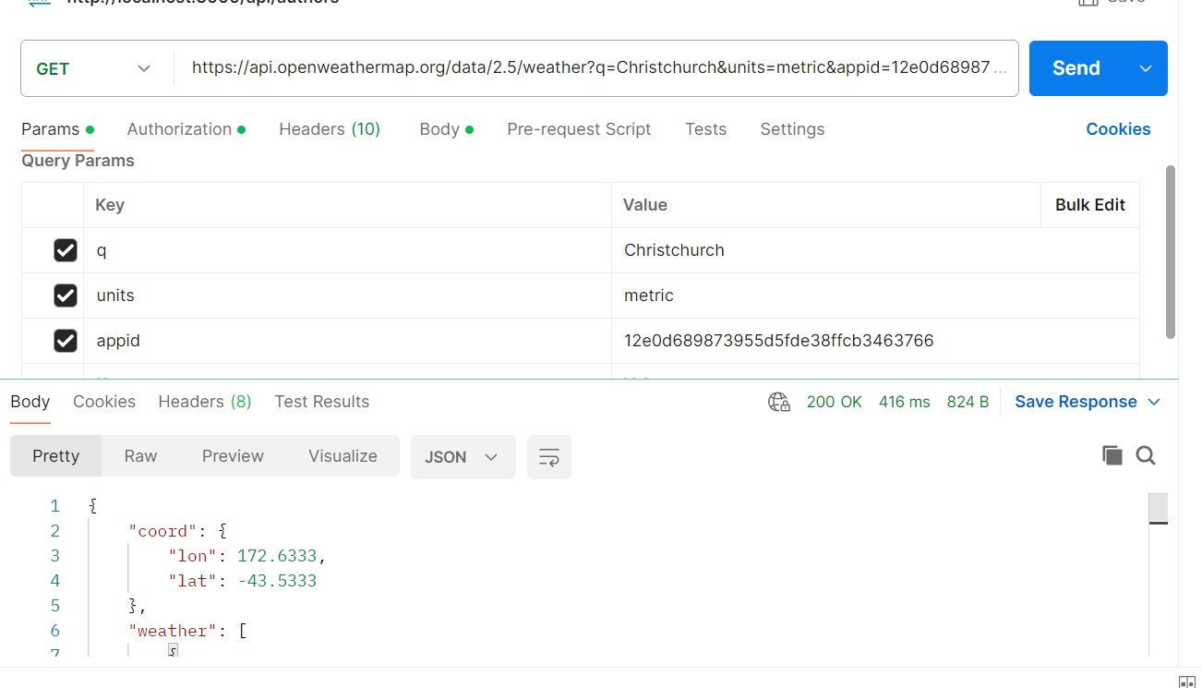
{
"coord": {
"lon": 172.6333,
"lat": -43.5333
},
"weather": [
{
"id": 804,
"main": "Clouds",
"description": "overcast clouds",
"icon": "04d"
}
],
"base": "stations",
"main": {
"temp": 8.01,
"feels_like": 6.06,
"temp_min": 8.01,
"temp_max": 8.01,
"pressure": 1006,
"humidity": 89,
"sea_level": 1006,
"grnd_level": 999
},
"visibility": 10000,
"wind": {
"speed": 3.1,
"deg": 218,
"gust": 6.98
},
"clouds": {
"all": 100
},
"dt": 1751086615,
"sys": {
"country": "NZ",
"sunrise": 1751054620,
"sunset": 1751086884
},
"timezone": 43200,
"id": 2192362,
"name": "Christchurch",
"cod": 200
}

London Weather Details :
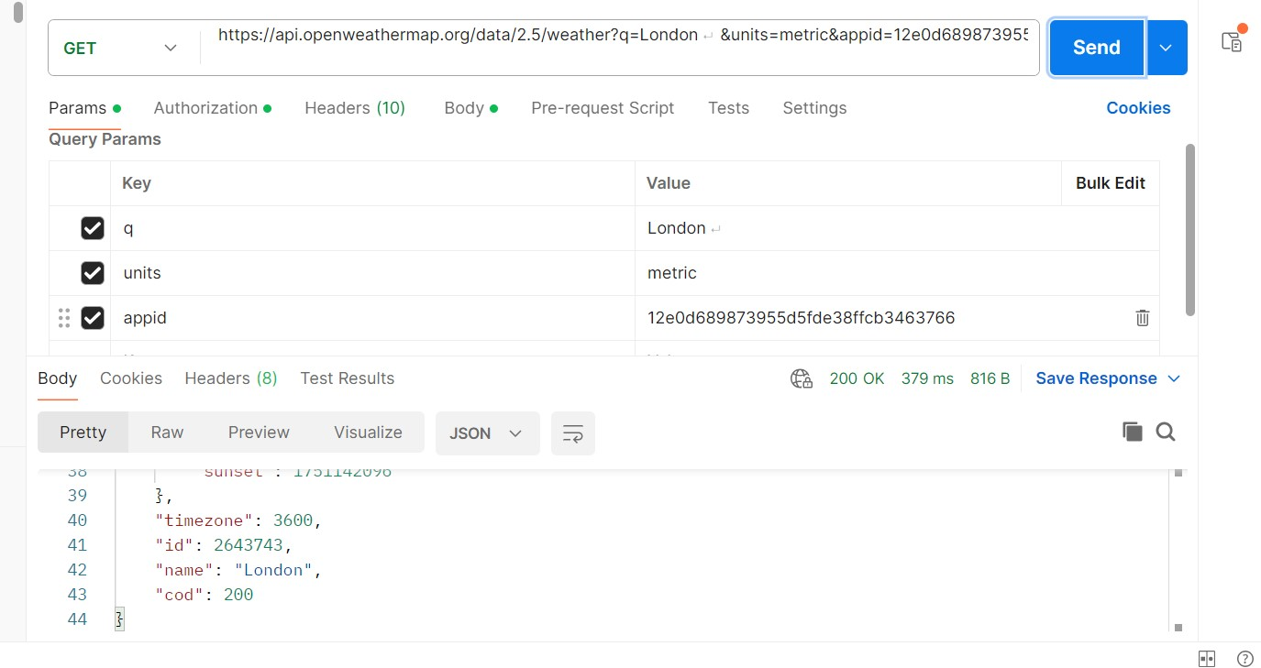
{
"coord": {
"lon": -0.1257,
"lat": 51.5085
},
"weather": [
{
"id": 803,
"main": "Clouds",
"description": "broken clouds",
"icon": "04d"
}
],
"base": "stations",
"main": {
"temp": 19.09,
"feels_like": 19.27,
"temp_min": 19.09,
"temp_max": 19.09,
"pressure": 1022,
"humidity": 85,
"sea_level": 1022,
"grnd_level": 1018
},
"visibility": 10000,
"wind": {
"speed": 3.91,
"deg": 236,
"gust": 10.34
},
"clouds": {
"all": 80
},
"dt": 1751087124,
"sys": {
"country": "GB",
"sunrise": 1751082344,
"sunset": 1751142096
},
"timezone": 3600,
"id": 2643743,
"name": "London",
"cod": 200
}

Paris Weather Details
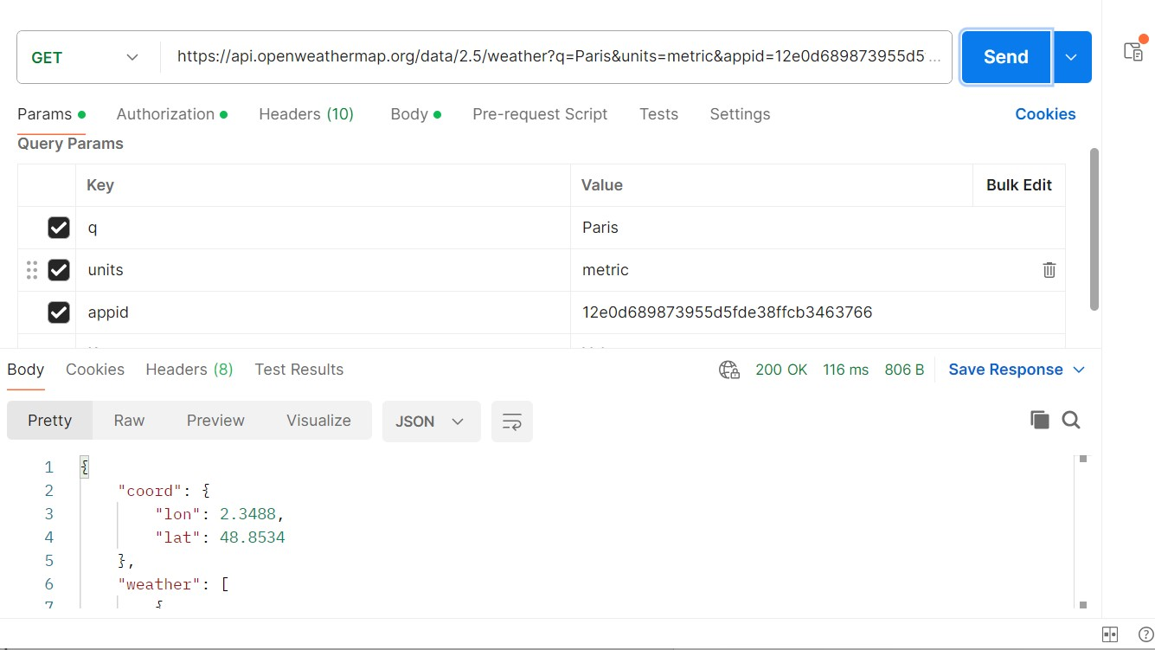
{
"coord": {
"lon": 2.3488,
"lat": 48.8534
},
"weather": [
{
"id": 801,
"main": "Clouds",
"description": "few clouds",
"icon": "02d"
}
],
"base": "stations",
"main": {
"temp": 18.87,
"feels_like": 19.06,
"temp_min": 18.87,
"temp_max": 18.87,
"pressure": 1026,
"humidity": 86,
"sea_level": 1026,
"grnd_level": 1016
},
"visibility": 10000,
"wind": {
"speed": 1.15,
"deg": 317,
"gust": 2.32
},
"clouds": {
"all": 22
},
"dt": 1751086801,
"sys": {
"country": "FR",
"sunrise": 1751082568,
"sunset": 1751140684
},
"timezone": 7200,
"id": 2988507,
"name": "Paris",
"cod": 200
}

TASK 02

CURL OPERATION

Queenstown
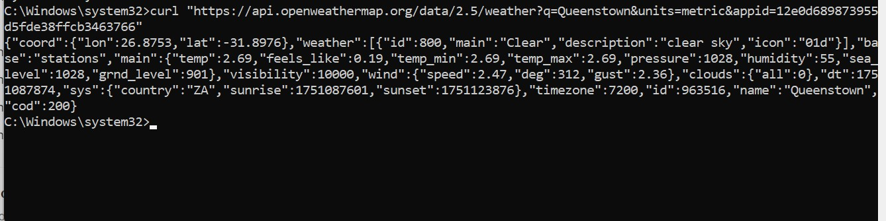

Dunedin
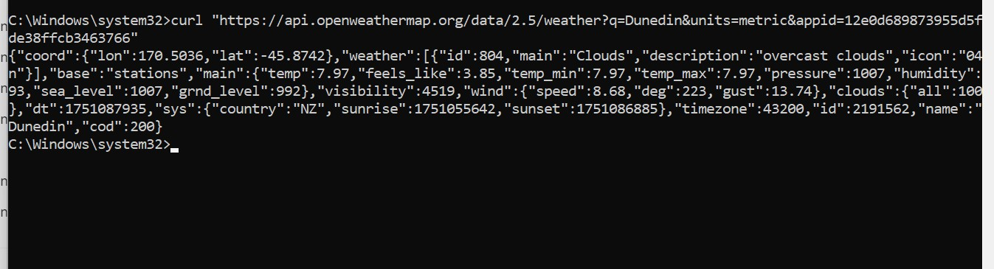

Rotorua
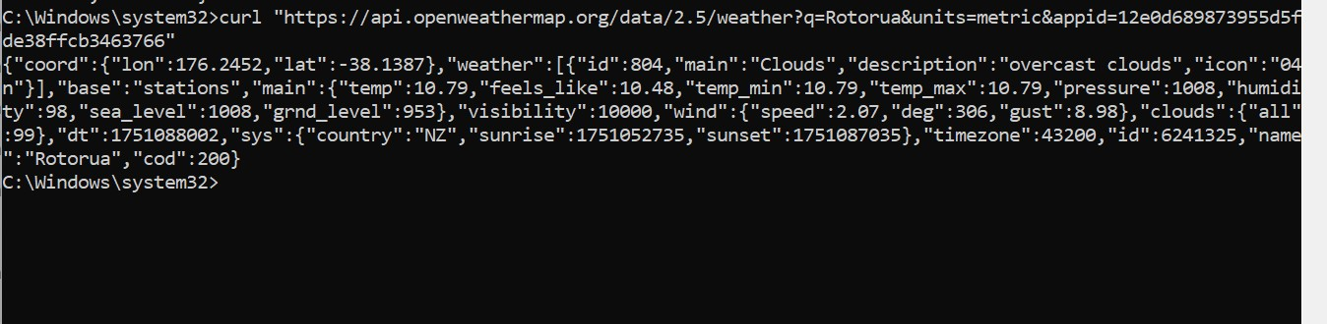

Munich
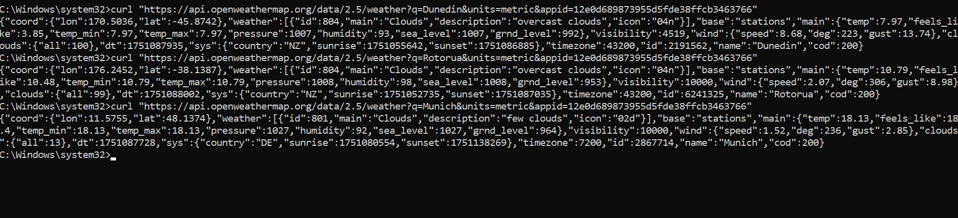

Madrid
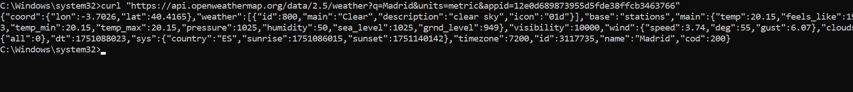

2)
Get city name, weather description and minimum and maximum temperature in Celsius for the following cities based on their geographical coordinates:

Longitude: 8.6, Latitude: 45.43

Longitude: 151.22, Latitude: -33.85

Longitude: -122.33, Latitude: 47.6

Task 3 Creating web hooks
Google :
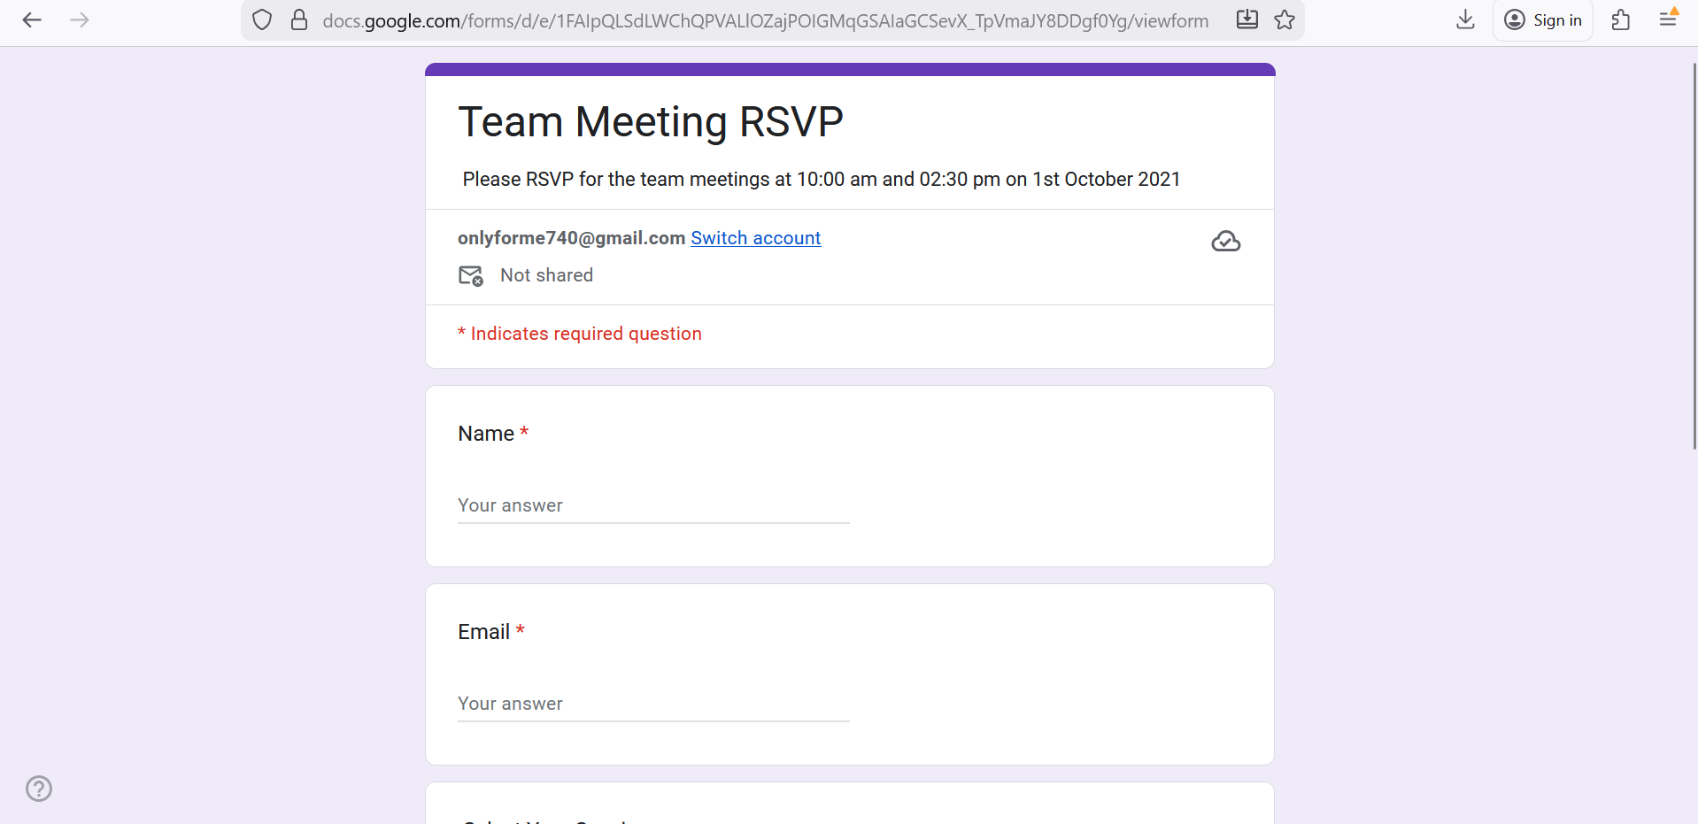


Google Sheet
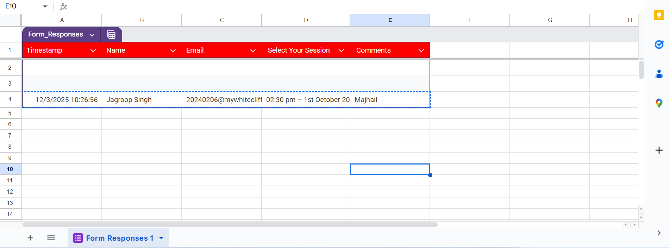

Zapier Zap :

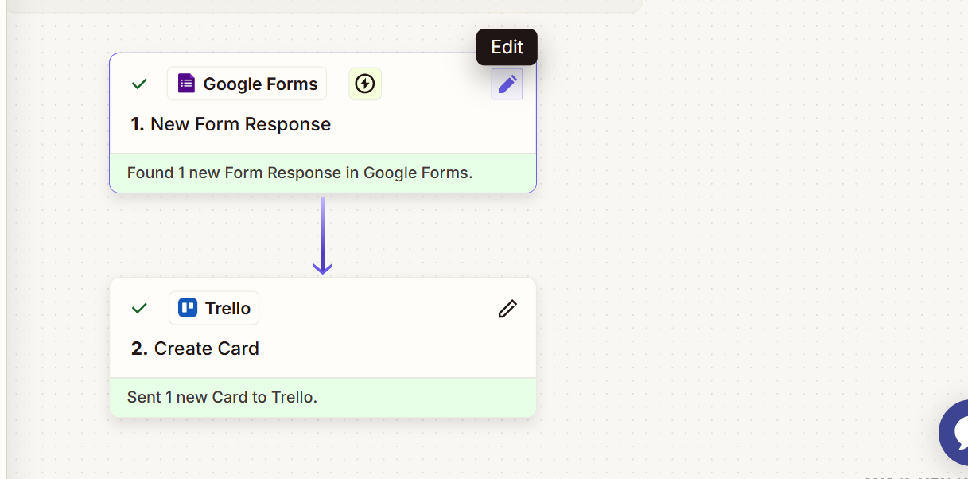

Trello Data Insertion
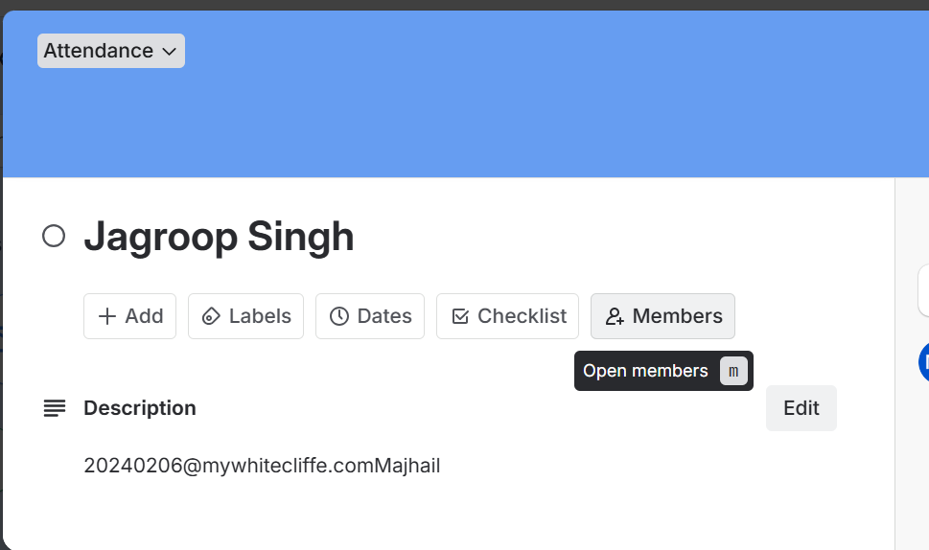

PART B
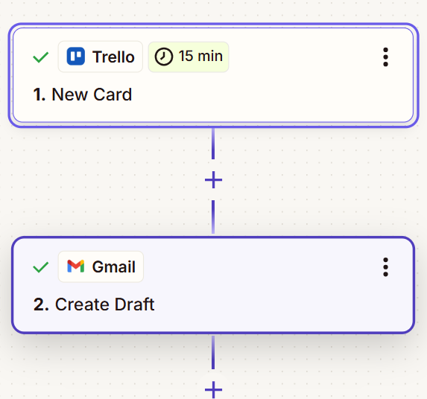
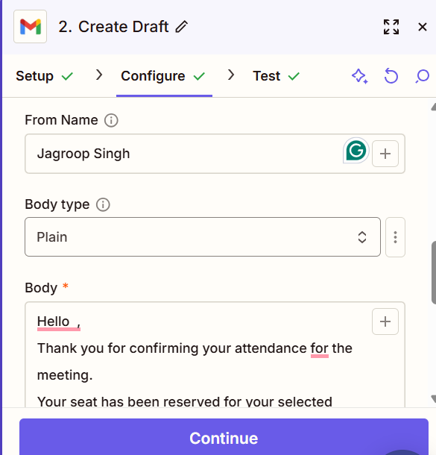
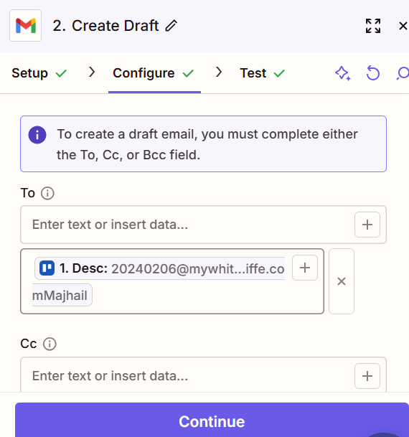

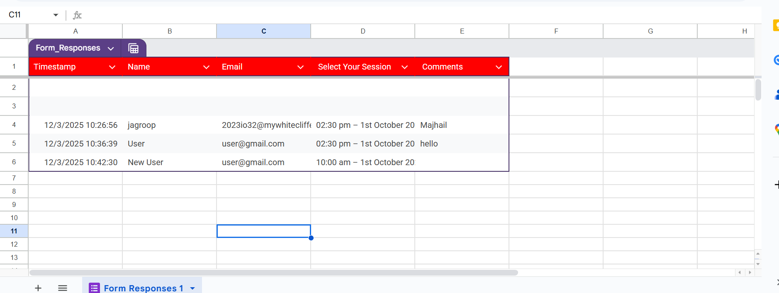

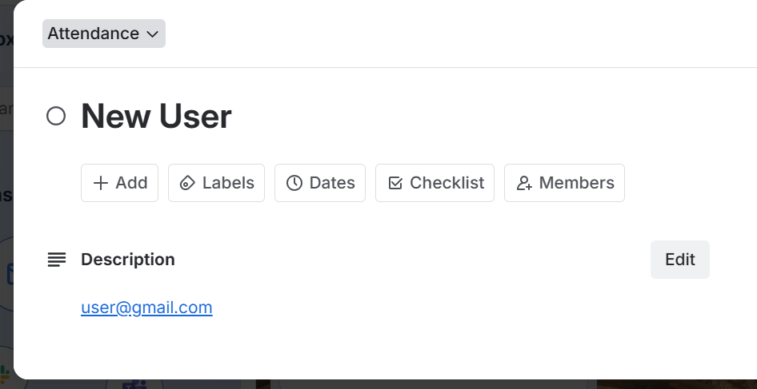



PART C

TASK 04

SOAP API

ENDPOINTS:
MUlTIPLICATION
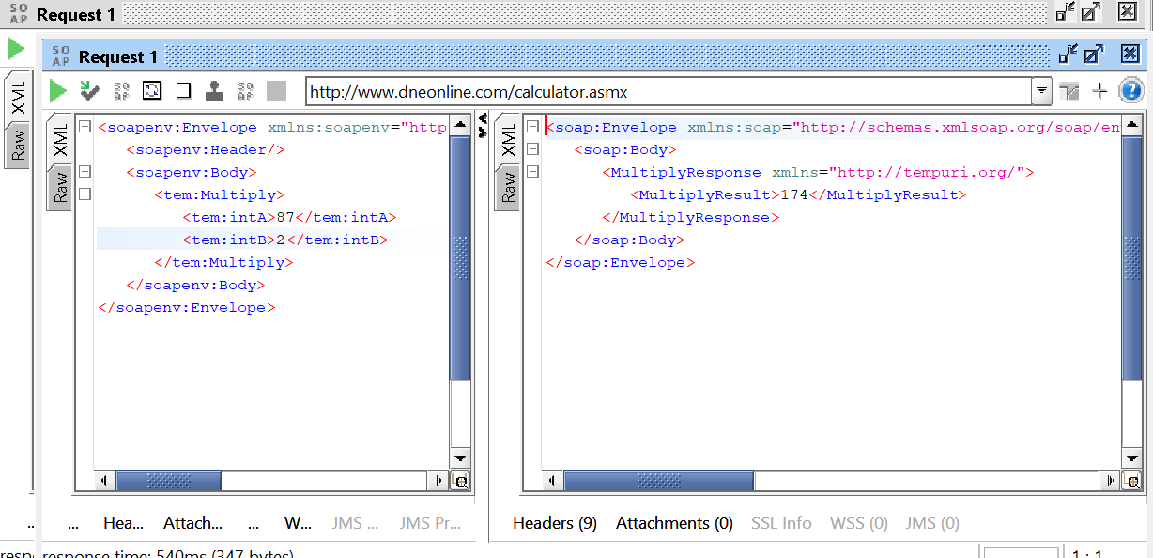
<soapenv:Envelope xmlns:soapenv="http://schemas.xmlsoap.org/soap/envelope/" xmlns:tem="http://tempuri.org/">
<soapenv:Header/>
<soapenv:Body>
<tem:Multiply>
<tem:intA>87</tem:intA>
<tem:intB>2</tem:intB>
</tem:Multiply>
</soapenv:Body>
</soapenv:Envelope>

RESULT
<soap:Envelope xmlns:soap="http://schemas.xmlsoap.org/soap/envelope/" xmlns:xsi="http://www.w3.org/2001/XMLSchema-instance" xmlns:xsd="http://www.w3.org/2001/XMLSchema">
<soap:Body>
<MultiplyResponse xmlns="http://tempuri.org/">
<MultiplyResult>174</MultiplyResult>
</MultiplyResponse>
</soap:Body>
</soap:Envelope>
SUBTRACTION
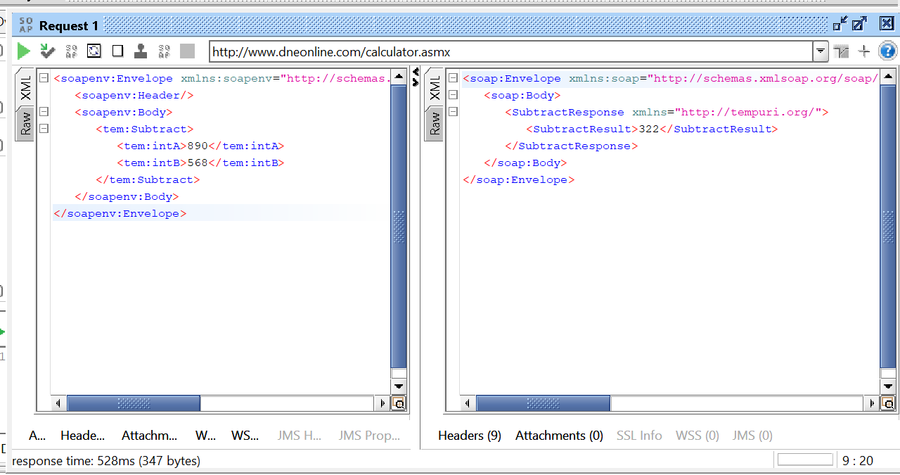
<soapenv:Envelope xmlns:soapenv="http://schemas.xmlsoap.org/soap/envelope/" xmlns:tem="http://tempuri.org/">
<soapenv:Header/>
<soapenv:Body>
<tem:Subtract>
<tem:intA>890</tem:intA>
<tem:intB>568</tem:intB>
</tem:Subtract>
</soapenv:Body>
</soapenv:Envelope>

Result
<soap:Envelope xmlns:soap="http://schemas.xmlsoap.org/soap/envelope/" xmlns:xsi="http://www.w3.org/2001/XMLSchema-instance" xmlns:xsd="http://www.w3.org/2001/XMLSchema">
<soap:Body>
<SubtractResponse xmlns="http://tempuri.org/">
<SubtractResult>322</SubtractResult>
</SubtractResponse>
</soap:Body>
</soap:Envelope>

