**PUNJAB UNIVERSITY COLLEGE OF INFORMATION & TECHNOLOGY**



**OS LAB 01**

**Submitted By:**

M. Hamza Azeem

**Roll Number:**

BSEF15M517

**QUESTION # 1**

**(1)**



**(2)**



**(3)**



**(4)**

**Difference b/w rmdir & rm**

**rmdir: rmdir** can only be used to remove an empty directory. It won't work for non-empty directories.

**rm: rm** removes both files and non-empty directories



**(5)**



**(6)**



**(7)**



**(8) (a)**

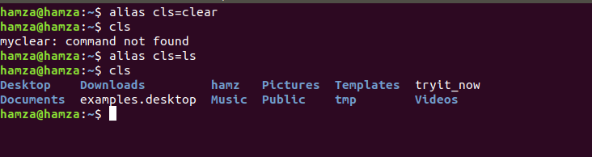

**(8) (b)**

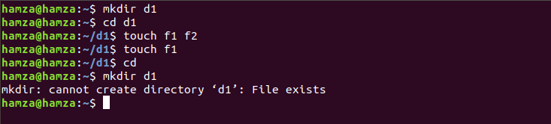

**QUESTION # 2**

**(1)**



**(2)**

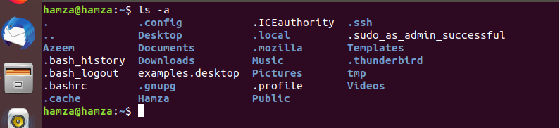

**(4)**

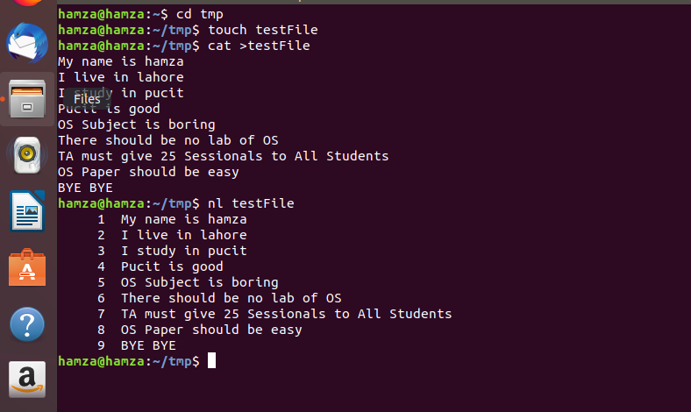

**(5)**



**(6)**

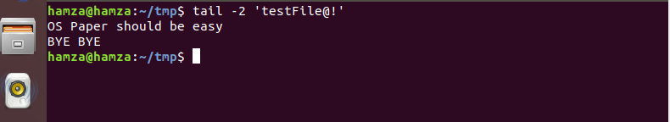

**(7)**

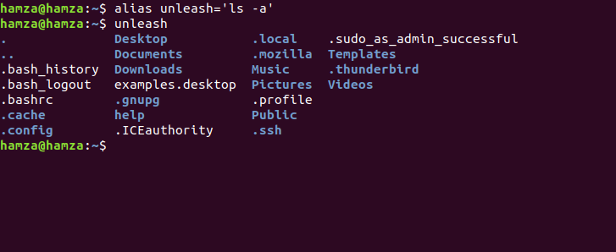

**(8)**

***‘man’*** command is used to show details/manual of a shell command.

**(9)**



**(10)**

rm –r can be used instead of rmdir to remove directory.

**QUESTION # 3**

**(1)**

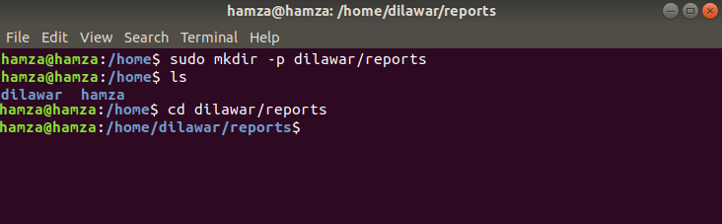

**(2)**

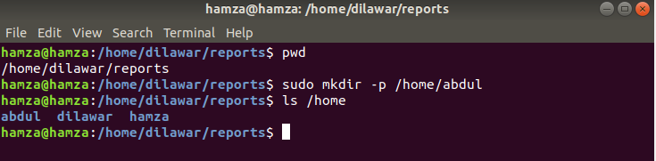

**(3)**

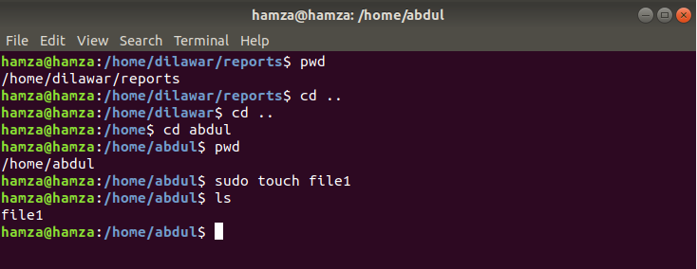

**(4)**

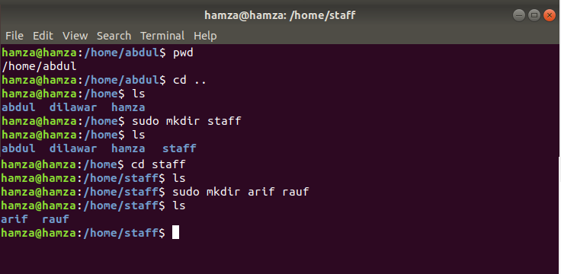

**(5)**

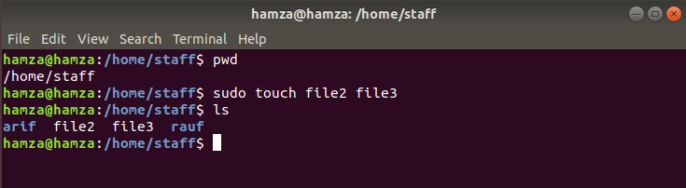

**(6)**

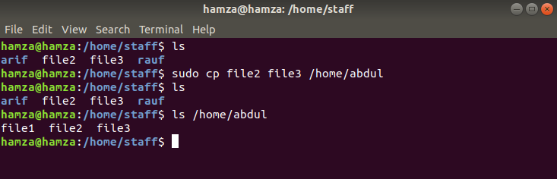

**(7)**

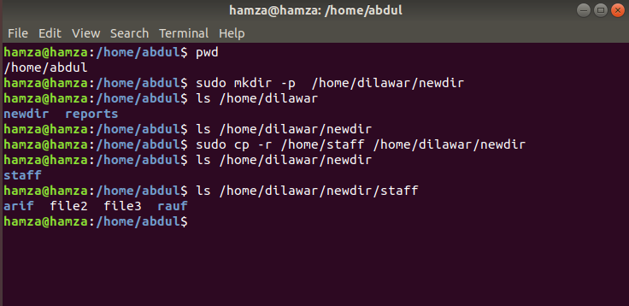

**(8)**

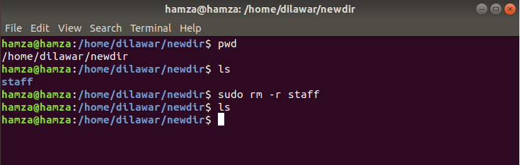

**(9)**

