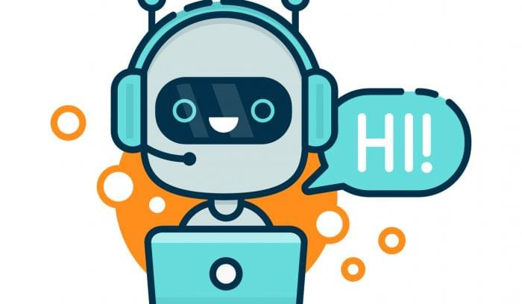

Chat-Bot

Nadeem Abbas 1602008

Muhammad Hamza 1602028

Report | Artificial Intelligence | 11/13/2018

# Introduction

Chatbot is an AI based program which conducts conversation weather it could be textual or auditory between human and machine or software.

This report is actually about our project which is basically a kind of chatbot in which questions are lying around Khan family Tree.

This report describes the following majors:

* Natural phenomenon behind its concept.
* Theory describing this phenomenon.
* Computational modal Based on the theory.
* Application

# Natural phenomenon

As human beings, we observe the things and learn them by the time. After facing some events or meeting with new people, we become able to tackle the things, events or questions relating to the earlier. This process continues and human brain becomes sharper and sharper.

# Theory

Following the natural process given, according to our understanding, after facing a new event, meeting with new people and taking part in different activities, we observe different things which actually are being stored in somewhere in the brain which provides help later to analyze different questions or events based on the previous stored ones. It actually maps the new problem come in its way with the previous experiences and predict a solution. The quality of solution prediction becomes better and better with the increment of our experience.

# Computational Modal

Following the theory, if we want to build a machine which can understand our questions or can predict a solution, we have to store facts or information somewhere in its memory, on the basis of which it can predict the solution of a given problem. If we want to add the feature of learning, then we have to make a mechanism in which our program can update its memory and can add more information come in its way so that it can increase its ability to predict more accurate solution.

# Application

On the basis of computational modal given, we actually has built a chatbot, in which you can ask any question about khan family tree. In this application we have stored some facts about Husband-Wife and Parent-Child relations and their gender information and so on.

The questions which are being asked are split out into a list of strings where system try to find key words (who, whose, father of, son of, A’s father etc.) on the basis of which it predicts solution and gives the answer of the question.