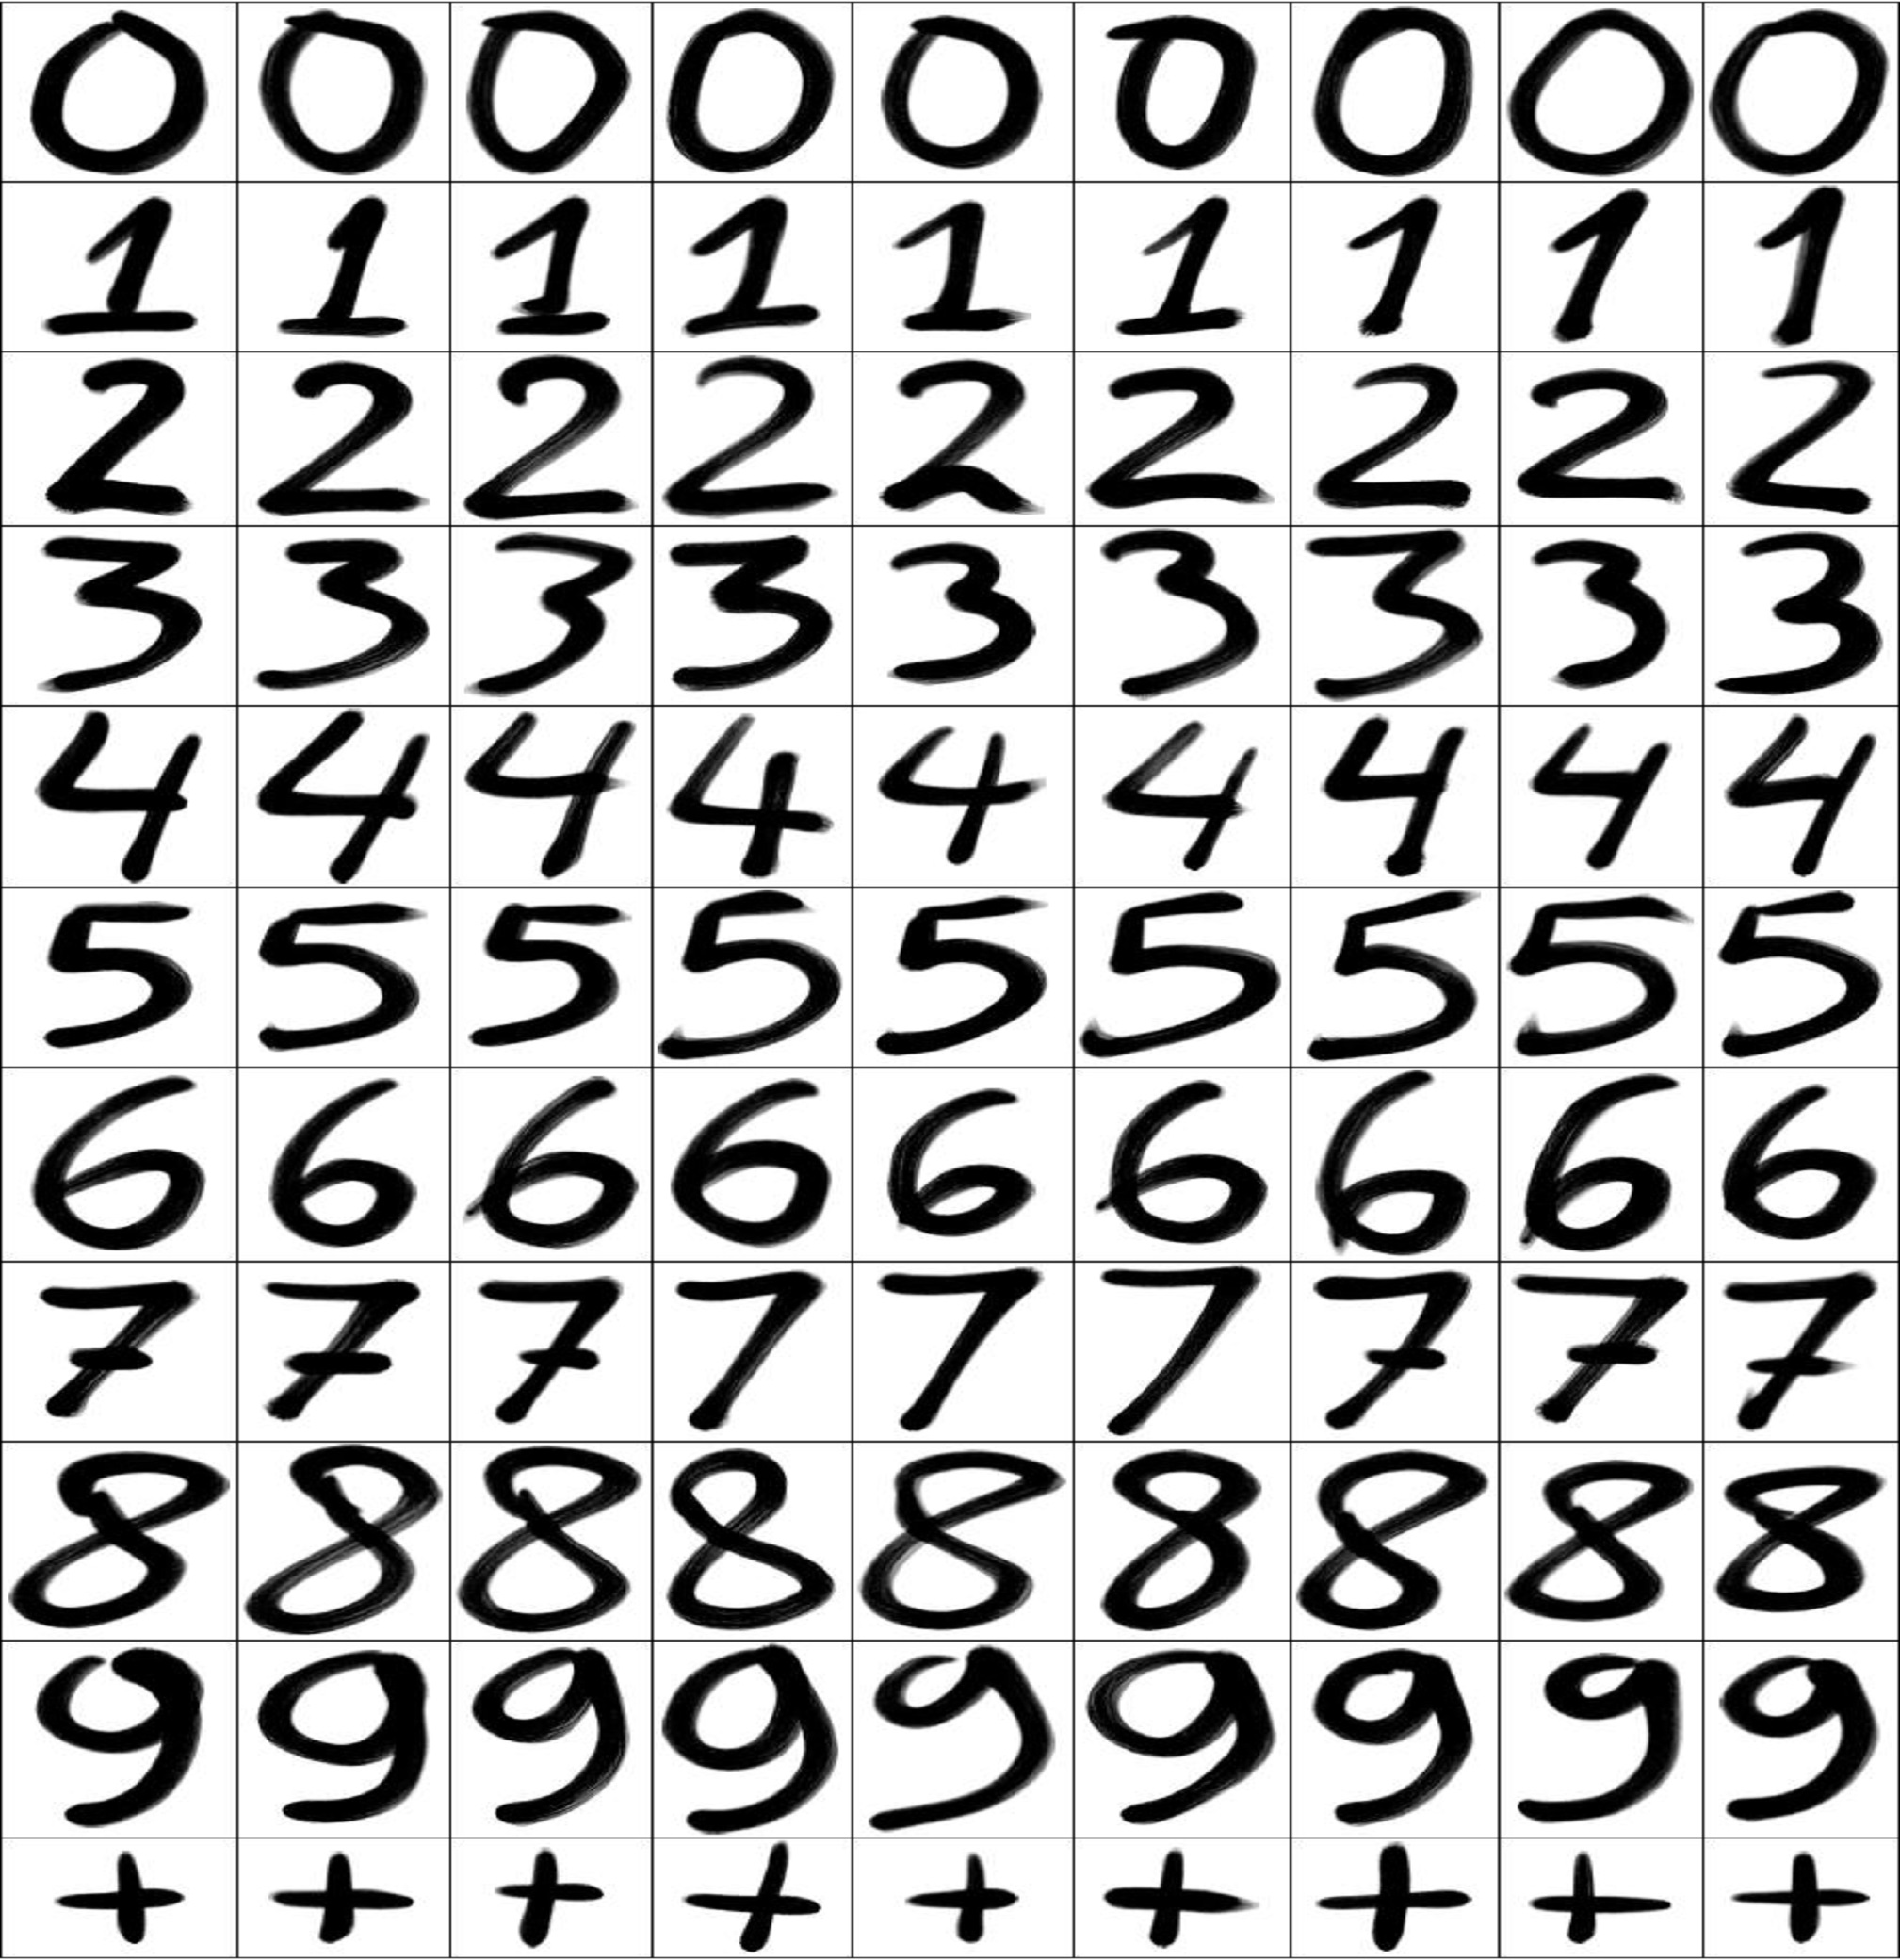

|  |
| --- |
| Hand Written Digit Recognition |

TABLE OF CONTENTS

Group members 3

Introduction 4

Material and Methods 5

Dataset Description 5

Feature Extraction Techniques 6

Methods/Classification Techniques 6

Result and discussion 7

Discussion 7

Results 8

Table 1 8

Literature Review 9

Table 2 9

# Group members

|  |  |
| --- | --- |
| Muhammad Ammar Farooq Khan  Reg No: 2016-UET-NML-CS-20 BS Computer Science at Namal College Mianwali.  [1602020@namal.edu.pk](mailto:1602020@namal.edu.pk) | |
| Muhammad Hamza  Reg No: 2016-UET-NML-CS-28 BS Computer Science at Namal College Mianwali.  [1602028@namal.edu.pk](mailto:1602028@namal.edu.pk) | Hamid Naseem  Reg No: 2016-UET-NML-CS-35 BS Computer Science at Namal College Mianwali.  [1602035@namal.edu.pk](mailto:1602035@namal.edu.pk) |

# Introduction

This article manifests the results of handwritten digit recognition on famous image database utilizing the art feature extraction and classification methods. The tested database is MNIST. The features include gradient feature (HOG Feature), LBP feature, Black and White and HWTP. The gradient feature is excerpted from the grey-scale image. The classifiers include the Decision Tree and SVM classifier. All the feature and classifiers vectors give high recognition accuracies. Comparatively, the gradient feature bestows an advantage over other features.

A regular HWDR framework comprises of various stages. First is the picture procurement, which is a procedure of acquiring input picture either by snapping a photo by utilizing a camera or by drawing on the bit of paper and afterward checked that paper or by making illustrations utilizing an advanced pen. Second step is the pre-processing which is a process by which we enhance the quality of the image there are certain things in the environment that may damage the quality of the obtained image. Preprocessing is a path by which we upgrade the nature of the picture by applying certain activities on it like separating, normalizing, diminishing, and so forth. These activities may fluctuate as indicated by our requirements and as per the further employments of the picture. Third steps are called division which is used to decompose the picture into important subparts. It is a process by which we separate the articles from each other that are available in the image. Thus, we can say that division is the procedure by which we isolate the picture into more subparts and every subpart speak to the nearness of an object on it. This procedure rearranges the picture for further handling. The subsequent stages are highlights extraction which is connected for considering and positioning attributes of the objects present in the subparts of the picture this is useful for separating between more than one articles. There are several techniques that are used for feature extraction. The next step is the classification which is applied for prediction which the object belongs to which class .In this phase, we define more than one classes, then, according to the characteristics of the object we assign them a class, for example, we have two classes human and cat now whenever an object with human characteristic is arrived, we will assign it to the class human and whenever an object with cat characteristics is arrived. We will assign it to the cat class on the basis of its characteristics. Several classifiers are used for classification purpose. This research paper focuses on various methods used for feature extraction and neural network methods for the HWDR and also shares the pros and cons of each technique.

# Material and Methods

## Dataset Description

The handwritten digit recognition is a extensive research topic which gives a comprehensive survey of the area including major feature sets, learning datasets and algorithms. Hand Written Digit recognition which focuses on recognition of Hand written output, where different writing can be used and the variability between digits along with the same and different size.

The feature extraction and the classification technique play an important role in offline Digits recognition system performance. Various feature extraction approaches have been proposed for digit recognition system. The problems faced in handwritten numeral recognition has been studied while using the techniques like Decision Tree, SVM, neural network, Knowledge system and combinations of above techniques.

In our experiment we used digit dataset provided by National Institute of Standards and Technology, United State of America. The MNIST database contains 60,000 training images and 10,000 testing images. Half of the training set and half of the test set were taken from NIST's training dataset, while the other half of the training set and the other half of the test set were taken from NIST's testing dataset.

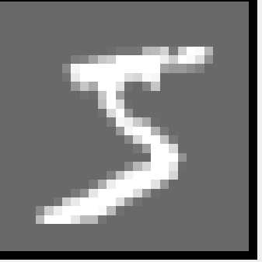

## Feature Extraction Techniques

We used four Techniques for Feature Extraction on MNIST Dataset these are

1. HOG (Histogram of Oriented Gradients)
2. LBP (Local Binary Patterns)
3. Black and White Pixels
4. Haar Wavelet Transformation

We different Techniques for feature extraction. The statistical features of the histogram mean and standard deviation, will be extracted from the images also we used LBP, BW Pixels and HWT techniques for feature extraction.

## Methods/Classification Techniques

We used two Techniques for Classification given below

1. Support Vector Machine
2. Decision Tree

#### **Support Vector Machine**

SVM or Support Vector Machine is a specific type of supervised ML method that intents to classify the data points by maximizing the margin among classes in a high-dimensional space. SVM is a representation of examples as points in space, mapped due to the examples of the separate classes are divided by a fair gap that is as extensive as possible. After that new examples are mapped into that same space and anticipated to reside to a category based on which side of the gap they fall on. The optimum algorithm is developed through a “training” phase in which training data are adopted to develop an algorithm capable to discriminate between groups earlier defined by the operator (e.g. patients vs. controls), and the “testing” phase in which the algorithm is adopted to blind-predict the group to which a new perception belongs. It also provides a very accurate classification performance over the training records and produces enough search space for the accurate classification of future data parameters. Hence it always ensures a series of parameter combinations no less than on a sensible subset of the data. In SVM it’s better to scale the data always because it will extremely improve the results. Therefore be cautious with big dataset, as it may leads to the increase in the training time.

#### **Decision Tree**

Decision trees is one of the simplest methods for supervised learning. It can be applied to both regression & classification. Decision tree learning uses a decision tree to go from observations about an item to conclusions about the item's target value. It is one of the predictive modelling approaches used in statistics, data mining and machine learning.

# Result and discussion

## Discussion

There are various methods of feature extraction in that depending on the features the technique for extracting the features are developed and then depending on that classification of features is done. We used different Feature extraction Techniques to extract the feature HOG, Black and White Pixels, Haar Wavelet Transformation, and Local Binary Pattern. Also can recognize the handwritten script, from curvature information extract the feature as a curve and so on. In general the properties or feature is used to invent the techniques for extracting feature.

There are five (5) step to train image classifier which is:

1. Step 1 – Structuring our initial dataset
2. Step 2 – Separate Training and Testing Images
3. Step 3 - Extracting features
4. Step 4 - Training the classification model
5. Step 5 – Evaluating classifier

We will download the MNIST dataset. First we will load the MNIST dataset into the system. Then we divide the dataset into training and testing data means in Training in Variable X and Testing part in Y. Then we will use Histogram of Oriented Gradients (HOG) feature detection to extract the feature of MNIST dataset. The dataset images of the digits will be save in a vector and corresponding labels. Next we will calculate the HOG features for each images and save them in another vector.

Then we will perform the classifier to the testing image. We will calculate the HOG features and predict the digit of the image. We used Decision Tree and SVM to predict/classify the images and calculate the accuracy. Similarly we extract feature using LBP, BW pixels, Haar and then apply Decision Tree and SVM on these feature and predict/classify the images and calculate the accuracy. The Table is below show the results.

## Results

### Table 1

|  |  |  |  |
| --- | --- | --- | --- |
| Sr. No | List of Features Used | List of Classifiers used | Accuracy (%) |
| 1 | HOG | Decision Tree | 89.4400 |
| 2 | HOG | SVM | 97.9400 |
| 3 | LBP | Decision Tree | 53.2400 |
| 4 | LBP | SVM | 53.8900 |
| 5 | Black White Pixels | Decision Tree | 24.8900 |
| 6 | Black White Pixels | SVM | Undefined |
| 7 | Haar Wavelet Trans | Decision Tree | 72.5100 |
| 8 | Haar Wavelet Trans | SVM | 76.5100 |

# Literature Review

Table 2: A COMPARATIVE ANALYSIS OF RESEARCH WORK FOR HWDR

|  |  |  |  |  |  |
| --- | --- | --- | --- | --- | --- |
| Sr. No | Title of Paper | First Author Name | List of Features Used | List of Classifiers used | Accuracy (%) |
| 1 | Simplified NN Architecture Digitization Learning and Recognizing Module Comparing Stored patterns | Mc Donnell | principal component analysis | Simplified ANN Architecture -Comparing Stored patterns | 97.35% Accuracy |
| 2 | Handwritten Digit Recognition using Machine Learning Algorithms | S M Shamim, Mohammad Badrul Alam Miah, Angona Sarker, Masud Rana  & Abdullah Al Jobair | Conventional Features are Used | Multilayer Perceptron, Support  Vector Machine, Naïve Bayes, Bayes Net, Random Forest, J48 and Random Tree | 90.37% for multilayer perceptron, 87.97% for Support Vector  Machine, 81.85%, 84.35%, 79.51% and 85.6% for others |
| 3 | Handwritten Recognition Using SVM, KNN and  Neural Network | Norhidayu binti Abdul Hamid and Nilam Nur Binti Amir Sjarif | Kernel Based Novel Feature Selection Models | Support Vector Machine (SVM), K-Nearest Neighbor  (KNN) and Neural Network | Recognition accuracy is 91.20% |
| 4 | Handwriting Digit Recognition using Local  Binary Pattern Variance and K-Nearest Neighbors  Classification | Nurul Ilmi, Tjokorda Agung Budi W and Kurniawan Nur R | OCR, Boundary Detection, Tokenization | KNN | MNIST dataset  with accuracy 89.81%  for data from C1 form, the accuracy  is 70.91% |
| 5 | Online Handwriting Verification with Safe  Password and Increasing Number of Features | [Tobias Kutzner](https://ieeexplore.ieee.org/search/searchresult.jsp?searchWithin=%22First%20Name%22:%22Tobias%22&searchWithin=%22Last%20Name%22:%22Kutzner%22&newsearch=true&sortType=newest), [Mario Dietze](https://ieeexplore.ieee.org/search/searchresult.jsp?searchWithin=%22First%20Name%22:%22Mario%22&searchWithin=%22Last%20Name%22:%22Dietze%22&newsearch=true&sortType=newest), [Ingrid Bönninger](https://ieeexplore.ieee.org/search/searchresult.jsp?searchWithin=%22First%20Name%22:%22Ingrid%22&searchWithin=%22Last%20Name%22:%22B%C3%B6nninger%22&newsearch=true&sortType=newest), [Carlos M. Travieso](https://ieeexplore.ieee.org/search/searchresult.jsp?searchWithin=%22First%20Name%22:%22Carlos%20M.%22&searchWithin=%22Last%20Name%22:%22Travieso%22&newsearch=true&sortType=newest), [Malay Kishore Dutta](https://ieeexplore.ieee.org/search/searchresult.jsp?searchWithin=%22First%20Name%22:%22Malay%20Kishore%22&searchWithin=%22Last%20Name%22:%22Dutta%22&newsearch=true&sortType=newest) and [Anushikha Singh](https://ieeexplore.ieee.org/search/searchresult.jsp?searchWithin=%22First%20Name%22:%22Anushikha%22&searchWithin=%22Last%20Name%22:%22Singh%22&newsearch=true&sortType=newest) | Structural, statistical, and global transformation feature | Bayes Net, Naïve Bayes, K-NN and Multi-layer Perceptron | Bayes  Net classifier is the best classifier with 100% correct for  priority time |
| 6 | Handwritten Arabic Numeral Recognition using  Deep Learning Neural Networks | Akm Ashiquzzaman and Abdul Kawsar Tushar | Conventional Feature Extraction Technique | deep learning neural networks using  appropriate activation function and regularization layer | 97.4% |
| 7 | *A Comparative Study on Handwriting Digit*  *Recognition Using Neural Networks* | Mahmoud M. Abu Ghosh and Ashraf Y. Maghari | Conventional Feature | deep neural network (DNN), deep belief network (DBN) and  convolutional neural network (CNN) | DNN is the most  accurate algorithm; it has 98.08% accuracy rate |
| 8 | Mixed-sentiment classification of web forum posts using lexical and non-lexical features | H. U. Khan, | Using Zoning method | Neural Network  (NN) | 91.2 |
| 9 | Capsule Network Performance on Complex Data | Edgar Xi | HOG and HAAR methods are used for feature extraction | convolutional neural networks (CNN) | 71.550 |
| 10 | Extended Kalman Filter (EKF) and modified pruning method | A. Mishra and D. Singh | Zoning, histogram, hole size, crossing count, direction, number of end points | MLFFN with periodical and monotonic activation function | 78.4% is achieved |