SOFTWARE REQUIREMENTS SPECIFICATION
for
Software House CRM
Prepared in accordance with IEEE Std 830-1998

Document Version: 1.0
Status: Draft
Prepared By: Client (Software House)
Prepared For: Development Team
Date: August 2026

Table of Contents
Table of Contents 2
1. Introduction 5
1.1 Purpose 5
1.2 Business Overview 5
1.3 Problem Statement 5
1.4 Proposed Solution 5
1.5 Project Objectives 6
1.5.1 Business Objectives 6
1.5.2 Technical Objectives 6
1.6 Project Scope 6
1.6.1 In Scope 6
1.6.2 Out of Scope (Version 1.0) 7
1.7 Stakeholders 8
1.8 Assumptions 8
1.9 Constraints 8
1.9.1 Technical Constraints 8
1.9.2 Business Constraints 8
1.10 Success Criteria 9
2. Overall Description 10
2.1 Product Perspective 10
2.2 Product Functions 10
2.3 User Classes and Characteristics 11
2.3.1 Super Administrator 11
2.3.2 Administrator / Project Manager 11
2.3.3 Employee / Developer 11
2.3.4 Client 11
2.3.5 User Role Summary 12
2.4 Operating Environment 12
2.5 Design and Implementation Constraints 12
2.6 User Documentation 12
2.7 Assumptions and Dependencies 13
3. Functional Requirements 14
3.1 User Authentication and Authorization 14
3.1.1 Description and Priority 14
3.1.2 Stimulus/Response Sequences 14
3.1.3 Functional Requirements 14
3.2 Dashboard 15
3.2.1 Description and Priority 15
3.2.2 Stimulus/Response Sequences 15
3.2.3 Functional Requirements 15
3.3 User and Role Management 15
3.3.1 Description and Priority 15
3.3.2 Stimulus/Response Sequences 16
3.3.3 Functional Requirements 16
3.4 Client Management 16
3.4.1 Description and Priority 16
3.4.2 Stimulus/Response Sequences 16
3.4.3 Functional Requirements 16
3.5 Project Management 17
3.5.1 Description and Priority 17
3.5.2 Stimulus/Response Sequences 17
3.5.3 Functional Requirements 17
3.6 Task Management 18
3.6.1 Description and Priority 18
3.6.2 Stimulus/Response Sequences 18
3.6.3 Functional Requirements 18
3.7 Meeting Management 18
3.7.1 Description and Priority 18
3.7.2 Stimulus/Response Sequences 18
3.7.3 Functional Requirements 19
3.8 Calendar Management 19
3.8.1 Description and Priority 19
3.8.2 Stimulus/Response Sequences 19
3.8.3 Functional Requirements 19
3.9 Quotation Management 20
3.9.1 Description and Priority 20
3.9.2 Stimulus/Response Sequences 20
3.9.3 Functional Requirements 20
3.10 Invoice and Payment Management 20
3.10.1 Description and Priority 20
3.10.2 Stimulus/Response Sequences 20
3.10.3 Functional Requirements 21
3.11 Reports and Analytics 21
3.11.1 Description and Priority 21
3.11.2 Stimulus/Response Sequences 21
3.11.3 Functional Requirements 21
3.12 AI Assistant 22
3.12.1 Description and Priority 22
3.12.2 Stimulus/Response Sequences 22
3.12.3 Functional Requirements 22
3.13 File Management 22
3.13.1 Description and Priority 22
3.13.2 Stimulus/Response Sequences 22
3.13.3 Functional Requirements 23
3.14 Notification Management 23
3.14.1 Description and Priority 23
3.14.2 Stimulus/Response Sequences 23
3.14.3 Functional Requirements 23
3.15 System Settings and Administration 24
3.15.1 Description and Priority 24
3.15.2 Stimulus/Response Sequences 24
3.15.3 Functional Requirements 24
4. External Interface Requirements 25
4.1 User Interface Requirements 25
4.2 Hardware Interface Requirements 26
4.3 Software Interface Requirements 26
4.4 Communication Interface Requirements 27
5. Non-Functional Requirements 29
5.1 Performance Requirements 29
5.2 Security Requirements 29
5.3 Reliability and Availability Requirements 30
5.4 Usability Requirements 30
5.5 Scalability and Maintainability Requirements 30
5.6 Compatibility Requirements 31
5.7 Backup and Recovery Requirements 31
5.8 Legal and Compliance Requirements 32
6. System Architecture 33
6.1 Architecture Overview 33
6.2 Technology Stack 33
6.3 High-Level Architecture 34
6.4 Application Layers 34
6.4.1 Presentation Layer 34
6.4.2 Application Layer 34
6.4.3 Data Layer 34
6.4.4 External Services Layer 35
6.5 Deployment Architecture 35
7. Database Design 36
7.1 Database Overview 36
7.2 Database Tables 36
7.3 Primary Key and Foreign Key Relationships 37
7.4 Database Normalization 37
7.5 Data Integrity 38
7.6 Database Indexing 38
7.7 Database Backup Strategy 38
8. Assumptions, Dependencies, and Constraints 40
8.1 Assumptions 40
8.2 Dependencies 40
8.3 Constraints 41
9. Future Enhancements 42
10. Appendices 43
10.1 Glossary 43
10.2 Acronyms and Abbreviations 43
10.3 References 44
10.4 Document Revision History 44

1. Introduction

1.1 Purpose
The purpose of this document is to define the requirements for the Software House CRM, a web-based application designed to help software development companies manage their daily business operations from a single platform.
The system will allow the company to manage clients, employees, software projects, meetings, quotations, invoices, payments, reports, documents, and AI-assisted workflows while providing role-based access to different users.
This document serves as the official agreement between the client and the development team and will guide the design, development, testing, and deployment of the application.

1.2 Business Overview
ABC Software Solutions is a medium-sized software development company that provides custom software development, web applications, mobile applications, UI/UX design, cloud services, maintenance, and consulting for local and international clients.
Currently, the company manages most of its work using spreadsheets, email, WhatsApp, Google Drive, and paper documents. As the number of clients and projects has grown, this approach has become inefficient and difficult to maintain.
The company requires a centralized CRM system that enables employees to collaborate efficiently while allowing management to monitor projects, finances, and team performance.

1.3 Problem Statement
The software house currently manages many of its daily operations using separate tools and manual processes. Client information, project details, meeting records, quotations, invoices, and important documents are stored in different locations, making information difficult to access and maintain.
Project tracking and task management are largely manual, reducing visibility into project progress and employee workload. Financial processes such as quotation preparation, invoice generation, payment tracking, and report preparation require considerable manual effort, increasing the possibility of errors and delays.
In addition, managers have limited access to real-time business insights, employee productivity metrics, and centralized project information. These challenges reduce operational efficiency and make it difficult to monitor the overall performance of the organization.

1.4 Proposed Solution
To address these challenges, a secure and modern web-based Customer Relationship Management (CRM) system will be developed. The proposed solution will centralize business operations into a single platform, allowing employees, managers, administrators, and clients to collaborate efficiently. The system will improve project management, financial tracking, communication, reporting, and document management while providing AI-assisted productivity features powered by the Groq API.
Core Module | Description
User & Role Management | Manage users and access permissions
Client & Employee Management | Maintain client and employee information
Project & Task Management | Track projects, tasks, and milestones
Meeting & Calendar | Schedule meetings and manage events
Finance | Manage quotations, invoices, and payments
AI Assistant | Generate meeting summaries and business content
Reports | Business analytics and data export
File Management | Store images and project documents

1.5 Project Objectives

1.5.1 Business Objectives
The CRM aims to reduce manual administrative work, improve collaboration between departments, centralize client and project information, enhance financial tracking, increase employee productivity, standardize business processes, and provide management with meaningful business insights for better decision-making.

1.5.2 Technical Objectives
From a technical perspective, the project aims to develop a secure, scalable, and responsive web application using modern technologies. The system will implement role-based access control, support image and document uploads, integrate AI-powered productivity features, provide RESTful APIs, and follow a modular architecture to simplify future enhancements.

1.6 Project Scope

1.6.1 In Scope
The first version of the Software House CRM will include modules for authentication, dashboard management, user and role management, client management, employee management, project management, task management, meetings, calendar scheduling, quotations, invoices, payments, reporting, AI-assisted productivity, file management, notifications, audit logs, and company settings. These modules will provide the core functionality required to manage the daily operations of a software house.
Module | Main Features
Authentication | Login, password management, JWT authentication, role-based authorization
Dashboard | Statistics, charts, recent activities
Client Management | Client profiles, contacts, documents
Employee Management | Profiles, departments, designations, skills
Project Management | Projects, milestones, team members, gallery
Task Management | Assignments, priorities, due dates, attachments
Meeting Management | Scheduling, notes, AI summaries
Calendar | Meetings, deadlines, company events
Finance | Quotations, invoices, payments
Reports | Business reports and exports
AI Assistant | Meeting summaries, email drafting, quotation generation
File Management | Images, PDFs, documents
Settings | Company profile, themes, permissions

1.6.2 Out of Scope (Version 1.0)
To keep the first release realistic and achievable, the following features are intentionally excluded:
- Live chat
- Video conferencing
- Real-time collaborative editing
- Online payment gateway integration
- SMS notifications
- Mobile applications (Android/iOS)
- Multi-company (multi-tenant) support
- Client ticketing/helpdesk
- Payroll processing
- Attendance tracking with biometric devices
- Inventory management
These items can be considered for future versions.

1.7 Stakeholders
Stakeholder | Responsibility
Company Owner | Overall business management, reporting, strategic decisions
Project Manager | Manage projects, assign tasks, monitor progress
Employee | Complete assigned work, update tasks, attend meetings
Client | View assigned projects, quotations, invoices, and meeting information
System Administrator | Configure users, roles, company settings, and permissions

1.8 Assumptions
The project assumes that users have a stable internet connection and appropriate system permissions. Each employee will have a unique company email address, every client will have at least one contact person, and each project will belong to a single client while allowing multiple employee assignments. AI features depend on the availability of the Groq API, and export functionality will support PDF, Excel, and CSV formats. Notifications will use a database-driven approach instead of real-time communication.

1.9 Constraints

1.9.1 Technical Constraints
- Frontend must use Next.js (App Router) with TypeScript.
- Backend must use Express.js with TypeScript.
- Database must be PostgreSQL with Prisma ORM.
- Authentication must use JWT.
- Development should rely on free-tier services where possible.
- Local file storage will be used during development; production storage strategy can be upgraded later.
- The application must support modern browsers (Chrome, Edge, Firefox, Safari).

1.9.2 Business Constraints
- No online payment gateway in Version 1.
- No real-time chat.
- No WebSocket-based notifications.
- AI features should work only when a valid Groq API key is configured.
- The first release should prioritize core CRM functionality over advanced enterprise features.

1.10 Success Criteria
The project will be considered successful if all user roles can authenticate securely, core business modules operate correctly, quotations and invoices can be generated and exported, reports are available in PDF, Excel, and CSV formats, AI features improve productivity without affecting normal workflows, uploaded files are managed efficiently, the application is responsive across supported devices, and the system can be deployed successfully using free-tier hosting services.

2. Overall Description

2.1 Product Perspective
The Software House CRM is a centralized web-based application designed to manage the daily operations of a software development company. It replaces the company's existing manual processes, which currently rely on spreadsheets, emails, messaging applications, and paper-based records. By bringing all business activities into a single platform, the system improves collaboration, reduces duplicate work, and provides better visibility into ongoing projects and business performance.
The CRM will support the complete project lifecycle, starting from client registration and project creation to task management, meeting scheduling, quotation generation, invoice management, payment tracking, and business reporting. The system will also provide AI-assisted features to improve productivity and reduce the time required for repetitive tasks such as preparing meeting summaries and drafting quotations.
The application will follow a modular architecture, allowing new modules and features to be added in future releases without affecting the existing functionality. The system will be accessible through modern web browsers and will provide a responsive user interface for desktop, tablet, and mobile devices.

2.2 Product Functions
The CRM consists of several integrated modules that work together to support the company's daily operations.
The Authentication Module provides secure user authentication, password management, and role-based access control to ensure that users can only access information relevant to their responsibilities.
The Dashboard Module presents an overview of important business information, including project statistics, upcoming meetings, pending tasks, revenue summaries, and recent activities through interactive charts and widgets.
The User Management Module allows administrators to manage employee accounts, assign user roles, and maintain profile information.
The Client Management Module stores client information, company details, contact persons, communication history, and project associations.
The Project Management Module enables the creation and monitoring of software projects, assignment of team members, definition of project milestones, and tracking of project progress.
The Task Management Module allows managers to assign tasks, monitor completion status, define priorities, set deadlines, and manage task-related attachments.
The Meeting Management Module supports scheduling meetings, recording meeting notes, storing attachments, and generating AI-powered meeting summaries.
The Calendar Module provides a centralized calendar displaying meetings, project deadlines, task due dates, employee leave, and company events.
The Quotation Module enables the preparation, review, and export of professional quotations for clients.
The Invoice and Payment Module manages invoice generation, payment records, outstanding balances, and transaction history.
The Reports Module provides analytical reports related to projects, clients, employees, revenue, and payments, with support for exporting reports in PDF, Excel, and CSV formats.
The AI Module integrates with the Groq API to assist users by generating meeting summaries, drafting emails, improving task descriptions, and preparing quotation content.
The File Management Module provides secure storage and organization of project documents, images, company logos, meeting attachments, quotations, invoices, and other uploaded files.
The Settings Module allows authorized users to configure company information, application preferences, notification settings, themes, and user permissions.

2.3 User Classes and Characteristics
The CRM is designed for four primary user groups, each with different responsibilities and levels of system access.

2.3.1 Super Administrator
The Super Administrator is the owner of the software house and has unrestricted access to all modules within the system. This role is responsible for managing company settings, user accounts, permissions, business reports, financial information, and overall system configuration. The Super Administrator can view and modify all records created within the application.

2.3.2 Administrator / Project Manager
The Administrator or Project Manager is responsible for managing software projects and coordinating development teams. This role can create and assign projects, manage clients, schedule meetings, assign tasks, monitor project progress, generate quotations and invoices, and review reports. Administrative users have broad access to operational modules but cannot modify critical system configurations reserved for the Super Administrator.

2.3.3 Employee / Developer
Employees use the CRM to manage their assigned work. They can view assigned projects, update task progress, upload project files, participate in meetings, access the project calendar, and update their personal profile. Employees cannot access confidential financial information or administrative settings unless explicitly permitted.

2.3.4 Client
Clients have limited access to the system through a dedicated client portal. They can view information related only to their own projects, quotations, invoices, meeting schedules, shared documents, and payment history. Clients cannot view internal company information or data belonging to other clients.

2.3.5 User Role Summary
Role | Primary Responsibility
Super Administrator | Complete system administration and business management
Administrator / Project Manager | Manage clients, projects, meetings, tasks, quotations, invoices, and reports
Employee / Developer | Complete assigned work, update tasks, upload files, and attend meetings
Client | Monitor assigned projects, quotations, invoices, payments, and shared documents

2.4 Operating Environment
The CRM will operate as a web-based application and will not require users to install any desktop software. Users will access the system through supported web browsers using an internet connection.
The frontend application will be developed using Next.js (App Router) with TypeScript and Tailwind CSS. The backend services will be implemented using Node.js, Express.js, and TypeScript. Business data will be stored in a PostgreSQL database managed through Prisma ORM.
The application will support the latest stable versions of Google Chrome, Microsoft Edge, Mozilla Firefox, and Safari. During development, the system will be tested on Windows, while production deployment will target cloud-based Linux environments using free-tier hosting services.

2.5 Design and Implementation Constraints
The application shall be developed using the technology stack approved for this project, including Next.js, Express.js, TypeScript, PostgreSQL, and Prisma ORM. Authentication shall be implemented using JWT, and AI functionality shall rely on the availability of the Groq API.
The first release will be deployed using free-tier hosting services. As a result, certain enterprise features such as real-time communication, live notifications, and integrated online payment gateways will not be included in Version 1.0. The application shall be designed with a modular architecture so that these features can be introduced in future releases without requiring significant architectural changes.

2.6 User Documentation
The completed system shall be accompanied by comprehensive documentation to support installation, deployment, maintenance, and daily usage. The project documentation shall include a Software Requirements Specification (SRS), database design documentation, API documentation, deployment guide, installation guide, user manual, and technical README. These documents will assist both developers and end users in understanding and operating the system effectively.

2.7 Assumptions and Dependencies
The successful operation of the CRM depends on several external factors. Users are expected to have reliable internet access and use supported web browsers. AI-assisted features depend on the availability and proper configuration of the Groq API. Email-related functionality, such as password reset, requires a configured email service. Database connectivity must be available at all times for normal system operation. The application also depends on third-party libraries used for PDF generation, spreadsheet export, calendar management, chart visualization, and authentication.

3. Functional Requirements
This section describes the major functional features of the Software House CRM. Each feature represents a core business function that supports the daily operations of a software house. The modules are organized according to their functionality and user roles. Features are prioritized based on their importance to the overall system, ensuring that the core business processes are implemented in the first release.

3.1 User Authentication and Authorization

3.1.1 Description and Priority
This feature enables secure access to the CRM through user authentication and role-based authorization. It allows authorized users to log in, manage their passwords, and access system resources according to their assigned roles. The supported roles include Super Administrator, Administrator/Project Manager, Employee, and Client. The feature protects sensitive business information by restricting access based on user permissions and is assigned High priority.

3.1.2 Stimulus/Response Sequences
A user accesses the login page and enters valid credentials. The system validates the email address and password, authenticates the user, and creates a secure session using JWT authentication. If the credentials are valid, the user is redirected to the appropriate dashboard according to their assigned role. If the credentials are invalid or the account is inactive, the system displays an appropriate error message. Users who forget their passwords may request a password reset through the provided recovery process.

3.1.3 Functional Requirements
REQ-1: The system shall allow authorized users to log in using their registered email address and password.
REQ-2: The system shall authenticate users using JWT-based authentication.
REQ-3: The system shall securely store user passwords using bcrypt hashing.
REQ-4: The system shall provide role-based access control for all protected modules.
REQ-5: The system shall redirect authenticated users to their respective dashboards based on their assigned roles.
REQ-6: The system shall allow users to change their passwords after successful authentication.
REQ-7: The system shall provide a secure password reset mechanism for users who forget their passwords.
REQ-8: The system shall automatically terminate user sessions after logout.
REQ-9: The system shall prevent unauthorized users from accessing protected resources.
REQ-10: The system shall display meaningful error messages for invalid authentication attempts.

3.2 Dashboard

3.2.1 Description and Priority
The Dashboard provides users with a quick overview of the information most relevant to their responsibilities. Instead of requiring users to navigate through multiple modules, the dashboard presents key business metrics, upcoming activities, pending work, and recent system updates in a single place. The displayed information varies according to the user's assigned role, ensuring that each user sees only the data necessary for their daily work. This feature is assigned High priority because it serves as the primary entry point after login.

3.2.2 Stimulus/Response Sequences
After a user successfully logs into the system, the CRM retrieves the user's role and loads the corresponding dashboard. The system displays summary cards, charts, recent activities, pending tasks, upcoming meetings, and other relevant information based on the user's permissions. Users may select any dashboard item to navigate directly to the related module for additional details.

3.2.3 Functional Requirements
REQ-11: The system shall display a role-specific dashboard after successful authentication.
REQ-12: The system shall present summary statistics relevant to the authenticated user's role.
REQ-13: The system shall display recent activities performed within the system.
REQ-14: The system shall display upcoming meetings and scheduled events.
REQ-15: The system shall display pending and overdue tasks assigned to the user.
REQ-16: The system shall present graphical summaries of business data using charts.
REQ-17: The system shall provide quick navigation to frequently used modules.
REQ-18: The system shall refresh dashboard information whenever new data becomes available through normal application operations.
REQ-19: The system shall prevent users from viewing dashboard information beyond their assigned permissions.
REQ-20: The system shall display appropriate messages when no data is available for a dashboard component.

3.3 User and Role Management

3.3.1 Description and Priority
The User and Role Management feature enables the organization to manage user accounts and control access to system resources. It allows administrators to create employee and client accounts, assign roles, manage departments and designations, and update user information. Role-based access ensures that users can only perform actions permitted by their assigned responsibilities. This feature is assigned High priority because it forms the foundation of system security and user administration.

3.3.2 Stimulus/Response Sequences
An authorized administrator accesses the User Management module to create a new employee or client account. The administrator enters the required information, assigns an appropriate role, and saves the record. The system validates the entered data and creates the account successfully. Existing user accounts can be updated, activated, or deactivated as needed. Users may also access their own profiles to update permitted personal information.

3.3.3 Functional Requirements
REQ-21: The system shall allow authorized administrators to create employee and client accounts.
REQ-22: The system shall allow administrators to assign an appropriate role to each user.
REQ-23: The system shall allow administrators to manage departments and designations.
REQ-24: The system shall allow administrators to update, activate, or deactivate user accounts.
REQ-25: The system shall prevent duplicate email addresses from being registered.
REQ-26: The system shall allow users to view and update their own profile information according to their permissions.
REQ-27: The system shall support uploading and updating user profile images.
REQ-28: The system shall allow administrators to search and filter users based on different criteria.
REQ-29: The system shall enforce role-based permissions for all user management operations.

3.4 Client Management

3.4.1 Description and Priority
The Client Management feature enables the software house to maintain a centralized database of clients and their business information. It allows authorized users to store company details, contact persons, communication information, project history, and supporting documents in a single location. This feature improves client relationship management by ensuring that all relevant information is organized, accessible, and easy to update. This feature is assigned High priority.

3.4.2 Stimulus/Response Sequences
An authorized user accesses the Client Management module to register a new client. The user enters the company information, adds one or more contact persons, and uploads supporting documents or the company logo if available. The system validates the information and creates the client profile. Users may later search, update, or review the client's details, projects, quotations, invoices, and payment history from the same profile.

3.4.3 Functional Requirements
REQ-30: The system shall allow authorized users to create and manage client profiles.
REQ-31: The system shall store company information, including contact details and business address.
REQ-32: The system shall allow multiple contact persons to be associated with a client.
REQ-33: The system shall support uploading and updating the client's company logo and related documents.
REQ-34: The system shall maintain a complete history of projects associated with each client.
REQ-35: The system shall display quotations, invoices, and payment records related to a client.
REQ-36: The system shall allow users to search, filter, and view client records efficiently.
REQ-37: The system shall allow authorized users to update client information while preserving existing project records.
REQ-38: The system shall prevent duplicate client records based on company name or registered email address where applicable.

3.5 Project Management

3.5.1 Description and Priority
The Project Management feature enables the software house to plan, organize, and monitor software development projects from initiation to completion. It allows authorized users to create projects, assign team members, define milestones, track progress, manage project files, and monitor the overall project status. This feature provides a centralized workspace where all project-related information is maintained, improving collaboration and project visibility. This feature is assigned High priority.

3.5.2 Stimulus/Response Sequences
An authorized user creates a new project by selecting a client and entering the required project information. The user assigns team members, defines milestones, and sets project timelines. As the project progresses, team members update task progress, upload project files, and record important activities. The system continuously updates the project's status, allowing managers and clients to monitor progress through their respective dashboards.

3.5.3 Functional Requirements
REQ-39: The system shall allow authorized users to create and manage software projects.
REQ-40: The system shall associate each project with a single client.
REQ-41: The system shall allow managers to assign employees to one or more projects.
REQ-42: The system shall allow project milestones and target completion dates to be defined.
REQ-43: The system shall track the current status and overall progress of each project.
REQ-44: The system shall support uploading project-related files and images.
REQ-45: The system shall maintain a history of project activities and updates.
REQ-46: The system shall allow authorized users to search, filter, and view projects based on different criteria.
REQ-47: The system shall allow project managers to update project information throughout the project lifecycle.
REQ-48: The system shall allow clients to view the progress and information of their own projects according to their assigned permissions.

3.6 Task Management

3.6.1 Description and Priority
The Task Management feature enables project managers to assign work to employees and monitor its progress throughout the project lifecycle. It helps organize project activities by defining priorities, deadlines, and responsibilities while allowing team members to update the status of their assigned tasks. This feature improves collaboration, accountability, and project execution. It is assigned High priority.

3.6.2 Stimulus/Response Sequences
A project manager creates a task and assigns it to one or more employees. The manager specifies the task details, priority, and due date. Assigned employees can view their tasks, update the progress, add comments, and upload supporting files. The system records each update and reflects the latest task status on the project dashboard.

3.6.3 Functional Requirements
REQ-49: The system shall allow authorized users to create tasks for a project.
REQ-50: The system shall allow tasks to be assigned to one or more employees.
REQ-51: The system shall allow users to define task priority, due date, and current status.
REQ-52: The system shall allow assigned employees to update the progress of their tasks.
REQ-53: The system shall allow users to add comments and attach supporting files to tasks.
REQ-54: The system shall maintain a history of task updates and status changes.
REQ-55: The system shall notify assigned users when a new task is created or updated.
REQ-56: The system shall allow users to search and filter tasks based on project, assignee, priority, status, or due date.
REQ-57: The system shall identify overdue tasks and display them appropriately.
REQ-58: The system shall restrict task modification according to the user's assigned role and permissions.

3.7 Meeting Management

3.7.1 Description and Priority
The Meeting Management feature enables users to schedule, organize, and document meetings related to projects and clients. It provides a centralized place to manage meeting details, participants, agendas, notes, and supporting documents. The module also uses AI to generate concise meeting summaries from the recorded notes, helping team members review important discussions efficiently. This feature is assigned Medium priority.

3.7.2 Stimulus/Response Sequences
An authorized user schedules a meeting by entering the meeting details, selecting participants, and specifying the date and time. After the meeting, the user records the meeting notes and uploads any related documents. If requested, the system sends the notes to the AI service to generate a summarized version, which is then stored with the meeting record.

3.7.3 Functional Requirements
REQ-59: The system shall allow authorized users to schedule project and client meetings.
REQ-60: The system shall store meeting details, including the agenda, date, time, and participants.
REQ-61: The system shall allow users to record meeting notes after the meeting is completed.
REQ-62: The system shall support uploading attachments related to a meeting.
REQ-63: The system shall generate AI-powered meeting summaries from recorded meeting notes.
REQ-64: The system shall allow users to view the history of meetings for a project or client.
REQ-65: The system shall notify meeting participants about scheduled meetings and updates.
REQ-66: The system shall allow authorized users to update or cancel scheduled meetings.
REQ-67: The system shall allow users to search and filter meetings based on project, client, participant, or date.

3.8 Calendar Management

3.8.1 Description and Priority
The Calendar Management feature provides a centralized view of important business events, including meetings, task deadlines, employee leave, and company events. It helps users plan their work, monitor upcoming activities, and avoid scheduling conflicts. The calendar automatically reflects information from other modules, eliminating the need to enter the same data multiple times. This feature is assigned Medium priority.

3.8.2 Stimulus/Response Sequences
A user opens the Calendar module to view scheduled activities. The system retrieves relevant events based on the user's role and displays them in a calendar view. Users may select an event to view its details or navigate directly to the related module for further information.

3.8.3 Functional Requirements
REQ-68: The system shall display meetings, task deadlines, employee leave, and company events in a unified calendar.
REQ-69: The system shall automatically synchronize calendar events with their respective modules.
REQ-70: The system shall allow authorized users to create, update, and delete company events.
REQ-71: The system shall allow users to view daily, weekly, and monthly calendar views.
REQ-72: The system shall display event details when a calendar entry is selected.
REQ-73: The system shall allow users to navigate from a calendar event to its related module.
REQ-74: The system shall display only events that the user is authorized to view.
REQ-75: The system shall allow users to filter calendar events by event type.

3.9 Quotation Management

3.9.1 Description and Priority
The Quotation Management feature enables the software house to prepare, manage, and share project quotations with clients. It allows authorized users to define project services, estimated costs, taxes, discounts, and validity periods before a project begins. The module helps standardize the quotation process, improve pricing accuracy, and maintain a complete history of client quotations. This feature is assigned High priority.

3.9.2 Stimulus/Response Sequences
An authorized user creates a quotation by selecting a client and entering the required project details, services, pricing, and applicable taxes or discounts. The system calculates the total amount and generates the quotation. The quotation can then be reviewed, updated, exported, and shared with the client. When the client responds, the quotation status is updated accordingly.

3.9.3 Functional Requirements
REQ-76: The system shall allow authorized users to create quotations for clients.
REQ-77: The system shall allow multiple service items to be added to a quotation.
REQ-78: The system shall automatically calculate the quotation total, including taxes and discounts where applicable.
REQ-79: The system shall assign a unique quotation number to each quotation.
REQ-80: The system shall maintain quotation statuses such as Draft, Sent, Accepted, Rejected, and Expired.
REQ-81: The system shall allow authorized users to update quotations before they are accepted.
REQ-82: The system shall allow quotations to be exported as PDF documents.
REQ-83: The system shall maintain a history of quotations associated with each client.
REQ-84: The system shall allow AI to assist in drafting the quotation description or scope of work.

3.10 Invoice and Payment Management

3.10.1 Description and Priority
The Invoice and Payment Management feature enables the software house to generate invoices, record payments, and monitor the financial status of client projects. It provides a structured process for billing clients, tracking outstanding balances, and maintaining a complete payment history. This feature helps improve financial management and ensures accurate record keeping. It is assigned High priority.

3.10.2 Stimulus/Response Sequences
After a quotation is accepted or a project reaches a billing stage, an authorized user generates an invoice for the client. The system calculates the invoice amount and assigns a unique invoice number. As payments are received, authorized users record the payment details and update the invoice status. Clients and authorized staff can view invoice and payment information through their respective dashboards.

3.10.3 Functional Requirements
REQ-85: The system shall allow authorized users to generate invoices for clients.
REQ-86: The system shall assign a unique invoice number to each invoice.
REQ-87: The system shall automatically calculate invoice totals, including taxes and discounts where applicable.
REQ-88: The system shall maintain invoice statuses such as Draft, Issued, Partially Paid, Paid, and Overdue.
REQ-89: The system shall allow authorized users to record full and partial payments.
REQ-90: The system shall maintain a complete transaction history for every invoice.
REQ-91: The system shall automatically update the invoice status based on recorded payments.
REQ-92: The system shall allow invoices to be exported as PDF documents.
REQ-93: The system shall allow users to search and filter invoices by client, project, status, or date.
REQ-94: The system shall display outstanding balances and payment history for each client.

3.11 Reports and Analytics

3.11.1 Description and Priority
The Reports and Analytics feature provides management with insights into the overall performance of the software house. It enables authorized users to view and analyze information related to projects, clients, employees, revenue, and payments through reports and visual charts. The module supports informed decision-making by presenting business data in an organized and easy-to-understand format. This feature is assigned High priority.

3.11.2 Stimulus/Response Sequences
An authorized user accesses the Reports and Analytics module and selects the desired report type or date range. The system retrieves the relevant data, generates the requested report, and displays it in both tabular and graphical formats. The user may then export the report for further analysis or record keeping.

3.11.3 Functional Requirements
REQ-95: The system shall generate reports for projects, clients, employees, invoices, and payments.
REQ-96: The system shall display business data using charts and summary statistics.
REQ-97: The system shall allow users to filter reports by date range and other relevant criteria.
REQ-98: The system shall allow reports to be exported in PDF, Excel, and CSV formats.
REQ-99: The system shall display key business metrics on management reports.
REQ-100: The system shall restrict report access according to the user's assigned role and permissions.
REQ-101: The system shall provide accurate and up-to-date information based on the latest available data.
REQ-102: The system shall allow users to search and view previously generated reports.

3.12 AI Assistant

3.12.1 Description and Priority
The AI Assistant feature enhances user productivity by assisting with routine business tasks using the Groq API. It helps users generate meeting summaries, draft professional emails, improve task descriptions, and prepare quotation content. AI-generated content is intended to assist users and should be reviewed before use. This feature is assigned Medium priority.

3.12.2 Stimulus/Response Sequences
A user selects an AI-assisted feature and provides the required input, such as meeting notes, a task description, or quotation details. The system sends the request to the Groq API and displays the generated response. The user can review, edit, and save the generated content or discard it if it is not suitable.

3.12.3 Functional Requirements
REQ-103: The system shall generate meeting summaries from user-provided meeting notes.
REQ-104: The system shall assist users in drafting professional emails.
REQ-105: The system shall assist users in preparing quotation descriptions and project scope summaries.
REQ-106: The system shall improve and rewrite task descriptions for better clarity.
REQ-107: The system shall allow users to review and edit AI-generated content before saving it.
REQ-108: The system shall notify users if the AI service is unavailable or a request cannot be completed.
REQ-109: The system shall allow authorized administrators to configure the Groq API settings.
REQ-110: The system shall ensure that AI-generated content does not automatically replace user-entered information without user confirmation.

3.13 File Management

3.13.1 Description and Priority
The File Management feature enables users to upload, organize, and manage files associated with different modules of the CRM. It supports images, PDF documents, and other project-related files, allowing important business documents to be stored in a centralized location. This feature improves document organization and makes project information easily accessible to authorized users. It is assigned High priority.

3.13.2 Stimulus/Response Sequences
A user uploads a file while creating or updating a record such as a client profile, project, meeting, quotation, or invoice. The system validates the file and stores it with the related record. Authorized users can later view, download, replace, or remove the file according to their assigned permissions.

3.13.3 Functional Requirements
REQ-111: The system shall allow authorized users to upload images and documents to supported modules.
REQ-112: The system shall support common file formats, including images and PDF documents.
REQ-113: The system shall associate uploaded files with their corresponding records.
REQ-114: The system shall allow authorized users to preview or download uploaded files.
REQ-115: The system shall allow users to replace or remove uploaded files when permitted.
REQ-116: The system shall validate uploaded files based on supported file types and size limits.
REQ-117: The system shall organize uploaded files according to their related modules.
REQ-118: The system shall restrict file access based on the user's assigned role and permissions.
REQ-119: The system shall maintain file information, including upload date and the user who uploaded the file.

3.14 Notification Management

3.14.1 Description and Priority
The Notification Management feature keeps users informed about important system activities and updates. Notifications are generated automatically for significant events such as task assignments, meeting schedules, project updates, quotations, invoices, and payments. Users can review their notifications from within the application, ensuring they remain informed without requiring real-time communication. This feature is assigned Medium priority.

3.14.2 Stimulus/Response Sequences
When an important system event occurs, such as assigning a task or scheduling a meeting, the system creates a notification for the relevant users and stores it in the database. When users access the application or refresh their notifications, the system retrieves and displays their latest notifications. Users may mark notifications as read or remove them when they are no longer needed.

3.14.3 Functional Requirements
REQ-120: The system shall generate notifications for important business events.
REQ-121: The system shall display unread and previously viewed notifications to each user.
REQ-122: The system shall allow users to mark notifications as read.
REQ-123: The system shall allow users to delete notifications from their notification list.
REQ-124: The system shall display notifications in chronological order, with the most recent notifications appearing first.
REQ-125: The system shall restrict notifications so that users can view only their own notifications.
REQ-126: The system shall maintain a history of notifications for future reference.
REQ-127: The system shall notify users of events such as task assignments, meeting updates, quotation status changes, invoice generation, and payment updates.

3.15 System Settings and Administration

3.15.1 Description and Priority
The System Settings and Administration feature enables authorized administrators to configure organization-wide settings and maintain the overall operation of the CRM. It allows administrators to manage company information, user preferences, roles, and other system configurations. The module also maintains audit logs of important administrative activities to improve accountability and system monitoring. This feature is assigned Medium priority.

3.15.2 Stimulus/Response Sequences
An administrator accesses the System Settings module to update company information or modify system settings. The system validates the changes and applies them to the application. Administrative actions such as updating settings, managing users, or changing permissions are recorded in the audit log for future reference.

3.15.3 Functional Requirements
REQ-128: The system shall allow authorized administrators to manage the company profile and branding information.
REQ-129: The system shall allow administrators to configure user roles and permissions.
REQ-130: The system shall allow users to manage their personal preferences, including theme selection.
REQ-131: The system shall maintain audit logs for important administrative activities.
REQ-132: The system shall allow authorized administrators to search and review audit log records.
REQ-133: The system shall restrict system configuration features to authorized administrators only.
REQ-134: The system shall record the date, time, user, and action for each audit log entry.
REQ-135: The system shall preserve audit log records unless removed by an authorized administrator according to the organization's retention policy.

4. External Interface Requirements

4.1 User Interface Requirements
The Software House CRM shall provide a modern, responsive, and user-friendly interface that enables users to perform their daily tasks efficiently. The interface shall remain consistent across all modules by using a common layout, navigation structure, color scheme, typography, and design components. The application shall be optimized for desktop devices while remaining fully functional on tablets and mobile devices.
The system shall provide separate dashboards for each user role. After successful authentication, users shall be redirected to the dashboard appropriate for their assigned role. Each dashboard shall display only the information and actions permitted for that user according to the implemented role-based access control.
Navigation shall be simple and intuitive. A collapsible sidebar shall provide access to all authorized modules, while a top navigation bar shall display the company logo, notification icon, user profile menu, and quick-access options. Breadcrumb navigation shall be used where appropriate to help users understand their current location within the application.
Data entry forms shall follow a consistent design throughout the system. Required fields shall be clearly identified, validation messages shall be displayed immediately when invalid data is entered, and users shall receive confirmation messages after successful operations. Error messages shall clearly describe the problem without exposing technical details.
The application shall support both Light Mode and Dark Mode, allowing users to choose their preferred theme. The selected theme shall remain consistent throughout the user's session.
Tables shall support searching, filtering, sorting, pagination, and data export where applicable. Images such as employee profile photos, client logos, company logos, and project gallery images shall be displayed with appropriate previews. Uploaded PDF documents shall also be previewed before downloading whenever supported by the browser.
Charts and graphical reports shall present business information using clear labels, legends, and responsive layouts. The dashboard shall remain readable across different screen sizes without requiring horizontal scrolling.
The user interface shall be developed using the following technologies:
- Next.js
- TypeScript
- Tailwind CSS
- Redux Toolkit
- React Hook Form
- Chart.js (or an equivalent charting library)

4.2 Hardware Interface Requirements
The Software House CRM is a web-based application and does not require specialized hardware for normal operation. Users shall access the system using standard computing devices connected to the internet.
The application shall support desktop computers, laptops, tablets, and modern smartphones. Since the primary users are software house employees, administrators, and managers, the system shall be optimized primarily for desktop usage while maintaining responsive layouts for smaller devices.
The server hosting the application shall provide sufficient processing power, memory, and storage to support application execution, database operations, and file management. Uploaded files such as images, documents, invoices, quotations, and project attachments shall be stored securely on the server.
The minimum hardware requirements for client devices are as follows:
Component | Minimum Requirement
Processor | Dual-Core Processor
RAM | 4 GB
Storage | 500 MB Free Space
Display Resolution | 1366 × 768 or Higher
Internet Connection | Broadband Connection

The recommended server requirements are as follows:
Component | Recommended Requirement
Processor | Quad-Core Processor
RAM | 8 GB or Higher
Storage | SSD Storage
Operating System | Linux (Ubuntu LTS)
Database Storage | PostgreSQL

4.3 Software Interface Requirements
The Software House CRM shall integrate with several software components and third-party services required for normal system operation. These interfaces provide support for authentication, database management, artificial intelligence, file handling, report generation, and application deployment.
The frontend application shall be developed using Next.js and TypeScript, while the backend shall be developed using Node.js and Express.js. PostgreSQL shall serve as the primary relational database, with Prisma ORM managing database interactions.
Artificial intelligence features such as meeting summaries, quotation generation, task description improvement, and email drafting shall be provided through the Groq API. AI services shall remain optional and shall not affect the core functionality of the CRM if the API becomes unavailable.
Reports shall be generated in PDF, Excel, and CSV formats using appropriate server-side libraries. Authentication shall be implemented using JSON Web Tokens (JWT), while passwords shall be securely encrypted using bcrypt.
The software interfaces used by the system include:
Component | Purpose
Next.js | Frontend framework
TypeScript | Type-safe application development
Tailwind CSS | User interface styling
Node.js | Backend runtime environment
Express.js | REST API development
PostgreSQL | Relational database management
Prisma ORM | Database access and migration
JWT | User authentication
bcrypt | Password encryption
Groq API | AI-powered content generation
Chart.js | Charts and analytics
PDF Library | PDF report generation
Excel Library | Excel report generation
CSV Utility | CSV export functionality

The system shall be deployable on free-tier hosting platforms suitable for academic and portfolio purposes.

4.4 Communication Interface Requirements
Communication between the frontend and backend shall be performed using RESTful APIs over the HTTPS protocol. All requests and responses shall use JSON as the standard data exchange format.
The system shall implement secure authentication using JSON Web Tokens. Authenticated requests shall include valid access tokens before protected resources can be accessed. Unauthorized requests shall receive appropriate HTTP status codes without exposing sensitive system information.
The frontend shall communicate with the backend through clearly defined API endpoints. The backend shall communicate with the PostgreSQL database through Prisma ORM, while AI requests shall be securely transmitted to the Groq API using encrypted HTTPS connections.
Instead of WebSocket-based communication, the Notification Module shall retrieve new notifications using periodic API requests. This approach ensures compatibility with free-tier deployment platforms while providing users with updated notification information.
The communication interfaces supported by the system include:
Interface | Purpose
HTTPS | Secure client-server communication
REST API | Data exchange between frontend and backend
JSON | Standard request and response format
JWT Authentication | Secure user authentication
Prisma ORM | Backend database communication
Groq API | AI service communication

All communication between system components shall use secure protocols whenever possible. Sensitive information, including authentication tokens and API keys, shall never be exposed to unauthorized users. Proper error handling and response validation shall be implemented to maintain reliable communication between all connected components.

5. Non-Functional Requirements

5.1 Performance Requirements
The Software House CRM shall provide responsive and reliable performance during normal business operations. The system shall efficiently handle user requests, database operations, report generation, file uploads, and AI-assisted features without causing unnecessary delays. Performance shall remain acceptable under the expected workload of a small to medium-sized software house.
ID | Requirement
NFR-001 | The system shall load dashboard pages within 3 seconds under normal network conditions.
NFR-002 | The system shall respond to user requests within 2 seconds for standard operations.
NFR-003 | The system shall support at least 100 concurrent users without significant performance degradation.
NFR-004 | The system shall generate reports within 10 seconds for typical datasets.
NFR-005 | The system shall support uploading files up to the configured maximum file size without affecting overall system performance.
NFR-006 | The system shall display search and filter results efficiently for large datasets.
NFR-007 | AI-assisted features shall display appropriate loading indicators while processing requests and shall not block other application functions.
NFR-008 | The system shall maintain stable performance during normal daily business operations.

5.2 Security Requirements
The Software House CRM shall protect user data, business information, and uploaded files from unauthorized access. Security mechanisms shall be implemented throughout the application to ensure data confidentiality, integrity, and secure communication.
ID | Requirement
NFR-009 | The system shall authenticate users before granting access to protected resources.
NFR-010 | The system shall enforce role-based access control for all modules.
NFR-011 | User passwords shall be securely encrypted before being stored in the database.
NFR-012 | All communication between the client and server shall use HTTPS.
NFR-013 | The system shall validate all user inputs to reduce common security risks.
NFR-014 | Uploaded files shall be validated before storage.
NFR-015 | The Groq API key shall be stored securely and shall not be exposed to users.

5.3 Reliability and Availability Requirements
The system shall provide reliable operation during normal business hours and maintain data consistency even when unexpected errors occur. Appropriate error handling shall minimize service interruptions.
ID | Requirement
NFR-016 | The system shall maintain consistent data during normal operations.
NFR-017 | The system shall display user-friendly error messages without exposing technical details.
NFR-018 | The application shall continue operating even if AI services are temporarily unavailable.
NFR-019 | Failed operations shall not corrupt existing data.
NFR-020 | The system shall be available whenever the hosting platform is operational.
NFR-021 | Unexpected errors shall be recorded for troubleshooting purposes.

5.4 Usability Requirements
The Software House CRM shall provide an intuitive and consistent user experience that enables users to perform their daily tasks with minimal training.
ID | Requirement
NFR-022 | The user interface shall remain consistent across all modules.
NFR-023 | The application shall support responsive layouts for desktop, tablet, and mobile devices.
NFR-024 | Navigation shall be simple and easy to understand.
NFR-025 | Forms shall provide clear validation and feedback messages.
NFR-026 | Tables shall support searching, filtering, sorting, and pagination where applicable.
NFR-027 | The application shall support both Light and Dark themes.

5.5 Scalability and Maintainability Requirements
The system shall be designed using a modular architecture to simplify future enhancements and support increasing business requirements.
ID | Requirement
NFR-028 | The system shall support future expansion without major architectural changes.
NFR-029 | The application shall follow a modular development approach.
NFR-030 | Source code shall follow consistent coding standards.
NFR-031 | Database design shall minimize unnecessary data duplication.
NFR-032 | New modules shall be integrated with minimal impact on existing functionality.
NFR-033 | The application shall be maintainable through proper documentation and code organization.

5.6 Compatibility Requirements
The Software House CRM shall operate correctly across commonly used browsers, operating systems, and deployment environments.
ID | Requirement
NFR-034 | The application shall support the latest versions of Google Chrome, Microsoft Edge, Mozilla Firefox, and Safari.
NFR-035 | The application shall function correctly on Windows, Linux, macOS, Android, and iOS devices.
NFR-036 | The user interface shall adapt to different screen sizes.
NFR-037 | The system shall be deployable on modern cloud hosting platforms.
NFR-038 | REST APIs shall return responses in JSON format.

5.7 Backup and Recovery Requirements
The system shall support data recovery procedures to minimize data loss caused by unexpected failures or maintenance activities.
ID | Requirement
NFR-039 | The database shall support periodic backup procedures.
NFR-040 | Uploaded files shall remain accessible after backup and restoration.
NFR-041 | The system shall support restoring data from available backups.
NFR-042 | Recovery procedures shall preserve data integrity.
NFR-043 | Backup operations shall not significantly affect normal system performance.

5.8 Legal and Compliance Requirements
The Software House CRM shall manage organizational data responsibly while protecting user privacy and maintaining appropriate access controls.
ID | Requirement
NFR-044 | The system shall protect confidential business information from unauthorized access.
NFR-045 | Users shall only access information permitted by their assigned roles.
NFR-046 | Uploaded files shall only be accessible to authorized users.
NFR-047 | AI-generated content shall remain subject to user review before use.
NFR-048 | Audit logs shall be maintained for important system activities.
NFR-049 | The application shall comply with applicable organizational policies regarding data management and security.

6. System Architecture

6.1 Architecture Overview
The Software House CRM follows a modern three-tier architecture consisting of the Presentation Layer, Application Layer, and Data Layer. This architecture separates the user interface, business logic, and database operations, making the system easier to develop, maintain, and scale.
The frontend is developed using Next.js and TypeScript, providing a responsive and interactive user experience. The backend is built with Node.js and Express.js, exposing RESTful APIs that process business logic and communicate with the database. PostgreSQL serves as the primary database, while Prisma ORM manages database access and migrations.
The system also integrates with the Groq API to provide AI-powered features such as meeting summaries, quotation generation, task description improvement, and email drafting.
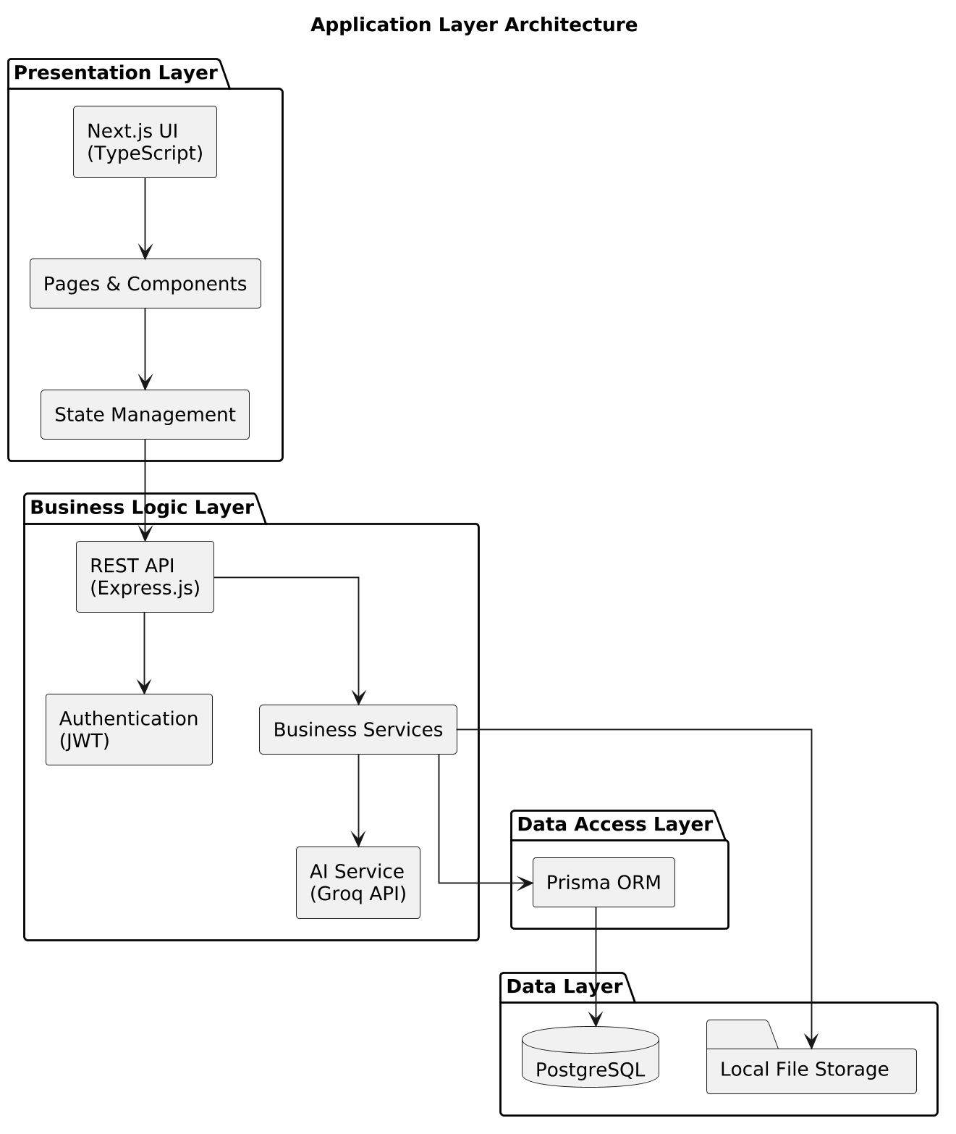
Figure 6.1: Overall System Architecture Diagram

6.2 Technology Stack
The following technologies are used to develop the Software House CRM.
Layer | Technology
Frontend | Next.js
Programming Language | TypeScript
UI Styling | Tailwind CSS
State Management | Redux Toolkit
Form Handling | React Hook Form
Backend | Node.js
Backend Framework | Express.js
Database | PostgreSQL
ORM | Prisma ORM
Authentication | JWT (JSON Web Token)
Password Encryption | bcrypt
AI Integration | Groq API
Charts | Chart.js
File Upload | Multer
PDF Generation | PDF Library
Excel Export | Excel Library
CSV Export | CSV Utility
Version Control | Git & GitHub
Deployment | Vercel (Frontend), Render/Railway (Backend), PostgreSQL

6.3 High-Level Architecture
The Software House CRM follows a client-server architecture where users interact with the frontend through a web browser. The frontend communicates with the backend using secure REST APIs over HTTPS. The backend processes requests, performs business logic, communicates with the PostgreSQL database, manages uploaded files, and interacts with the Groq API whenever AI-powered features are requested.
This architecture ensures a clear separation of responsibilities between the client application, server application, database, and external services.
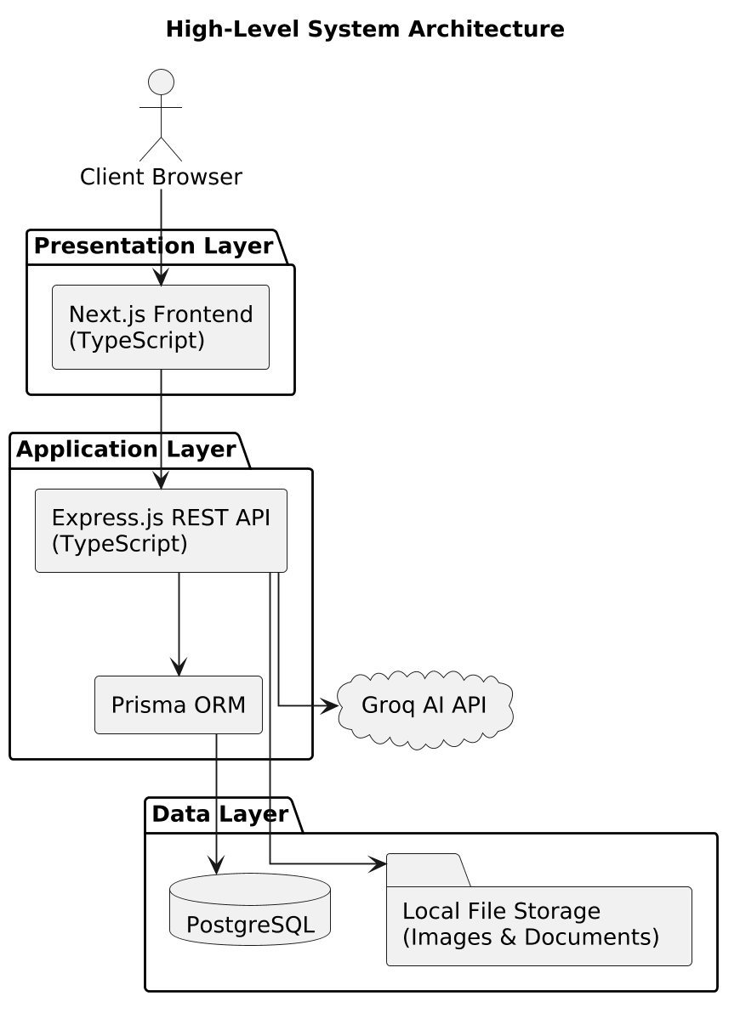
Figure 6.2: High-Level System Architecture Diagram

6.4 Application Layers
The application is divided into multiple logical layers, each with a specific responsibility.

6.4.1 Presentation Layer
The Presentation Layer provides the user interface through Next.js and TypeScript. It manages user interactions, form validation, navigation, dashboards, charts, and responsive layouts while communicating with the backend using REST APIs.

6.4.2 Application Layer
The Application Layer is implemented using Node.js and Express.js. It contains the business logic responsible for authentication, authorization, project management, client management, task management, quotation processing, invoice generation, payment management, AI integration, report generation, notifications, and file management.

6.4.3 Data Layer
The Data Layer stores and manages all application data using PostgreSQL. Prisma ORM handles database communication, schema migrations, and query execution. Uploaded files are stored on the server and linked to their corresponding database records.

6.4.4 External Services Layer
The External Services Layer includes third-party services used by the application. The Groq API provides AI-powered content generation, while additional libraries support PDF generation, Excel export, CSV export, chart visualization, authentication, and file handling.

Figure 6.3: Application Layer Architecture Diagram

6.5 Deployment Architecture
The Software House CRM is designed to support deployment on modern cloud platforms using separate frontend and backend services.
The frontend application is deployed on Vercel, while the backend API is deployed on a Node.js-compatible hosting platform such as Render or Railway. PostgreSQL is hosted as a managed database service, and uploaded files are stored on the backend server. Communication between all components is secured using HTTPS.
This deployment architecture allows each component to be managed independently while maintaining secure and reliable communication between the frontend, backend, database, and external AI services.
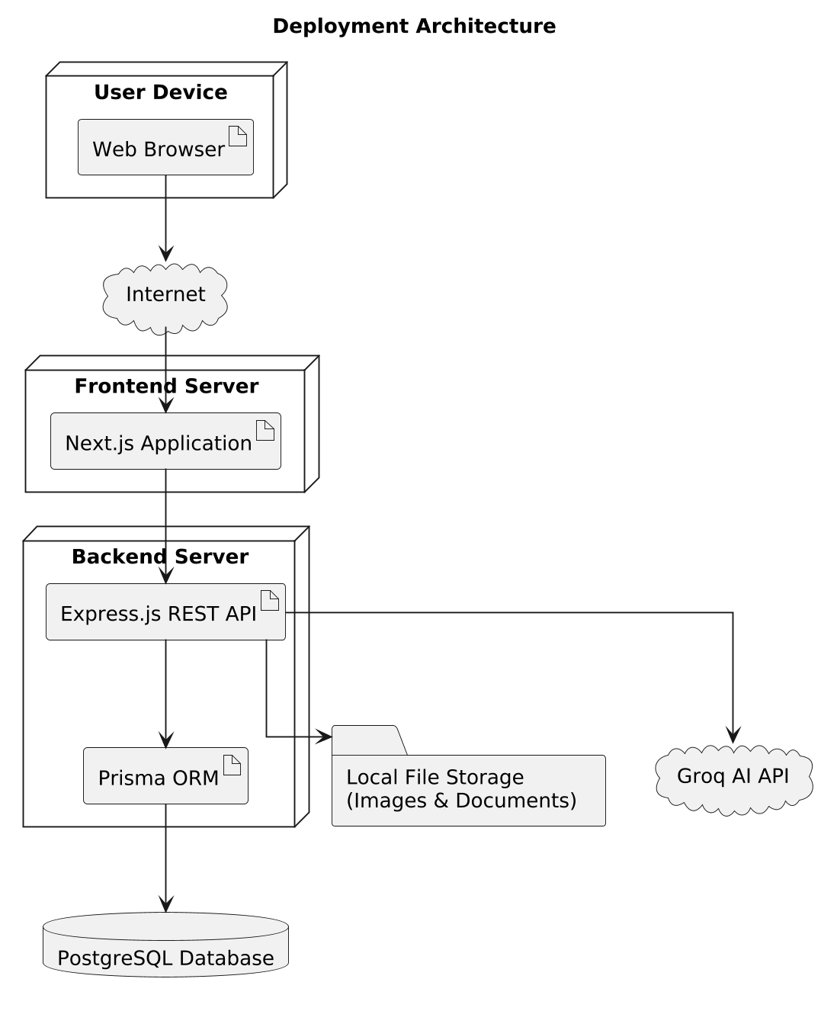
Figure 6.4: Deployment Architecture Diagram (to be inserted)

7. Database Design

7.1 Database Overview
The Software House CRM uses PostgreSQL as its primary relational database management system. The database is designed using a normalized structure to reduce data redundancy, maintain data integrity, and efficiently manage relationships between different entities. Prisma ORM is used to interact with the database, manage schema migrations, and simplify database operations within the application.
The database stores information related to users, clients, projects, tasks, meetings, quotations, invoices, payments, notifications, files, reports, audit logs, and system settings. Relationships between entities are established using primary keys and foreign keys to ensure consistency across the application.
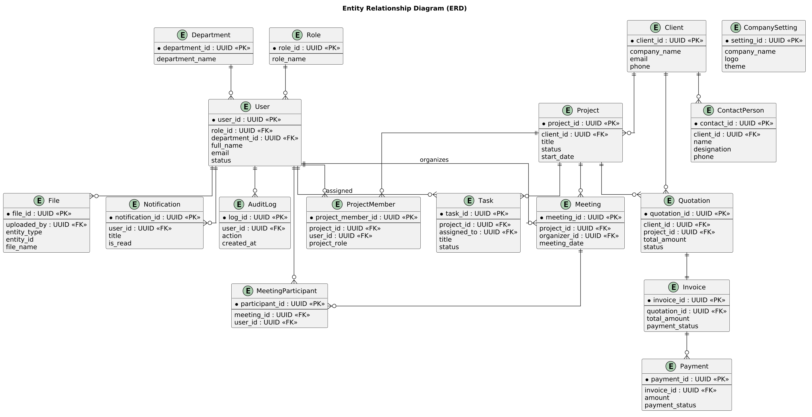
Figure 7.1: Entity Relationship Diagram – ERD

7.2 Database Tables
The Software House CRM consists of the following primary database tables.
Table Name | Purpose
users | Stores user accounts and authentication information.
roles | Stores system roles and permissions.
departments | Stores department information.
designations | Stores employee designation details.
clients | Stores client information.
projects | Stores software project information.
project_members | Maps employees to projects.
tasks | Stores project tasks and assignments.
meetings | Stores meeting schedules and details.
quotations | Stores client quotations.
quotation_items | Stores individual quotation items.
invoices | Stores invoice information.
invoice_items | Stores individual invoice items.
payments | Stores payment records.
payment_transactions | Stores payment transaction history.
files | Stores uploaded file metadata.
notifications | Stores user notifications.
audit_logs | Stores system activity logs.
ai_requests | Stores AI request history.
company_settings | Stores organization-wide settings.

7.3 Primary Key and Foreign Key Relationships
Each table contains a primary key that uniquely identifies its records. Relationships between tables are established using foreign keys to maintain referential integrity and support efficient data retrieval.
Some of the primary relationships within the database include:
Parent Table | Child Table | Relationship
roles | users | One-to-Many
departments | users | One-to-Many
designations | users | One-to-Many
clients | projects | One-to-Many
projects | tasks | One-to-Many
projects | meetings | One-to-Many
projects | invoices | One-to-Many
projects | quotations | One-to-Many
users | tasks | One-to-Many
users | meetings | One-to-Many
invoices | payments | One-to-Many
payments | payment_transactions | One-to-Many
users | notifications | One-to-Many
users | audit_logs | One-to-Many
users | ai_requests | One-to-Many

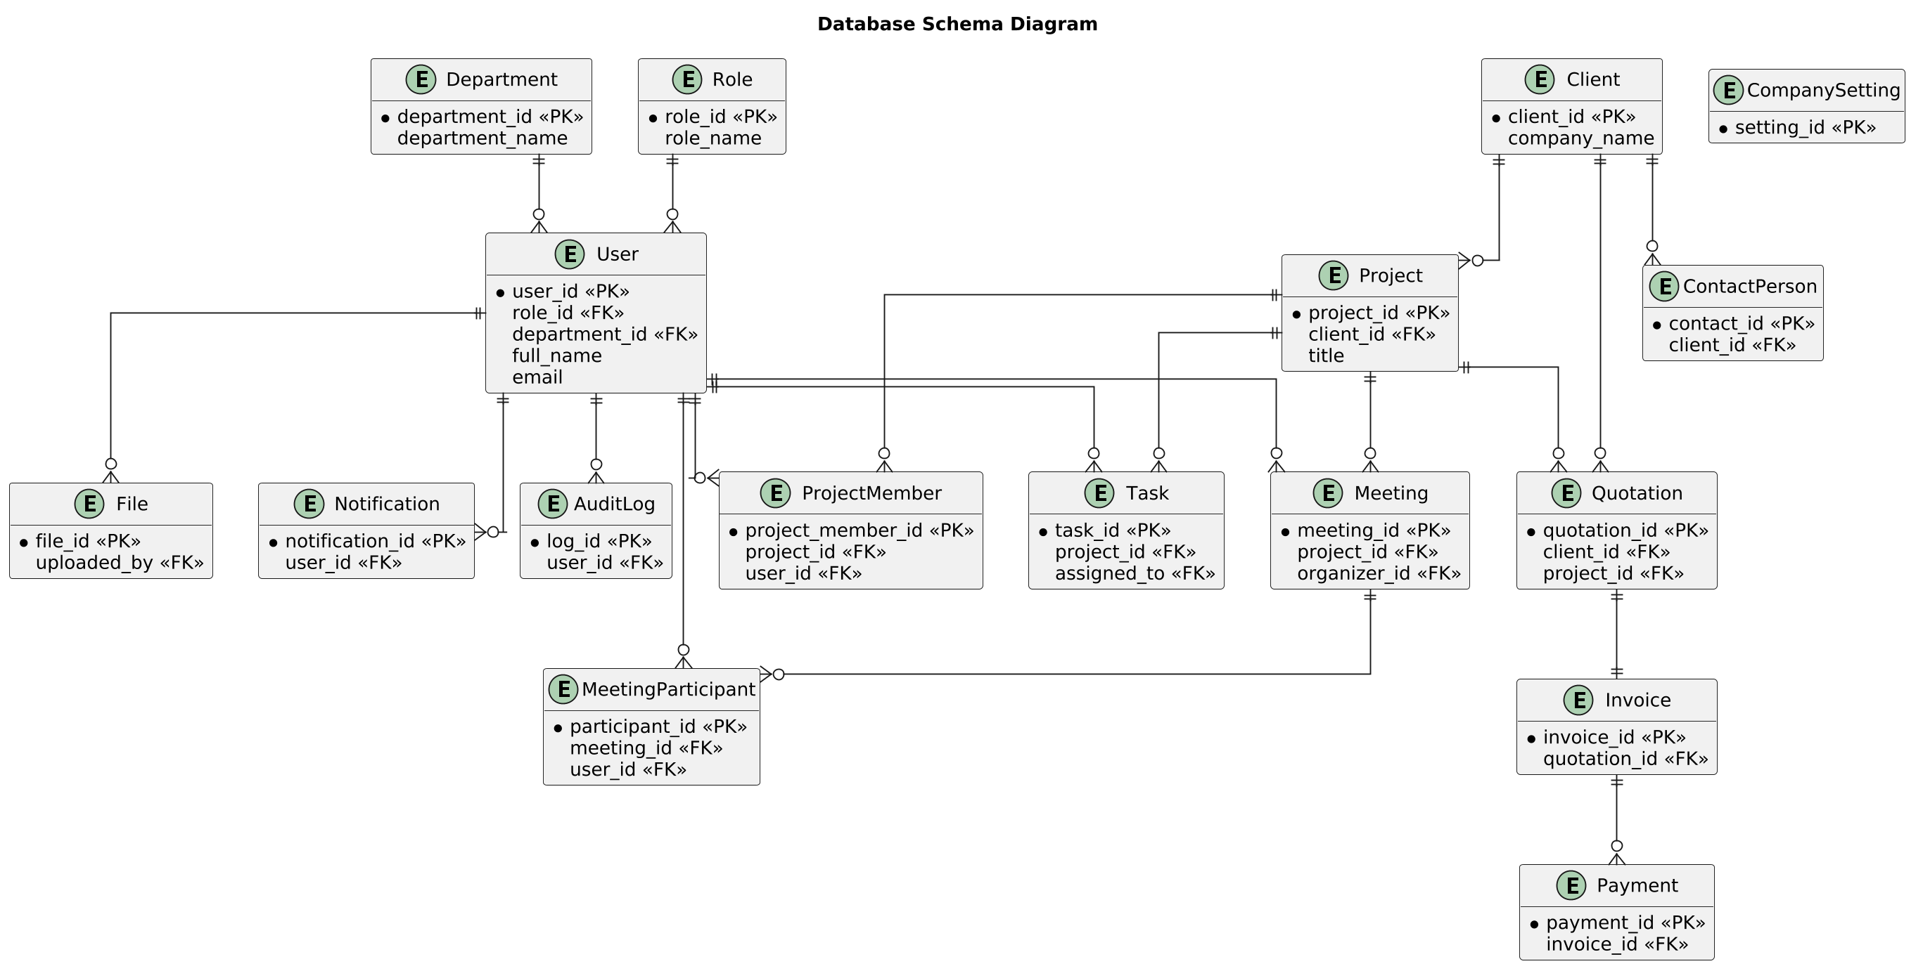
Figure 7.2: Database Relationship Diagram

7.4 Database Normalization
The database design follows normalization principles to improve data consistency and reduce redundancy. Separate tables are maintained for users, clients, projects, tasks, financial records, and supporting entities. Relationships are managed using foreign keys instead of duplicated data, allowing the system to maintain accurate and reliable information.
The database is designed to satisfy the requirements of Third Normal Form (3NF), ensuring that each table stores information related to a single entity while minimizing data duplication.

7.5 Data Integrity
The database maintains data integrity through primary keys, foreign keys, unique constraints, and validation rules. These mechanisms ensure that relationships between records remain valid and that duplicate or inconsistent data is prevented.
Important integrity rules include:
- Every user shall have one assigned role.
- Every project shall belong to one client.
- Every task shall belong to one project.
- Every meeting shall belong to one project.
- Every quotation shall belong to one client.
- Every invoice shall belong to one project and one client.
- Every payment shall reference a valid invoice.
- Every uploaded file shall be associated with an existing system record.

7.6 Database Indexing
Indexes shall be created on frequently searched columns to improve query performance. Primary keys shall be indexed automatically, while additional indexes shall be created for fields commonly used in searching, filtering, and sorting operations.
Typical indexed columns include user email addresses, project names, client names, invoice numbers, quotation numbers, payment status, task status, and notification status. Proper indexing helps maintain efficient performance as the database grows.

7.7 Database Backup Strategy
The database shall support regular backup procedures to minimize the risk of data loss. Backup files shall be stored securely and may be restored when necessary. Uploaded files should be backed up together with the database to maintain consistency between stored records and physical files.
The backup strategy shall support periodic backups, data restoration, and verification of backup integrity to ensure reliable recovery in case of system failure.
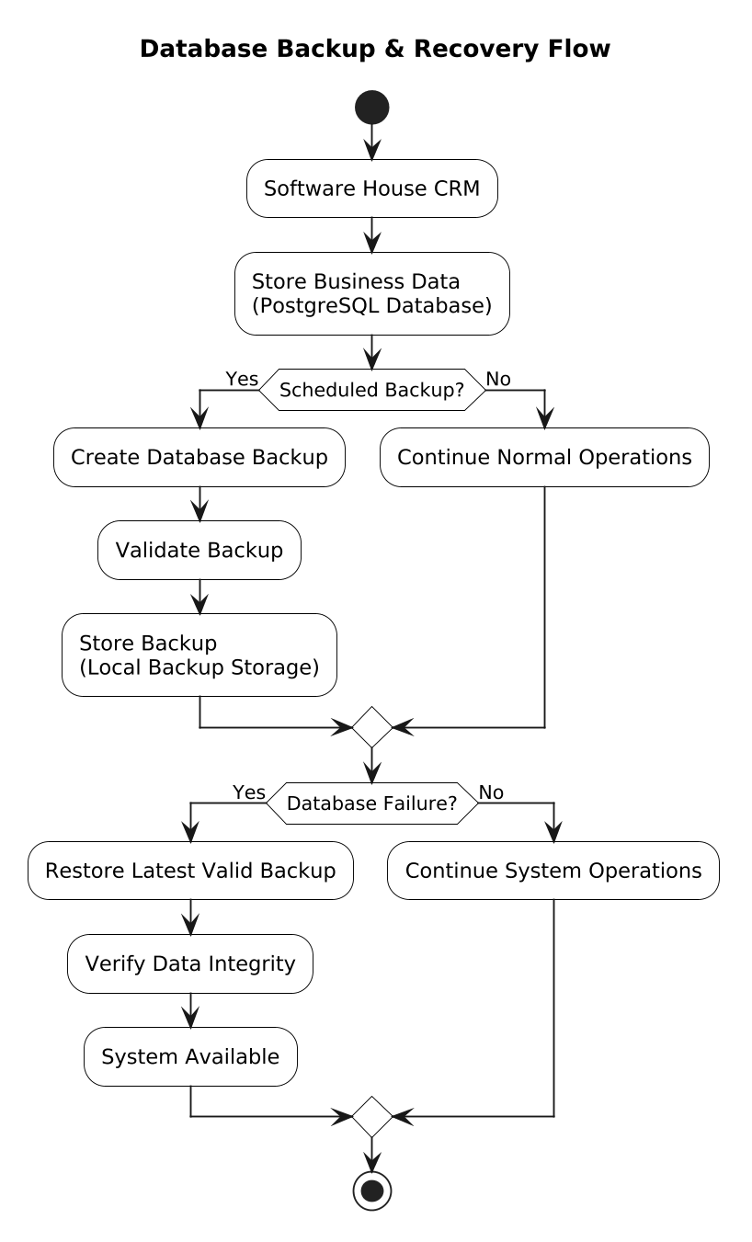
Figure 7.3: Database Backup and Recovery Flow Diagram

8. Assumptions, Dependencies, and Constraints

8.1 Assumptions
The development of the Software House CRM is based on several assumptions regarding the system environment, users, and available resources. These assumptions help define the project scope and expected operating conditions.
ID | Assumption
A-001 | Users have a stable internet connection to access the web application.
A-002 | Users have basic knowledge of using web-based business applications.
A-003 | The hosting platform remains available during normal business operations.
A-004 | PostgreSQL is available and properly configured before deploying the application.
A-005 | The Groq API is available whenever AI-powered features are used.
A-006 | Supported web browsers are installed on user devices.
A-007 | Authorized users manage system data responsibly according to their assigned roles.

8.2 Dependencies
The Software House CRM depends on several technologies and external services for its core functionality. Proper installation and configuration of these dependencies are required for successful deployment and operation.
ID | Dependency
D-001 | Next.js and TypeScript for frontend development.
D-002 | Node.js and Express.js for backend services.
D-003 | PostgreSQL as the primary database.
D-004 | Prisma ORM for database access and migrations.
D-005 | JWT and bcrypt for authentication and password security.
D-006 | Groq API for AI-powered features.
D-007 | Internet connectivity for accessing external services and application updates.
D-008 | Cloud hosting platforms for frontend, backend, and database deployment.

8.3 Constraints
The following constraints are considered during the development and deployment of the Software House CRM.
ID | Constraint
C-001 | The project shall use the selected technology stack defined in this SRS.
C-002 | The application shall be deployable on free-tier hosting platforms where possible.
C-003 | AI features depend on the availability of the Groq API.
C-004 | Real-time communication features are not implemented using WebSockets due to free-tier hosting limitations.
C-005 | The system is designed primarily for small and medium-sized software houses.

9. Future Enhancements
The current version of the Software House CRM provides the core features required to manage clients, projects, employees, meetings, quotations, invoices, payments, reports, file management, and AI-assisted productivity. However, the system has been designed with a modular architecture that allows new features to be added with minimal changes to the existing application.
The following enhancements may be considered for future versions of the system.
ID | Future Enhancement
FE-001 | Real-time chat between employees and clients using WebSockets or similar technologies.
FE-002 | Real-time push notifications for instant system updates.
FE-003 | Integration with online payment gateways such as Stripe or PayPal.
FE-004 | Mobile applications for Android and iOS platforms.
FE-005 | Email notifications for important system events.
FE-006 | SMS notifications for meetings, invoices, and payment reminders.
FE-007 | Two-Factor Authentication (2FA) for enhanced account security.
FE-008 | Calendar synchronization with Google Calendar and Microsoft Outlook.
FE-009 | Advanced business intelligence dashboards with predictive analytics.
FE-010 | Multi-language support for international users.
FE-011 | Multi-company support within a single application instance.
FE-012 | Integration with cloud storage services such as Google Drive and Dropbox.
FE-013 | Digital signatures for quotations and invoices.
FE-014 | Automated scheduled database backup and recovery.
FE-015 | Public REST API for integration with third-party applications.

The modular design of the application ensures that these enhancements can be implemented in future releases without requiring major changes to the existing architecture.

10. Appendices

10.1 Glossary
The following terms are used throughout this Software Requirements Specification (SRS) document.
Term | Definition
Client | An individual or organization that requests software development services.
Employee | A user who performs assigned tasks and participates in software projects.
Project | A software development assignment managed within the CRM.
Task | A unit of work assigned to an employee within a project.
Meeting | A scheduled discussion related to a client or project.
Quotation | A document that provides the estimated cost and scope of a proposed project.
Invoice | A billing document issued to a client for completed or ongoing work.
Payment | A financial transaction recorded against an invoice.
Dashboard | The main screen displaying summaries, statistics, and quick access to system modules.
AI Assistant | The module that provides AI-powered features using the Groq API.

10.2 Acronyms and Abbreviations
The following abbreviations are used throughout this document.
Acronym | Meaning
SRS | Software Requirements Specification
CRM | Customer Relationship Management
UI | User Interface
API | Application Programming Interface
REST | Representational State Transfer
JWT | JSON Web Token
ORM | Object Relational Mapping
AI | Artificial Intelligence
PDF | Portable Document Format
CSV | Comma-Separated Values
UUID | Universally Unique Identifier
HTTPS | Hypertext Transfer Protocol Secure

10.3 References
The development of this Software Requirements Specification is based on commonly accepted software engineering principles, official technology documentation, and industry best practices.
Reference | Description
IEEE Software Engineering Standards | Guidelines for Software Requirements Specification (SRS).
Next.js Documentation | Official documentation for Next.js.
TypeScript Documentation | Official documentation for TypeScript.
Node.js Documentation | Official documentation for Node.js.
Express.js Documentation | Official documentation for Express.js.
PostgreSQL Documentation | Official documentation for PostgreSQL.
Prisma Documentation | Official documentation for Prisma ORM.
Groq API Documentation | Official documentation for AI integration.

10.4 Document Revision History
The following table records revisions made to this Software Requirements Specification.
Version | Date | Description | Author
1.0 | August 2026 | Initial version of the Software Requirements Specification | Muhammad Haroon

