Detecting Planned and Unplanned Locality Using Satellite Imagery

Ahmad Saleem  msds18026@itu.edu.pk  Usman Tariq  msds18048@itu.edu.pk | M. Haseeb Ali  msds18037@itu.edu.pk  Farrukh Butt  msds18058@itu.edu.pk

Abstract

Unplanned settlements exist all over the world. The geospatial information of these areas is critical for urban management and reconstruction planning but usually unavailable. Field surveys are costly and labor-extensive because of wide urbanization. So in this project we aim to automatic segmentation and classification of planned and unplanned locality using remote sensing imagery. The main challenge is the existence of complex landscapes and high density settlements which are very complex to segment. In our project we gathered the data of 3 cities of Pakistan, separated build up area with u-net, assigned 12 labels and tagged the data and finally trained a multi-label classification model to predict the labels. We also perform experiments around model and compared the results, for further verification of our model we tested it on Model town and Raiwind, results of these towns have also been shared.

- Introduction
In under developed countries like Africa and Asia, unplanned settlements like slums come into existence with the spread of urban populations. People from remote areas comes to the city for finding jobs and labor work and demand lost cost residency which in turn give raise to these unplanned slums and shantytowns.
Effective management, improvements and reconstruction of these unplanned settlement become important policy in big city. So for urban reconstruction identification and characterization of these areas is very crucial for reconstructing those areas. As these areas are widely spread so field surveys are very time consuming and costly so we want to use remote sensing techniques for the segmentation of these areas.
In this regard we use deep learning framework based on U-net for segmentation of these areas and multi-label classification in order to know that what kind of things those areas comprises off.

Related Work

The first paper we read regarding our project is U-net for segmentation. The network architecture of U-net is simple and easy to follow. It consists of the following steps:
- First 2-d convolution layers with padding and 3*3 kernel.
- Then2-d max-polling with 2*2 kernel.
- Thirdly cropping layer is used to crop feature maps.
- Then a concatenate layer is using to combine multiple feature maps
- Then an up-sampling layer to increase the size of feature map.
- And in the last a softmax layer to generate final output.

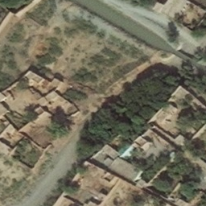

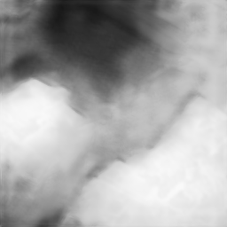

Another paper we read is to learn about multi-label classification which is again used in our project.

In multi-label classification, the training set is composed of instances each associated with a set of labels, and the task is to predict the label sets of unseen instances through analyzing training instances with known label sets.

The basic idea of multi-label classification is as follow:-

Model the label relatedness.
- Learn all labels simultaneously.
- Labels may share the same data/features.

Moreover we also read about identification of patterns using CNNs and attention-based learning
in satellite imagery.

Base Papers
Following are the base papers we read in detail for understanding the underlying concepts which we implemented in our term project.

- Pan, Z.; Xu, J.; Guo, Y.; Hu, Y.; Wang, G. Deep Learning Segmentation and Classification for Urban Village Using a Worldview Satellite Image Based on U-Net. Remote Sens. 2020, 12, 1574.

- Shakeel, Anza, Waqas Sultani, and Mohsen Ali. "Deep built-structure counting in satellite imagery using attention based re-weighting." ISPRS Journal of Photogrammetry and Remote Sensing 151 (2019): 313-321.

- Albert, Adrian and Kaur, Jasleen and Gonzalez, Marta C, "Using convolutional networks and satellite imagery to identify patterns in urban environments at a large scale," Proceedings of the 23rd ACM SIGKDD international conference on knowledge discovery and data mining, pp. 1357-1366, 2017.

- Deliverable
- 1st we build a U-net architecture which help us to generate masks of images which tell us about either the area is covered with building or empty
- 2nd we tagged collected data
- 3rd we build a model which predict the labels according to the image provided to the model
- 4th we build a classification model which takes an image and the labels predicted by the 2nd model and tell us whether the image is a planned area or an unplanned one
- 5th we did different experiments to improve the results
- And lastly if we have time we will try to automate all the steps starting from mask generation till image classification.

Data Collection

Three groups are working on this project and we collectively collect the dataset for this project. We used Bing Satellite on SASGIS application with 19 zoom level to download images of different cities of Pakistan that are
- Lahore,
- Peshawar
- Hyderabad.

After downloading these images we generated mask on them to filter images with denser buildings using mean > 0.1. After selecting more than 6000 images with resolution of 256*256 from filtered ones we use Dataturks online software for image labelling

Tasks
Following are the main tasks we divide among our group members for the timely completion of the project.
- Read up relevant stuff and get the data
- Training a U-net model to generate masks
- Using U-net model separate the images that have a relatively high buildup
- Labeling the data using Dataturks
- Preparing the data received from Dataturks
- Training the multi label model to predict up to 12 labels in a data
- Further feed the images with labels to predict whether an area is planned or unplanned

Current Status
We have completed most of our tasks we have trained U-net, generated masks and used them to separate buildup area.
We also labeled the data, preprocessed it and learned a multi-label model. Now we have to learn a model that can classify planned vs unplanned areas using the labels

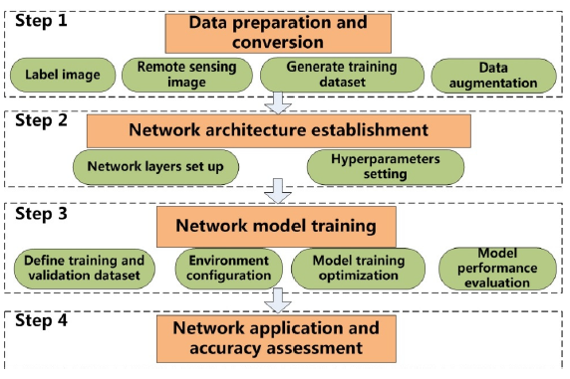

U-net Architecture
Following is the architecture diagram for u-net

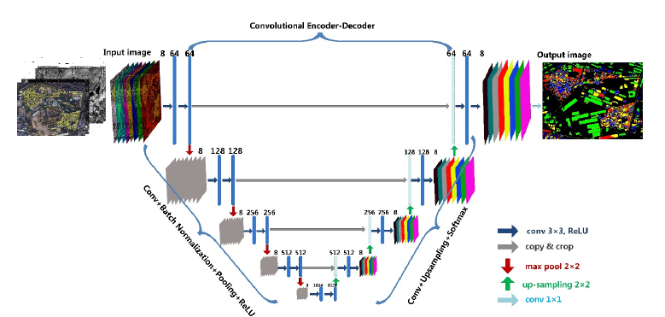

- Multi-label Classification Network Diagram

Following is the network diagram for multi-label classification. (If you cannot read this here, we have also added this in figure folder)

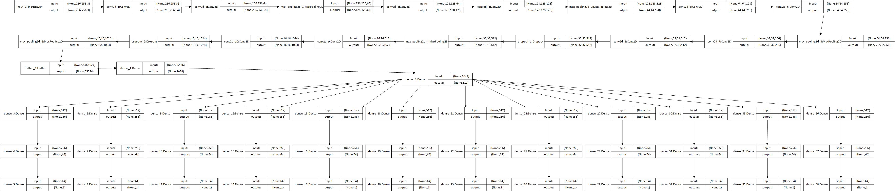

Experiments and Results
We worked upon generating masks for satellite images to identify the buildup area. For that purpose, we used Unet and achieved an accuracy of 95% on training data. We used keras to build up U-net and dataload pipeline.
To train the data we used village dataset. We worked around image preprocessing to achieve better results also overcome some difficulties related to loading tiff image format.
After Some research and study we decided to use Multi Label classification model for this problem. We tried different convolutional and pooling layers and get the best results at 10 convolutional and 5 pooling layers. Also we tried Average and Max pooling but the results were same for both of them.

Average accuracy is 0.81 but the lowest accuracy is for “High Building Density” which is 0.49 as per our undertaking there could be two possible problem.

1) There is very less data for this label

2) If we give the same image to different people they will give different class for this label.

 | Loss | Accuracy
High Building Density | 0.2849 | 0.4908
Moderate Building Density | 0.5028 | 0.8849
Low Building Density | 0.4356 | 0.7762
Regular Layout | 0.5788 | 0.8725
Irregular Layout | 0.5835 | 0.7300
Dense Greenery | 0.3670 | 0.7200
Sparse Greenery | 0.5877 | 0.9162
Very Sparse Greenery | 0.3845 | 0.7024
Grass | 0.3845 | 0.8562
Trees | 0.5712 | 0.7425
Large Buildings | 0.4000 | 0.8525
Exposed Soil | 0.5388 | 0.7887
Average | 0.44 | 0.8187

Milestones and deadlines
- Project Selection and proposal writing: 27, 28 May
- Research and understanding of Project : 29 may - 6 June
- Paper Selection and Presentation : 7-9 June
- Mask Generation Model: 10,11 June
- Data Labelling : 12 – 14 June
- Research related to Architecture Selection : 15 -16 June
- Data Preparation :17,18 June
- Model Development and Training : 19 – 22 June
- Project Report/Poster Draft : 21 – 22 June
- Other Experiments and Results improvement: Until deadline

- Comparison of Results

Results of labels with cross entropy loss

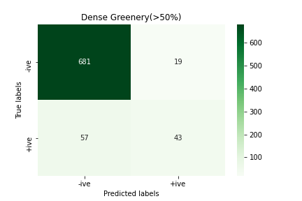
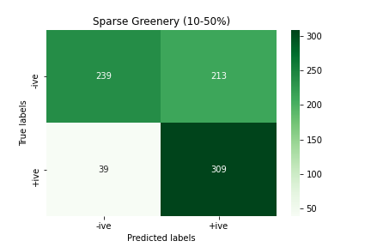
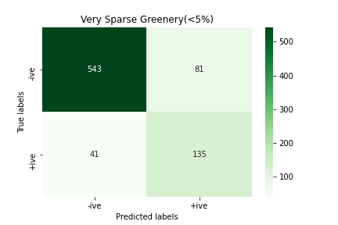
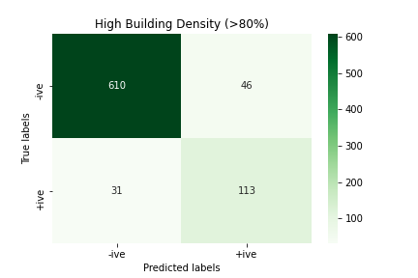
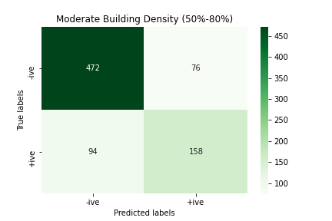
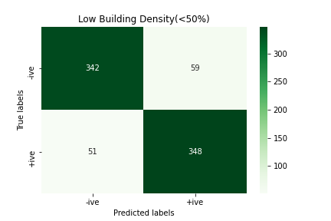
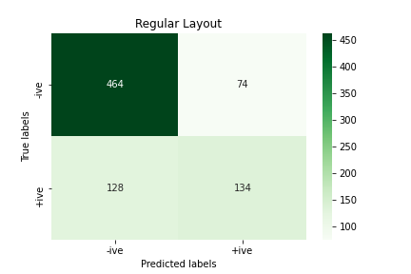
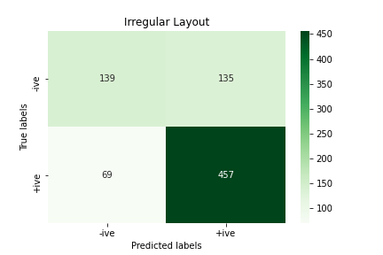
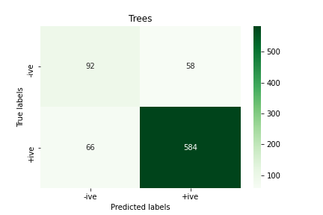
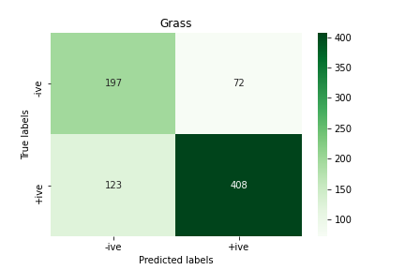
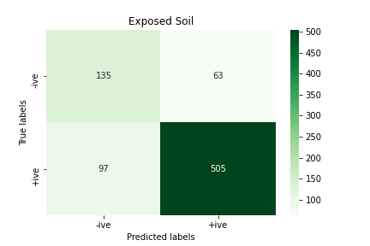
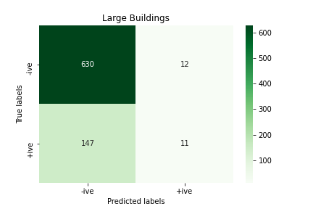
Precision/Recall Table
 | Precision | Recall | F1 Score
High Building Density | 0.71 | 0.78 | 0.75
Moderate Building Density | 0.68 | 0.63 | 0.65
Low Building Density | 0.86 | 0.87 | 0.86
Regular Layout | 0.64 | 0.51 | 0.57
Irregular Layout | 0.77 | 0.87 | 0.82
Dense Greenery | 0.69 | 0.43 | 0.53
Sparse Greenery | 0.59 | 0.89 | 0.71
Very Sparse Greenery | 0.62 | 0.77 | 0.69
Grass | 0.85 | 0.77 | 0.81
Trees | 0.91 | 0.90 | 0.90
Large Buildings | 0.48 | 0.07 | 0.12
Exposed Soil | 0.89 | 0.84 | 0.86

Micro Avg. | 0.78 | 0.77 | 0.78
Macro  Avg. | 0.72 | 0.69 | 0.69
Weighted Avg. | 0.78 | 0.77 | 0.76
Sample Avg. | 0.78 | 0.78 | 0.77

Results of labels of Batch Normalization with Focal loss
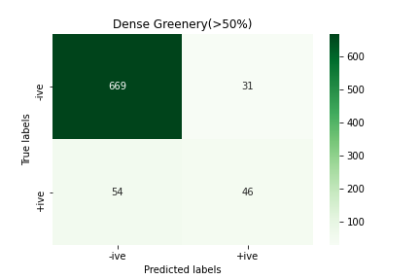
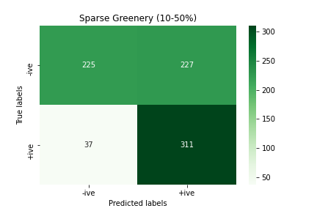
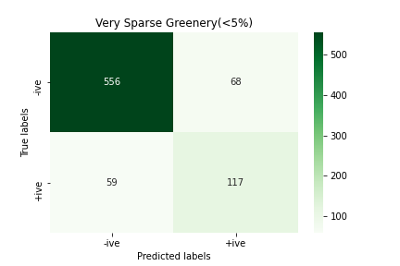

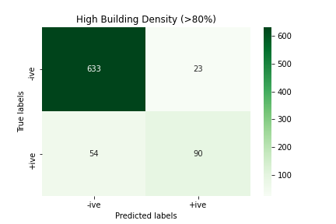
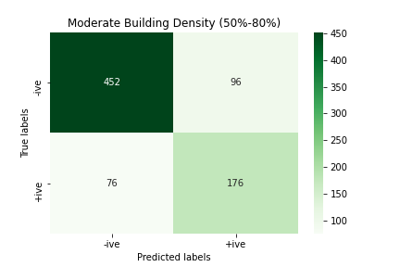
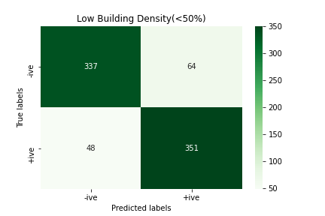
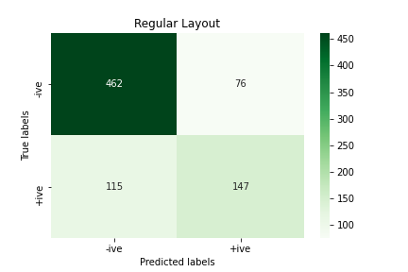
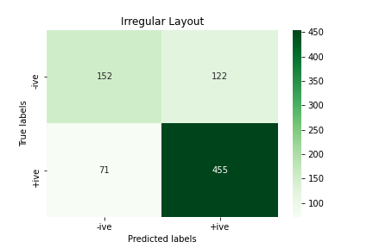
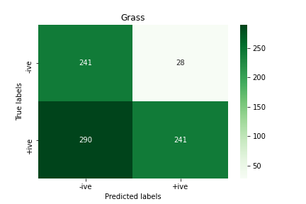
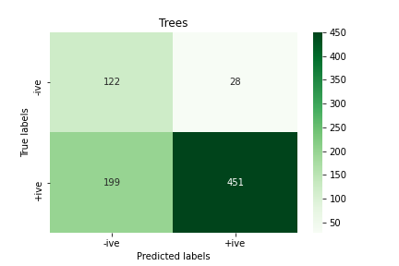
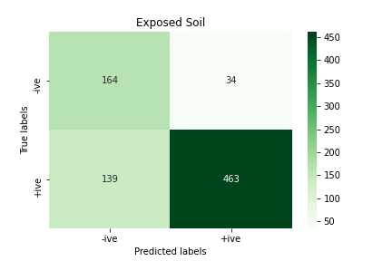
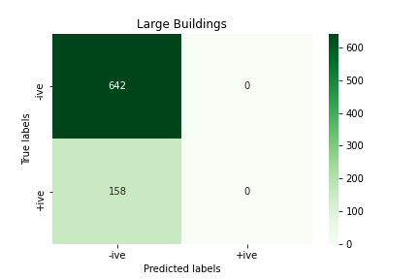
Precision/Recall Table
 | Precision | Recall | F1 Score
High Building Density | 0.80 | 0.62 | 0.70
Moderate Building Density | 0.65 | 0.70 | 0.67
Low Building Density | 0.85 | 0.88 | 0.86
Regular Layout | 0.66 | 0.56 | 0.61
Irregular Layout | 0.79 | 0.87 | 0.83
Dense Greenery | 0.60 | 0.46 | 0.52
Sparse Greenery | 0.58 | 0.89 | 0.70
Very Sparse Greenery | 0.63 | 0.66 | 0.65
Grass | 0.90 | 0.45 | 0.60
Trees | 0.94 | 0.69 | 0.80
Large Buildings | 0.00 | 0.00 | 0.00
Exposed Soil | 0.93 | 0.77 | 0.84

Micro Avg. | 0.78 | 0.69 | 0.73
Macro  Avg. | 0.69 | 0.63 | 0.65
Weighted Avg. | 0.78 | 0.69 | 0.71
Sample Avg. | 0.78 | 0.69 | 0.73

Comparison Table
 | Avg. Precision | Avg. Recall | Avg. F1-Score
With Cross Entropy | 0.78 | 0.77 | 0.78
With Focal Loss | 0.77 | 0.71 | 0.74
With Batch Norm. Focal Loss | 0.62 | 0.48 | 0.54
With Batch Norm. Cross Entropy | 0.77 | 0.71 | 0.74

  - Comparison Of Model Town Locality With Raiwind Locality

Model Town Locality

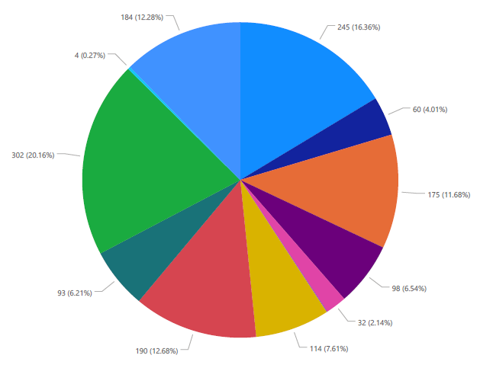

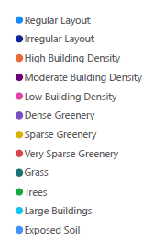
Raiwind Locality

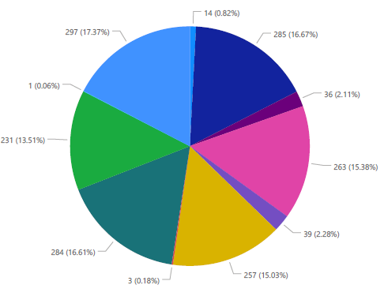

From these two pie charts you can clearly see the difference between two localities of the same city that are model town and raiwind.

Conclusion

The increased availability of high resolution satellite imagery allows to sense very detailed structures on the surface of our planet. Access to such information opens up new directions in the analysis of different information like poverty estimation, slum detection, population estimation, Buildings count etc.
Deep Learning and satellite imagery together can help us reduce cost for different industrial and research project which will be very high is case manual estimation techniques like surveys. Our goal was to detect if the locality is planned or unplanned for this purpose we used 7 labels which will decide whether it’s a planned or unplanned locality these labels are building density, greenery density, pattern of locality (regular or irregular) , tree presence, grass presence, exposed soil presence, large building presence.
We achieve 81% accuracy for prediction of these labels. These labels are not only used for this specific problem but can also be helpful for increasing the results for different satellite imagery problems.

- References
[1] Pan, Z.; Xu, J.; Guo, Y.; Hu, Y.; Wang, G. Deep Learning Segmentation and Classification for Urban Village Using a Worldview Satellite Image Based on U-Net. Remote Sens. 2020, 12, 1574

[2] Shakeel, Anza, Waqas Sultani, and Mohsen Ali. "Deep built-structure counting in satellite imagery using attention based re-weighting." ISPRS Journal of Photogrammetry and Remote Sensing 151 (2019): 313-321.

[3] Albert, Adrian and Kaur, Jasleen and Gonzalez, Marta C, "Using convolutional networks and satellite imagery to identify patterns in urban environments at a large scale," Proceedings of the 23rd ACM SIGKDD international conference on knowledge discovery and data mining, pp. 1357-1366, 2017.

[4] Long, J.; Shelhamer, E.; Darrell, T. Fully convolutional networks for semantic segmentation. In Proceedings of the 2015 IEEE Conference on Computer Vision and Pattern Recognition (CVPR), Boston, MA, USA,7–12 June 2015.

[5] Io_e, S.; Szegedy, C. Batch normalization: Accelerating deep network training by reducing internal covariate shift. In Proceedings of the 32nd International Conference on International Conference on Machine Learning,Lille, France, 6–11 July 2015

