**USMAN INSTITUTE OF TECHNOLOGY**

Affiliated with NED University of Engineering & Technology, Karachi

**Department of Computer Science**

B.S. Computer Science / Software Engineering

FINAL YEAR PROJECT REPORT

**Batch-2020**

**FYPdhundo.com**

**By**

|  |  |
| --- | --- |
| Muhammad Moin Tabani | 20B-016-CS |
| Muhammad Hassaan Shoukat | 20B-031-CS |
| Muhammad Daniyaal | 20B-119-CS |
|  |  |

**Supervised by**

Ali Ahmed

*ST-13, Block 7, Gulshan-e-Iqbal, Abul Hasan Isphahani Road, Opposite Safari Park, P.O. Box 75300,*

*Karachi, Pakistan. Phone: 34978274-5; 34994305; 34982476;* [*http://www.uit.edu*](http://www.uit.edu/)

Submission Performa

Name: (1) Muhammad Moin Tabani

(2) Muhammad Hassaan Shoukat

(3) Muhammad Daniyaal

Address: (1) House no B98, post office society, Sector13-A, Gulzar Hijri, Karachi.

(2) Nagori Manzil Moosa Lane Street no 3 ARPT road Karachi.

(3) House no A-11, Sector U-3, Gulshan e Maymaar, Karachi.

FYPDhundo.com

Project Supervisor: Ali Ahmed



This report is submitted as required for the Project in accordance with the rules laid down by the Usman Institute of Technology as part of the requirements for the award of the degree of Bachelor of **Computer Science/Software Engineering**. I declare that the work presented in this report is my own except where due reference or acknowledgment is given to the work of others.

Signatures of students Date

(1)…………………………….. ……………………..

(2)……………………………. …………………….

(3)…………………………….. …………………….

(4) …………………………….. …………………….

Acknowledgments

This page should consist of the acknowledgements to the people, companies and institutions that have been helpful to the author in compiling the reports. It is normal practice to thank the Head of Institute for the use of facilities with which the project was carried out, the head of department, the supervisor for his/her suggestions and guidance and any other member of the academic and technical support staff who have made a significant contribution to the success of the project, and finally your family member (that is optional).

Abstract

The abstract is a brief summary of your research. Typically, an abstract should be one page and/or less than 350 words. Your abstract should consist of concise precise to inform the reader of the content of the report, what the project was about, the main aim of the project, how the work was undertaken and major conclusions drawn from the work performed. It is important not to confuse an abstract with an introduction. The first sentence should give the subject of the report and the last sentence should state the primary conclusion of the report. The abstract should be written in the present tense. It should not include illustrative material such as formulas, diagrams, and charts. The abstract page is numbered ii. It should conclude with short entry ‘Keywords’, Nominating several keywords by which a computerized library would find the project.

Table of contents

Acknowledgments ii

Abstract iii

List of tables vi

List of figures vii

List of symbols and Units viii

CHAPTER I 1

introduction 1

1.1 INTRODUCTION 1

1.2 AIM AND STATEMENT OF PROBLEM 1

CHAPTER II 2

Background and Literature Review 2

2.1 INTRODUCTION 2

CHAPTER III 3

Hardware, Software analysis and requirements 3

3.1 INTRODUCTION 3

CHAPTER IV 4

Software design and modeling 4

4.1 INTRODUCTION 4

CHAPTER V 5

Algorithm analysis and complexity 5

5.1 INTRODUCTION 5

CHAPTER VI 6

Implementation 6

6.1 INTRODUCTION 6

CHAPTER VII 7

Testing 7

7.1 INTRODUCTION 7

7.2 DISCUSSION 7

CHAPTER VIII 8

Conclusions 8

CHAPTER IX 9

Future work 9

References 14

The table of the contents is on a separate page and is numbered iii. The table of contents lists the sections of the report, a list of figures and a list of tables along with the page on which they begin. It is to be generated by MS word -> references -> table of contents, similarly list of tables and list of figures.

List of tables

List of figures

List of symbols and Units

A list of symbols and units should be included to assist the reader. This should include any Greek letters or other mathematical symbols together with the quantities to which they refer, and their appropriate units. Preferred 2-3 pages of UML notations used in the project

# 



introduction

* + 1. INTRODUCTION

In the rapidly evolving landscape of education and industry collaboration, FYP Dhundo.com emerges as a pioneering initiative, addressing the crucial need for seamless connectivity between students, teachers, and industry professionals. The project was conceptualized in response to the growing demand for practical, real-world learning experiences, where students can apply theoretical knowledge to tangible projects and industry challenges. FYP Dhundo.com stands as a digital nexus, facilitating the convergence of academia and industry by providing a platform where teachers can post research projects, students can explore tailored opportunities, and industry experts can engage the next generation of talent.

## Project Function and System Diagram

The core function of FYP Dhundo.com revolves around an intelligent recommendation system that matches students with projects based on their skills, interests, and academic profiles. Leveraging advanced algorithms, the platform analyzes these variables to create optimal project-student pairings. The block diagram showcases the seamless flow of information, from project posting to student engagement, highlighting the intuitive nature of the system.

Figure 1 System Diagram

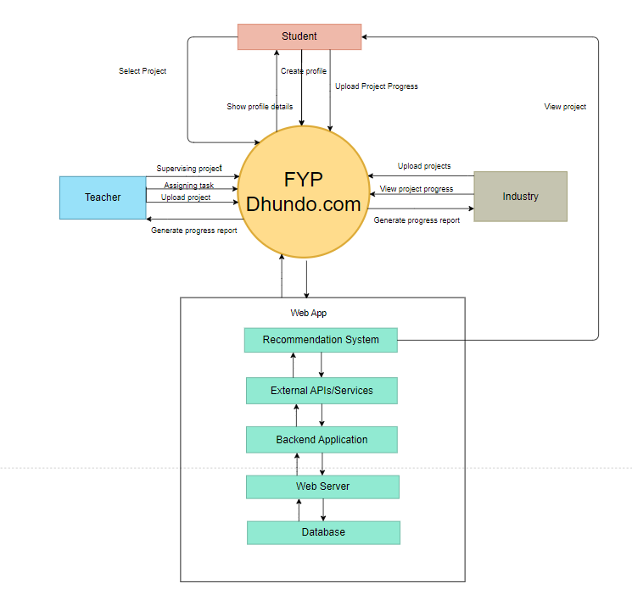

This above system diagram shows how users communicate with the system and how system communicate with backend to respond them.

## Performance Specifications

Key performance specifications encompass the efficiency of the recommendation algorithm, measured by the accuracy of student-project matches. Additionally, the platform's user interface responsiveness and real-time progress tracking are vital indicators. The variables critical to the project's performance include recommendation accuracy, response time, and user engagement metrics. These variables are essential in ensuring the platform's efficacy and user satisfaction.

## Project Structure

The project has been meticulously divided into several subprojects, each focusing on specific aspects critical to its overall functionality. These subprojects include the development of the recommendation algorithm, the creation of user profiles and project posting interfaces, real-time progress tracking modules, and database management for seamless data retrieval. Each subproject aligns cohesively to bring forth the comprehensive capabilities of FYP Dhundo.com.

## Report Structure

In this report, we will delve into the intricacies of FYP Dhundo.com, beginning with an in-depth exploration of the project's background and the rationale behind its inception. The subsequent chapters will provide detailed insights into the recommendation algorithm's architecture, the user interface design, and the database management system. We will discuss the challenges faced during the development process and the innovative solutions devised to overcome them. The report will culminate in a comprehensive analysis of the project's outcomes and prospects, offering a holistic view of the project's journey from concept to implementation.

1. **Introduction:** This section provides an introduction to the report, offering a brief overview of the topic, its significance, and the scope of the report.
2. **Aim and Statement of Problem:** This section outlines the specific objectives or aims of your research or project. It also clearly defines the problem you are addressing in your report.
3. **Background and Literature Review:** This section provide the context and background information about the topic of your report. You also review relevant literature to establish the existing knowledge in the field.
4. **Hardware, Software Analysis, and Requirements:** This section discusses about the hardware and software components relevant to your project. You may also detail the requirements needed to carry out your work.
5. **Software Design and Modeling:** This section focuses on the design and modeling of any software systems or components related to your project.
6. **Algorithm Analysis and Complexity**:This section focuses on the algorithm used and their complexity. If your project involves algorithms, this section is where you analyze the algorithms used and discuss their complexity.
7. **Implementation:** This section describe the actual implementation of your project or research, detailing the steps taken to execute your plan.
8. **Testing:** Discuss the testing methods and results related to your project or research. This section shows how well your work performs and meets the defined criteria.
9. **Discussion (Optional):** This section is optional but provides a space to discuss your findings and results in more detail. You can analyze and interpret your data here.
10. **Conclusions:** Summarize the key findings and outcomes of your work. State the conclusions you've drawn from your research or project.
11. **Future Work:** Discuss any future work or research that can build upon your current findings. This section looks forward to potential developments.
12. **Achievements:** Highlight the significant achievements or contributions of your work.
13. **Appendices:** This section is for supplementary information, such as additional data, charts, or detailed technical information that supports the main content of the report.
14. **General Guidelines:** This section can provide any general guidelines, references, or resources for further reading or research.
    * 1. AIM AND STATEMENT OF PROBLEM

The aim of the project should be clearly stated with sufficient explanation to make these easily understandable. Write succinct definition of the problem. Defines and limits the ‘Scope’ of the effort. Clearly describe how you tackled the problem. Preferred to explain each problem in separate subheading.

# Aim and Statement of Problem

## Aim of the Project:

The primary aim of the FYP Dhundo.com project is to create a robust and user-friendly online platform that bridges the gap between students, teachers, and industry professionals. The platform seeks to facilitate seamless collaboration, enabling students to find relevant research projects, teachers to supervise and guide these projects effectively, and industry professionals to engage with the next generation of talent. By providing a centralized hub for these stakeholders, the project aims to enhance the educational experience, foster practical learning, and promote industry-academia collaboration.

## Problem Statement

In contemporary education, the disconnect between theoretical knowledge and practical application poses a significant challenge. Students often struggle to find relevant and engaging research projects, while teachers find it cumbersome to supervise and guide numerous projects effectively. Simultaneously, industry professionals face obstacles in identifying suitable student projects for collaboration, hindering meaningful engagement between academia and real-world applications. The lack of a centralized platform exacerbates these challenges, leading to reduced student engagement, limited industry-academia collaboration, and inefficient supervision methods. Addressing these multifaceted issues is crucial for enhancing the educational experience, promoting effective mentorship, encouraging industry engagement, and fostering a seamless collaboration environment. The FYP Dhundo.com project aims to bridge these gaps and provide a solution that empowers students, teachers, and industry professionals to collaborate meaningfully, thereby enriching the learning experience for all stakeholders involved. The existing problems can be summarized as follows:

### **Inefficient Project Selection**

Students struggle to find FYPs that match their skills and interests due to limited options and lack of personalized guidance.

### Limited Industry Integration

FYPs often lack real-world relevance because of limited interaction between students and industry professionals, resulting in a gap between academic learning and industry requirements.

### Lack of Transparency

There is a lack of transparency in the project progress, making it difficult for teachers, students, and industry partners to monitor and assess the project's development effectively.

### Underutilization of Student Potential

Students' skills and potential remain underutilized due to a mismatch between their capabilities and the projects they are assigned, leading to a suboptimal learning experience.

## Proposed Solutions

A functional web portal including user authentication, project listings, recommendation algorithms, real-time communication tools, progress tracking. The functional web portal serves as the primary product, providing a comprehensive online platform where students, teachers, and industry professionals can collaborate, post, and engage in research projects, communicate, and track project progress. This deliverable represents the tangible outcome of the development process, allowing users to access and utilize the services provided by FYP Dhundo.com. Proposed solution can be summarized as follows:

### Intelligent Recommendation System

Implement a sophisticated recommendation algorithm that assesses student profiles, skills, and interests. By analyzing historical data and utilizing machine learning techniques, the system can accurately match students with projects tailored to their abilities and preferences, enhancing student engagement.

### Efficient Project Supervision Tools

Develop a comprehensive dashboard for teachers, enabling them to monitor multiple projects efficiently. This dashboard should facilitate progress tracking, feedback provision, and communication channels with students, streamlining the supervision process and ensuring effective mentorship.

### Enhanced Industry Engagement

Introduce a user-friendly project posting interface for industry professionals, allowing them to outline their projects' requirements and objectives. Implement direct messaging features, enabling seamless communication between industry experts and students. Additionally, provide tools for industry mentors to monitor project progress, fostering meaningful collaborations.

### Advanced Technological Infrastructure

Utilize robust backend technologies such as Node.js for scalable, high-performance server operations. Adopt cloud-based solutions, leveraging platforms like AWS, to ensure seamless scalability and data management. Employ real-time data processing techniques, such as WebSockets, to enable instant collaboration features while maintaining system responsiveness.

### User-Centric Interface and Experience

Invest in intuitive UI/UX design, ensuring a user-friendly interface accessible across various devices. Conduct thorough usability testing to refine the interface based on user feedback, optimizing the platform for ease of use. Implement responsive design principles to enhance accessibility and user satisfaction.

# 



Background and Literature Review

* + 1. INTRODUCTION

This Chapter provides the context and background information about the FYP dhundo.com and this chapter will cover the related work about the topic. This chapter will also cover information related to similar applications(upwork , gihub) etc and algorithms preferred from research papers.

## Background

The background of the FYP Dhundo.com project lies in the intersection of education, technology, and industry collaboration. Traditional educational systems often lack avenues for students to apply theoretical knowledge to real-world projects, while industry professionals struggle to identify suitable projects and talent. FYP Dhundo.com addresses these challenges by creating a dynamic online platform where students, teachers, and industry experts can seamlessly collaborate.

Inspired by the need for practical, hands-on learning experiences, the project aims to revolutionize how students engage with their studies and the professional world. By leveraging advanced technologies such as recommendation algorithms, real-time collaboration tools, and intuitive user interfaces, FYP Dhundo.com provides a solution to bridge the gap between classroom learning and practical application.

This project's genesis also stems from the growing importance of interdisciplinary skills and industry-specific knowledge. FYP Dhundo.com acknowledges that the future workforce needs individuals to be adept at applying knowledge in diverse contexts. The platform not only facilitates educational growth but also nurtures vital skills such as project management, communication, and problem-solving, aligning with the demands of the modern job market.

Furthermore, the project is influenced by the paradigm shift in education, emphasizing personalized learning experiences. FYP Dhundo.com recognizes that every student is unique, and their educational journey should reflect their interests, skills, and aspirations. By tailoring project recommendations and mentorship opportunities, the platform creates an individualized learning environment, fostering a passion for learning and professional development. In summary, the background of the FYP Dhundo.com project emerges from the need for practical, personalized, and industry-relevant educational experiences.

### Traditional Fyp methods

Traditional methods of Final Year Projects (FYPs) typically involve students selecting projects from a limited pool provided by their educational institutions. These projects often lack real-world relevance and may not align with students' individual skills or career aspirations. Students work on these projects with minimal industry engagement and mentorship, limiting their exposure to diverse challenges and interdisciplinary collaboration. The evaluation of these projects is often confined to academic contexts, providing limited recognition for students' achievements beyond their educational institutions. Consequently, traditional FYPs might not adequately prepare students for the complexities of the professional world, lacking the industry relevance, mentorship, and interdisciplinary experiences crucial for holistic skill development and future employability.

### Benefits of Fypdhundo.com

FYP Dhundo.com revolutionizes traditional Final Year Projects (FYPs) by offering a diverse and industry-relevant project selection sourced globally. The platform facilitates direct collaboration between students and industry professionals, providing valuable mentorship and real-world challenges. Using advanced recommendation algorithms, FYP Dhundo.com matches students with projects tailored to their skills and interests, ensuring engagement and meaningful learning experiences. Additionally, the platform promotes interdisciplinary collaboration and recognizes students' achievements through certifications and skill badges, enhancing their visibility to potential employers. By addressing limitations in project options, industry engagement, mentorship, and interdisciplinary experiences, FYP Dhundo.com transforms the FYP landscape, preparing students comprehensively for their future careers.

## Similar applications

Several similar applications exist in the realm of online project collaboration and education, each offering unique features catering to different aspects of the learning and collaboration process. Here are a few examples:

**1. LinkedIn Learning:**

Offers a vast library of online courses and tutorials covering various topics. Provides personalized learning recommendations based on user profiles and interests.

**2. Upwork:**

Connects freelancers with clients seeking various services. Allows users to create profiles, submit proposals, and collaborate on projects.

**3. GitHub:**

Web-based platform for version control and collaborative software development. Enables developers to work on projects, contribute to open-source repositories, and track code changes.

**4. Trello:**

Visual project management tool using cards and boards. Allows users to create tasks, set deadlines, and collaborate with team members.

Each of these applications serves different purposes, ranging from online learning and skill development to collaborative project management and creative portfolio showcasing. FYP Dhundo.com distinguishes itself by focusing specifically on facilitating meaningful collaboration between students, teachers, and industry professionals, providing a centralized platform tailored to the unique needs of academic project work and industry engagement.

### Comparison

Table 1 Comparison of fypdhundo.com with similar application

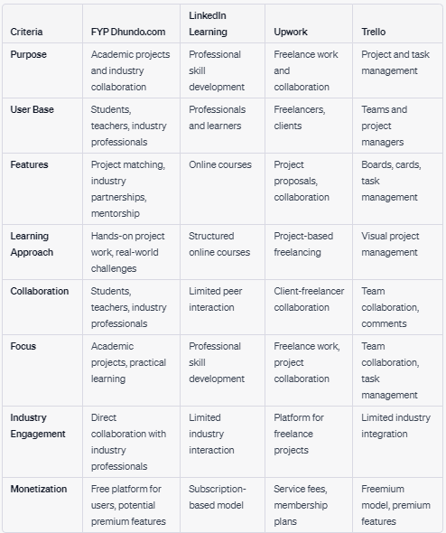

## Algorithms

Here are the key algorithms used in FYP Dhundo.com to enhance user experience, facilitate project matching, and optimize the recommendation system.

### Collaborative Filtering:

* **Description:** Collaborative filtering is used to make automatic predictions about the preferences of a user by collecting preferences from many users.
* **Application:** In FYP Dhundo.com, collaborative filtering algorithms analyze the past project choices and interactions of users to recommend similar projects that might align with their interests and skills.
* **Implementation Steps:**
* Gather user preferences and interactions data from the database.
* Compute similarities between users based on their project choices and interactions. Common similarity metrics include cosine similarity or Pearson correlation.
* Predict preferences for projects that a user has not yet interacted with, based on the preferences of similar users.

### Content-Based Filtering:

* **Description:** Content-based filtering recommends items like what a user likes, based on their previous actions or explicit feedback.
* **Application:** Content-based filtering in the project analyzes the attributes of projects (such as skills required, project description, industry sector) and user profiles to recommend projects that match the user's skills and interests.
* **Implementation Steps:**
* Extract textual information from project descriptions and user profiles.
* Use natural language processing (NLP) techniques to tokenize, clean, and analyze the text data.
* Build a profile of user preferences based on the skills, keywords, or project attributes extracted from their profiles and past interactions.
* Recommend projects that match the user's profile preferences.

### Hybrid Filtering:

* **Description:** Hybrid filtering combines collaborative and content-based filtering techniques to improve the accuracy and coverage of recommendations.
* **Application:** FYP Dhundo.com employs hybrid filtering to provide more accurate project suggestions. By combining collaborative and content-based methods, the platform offers well-rounded recommendations, considering both user preferences and project attributes.
* **Implementation Steps:**
* Implement both collaborative and content-based algorithms separately.
* Combine the recommendations from both algorithms using a weighting system or by merging the lists.
* Adjust the weights dynamically based on the user's historical interactions and feedback to fine-tune the recommendations.

## References

* Resnick, P., & Varian, H. R. (1997). Recommender systems. Communications of the ACM, 40(3), 56-58.
* Pazzani, M. J., & Billsus, D. (2007). Content-based recommendation systems. In The Adaptive Web (pp. 325-341). Springer.
* Burke, R. (2002). Hybrid recommender systems: Survey and experiments. In User Modeling 2002 (pp. 286-297). Springer.
* Hastie, T., Tibshirani, R., & Friedman, J. (2009). The Elements of Statistical Learning: Data Mining, Inference, and Prediction. Springer.
* Jain, A. K. (2010). Data clustering: 50 years beyond K-means. Pattern recognition letters, 31(8), 651-666.

# 



Hardware, Software analysis and requirements

* + 1. INTRODUCTION

This chapter discusses about the hardware and software components relevant to our project.This chapter will be covering functional and non –functional requirements.It will also include the technologies and algorithms used in the project.

**Software Requirements**

The software requirements for the FYP Dhundo.com project can be broken down into several categories, encompassing functional and non-functional aspects. Here's a detailed breakdown of the software requirements for the project:

**Functional Requirements:**

**1. User Management:**

* User registration and authentication (students, teachers, industry professionals).
* User profiles with detailed information (skills, interests, expertise).
* Role-based access control (students, teachers, administrators).

**2. Project Management:**

* Project posting with detailed descriptions, requirements, and deadlines.
* Project recommendation algorithms based on student profiles.
* Search and filtering options for projects.
* Project application and acceptance/rejection process.
* Progress tracking for ongoing projects.
* File upload and download functionality for project-related documents.

**3. Collaboration Tools:**

* Real-time chat communication between students, teachers, and industry.
* Document sharing and collaborative editing features.

**4. Mentorship:**

* Mentor matching based on student needs and project requirements.
* Scheduling system for mentor-student meetings.
* Feedback and rating mechanisms for mentors and mentees.

**5. Administration:**

* Dashboard for administrators to manage user accounts and projects.
* Content management system for updating platform content.
* Analytics tools to track user engagement and project progress.
* Management interface for industry partnerships and project submissions.

**Non-functional Requirements:**

**1. Performance:**

* Low latency and quick response times for all platform interactions.
* Scalability to handle many concurrent users.
* Efficient database queries for quick data retrieval.

**2. Security:**

* Secure user authentication and authorization mechanisms.
* Encryption of sensitive data, both in transit and at rest.
* Regular security audits and vulnerability assessments.

**3. Reliability:**

* High availability with minimal downtime.
* Regular automated backups of the database and project-related data.

**4. Usability:**

* Intuitive and user-friendly interface for seamless navigation.
* Responsive design to ensure accessibility from various devices.

**Software Technologies**

**Frontend Development:**

* React.js: A popular JavaScript library for building user interfaces. Its component-based architecture will help create dynamic and responsive user interfaces.
* Redux: For state management in large applications, especially when dealing with complex data flows.
* HTML5/CSS3: For structuring and styling the web pages. Utilize CSS frameworks like Bootstrap or Materialize for responsive design.
* JavaScript/ES6+: For client-side scripting and interactive features.

**Backend Development:**

* Node.js: A server-side JavaScript runtime environment. Its non-blocking, event-driven architecture makes it suitable for building scalable network applications.
* Express.js: A minimal and flexible Node.js web application framework that provides robust features for web and mobile applications.
* MongoDB: A NoSQL database to store user profiles, project data, and other non-relational data. Its flexibility allows for easy integration and scalability.
* Firebase Authentication: For secure user authentication and authorization.
* RESTful API: For communication between the frontend and backend. Express.js can be used to create a RESTful API for data exchange.
* Socket.io: For real-time bidirectional event-based communication. Useful for implementing chat features.

**Version Control:**

* Git/GitHub: Git is a version control system that tracks changes in the source code during software development. Using Git and GitHub allows for collaborative coding, version tracking, and project management.

**Cloud Services**

* Amazon Web Services (AWS): Cloud computing platform offering a wide range of services, including server hosting, databases, storage, and more.

**Algorithms**

Here are the key algorithms used in FYP Dhundo.com to enhance user experience, facilitate project matching, and optimize the recommendation system.

**Collaborative Filtering:**

* **Description:** Collaborative filtering is used to make automatic predictions about the preferences of a user by collecting preferences from many users.
* **Application:** In FYP Dhundo.com, collaborative filtering algorithms analyze the past project choices and interactions of users to recommend similar projects that might align with their interests and skills.

**Content-Based Filtering:**

* **Description:** Content-based filtering recommends items like what a user likes, based on their previous actions or explicit feedback.
* **Application:** Content-based filtering in the project analyzes the attributes of projects (such as skills required, project description, industry sector) and user profiles to recommend projects that match the user's skills and interests.

**Hybrid Filtering:**

* **Description:** Hybrid filtering combines collaborative and content-based filtering techniques to improve the accuracy and coverage of recommendations.
* **Application:** FYP Dhundo.com employs hybrid filtering to provide more accurate project suggestions. By combining collaborative and content-based methods, the platform offers well-rounded recommendations, considering both user preferences and project attributes.

## Actor Use Case Diagram

Figure 2 Actor use case diagram for student(actor)

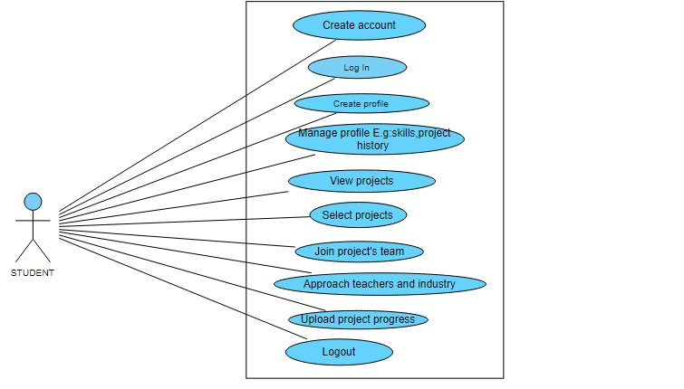

Represents individuals pursuing educational projects. Students can browse available projects, apply for projects of interest, update project progress, and seek mentorship from teachers or industry professionals.

Figure 3 Actor use case diagram for teacher(actor)

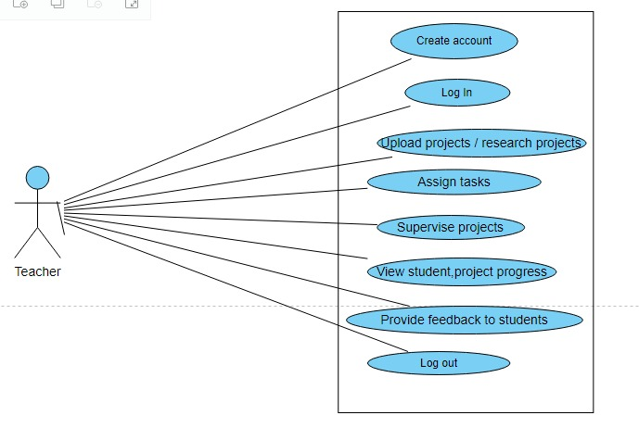

Represents educators who post research projects, supervise student projects, and provide feedback. Teachers can also mentor students, evaluate project applications, and monitor project progress.

Figure 4 Actor use case diagram for industry(actor)

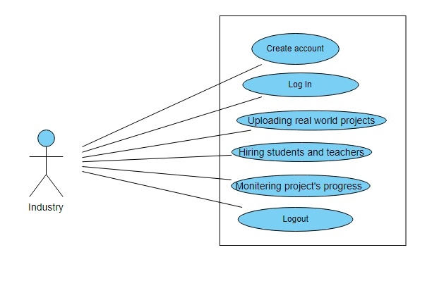

Represents professionals from the industry who collaborate with students on projects. Industry professionals can post real-world projects, review student applications, provide mentorship, and assess project progress.

## Activity Diagram

Figure 5 Activity Diagram

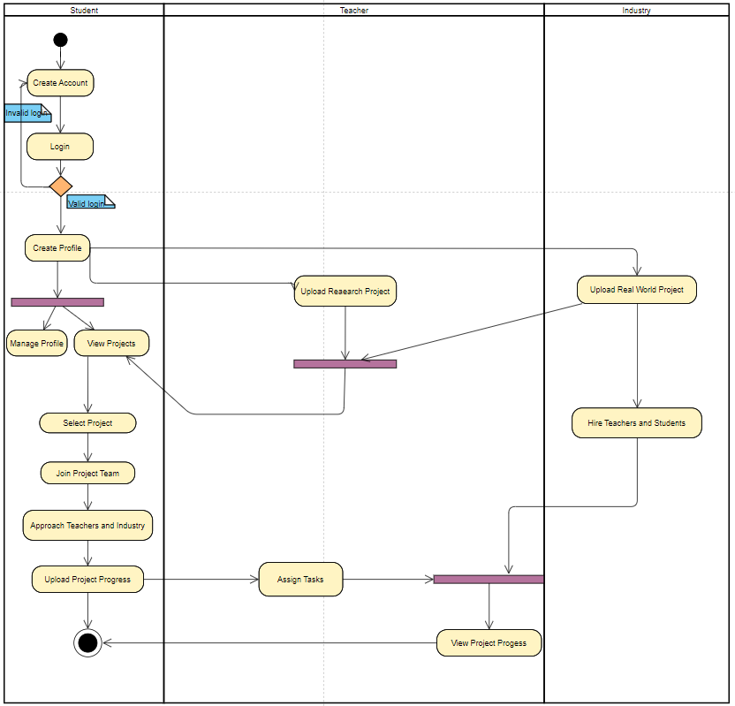

The above diagram shows the flow of activities within a system

## System Diagram

Figure 6 System Diagram



This above system diagram shows how users communicate with the system and how system communicate with backend to respond them

Resource:

*For user stories:* [*https://www.amazon.com/User-Stories-Applied-Software-Development/dp/0321205685*](https://www.amazon.com/User-Stories-Applied-Software-Development/dp/0321205685)



Software design and modeling

* + 1. INTRODUCTION

In this chapter project architecture is presented (explain which architecture is used), overall design diagrams (complete object diagram, complete class diagram, database diagram, etc.) to be shown. (as such diagrams are usually huge in nature, it is appropriate to print in on A3 or bigger sheets, and then fold it to A4 size).use few behavioral diagrams (sequence diagram, timing diagram, activity diagram, state transition diagram, or composite diagram) only for core technical functionality of the project against use cases. Show application’s landing/main/home interface, also show high fidelity prototypes (input, output, inquiry, debugging, configuration, and wrapper) on (Image, Audio, video, text, tags, AR, VR) against specific use case.

## class Diagram

Figure 7 Class Diagram

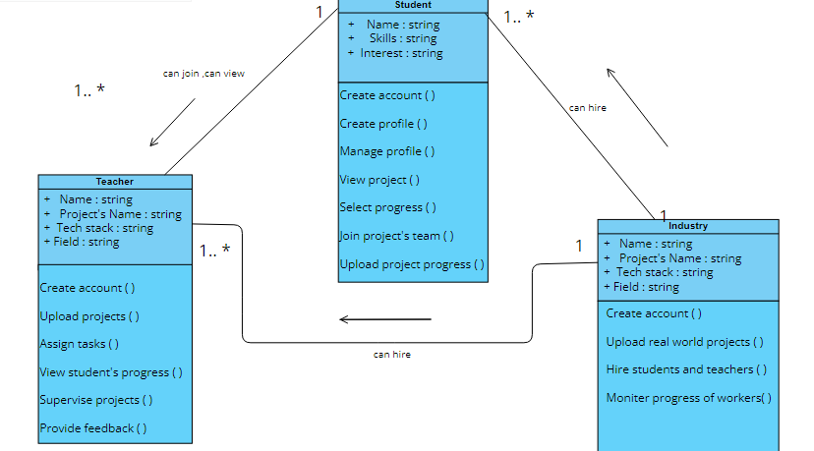

The above diagram shows classes including their attributes and operations and there relationship with other classes.

## Object Diagram

Figure 8 Object Diagram

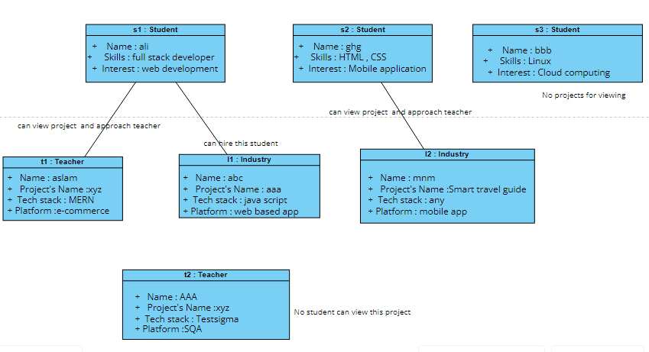

The above diagram represents the objects of the classes which provide a view nearer to real time of the system that how the system will work.

## Entity relationship Diagram

Figure 8 ER diagram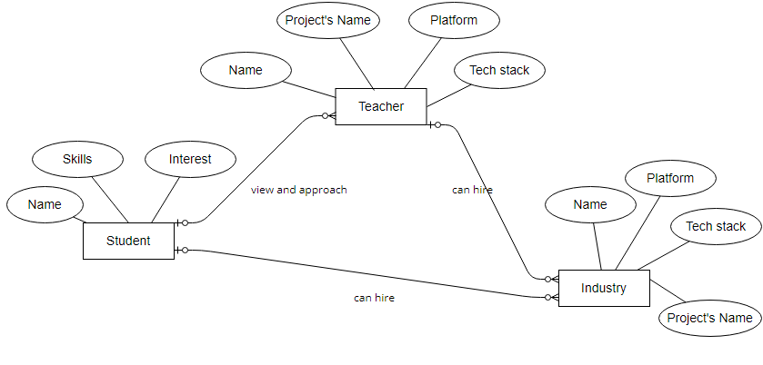

The above diagram shows attributes of classes and the relation between each class.Student and Teacher has one to many realation while industry and student also has one to many realtion.

## Sequence Diagram

Figure 9 Sequence Diagram for Student(actor)

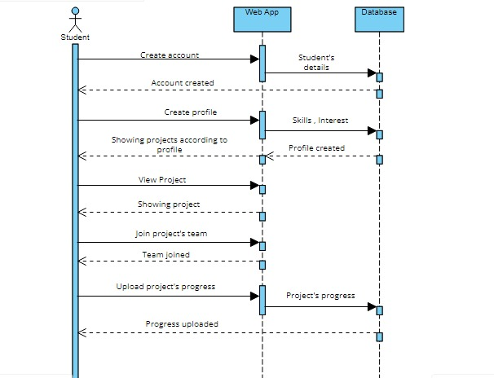

The above Sequence diagram shows the working of student(actor). It shows the working in sequence that how the web app responds to the student.

Figure 10 Sequence Diagram for Teacher(actor)

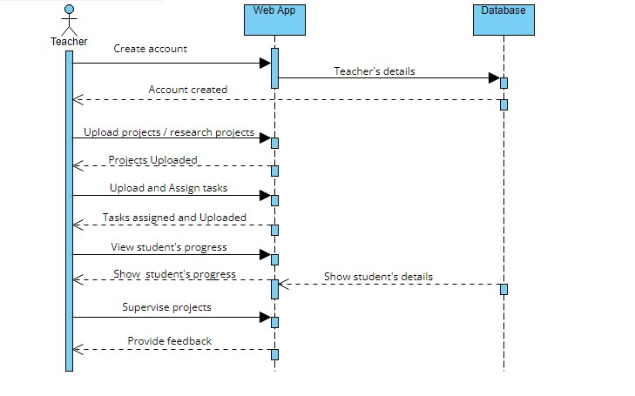

The above Sequence diagram shows the working of Teacher(actor).It shows the working in sequence that how the web app responds to the teacher

Figure 10 Sequence Diagram for Industry(actor)

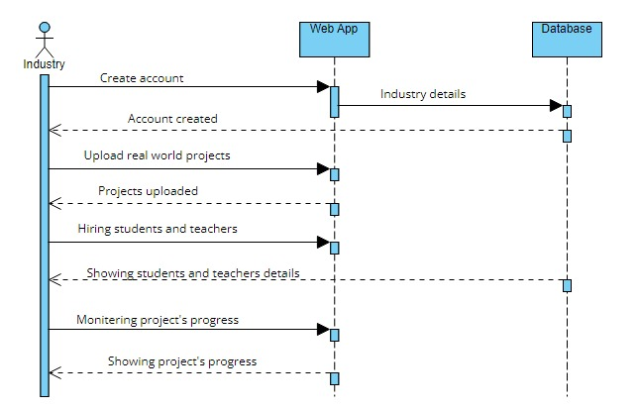

The above Sequence diagram shows the working of Industry(actor).It shows the working in sequence that how the web app responds to the industry.

Resources:

[**https://www.uml-diagrams.org/uml-25-diagrams.html**](https://www.uml-diagrams.org/uml-25-diagrams.html)

[**https://sysml.org/**](https://sysml.org/)

# 



Algorithm analysis and complexity

* + 1. INTRODUCTION

In this chapter you have to mention algorithms that are used in project. Its purpose and significance, along with its pseudocode. Compare your selected algorithm with such other algorithms. For each algorithm show its best, average, and worst values in context of time and space complexity. Show primary references of all mentioned algorithms.

# 



Implementation

* + 1. INTRODUCTION

Give code details (not a complete listing, but description of key parts). Discuss the most important/interesting aspects. It probably won’t be possible to discuss everything- give a rationale for what you do. Code shall not be more than 3-5 pages. Use appropriate code writing standards, draw operational diagram, component diagram and deployment diagram. Show only two to three technical interfaces that represents the core project functionality with explanation (You may use POC interfaces). Draw state transition diagram of project interface (input, output, and processes).

# 



Testing

* + 1. INTRODUCTION

This chapter contains White box of most logical code, and black box testing of that interfaces that represents core functionality of the project1 (onlyshow test cases and their results). Some of the system level structural and functional testing must be shown with the help of tools2. You have to show test plan – how the program/system was verified. Put the actual test results in the annexure.

This chapter also covers results of different types of experiments/simulations that were carried out with the code written. Why were certain experiments in the simulation used and how did they affect the results? If there are very many graphs and tables associated with this Chapter they may be placed in annexure.

* + 1. DISCUSSION

This section should fully and logically discuss the progression of the project including the methods used and the results of experimentation, or the design; in such a way that examiner can evaluate the worth of the project. The discussion should be backed by detailed reference to material in the testing chapter of the report.

***Resources:***

1. Pressman, Roger S. "Software Engineering: A practitioner’s approach." *9th Edition* (2020), Chapter 19-21
2. Perry, William E. *Effective Methods for Software Testing, CafeScribe: Includes Complete Guidelines, Checklists, and Templates*. John Wiley & Sons, 2007, Chapter 8

# 



Conclusions

This Chapter should be a concise statement of the conclusions which may be drawn from the work attempted. The reader needs to be convinced that the design will work. If Uncertainties remain, they should be pointed out, and alternatives, such as modifying performance specifications, should be spelled out to deal with foreseeable outcome.

# 



Future work

This Chapter may be used to propose further work which may be carried out on the project in subsequent study projects. Suggestions of this type should be limited to proposals which involve significant amounts of work such as major modifications of equipment or development of student practical experiments/enhancement. If any component is developed, how it can be utilized with proper documentation. Any suggestion is to be given in sufficient detail to provide adequate information for a future student to be able to fully appraise the proposal. which other similar project can be developed by using same concept with different domain/technology.

**Achievements**

In this chapter you have to summarize your participations in different competitions, conferences, incubation activities, and exhibitions. It is desired to express your experience about such activities. Also mention what you achieved in such activities e.g experience, acknowledgement, certificates, souvenirs , and rewards. If it is in process show correspondence evidence.

**Appendices**

These shall be used to give detailed results that shall be summarized in main text. The normal practice is “Annex A, B, C…” and, when required, “Appendix (to annex) 1, 2, 3…..” They should identify on every page by running header. Following items should be included in appendices

In **acknowledgement chapter**, you may include official letters from organizations.

In **introduction chapter** 2-3 pages about organization for which you are developing the project

In **background and literature review chapter**, research paper that is basis of your project, details of similar projects, any UML diagrams from other sources that has strong relationship with your project

In **hardware, software analysis and requirement,** you may add hardware pacification, use case narrations, or detailed requirement specification document.

In **software design and modeling chapter**, you may add detailed design documents other than most significant.

In **software algorithm and complexity**, you may attach actual algorithm or its research paper.

In **achievement chapter**, you have to mention correspondence (letters, emails etc.), copy of certificate, pictures of participation specially at time of award ceremony.

You may add any detail that is summarized in any chapters but need more focus and clarity for reader.

**General Guidelines**

- Begin each chapter on new page.

- Each chapter should have small introduction at beginning of chapter. Introduction must link to previous chapter. It is a one or more then one paragraph but not more than one page that introduces the reader to the subject. The introduction presents basic background material, the history of the problem and contains the key sentence outlining the subjects to be discussed.

The total report length should be **100- 120 pages**; most projects somewhat shorter. There is no value in trying to artificially lengthen your project by ‘padding’ it. Each project is unique and has its own natural length, and you will probably know when you have said everything that you need to be said.

**Typing and size of paper**

I. The report is to be typewritten on one side of the paper on international size A4 paper (297mmX210mm). This paper must be good quality bond (70-90 gsm).

ii. Reports length should be 100-120 pages.

iii. Use Times New Roman, size 12 font throughout the reports.

Use 1.5 or double spacing.

**Page number and Chapter number**

Use lower case Roman numerals for preliminary pages

I. Title page (not numbered on page)

ii. Abstract

Table of Contents

The text of the report begins with Roman number 1. Number all pages. Page numbers can be inserted either at the bottom/top right or the bottom/top center.

All appendices should number as A-1, A-2, etc. for pages under appendix A, and B-1, B-2, etc. for pages under appendix B (See Table of Contents.).

A hierarchical numbering scheme for chapter numbering shall be used. For instance, use 1 for chapter one, 2 for chapter 2, 1.1 for the subsection 1 of chapter 1, etc. (See the Table of Contents).

**Margin boundaries**

I. 1 -inch left margin.

ii. 0.5-inch margin on the other three sides.

**Diagrams and figures**

Figures and table should be inserted in the text in one of the three places.

A full page figure or illustration must be inserted on the left hand side facing the typescript which described it.

Small figure should be incorporated in the text with the legend appearing below (not recommended).

Each graph, figure, etc., should have a figure number and title typed below it. The type style should be same as the text. Figures should be numbered by chapters (Fig. 1.1, Fig 1.2, Fig. 2.1, etc). explain each figure by referring to its number (e.g. in Fig 1.1), don’t assume any figure is self-explanatory. Whichever numbering system you use, make sure that you follow the same system for tables and equations, also explain then as figures.

Line drawings, graphs, and monograms should be in bold clear lines. Where graphs, diagrams and figures cannot be mounted vertically on the page these are to be mounted and labeled in such a way that they can be read from the right hand side(900 on the page) of the page .

All the axes of graphs are to be labeled with the parameter and its units. Information on illustrations and graphs such as labels, scales etc. must be typewritten.

**Photocopying**

All the figures, etc. must be reproduced by an electronic or electrostatic or photographic method which is known not to fade.

**Fixing of photograph**

Full page photographs should be bound into the report. Small photographs must be firmly fixed to the paper. An alternative is to use color photocopying or digital processing.

**Tables**

Each table should be numbered consecutively (Table 1, Table 2) or by chapter (Table 1.1, Table 1.2, Table 2.1).Table number should be centre above the top of the table and be followed on the next line by a brief descriptive caption, preferably in cap. The type should be the same as the text. Refer to each table in text by number “In Table 1, one can clearly see………”The same rules for location of figures apply to tables.

TABLE 1. MEASURED RESISTOR VALUES AND THE METER ERROR

|  |  |  |
| --- | --- | --- |
| Nominal Value Marked | Measured Value | Error (%) |
|  |  |  |
|  |  |  |

**Equations**

Centre each equation on separate line. Number equations consecutively in parentheses at the right margin. Equation may be referenced by number in the text, using parentheses around the number.

Y (t) = ∫sin (x) dx (1)

**Units**

The S.I. system of units is to be used throughout. Where difficulties are introduced by quotation of imperial units from reference source, these should be accompanied by the appropriate conversion to S.I. units in parentheses.

References

At the end of your work, list full details of all of the sources which you have cited in your text in a section headed *References*, in numeric order. References listed must follow IEEE formatting guidelines (see reference examples overleaf). Your reference list should allow anyone reading your work to identify and find the material to which you have referred.

In IEEE style your reference list should be formatted in the following way:

* Align references left
* Single-space each entry, double-space between every new entry
* Place number of entry at left margin, enclose in square brackets [ ] Indent text of entries

**Citations/references with multiple authors**

If you choose to mention the author(s) of a source whilst citing it in the text of your work, if there are three or more you can abbreviate them using ‘et al.’ e.g. During their research, Fan, et al. [4] discuss lasers in detail. However, in general you do not need to mention the authors by name, just use the numeric citation in square brackets. In your full reference list at the end however, you always give the authors’ names. In the reference list you can only abbreviate these using ‘et al.’ if there are six or more authors.

**Reference examples**

There are standard reference formats for most types of document. Below are examples of the most common types of document you might want to reference. Each of the following gives a suggested standard format for the reference followed by examples for the different document types.

**Book**

[Ref number] Author’s initials. Author’s Surname, *Book Title*, edition (if not first). Place of publication: Publisher, Year.

[1] I.A. Glover and P.M. Grant, *Digital Communications*, 3rd ed. Harlow: Prentice Hall, 2009.

**Book chapter**

[Ref number] Author’s initials. Author’s Surname, “Title of chapter in book,” in *Book Title,* edition (if not first), Editor’s initials. Editor’s Surname, Ed. Place of publication: Publisher, Year, page numbers.

[2] C. W. Li and G. J. Wang, "MEMS manufacturing techniques for tissue scaffolding devices," in *Mems for Biomedical Applications*, S. Bhansali and A. Vasudev, Eds. Cambridge: Woodhead, 2012, pp. 192-217.

**Electronic Book**

[Ref number] Author’s initials. Author’s Surname. (Year, Month Day). *Book Title* (edition) [Type of medium]. Available: URL

[3] W. Zeng, H. Yu, C. Lin. (2013, Dec 19). *Multimedia Security Technologies for Digital Rights Management* [Online]. Available: http://goo.gl/xQ6doi

Note: If the e-book is a direct equivalent of a print book e.g. in PDF format, you can reference it as a normal print book.

**Journal article**

[Ref number] Author’s initials. Author’s Surname, “Title of article,” *Title of journal abbreviated in Italics,* vol. number, issue number*,* page numbers, Abbreviated Month Year.

[4] F. Yan, Y. Gu, Y. Wang, C. M. Wang, X. Y. Hu, H. X. Peng, et al., "Study on the interaction mechanism between laser and rock during perforation," *Optics and Laser Technology,* vol. 54, pp. 303-308, Dec 2013.

Note: the above example article is from a journal which does not use issue numbers, so they are not included in the reference.

**E-Journal article**

PDF versions of journal articles are direct copies of the print edition, so you can cite them as print journals.

[Ref number] Author’s initials. Author’s Surname. (Year, Month). “Title of article.” *Journal Title* [type of medium]. volume number, issue number, page numbers if given. Available: URL

[5] M. Semilof. (1996, July). “Driving commerce to the web-corporate intranets and the internet: lines blur”. *Communication Week* [Online]. vol. 6, issue 19. Available: http://www.techweb.com/se/directlinkcgi?CWK19960715S0005

**When you are compiling your reference list you may abbreviate journal titles:**

For a list of IEEE abbreviations go to:

<https://www.ieee.org/documents/trans_journal_names.pdf>

For non IEEE journal abbreviations go to:<http://www.bath.ac.uk/library/help/infoguides/abbreviations.html>

For further information on the common abbreviations of words used in references for the IEEE style go to:

<http://www.ieee.org/documents/style_manual.pdf>

**Conference papers**

[Ref number] Author’s initials. Author’s Surname, “Title of paper,” in *Name of Conference,* Location, Year, pp. xxx.

[6] S. Adachi, T. Horio, T. Suzuki. "Intense vacuum-ultraviolet single-order harmonic pulse by a deep-ultraviolet driving laser," in *Conf.* *Lasers and Electro-Optics*, San Jose, CA, 2012, pp.2118-2120.

Standard abbreviations may be applied to the title of the conference. For a table of abbreviations go to: <http://www.ieee.org/documents/ieeecitationref.pdf>

**Reports**

The general form for citing technical reports is to place the name and location of the company or institution after the author and title and to give the report number and date at the end of the reference. If the report has a volume number add it after the year.

[Ref number] Author’s initials. Author’s Surname, “Title of report,” Abbreviated Name of Company., City of Company., State, Report number, year.

[7] P. Diament and W. L. Luptakin, “V-line surface-wave radiation and scanning,” Dept. Elect. Eng., Colombia Univ., New York, Sci Rep. 85, 1991.

**Patents**

[Ref number] Author’s initials. Author’s Surname, “Title of patent,” Country where patent is registered. Patent number, Abbrev of Month Day Year.

[8] J. P. Wilkinson, “Nonlinear resonant circuit devices,” U.S. Patent 3 624 125, July 16 1990.

Note: Use “issued date” if several dates are given.

**Standards**

[Reference number] *Title of Standard*, Standard number, date.

[9] *Shunt power capacitors*, IEEE standard18-2012, 2013.

**Theses/Dissertations**

[Ref number] Author’s initials. Author’s Surname, “Title of thesis,” Designation type, Abbrev. Dept., Abbrev. Univ., City of Univ., State, Year.

[10] J. O. Williams, “Narrow-band analyser,” Ph.D. dissertation, Dept. Elect. Eng., Harvard Univ., Cambridge, MA, 1993.

**Datasheets**

[Ref number] Author’s initials. Authors Surname, “Title of Datasheet,” Part datasheet, Publication date [Latest revision date].

[11] Texas Instruments, “High speed CMOS logic analog multiplexers/demultiplexers,” 74HC4051 datasheet, Nov. 1997 [Revised Sept. 2002].

**Online Documents**

If you are using documents such as a report, conference paper, standard, patent or thesis online and it also exists as an identical print equivalent i.e. with the same format and pagination, it can be usually be referenced as the print version.

If it is e-only, you can make the standard reference template an electronic version by adding the material type in square brackets

e.g. [Online] after the document title. If there is no specific document title you can place this after the document number (e.g. patent number).

At the end of the reference add: Available: URL. See below for an example of an online patent:

[12] M.R. Brooks, “Musical toothbrush with adjustable neck and mirror,” U.S Patent *326189* [Online], May 19 1992. Available: http://goo.gl/VU1WEk

**Websites**

Note: Include as much of the key information as you can find for a given website. If a web page has no personal author, you can use a corporate author. Failing that, you can use either Anon. (for anonymous) or it is permissible to use the title of the site.

[Ref number] Author’s initials. Authors Surname. (Year, Month. Day). *Title of web page* [Online]. Available: URL

1. BBC News. (2013, Nov. 11). *Microwave signals turned into electrical power* [Online]. Available: http://www.bbc.co.uk/news/technology-24897584
2. M. Holland. (2002). *Guide to citing internet sources* [Online]. Available: http://www.bournemouth.ac.uk/library/using/guide_to_citing_internet_sourc.html