**Report on Mobile Application Development Project**

**Prepared by:**

Bilal Majid - 21SW010

Asadullah Samo - 21SW036

Muhammad Hassan – 21SW094

**Course:** Mobile Application Development (SW-327)  
**Date:** 24-Oct-2024

**1. Real-World Problem Identification**

The mobile application development project focuses on addressing a significant real-world issue: the lack of user-friendly solutions for plant enthusiasts to effectively manage their indoor and outdoor plants. As interest in gardening and plant care grows, many users face challenges in identifying plants, understanding their care requirements, and accessing information about their plants in an intuitive way. The aim is to create a user-friendly mobile solution that helps users identify plants, understand care requirements, and manage their plants. The app also integrates an authentication system to offer personalized experiences such as saving plant preferences and custom reminders.

**Problem Details:**   
**Scope:**

This issue affects urban dwellers and gardening enthusiasts, leading to challenges such as misidentifying plants, lack of guidance on plant care, and difficulty in tracking plant health and growth.

**User Needs:**

Users require a seamless and intuitive mobile experience that provides accurate plant information, care tips, and secure access to their data, which is achieved through a robust authentication system.

**2. Proposed Solution**

The proposed mobile application offers a solution to the identified problem by integrating key features and technologies that streamline processes and enhance user interaction. The app is developed using the Flutter framework, ensuring compatibility with various devices.

**Key Features:**

* **Cross-platform Compatibility:**

The application is designed to work uniformly on Android and iOS devices, providing a consistent experience across different screen sizes.

* **Data Management:**

The app employs a local JSON database to store plant data in conjunction with cloud firestore for storing user credentials and Firebase Authentication for secure user login.

* **Optimized State Management:**

The app uses the Provider package for state management, ensuring efficient memory usage and performance.

* **Authentication:**

Secure user login is implemented using Firebase Authentication, allowing users to sign in using email/password.

**3. Responsive User Interfaces**

Screenshots of the app's UI across different platforms demonstrate its adaptability to various screen sizes, providing users with a consistent experience.

**Screenshots:**

* **Authentication Screens:** Sign-in and sign-up screens provide users with a smooth onboarding experience.

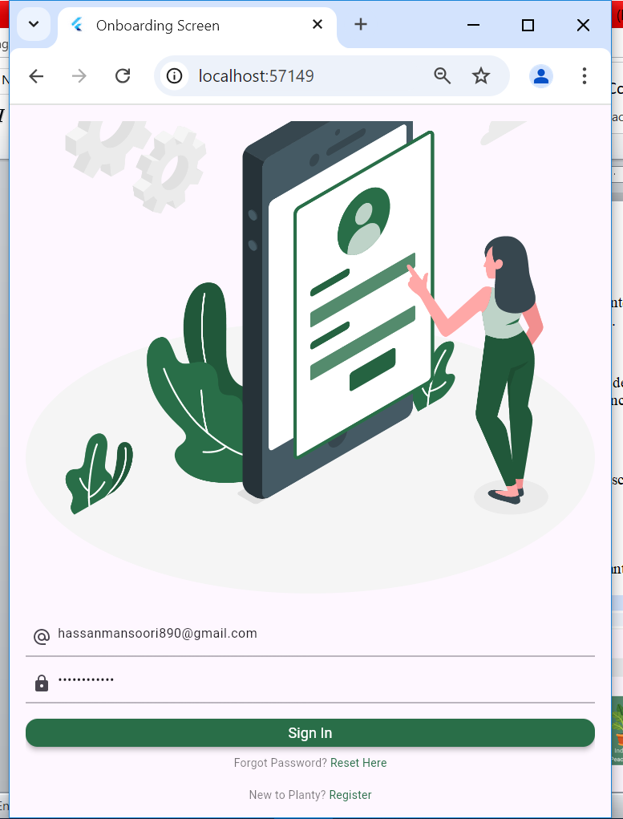

* **Home Screen:** Displays a grid of available plants, utilizing cards for each plant with an image and brief description.

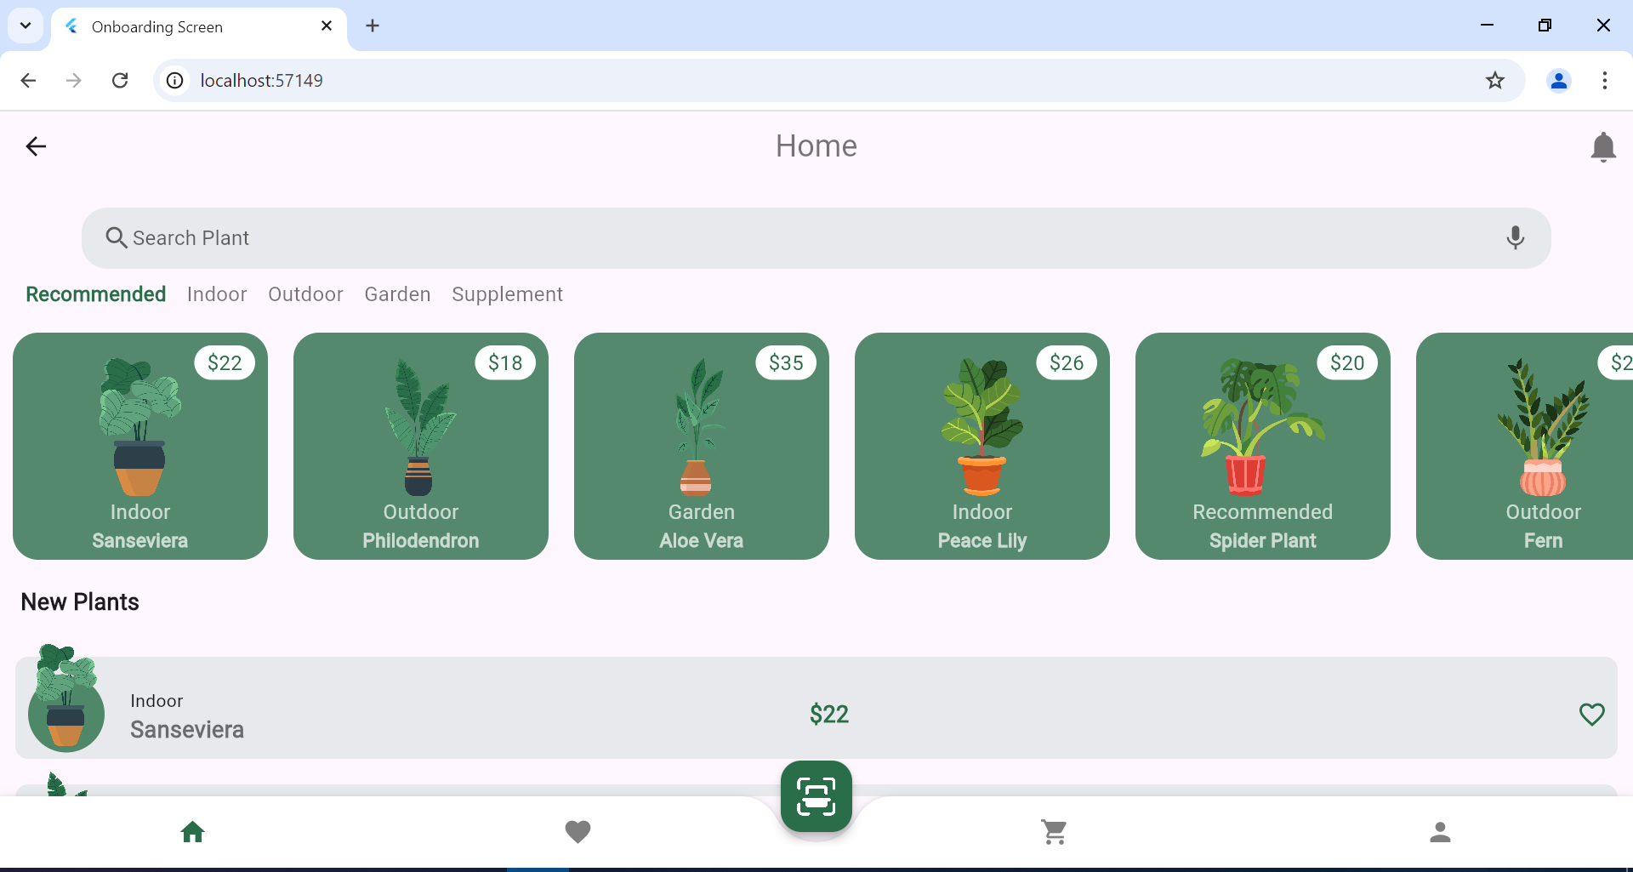

* **Plant Detail Screen:** Provides in-depth information about a selected plant, including care instructions and additional images.

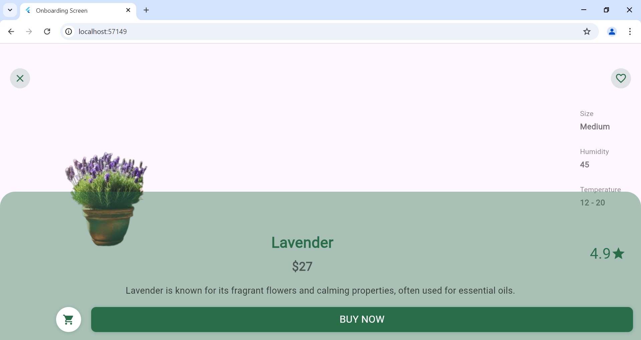

**Responsive Design Features:**

* UI elements adjust based on screen size, allowing for optimal use of space on both larger tablets and smaller phones.
* User-friendly navigation is implemented with fluid transitions between pages, enhancing the overall user experience.

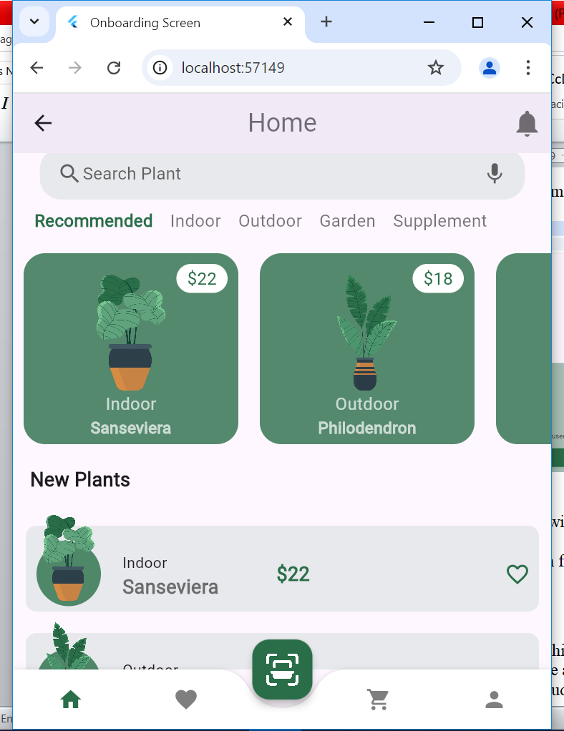

**4. Data Storage**

The project uses local storage to efficiently store plant data in JSON format and cloud firestore to store the user credential details along with Firebase for user authentication. This setup ensures optimal performance, secure data storage and seamless access to personalized information.

* **Data Handling:**

Local storage is used due to its availability and performance, allowing for fast access to plant data even when offline.

* **Security and Accessibility:**

Firebase Authentication provides secure, scalable, and easy-to-implement authentication for the app.

**5. APIs, Packages, and Plugins**

In this project, several packages were integrated to extend functionality. Justification for their use includes:

* **provider package:**

This package facilitates effective state management, ensuring the UI remains responsive as the underlying data changes.

* **firebase_auth package:**

To integrate user authentication.

**cloud_firestore package:**

To store user credentials

* **page_transition:**

To ensure seamless page transitions while navigating through different pages/screens in the app.

**6. Issues and Bugs Encountered**

During the development phase, several challenges were encountered, including:

* **Issue #1:** Handling state changes across authentication and plant data management.  
  **Resolution:** Implemented the Provider package to manage state efficiently between the two functions.
* **Issue #2:** Implementing secure user authentication with Firebase.  
  **Resolution:** Set up Firebase Authentication to ensure secure login and protected user data.

**7. Conclusion**

This mobile application successfully addresses the problem of managing plant care. The project provides a scalable, efficient solution with robust cross-platform support, secure data storage, and a user-friendly interface. Despite challenges in integrating authentication and state management, these were resolved effectively, leading to a complete and functional application.