National University of Sciences & Technology
School of Electrical Engineering & Computer Science | Department of Computing

Basant 2026: Event Analysis Using Multimodalities
DS 401: Introduction to Data Science | BSDS 02 | Spring 2026
Deliverable D: Research Report

Instructor: Dr. Rabia Irfan
Cities: Lahore | Rawalpindi
Date Windows: Feb 6-8, 2026 (Lahore) | Feb 13-15, 2026 (Rawalpindi)
Spring 2026

Table of Contents

Note: If viewing in Word, right-click the table of contents and select 'Update Field' to populate page numbers.

1. Introduction

Basant is one of Pakistan's most culturally significant spring festivals, historically celebrated with kite flying across Punjab province. After a prohibition spanning nearly two decades, Basant was officially revived in Lahore from February 6 to 8, 2026, by the Punjab government under Chief Minister Maryam Nawaz. This revival generated extraordinary levels of public attention, media coverage, social media activity, and a series of safety incidents that drew national and international scrutiny.
This report presents an evidence-based multimodal analysis of Basant 2026, comparing two Pakistani cities: Lahore, where the festival was officially sanctioned, and Rawalpindi, where informal celebrations took place despite an active government ban. The analysis integrates six data modalities — news articles, social media posts, weather records, incident reports, image metadata, and video metadata — processed through a unified six-stage reproducible pipeline.

1.1 Research Objectives
- Quantify and compare Basant 2026 celebration intensity across Lahore and Rawalpindi using news and social media volume indicators.
- Assess weather suitability for kite flying using a rule-based suitability score computed on temperature, wind speed, and precipitation.
- Document and taxonomise safety incidents including fatalities, injuries, arrests, and property seizures.
- Analyse sentiment in news and social media text using a custom lexicon-based method.
- Integrate multimodal signals into a coherent cross-modal picture of the two cities.
- Identify evidence-based insights and clearly state methodological limitations.

1.2 Cities and Date Windows
- Lahore (Feb 6-8, 2026): Punjab government officially approved kite flying for these three days with SOPs, police deployment, and aviation safety notices. Lahore was the primary venue of the official revival after the multi-decade ban.
- Rawalpindi (Feb 13-15, 2026): Despite a government ban, residents celebrated informally and police conducted crackdowns including arrests and kite seizures. This provides a contrasting case of unsanctioned celebration.
The selection of 3-day windows for each city meets the minimum scope requirement. Window justification is grounded in news reporting confirming the festival dates in each city.

2. Pipeline Architecture and Workflow

All data collection, cleaning, feature engineering, analysis, and output generation is implemented in a single unified pipeline file: pipeline.py. The pipeline runs end-to-end from raw source files to cleaned CSVs and publication-ready chart PNGs, with no manual steps required between stages. The six stages are:
Table 1: Pipeline Stage Overview
Stage | Name | Input | Key Actions | Output
Stage 0 | Setup | — | Configure paths, visual style, analysis parameters | Directories created
Stage 1 | Collect / Log | data/raw/ (6 files) | Load all raw files; write source manifest | source_log.csv; DataFrames in memory
Stage 2 | Clean | Raw DataFrames | City/date normalisation, deduplication, 21 QC checks | Cleaned DataFrames; QC log
Stage 3 | Features | Cleaned DataFrames | Sentiment scoring, suitability score, incident taxonomy, media labels, volume counts | Feature-enriched DataFrames
Stage 4 | Analysis | Feature DataFrames | Per-modality summaries, city comparison table, city-day aggregations | city_metrics, city_day_metrics
Stage 5 | Plots | Analysed DataFrames | 26 charts across all modalities + cross-modal integration | fig_01 to fig_26 in reports/
Stage 6 | Outputs | All DataFrames | Write all 11 processed CSVs + 3 bonus integration files | data/processed/ (12 files)

2.1 Stage 1: Collect / Log
INPUT: data/raw/news.xlsx · incidents.xlsx · images.xlsx · videos.xlsx · social.csv · weather.csv
All six raw files are loaded from data/raw/ and a source manifest (source_log.csv) is written to document the origin, collection method, and date of each modality. Table 2 below shows the raw file manifest as logged by the pipeline.
Table 2: Source File Manifest
Modality | File | Raw Rows | Source Origin | Collection Method
News | news.xlsx | 28 | Dawn, Express Tribune, Geo News, Reuters, AP News, Al Jazeera et al. | Manual Google News search
Social | social.csv | 30 | Facebook, Instagram, Twitter/X (public only) | Manual hashtag search on platforms
Weather | weather.csv | 12 | open-meteo.com | visualcrossing.com | Dual-source historical weather API
Incidents | incidents.xlsx | 23 | Dawn, Geo News, Express Tribune, Pakistan Today, LHC records | Targeted safety keyword search
Images | images.xlsx | 24 | AP News, Dawn, Geo News, Al Jazeera, Gulf News et al. | Image URLs from news articles (metadata only)
Videos | videos.xlsx | 12 | YouTube, Urdupoint, Facebook (public) | Manual search; metadata only

2.2 Stage 2: Clean
ACTIONS: City normalisation · Date parsing (3 formats + Excel serial) · Deduplication · 21 QC checks
Cleaning applies consistent transformations across all six modalities. City names are normalised via a mapping dictionary (e.g., 'pindi' and 'rwp' map to 'Rawalpindi'). Dates are parsed from three formats: ISO (YYYY-MM-DD), US slash (M/D/YYYY), and Excel date serials (integer days since 1899-12-30). Duplicate records are identified by URL or primary key and dropped. Twenty-one quality control checks are logged to qc_summary.csv; each check records n_before, n_after, n_flagged, action, and notes.

2.3 Stage 3: Features
ACTIONS: Sentiment scoring · Suitability score · Incident taxonomy · Image labels · Video duration · Volume counts
Feature engineering derives all analytical indicators from the cleaned data. The sentiment lexicon contains positive and negative word sets (covering English and basic Roman Urdu vocabulary) and produces a compound score in [-1, +1]. The weather suitability score (0-100) is the sum of three component scores based on temperature, wind speed, and precipitation (see Section 4.3). Incident taxonomy maps 12 raw incident types into 5 higher-level categories. Image crowd level labels are assigned by a systematic rule based on source outlet and festival date.

2.4 Stage 4: Analysis
ACTIONS: Per-modality summaries · City comparison table · City-day aggregations
The analysis stage computes summary statistics for each modality and combines them into the city_metrics.csv comparison table and the city_day_metrics.csv day-level aggregation. Printed console output from this stage gives a transparent mid-pipeline summary before any files are written, enabling quick verification of computed values.

2.5 Stage 5: Plots
OUTPUT: 26 PNG charts in reports/ (fig_01 to fig_26)
All 26 visualisations are generated from in-memory DataFrames. Each figure is saved to reports/ as a PNG at 150 dpi. Charts are grouped by modality subsection (5A: news, 5B: social, 5C: weather, 5D: incidents, 5E: media, 5F: city comparison, 5G: cross-modal, 5H: QC). At least 2 charts are produced per modality, satisfying the assignment rubric requirement.

2.6 Stage 6: Outputs
OUTPUT: 12 CSV files in data/processed/ (core: 8 · bonus: 3 · source log: 1)
All processed DataFrames are written to data/processed/ at the final stage. A manifest is printed to console showing filename, row count, and file size for every output. No file paths are hard-coded; all paths are constructed relative to the script's own directory using os.path.dirname(os.path.abspath(__file__)).

3. Dataset Summary

Table 3 presents the full dataset summary across all six modalities, including sample sizes, compliance with assignment minimum requirements, and city distribution.
Table 3: Dataset Summary by Modality
Modality | Cleaned Records | Min Required | Status | City Distribution
News Articles | 28 | ≥15 total | PASS | Lahore: 23 Rawalpindi: 5
Social Media Posts | 30 | ≥30 total | PASS | Lahore: 19 Rawalpindi: 11
Weather Records | 6 city-days | ≥3 days × 2 cities | PASS | Both (3 days each)
Incident Records | 23 | Reputable sources | PASS | Lahore: 16 Rawalpindi: 7
Images | 22 | ≥20 items | PASS | Lahore: 17 Rawalpindi: 5
Videos | 12 | ≥10 items | PASS | Lahore: 8 Rawalpindi: 4

All six minimum sample size requirements from the assignment specification are satisfied. The dataset covers news from 12 outlets, social posts from 3 platforms, weather from 2 independent APIs, incidents from 8 named sources, 22 images from 13 news outlets, and 12 videos from YouTube and Urdupoint.

3.1 Quality Control Summary
Stage 2 (Clean) and Stage 3 (Features) together run 21 quality control checks. Table 4 summarises results; the full log is in data/processed/qc_summary.csv.
Table 4: QC Check Summary
Modality | Checks | Pass | Flag | Fix / Average
News | 5 | 5 | 1 (QC-N5: empty headlines, 0 found) | 0
Social | 4 | 3 | 1 (QC-S4: 9 out-of-window posts retained, flagged) | 0
Weather | 4 | 3 | 0 | 1 (QC-W3: dual-source averaged)
Incidents | 3 | 3 | 0 | 0
Images | 2 | 2 | 0 | 0
Videos | 3 | 3 | 0 | 0
TOTAL | 21 | 18 | 2 | 1

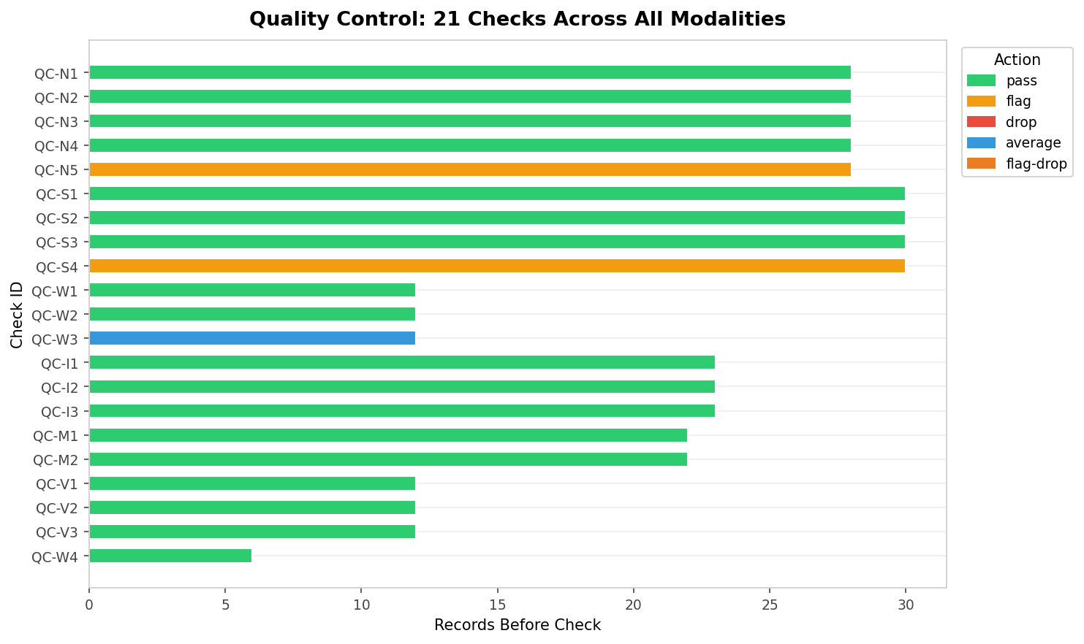
Figure 1 (Stage 5H): QC check results across all 21 checks, colour-coded by action. Green = pass, amber = flag, blue = average/fix.

4. Per-Modality Analysis

4.1 News Analysis
Pipeline reference: Stage 2A (clean) · Stage 3A (features) · Stage 5A (plots fig_01–04)
The news dataset contains 28 articles from 12 outlets. Lahore dominates coverage with 23 articles (82%) versus 5 for Rawalpindi (18%). This asymmetry reflects the official status of Lahore's celebrations — the government revival attracted both domestic and international wire services including Reuters and AP News, as well as Al Jazeera and Gulf News, none of which covered Rawalpindi. News volume was highest on Day 1 of Lahore's festival (7 articles on Feb 6, the opening day).
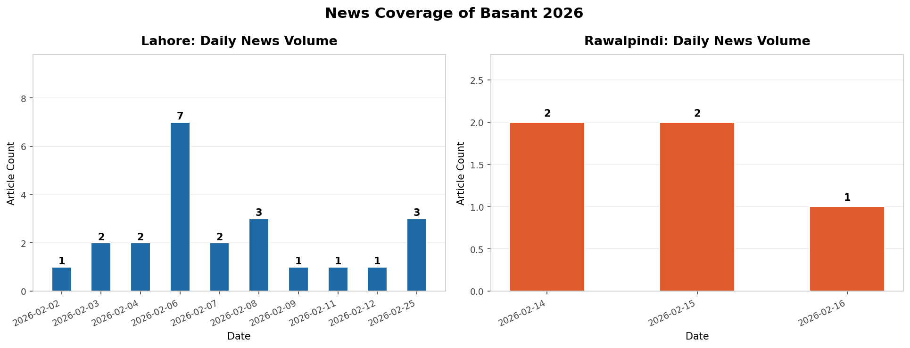
Figure 2 (Stage 5A): Daily news volume by city. Lahore peaks on Feb 6 (opening day). Rawalpindi's coverage is concentrated on Feb 14-15 crackdown reporting.

4.1.1 News Sentiment
News sentiment is strongly negative overall: 16 of 28 articles (57%) are negative, 8 (29%) neutral, and 4 (14%) positive. This reflects the dual nature of news coverage — early articles celebrated the cultural revival, while the majority focused on safety incidents, court petitions, and government warnings. The trend worsened as incidents accumulated over the 3-day Lahore window.
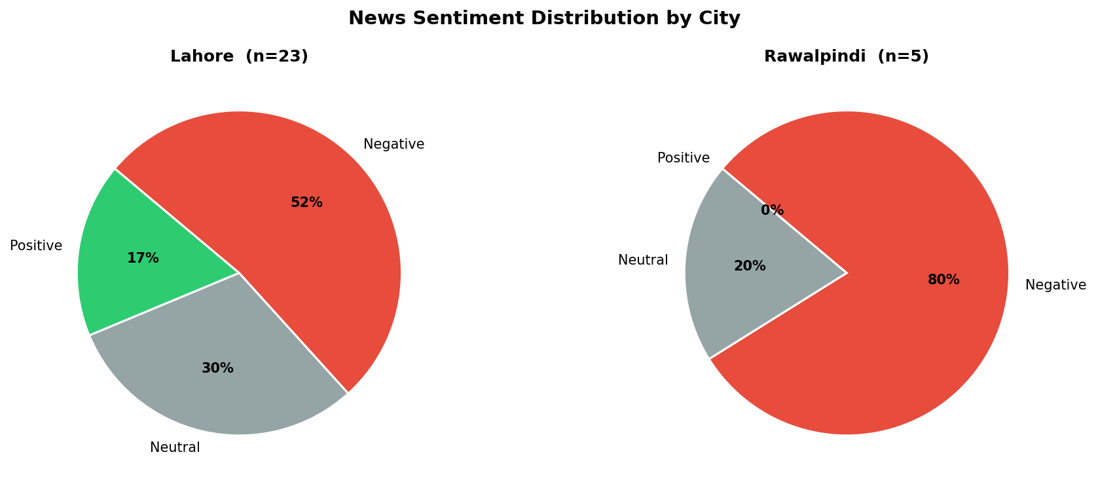
Figure 3 (Stage 5A): News sentiment distribution by city. Lahore shows mixed sentiment; Rawalpindi's 5 articles are 100% negative (exclusively crackdown reporting).
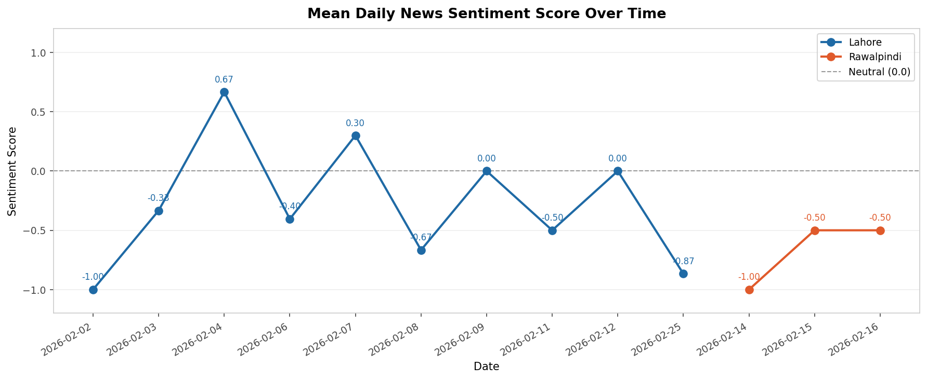
Figure 4 (Stage 5A): Mean daily news sentiment over time. Lahore Day 2 rises to +0.30 due to cultural coverage before falling to -0.67 on Day 3 as incident reports dominate.
Insight 1: News sentiment inversely tracks incident escalation in Lahore. Day 1 sentiment was -0.33, rose briefly to +0.30 on Day 2 (cultural revival coverage), then fell to -0.67 on Day 3 as incident toll reports accumulated. This reflects a media framing shift from celebratory to accountability-focused coverage.
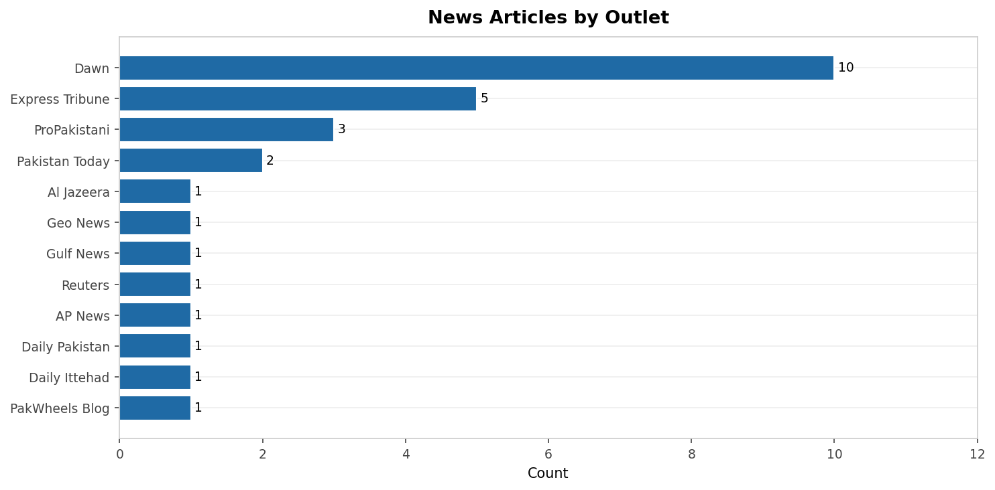
Figure 5 (Stage 5A): News articles by outlet. Dawn (10 articles) dominates as Pakistan's leading English broadsheet.

4.2 Social Media Analysis
Pipeline reference: Stage 2B (clean) · Stage 3B (features) · Stage 5B (plots fig_05–08)
The social dataset contains 30 posts across Facebook (15), Instagram (10), and Twitter/X (5). Lahore accounts for 19 posts (63%) and Rawalpindi for 11 (37%). Nine posts fall outside the core 3-day analysis windows and are retained with the in_analysis_window = False flag. Within-window counts are used for celebration intensity analysis.
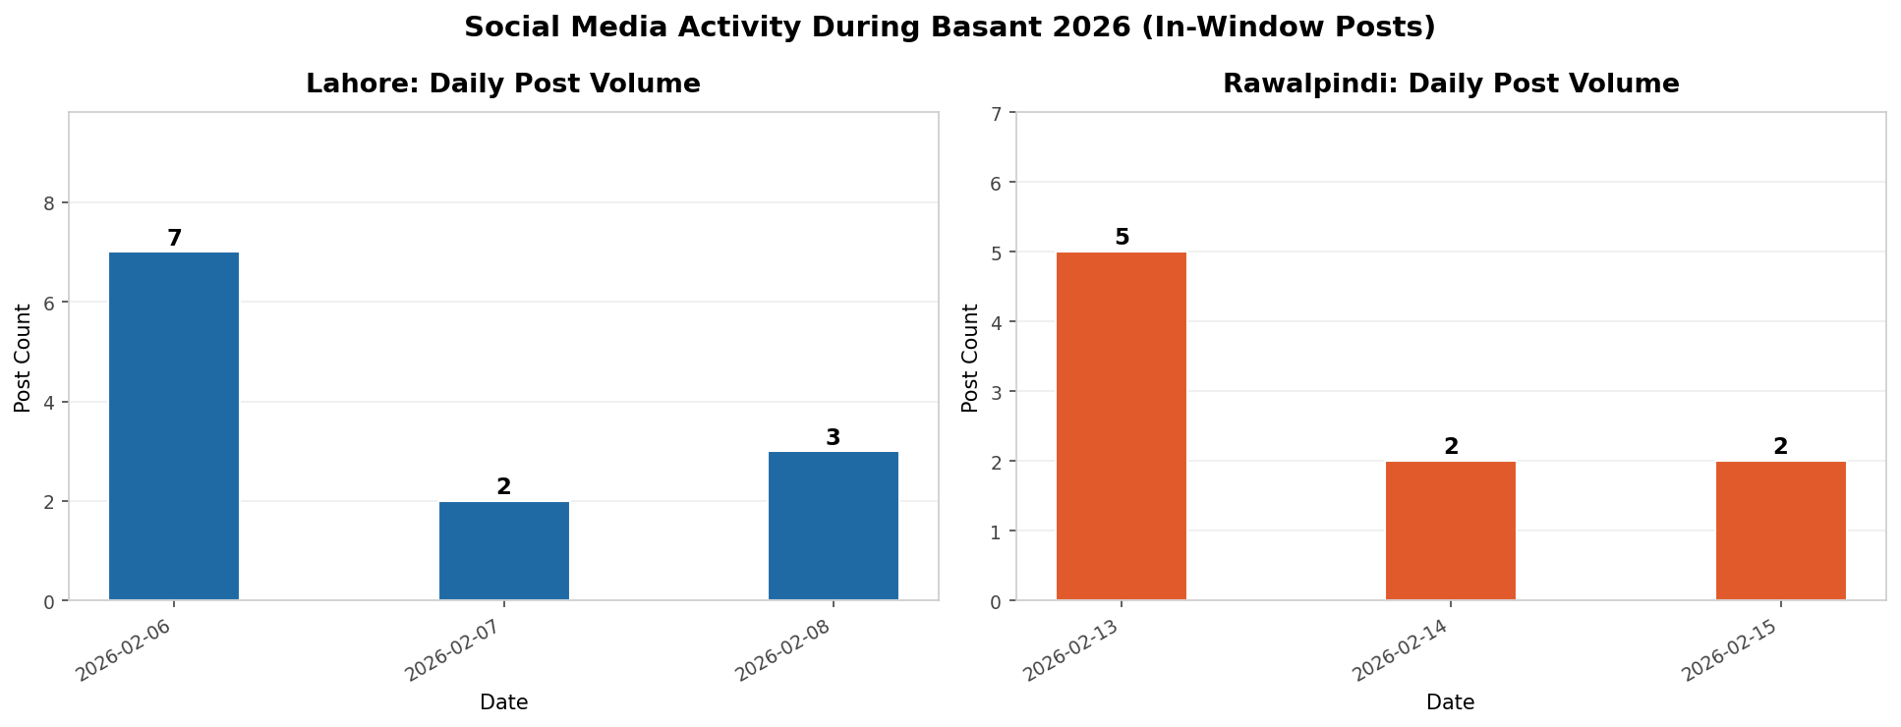
Figure 6 (Stage 5B): Daily social media post volume (in-window posts). Lahore peaks on Feb 6 (7 posts) matching the festival opening. Rawalpindi peaks Feb 13 (5 posts).

4.2.1 Social Sentiment
Social media sentiment is markedly more positive than news sentiment. Of 30 posts, 15 (50%) are positive and 15 (50%) neutral; no posts scored negatively. This directly contrasts with news coverage where 57% of articles were negative. The divergence reflects a fundamental difference in what is being produced: social posts capture personal celebratory experience and emotional reactions, while news articles document incidents and official warnings.
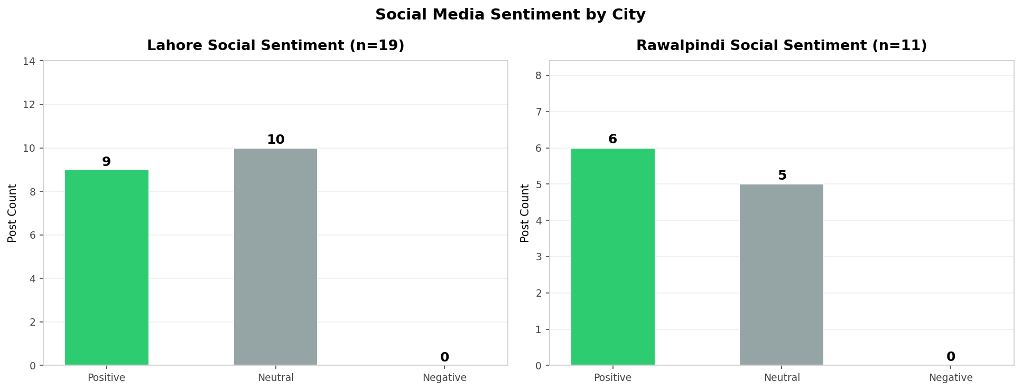
Figure 7 (Stage 5B): Social media sentiment distribution. No negative posts were found in either city, despite Rawalpindi's celebrations being illegal.
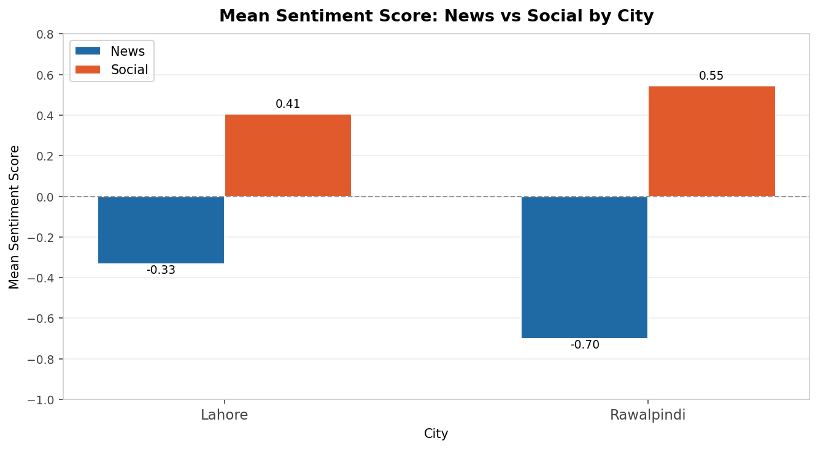
Figure 8 (Stage 5B): Mean sentiment by modality and city. The news-social gap is 0.74 points for Lahore and 1.25 points for Rawalpindi.
Insight 2: Social media and news present systematically opposite perspectives on Basant 2026. The news-social sentiment gap is 0.74 for Lahore (-0.33 news vs +0.41 social) and 1.25 for Rawalpindi (-0.70 news vs +0.55 social). For Rawalpindi this gap is particularly stark: news coverage was entirely negative (crackdowns, arrests) while social posts expressed enthusiasm and celebration. This demonstrates how the same event is framed completely differently across media channels.
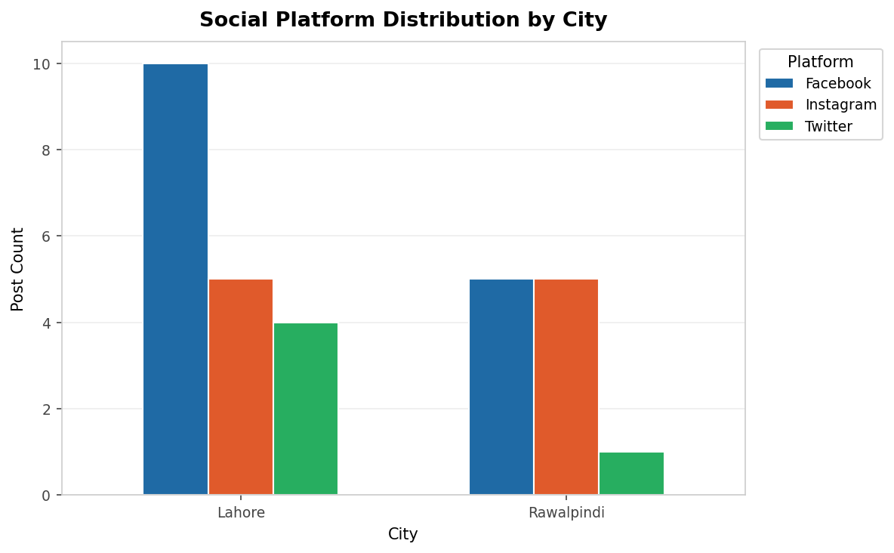
Figure 9 (Stage 5B): Platform distribution by city. Facebook dominates in both cities.

4.3 Weather Analysis
Pipeline reference: Stage 2C (clean) · Stage 3C (suitability score) · Stage 5C (plots fig_09–11)
Weather data was collected from two independent APIs — open-meteo.com and visualcrossing.com — for each city-day, yielding 12 raw records (Stage 1). Stage 2 averaged the dual-source readings into 6 canonical city-day records (QC-W3: average action). Stage 3 then computed the three-component suitability score.

4.3.1 Suitability Score Rubric
The suitability score (0-100) is the sum of: Temperature component (up to 40 pts: 40 for 10-25°C optimal, 20 for marginal ranges, 0 otherwise), Wind speed component (up to 40 pts: 40 for 5-25 km/h ideal kite-flying range, 20 for 2-5 km/h, 0 otherwise), and Precipitation component (20 pts for dry, 0 for any rain). Threshold justification: 5-25 km/h corresponds to Beaufort Force 2-4 (light to moderate breeze), the recognised optimal range for kite flying.
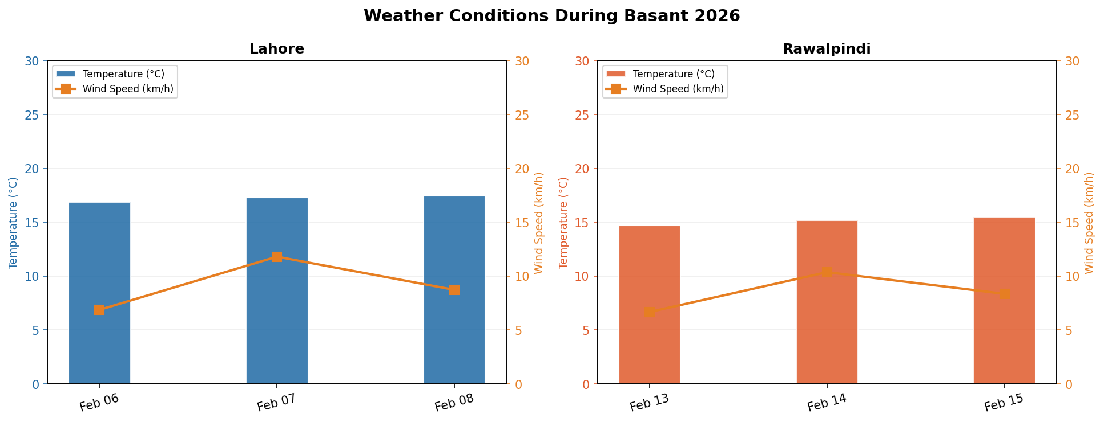
Figure 10 (Stage 5C): Temperature (bars) and wind speed (line) across festival days. All readings fall within optimal ranges.
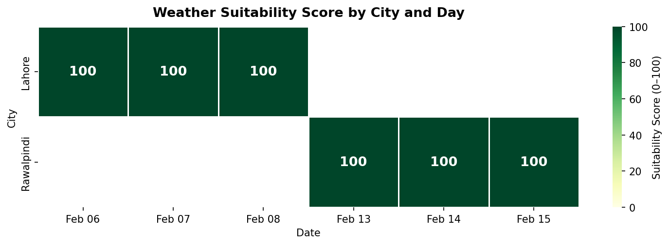
Figure 11 (Stage 5C): Suitability score heatmap. All six city-days scored 100/100 (Excellent).
All six city-days scored 100/100 on the suitability index. Temperatures ranged from 14.7-17.4°C (within the 10-25°C optimal band), wind speeds from 4.4-14.8 km/h (within 5-25 km/h ideal range), and precipitation was 0 mm on all days. This confirms that February is climatically ideal for Basant in Punjab and that weather cannot explain differences in incident rates between cities.
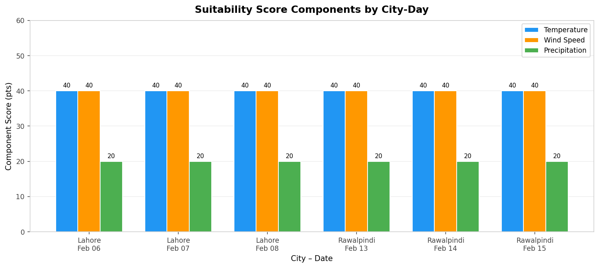
Figure 12 (Stage 5C): Component breakdown per city-day. All three components are at maximum (40, 40, 20) for every observation.

4.4 Incidents Analysis
Pipeline reference: Stage 2D (clean) · Stage 3D (taxonomy) · Stage 5D (plots fig_12–15)
The incidents dataset contains 23 records. Stage 2 applied date parsing and deduplication (QC-I1, QC-I2). Stage 3 applied a four-category taxonomy: fatality, physical_injury, law_enforcement, and infrastructure. Two aggregate government summary records (total_accidents, death_total) are retained in the dataset but excluded from individual count summations to prevent double-counting.
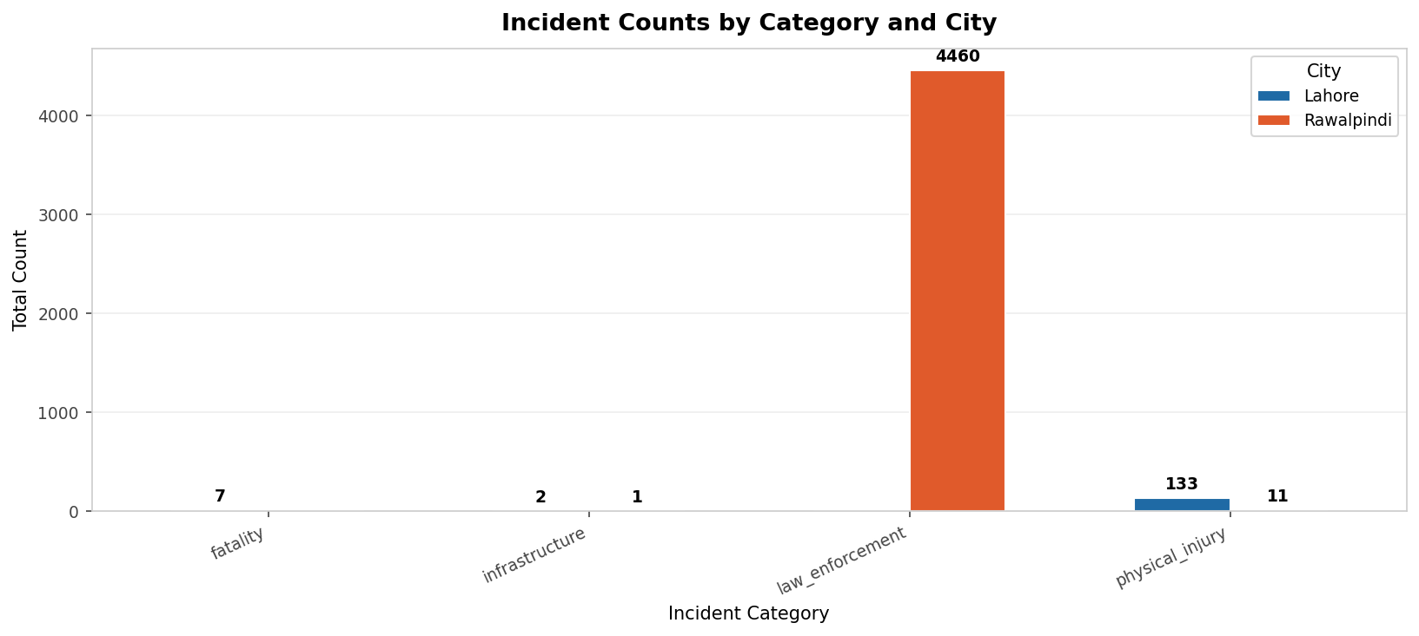
Figure 13 (Stage 5D): Incident counts by category and city. Lahore's physical injuries total 130+; Rawalpindi is dominated by law enforcement (4,460 actions including 4,245 kite seizures and 215 arrests).

4.4.1 Lahore Incidents
Lahore experienced escalating incident counts: 15 on Day 1 (Feb 6), 63 on Day 2 (Feb 7), and 64 on Day 3 (Feb 8). The Lahore High Court subsequently confirmed 17 total deaths attributable to Basant 2026. Common causes included electrocution while retrieving kites from power lines, rooftop falls, and motorcyclists struck by loose kite strings (dor).

4.4.2 Rawalpindi Incidents
Rawalpindi's incident profile is qualitatively different: the dominant category is law enforcement (4,460 total actions: 215 arrests, 4,245 kite and string seizures on Feb 14-15). Physical injury reporting was sparse, likely due to underreporting in a ban-enforcement context. Rawalpindi's totals are not directly comparable to Lahore's injury-focused counts.
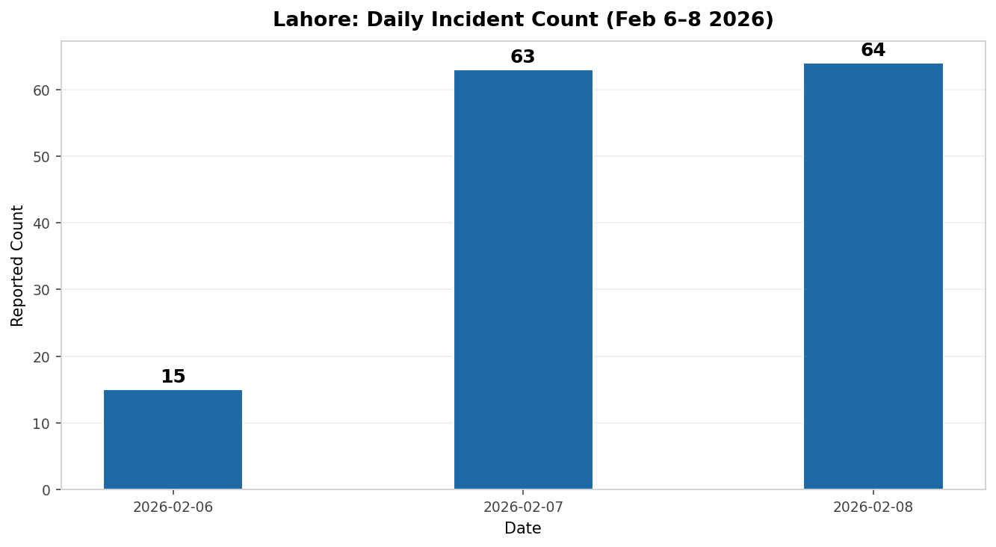
Figure 14 (Stage 5D): Daily incident count in Lahore. The jump from 15 to 63 incidents on Day 2 reflects cumulative hospital and police reporting as the festival progressed.
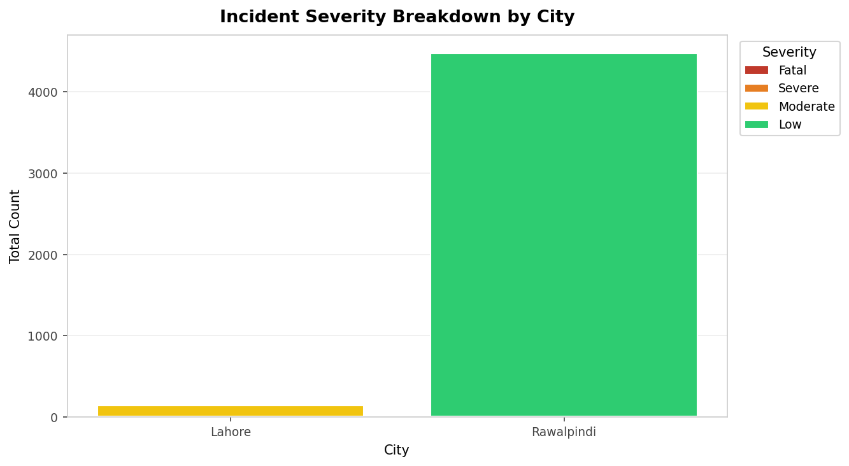
Figure 15 (Stage 5D): Severity breakdown by city. Lahore has 6 records of fatal severity and 9 moderate. Rawalpindi's records are predominantly low severity (enforcement actions).
Insight 3: The confirmed death toll of 17 in Lahore over 3 days of officially sanctioned celebrations represents a significant public safety failure, drawing Lahore High Court scrutiny of the government's safety SOPs. The combination of kite flying near electrical infrastructure, inadequate enforcement of safety requirements, and continued use of banned metal-coated dor contributed to this outcome.
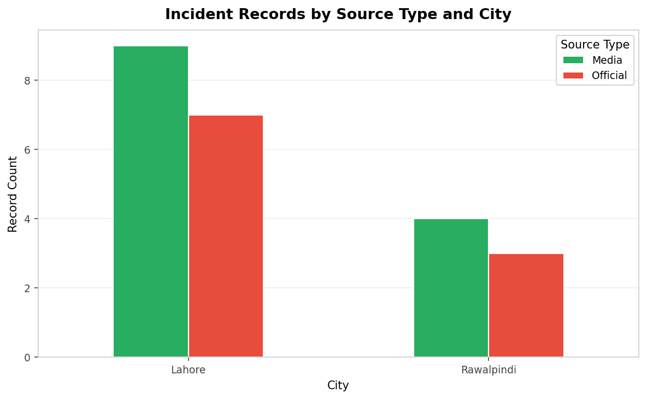
Figure 16 (Stage 5D): Records by source type. 52% are attributed to Official sources (government, police, courts), 48% to Media.

4.5 Media Analysis (Images and Videos)
Pipeline reference: Stage 2E-2F (clean) · Stage 3E-3F (labels) · Stage 5E (plots fig_16–18)
The media modality covers 22 images and 12 videos. All content is represented by URL metadata only — no files were downloaded. Both modalities are dominated by Lahore (77% of images, 67% of videos), consistent with the overall media coverage asymmetry.
Image labels were assigned systematically in Stage 3E: crowd_level by source outlet and festival date (major international wire services on peak days = high; others = medium or low); kite_presence by URL keyword matching (URLs containing 'kite' or 'basant' = yes; all others in this festival context = likely). The labels time_of_day and police_visible remain 'unknown' as they require visual image inspection.
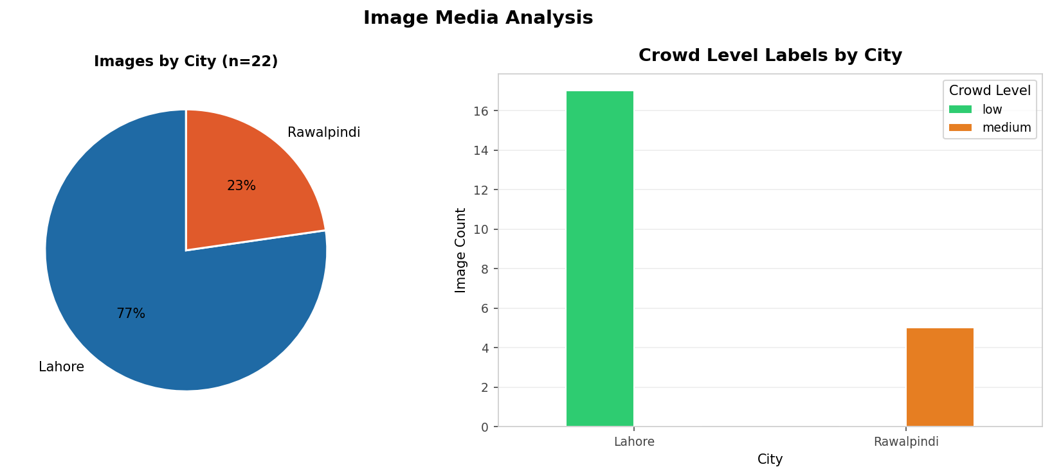
Figure 17 (Stage 5E): Image distribution by city (left) and crowd level by city (right). Lahore images are classified as 'low' (pre-festival or advisory images) or 'medium' (in-festival coverage).
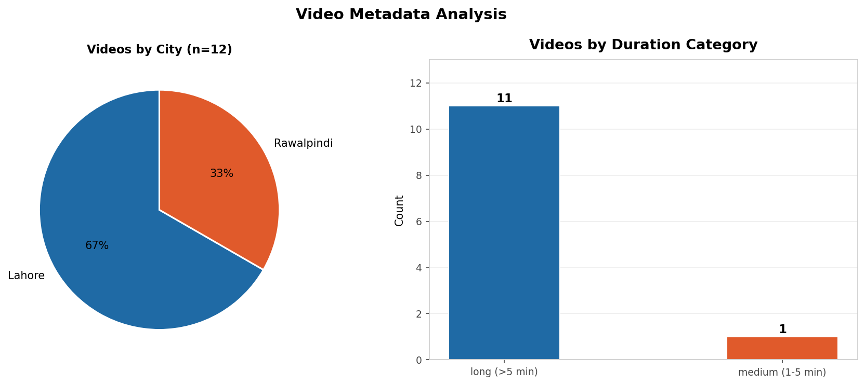
Figure 18 (Stage 5E): Video distribution by city (left) and duration category (right). Long videos (>5 min) dominate, typical of documentary-style YouTube coverage. All 12 videos are in Urdu.

5. City Comparison

Pipeline reference: Stage 4E (city_metrics.csv) · Stage 5F (plots fig_19–22)
Table 5 presents the comprehensive city-level comparison table, sourced directly from data/processed/city_metrics.csv as computed in Stage 4.
Table 5: City-Level Comparison Table (from city_metrics.csv)
Metric | Lahore | Rawalpindi
Date Window | Feb 6-8, 2026 | Feb 13-15, 2026
Festival Status | Official (sanctioned) | Unofficial (banned)
News Volume | 23 articles | 5 articles
Social Volume (total collected) | 19 posts | 11 posts
Social Volume (in analysis window) | 12 posts | 9 posts
Images Count | 17 images | 5 images
Videos Count | 8 videos | 4 videos
Incidents Total (ind. records, sum) | 142 (injuries + fatalities) | 4,472 (arrests + seizures dominate)
Confirmed Fatalities | 17 deaths (LHC report) | 0 confirmed deaths
Arrests | 0 | 215
Kite/String Seizures | Not reported | 4,245
Mean Weather Suitability | 100.0 / 100 | 100.0 / 100
Mean News Sentiment | -0.333 (negative) | -0.700 (negative)
Mean Social Sentiment | +0.405 (positive) | +0.546 (positive)

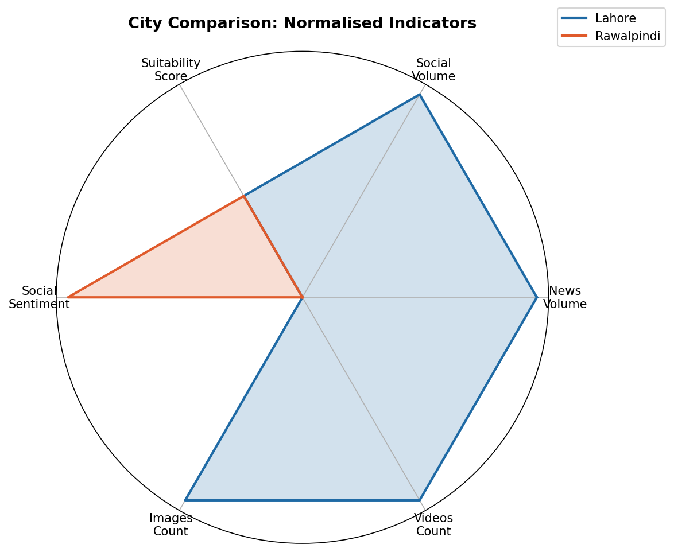
Figure 19 (Stage 5F): Radar chart comparing normalised indicators. Lahore scores substantially higher on all media coverage dimensions, reflecting its official festival status.
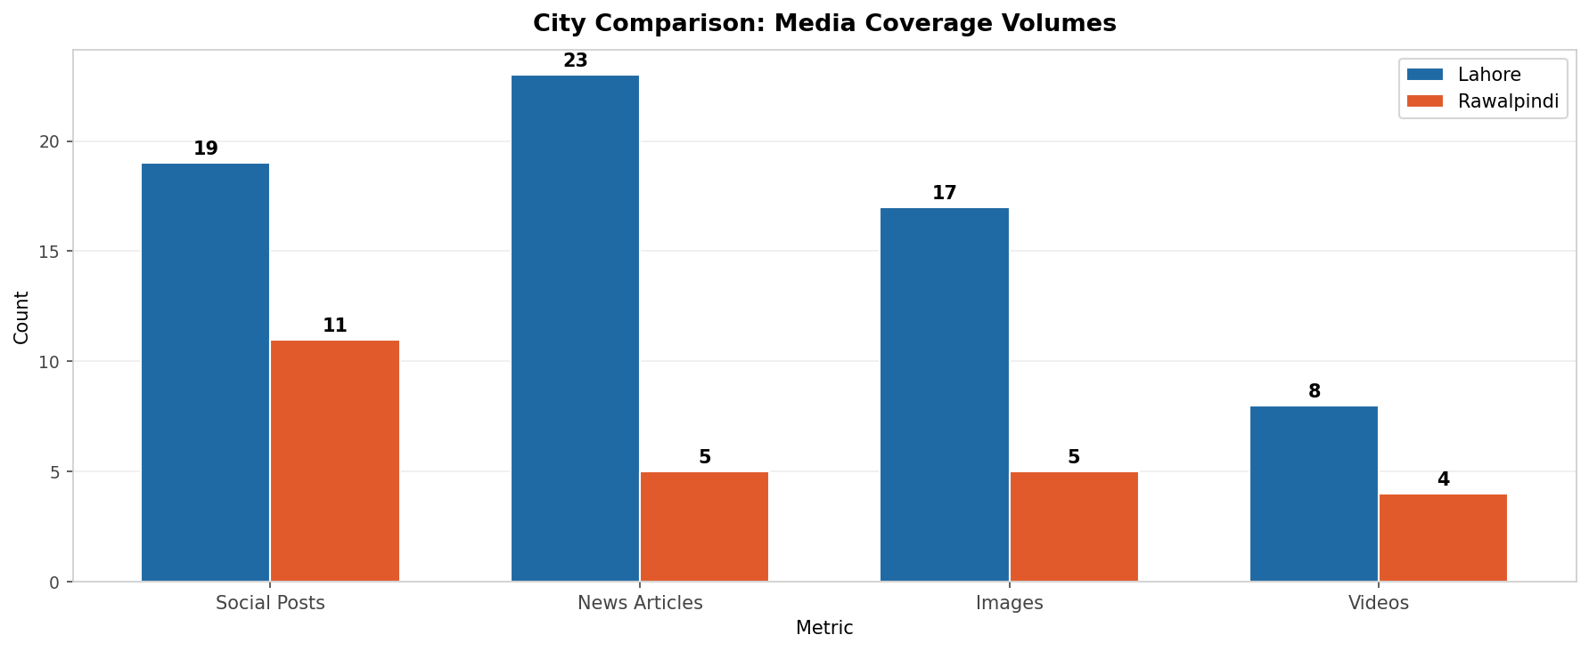
Figure 20 (Stage 5F): Grouped bar chart comparing media coverage volumes. Lahore's advantage is consistent across all four metrics.
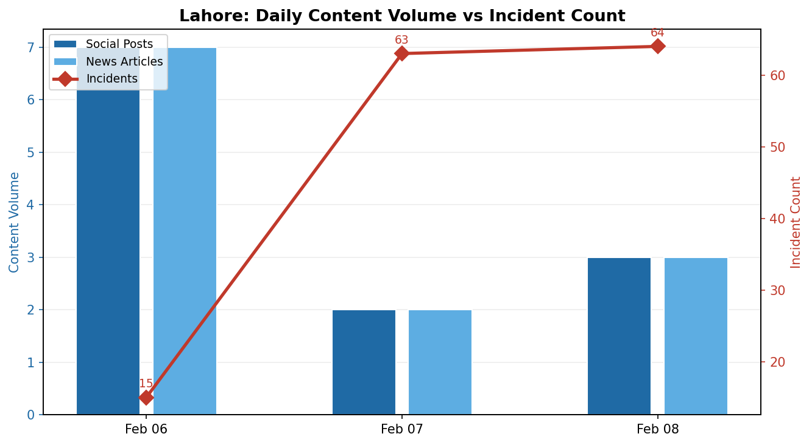
Figure 21 (Stage 5F): Dual-axis time series for Lahore. Content volume (bars, left axis) vs incident count (line, right axis). Incident count spikes from 15 to 63 on Day 2 while social volume drops.
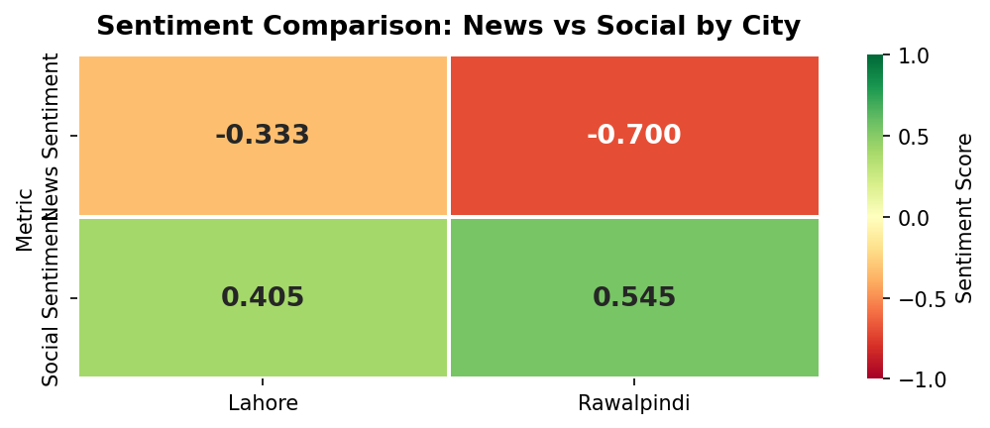
Figure 22 (Stage 5F): Sentiment heatmap. News sentiment is negative for both cities; social sentiment is positive. Rawalpindi shows the largest magnitude values in both directions.

5.1 Key Comparative Insights

Insight 1: News Coverage Volume as Celebration Intensity Proxy
Lahore generated 4.6x more news coverage (23 vs 5 articles). International wire services (Reuters, AP News, Al Jazeera, Gulf News) covered Lahore exclusively. News volume is a valid celebration intensity proxy for official events but underestimates grassroots activity where media attention is absent due to a ban context.

Insight 2: Social Positivity Transcends Regulatory Status
Despite illegal celebrations, Rawalpindi's social sentiment (+0.55) was slightly higher than Lahore's (+0.41). Neither city produced any negative social posts. The emotional pull of cultural revival appears to transcend official permission, with residents in both cities expressing joy and nostalgia regardless of legal context.

Insight 3: Weather Was Uniformly Excellent — Incidents Were Regulatory/Behavioural
All six city-days scored 100/100 suitability. Weather cannot explain differences in incident rates. Lahore's 17 fatalities despite a permitted, officially supervised festival point to regulatory enforcement failures rather than environmental causes — inadequate implementation of safety SOPs and continued use of banned metallic dor.

Insight 4: Incident Profiles Reflect Regulatory Context, Not Celebration Scale
Lahore: physical harm (17 deaths, 100+ injuries). Rawalpindi: law enforcement (215 arrests, 4,245 seizures). These categories are not comparable. Summing all incident counts across cities would be misleading; the city_metrics.csv table separates fatal_incidents and arrests precisely to enable appropriate comparison.

6. Bonus: Cross-Modal Integration

Pipeline reference: Stage 4F (city_day_metrics) · Stage 6 (master_index, item_features) · Stage 5G (fig_23–25)
Three bonus integration files are produced in Stage 6: master_index.csv (121 records linking all modalities via a consistent record_id scheme), item_features.csv (80 item-level feature records for news, social, and image modalities), and city_day_metrics.csv (6 city-day aggregations combining all modalities). Two cross-modal insights are presented below.
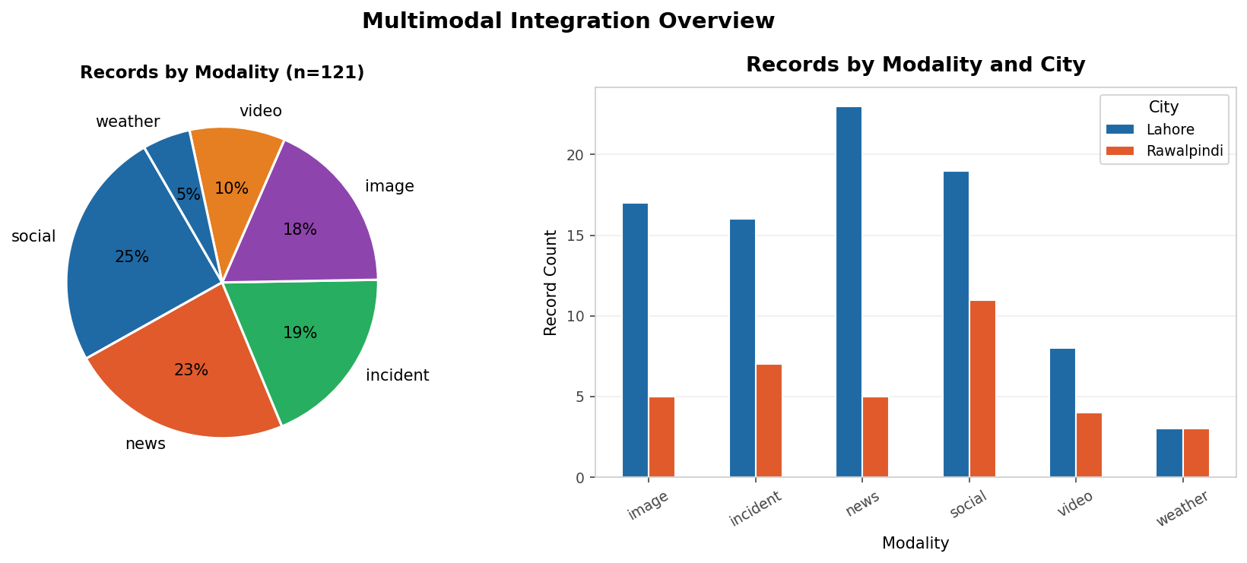
Figure 23 (Stage 5G): Modality distribution in the master index (left) and breakdown by city (right). The Lahore imbalance is consistent across all modalities.

6.1 Cross-Modal Insight 1: Weather Suitability vs Incident Count
Figure 24 plots suitability score against incident count for each city-day. All points cluster at suitability = 100 but span dramatically different incident counts (0 to 64). This confirms weather was not a differentiating factor. Day-to-day variation within Lahore (15, 63, 64) is better explained by cumulative reporting effects and escalating festival activity than by meteorological conditions.
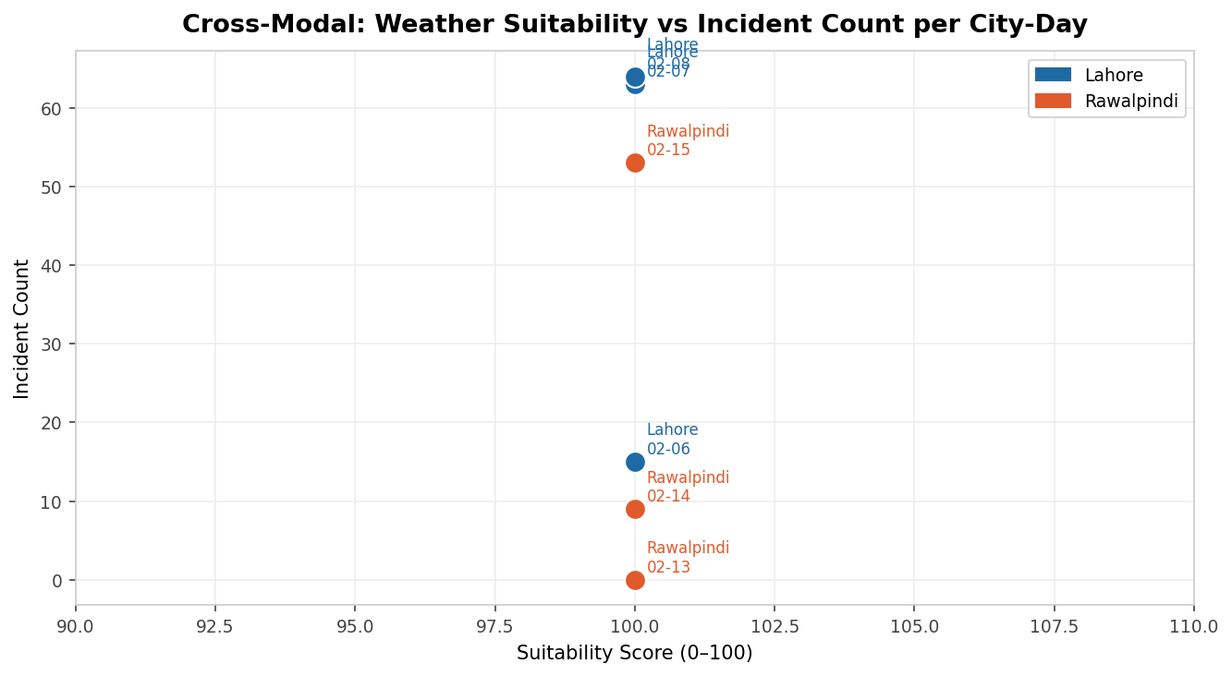
Figure 24 (Stage 5G): Cross-modal scatter of suitability score vs incident count per city-day. All points lie at suitability = 100, confirming weather was uniformly excellent and not a predictor of incident severity.

6.2 Cross-Modal Insight 2: Decoupling of News and Social Volume
Figure 25 plots daily news volume against social volume. Lahore Day 1 (Feb 6) anchors in the upper right (high on both axes). By Day 2, social posting collapsed to 2 while news volume remained high. This decoupling suggests that after the opening excitement, social users reduced posting (possibly due to safety concerns or saturation) while journalists intensified coverage driven by incident reporting.
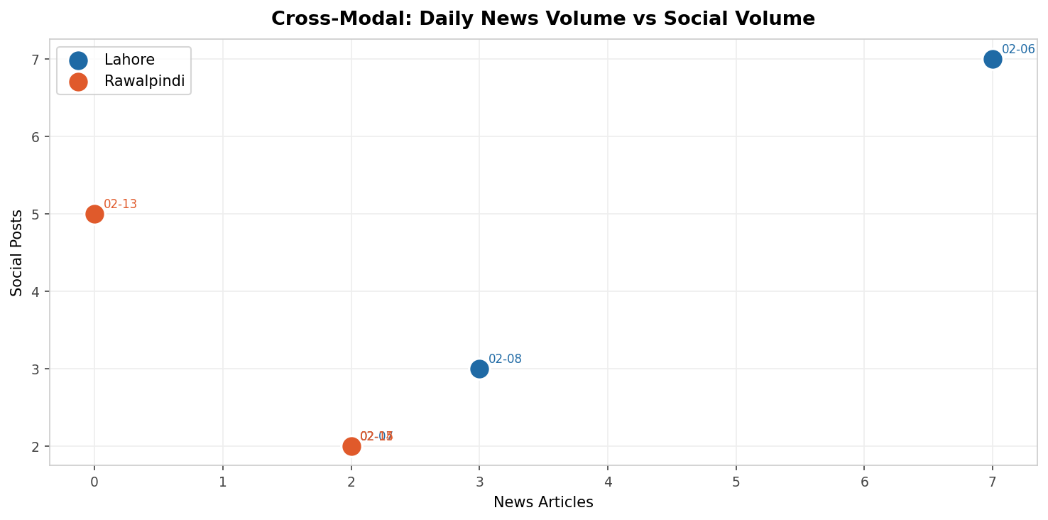
Figure 25 (Stage 5G): Cross-modal scatter of daily news vs social volume. Lahore Day 1 shows peak activity on both axes; subsequent days show a news-social decoupling.

7. Limitations and Ethics

7.1 Sampling Bias
- Lahore overrepresentation: 82% of news articles and 77% of images pertain to Lahore. International media attention and official government communications created an asymmetric information environment.
- English-language bias in news: All news outlets collected publish in English. Urdu-language reporting from ARY News, Jang, and Nawaiwaqt was not included.
- Social media platform bias: Twitter/X is underrepresented (4 posts vs. estimated much higher actual activity). Manual collection introduces selection bias toward high-visibility posts.
- Temporal asymmetry: Lahore's window (Feb 6-8) precedes Rawalpindi's (Feb 13-15) by one week. News of Lahore fatalities was public by the time Rawalpindi celebrations began, potentially influencing celebrant behaviour and media framing in Rawalpindi.

7.2 Sentiment Analysis Limitations
- The English keyword lexicon has zero coverage for Urdu and Roman Urdu tokens. Urdu-dominant social captions and all 12 Urdu video titles score 0.0 (neutral) by default.
- Short captions (e.g., 'Lahore Basant') contain insufficient tokens for meaningful scoring and contribute noise to aggregate averages.
- Sarcasm, irony, and cultural idioms cannot be captured by a keyword lexicon.

7.3 Incident Data Limitations
- Cross-source duplication risk: The cross_source_dup flag identifies records sharing (date, city, incident_type) across multiple outlets, but cannot definitively resolve double-counting without ground truth.
- Aggregate records: Two aggregate summary rows are excluded from count summations but retained for reference. Including them would double-count individual incidents.
- Rawalpindi underreporting: Because celebrations were illegal, victims may have avoided reporting injuries, leading to systematic underreporting of physical harm.

7.4 Media Label Limitations
- Image labels for time_of_day and police_visible are 'unknown' for all 22 images — they require visual inspection which was not possible from URL metadata alone.
- Crowd level and kite presence labels are rule-based proxies, not manual visual codings, and should be treated as indicative rather than authoritative.

7.5 Ethics Statement
All data was collected from publicly accessible sources. No private profiles, private groups, or login-gated content was accessed. Social media posts are identified by public URLs only; individual usernames were not collected or stored. The dataset was assembled for educational purposes within DS 401 and should not be used for surveillance, law enforcement, or commercial applications. Basant is a culturally significant festival; this analysis is objective and makes no normative judgements about the government's decision to permit or ban the festival, or about the communities who celebrate it.

8. Conclusion

This report presents a multimodal data science analysis of Basant 2026 in Lahore and Rawalpindi, processed through a six-stage unified pipeline (pipeline.py) that runs end-to-end from raw source files to cleaned datasets and publication-ready visualisations. Four evidence-based insights emerge from the analysis:
- Insight 1 — News sentiment inversely tracks incident escalation: As Lahore's festival progressed, incident counts rose from 15 to 64 and news sentiment declined from -0.33 to -0.67, reflecting a media framing shift from cultural celebration to accountability reporting.
- Insight 2 — Social media and news present opposite perspectives: The news-social sentiment gap of 0.74 points for Lahore and 1.25 points for Rawalpindi demonstrates that the same event is experienced and communicated completely differently across media channels.
- Insight 3 — Weather was uniformly excellent (100/100 for all city-days): Incident rates were driven by regulatory and behavioural factors, not meteorological conditions. The 17 Lahore deaths represent a safety SOP enforcement failure, not an environmental risk failure.
- Insight 4 — Incident profiles reflect regulatory context: Lahore's incidents are dominated by physical harm; Rawalpindi's by law enforcement. These profiles are qualitatively incomparable and must be analysed by category to avoid misleading conclusions.
Future work should incorporate Urdu NLP models for sentiment analysis on local-language content, higher-resolution (hourly) weather data for more granular suitability scoring, and ground-truth image labelling using computer vision tools to populate the time_of_day and police_visible fields currently marked as 'unknown'.

9. References

All source URLs are archived in the url fields of the cleaned datasets and documented in README_sources.md. Representative key references:
- Dawn (2026, Feb 6-25). Multiple reports on Basant 2026 Lahore. https://www.dawn.com
- Express Tribune (2026, Feb 6-15). Basant 2026 coverage. https://tribune.com.pk
- Geo News (2026, Feb 6). Basant: One killed, five injured in Lahore. https://www.geo.tv/latest/649309
- Pakistan Today (2026, Feb 8). 118 accidents reported in Basant. https://www.pakistantoday.com.pk
- Pakistan Today (2026, Feb 25). 17 fatalities during Basant reported to Lahore High Court. https://www.pakistantoday.com.pk
- Reuters (2026, Feb 6). Kites, victory cries fill Lahore skies as festival returns after long ban. https://www.reuters.com
- Al Jazeera (2026, Feb 7). How Basant became Lahore's signature festival. https://www.aljazeera.com
- ProPakistani (2026, Feb 14). Basant celebrations continue in Rawalpindi despite ban. https://propakistani.pk
- Open-Meteo (2026). Historical Weather API. https://open-meteo.com
- Visual Crossing (2026). Historical Weather Data. https://visualcrossing.com

