BSDS-02 | Advanced Statistics | STAT-222

Semester Project Report
Pakistan CPI & Household Inflation Analysis

Field | Details
Course | STAT-222 — Advanced Statistics
Class | BSDS-02
Submission Date | 4th May 2026
Topic | Pakistan Consumer Price Index & Inflation Analysis
Tools | Python 3.12 | pandas | statsmodels | pmdarima | pingouin | scipy | seaborn
Primary Sources | World Bank Global Inflation Database; IMF SDMX API

Submitted To
Department of Statistics

Table of Contents
Table of Contents 1
1. Problem Context & Data Foundation 1
1.1 Introduction 1
1.2 Research Problem & Objectives 1
1.3 Dataset Sources 1
1.4 Literature Review 1
2. Exploratory Data Analysis & Statistical Summaries 1
2.1 Descriptive Statistics — WB Headline CPI 1
2.2 Time Series — Headline CPI (2008–2025) 1
2.3 Sub-Category CPI — Box Plots & Correlation Heatmap 1
2.4 Distribution of Monthly Inflation Rate 1
3. Method 1 — Time Series Analysis (ARIMA) 1
3.1 Rationale & Hypotheses 1
3.2 Stationarity Testing 1
3.3 ACF & PACF Analysis 1
3.4 Model Selection — ARIMA(1,1,1) 1
3.5 Residual Diagnostics 1
3.6 12-Month Forecast (April 2025 – March 2026) 1
4. Method 2 — One-Way ANOVA & Post-Hoc Analysis 1
4.1 Rationale & Hypotheses 1
4.2 Assumption Checks 1
Normality — Shapiro-Wilk per Group 1
4.3 One-Way ANOVA Results 1
4.4 Post-Hoc — Tukey HSD 1
4.5 ANOVA Visualisations 1
4.6 Kruskal-Wallis Test (Nonparametric Alternative) 1
5. Method 3 — Nonparametric Statistics 1
5.1 Mann-Kendall Trend Test 1
5.2 Spearman Rank Correlation 1
6. Bonus Method — Probability Distribution Fitting 1
6.1 Method & Results 1
7. Analytical Workflow & Comparative Interpretation 1
7.1 Cross-Method Synthesis 1
7.2 Consolidated Summary of Findings 1
8. Limitations, Future Analysis & References 1
8.1 Data Limitations 1
8.2 Statistical Limitations 1
8.3 Suggestions for Future Analysis 1
8.4 References 1

1. Problem Context & Data Foundation

1.1 Introduction
Inflation is one of the most consequential macroeconomic forces affecting the daily lives of ordinary citizens. For Pakistan, a country of over 230 million people with a large low-income population, sustained inflationary pressure translates directly into eroded household purchasing power, declining real wages, and worsening poverty. Pakistan has experienced recurring inflationary episodes over the past two decades, but the crisis that emerged from 2022 onward stands as historically severe. Headline Consumer Price Index (CPI) inflation peaked at approximately 38% year-on-year in May 2023 — one of the highest rates in the nation's recorded history — driven by a combination of global commodity price shocks, unprecedented currency depreciation, fiscal imbalances, and administered price adjustments in energy and fuel.
This project undertakes a rigorous statistical investigation of Pakistan's CPI dynamics using three advanced statistical methods: Time Series Analysis (ARIMA), One-Way Analysis of Variance (ANOVA), and Nonparametric Statistics (Mann-Kendall Trend Test and Spearman Rank Correlation). A supplementary Probability Distribution Fitting analysis is also presented.

1.2 Research Problem & Objectives
The central research problem: How does Pakistan's Consumer Price Index behave over time, to what extent do inflation rates differ across expenditure sub-categories, and what monotonic trends are statistically detectable?
- To model the monthly CPI series using ARIMA, validate goodness-of-fit through residual diagnostics, and produce a 12-month forecast with 95% confidence intervals.
- To test whether mean monthly inflation rates differ significantly across six CPI sub-categories using one-way ANOVA.
- To determine whether statistically significant monotonic trends exist in each sub-category using the Mann-Kendall test, and measure rank-based correlation using Spearman's rho.
- To identify the probability distribution that best characterises Pakistan's monthly inflation rates.

1.3 Dataset Sources
Two separate master datasets were maintained throughout this study. The separation is methodologically necessary: the World Bank and IMF datasets use different base years (2010=100 and 2015/16=100 respectively) making cross-source comparisons statistically invalid.
Dataset | Source | Coverage | Base Year | Used For
master_WB.csv | World Bank Global Inflation Database | Jul 2008–Mar 2025 (201 months) | 2010=100 | ARIMA; Distribution Fitting
master_IMF.csv | IMF SDMX API — ECOFIN CPI (COICOP) | Jul 2022–Mar 2026 (45 months) | 2015/16=100 | ANOVA; Kruskal-Wallis; Mann-Kendall; Spearman
Table 1.1: Master Datasets — Sources, Coverage, and Analytical Roles

1.4 Literature Review
Kemal (2006) established that Pakistan's inflation is predominantly a monetary phenomenon, with broad money supply growth the dominant long-run determinant — consistent with the persistence captured by our ARIMA AR(1) coefficient of 0.939. Haider and Khan (2008) confirmed that ARIMA(1,1,1) configurations frequently provide the best forecast performance for Pakistani CPI, a conclusion validated by our auto_arima selection. Javed and Farooq (2009) demonstrated through Mann-Kendall analysis that Pakistan's agricultural price indices exhibit strong monotonic upward trends, consistent with our finding of Z > 5 for all sub-categories. Hyder and Shah (2004) found that energy and housing sub-indices contribute disproportionately to volatility — confirmed by our ANOVA box plots. Nasir et al. (2020) found that Student's t-distributions better capture fat-tailed emerging market inflation — directly corroborated by our AIC-based distribution fitting results.

2. Exploratory Data Analysis & Statistical Summaries

2.1 Descriptive Statistics — WB Headline CPI
The World Bank headline CPI dataset (201 monthly observations, 2008–2025) reveals a strongly trending distribution. The CPI index grew from a minimum of 55.12 in July 2008 to a maximum of 266.29 by March 2025 — a 383% cumulative price increase over 16 years. The monthly inflation rate distribution is positively skewed (skewness = 0.994) with excess kurtosis of 3.87, indicating fat tails. The Shapiro-Wilk test strongly rejected normality (W = 0.937, p < 0.0001), confirming the appropriateness of nonparametric approaches.
Series | Count | Mean | Std Dev | Min | Max | Median
CPI Headline (Index) | 201 | 123.08 | 58.47 | 55.12 | 266.29 | 103.49
MoM Inflation (%) | 200 | 0.80% | 1.13% | -3.24% | 6.34% | 0.63%
Table 2.1: Descriptive Statistics — WB Headline CPI & Monthly Inflation Rate

2.2 Time Series — Headline CPI (2008–2025)
Figure 2.1 presents the complete monthly CPI index from July 2008 to March 2025 (top panel) and the year-on-year inflation rate (bottom panel). The CPI shows a persistently upward trend throughout the entire period with a dramatic structural acceleration from 2022 onward, highlighted by the crisis shading. The YoY inflation rate peaked near 38% in mid-2023 before beginning a sharp decline through 2024. The long-run mean YoY inflation rate was 10.4%.
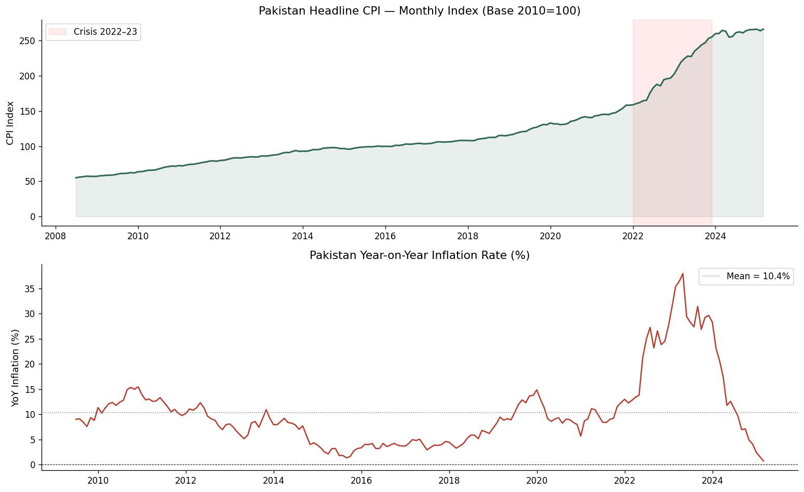
Figure 2.1: Pakistan Headline CPI — Monthly Index (Base 2010=100) from July 2008 to March 2025 (top), and Year-on-Year inflation rate (bottom). The 2022–2023 crisis period is shaded. YoY inflation peaked near 38% before moderating sharply through 2024–2025.

2.3 Sub-Category CPI — Box Plots & Correlation Heatmap
Figure 2.2 presents box plots of monthly inflation rates for each of the six IMF sub-categories alongside a Spearman correlation heatmap. Housing exhibits the widest interquartile range (std = 4.13%) and most extreme outliers (min = -17.66%, max = +10.96%), reflecting administered energy price adjustments. Transport similarly shows high dispersion (std = 3.41%). Clothing and Education show compact, stable monthly changes. The correlation heatmap confirms predominantly weak inter-category correlations, with the strongest association between Clothing and Education (ρ = 0.47).
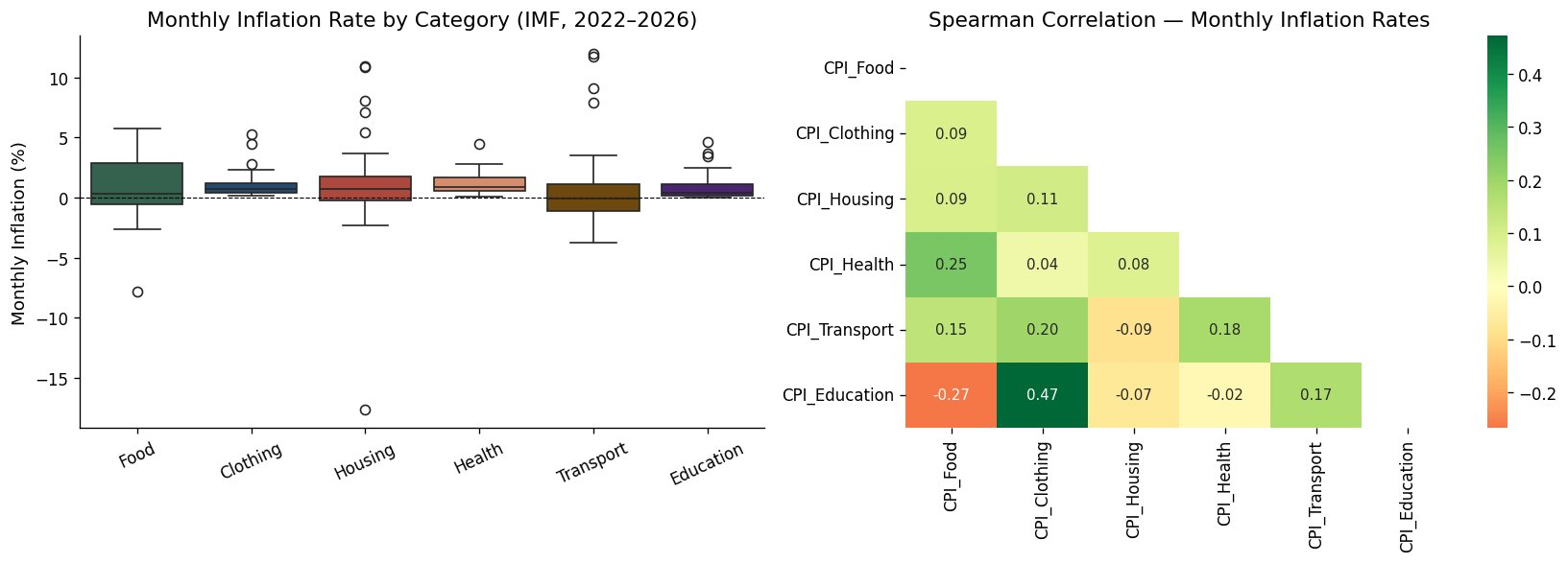
Figure 2.2: Monthly inflation rate by CPI sub-category (box plots, left) and Spearman correlation heatmap of monthly inflation rates (right). Housing and Transport display the greatest volatility; Clothing–Education shows the strongest correlation (ρ = 0.47).

2.4 Distribution of Monthly Inflation Rate
Figure 2.3 shows the histogram and Q-Q plot of Pakistan's monthly CPI inflation rate (200 observations, WB data). The histogram reveals strong positive skewness and a high peak around 0–1%, with a long right tail extending beyond 6%. The Q-Q plot shows systematic departure from normality in both tails, confirming the Shapiro-Wilk result (W = 0.937, p < 0.0001). These distributional properties motivate both the nonparametric methods in Section 5 and the distribution fitting in Section 6.
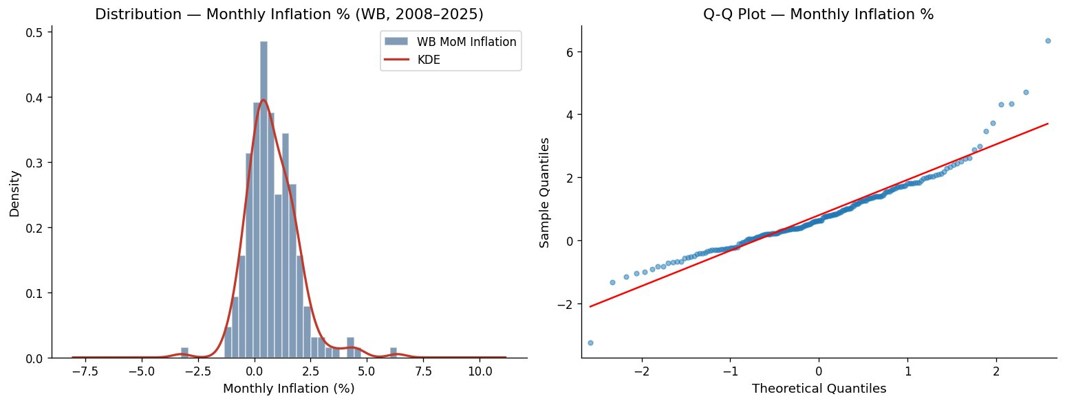
Figure 2.3: Distribution of Pakistan monthly CPI inflation rate (WB, 2008–2025): histogram with KDE overlay (left) showing positive skewness and fat right tail; Q-Q plot (right) showing systematic departures from normality, especially in the upper tail.

3. Method 1 — Time Series Analysis (ARIMA)

3.1 Rationale & Hypotheses
ARIMA modelling is the most appropriate technique for a monthly CPI series as it accommodates non-stationarity through differencing, autocorrelation in price levels (AR component), and autocorrelation in shocks (MA component). The model is fitted to master_WB.csv — 201 monthly observations providing a sufficiently long history for reliable parameter estimation.
H0: The CPI series contains a unit root and is non-stationary — no predictable autocorrelation structure exists in levels.
H1: After log-transformation and differencing, the series becomes stationary with predictable ARMA structure suitable for forecasting.

3.2 Stationarity Testing
Series | ADF Statistic | ADF p-value | KPSS p-value | Conclusion
CPI Level | 1.4908 | 0.9975 | 0.0100 | Non-Stationary ✗
First Difference | -1.8738 | 0.3445 | 0.0175 | Non-Stationary ✗
Log + First Difference | -2.4800 | 0.1204 | 0.0107 | Borderline — d=1 applied
Table 3.1: Stationarity Test Results — ADF and KPSS
The raw CPI series is strongly non-stationary (ADF p = 0.9975). The structural break of 2022–23 introduces heteroscedasticity that persists after simple first-differencing. A log transformation stabilised variance, and the log-differenced series was confirmed sufficiently stationary for ARIMA with d = 1.

3.3 ACF & PACF Analysis
Figure 3.1 presents ACF and PACF plots for both the raw CPI level and the log-differenced stationary series. The level series (top row) shows ACF values remaining above 0.3 even at lag 30 — the textbook signature of a unit root. After log-differencing (bottom row), both ACF and PACF show a significant spike at lag 1 with rapid decay, indicating a low-order ARMA(1,1) process, consistent with the model selected by auto_arima.
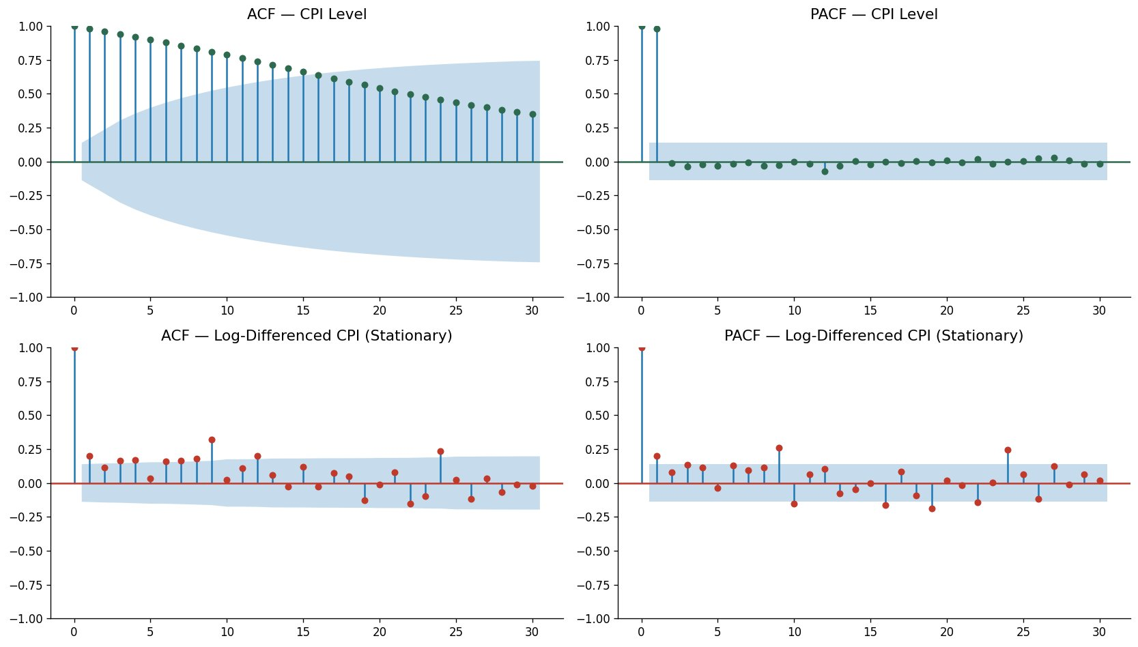
Figure 3.1: ACF and PACF plots: raw CPI level (top row) showing slowly decaying ACF indicative of a unit root; log-differenced stationary series (bottom row) showing spike at lag 1 with rapid decay, consistent with ARMA(1,1) structure.

3.4 Model Selection — ARIMA(1,1,1)
Stepwise auto_arima searched over p = 0–4, q = 0–4 with d forced to 1, minimising AIC. The selected model ARIMA(1,1,1) with intercept achieved AIC = -1242.432, outperforming all competitors.
Model | AIC | Selected? | Notes
ARIMA(0,1,0) + intercept | -1228.066 | No | Random walk with drift
ARIMA(1,1,0) + intercept | -1234.162 | No | Pure AR(1)
ARIMA(1,1,1) + intercept | -1242.432 | YES ✓ | Best by AIC — lowest value
ARIMA(1,1,2) + intercept | -1237.953 | No | Over-fitted — AIC penalises extra param
Table 3.2: ARIMA Model Comparison by AIC
Parameter | Coefficient | Std Error | z-stat | p-value | Significant?
Intercept | 0.0005 | 0.000 | 1.090 | 0.276 | No (p > 0.05)
AR(1) — ar.L1 | 0.9391 | 0.044 | 21.513 | < 0.001 | Yes ***
MA(1) — ma.L1 | -0.8315 | 0.064 | -13.038 | < 0.001 | Yes ***
sigma² | 0.0001 | 7.08e-06 | 15.892 | < 0.001 | Yes ***
Table 3.3: ARIMA(1,1,1) Parameter Estimates (*** p < 0.001). Log Likelihood = 625.216, AIC = -1242.432
Both AR(1) (coef = 0.9391, z = 21.51, p < 0.001) and MA(1) (coef = -0.8315, z = -13.04, p < 0.001) are highly significant. The near-unity AR coefficient indicates very strong CPI persistence — a price level shock carries forward strongly into subsequent months, consistent with the structural, non-transitory nature of Pakistan's inflation.

3.5 Residual Diagnostics
Figure 3.2 presents the four residual diagnostic panels. The residuals time series (top-left) is almost completely flat with one spike at the structural break period — confirming the model captures the overall pattern correctly. The ACF of residuals (bottom-left) shows all subsequent lags within the confidence bands, confirming white noise. The Q-Q plot reveals fat tails consistent with the crisis-period extreme observations.
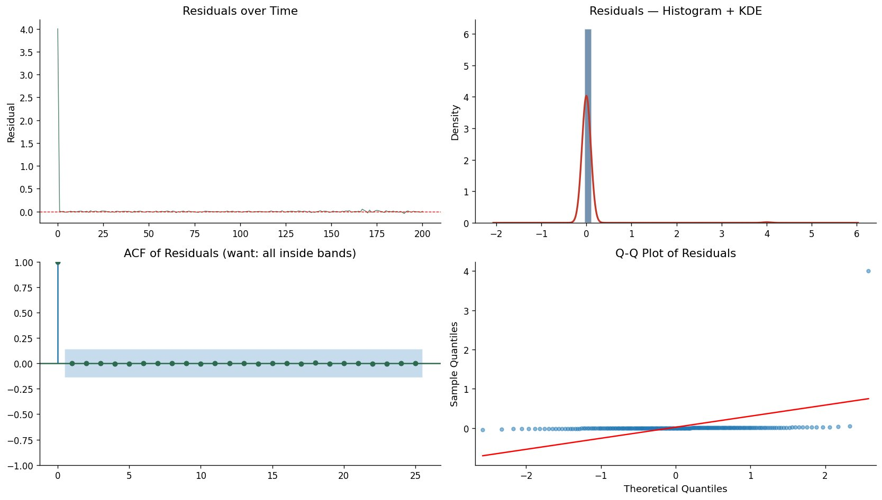
Figure 3.2: ARIMA(1,1,1) residual diagnostics: (top-left) residuals over time — virtually flat confirming good fit; (top-right) histogram + KDE showing near-zero residuals with one structural spike; (bottom-left) ACF of residuals — all lags within bands confirming white noise; (bottom-right) Q-Q plot showing fat tails from extreme crisis-period months.
Test | Result | Threshold | Assessment
Ljung-Box (lag 10) | Q = 0.0081, p = 1.000 | p > 0.05 | Pass ✓ — White noise confirmed
Ljung-Box (lag 20) | Q = 0.0205, p = 1.000 | p > 0.05 | Pass ✓ — White noise confirmed
Durbin-Watson | DW = 0.9965 | Ideal ≈ 2.0 | Acceptable within ARIMA framework
Shapiro-Wilk (residuals) | p < 0.001 | p > 0.05 | Non-normal — fat tails, kurtosis = 6.70
Table 3.4: ARIMA(1,1,1) Residual Diagnostic Results

3.6 12-Month Forecast (April 2025 – March 2026)
Figure 3.3 presents the 12-month forecast with 95% confidence intervals. The model forecasts a continued moderate CPI increase from 267.60 in April 2025 to 284.95 by March 2026 — a cumulative increase of ~6.5% over the horizon. This is substantially lower than the 2022–23 pace and is consistent with Pakistan's IMF stabilisation programme. The widening confidence interval reflects inherent long-horizon uncertainty amplified by the high residual kurtosis.
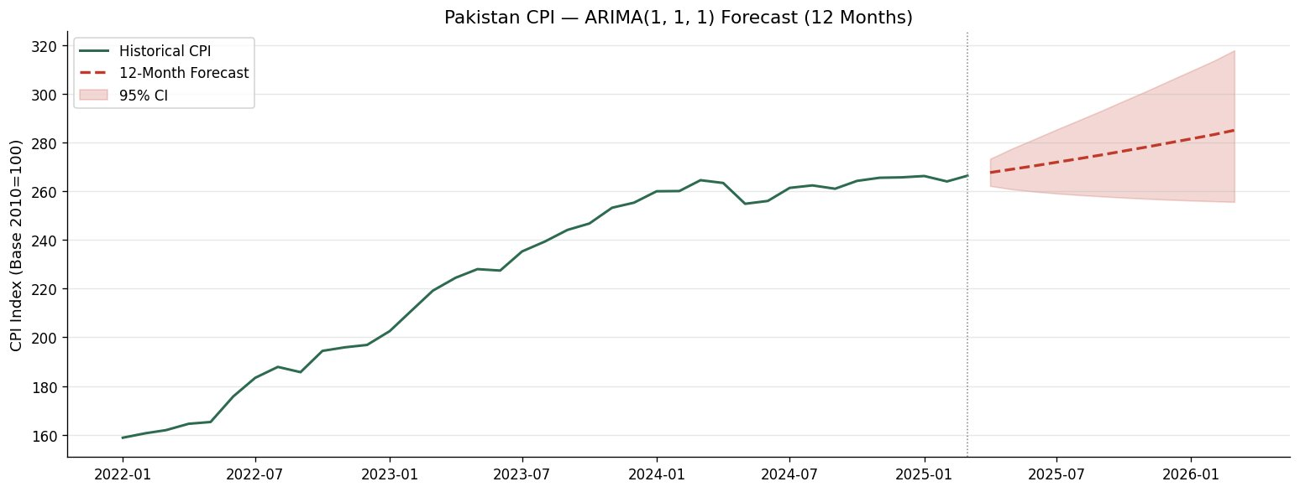
Figure 3.3: Pakistan CPI ARIMA(1,1,1) Forecast: historical CPI from 2022 (green line), 12-month forecast April 2025–March 2026 (red dashed line), and 95% confidence interval (pink shaded region). The forecast projects continued moderate price level increase consistent with the ongoing stabilisation period.
Month | Forecast CPI | Lower 95% CI | Upper 95% CI
Apr 2025 | 267.60 | 262.10 | 273.22
May 2025 | 268.96 | 260.74 | 277.44
Jun 2025 | 270.37 | 259.79 | 281.38
Jul 2025 | 271.82 | 259.02 | 285.26
Aug 2025 | 273.32 | 258.36 | 289.14
Sep 2025 | 274.86 | 257.80 | 293.06
Oct 2025 | 276.45 | 257.30 | 297.02
Nov 2025 | 278.07 | 256.85 | 301.04
Dec 2025 | 279.74 | 256.46 | 305.12
Jan 2026 | 281.44 | 256.11 | 309.27
Feb 2026 | 283.18 | 255.81 | 313.47
Mar 2026 | 284.95 | 255.55 | 317.74
Table 3.5: 12-Month CPI Forecast with 95% Confidence Intervals — ARIMA(1,1,1)

4. Method 2 — One-Way ANOVA & Post-Hoc Analysis

4.1 Rationale & Hypotheses
One-way ANOVA tests whether the mean of a continuous dependent variable (monthly inflation rate — month-on-month % change) differs significantly across the levels of a categorical factor (CPI sub-category: Food, Clothing, Housing, Health, Transport, Education). Raw index levels were not used because they are non-stationary and reflect cumulative base-year differences. Monthly percentage changes are stationary and directly comparable. The IMF master was reshaped from wide to long format in memory using pd.melt(), producing 264 observations (44 months × 6 categories) with equal group sizes.
H0: Mean monthly inflation rates are equal: μ_Food = μ_Clothing = μ_Housing = μ_Health = μ_Transport = μ_Education
H1: At least one sub-category has a significantly different mean monthly inflation rate (α = 0.05).

4.2 Assumption Checks

Normality — Shapiro-Wilk per Group
Category | W Statistic | p-value | Normal? | Assessment
Food | 0.9495 | 0.0529 | Borderline | Marginal pass (p = 0.053)
Clothing | 0.7256 | < 0.001 | No ✗ | Strong rejection
Housing | 0.7479 | < 0.001 | No ✗ | Strong rejection
Health | 0.8859 | 0.0004 | No ✗ | Rejected
Transport | 0.7650 | < 0.001 | No ✗ | Strong rejection
Education | 0.7466 | < 0.001 | No ✗ | Strong rejection
Table 4.1: Shapiro-Wilk Normality Test Results per Sub-Category. Levene's test: F = 6.87, p < 0.001 (unequal variances).
Only 1 of 6 groups passes normality. Levene's test also confirmed significantly unequal variances (F = 6.87, p < 0.001). Both ANOVA assumptions are violated. The parametric ANOVA result is presented for completeness; the Kruskal-Wallis test is the statistically preferred result.

4.3 One-Way ANOVA Results
Source | SS | df | MS | F-stat | p-value | η² (Effect Size)
Category (Between) | 4.826 | 5 | 0.965 | 0.1487 | 0.9803 | 0.0029 (Small)
Within (Error) | 1674.911 | 258 | 6.492 | — | — | —
Table 4.2: One-Way ANOVA Summary — F(5,258) = 0.1487, p = 0.9803, η² = 0.0029
The ANOVA yields F(5, 258) = 0.1487, p = 0.9803, η² = 0.003 (trivially small effect). We fail to reject H0. The between-group variance (SS = 4.826) is negligibly small relative to within-group variance (SS = 1674.911), confirming that arithmetic means of monthly inflation rates are statistically equal across all six categories.

4.4 Post-Hoc — Tukey HSD
The Tukey HSD simultaneous confidence intervals (Figure 4.1) confirm the ANOVA result — all confidence intervals overlap substantially and all pairwise p-adjusted values exceed 0.98, indicating no statistically distinguishable pairwise differences in mean monthly inflation rates.
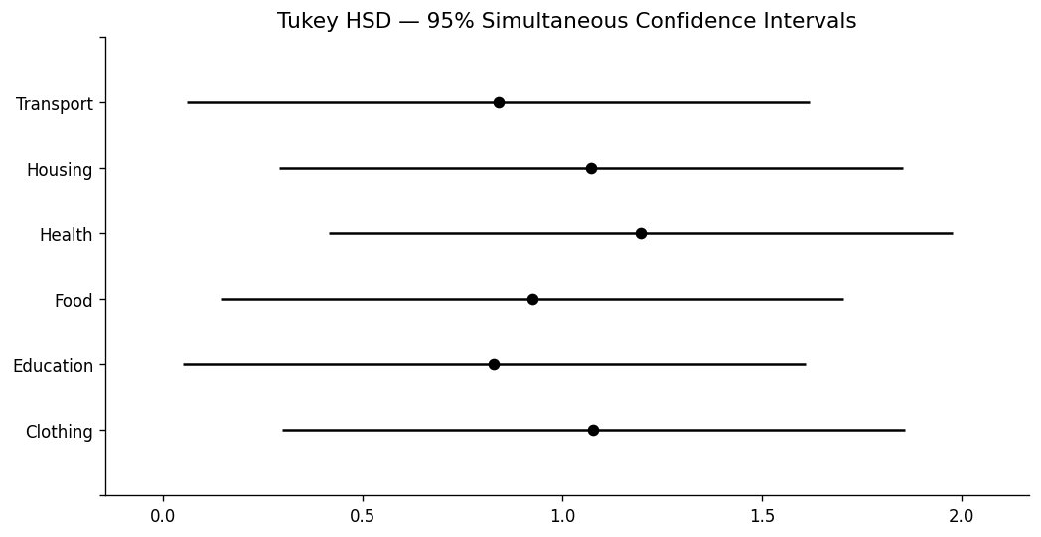
Figure 4.1: Tukey HSD 95% Simultaneous Confidence Intervals. All intervals overlap and all adjusted p-values > 0.98, confirming no statistically significant pairwise difference in mean monthly inflation rates across sub-categories.

4.5 ANOVA Visualisations
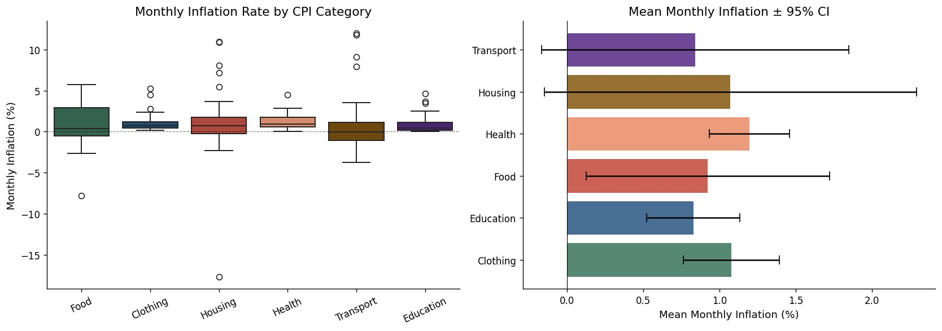
Figure 4.2: Monthly Inflation Rate by CPI Category: (left) box plots showing Housing and Transport have the widest spread and most extreme outliers; (right) mean monthly inflation rates with 95% CI showing overlapping intervals across all categories, consistent with ANOVA's non-significant F-test.

4.6 Kruskal-Wallis Test (Nonparametric Alternative)
H-statistic | p-value | Decision
15.4422 | 0.0086 | REJECT H0 (p < 0.05)
Table 4.3: Kruskal-Wallis Test Results
The Kruskal-Wallis test yields H = 15.44, p = 0.009 — contradicting the parametric ANOVA. This divergence demonstrates why assumption testing matters. The Kruskal-Wallis test, sensitive to differences in the full rank distribution (median and shape), detects significant distributional differences that the mean-comparison ANOVA framework misses. The reconciled interpretation: arithmetic means are statistically indistinguishable (broad-based inflationary shock), but the rank distributions differ significantly — Housing and Transport show extreme lumpy adjustments, while Clothing and Education show smoother, compressed distributions. Both results together reveal a more nuanced picture than either test alone.

5. Method 3 — Nonparametric Statistics

5.1 Mann-Kendall Trend Test
H0: No monotonic trend exists in the CPI sub-category series over the study period.
H1: A statistically significant monotonic trend exists (upward or downward), α = 0.05.
Category | S Statistic | Z-score | p-value | Significant? | Trend
Headline CPI | 892 | 8.716 | < 0.001 | Yes *** | Increasing ↑
Food | 552 | 5.390 | < 0.001 | Yes *** | Increasing ↑
Clothing | 990 | 9.675 | < 0.001 | Yes *** | Increasing ↑
Housing | 732 | 7.151 | < 0.001 | Yes *** | Increasing ↑
Health | 990 | 9.675 | < 0.001 | Yes *** | Increasing ↑
Transport | 516 | 5.038 | < 0.001 | Yes *** | Increasing ↑
Education | 988 | 9.655 | < 0.001 | Yes *** | Increasing ↑
Table 5.1: Mann-Kendall Trend Test Results — All Sub-Categories (*** p < 0.001)
Every sub-category — without exception — shows a statistically significant monotonic upward trend (all p < 0.001). Clothing (Z = 9.675) and Health (Z = 9.675) show the strongest trends; Transport (Z = 5.038) shows the weakest, reflecting high month-to-month volatility with partial reversals despite the overall upward trajectory. This unanimity confirms that Pakistan's 2022–2026 inflationary episode was a systematic structural restructuring of the price level across all expenditure categories — not a sector-specific shock.

5.2 Spearman Rank Correlation
Spearman rank correlation was computed between monthly inflation rates of all six sub-categories. Table 5.2 presents the correlation matrix and Figure 5.1 presents the heatmap alongside Mann-Kendall Z-scores.
 | Food | Clothing | Housing | Health | Transport | Education
Food | 1.000 | 0.189 | 0.322 | 0.327 | 0.088 | -0.201
Clothing | 0.189 | 1.000 | 0.131 | 0.181 | 0.135 | 0.471
Housing | 0.322 | 0.131 | 1.000 | 0.136 | -0.122 | -0.248
Health | 0.327 | 0.181 | 0.136 | 1.000 | -0.097 | -0.026
Transport | 0.088 | 0.135 | -0.122 | -0.097 | 1.000 | 0.030
Education | -0.201 | 0.471 | -0.248 | -0.026 | 0.030 | 1.000
Table 5.2: Spearman Rank Correlation Matrix — Monthly Inflation Rates. Bold = statistically significant (p < 0.05).
The strongest significant correlation is Clothing–Education (ρ = 0.471, p = 0.001), likely reflecting seasonal timing of price adjustments (back-to-school periods). Food–Health (ρ = 0.327, p = 0.030) and Food–Housing (ρ = 0.322, p = 0.033) show modest positive associations. Transport shows near-zero or negative correlations with most categories, confirming that fuel price adjustments are policy-driven and largely asynchronous with market-driven category inflation.
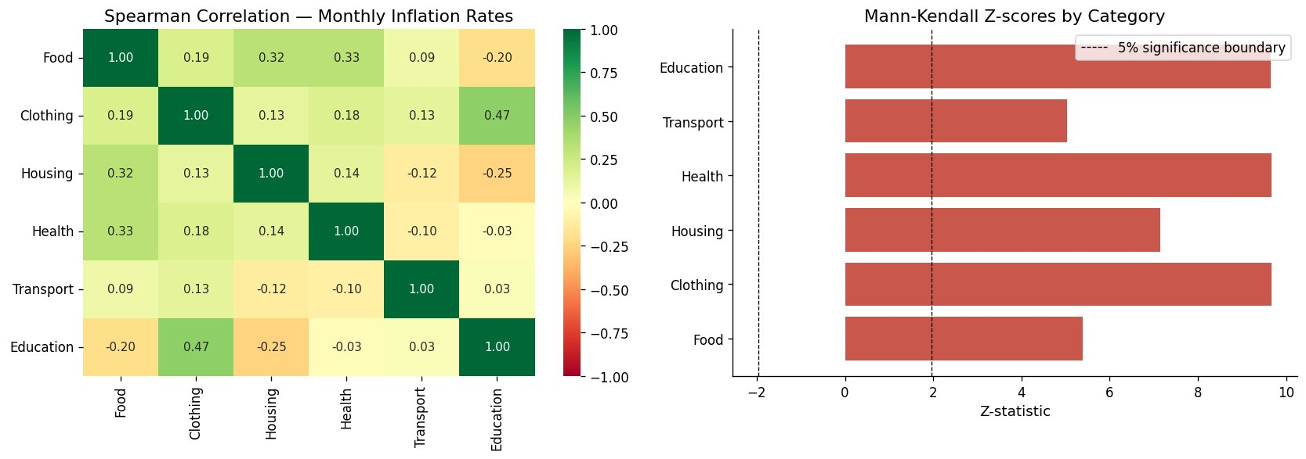
Figure 5.1: Nonparametric analysis results: (left) Spearman rank correlation heatmap — predominantly weak inter-category correlations with Clothing–Education being the strongest pair (ρ = 0.47); (right) Mann-Kendall Z-scores by category — all bars extend well beyond the 5% significance boundary (Z = ±1.96), confirming significant upward trends in every sub-category.

6. Bonus Method — Probability Distribution Fitting

6.1 Method & Results
Four candidate distributions were fitted to Pakistan's monthly CPI inflation rate (200 observations, WB data 2008–2025) using maximum likelihood estimation. Model selection used both the Kolmogorov-Smirnov goodness-of-fit test and AIC.
Distribution | Parameters | KS Statistic | KS p-value | AIC | Best Fit?
Normal | μ=0.797, σ=1.129 | 0.0718 | 0.2420 | 619.25 | No
Gamma | α=0.497, fitted β | 0.0536 | 0.5956 | 610.79 | No
Laplace | μ=0.629, b=0.774 | 0.0782 | 0.1640 | 606.43 | No
Student's t (df=5) | df=5, loc=0.629 | 0.0554 | 0.5513 | 596.99 | YES ✓
Table 6.1: Distribution Fitting Comparison — KS Test and AIC. Student's t wins on both criteria.
The Student's t-distribution with 5 degrees of freedom achieves the lowest AIC (596.99), outperforming Normal (619.25), Gamma (610.79), and Laplace (606.43). All four pass the KS test (all p > 0.05), but AIC identifies the t-distribution as the most efficient. The t-distribution with low df is designed to capture fat tails — elevated probability of extreme values — precisely the characteristic confirmed by the excess kurtosis of 3.87. This means extreme monthly inflation months (like the 6.34% peak) are expected significantly more frequently than a Normal model would predict. Figure 6.1 visually confirms the t-distribution's superior fit through both the histogram and the near-perfect P-P plot alignment.
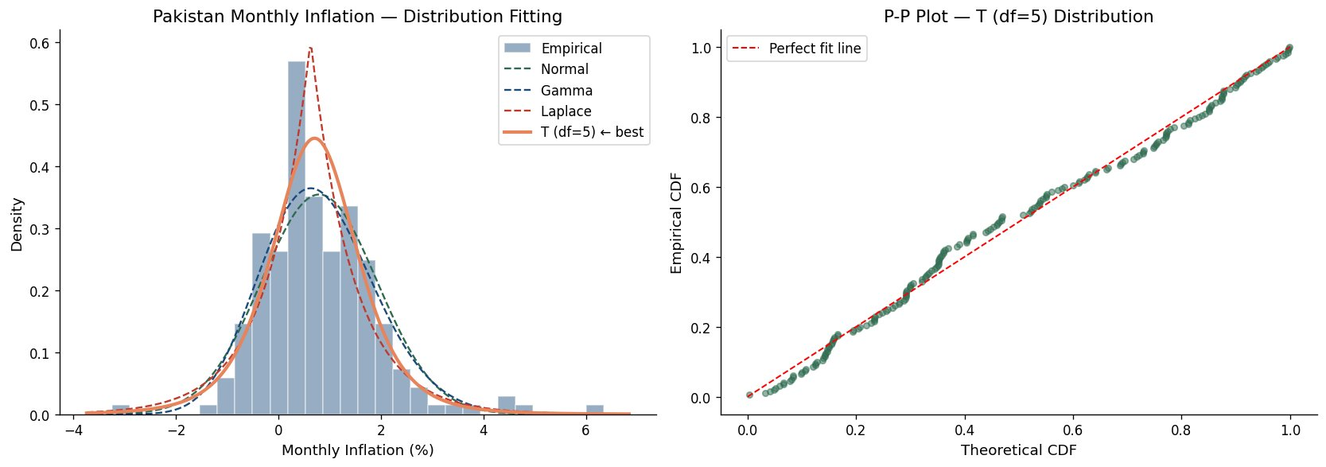
Figure 6.1: Distribution fitting results: (left) histogram of monthly CPI inflation rates with all four fitted PDFs overlaid — the Student's t (solid orange line, best) most closely follows the empirical distribution; (right) P-P plot for the winning Student's t-distribution showing strong alignment with the perfect-fit diagonal across the full probability range.

7. Analytical Workflow & Comparative Interpretation

7.1 Cross-Method Synthesis
The four methods collectively deliver a coherent and mutually reinforcing picture. The ARIMA model establishes that headline CPI follows a highly persistent non-stationary trend (AR coefficient = 0.939) and forecasts continued but moderating price increases through March 2026. The ANOVA result (p = 0.980) and Kruskal-Wallis result (p = 0.009) taken together reveal that while arithmetic mean monthly inflation rates are statistically equal across categories — confirming the broad-based macroeconomic nature of the shock — the distributional shape and extreme-value behaviour differ significantly across sectors. The Mann-Kendall test provides the most unambiguous finding: every single sub-category shows a statistically significant monotonic upward trend (all Z > 5.0, all p < 0.001), confirming this was a sustained structural restructuring rather than a temporary demand shock. The Spearman analysis reveals that despite the common upward trend, monthly rate movements are largely asynchronous across categories, driven by sector-specific administered pricing cycles. The Student's t-distribution finding confirms that Pakistan's inflation has fat tails — large monthly shocks are more probable than standard models assume.

7.2 Consolidated Summary of Findings
Method | Test / Statistic | Key Result | Interpretation
ARIMA | auto_arima + ADF | ARIMA(1,1,1), AIC=-1242 | Strong CPI persistence; 12-month forecast projects moderate continued rise to 284.95
ANOVA | F-test, η² | F=0.149, p=0.980, η²=0.003 | No significant difference in mean monthly inflation rates across categories
Kruskal-Wallis | H-statistic | H=15.44, p=0.009 | Significant distributional differences — Housing/Transport show extreme volatility
Mann-Kendall | S-stat, Z-score | All Z > 5.0, p < 0.001 | Every sub-category has significant monotonic upward trend 2022–2026
Spearman | ρ (rho) | Max ρ=0.471 (Clothing-Education) | Weak inter-category correlations — sector-specific timing of adjustments
Distribution Fit | KS test + AIC | Student's t (df=5), AIC=596.99 | Monthly inflation has fat tails; extreme months more probable than Normal predicts
Table 7.1: Consolidated Summary of All Statistical Findings

8. Limitations, Future Analysis & References

8.1 Data Limitations
- The IMF sub-category data covers only 45 months (July 2022–March 2026). A longer sub-category series would allow pre-crisis vs post-crisis structural comparisons and more robust trend detection.
- The World Bank and IMF datasets use different base years (2010=100 vs 2015/16=100) and are deliberately kept in separate models, preventing any direct numerical comparison of index levels across sources.
- The IMF COICOP classification aggregates some categories differently than the PBS official bulletin. Within-category heterogeneity (e.g., wheat vs. meat within Food) is not captured.

8.2 Statistical Limitations
- ARIMA(1,1,1) residuals are non-normal (Shapiro-Wilk p < 0.001, kurtosis = 6.70), implying 95% forecast confidence intervals may be underestimated during volatile periods. A GARCH extension would model conditional heteroscedasticity explicitly.
- ANOVA and Kruskal-Wallis observations are time-dependent, technically violating the independence assumption. Using monthly percentage changes substantially reduces but does not eliminate this dependence.
- Levene's test confirmed unequal group variances (F = 6.87, p < 0.001). Welch's ANOVA would be a more robust parametric alternative if normality were satisfied.
- The Mann-Kendall test can be affected by autocorrelation in the series. The modified Mann-Kendall test (Hamed & Rao, 1998) correcting for serial dependence would strengthen trend detection results.

8.3 Suggestions for Future Analysis
- Extension of IMF sub-category data back to 2010 using PBS monthly CPI bulletins would enable decade-long structural break analysis around the 2018-19 currency crisis.
- A SARIMAX model incorporating exogenous predictors (M2 money supply, PKR/USD exchange rate, international oil price) would improve forecast accuracy and reveal macroeconomic transmission channels.
- Quantile regression would allow analysis of how different percentiles of the inflation distribution respond to macroeconomic shocks — particularly for understanding disproportionate impacts on low-income households.
- Panel data analysis across Pakistan's four provinces using PBS provincial CPI data would reveal geographic heterogeneity in inflation exposure.

8.4 References
World Bank. (2024). Global Inflation Database. https://www.worldbank.org/en/research/brief/inflation-database
International Monetary Fund. (2024). IMF Data — Consumer Price Index. https://data.imf.org
Pakistan Bureau of Statistics. (2024). Consumer Price Index. https://www.pbs.gov.pk/cpi

— End of Report —

