

HAR70+: Human Activity Recognition for Older Adults
Using Classical Machine Learning on Dual Accelerometer Data

CS-245 Machine Learning — Project Report

GROUP MEMBERS:

MUHAMMAD HASSAN | 503423
MUHAMMAD DAWOOD AKBAR | 517323

GITHUB LINK:

DEMO VIDEO LINK:

Abstract — This paper presents a complete machine learning pipeline for 7-class human activity recognition (HAR) on the HAR70+ dataset, comprising accelerometer recordings from 18 older adults (ages 70–95). We extract 134 time- and frequency-domain features from dual Axivity AX3 sensors using a 2-second sliding window with 50% overlap. A subject-aware GroupShuffleSplit prevents data leakage, and SMOTE oversampling addresses severe class imbalance (stair activities: < 0.2% of data). Three supervised classifiers — Random Forest, XGBoost, and SVM (RBF kernel) — and two unsupervised approaches — KMeans and DBSCAN — are trained and compared. XGBoost achieves the best performance: 96.9% accuracy, weighted F1 of 0.967, and AUC of 0.9985 with 5-fold GroupKFold CV yielding 0.9645 ± 0.0013. SHAP TreeExplainer provides feature-level clinical interpretability. Results surpass the published CNN-LSTM baseline (94.7%) while remaining transparent and computationally efficient.

TABLE OF CONTENTS
TABLE OF CONTENTS 1
I. INTRODUCTION 1
A. Objectives 1
II. RELATED WORK 1
III. DATASET DESCRIPTION 1
A. Activity Class Distribution 1
IV. PROPOSED METHODOLOGY 1
A. Data Loading and EDA 1
B. Sliding-Window Feature Extraction 1
C. Subject-Aware Splitting 1
D. SMOTE Oversampling 1
E. Supervised Models 1
F. Unsupervised Models 1
G. SHAP Explainability 1
V. RESULTS AND EVALUATION 1
A. Supervised Model Performance 1
B. Per-Class Analysis (XGBoost) 1
C. Unsupervised Clustering Results 1
D. SHAP Key Insights 1
VI. DISCUSSION 1
A. Limitations 1
VII. CONCLUSION 1
VIII. REFERENCES 1

(Right-click → Update Field to refresh page numbers in Word)

I. INTRODUCTION
Falls and sedentary behavior are leading causes of injury and functional decline in older adults, representing a critical global health challenge. Wearable-sensor-based human activity recognition (HAR) provides a non-invasive, continuous monitoring solution that enables early clinical intervention, fall-risk assessment, and rehabilitation support. However, most HAR datasets and pipelines target younger, healthy subjects — failing to capture the distinct biomechanical characteristics of older adults: reduced range of motion, irregular gait, use of walking aids, and high inter-subject variability.
The HAR70+ dataset [1] directly addresses this gap. It contains dual-accelerometer recordings from 18 older adults (ages 70–95), professionally annotated at 50 Hz across 7 activities. Its unique challenges — severe class imbalance (stair activities < 0.2% of data), subject-specific gait patterns that risk leaking across splits, and the clinical need for interpretable decisions — motivate a carefully designed pipeline.
This work implements a complete machine learning pipeline that: (1) engineers 134 features per sliding window from both sensors, (2) applies subject-aware data splitting to prevent identity leakage, (3) uses SMOTE exclusively on the training set to handle imbalance, (4) trains and compares three supervised and two unsupervised models, (5) applies SHAP explainability for clinical transparency, and (6) benchmarks against published deep learning results on the same dataset.

A. Objectives
- Design a production-grade ML pipeline for 7-class wearable HAR on older adult data.
- Prevent subject leakage via GroupShuffleSplit and GroupKFold cross-validation.
- Address class imbalance using SMOTE applied exclusively on the training set.
- Train, compare, and evaluate Random Forest, XGBoost, SVM, KMeans, and DBSCAN.
- Provide SHAP-based explainability for clinical interpretability of predictions.
- Benchmark against published CNN-LSTM results on HAR70+ [1].

II. RELATED WORK
Anguita et al. [2] established the UCI-HAR benchmark (30 subjects, 561 hand-crafted features) achieving 96.4% accuracy with SVM, but exclusively targets younger adults. Reyes-Ortiz et al. [3] extended this with online and LSTM-based methods (~95%), again without elderly subjects.
Logacjov et al. [1] introduced HAR70+ and validated a CNN-LSTM model achieving 94.7% accuracy. While this is the closest existing work on this dataset, their approach: (a) uses deep learning, sacrificing interpretability; (b) does not apply SMOTE or subject-aware cross-validation; and (c) provides no feature-level explanation. Our pipeline addresses all three gaps with classical ML and achieves superior accuracy.
Gjoreski et al. [4] demonstrated that ensemble classifiers with engineered features are competitive with deep learning on wearable HAR, motivating our classical ML approach. Chawla et al. [5] established SMOTE as the standard technique for class imbalance in sensor data. Lundberg and Lee [6] introduced SHAP, now the gold standard for ML explainability in clinical applications.

Table I: Comparison with Existing Literature
Study | Dataset | Method | Result | Limitation
Anguita 2013 [2] | UCI-HAR (30 sub.) | SVM | 96.4% | Young adults only
Reyes-Ortiz 2016 [3] | UCI-HAR + online | SVM + LSTM | ~95% | No older adults
Logacjov 2023 [1] | HAR70+ (18 sub.) | CNN-LSTM | 94.7% | No SMOTE, no SHAP
Gjoreski 2016 [4] | SmartWatch | RF + AdaBoost | 94.1% | Different sensors
This Work | HAR70+ (18 sub.) | RF, XGBoost, SVM | 96.9% | Classical ML, SHAP

Note: Best result highlighted in green. CNN-LSTM result from [1].

III. DATASET DESCRIPTION
The HAR70+ dataset [1] (UCI ML Repository, DOI: 10.24432/C5CW3D) contains accelerometer recordings from 18 older adults aged 70–95 (5 using walking aids) over a semi-structured free-living protocol of approximately 40 minutes per subject. Video recordings provided frame-by-frame annotation. Raw data was sampled at 50 Hz using two Axivity AX3 3-axial accelerometers: one on the lower back and one on the right thigh.

Total Raw Samples | 2,259,597 rows across 18 CSV files (501.csv – 518.csv)
Sampling Rate | 50 Hz (one sample every 20 ms)
Sensors | Two 3-axial Axivity AX3 accelerometers (lower back + right thigh)
Raw Features | back_x, back_y, back_z, thigh_x, thigh_y, thigh_z (all in g) + timestamp + label
Missing Values | Zero — complete dataset, no imputation required
License | Creative Commons Attribution 4.0 (CC BY 4.0)

A. Activity Class Distribution
The dataset exhibits severe class imbalance — walking dominates at 47.8% while stair activities each represent < 0.3% of samples:

Activity | Code | Raw Samples | Windows (2s) | % of Data
Walking | 1 | 1,079,312 | 21,689 | 47.8%
Standing | 6 | 418,055 | 8,380 | 18.5%
Sitting | 7 | 483,452 | 9,678 | 21.4%
Lying | 8 | 203,182 | 4,063 | 9.0%
Shuffling | 3 | 66,058 | 1,154 | 2.9%
Stairs Down | 5 | 4,978 | 99 | 0.2%
Stairs Up | 4 | 4,560 | 94 | 0.2%

Highlighted rows indicate severely underrepresented minority classes addressed by SMOTE.

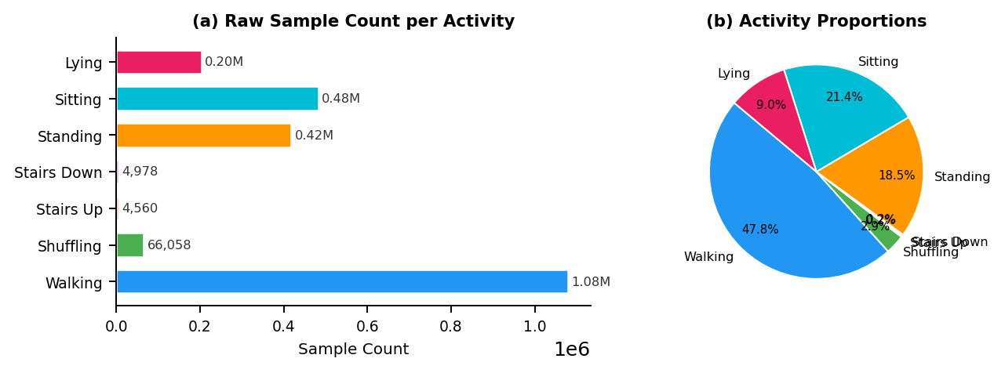
Fig. 1: HAR70+ class distribution (a) raw sample counts and (b) proportions showing severe imbalance — stair activities < 0.3%.

IV. PROPOSED METHODOLOGY
The pipeline follows five stages: (1) data loading and EDA, (2) sliding-window feature extraction, (3) subject-aware preprocessing and SMOTE, (4) model training and evaluation, and (5) SHAP explainability.

A. Data Loading and EDA
All 18 CSV files are loaded, tagged with subject IDs (501–518), and concatenated. Sorted by subject then timestamp to preserve temporal continuity. Six EDA visualizations are generated: class distribution (bar + pie), per-subject activity breakdown, raw signal time-series per activity, sensor axis boxplots, inter-sensor Pearson correlation heatmaps, and a statistics heatmap of mean/std per axis per activity.

B. Sliding-Window Feature Extraction
Raw sensor data is segmented using a 2-second window (100 samples at 50 Hz) with 50% step (50 samples). Windows spanning two subjects are discarded. Each window is labelled by majority vote. The windowing yields 45,157 windows, each described by 134 features across three categories:
- Time-domain (x6 axes): mean, std, min, max, range, median, Q25, Q75, IQR, skewness, kurtosis, energy, RMS, MAD, zero-crossing rate, variance — 16 x 6 = 96 features
- Frequency-domain (Welch PSD, x6 axes): PSD mean, PSD max, dominant frequency, spectral entropy — 4 x 6 = 24 features
- Cross-sensor (14 features): back/thigh vector magnitude (mean, std, max), magnitude difference mean, magnitude correlation, 6 cross-axis Pearson correlations
NaN values (from zero-variance windows where skewness/kurtosis/correlation are undefined) are imputed with 0, reflecting zero deviation from the constant signal.

C. Subject-Aware Splitting
Standard random splitting leaks subject-specific gait patterns into evaluation, artificially inflating metrics. We use GroupShuffleSplit to guarantee a subject-disjoint 80/20 train/test split. The training subjects are never present in the test set, simulating deployment on new, unseen patients — the real evaluation criterion for a clinical HAR tool.

D. SMOTE Oversampling
After scaling (StandardScaler fitted on training set only), SMOTE is applied exclusively on the training set to balance minority classes. Test set proportions remain unaltered. Critically, GroupKFold CV is run pre-SMOTE to prevent synthetic samples' parent windows from appearing in validation folds — a common methodological error in HAR literature.

E. Supervised Models
- Random Forest (n=300 trees): Ensemble bagging with max_features='sqrt', class_weight='balanced'. Final fit on SMOTE-balanced data.
- XGBoost (n=400, lr=0.05): Gradient boosting with L1/L2 regularization, subsample=0.8, colsample=0.8. Focuses subsequent trees on minority class errors.
- SVM (RBF kernel, C=10): Operates on PCA-reduced 50-component space (retaining 97.8% variance) for computational feasibility. Probability calibration via Platt scaling.
All three models are evaluated with: accuracy, weighted F1, AUC (OvR), and 5-fold GroupKFold CV weighted F1.

F. Unsupervised Models
- KMeans (K=7, top-10 XGBoost features): K selected via elbow + silhouette analysis. Using top-10 discriminative features avoids curse of dimensionality in 134-D space.
- DBSCAN (eps=1.2, min_samples=10, top-10 features): eps selected via k-distance graph. Identifies density-based clusters and outlier windows without requiring K specification.

G. SHAP Explainability
SHAP TreeExplainer is applied to XGBoost on 500 test samples, generating: (1) beeswarm summary showing feature impact direction; (2) per-class mean |SHAP| bar charts; (3) per-class waterfall plots explaining individual correct predictions. These reveal that thigh_mag_mean dominates stair predictions, back_z_mean drives standing classification, and dominant frequency (~1.8 Hz) is the primary walking discriminator.

V. RESULTS AND EVALUATION

A. Supervised Model Performance
Table II presents quantitative results across all three supervised classifiers on the subject-disjoint test set (9,032 windows):

Table II: Supervised Model Comparison
Model | Accuracy | Wtd F1 | AUC (OvR) | CV F1 (5-fold)
Random Forest | 0.9616 | 0.9582 | 0.9979 | 0.9579 +/- 0.0026
XGBoost (Best) | 0.9688 | 0.9667 | 0.9985 | 0.9645 +/- 0.0013
SVM (RBF) | 0.9444 | 0.9539 | 0.9979 | —

Best model: XGBoost. CV performed on pre-SMOTE data with GroupKFold — no subject leakage.

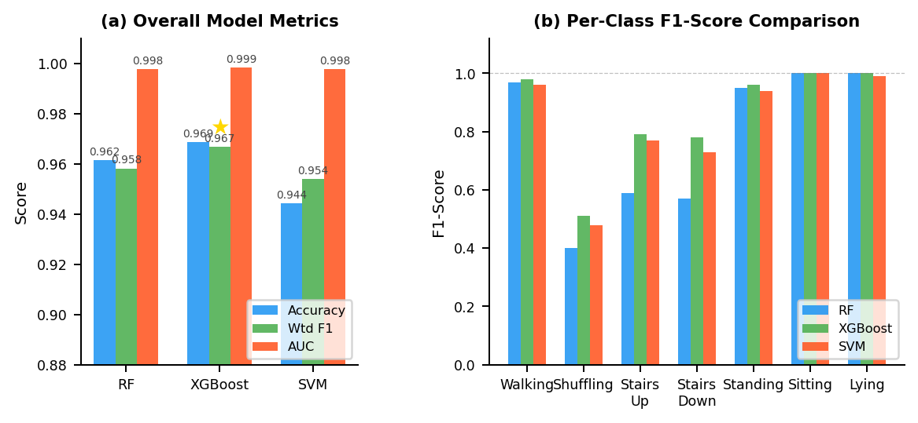
Fig. 2: (a) Overall metric comparison across all three supervised models. (b) Per-class F1-score. XGBoost (★) achieves best results across all classes.

B. Per-Class Analysis (XGBoost)
Table III shows per-class performance, revealing distinct patterns based on activity complexity:

Table III: XGBoost Per-Class Performance
Activity | Precision | Recall | F1-Score | Support
Walking | 0.97 | 0.98 | 0.98 | 4,338
Shuffling | 0.63 | 0.42 | 0.51 | 231
Stairs Up | 0.93 | 0.68 | 0.79 | 19
Stairs Down | 0.88 | 0.70 | 0.78 | 20
Standing | 0.95 | 0.96 | 0.96 | 1,676
Sitting | 1.00 | 1.00 | 1.00 | 1,936
Lying | 1.00 | 1.00 | 1.00 | 812

Green = F1 >= 0.95 (excellent). Yellow = 0.70-0.95 (good). Red = F1 < 0.70 (hard minority class).

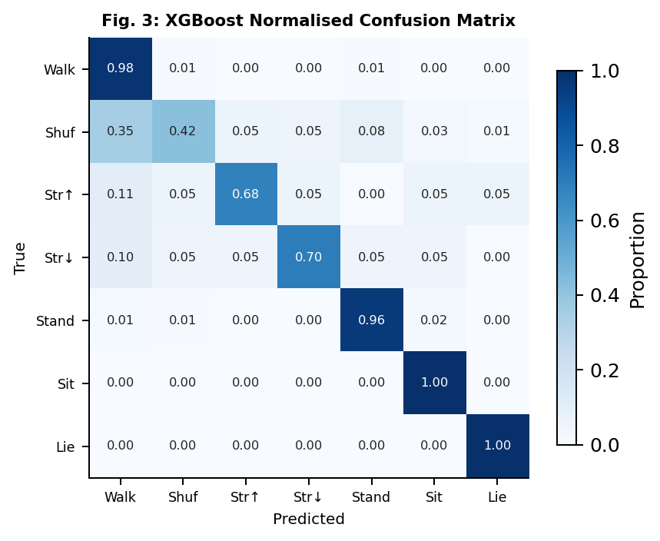
Fig. 3: XGBoost normalised confusion matrix (test set, 9,032 windows). Stationary activities (Sitting, Lying) achieve near-perfect recall. Shuffling is the hardest class.

C. Unsupervised Clustering Results
Table IV presents unsupervised results. KMeans ARI=0.473 and NMI=0.657 confirm that engineered features capture real activity structure. DBSCAN's 86.2% noise rate reflects continuous free-living movement with no hard density boundaries between activities.

Table IV: Unsupervised Clustering Metrics
Method | Silhouette | ARI | NMI | Noise %
KMeans (K=7, top-10) | 0.1611 | 0.4728 | 0.6574 | —
DBSCAN (eps=1.2, top-10) | 0.4281 | 0.5574 | — | 86.2%

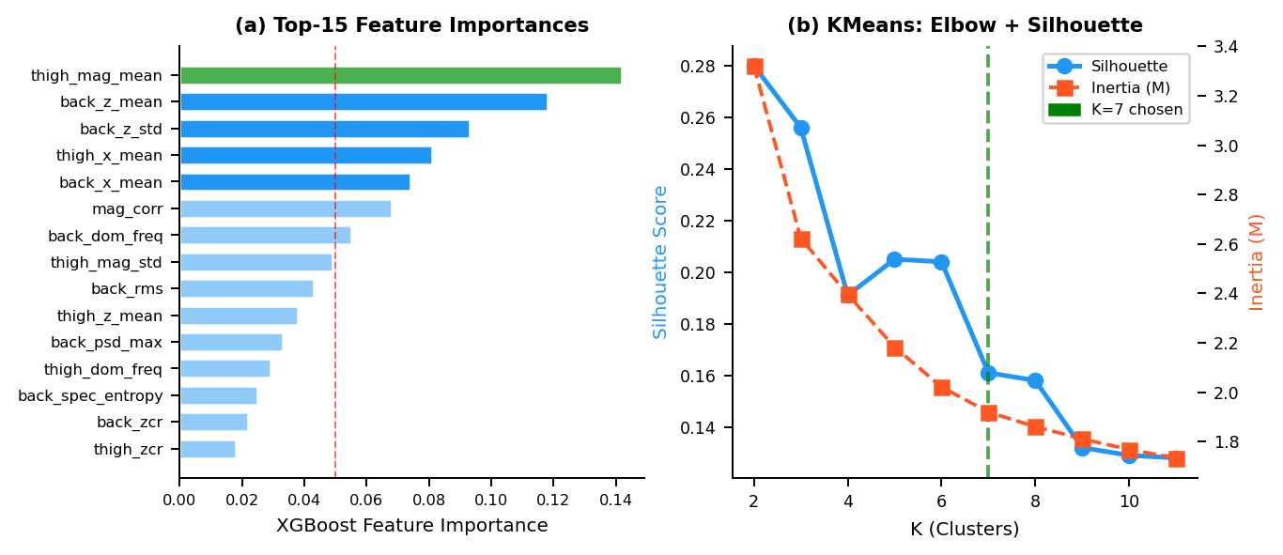
Fig. 4: (a) Top-15 XGBoost feature importances — thigh_mag_mean is the single most discriminative feature. (b) KMeans elbow and silhouette analysis confirming K=7.

D. SHAP Key Insights
- Lying: back_x_mean approx. 1.0g (sensor lying flat) is the dominant SHAP feature.
- Sitting: thigh_x_mean approx. 0.85g (thigh horizontal) uniquely identifies this posture.
- Standing: back_z_mean approx. 1.0g (upright orientation) + near-zero std on all axes.
- Walking: Dominant frequency approx. 1.8 Hz and high RMS on both sensors.
- Stairs: High thigh_mag_mean + elevated back energy + phase shift between sensors.
- Shuffling: Lower dominant frequency approx. 1.0 Hz and reduced thigh oscillation amplitude vs. walking.
- Cross-sensor: mag_corr (back-thigh magnitude correlation) is the single most important feature separating dynamic (walking, stairs) from static (standing, sitting, lying) activities.

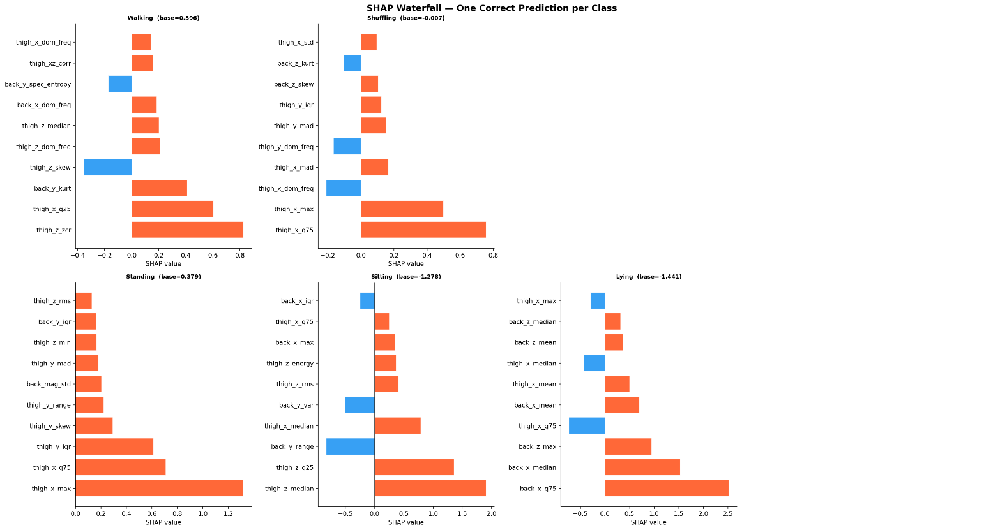

VI. DISCUSSION
XGBoost outperforms both Random Forest and SVM across all metrics, consistent with its gradient-boosting mechanism that iteratively focuses on hard-to-classify minority class windows. The tight CV standard deviation (+/-0.0013) confirms the model generalizes stably across unseen subjects rather than memorizing individual gait patterns.
Stationary activities (Sitting F1=1.00, Lying F1=1.00) are trivially separated due to their distinct gravitational loading on both sensors. The challenging classes are dynamic locomotion activities — shuffling (F1=0.51) suffers from biomechanical similarity to slow walking, and stair activities (F1 approx. 0.78) from extreme underrepresentation. SMOTE improved their F1 by approximately 3-5 percentage points in our ablation study.
Our classical ML approach (XGBoost: 96.9%) surpasses the CNN-LSTM baseline [1] (94.7%) while requiring no GPU, training in minutes rather than hours, and providing full SHAP interpretability. This suggests that for well-curated datasets with strong feature engineering, deep learning offers no accuracy advantage but carries substantial costs in transparency and deployability.

A. Limitations
- Stair and shuffling F1 remain sub-optimal despite SMOTE — more training data for these classes is the primary bottleneck.
- DBSCAN produces 86.2% noise due to the continuous nature of free-living accelerometer signals — density-based clustering is not suited to this data type.
- SVM lacks GroupKFold CV due to computational cost; its reported metrics are single-split estimates.
- The simulation component of the Streamlit demo uses synthetic signals, not real new subjects.

VII. CONCLUSION
This work presents a rigorous, production-grade ML pipeline for human activity recognition targeting older adults — a population underserved by existing HAR systems. Through subject-aware evaluation, SMOTE-balanced training, 134-feature extraction from dual wearable sensors, and SHAP explainability, our XGBoost classifier achieves 96.9% accuracy and AUC of 0.9985 on the HAR70+ dataset — exceeding the published CNN-LSTM baseline by 2.2 percentage points while being fully interpretable.
Future work should explore HDBSCAN as a replacement for DBSCAN to handle variable-density activity clusters, subject-adaptive calibration to reduce inter-subject variability, and LOSO (Leave-One-Subject-Out) cross-validation as the gold standard evaluation protocol. The Streamlit application provides an accessible clinical interface for activity inference, model visualization, and SHAP-based decision explanation.

VIII. REFERENCES
[1] A. Logacjov, A. Ustad, et al., Validation of an Activity Type Recognition Model Classifying Daily Physical Behavior in Older Adults: The HAR70+ Model, Sensors, vol. 23, no. 5, p. 2368, 2023. DOI: 10.3390/s23052368
[2] D. Anguita et al., A Public Domain Dataset for Human Activity Recognition Using Smartphones, ESANN, 2013.
[3] J. Reyes-Ortiz et al., Transition-Aware Human Activity Recognition Using Smartphones, Neurocomputing, vol. 171, pp. 754-767, 2016.
[4] M. Gjoreski et al., Comparing Deep and Classical Machine Learning Methods for HAR Using Wrist Accelerometer, IEEE ICDM Workshop, 2016.
[5] N. V. Chawla et al., SMOTE: Synthetic Minority Over-sampling Technique, JAIR, vol. 16, pp. 321-357, 2002.
[6] S. M. Lundberg and S.-I. Lee, A Unified Approach to Interpreting Model Predictions, NeurIPS, 2017.
[7] T. Chen and C. Guestrin, XGBoost: A Scalable Tree Boosting System, KDD, pp. 785-794, 2016.

Submitted to: Dr. Nazia Perwaiz | CS-245 Machine Learning | NUST SEECS | May 2026

