
University Of Engineering And Technology Pesh
(Department of Computer Science)

Name : Muhammad Hassan

Section : A

Reg No: 24pwbcs1246

Subject: Web development

Instructor: Sir Muhammad

TASK: Webstrome IDE connected to Github and the whole project is commit to repository
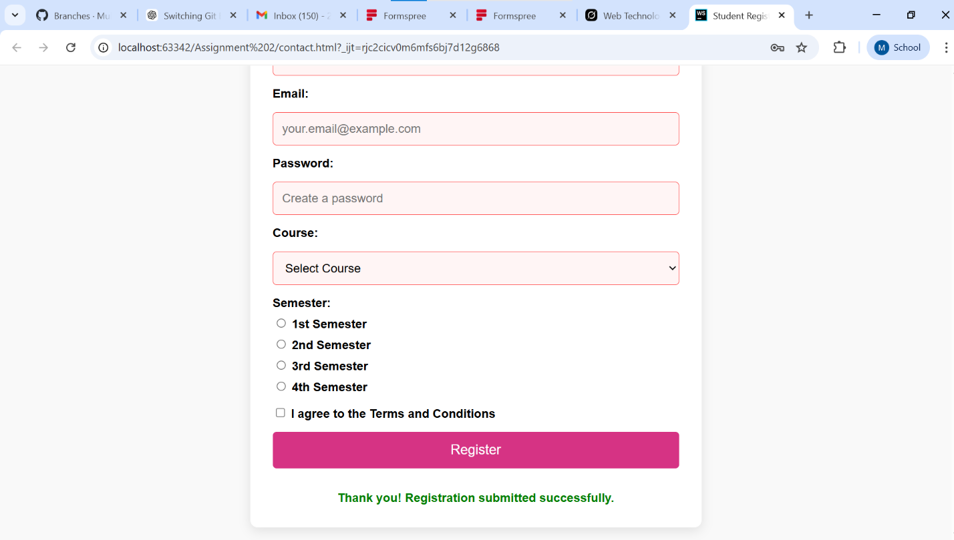
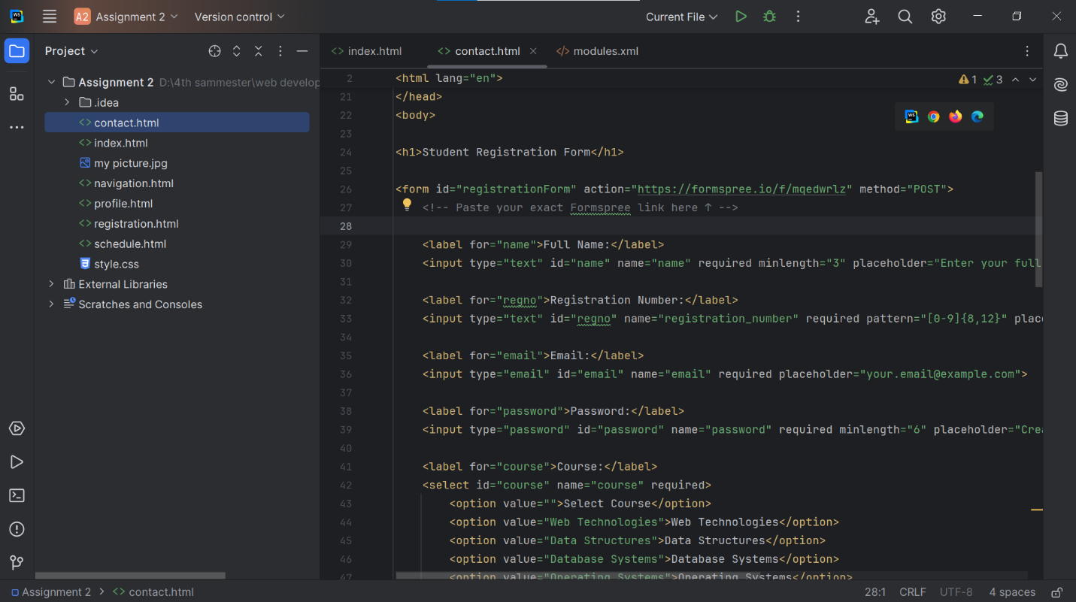

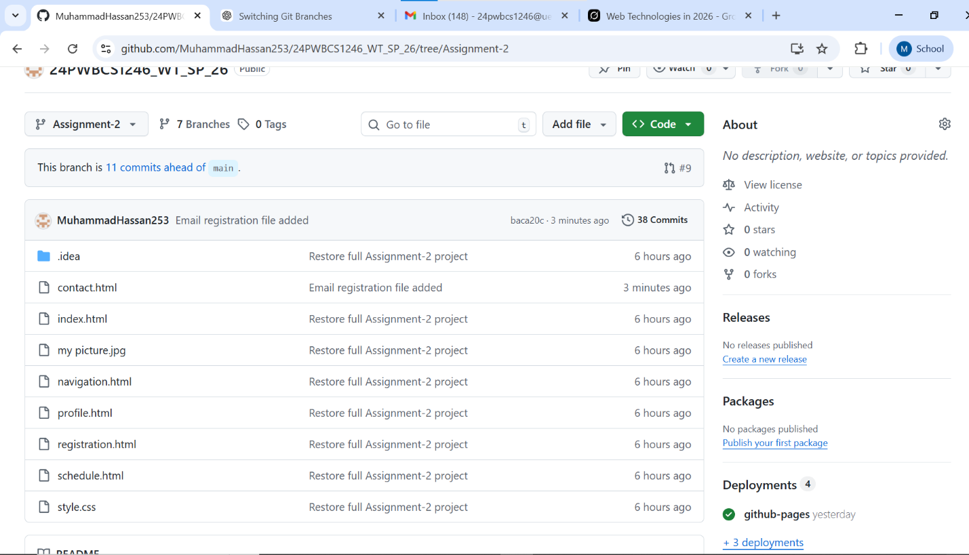

MY GITHUB LINK :
https://github.com/MuhammadHassan253/24PWBCS1246_WT_SP_26/tree/Assignment-2

