Event Discovery & Community Engagement Platform
Design Document
Version 1.0

Group Id: S26PROJECTC0D01
Supervisor Name: Amjad Iqbal Khan

Revision History
Date (dd/mm/yyyy) | Version | Description | Author
24-07-2026 | 1.0 | This Design Document presents the technical design and solution of the Event Discovery & Community Engagement Platform. It describes the overall system architecture, database design, Entity Relationship Diagram (ERD), class diagram, sequence diagrams, interface design, and test cases needed for implementation. The platform allows users to discover and participate in local and online events through interactive map and list views, search and filter events, RSVP for events, save favorite events, and submit new events for administrator review. The Administrator manages event records, categories, featured events, user-submitted events, registered users, and RSVP records through a secure administration panel. | BC250212514

Table of Contents

- Introduction of Design Document
- Entity Relationship Diagram (ERD)
- Sequence Diagrams
- Architecture Design Diagram
- Class Diagram
- Database Design
- Interface Design
- Test Cases

- Introduction of Design Document
Design Document is a technical solution of the SRS. It serves as the blueprint of the system, which describes the design and architecture of the whole system. It includes:
- “Entity Relationship Diagram” which describes the conceptual design of the database, i.e. entities of the system, their attributes and relationships among them.
- “Database Design”, which describes the logical design of the database, which is then implemented in any DBMS.
- “Sequence Diagrams”, describing the sequence of events that occur among different objects and services of the system, to perform a specific functionality.
- “Architecture Diagram”, which describes the tiered architecture of the system.
- “Class Diagram”, which depicts the object-oriented design of the system. It describes the attributes and methods associated with each class, and also inheritance (conceptual link among classes) and association (physical link among objects) relationships.
- “Interface Design”, which describes the user interface / front-end view of the system to which user will interact.
- “Test Cases” for each use-case / usage scenario.
Design Document is a very critical phase of the SDLC. It outlines what needs to be built, and provide a clear understanding of the system to all stakeholders like testers, client and developers etc. Many potential risks are identified and mitigated in the design phase, before moving ahead. It serves as the blueprint for the developers and provide consistency and standardization during development. It helps testers to test a particular functionality efficiently and make effective test plans as it provides the complete design of the system. It is very beneficial for maintenance and scalability, because it provides the complete architecture and design of the system and helps that how a specific area can be maintained and scaled up. It helps in quality assurance as a review and feedback reference and avoid rework result in cost efficiency. Moreover, it helps project managers to allocate resources for each activity of the SDLC.
- Entity Relationship Diagram (ERD)
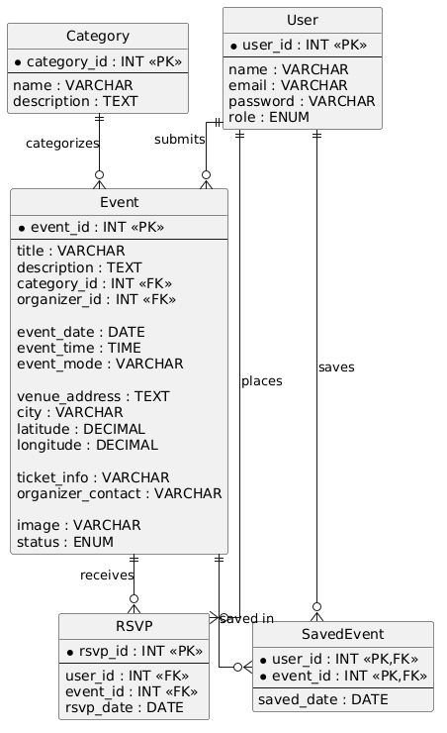

- Sequence Diagrams
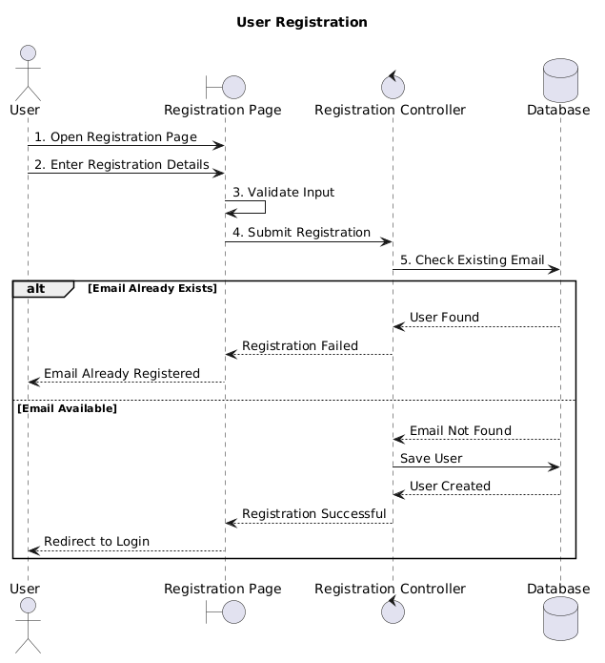
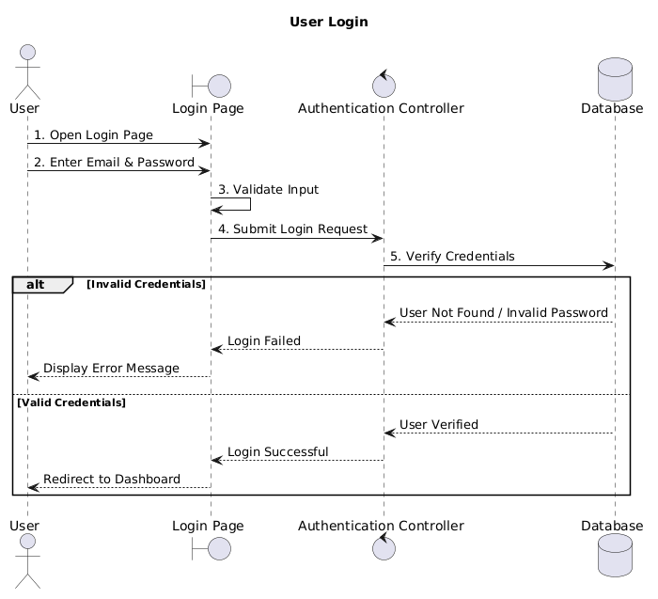
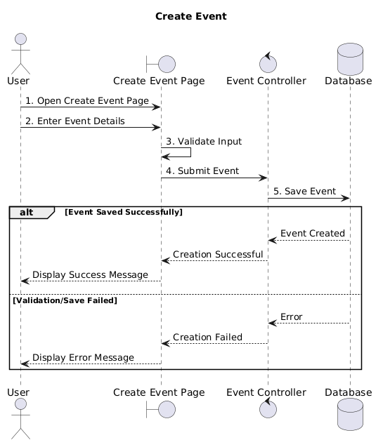
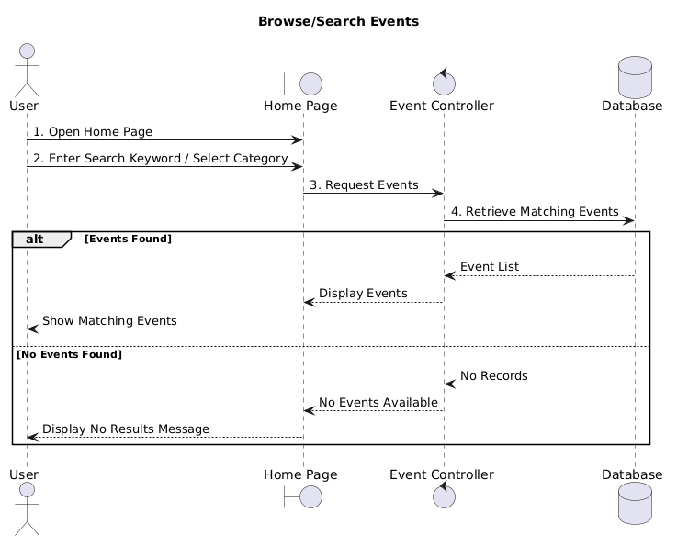
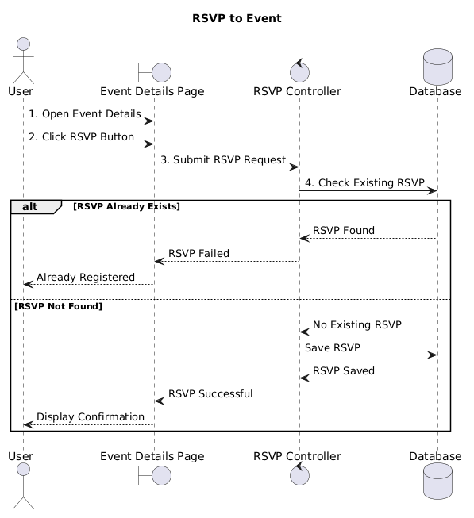
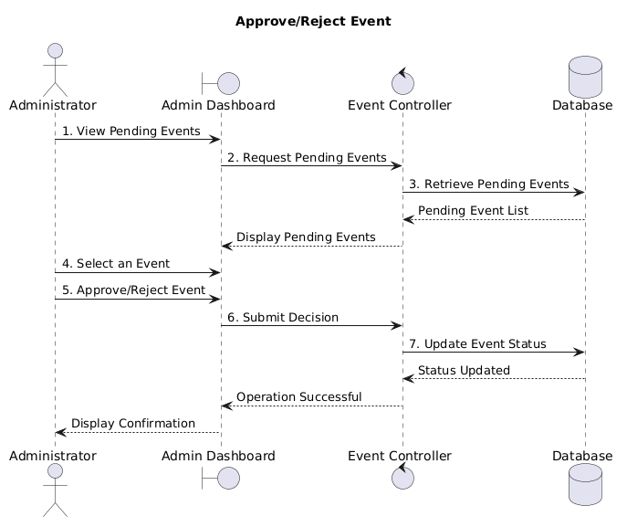

- Architecture Design Diagram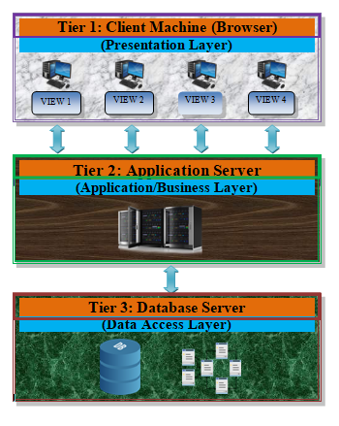

- Class Diagram

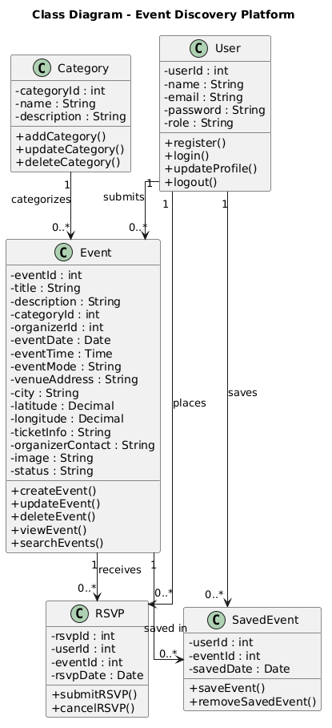

- Database Design

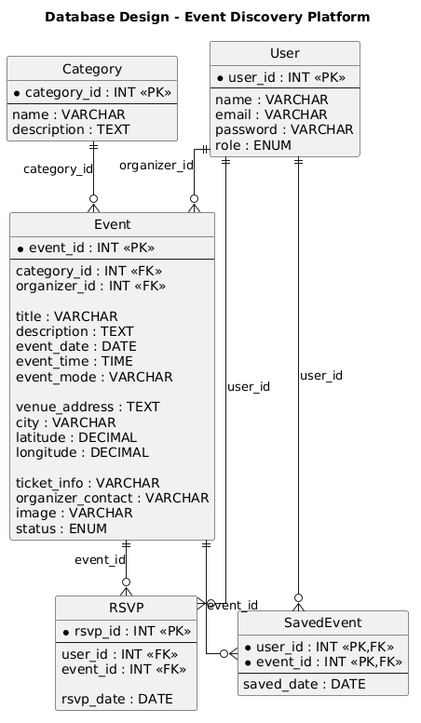
- Interface Design

Homepage view:

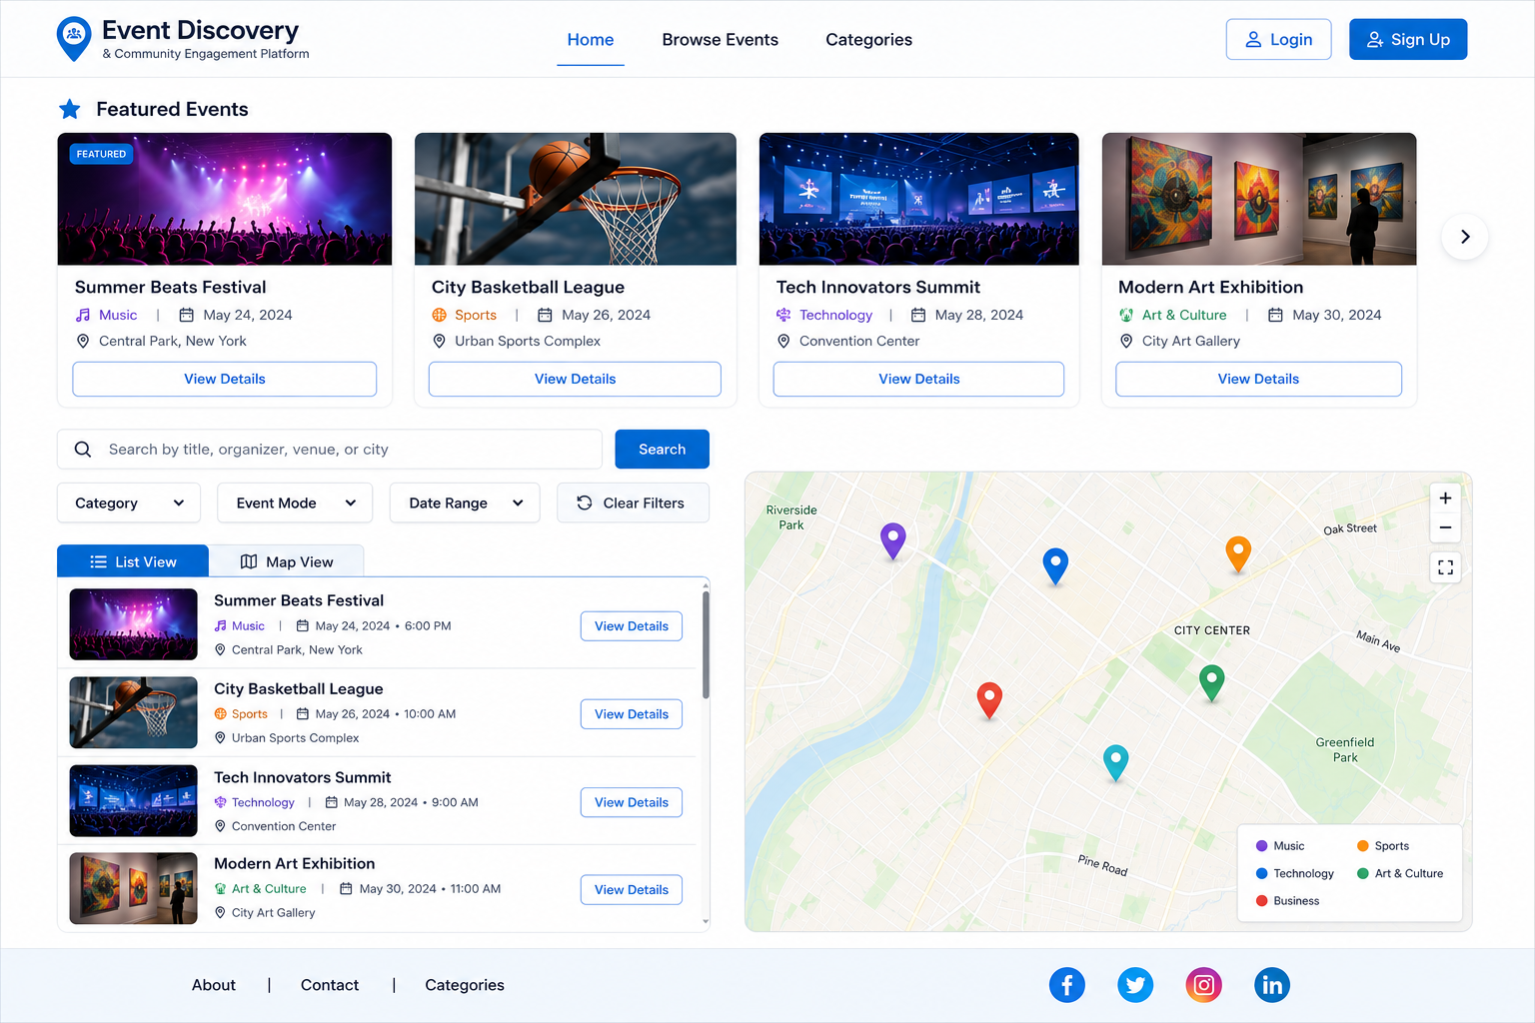

Login View:

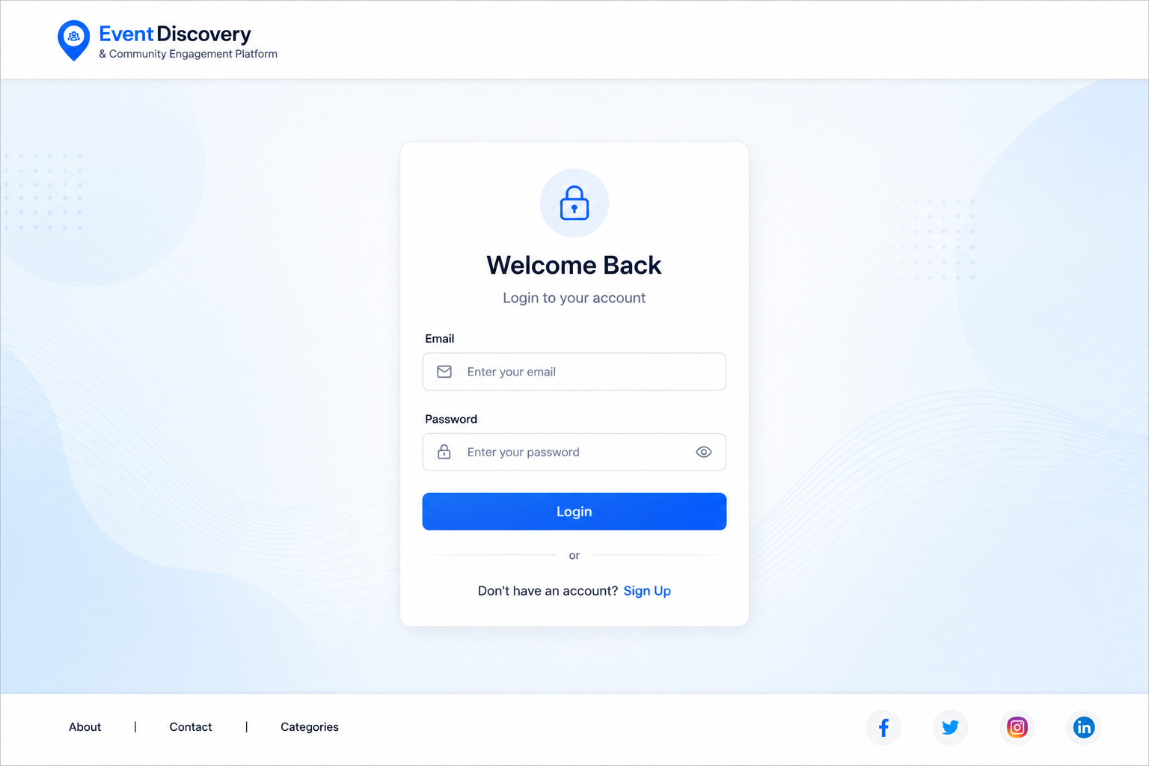
User Profile Dashboard view:

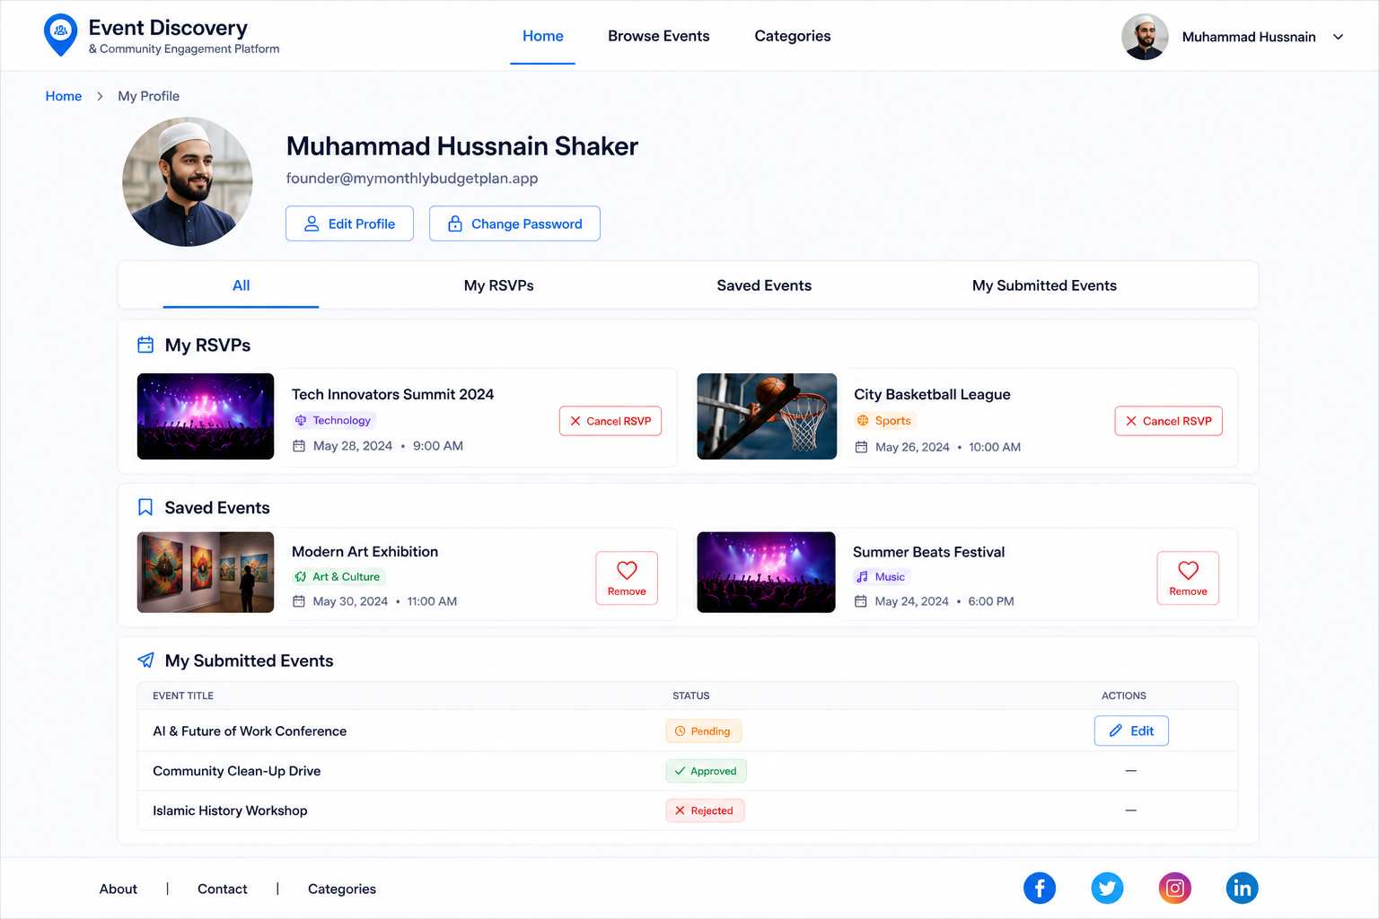

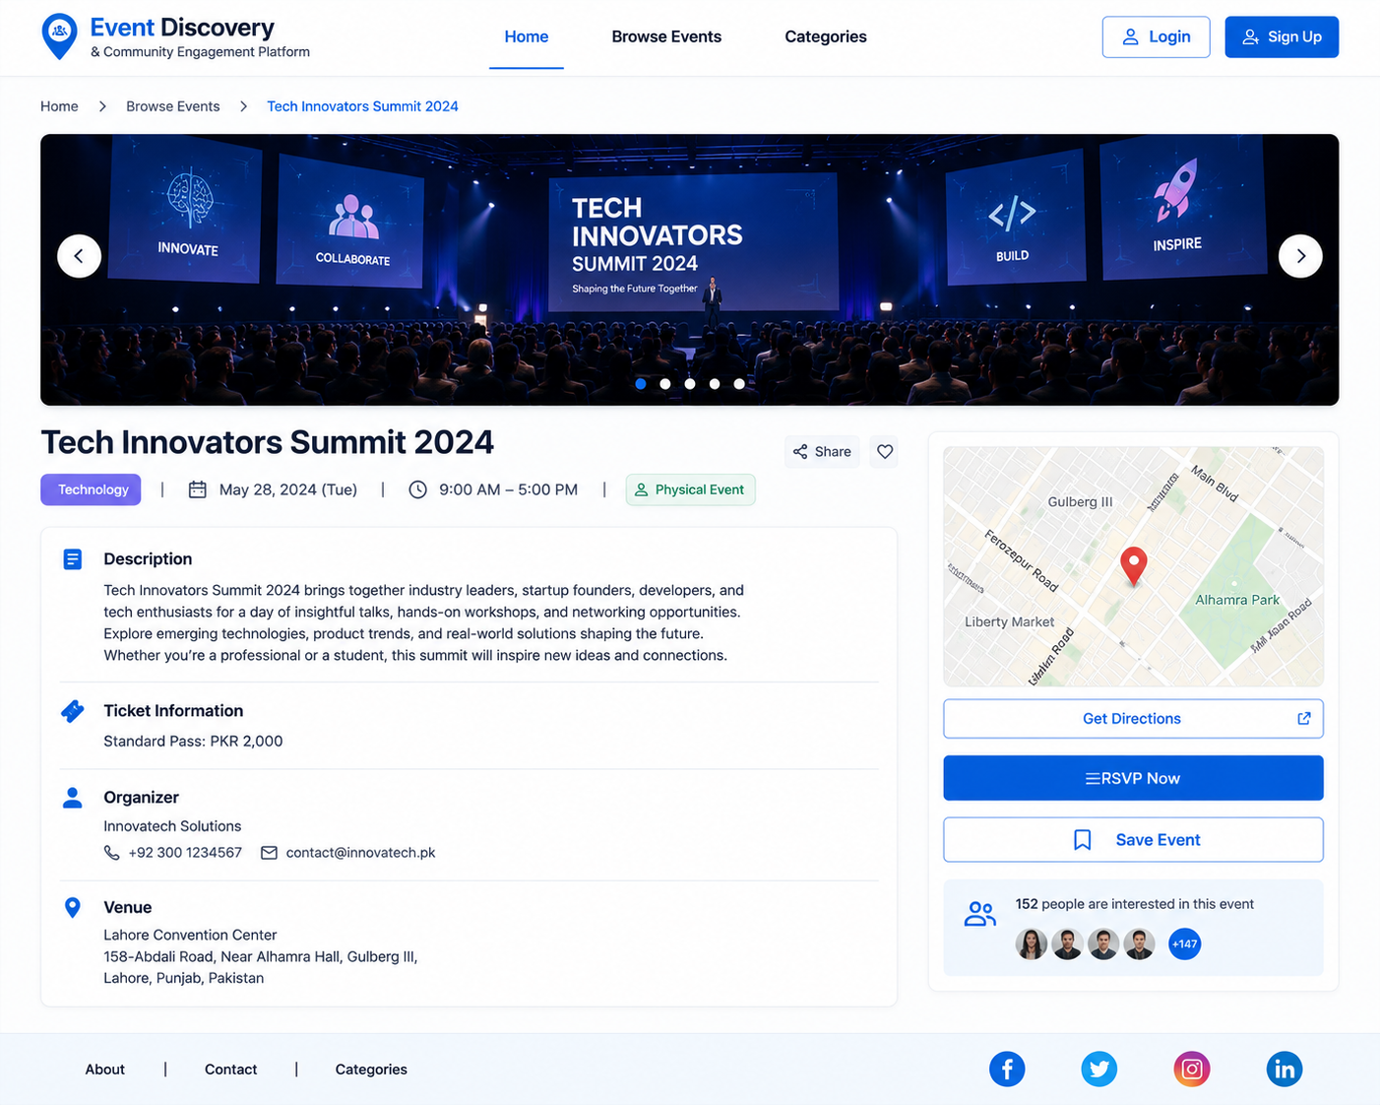

Event Detail Page View:

Submit Event View:

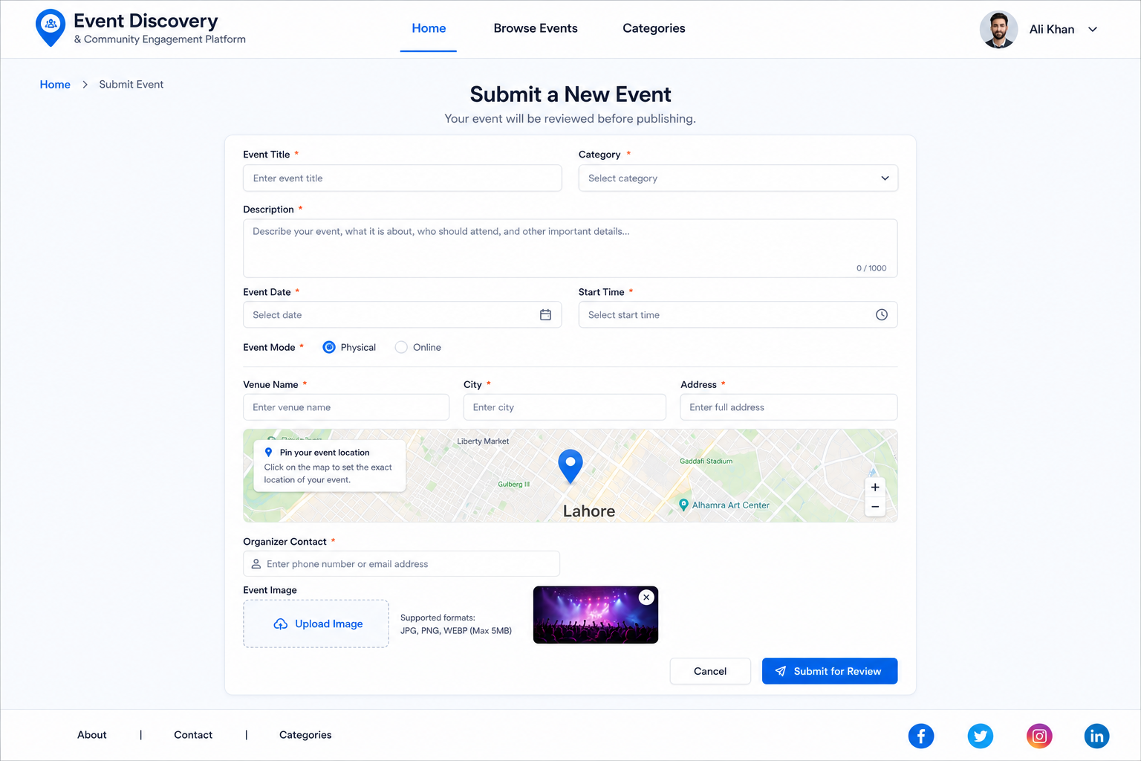
Admin Dashboard view:

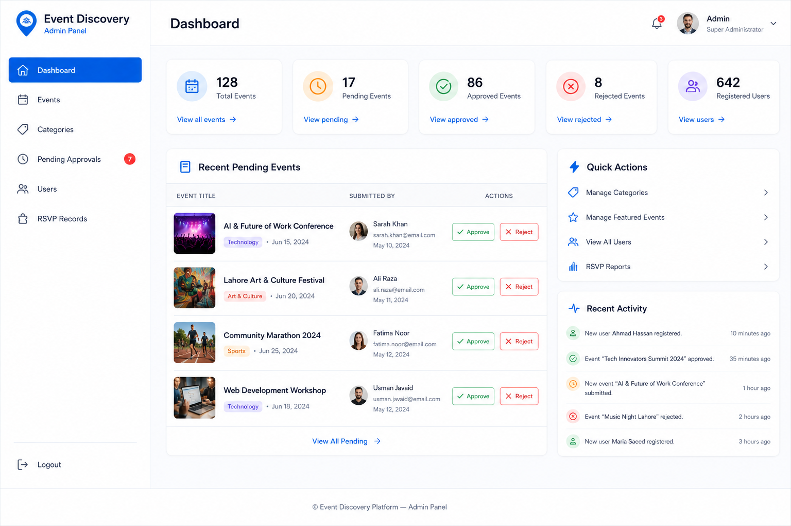

- Test Cases

TC-01: User Registration
Test Case ID | TC-01
Test Case Title | User Registration
UC Reference | UC-01
Pre-Conditions | User is not registered. Registration page is accessible.
Actions | 1. Open Sign Up / Register page.  2. Enter valid name, email address, password and confirm password.  3. Click the Submit / Register button.  4. System validates the entered information.
Expected Results | User account is created successfully and system displays a confirmation message.
Results | Pass / Fail
Author | BC250212514

TC-02: User Login
Test Case ID | TC-02
Test Case Title | User Login
UC Reference | UC-02
Pre-Conditions | User account already exists. Login page is accessible.
Actions | 1. Open Login page.  2. Enter registered email address and correct password.  3. Click the Login / Submit button.  4. System verifies the credentials.
Expected Results | Registered User is logged in successfully and redirected to homepage or user dashboard.
Results | Pass / Fail
Author | BC250212514

TC-03: Browse Events in List View
Test Case ID | TC-03
Test Case Title | Browse Events in List View
UC Reference | UC-03
Pre-Conditions | Application is accessible. At least one approved event exists in the system.
Actions | 1. Open homepage or Browse Events page.  2. System loads and displays approved events.  3. Observe events displayed in structured list view.  4. Verify each event card shows title, category, date, location/mode and short description.
Expected Results | All approved events are displayed correctly in list view with complete event card information.
Results | Pass / Fail
Author | BC250212514

TC-04: Browse Events on Map View
Test Case ID | TC-04
Test Case Title | Browse Events on Map View
UC Reference | UC-03
Pre-Conditions | Application is accessible. At least one approved physical event with valid coordinates exists.
Actions | 1. Open Browse Events page.  2. Switch to Map View tab.  3. Observe map markers loaded for physical events.  4. Click on a map marker.  5. Verify popup appears with event title, category, date and View Details option.
Expected Results | Map displays correct markers for physical events. Clicking a marker shows the correct event popup.
Results | Pass / Fail
Author | BC250212514

TC-05: Search Events
Test Case ID | TC-05
Test Case Title | Search Events
UC Reference | UC-04
Pre-Conditions | Browse Events page is open. At least one approved event exists.
Actions | 1. Enter a keyword (event title, organizer name, venue, city or description keyword) in the search bar.  2. Click Search button or press Enter.  3. System retrieves and displays matching approved events.  4. Verify list view and map markers update to show only matching results.
Expected Results | Only events matching the search keyword are displayed in list view and map view.
Results | Pass / Fail
Author | BC250212514

TC-06: Filter Events
Test Case ID | TC-06
Test Case Title | Filter Events
UC Reference | UC-04
Pre-Conditions | Browse Events page is open. Approved events of multiple categories and modes exist.
Actions | 1. Select a category from the Category dropdown.  2. Select an event mode from the Event Mode dropdown.  3. Select a date range from the Date Range filter.  4. System applies filters and updates results.  5. Click Clear Filters button to reset.
Expected Results | Only events matching all selected filter criteria are displayed. Clearing filters restores full approved events list.
Results | Pass / Fail
Author | BC250212514

TC-07: View Event Details
Test Case ID | TC-07
Test Case Title | View Event Details
UC Reference | UC-05
Pre-Conditions | At least one approved event exists in the system.
Actions | 1. Open event list, map popup, or featured event section.  2. Click View Details on an approved event.  3. System opens the event detail page.  4. Verify page displays event title, full description, category, date, time, venue/online info, organizer contact, ticket information, image, and mini map where available.
Expected Results | Event detail page displays all available complete information for the selected event.
Results | Pass / Fail
Author | BC250212514

TC-08: RSVP for Event
Test Case ID | TC-08
Test Case Title | RSVP for Event
UC Reference | UC-06
Pre-Conditions | Registered User is logged in. An approved event exists that the user has not already RSVP'd for.
Actions | 1. Open event detail page.  2. Click RSVP / Register button.  3. System checks for duplicate RSVP record.  4. System saves RSVP record.  5. Verify confirmation message is displayed.
Expected Results | RSVP record is saved against the user account and a confirmation message is displayed.
Results | Pass / Fail
Author | BC250212514

TC-09: Cancel RSVP
Test Case ID | TC-09
Test Case Title | Cancel RSVP
UC Reference | UC-06
Pre-Conditions | Registered User is logged in and has an existing RSVP for a future event.
Actions | 1. Open User Profile Dashboard.  2. Navigate to My RSVPs tab.  3. Click Cancel RSVP on an existing RSVP entry.  4. Confirm cancellation.  5. Verify RSVP is removed from the list.
Expected Results | RSVP record is removed successfully and no longer appears in the user's RSVP history.
Results | Pass / Fail
Author | BC250212514

TC-10: Save / Bookmark Event
Test Case ID | TC-10
Test Case Title | Save / Bookmark Event
UC Reference | UC-07
Pre-Conditions | Registered User is logged in. An approved event exists that has not been saved by this user.
Actions | 1. Open event card or event detail page.  2. Click Save / Bookmark button.  3. System checks for duplicate saved event record.  4. System saves the event against the user account.  5. Verify confirmation message is displayed.
Expected Results | Event is added to the user's saved events list and a confirmation message is displayed.
Results | Pass / Fail
Author | BC250212514

TC-11: Remove Saved Event
Test Case ID | TC-11
Test Case Title | Remove Saved Event
UC Reference | UC-07
Pre-Conditions | Registered User is logged in and has at least one saved event.
Actions | 1. Open User Profile Dashboard.  2. Navigate to Saved Events tab.  3. Click Remove / Bookmark icon on a saved event.  4. Verify event is removed from saved events list.
Expected Results | Event is removed from the user's saved events list successfully.
Results | Pass / Fail
Author | BC250212514

TC-12: Submit New Event
Test Case ID | TC-12
Test Case Title | Submit New Event
UC Reference | UC-08
Pre-Conditions | Registered User is logged in.
Actions | 1. Click Submit Event option.  2. System displays event submission form.  3. Enter event title, category, full description, event date, start time, event mode, and organizer contact.  4. For physical event: enter venue name, city, address and coordinates.  5. Upload event image in JPG, JPEG, PNG or WEBP format.  6. Click Submit button.  7. System validates and stores the event with Pending status.
Expected Results | Submitted event is saved with Pending status and is not visible to public until approved by Administrator.
Results | Pass / Fail
Author | BC250212514

TC-13: Change Password
Test Case ID | TC-13
Test Case Title | Change Password
UC Reference | UC-09
Pre-Conditions | Registered User is logged in.
Actions | 1. Open account settings or profile page.  2. Click Change Password.  3. Enter current password, new password and confirm new password.  4. Click Submit.  5. System validates and updates the password.
Expected Results | Password is changed successfully and system displays a success confirmation message.
Results | Pass / Fail
Author | BC250212514

TC-14: Administrator Login
Test Case ID | TC-14
Test Case Title | Administrator Login
UC Reference | UC-10
Pre-Conditions | Administrator account exists in the system.
Actions | 1. Open the Administrator login page.  2. Enter administrator username/email and password.  3. Click Login button.  4. System validates administrator credentials and role.
Expected Results | Administrator is logged in successfully and redirected to the Administrator Dashboard.
Results | Pass / Fail
Author | BC250212514

TC-15: Manage Events (Admin)
Test Case ID | TC-15
Test Case Title | Manage Events (Admin)
UC Reference | UC-11
Pre-Conditions | Administrator is logged in.
Actions | 1. Open Event Management page from the admin sidebar.  2. View the list of all events including Pending, Approved, Rejected and Draft.  3. Click Create New Event and enter all required event fields.  4. Save the new event.  5. Select an existing event and click Edit, modify fields and save.  6. Select an event and click Delete, confirm deletion.  7. Change the status of an event (Approved / Pending / Rejected / Draft).
Expected Results | Event is created, updated, deleted, or status is changed correctly. Changes reflect immediately in the event list.
Results | Pass / Fail
Author | BC250212514

TC-16: Manage Categories (Admin)
Test Case ID | TC-16
Test Case Title | Manage Categories (Admin)
UC Reference | UC-12
Pre-Conditions | Administrator is logged in.
Actions | 1. Open Category Management page from admin sidebar.  2. Click Create New Category and enter category name.  3. Save the category and verify it appears in the list.  4. Select an existing category, edit its name and save.  5. Attempt to delete a category that is linked to existing events.  6. Delete a category that has no linked events.
Expected Results | Categories are created and updated successfully. Deletion of a category linked to events is prevented with a message. Unlinked category is deleted successfully.
Results | Pass / Fail
Author | BC250212514

TC-17: Review Submitted Events (Admin)
Test Case ID | TC-17
Test Case Title | Review Submitted Events (Admin)
UC Reference | UC-13
Pre-Conditions | Administrator is logged in. At least one user-submitted event with Pending status exists.
Actions | 1. Open Pending Approvals page from admin sidebar.  2. System displays all user-submitted events with Pending status.  3. Click on a pending event to open its full details.  4. Review event title, description, date, category, location/mode, image and organizer contact.
Expected Results | Administrator can view complete details of pending submitted events before making an approval decision.
Results | Pass / Fail
Author | BC250212514

TC-18: Approve Submitted Event (Admin)
Test Case ID | TC-18
Test Case Title | Approve Submitted Event (Admin)
UC Reference | UC-14
Pre-Conditions | Administrator is logged in. A user-submitted event with Pending status exists.
Actions | 1. Open Pending Approvals page.  2. Select a pending event and review its details.  3. Click the Approve button.  4. System updates event status to Approved.  5. Verify the event is now visible in the public events list.
Expected Results | Event status is changed to Approved and the event becomes publicly visible to Guest Users and Registered Users.
Results | Pass / Fail
Author | BC250212514

TC-19: Reject Submitted Event (Admin)
Test Case ID | TC-19
Test Case Title | Reject Submitted Event (Admin)
UC Reference | UC-14
Pre-Conditions | Administrator is logged in. A user-submitted event with Pending status exists.
Actions | 1. Open Pending Approvals page.  2. Select a pending event and review its details.  3. Click the Reject button.  4. Enter or select a rejection reason.  5. System updates event status to Rejected.  6. Verify rejected event is not visible in public event browsing.
Expected Results | Event status is changed to Rejected. Rejection reason is recorded. Event remains hidden from public browsing.
Results | Pass / Fail
Author | BC250212514

TC-20: Manage Featured Events (Admin)
Test Case ID | TC-20
Test Case Title | Manage Featured Events (Admin)
UC Reference | UC-15
Pre-Conditions | Administrator is logged in. At least one approved event exists.
Actions | 1. Open Event Management page.  2. Select an approved event.  3. Click Mark as Featured.  4. System saves the featured status.  5. Verify event appears in the Featured Events section on homepage.  6. Select the same event and click Remove Featured status.  7. Verify event is removed from the Featured Events section.
Expected Results | Featured status is toggled correctly. Featured events appear on homepage featured section and non-featured events do not.
Results | Pass / Fail
Author | BC250212514

TC-21: View RSVP Records (Admin)
Test Case ID | TC-21
Test Case Title | View RSVP Records (Admin)
UC Reference | UC-16
Pre-Conditions | Administrator is logged in. At least one event with RSVP records exists.
Actions | 1. Open RSVP Records page from admin sidebar or open event details.  2. Select an event from the list.  3. System displays RSVP count and list of registered users for the selected event.  4. Verify user names and RSVP details are shown correctly.
Expected Results | Administrator can view the complete RSVP record including count and list of registered users for the selected event.
Results | Pass / Fail
Author | BC250212514

