Muhammad Huzaifa Azeem

F2019105030

W1

Assignment #5

Code to scrap and download images in folders

1. Nature

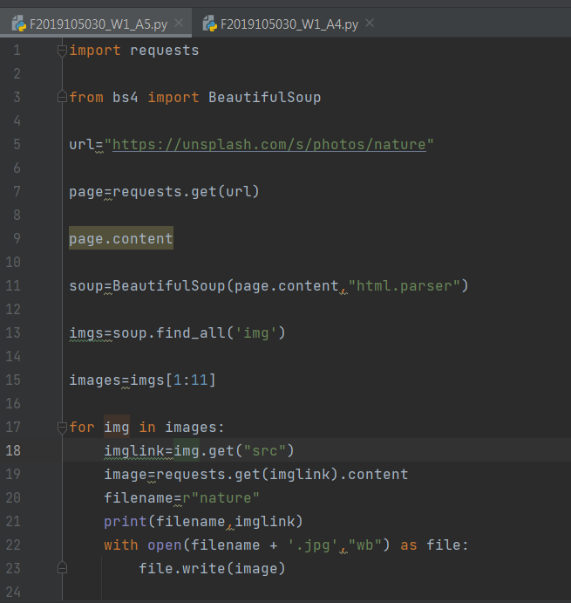

1. Beach

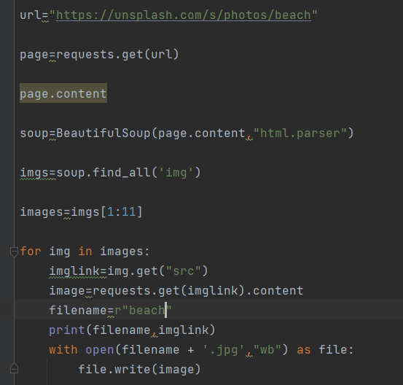

1. Animal

