Campaign Performance Evidence: SpyingAgent Google Ads
Co-Founder, Growth & Marketing | B2B SaaS (AI ad-intelligence platform) | Sep 2024 – Mar 2025 | Part-time

Summary
I owned paid acquisition end-to-end for SpyingAgent, a B2B SaaS product built with a partner that scans competitor ads daily and delivers top-performing creatives, copy, and scripts to Slack. I defined the audience and positioning, built the landing pages, set up the Google Search campaigns and conversion tracking, and tested campaign structures, pricing, and onboarding. The goal was trial sign-ups, mainly from small startups.
Over seven months, three Search campaigns spent $2,808 and produced 73 trial sign-ups at a blended $38.52 per sign-up and a 6.4% conversion rate.

Objective and budget
- Objective: drive trial sign-ups for a B2B SaaS product
- Channel: Google Ads, Search campaigns
- Budget: $15/day cap per campaign, $45/day across the account. Actual spend averaged about $13/day ($2,808 over 212 days), as campaigns were adjusted and paused during testing.
- Bid strategy: Maximise clicks
- Period: 1 Sep 2024 – 31 Mar 2025
- Ownership: audience definition, positioning, landing pages, campaign setup, testing and reporting

Results (Google Ads, full period)
Campaign | Cost | Impressions | Conversions | Conv. rate | Cost / conv.
High-intent Search | $1,275.00 | 8,500 | 38 | 8.9% | $33.55
Landing-page experiments | $308.11 | 7,000 | 8 | 5.7% | $38.50
Problem-focused | $1,225.00 | 20,000 | 27 | 4.7% | $45.37
Total | $2,808.00 | 35,500 | 73 | 6.4% | $38.52
Average CPC across the account was $2.33.

What the data showed
- Intent beat reach. The high-intent campaign converted at 8.9% and cost $33.55 per sign-up, about 26% less than the problem-focused campaign ($45.37).
- Impressions did not equal sign-ups. Problem-focused drew 56% of all impressions but only 37% of conversions.
- Efficiency was concentrated. High-intent produced 52% of all sign-ups on 45% of spend.

A/B testing and optimisation
I tested three things: how the campaigns were structured, how the product was priced, and how new users were onboarded. A dedicated Landing-page experiments campaign also ran landing-page variants, spending $308.11 for 8 sign-ups at a 5.7% conversion rate.
- Campaign structure: High-intent keywords beat problem-led keywords. High-intent converted at 8.9% and cost $33.55 per sign-up, against 4.7% and $45.37 for Problem-focused. High-intent was the strongest campaign.
- Pricing: I first offered several pricing plans, all priced above $50 a month. The first 3 to 4 prospects pushed back on the price and made counter-arguments. After 3 to 4 rounds of customer feedback, I dropped to a single $50/month plan.
- Onboarding: I replaced a payment integration on the website with a short Calendly walkthrough call, in which I explained the tool and how to use it. Feedback on the calls was positive and it was faster to run. The trade-off was that about 10 prospects hesitated to join a meeting.

Funnel analysis (GA4)
I analysed the full funnel (ad click, landing page, sign-up, activation) in GA4. The finding was that activation, not traffic, was the main bottleneck: the ads delivered sign-ups, but too few trial users reached activation.
- Sign-up to activation rate: about 10 to 15 of the 73 sign-ups activated, roughly 14% to 21%.
- Where users dropped off: between sign-up and activation. About 10 sign-ups declined the onboarding call because they were reluctant to join a meeting. The remaining sign-ups who did not activate did not progress beyond sign-up.
- Change made: short, plain walkthrough calls to get users to their first result, and a single $50/month plan after early pricing feedback.

Tracking setup
Before spending anything, I set up and tested conversion tracking with Google Tag Manager and GA4 and confirmed it worked end to end. This meant the Google Ads conversions and the GA4 funnel data could be trusted when I analysed where users dropped off.

Outcome and lessons
We ran SpyingAgent as an independent experiment. Some activated users did become paying customers, but some left before four months, and when they left, their feedback was that they were choosing a better alternative tool. Competitors were performing far better, so overall the venture did not cover its costs and we wound it down. All three campaigns are now paused, which is why the account shows them as not eligible.
The main lessons were to validate positioning and differentiation before scaling spend, to treat activation as a first-class metric alongside cost per sign-up, and to favour high-intent keywords over broad problem-led ones. I applied these to later B2B lead-gen work.

Evidence

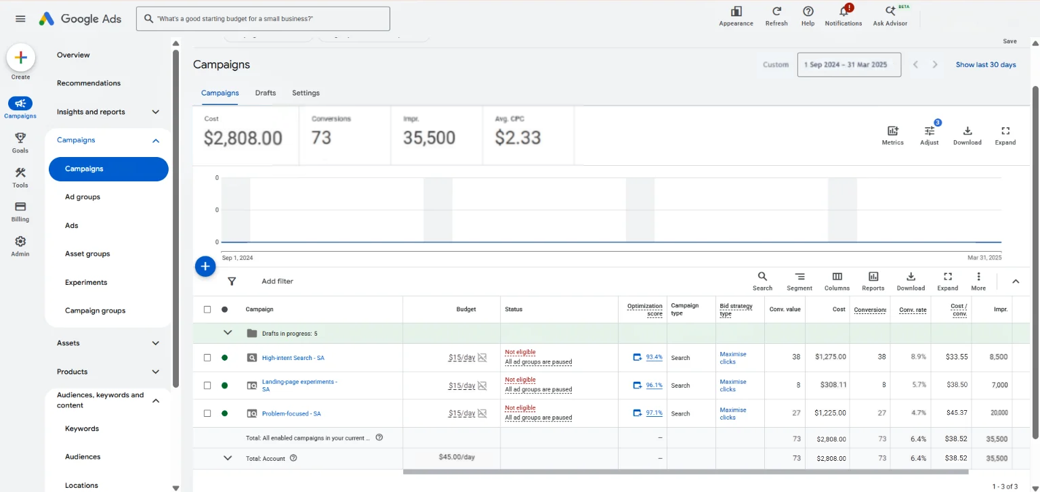
Source: Google Ads campaign dashboard, 1 Sep 2024 – 31 Mar 2025 (screenshot attached).

