Artificial Intelligence Lab# 3

1. Consider the following graph:
2. Apply BFS to find to every possible node present in graph. Starting from 1.
3. Find all paths between 1 & 6.
4. Find shortest path between 1 & 6.

Code:

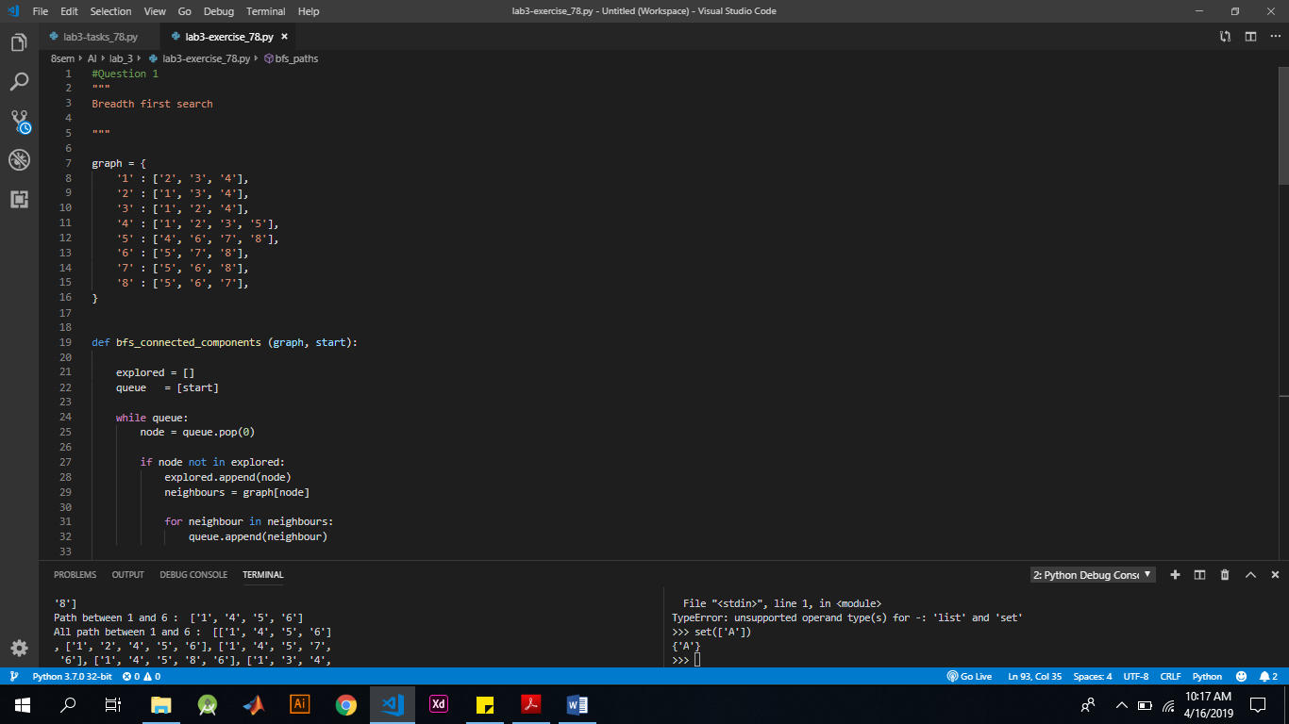

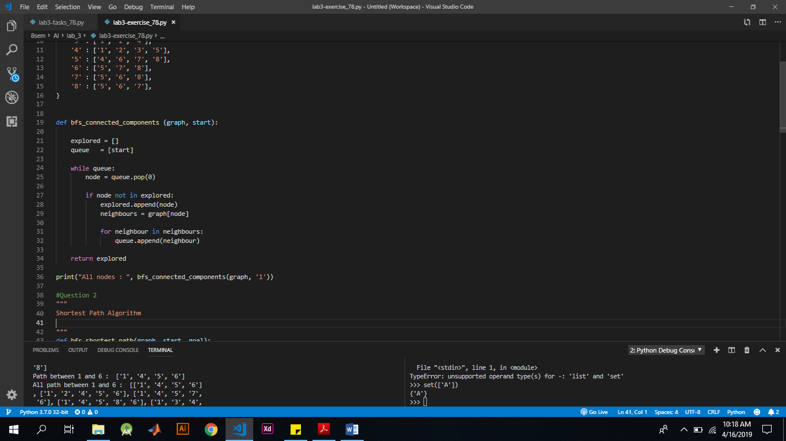

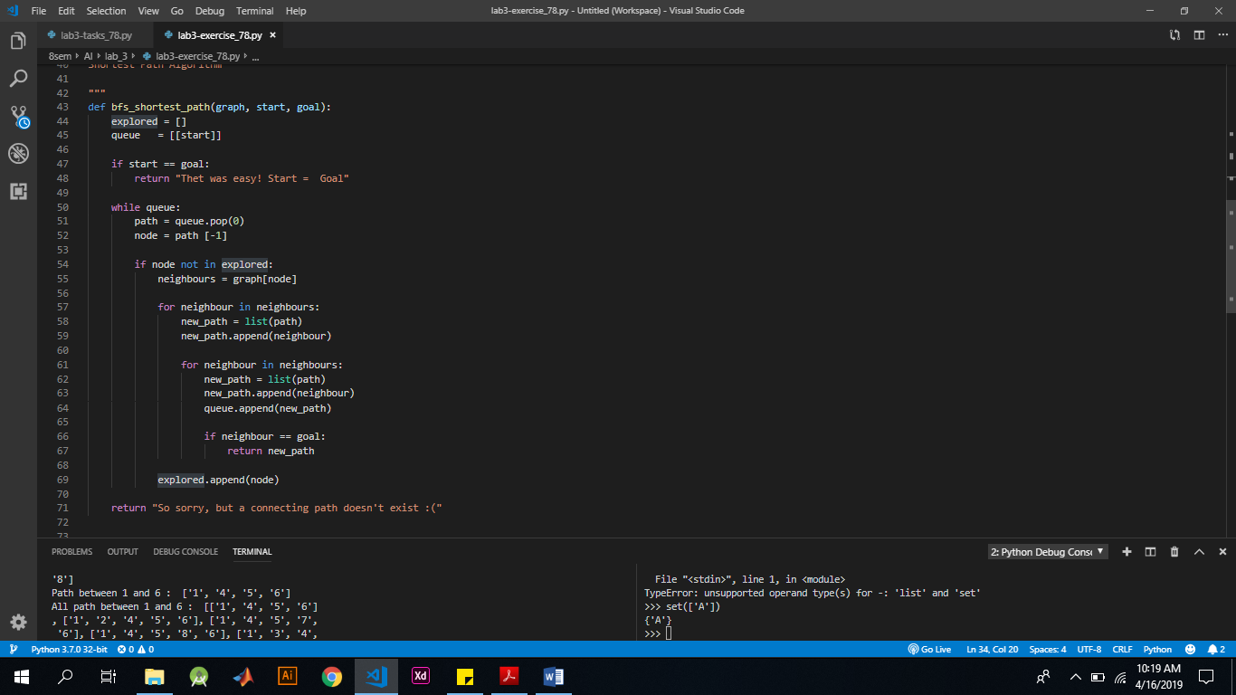

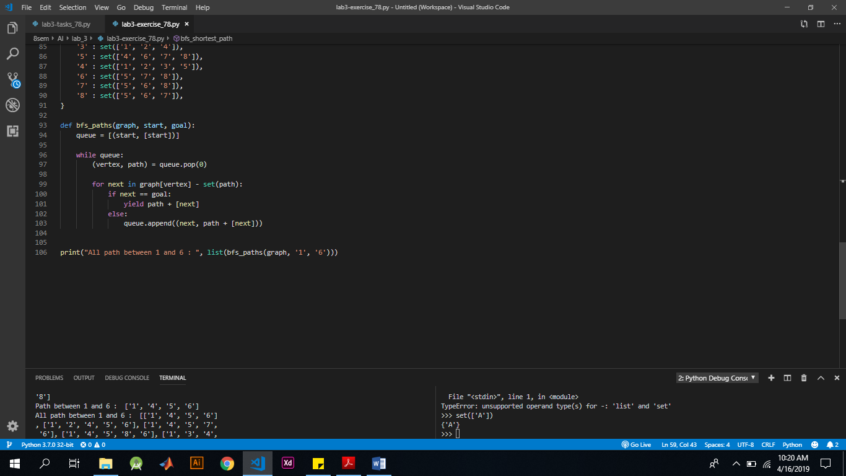

Answer:

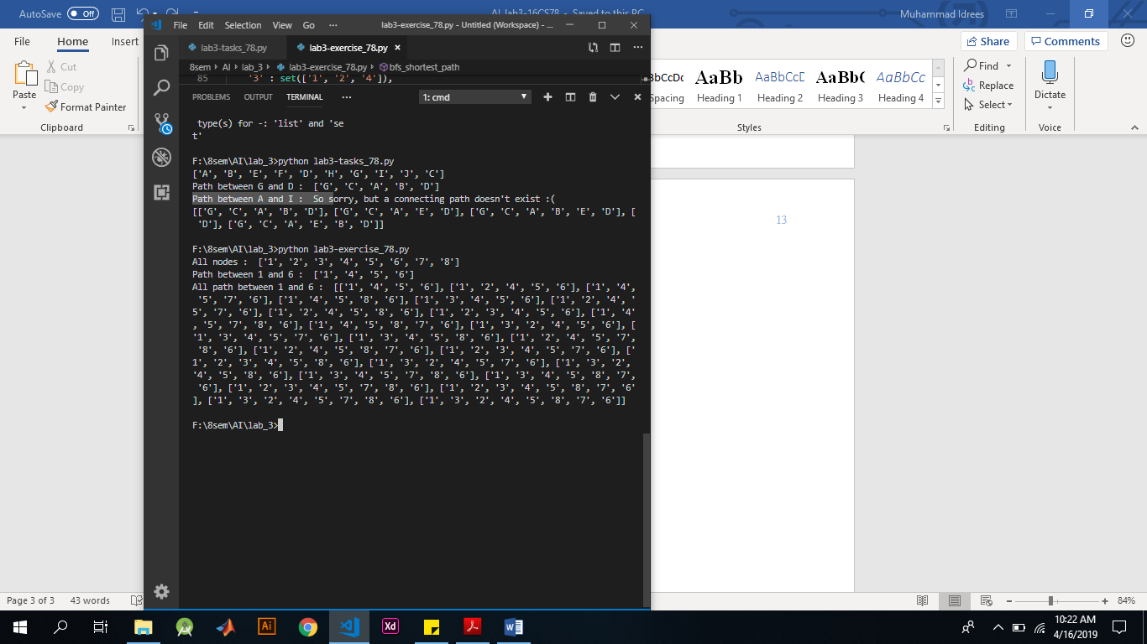

1. Consider the following graph:
2. Apply BFS to find to every possible node present in graph. Starting from A.
3. Find all paths between A & G.
4. Find shortest path between A & G.

